Windows puTTY setup to interact with SOC_Particle serial port for SOC_Test.py

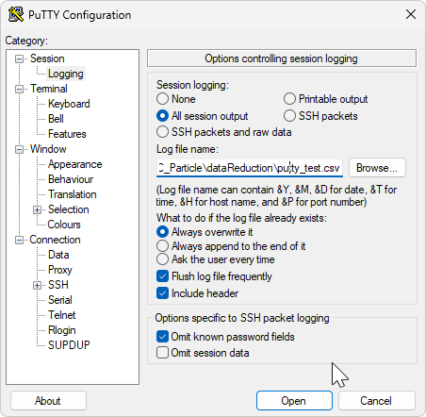
Same as ‘def’ except log file location

