SDN621S Software Design · Assessment 4

STEMMate Namibia
Final Consultancy Report: Architecture, Vertical Slice, Tests, Evaluation and Redesign
Item | Detail
Team name | Group 2
Consultancy | Namibian Sustainable Software Design Laboratory (NSSDL)
Course | Software Design (SDN621S), Level 6, Semester 2, 2026, NUST
Team representative | Dawid Cornelius /Howoseb (200911422)
Vertical slice | STEMMate v1.3 – source in stemmate-slice/ · repository: https://github.com/daveguyz/SDNsubmission
A3 baseline prototype | v1.2 – https://claude.ai/artifact/5sQfpnNzJ6FsQLVNraqDG4 (copy included as public/prototype-v1.2.html)
Briefing and demonstration | A4_Group2_Client_Briefing.pptx (7 minutes, script in speaker notes) · recording: [video link]
Submission date | [date submitted]

Team members and consultancy roles
Student no. | Name | Practical group | Primary consultancy role(s)
200911422 | Dawid Cornelius /Howoseb | Group 5 | Project manager; development lead (sync engine, encrypted store, server); testing
225165848 | Phillip Munenguni | Group 5 | Requirements and architecture lead; UX/UI; documentation; evaluation moderator
[student no.] | [name – add any further members] | [group] | [role]

Every role named in the brief is assigned: project management (Dawid), requirements (Phillip), architecture (Phillip, with Dawid for the sync design), UX/UI (Phillip), development (Dawid), testing (Dawid, with Phillip for the evaluation) and documentation (Phillip). [The brief requires 5–8 members per team. Add any members who are not listed, or attach the lecturer's approval for a smaller team.]
Text in [yellow brackets] marks information only the team can supply. Remove the highlighting once it is filled in.

If page numbers are missing, right-click the contents and choose Update Field.
1. Executive summary
2. Context and scope
2.1 Vertical slice chosen and why
2.2 Out of scope (unchanged from A3 unless noted)
3. Updated requirements baseline
3.1 A4 change record
4. Design argument
5. Architecture
5.1 System context view
5.2 Container view
5.3 Component view (UML class diagram)
5.4 Deployment view
5.5 Sequence view of the slice
5.6 Architecture Decision Records
6. Data, access and recovery
6.1 Logical data model
6.2 Role and access rules
6.3 Offline, synchronisation and failure strategy
7. Implementation of the vertical slice
7.1 Setup (from a clean machine)
8. Requirements-based testing
8.1 Traceability matrix
8.2 Automated tests
8.3 Accessibility, failure and recovery checks
8.4 Issue log
9. Evaluation
9.1 Ethics and method
9.2 Round 1 (A3, prototype v1.2): findings carried into A4
9.3 Round 2 (A4, slice v1.3): tasks
9.4 Round 2 results
9.5 Limitations
10. Evidence-led redesign
10.1 Options considered and rejected
10.2 Unresolved after redesign
11. Sustainability and handover
11.1 Decommissioning plan
11.2 Handover package
12. Risks and recommendation
12.1 Recommendation to the client
13. Known limitations
References
Appendix A: Team AI-use declaration

1. Executive summary
STEMMate helps adult STEM facilitators in Namibia, often volunteers on a shared, low-specification phone with unreliable signal, find an activity that fits the materials on hand, plan the session, run it without internet and deliver a comparable plan to the outreach unit when signal returns. A3 tested this loop as a clickable prototype (v1.2) with simulated storage and synchronisation. A4 replaces the simulation with a working vertical slice (v1.3) for the priority workflow: plan a session offline, mark it complete and deliver it to the outreach unit.
The slice runs from the user interface through shared validation, domain logic and an AES-256-GCM encrypted store on the phone, to a Node.js sync API that writes plans to a persistent file, and back to a visible status. It handles no signal, three server failures with Retry, a lost response (no duplicate is created) and an edit conflict in which neither copy is overwritten.
Evidence | Result
Automated tests (unit + integration) | 18 tests (AT-01–AT-18). Run 1: 17 pass, 1 fail (AT-16, a real conflict defect). After the fix: 18/18 pass.
Accessibility audit (axe-core 4.10.2, WCAG 2.2 AA tags) | 14 screen states: 0 violations, 0 targets under 24 × 24 px, no horizontal scroll at 320 px, 3 px focus outline on every control.
Manual and browser checks | 11 checks (MT-01–MT-11), including 2 failures reproduced on the v1.2 baseline and 1 new defect found and fixed.
Redesign | 5 before/after changes; 4 are major and each is tied to an evaluation finding or a failing test.
Evaluation | A3 round: 5 simulated stakeholders, 4 findings. A4 re-test protocol for v1.3 is ready; [round-2 results to be entered from the team's session sheets].

Recommendation. The architecture is sound for one outreach unit and should go forward to a supervised pilot-readiness phase, not deployment. Four conditions apply first: replace 4-digit demo PINs with 6-digit PINs and an attempt limit, test on a real low-spec Android phone, have an experienced screen-reader user test it, and get lecturer and institutional approval before any contact with real facilitators (Section 12).

2. Context and scope
Client and problem. The client is a STEM outreach unit that supports adult facilitators running hands-on sessions for learners. Evidence codes E1–E6 come from the A1 evidence dossier: facilitators choose activities from the materials in the box (E1); the unit needs comparable plans and participation counts without learner names (E2); volunteers need clear steps, timing and safety (E3); shared kits need responsible people (E4); facilitators fear losing drafts on shared phones with poor signal (E5); school managers want to see a plan before the session (E6).
Low-resource constraints that drive every decision. Intermittent and costly mobile data; shared, low-specification Android phones; limited local technical support; content that must be changed by non-programmers; strict privacy because the work involves children.

2.1 Vertical slice chosen and why
Slice | Path through the system | Requirements
Plan offline, complete and deliver | Sign in with PIN → open an activity → create plan → edit steps, safety, inclusion and counts (autosaved, encrypted) → Mark complete (validated) → queued → conditional PUT to the sync API → server validates and writes plans.json → status "Sent to outreach unit" or a recovery state | FR-03, FR-04, FR-05, FR-06, FR-07, QR-01, QR-02, QR-03, SR-01

This slice was chosen because it crosses every layer (UI, validation, logic, two persistent stores, network) and carries most of the project risk: data loss on shared phones, privacy, and the sync conflict rule that A2 and A3 could only simulate. Finding activities (FR-01) is also in the slice. Per-activity download with rollback (FR-02) stays at prototype level: v1.3 caches the whole 3.9 KB catalogue in the app shell instead (Section 13).

2.2 Out of scope (unchanged from A3 unless noted)
- Kit booking and return – a Could requirement in A2; no evidence about the core loop.
- Translated activity content – interface labels now live in data/labels.json, so translation needs no code change; translating content needs outreach-unit review.
- Automatic merging of conflicting plans – rejected again in ADR-02.
- Outreach-unit web dashboard and staff accounts – the server exposes the API; staff read plans.json or the GET endpoint. New deferral in A4.

3. Updated requirements baseline
The 12 A3 identifiers are kept unchanged. A4 adds no new requirement IDs; it refines five requirements where building and testing the slice exposed ambiguity. Priorities are unchanged (10 Must, 2 Should).
ID | Pri. | Requirement (A3 wording, A4 refinements in bold) | Slice?
FR-01 | Must | Filter the catalogue by level, topic, maximum duration and materials on hand; return only activities whose required materials are all selected. | Yes
FR-02 | Must | Save an activity's full content to the device; a failed download leaves no partial copy and offers Retry and Cancel. | Prototype v1.2
FR-03 | Must | Create a session plan from one activity with ordered steps, durations, safety notes and an inclusion prompt; reorder with buttons. A plan cannot be completed without a date, at least one step, safety notes and an inclusion prompt. | Yes
FR-04 | Must | Autosave on every committed change and at least every 2 s while typing. Leaving a screen saves first; the slice debounces at 1 s. | Yes
FR-05 | Must | Participation only as counts per broad category; no names, identifiers, photos or notes about individuals. Counts are whole numbers 0–9 999. | Yes
FR-06 | Must | Queue a completed plan and send it automatically when online; an interrupted send resumes without duplicates; on conflict overwrite neither copy and let the facilitator choose. Each completion carries an idempotency key (editId); "Keep this phone's version" re-bases on the server revision. | Yes
FR-07 | Must | Show each plan's sync status in words and an icon, offline, within 1 s; announce success and failure. Labels reworded from evaluation finding F2 (Section 10). | Yes
FR-08 | Should | Read-only plan summary printable on A4. | Yes
QR-01 | Must | FR-01–FR-05 work offline; filter within 1 s for 500 activities; ≤ 200 KB per activity download; ≤ 500 KB per sync request. The 500 KB limit is enforced by the server (HTTP 413). | Yes
QR-02 | Must | WCAG 2.2 AA: keyboard, visible focus, accessible names, no colour-only information, targets ≥ 24 × 24 px, reflow at 320 px, error identification and suggestion. | Yes
QR-03 | Must | Per-facilitator encrypted drafts (AES-256-GCM); sign-out locks without deleting; TLS 1.3; only domain-model data stored. Key derived from the PIN with PBKDF2-SHA-256 (210 000 iterations); the server rejects any field outside the domain model. | Yes
SR-01 | Should | Content and interface text in data files the outreach unit can edit without code changes; runs as a cached web app; no paid third-party services. | Yes

3.1 A4 change record
# | Change | Evidence that caused it | Effect
C-A4-1 | FR-07 status wording replaced ("Waiting for signal", "Sending now", "Sent to outreach unit", "Not sent – tap Retry", "Needs your choice"). | A3 finding F2: 2 of 5 participants did not understand "Synchronise". | R1; data/labels.json
C-A4-2 | FR-04 refined: save before leaving a screen. | MT-03: v1.2 lost typed text and threw a TypeError. | R2; AT-09, MT-04
C-A4-3 | FR-06 refined: idempotency key and re-base on conflict. | AT-16 failed in run 1; AT-12 designed for the lost-response case. | R3; ADR-02
C-A4-4 | QR-03 made concrete (PBKDF2, server field whitelist). | MT-05: v1.2 stored drafts in plain text. | R4; ADR-03; AT-07, AT-08, AT-10, AT-18
C-A4-5 | QR-01 500 KB limit enforced on the server. | Design review: a client-side limit alone cannot be trusted. | AT-18
C-A4-6 | Outreach dashboard deferred. | Slice scope; no requirement depends on it. | Section 2.2

4. Design argument
Three ideas from A2 and A3 still carry the design, and the slice now proves them in code rather than in simulation:
- The phone is the source of truth. Every planning task works with no network. The network is used only to fetch the app and content once and to deliver completed plans. This follows from E1 and E5 and the cost of data.
- Delivery is revision-based, never last-write-wins. A plan changed by the outreach unit is never silently overwritten, and a repeated send never creates a second copy (E2, E5).
- Shared phones need locking, not deleting. Each facilitator's drafts are encrypted under a key derived from their PIN; signing out forgets the key, so the next person cannot read the drafts, but nothing is lost (E5, QR-03).
The quality attributes that matter most, in order, are recoverability, privacy, accessibility, affordability and maintainability. Where they compete, the report states the trade-off in the ADRs (Section 5.6). For example, PBKDF2 with 210 000 iterations took 43 ms per sign-in on the team laptop and will be several times slower on a low-spec phone (not yet measured). We accepted that cost because sign-in happens once per session, but Section 12 shows it is not enough protection for a 4-digit PIN.

5. Architecture
Each view below states its purpose and how to read it. All diagram sources are in architecture/*.mmd (Mermaid) and can be edited and re-rendered without special tools.

5.1 System context view
Purpose: fix the system boundary and the people and systems it serves. Legend: light boxes are people, the dark box is STEMMate, the orange box is an external system, solid arrows are data the system exchanges, dotted arrows are optional or conditional.
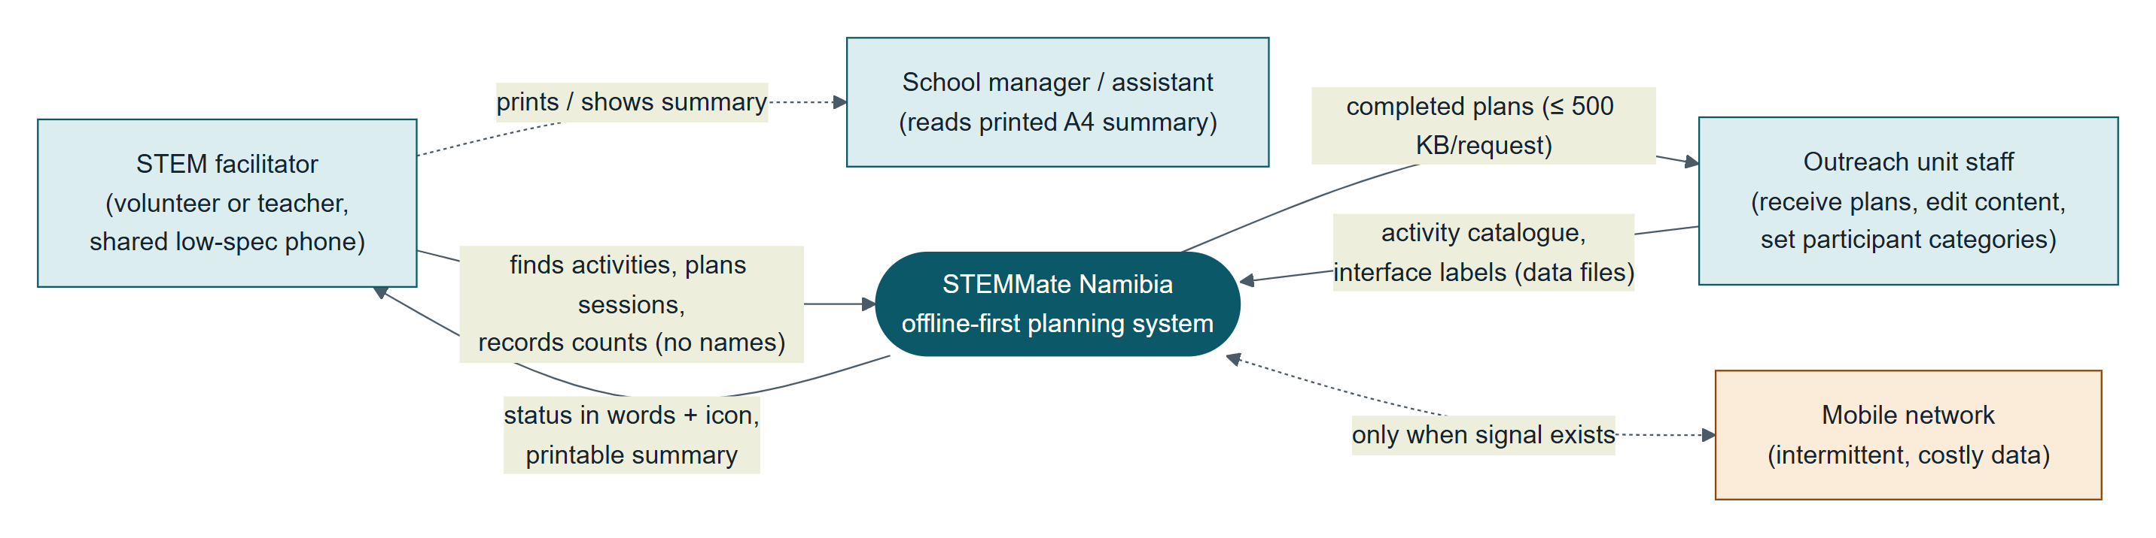
Figure 1. System context. Plans leave the phone only as complete, validated plans; learners never appear as data.

5.2 Container view
Purpose: show the deployable parts, what each is responsible for and how they talk. Legend: blue boxes are code containers or modules with their source file, orange cylinders are data stores, arrows point from caller to called.
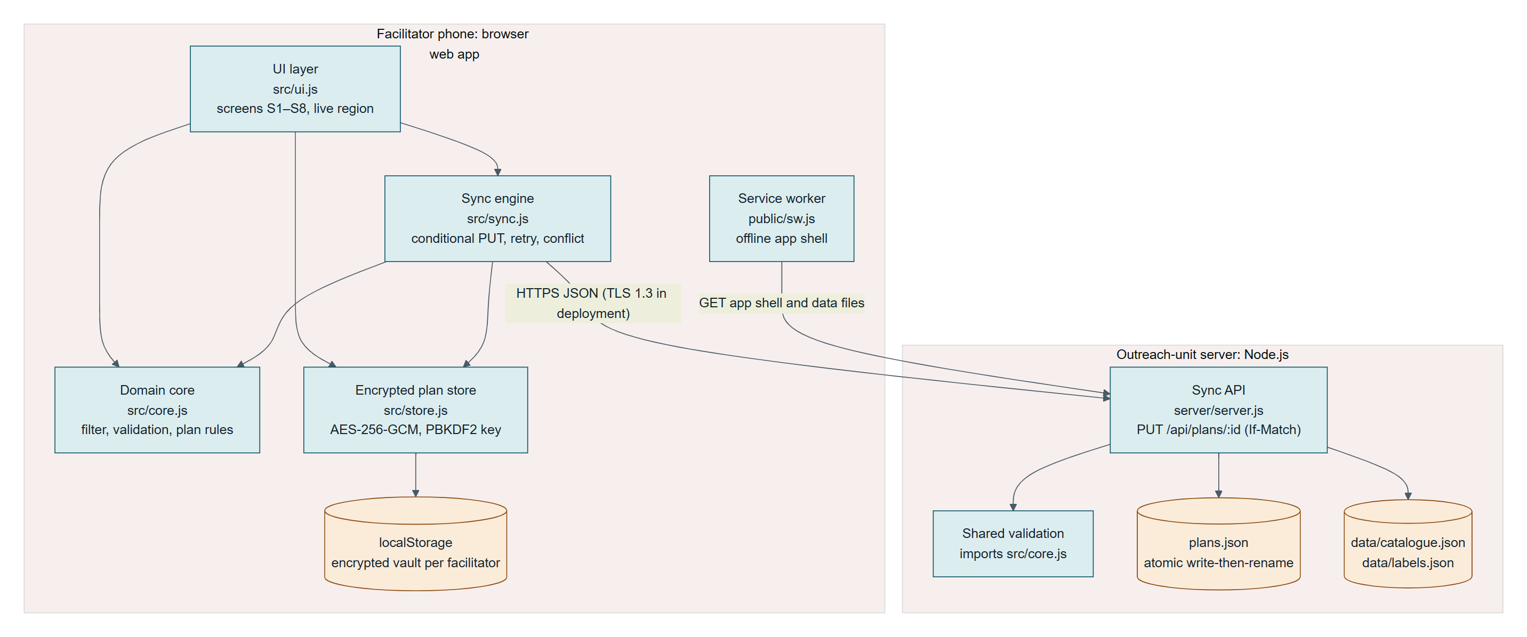
Figure 2. Containers. The domain core (core.js) is imported by both the phone and the server, so validation exists once.

5.3 Component view (UML class diagram)
Purpose: show module responsibilities and dependencies inside the slice. Legend: UML class notation; solid arrows are associations or calls, dashed arrows are dependencies. The UI depends on the core, the store and the sync engine. Nothing depends on the UI, so screens can change without touching the rules.
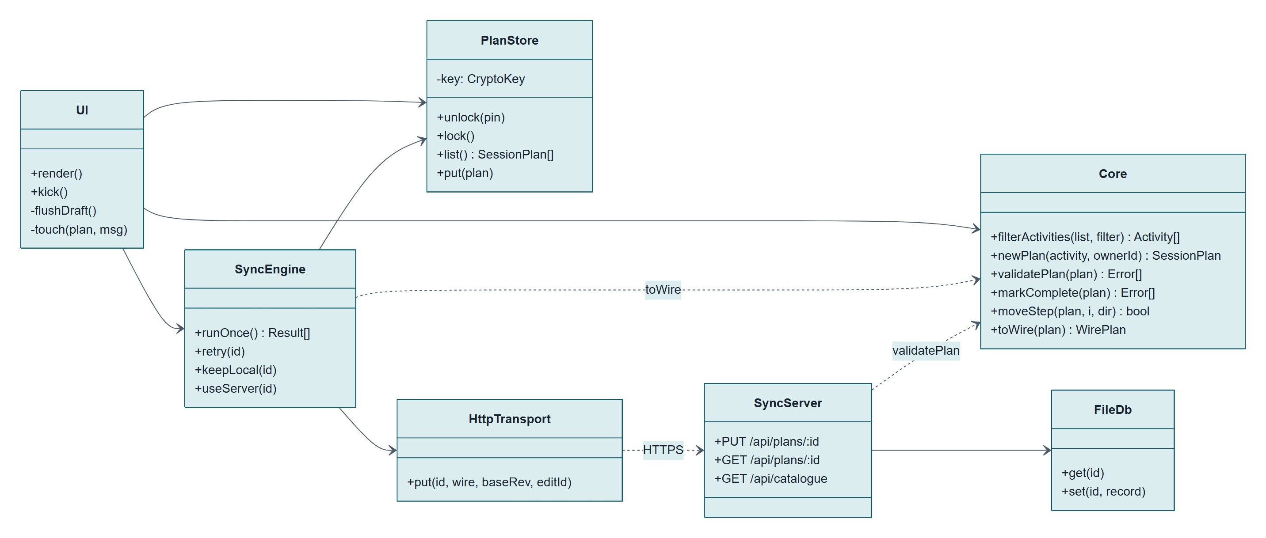
Figure 3. Components of the vertical slice with their public operations.

5.4 Deployment view
Purpose: show where each part runs in the low-resource setting. Legend: «device» is hardware, «execution env» is the runtime, arrows are network or file paths. The server runs on an office PC or a low-cost virtual server; a Caddy reverse proxy supplies TLS 1.3 certificates automatically.
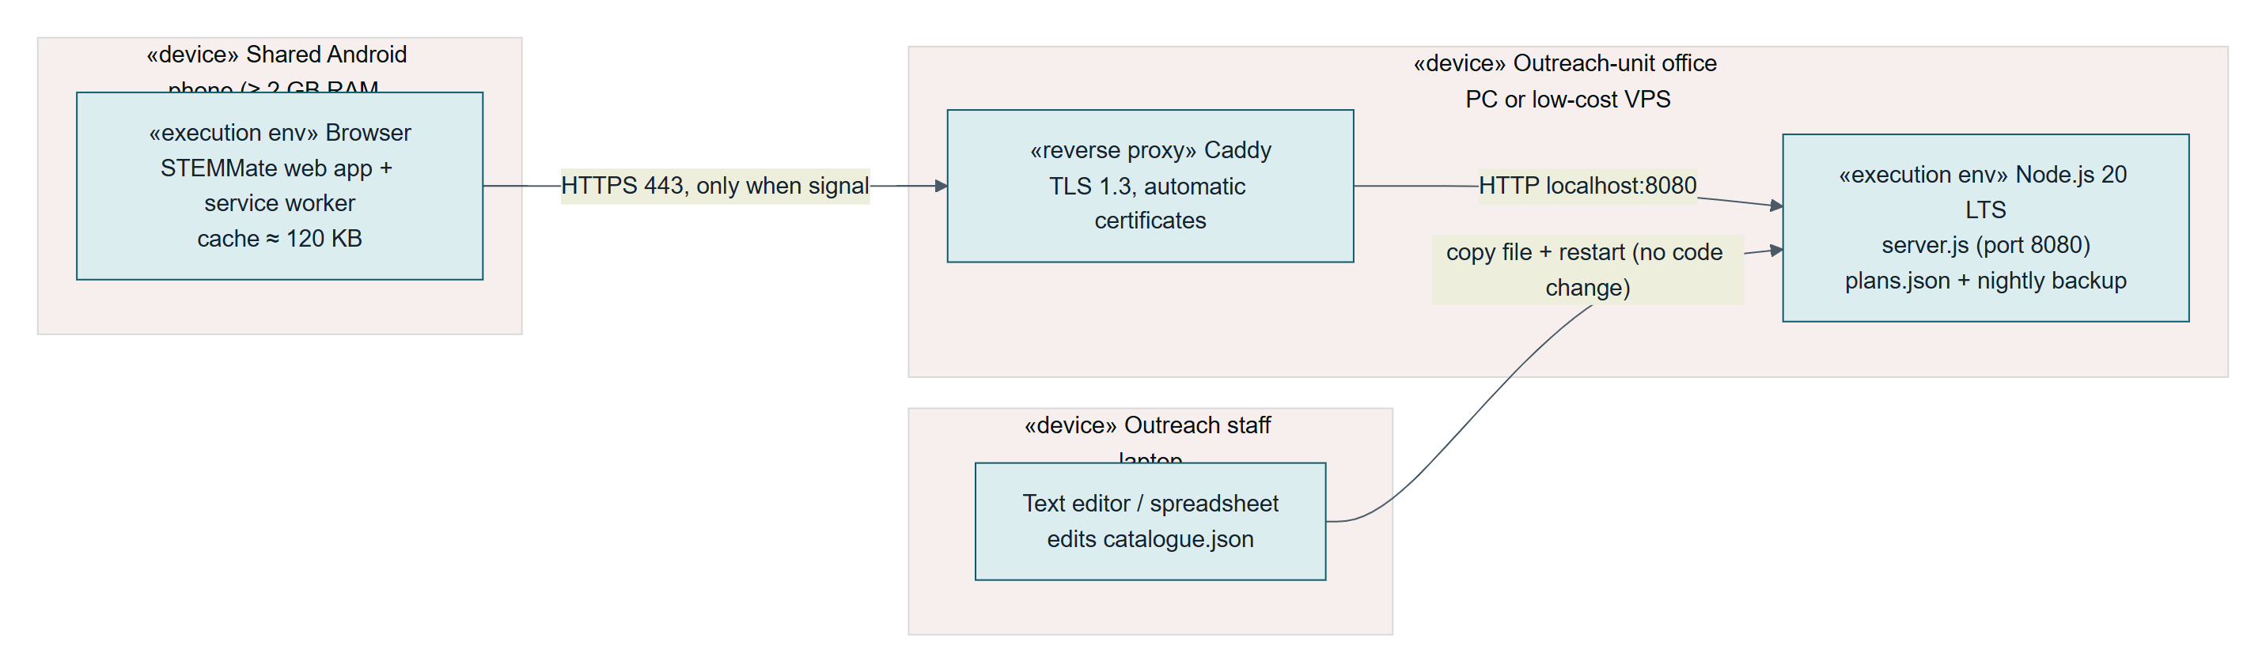
Figure 4. Deployment. The phone needs signal only to fetch the app once and to deliver plans.

5.5 Sequence view of the slice
Purpose: show the complete path for the priority workflow, including validation failure, no signal, idempotent replay and conflict. Legend: UML sequence notation; alt frames are alternative outcomes.
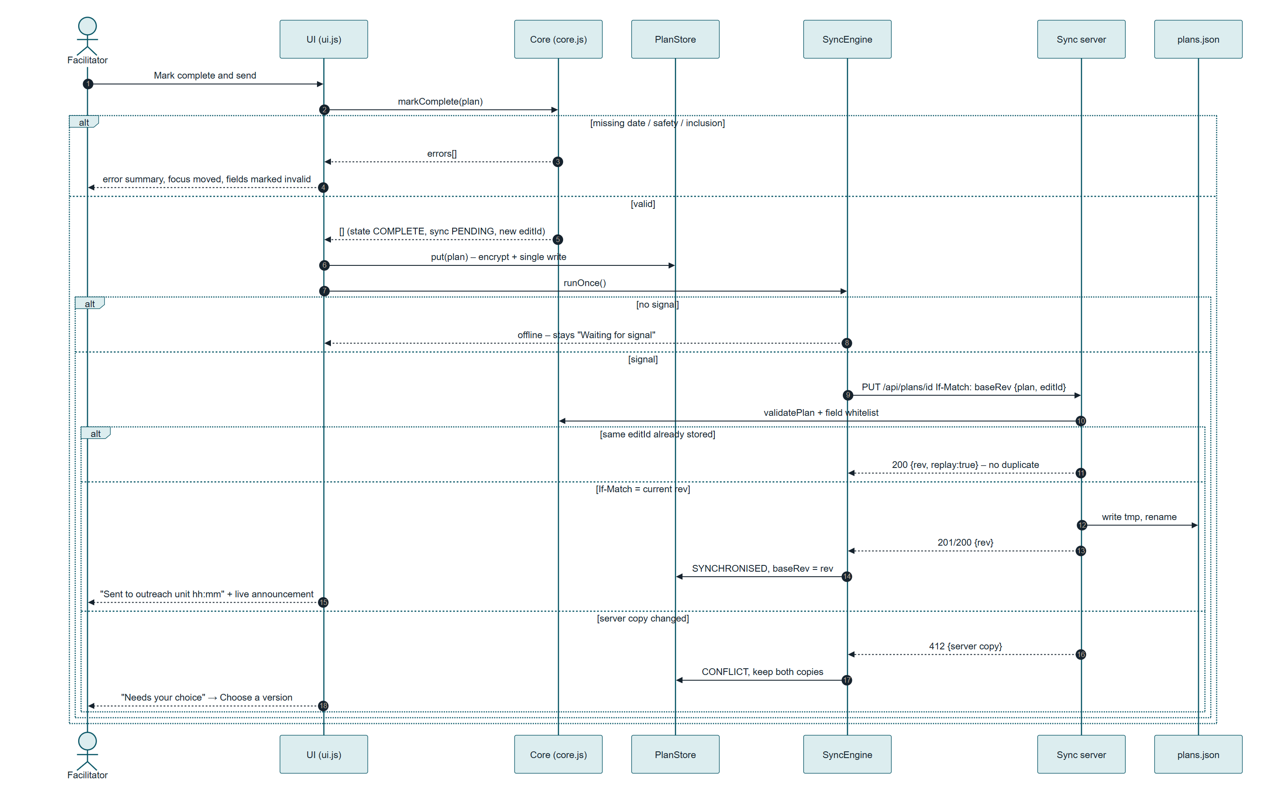
Figure 5. Mark complete and send: UI → core validation → encrypted store → sync engine → API → persistent file → visible status.

5.6 Architecture Decision Records
Five ADRs are recorded. ADR-01 to ADR-03 are the decisions with the most consequence for the low-resource context.

ADR-01 Offline-first installable web app
Field | Record
Status | Accepted · [date agreed]
Context | Facilitators use shared, low-spec Android phones with intermittent, costly data. The outreach unit has no mobile developers.
Options | (a) Native Android app; (b) installable web app (PWA) with a service worker; (c) SMS/USSD service.
Decision | (b). One small code base (≈ 50 KB app shell uncompressed) that runs in any current browser, installs from a link without an app store, and updates when signal returns.
Trade-offs and consequences | No access to Android background sync on all browsers, so delivery is retried when the app is open and every 20 s while it is open. iOS storage may be cleared after weeks without use. SMS was rejected because plans with steps and safety notes do not fit and messages cost each facilitator money.

ADR-02 Revision-based conditional PUT with idempotency key
Field | Record
Status | Accepted · [date agreed] · amended 4 Nov 2026 after AT-16 failed (re-base rule)
Context | Plans are edited on the phone offline and sometimes by the outreach unit. E5: facilitators fear losing work. Responses can be lost when signal drops mid-request.
Options | (a) Last write wins; (b) conditional PUT with If-Match revision and a per-completion editId; (c) automatic field-level merge or CRDT.
Decision | (b). The server accepts a PUT only if the device's base revision matches; an identical editId returns the stored revision (no duplicate); a mismatch returns 412 with the server copy, and the facilitator chooses.
Trade-offs and consequences | A facilitator who wants changes from both copies re-enters one by hand. Accepted because conflicts are expected to be rare and a wrong automatic merge of reordered steps would be worse. AT-16 showed that "keep mine" must re-base on the server revision, otherwise the plan loops in conflict; the amendment adds that rule.

ADR-03 Client-side encryption with a PIN-derived key per facilitator
Field | Record
Status | Accepted · [date agreed]
Context | Phones are shared; drafts may contain school names and dates; sign-out must not delete unsynced work (FR-04 vs QR-03).
Options | (a) Rely on the phone lock screen; (b) server-only storage; (c) AES-256-GCM vault per facilitator, key from PIN via PBKDF2 held only in memory.
Decision | (c) using the browser's built-in Web Crypto API: no library, no cost.
Trade-offs and consequences | A 4-digit PIN has only 10 000 values; one PBKDF2 guess took 43 ms on the team laptop, so all 10 000 PINs can be tried in about 7 minutes by someone who copies the phone storage (residual risk RR-1). PBKDF2 stops casual guessing, not a determined attacker. A forgotten PIN means drafts cannot be recovered: synced plans are safe on the server, unsynced drafts are lost. This is stated in the handover.

ADR-04 JSON file store on the server
Field | Record
Status | Accepted · [date agreed]
Context | One outreach unit, hundreds of plans a year, no database administrator.
Options | (a) PostgreSQL; (b) hosted backend (e.g. Firebase); (c) one JSON file with atomic write-then-rename.
Decision | (c). Readable and backed up by copying one file, no running database, no vendor account or bill.
Trade-offs and consequences | Does not scale to several units or concurrent staff editing; the FileDb class is the single seam to swap for SQLite or PostgreSQL later.

ADR-05 One domain module shared by phone and server
Field | Record
Status | Accepted · [date agreed]
Context | Validation rules must be identical on both sides or plans will be accepted offline and refused later.
Options | (a) Duplicate rules in each tier; (b) JSON-schema file; (c) import core.js in both.
Decision | (c). Both tiers run JavaScript, so one module is the simplest single source of truth.
Trade-offs and consequences | Ties the server to JavaScript. Acceptable: Node.js is free, small and widely taught.

6. Data, access and recovery

6.1 Logical data model
Purpose: define what is stored, where, and what never leaves the phone. Legend: crow's-foot notation; PK primary key, FK foreign key; fields marked "device only" are never sent.
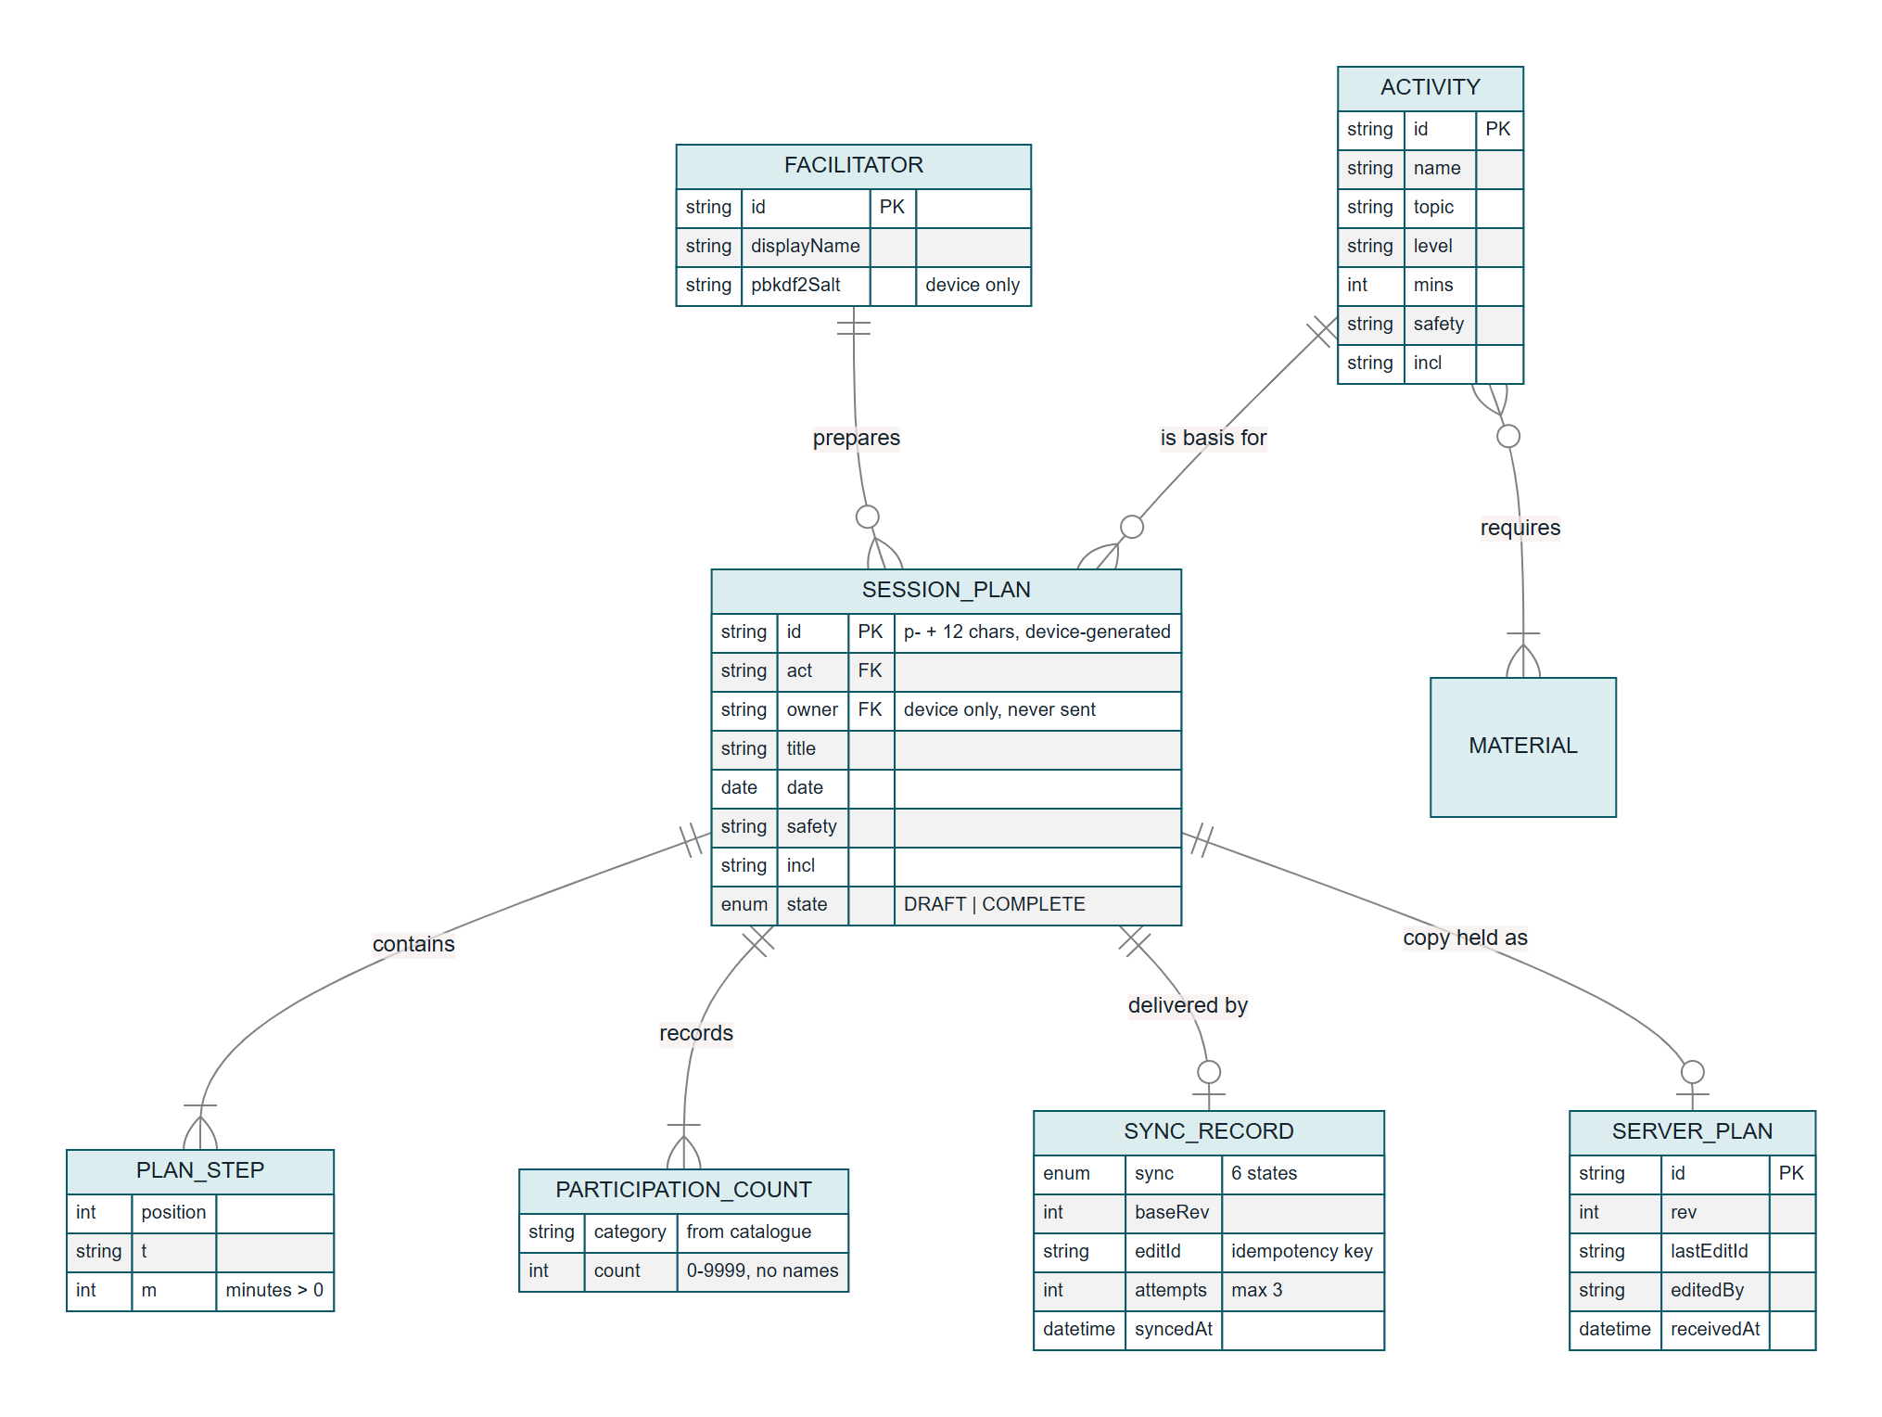
Figure 6. Logical data model. There is no learner entity; participation exists only as counts.
Data minimisation in code. toWire() sends only eight fields (id, act, title, date, steps, safety, incl, counts). The server refuses any other field with HTTP 400 (AT-06, AT-18). Facilitator identity is not sent in the slice; the deployed version will attach it from the authenticated session.

6.2 Role and access rules
Role | Can | Cannot | Enforced by
Facilitator | Create, edit, complete and resend own plans; read catalogue; print summary | Read another facilitator's drafts on the same phone; enter learner names | Per-facilitator vault and PIN (AT-08, AT-10); no name fields (FR-05)
Outreach-unit staff | Read delivered plans; edit a plan (creates a new revision); edit catalogue and labels files | Silently overwrite a facilitator's newer copy | Conditional PUT (AT-15)
School manager / assistant | Read a printed or shown summary | Use the app or hold an account | No account type exists
Server administrator | Back up, restore and export plans.json; turn test controls off (TEST_CONTROLS=0) | Read drafts that were never sent | Drafts never leave the phone unencrypted

6.3 Offline, synchronisation and failure strategy
Purpose: show every delivery state and what moves a plan between them. Legend: UML state machine; notes give the wording the facilitator sees.
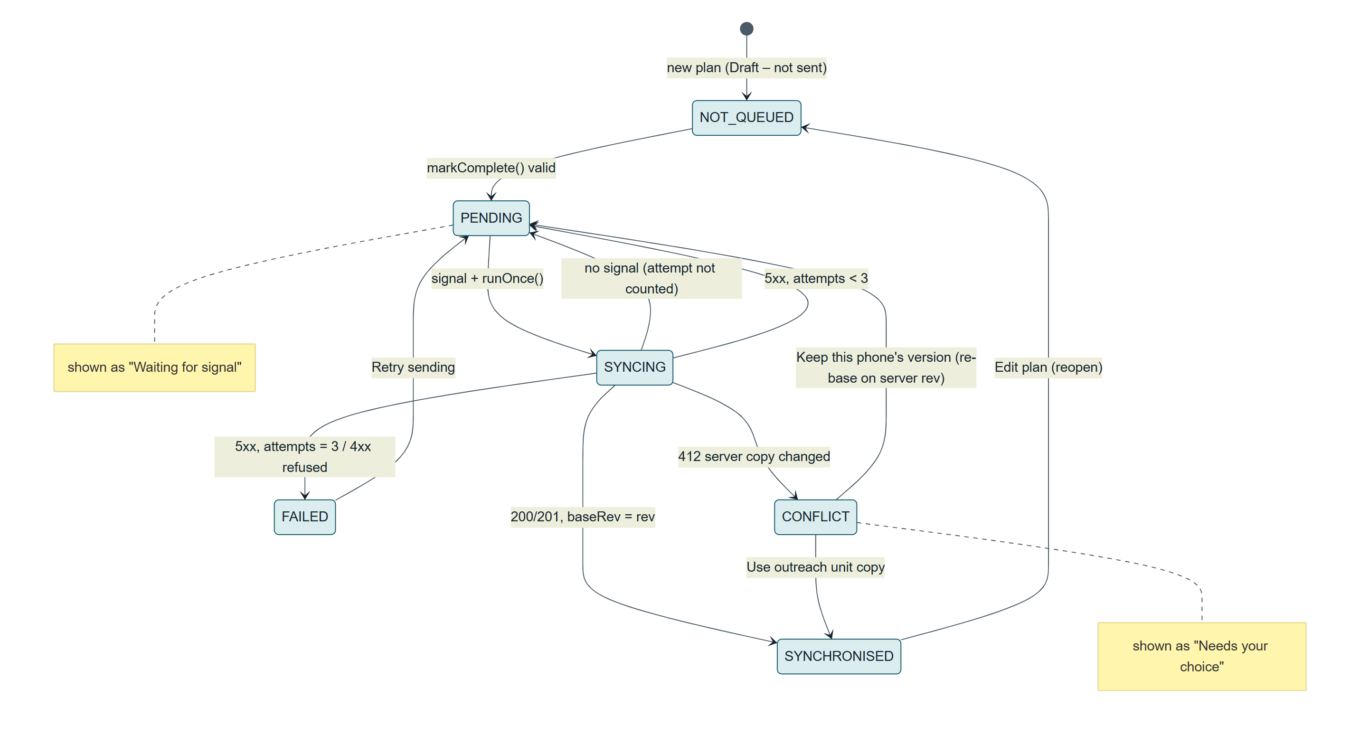
Figure 7. Delivery states. No signal never uses up an attempt; three server errors give "Not sent – tap Retry".
Failure | Behaviour | Evidence
No signal | Plan stays "Waiting for signal"; attempt not counted; banner shows the queue | AT-14, MT-07
Server error (5xx) | Retried; after 3 attempts "Not sent – tap Retry"; plan still on phone | AT-13, MT-08
Response lost after the server saved | Resend carries the same editId; server returns the stored revision; no duplicate | AT-12
Outreach unit changed the plan | 412 → "Needs your choice"; both copies kept; keep mine / use theirs / decide later | AT-15–AT-17, MT-09
Incomplete or tampered plan | Server refuses with 422/400; plan marked not sent | AT-18
App closed while typing | Debounced save after 1 s; save before every screen change | AT-09, MT-04
Server crash while writing | Write to temporary file then rename: old file or new file, never half | Code review of FileDb.save(); not fault-injected (Section 13)

7. Implementation of the vertical slice
Layer | Implementation | Requirement
Interface | Screens S1–S8 in src/ui.js; Up/Down step buttons; error summary with links; polite live region; status chips with icon and words | FR-03, FR-07, QR-02
Validation | validatePlan() in src/core.js, called on the phone before completion and again on the server | FR-03, ADR-05
Application logic | markComplete(), moveStep(), toWire(); SyncEngine.runOnce(), retry(), keepLocal(), useServer() | FR-03, FR-06
Persistent data – phone | Encrypted vault per facilitator in localStorage (src/store.js), one write per save | FR-04, QR-03
Persistent data – server | server/data/plans.json with revision, editId and timestamp | FR-06
Visible output | Status chips, network banner, announcements, A4 printable summary | FR-07, FR-08
Offline | Service worker caches the shell and data files; simulated offline control for evaluation | QR-01

Synthetic data only: eight invented activities, two demo facilitators ("Selma (demo)", "Johannes (demo)"), invented school names. The server's test controls (inject 3 failures, simulate an outreach edit) exist only for evaluation and can be switched off.
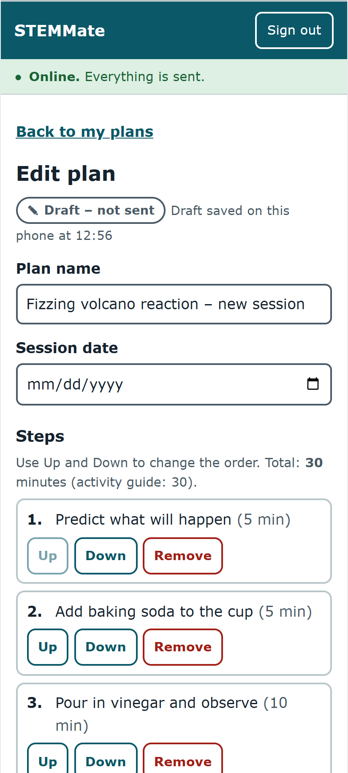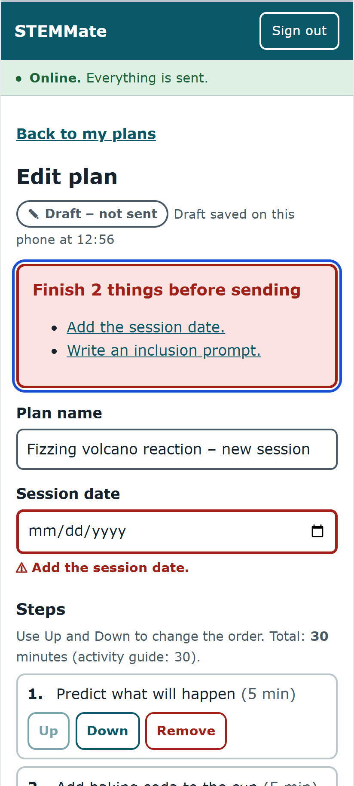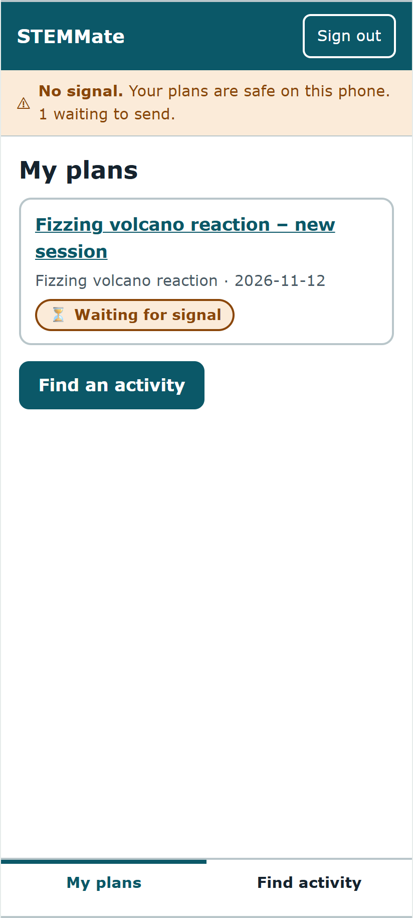
Figure 8. Slice v1.3: plan editor, validation error summary, and offline queue ("Waiting for signal").
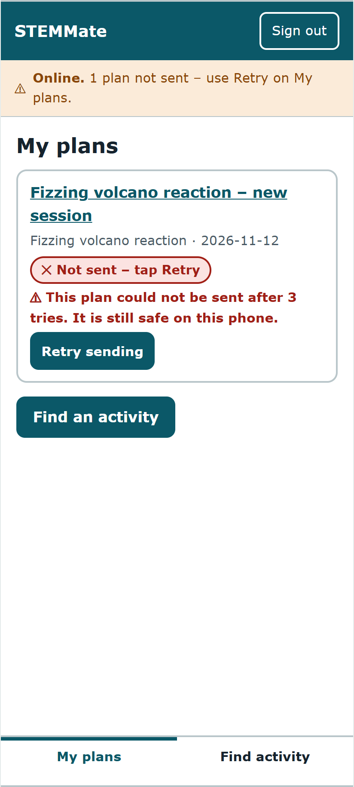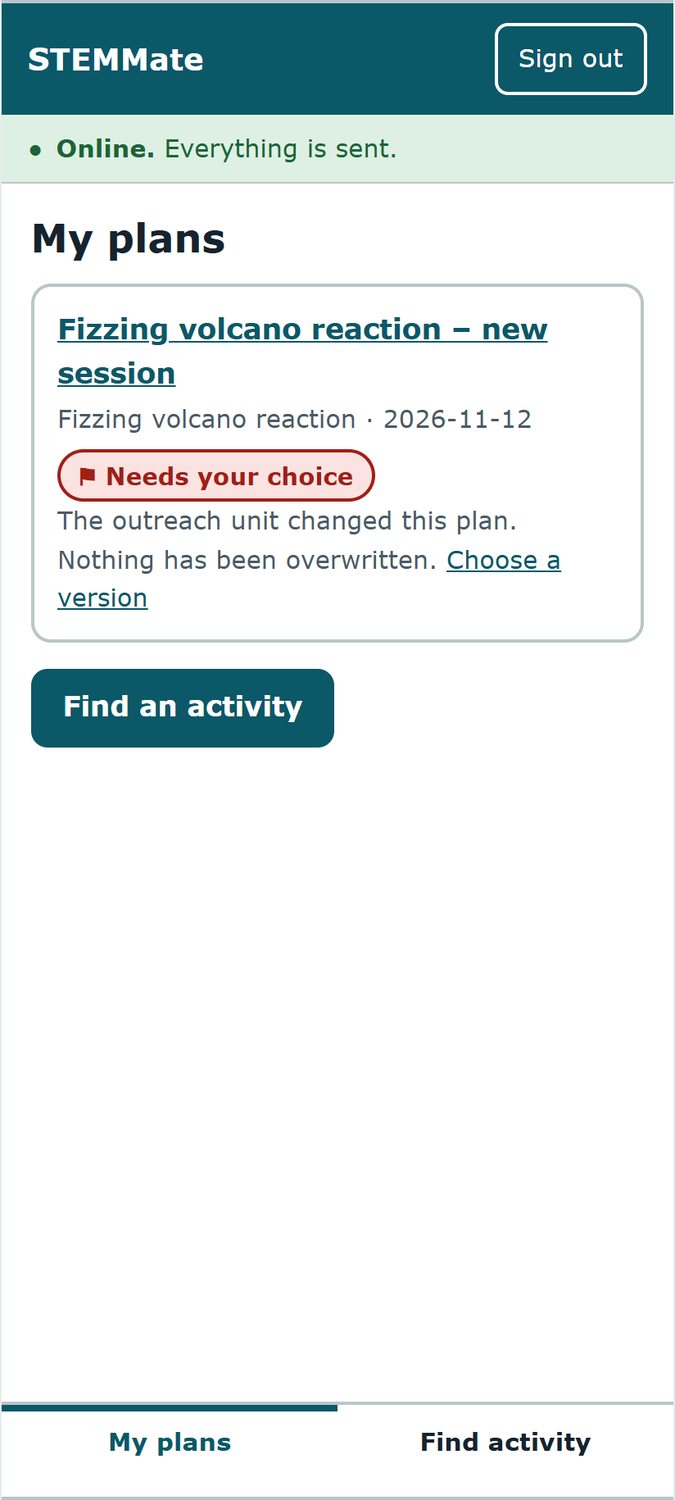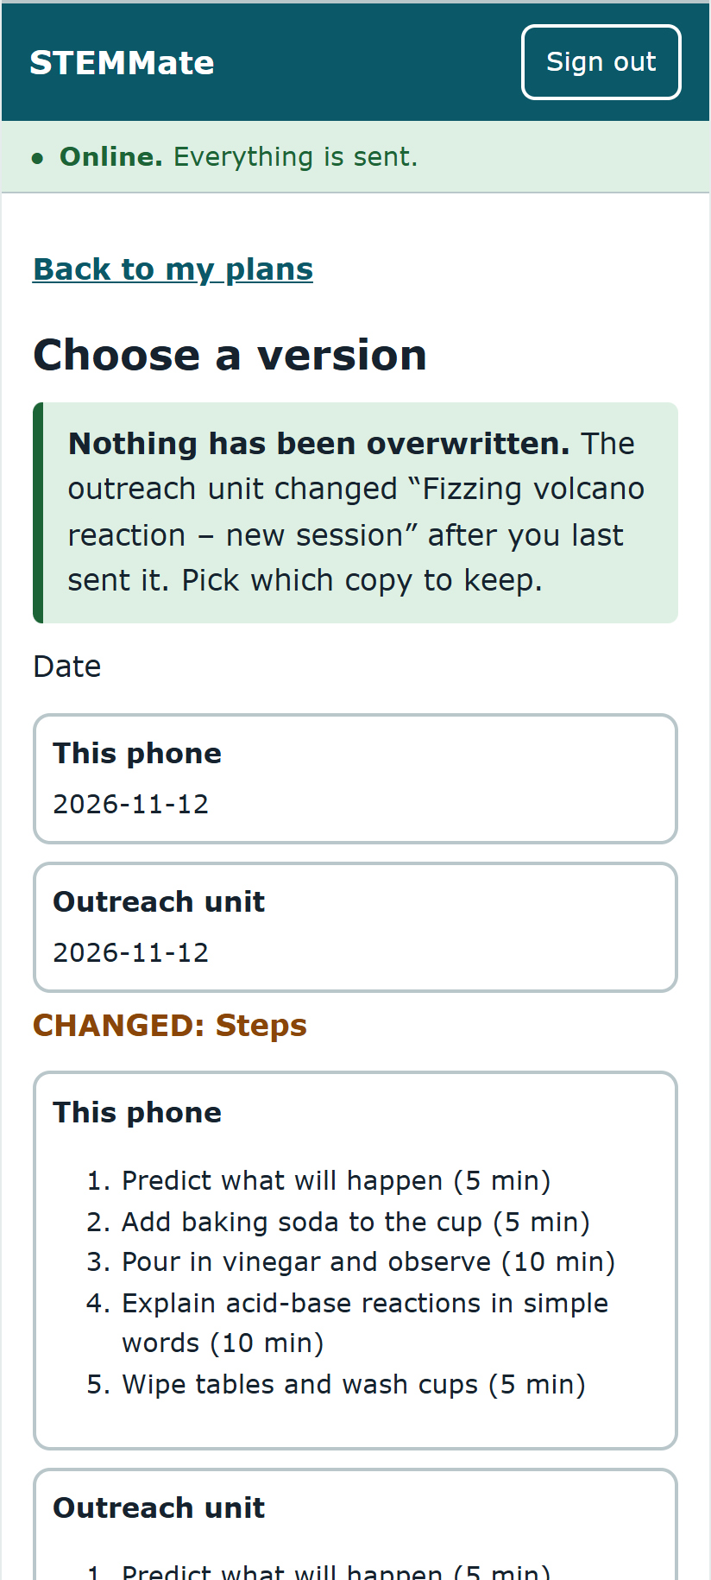
Figure 9. Recovery states: not sent after 3 tries with Retry, conflict flagged, and Choose a version.

7.1 Setup (from a clean machine)
- Install Node.js 20 or newer.
- Unzip the source or clone https://github.com/daveguyz/SDNsubmission; open a terminal in stemmate-slice/.
- npm install (installs the two test tools only; the app itself has no dependencies).
- npm start and open http://localhost:8080. Sign in as Selma (demo) with PIN 1234.
- npm test runs the 18 automated tests; node test/e2e/audit.mjs ../test-evidence/audit runs the accessibility audit.
The full steps, a demo script and the known limitations are in stemmate-slice/README.md. The package contains no generated folders, secrets or personal data (node_modules/ and server/data/ are excluded).

8. Requirements-based testing
29 documented tests: 18 automated (Node.js built-in test runner, node:test) and 11 manual or browser checks. The automated set contains unit tests (core and store) and integration tests that start the real server on a free port with a temporary data file and talk to it over HTTP. Results are copied unedited from test-evidence/run1_before_fix.txt, run2_after_fix.txt, run3_final.txt, audit_console.txt and MANUAL_CHECKS.md, all dated 4 November 2026.

8.1 Traceability matrix
Req. | Component | Tests | Result | Issue
FR-01 | core.filterActivities | AT-01, AT-02 | Pass | –
FR-03 | core.validatePlan, markComplete, moveStep; ui editor | AT-04, AT-05, MT-02 | Pass | –
FR-04 | store.put; ui.flushDraft | AT-09, MT-03 (v1.2), MT-04 | v1.2 fail → v1.3 pass | I-02
FR-05 | core.sanitiseCounts, toWire | AT-06 | Pass | –
FR-06 | sync.SyncEngine; server PUT; FileDb | AT-11–AT-17, MT-07–MT-09 | AT-16 fail → pass | I-04
FR-07 | labels.json; ui.chip, renderChrome | AT-13, MT-07, MT-08 | Fail → pass | I-05
FR-08 | ui.summary | MT-10 (S7 states) | Pass | –
QR-01 | core filter; server body limit; sw.js | AT-03, AT-14, AT-18 | Pass | –
QR-02 | All screens | MT-01, MT-02, MT-10, MT-11 | Pass | I-07 (open)
QR-03 | store (AES-GCM, PBKDF2); server whitelist | AT-07, AT-08, AT-10, AT-18, MT-05 (v1.2), MT-06 | v1.2 fail → v1.3 pass | I-03, I-06 (open)
SR-01 | data/catalogue.json, labels.json | Code review; R1 wording change made in data only | Pass | –

8.2 Automated tests
ID | Type | What is checked | Req. | Run 1 | Final
AT-01 | Unit | Materials filter returns only activities whose materials are all on hand | FR-01 | Pass | Pass
AT-02 | Unit | Level, topic, duration filters combine; impossible filter gives empty list | FR-01 | Pass | Pass
AT-03 | Unit | 500-activity catalogue filtered in < 1 s (measured ≈ 0.3 ms per run) | QR-01 | Pass | Pass
AT-04 | Unit | Incomplete plan refused; every missing field reported; valid plan queued | FR-03 | Pass | Pass
AT-05 | Unit | Up/Down reorder and bounds | FR-03 | Pass | Pass
AT-06 | Unit | Only counts and 8 domain fields leave the device | FR-05, QR-03 | Pass | Pass
AT-07 | Unit | No plan text in device storage | QR-03 | Pass | Pass
AT-08 | Unit | Wrong PIN refused; sign-out locks without deleting | QR-03 | Pass | Pass
AT-09 | Unit | Draft survives app restart | FR-04 | Pass | Pass
AT-10 | Unit | Second facilitator cannot open first one's drafts | QR-03 | Pass | Pass
AT-11 | Integration | Plan delivered; persists across server restart | FR-06 | Pass | Pass
AT-12 | Integration | Repeated send after lost response: one record, revision 1 | FR-06 | Pass | Pass
AT-13 | Integration | 3 server errors → FAILED; Retry → delivered | FR-06, FR-07 | Pass | Pass
AT-14 | Integration | No signal: stays queued, no attempt used | QR-01, FR-06 | Pass | Pass
AT-15 | Integration | Outreach edit → conflict; neither copy overwritten | FR-06 | Pass | Pass
AT-16 | Integration | "Keep this phone's version" then delivers phone copy (rev 3) | FR-06 | Fail | Pass
AT-17 | Integration | "Use outreach unit copy" replaces phone copy | FR-06 | Pass | Pass
AT-18 | Integration | Server refuses incomplete (422), extra fields (400), > 500 KB (413), bad id (400) | QR-03, QR-01 | Pass | Pass

Honest failure. Run 1 failed AT-16 with actual: 'CONFLICT', expected: 'SYNCHRONISED'. The v1.2 logic carried into the slice cleared the conflict but kept the old base revision, so the next conditional PUT was refused again and the plan would loop in "Needs your choice" forever. The prototype could not show this because its server was simulated. Fixed in SyncEngine.keepLocal() (redesign R3); run 2 and run 3: 18/18 pass.

8.3 Accessibility, failure and recovery checks
ID | Check | Result
MT-01 | Wrong PIN: message names the facilitator, aria-invalid, focus returned (WCAG 3.3.1) | Pass
MT-02 | Validation summary lists missing items as links; focus moves to it (3.3.1, 3.3.3) | Pass
MT-03 | v1.2 baseline: type, leave editor within 2 s → text lost, TypeError | Fail (I-02)
MT-04 | v1.3: same steps, then reload → text kept, no errors | Pass
MT-05 | v1.2 baseline: drafts readable in localStorage | Fail (I-03)
MT-06 | v1.3: plan text not found in storage | Pass
MT-07 | Offline: "Waiting for signal", banner shows queue | Pass
MT-08 | 3 injected errors → "Not sent – tap Retry"; banner said "Sending 1 plan…" at the same time | Fail (I-05) → fixed → Pass
MT-09 | Conflict screen: "Nothing has been overwritten", changed sections labelled; keep mine → server rev 3 | Pass
MT-10 | axe-core 4.10.2 (wcag2a/aa, 21a/aa, 22aa) on 14 states incl. dark mode; target-size scan; 320 px reflow; 3 px focus outline on every control | Pass: 0 violations, 0 undersized, scrollWidth 320
MT-11 | Keyboard tab order on My plans: plan link → conflict link → Find an activity → navigation | Pass

What the checks cannot show. Automated tools catch only part of WCAG. No screen-reader session with NVDA or TalkBack has been recorded for v1.3, and nothing was run on a physical low-spec phone ([record device and date if done]). Both remain open as I-07.

8.4 Issue log
ID | Found by | Issue | Severity | Status
I-01 | A3 target-size scan | Back links and checkboxes under 24 px | 3 | Fixed v1.2
I-02 | MT-03 | Autosave lost text on quick navigation; TypeError | 4 | Fixed v1.3 (R2)
I-03 | MT-05 | Drafts stored in plain text on shared phone | 4 | Fixed v1.3 (R4)
I-04 | AT-16 run 1 | Keep-mine conflict loop | 4 | Fixed v1.3 (R3)
I-05 | MT-08 screenshot | Banner said "Sending" for a failed plan | 2 | Fixed v1.3 (R5)
I-06 | Design review | 4-digit PIN is brute-forceable offline | 3 | Open – RR-1
I-07 | Method limitation | No screen-reader or real-device test | 3 | Open – RR-4

9. Evaluation

9.1 Ethics and method
All evaluation is with consenting adult classmates acting as simulated stakeholders in a timetabled class or team session. No schools, teachers, facilitators, learners or community organisations were contacted. Participants role-play a volunteer STEM facilitator and are told they are testing the design, not themselves. Only anonymous labels (P1–P8) are recorded; no names, photographs, audio, video or contact details. Only synthetic data is used. Consent script: "This is a class exercise. You will play a volunteer STEM facilitator using a prototype with made-up data. We will not record your name. You can stop at any time. Are you happy to continue?"
Format: moderated think-aloud, one participant at a time, about 15 minutes; one moderator and one note-taker. Measures per task: completed (yes / with help / no), time, errors, assists and a 1–7 Single Ease Question (Sauro & Lewis, 2016). Severity: 4 blocks the task, 3 major delay or error, 2 minor, 1 cosmetic (Nielsen, 1994).

9.2 Round 1 (A3, prototype v1.2): findings carried into A4
# | Observed finding | Participants | Severity | Req. | Action in A4
F1 | Save-for-offline button below the fold, not noticed | 3 of 5 | 3 | FR-02 | Fixed in A3 (C1); FR-02 not in slice
F2 | "Synchronise" not understood; hesitation before tapping | 2 of 5 | 2 | FR-07 | R1 status wording
F3 | "409 Version conflict" gave no next step; no recovery attempted | 2 of 5 | 4 | FR-06, FR-07 | Fixed in A3 (C2); kept and extended in v1.3
F4 | Success/failure badge distinguishable only by colour for one participant | 1 of 5 | 3 | QR-02 | Icon + words kept; MT-10 colour checks

Source: A3 team milestone, Sections 5.4–5.5 (team session notes, P1–P5).

9.3 Round 2 (A4, slice v1.3): tasks
Task | Scenario given to the participant | Success criterion | Tests redesign
T1 | "You have vinegar, baking soda and paper cups. Plan the volcano activity for 12 November and send it." | Plan reaches "Sent" without help | R1, R2
T2 | Moderator sets Offline. "Finish a second plan. Tell me what will happen to it." | Says it will send when there is signal | R1
T3 | Moderator injects 3 server errors and sets Online. "Make sure the plan reaches the outreach unit." | Uses Retry; plan sent | R1, R5
T4 | Moderator triggers an outreach edit. "Change the plan and make sure your version is the one kept." | Chooses "Keep this phone's version"; plan sent | R3
T5 | Hand the phone to a second participant: "Sign in as Johannes and look for Selma's plan." | States Selma's plan cannot be seen | R4

9.4 Round 2 results
[Fill this table only from the team's own session sheets. Do not estimate. At least 5 participants are required (brief: 5–8).]
Participant (role played) | T1 | T2 | T3 | T4 | T5 | SEQ (1–7) | Notes
P1 [role] | [ ] | [ ] | [ ] | [ ] | [ ] | [ ] | [ ]
P2 [role] | [ ] | [ ] | [ ] | [ ] | [ ] | [ ] | [ ]
P3 [role] | [ ] | [ ] | [ ] | [ ] | [ ] | [ ] | [ ]
P4 [role] | [ ] | [ ] | [ ] | [ ] | [ ] | [ ] | [ ]
P5 [role] | [ ] | [ ] | [ ] | [ ] | [ ] | [ ] | [ ]

Session details: [venue, date, time, device used]. New findings, severity and recommendations: [F5, F6 … from the session; add them to the issue log in 8.4].

9.5 Limitations
- Classmates are not facilitators; they know the case and are more technically confident than many volunteers, so ease scores are likely to be optimistic.
- Offline and failure conditions are produced by test controls on a laptop or phone browser, not by real network loss in the field.
- Five to eight participants find common problems but cannot give statistical measures of performance.

10. Evidence-led redesign
Five changes were made between v1.2 (A3) and v1.3 (A4). R1–R4 are the substantial changes required by the brief; R5 is a smaller defect fix found during testing. Each row links the evidence, the change, the artefacts updated and how the change was verified.
# | Evidence | Before (v1.2) | After (v1.3) | Updated artefacts | Verified by
R1 | Evaluation F2 (2/5) and F3 | "Pending – waiting to send", "Syncing", "Synced", "Sync failed", "Conflict – choose a version"; words in code | "Waiting for signal", "Sending now", "Sent to outreach unit", "Not sent – tap Retry", "Needs your choice"; words in data/labels.json | FR-07, SR-01, Fig. 6 notes, screens | MT-07–MT-09; [round-2 T2–T3]
R2 | MT-03: text lost, TypeError | Form read from the screen 2 s after typing stopped; leaving earlier lost text | Each keystroke updates the plan in memory; 1 s debounced save; save before every screen change and when the app is hidden | FR-04, Fig. 3, ui.js | AT-09, MT-04
R3 | AT-16 failed in run 1 | Keep mine → back to Pending with the old revision → 412 again | Keep mine re-bases on the server revision the facilitator has seen | FR-06, ADR-02, Fig. 6, sync.js | AT-16 pass, MT-09
R4 | MT-05: plain-text drafts; QR-03 only simulated | One unencrypted localStorage entry for all users; PIN compared in code | AES-256-GCM vault per facilitator, PBKDF2 key from PIN, key forgotten on sign-out; server field whitelist | QR-03, ADR-03, Fig. 2, Fig. 5, store.js | AT-07, AT-08, AT-10, AT-18, MT-06
R5 | MT-08 screenshot | Banner "Sending 1 plan…" while the plan had failed | Queued and failed counts reported separately with the next step | ui.js | Audit re-run, 0 violations

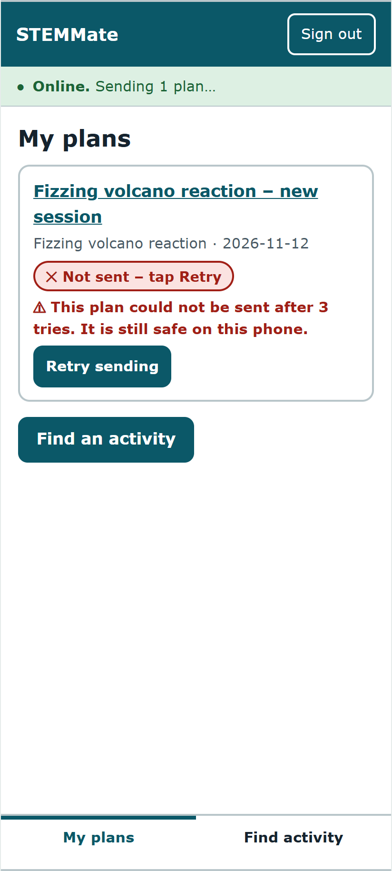
Figure 10. R5 before (left: banner says "Sending 1 plan…") and after (right: banner names the failed plan and the next step).

10.1 Options considered and rejected
Option | Why rejected
Automatic merge of conflicting plans (CRDT or field-by-field) | Merging reordered steps is error-prone and hard to explain on a small screen; conflicts expected to be rare (ADR-02).
Keep the 2 s DOM-based autosave and just guard against a missing field | Hides the error but still loses up to 2 s of text when leaving the screen.
IndexedDB instead of localStorage | Better for large data, but plans are small (≈ 0.7 KB each) and localStorage writes the whole vault in one synchronous step, which keeps the save atomic. Revisit if plans grow.
Server-generated plan IDs | Would need a round trip before a plan exists; device IDs let plans be created offline.
A front-end framework (React, Vue) | Adds download size and a build step the outreach unit could not maintain; plain modules are enough for eight screens.

10.2 Unresolved after redesign
A forgotten PIN still loses unsynced drafts; 4-digit PINs remain weak (I-06); the wording change R1 has not yet been re-tested with participants ([update after round 2]).

11. Sustainability and handover
Concern | Assumption or design response | Evidence
Affordability | No licences or paid services. Server runs on an existing office PC or a small virtual server ([confirm local monthly cost, e.g. N$ 100–200]). Facilitators need no app store account. | ADR-01, ADR-04
Bandwidth | App shell ≈ 50 KB uncompressed, fetched once; catalogue 3.9 KB; a typical plan upload is 691 bytes (limit 500 KB). No network traffic while nothing is queued apart from the 20 s check, which sends nothing when the queue is empty. | Measured 4 Nov 2026; AT-18
Energy and device | No animation beyond a progress bar; no background polling when the app is closed; works on a 320 px screen and in dark mode for battery and sunlight. | MT-10
Maintainability | 705 lines of plain JavaScript in five modules with one direction of dependency; 18 automated tests run in under one second; no build step. | Fig. 3; npm test
Local administration | Outreach staff edit data/catalogue.json and data/labels.json with a text editor and restart the server; R1 was made this way with no code change. | SR-01
Privacy | No learner data by design; drafts encrypted per facilitator; only 8 fields leave the phone; server refuses others. A data-protection notice must be written before any pilot. | FR-05, QR-03
Backup and export | Nightly copy of plans.json (one file) to a second disk or encrypted cloud folder; the file is JSON and can be converted to CSV for reporting. Restore = copy back and restart. | ADR-04
Support | Every error says what happened, that work is safe, and what to do next. First-line support is a one-page guide for lead facilitators; second line is the outreach unit's administrator. | MT-01, MT-02, MT-08
Deployment | Install Node.js 20 LTS and Caddy; copy the source; set TEST_CONTROLS=0; Caddy obtains a TLS certificate; share the URL; facilitators install from the browser. | Fig. 4

11.1 Decommissioning plan
- Announce the end date to facilitators at least one month ahead; ask them to open the app with signal so that every queued plan is sent.
- Export plans.json and convert it to CSV; hand both to the outreach unit's records officer with a checksum.
- Agree the retention period with the unit; delete server copies and backups at the end of it and record the deletion.
- Publish a final app version whose sign-in screen explains the closure and offers "Delete all STEMMate data on this phone" (the existing Reset function).
- Transfer the repository, domain name and server credentials to the unit or the replacement supplier; revoke the team's access.

11.2 Handover package
Item | Location
Source code and setup guide | stemmate-slice/ and README.md; https://github.com/daveguyz/SDNsubmission
Architecture sources | architecture/*.mmd (editable) and rendered *.png
Test evidence | test-evidence/ (test runs, audit JSON and screenshots, manual check log)
Client briefing and demonstration | A4_Group2_Client_Briefing.pptx (7 slides, script in notes); [recording link]
Demo sign-in | Selma (demo) PIN 1234 · Johannes (demo) PIN 5678 – synthetic only

12. Risks and recommendation
ID | Residual risk | Likelihood | Impact | Mitigation now / next
RR-1 | Someone who copies a phone's storage guesses a 4-digit PIN offline (≈ 7 min on a laptop) | Low | High | PBKDF2 210 000 iterations / move to 6-digit PIN, lock after 5 tries, shorter idle lock
RR-2 | Forgotten PIN loses unsynced drafts | Medium | Medium | Prompt to send before sign-out / optional recovery code
RR-3 | Browser clears storage on low space or long non-use (especially iOS) | Medium | High | Banner encourages sending promptly / test on target phones; request persistent storage
RR-4 | Accessibility problems not visible to automated tools | Medium | Medium | Axe, keyboard and reflow checks / screen-reader session and real-device test
RR-5 | Single JSON file outgrows one unit or two staff editing at once | Low | Medium | Atomic writes / swap FileDb for SQLite behind the same interface
RR-6 | Server has no staff authentication yet | High if deployed as is | High | Not deployable as is / add staff sign-in and facilitator tokens before pilot
RR-7 | Evaluation with classmates overstates ease of use | High | Medium | Stated limitation / supervised, approved pilot with real facilitators

12.1 Recommendation to the client
Proceed to a supervised pilot-readiness phase with STEMMate v1.3's architecture. Do not deploy it to schools yet. The slice shows that the riskiest ideas work in code: offline planning, encrypted drafts on shared phones, delivery without duplicates, and conflicts with no silent overwrite. 18 automated tests and a clean WCAG 2.2 AA audit support this.
Before any pilot: (1) add staff authentication and facilitator tokens to the server (RR-6); (2) strengthen PINs (RR-1); (3) run a screen-reader session and test on two low-spec Android phones (RR-4); (4) restore per-activity download with rollback (FR-02) from the prototype; (5) obtain written lecturer approval and institutional ethics clearance before involving any real facilitator.

13. Known limitations
- FR-02 per-activity download with rollback is demonstrated in prototype v1.2, not in the slice; v1.3 caches the whole catalogue with the app shell.
- TLS 1.3 is supplied by the reverse proxy in the deployment design; the slice server runs plain HTTP on localhost.
- Crash safety of the server's write-then-rename was reviewed in code but not fault-injected.
- Up to one second of typing can be lost if the browser is killed (FR-04 allows two).
- Round-2 evaluation results are not yet included ([complete Section 9.4]).

References
Deque Systems. (2024). axe-core (Version 4.10.2) [Computer software]. https://github.com/dequelabs/axe-core
Fielding, R., Nottingham, M., & Reschke, J. (Eds.). (2022). HTTP semantics (RFC 9110; conditional requests, If-Match and 412). IETF. https://www.rfc-editor.org/rfc/rfc9110
Moriarty, K., Kaliski, B., & Rusch, A. (2017). PKCS #5: Password-based cryptography specification version 2.1 (RFC 8018). IETF. https://www.rfc-editor.org/rfc/rfc8018
National Institute of Standards and Technology. (2007). Recommendation for block cipher modes of operation: Galois/Counter Mode (GCM) and GMAC (SP 800-38D).
Nielsen, J. (1994). Severity ratings for usability problems. Nielsen Norman Group.
Nygard, M. (2011). Documenting architecture decisions. Cognitect blog.
Rescorla, E. (2018). The Transport Layer Security (TLS) protocol version 1.3 (RFC 8446). IETF.
Sauro, J., & Lewis, J. R. (2016). Quantifying the user experience (2nd ed.). Morgan Kaufmann.
World Wide Web Consortium. (2023). Web Content Accessibility Guidelines (WCAG) 2.2. https://www.w3.org/TR/WCAG22/
/Howoseb, D. C. (2026). SDN621S A2 requirements-to-design portfolio: STEMMate Namibia [Unpublished coursework]. NUST.
Munenguni, P. (2026). SDN621S A2 portfolio: STEMMate Namibia [Unpublished coursework]. NUST.
Group 2. (2026). SDN621S A3 team accessible-prototype milestone: STEMMate Namibia [Unpublished coursework]. NUST.

Appendix A: Team AI-use declaration
Field | Statement
Tool | Claude (Anthropic), November 2026.
Purpose | Coding assistance for the vertical slice, tests and audit script; rendering diagrams from team-agreed models; drafting report structure and wording; drafting the briefing script.
Output used | Source in stemmate-slice/; architecture/*.mmd; draft text of Sections 1–13; slide script.
Verification performed | Every test result in Section 8 was produced by running the commands listed and is copied from the saved output files; no result was typed by hand. [Team members: re-run `npm test` and the audit yourselves and record the date.]
Not AI-generated | Round-1 evaluation findings (from A3 team sessions). Round-2 results in Section 9.4 must come only from the team's own sessions.
Changes made by the team | [List what the team reviewed, corrected or rewrote.]

