Outline for Senior Design Project

Students should fill out the form below, noting special instructions where relevant, before the Preliminary Design Review (PDR) of Fall Semester. Note, delete any and all text in **red**. Those are examples.

**Contact Information**

* Name – Tim Nugent
  + E-mail – nugentt1@tcnj.edu
  + Phone (optional) – (908) 334-5516
  + Technical Role – Team Manager, Circuit design and implementation
* Name – Stephen Coppi
  + E-mail: coppis1@tcnj.edu
  + Phone (optional) – (908) 930-2120
  + Technical Role – Circuit design and implementation
* Name – Dave Hand
  + E-mail: handd1@tcnj.edu
  + Phone (optional) – (609) 408-1609
  + Technical Role – Software Manager, Arduino programming and networking
* Name – Eddie Spencer
  + E-mail: spencee1@tcnj.edu
  + Phone (optional) – (551) 579-0479
  + Technical Role – Networking Manager, Arduino programming

**Primary Objective**

To design and construct a three-phase device with relaying, phasor measurement, and wireless communication capability.

**Secondary Objectives and Tasks**

The student team should describe the secondary objectives and tasks of their project. There should be at least one secondary objective per team member. Each secondary objective should be described in ten words or less. Each task should be described in five words or less.

§ Objective #1 – Design and Simulate Circuit Hardware

o Task #1 – Research different components of main figure

o Task #2 – Simulation of design and building blocks using PSpice

o Task #3 – Optimize design from simulation.

§ Objective #2 – Implementation of simulation to hardware

o Task #1 – Gather parts and materials

o Task #2 – Construction of circuitry

o Task #3 – Testing and Optimization

§ Objective #3 – Coding

o Task #1 – Outline problem to be solved

o Task #2 – Development of Arduino solution and communication with Android/Apple

o Task #3 – Testing and optimization

§ Objective #4 – Networking

o Task #1 – Development of solution to network

o Task #2 – Construction of Arduino network

o Task #3 – Testing and optimization

§ Objective #5 - Physical Implementation and Optimization

o Task #1 – Gather parts and materials

o Task #2 – Construction of circuitry

o Task #3 – Testing and Optimization

**Requirements / Specifications**

The student team should describe the software and hardware requirements / specifications associated with their project.

§ Electrical Ratings – rated power = 0.2kW, rated voltage = 120VLN, rated current = 5A, three-phase configuration

§ Speed / Time – switching response time < 1 sec

§ Cost – cost per relay < $10, total project cost < $200

§ Arduino Nano or Mini board < $25

§ Arduino SDK

§ PCB board <$20

§ Various Electrical Components

**Deliverables**

The student team should describe the deliverables of their project. There should be at least one deliverable per secondary objective (aka. per team member). Each deliverable should be described in five words or less.

§ Deliverable #1 – Circuit Schematics

§ Deliverable #2 – Circuit Implementation on Breadboard

§ Deliverable #3 – Arduino software for data processing and communication with Android/Apple

§ Deliverable #4 – Functional network to connect components and network structure

§ Deliverable #5 – Final Device

**Master Figure**

The student team should create one figure that describes the entire project (as well as possible). It may describe the project from a system POV as a block diagram or flow chart, hardware POV as circuit schematic or CAD diagram, etc… Students are encouraged to utilize Microsoft Visio, Cadence PSpice, or Google Sketch.

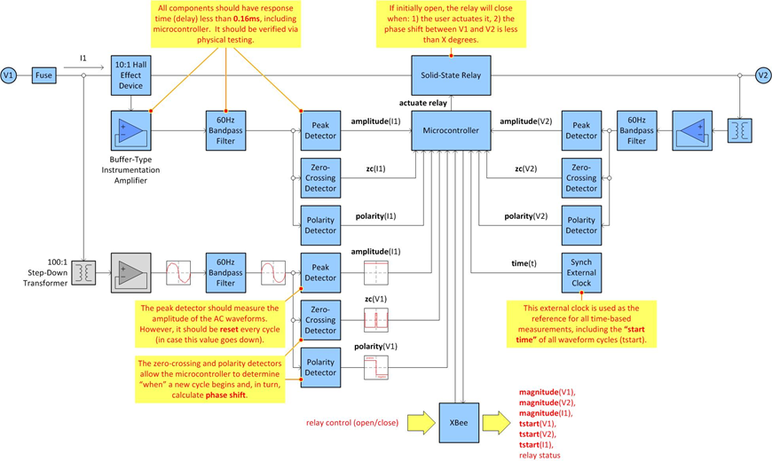

**Milestones**

The student team should describe the milestones of their project below.

§ ½ Fall – Circuitry designed and code outlined (UML)

§ End of Fall –Hardware functioning on breadboard and code functioning on Arduino

§ ½ Spring – PCB board construction and networking

§ End of Spring – Final functional device

**Simulation**

he student team should describe the simulation packages to be utilized in their project. How will they be employed? There should be (at least) one simulation package per secondary objective.

§ PSpice will be used to test the circuitry

§ Experimental lab testing of fully functional device and test of for communication between Android and Arduino.

**Final Demonstration**

The student team should describe their vision of the final project demonstration. What will the audience see?

The final presentation would include a demonstration on how the system works. Various devices would be plugged into the system and the operation of the controller will be shown.

**Main Difficulties**

The student team should describe, in ten words or less, the top three to five difficulties they expect to address.

* Difficulty #1 – Miniaturization
* Difficulty #2 – Reliable network (hardware/software integration)
* Difficulty #3 – Etching PCB board
* Seamless integration of custom software and hardware

**Innovation**

The student team should describe, in ten words or less, the top three to five innovative aspects of their project.

* Innovation #1 – Hardware allowing safe use of multiple power sources. (e.g. Generator and Solar Panel)
* Innovation #2 – Energy efficiency and cost savings
* Innovation #3 – Use of networking with Arduino

**Grading Expectations** (for Spring)

Here, the student team should describe their grading expectations. In other words, what objectives and tasks (as presented above) must be completed to warrant an A? a B?

§ A requires completion of…

o all objectives and all tasks

o fully functional device

§ B requires completion of…

o all objectives and tasks except for full completion

§ C requires completion of…

o objective #1

o objective #2

o objective #3

§ D requires completion of…

o All objectives unsatisfactory

**Questions**

Does the team require a budget of more than $100 per team member? y/**n**

Is travel required for project? **y**/n : **IEEE PES General Meeting**

What is the faculty-student meeting time? By appointment time

What is the team meeting time (students only)? Every week