TECH102 – Assignment 8

1.
The reason why circle are not used is because circle cannot join together neatly. There is either a space in-between the circles or they intersect. Neither option is useful for cellphones. You either have areas where there is no coverage, or areas with lots of coverage, meaning that the area covered is less then the optimal area.
As you can see below, the left has more area covered, but with a big area in the middle (in blue) with no coverage. The diagram on the right covers less area, but has no coverage ‘holes’.

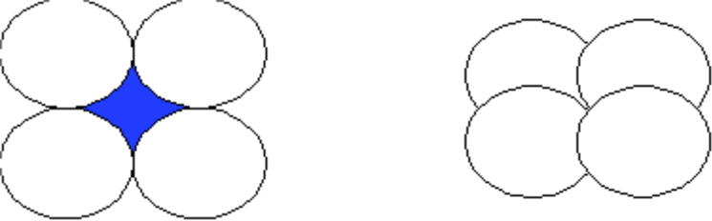

As the signal from the tower spreads out in a circular form, the area we want to make must be as circular as possible, but still fit together. The diagram below shows how the square is not a very useful shape for a cell. The blue circle is the signal from the tower, and as you can see there is a lot of extra area covered by the cell where there is no coverage.

As we are trying to approximate the circle, perhaps an octagon would be better, but the octagon does not fit together as a hexagon does, so the hexagon seems the obvious choice. This is because they fit together well, and approximate a circle.
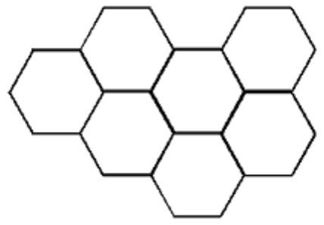

2.
Possible combinations of red: 2⁸ = 256
Possible combinations of red: 2⁸ = 256
Possible combinations of red: 2⁸ = 256

Total possible combinations = 256*256*256 = 16,777,216

The eye detects light by decoding the signal passed to it by the cones in the retina of our eye. For example, 450 nm light is determined to be purplish blue because the cones that detect blue light respond strongly. The cones that detect green light will respond weakly, and the red cones almost not at all. This combination is sent to brain and interpreted as purplish blue.

3.
When FM radio first became available in the 1930’s the frequency range was from 30-42 MHz. After WWII, the commercial stations were moved to the range 83-108 MHz. The radios were bought before WWII now didn’t work because they weren’t able to handle the higher frequencies. Radios were very expensive and now these were useless. This made the development of FM radio less because people didn’t want to be caught out again. When stereo radio was available in the 1960’s a big effort was made to make the new broadcast able to be heard on old radios. Older radios still worked, picking up the mono signal, while new radios picked up the stereo broadcast.

4.
“The Edge” broadcasts at 97.5 MHz FM.
The wavelength is: frequency / velocity
= 97.5 * 10⁶ / 3 *10⁸
= 0.325m
= 32.5 cm

5.
To find your blind spot, take a piece of paper with a small circle on the left, and a small cross on the right of the paper. Look directly at the circle with the right eye closed. Hold the piece of paper at arms length away from your face, and slowly move the paper towards your face. At a certain distance the cross will disappear. This is because the image of the cross is formed on the optic nerve connecting your eye to the brain.

The reason why you don’t notice the blind spot in everyday life is because it only occurs at a certain distance from the eye, and the two eyes fill in for each other.

