How to build librf21x

# Introduction

Librf21x must be compiled by CMake. In this way, librf21x can be built on different system, such as Windows, Mac and Linux. C and C++ is supported by default. Different kinds of language wrap (i.e., C#, Python, Java) are generated by SWIG.

Here we give a simple instruction for building librf21x. Or you can just use the prebuild release package.

CMake and SWIG can be downloaded from following sites.

* CMake: http://www.cmake.org/
* SWIG: http://swig.org/

# Basic compilation in Windows

## Environment

Here are our environments used in this step by step compilation:

* Windows 8
* VC2010
* CMake 2.8
* Source code of librf21x is in “C:/GMiaow/pro/librf21x”

## Steps

Open cmake-gui, and follow the steps in figures 1~5.

After these steps, we have follow outputs.

* VS2010 projects files in “C:/GMiaow/pro/librf21x-build-vs2010”.
* Binary files of librf21x can be found in “C:/GMiaow/pro/librf21x-build-vs2010/librf21x”.

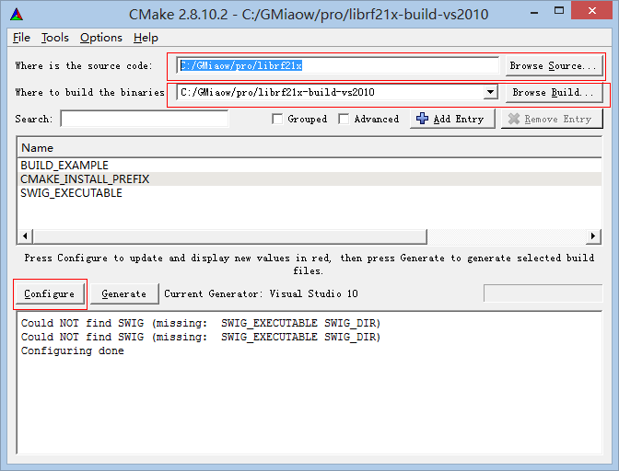

Figure Choose pathes of source code and build directory

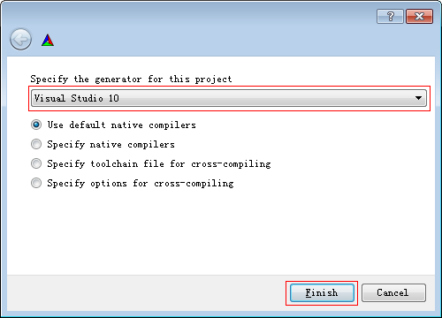

Figure Choose VS2010 as the compiler

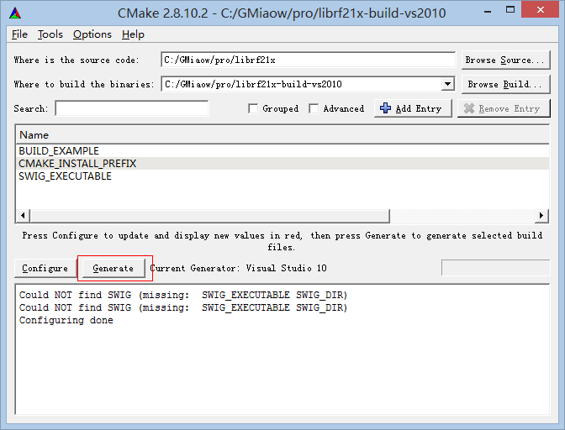

Figure Click "Configure" and "Generate" to generate files for compilation



Figure Open generated files for compilation

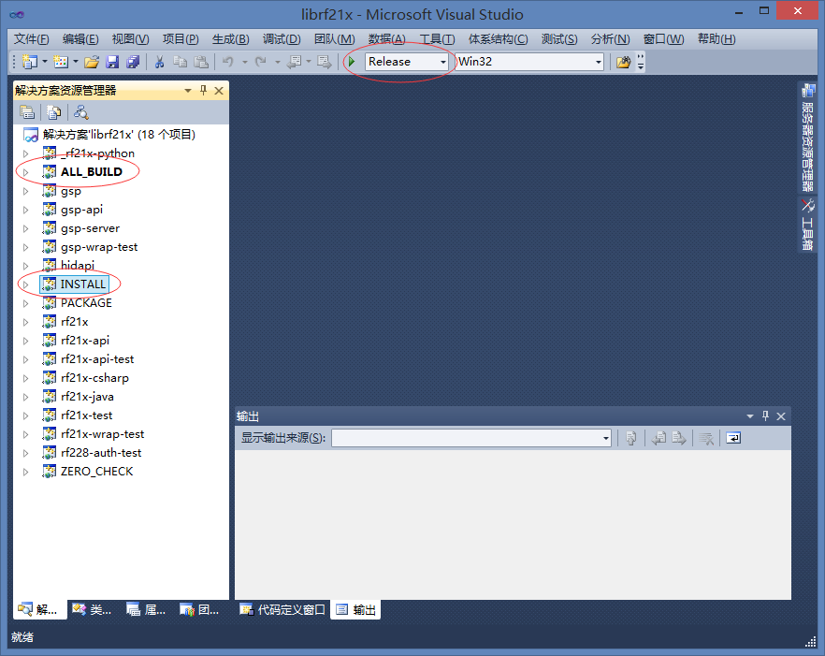

Figure Build target "ALL_BUILD" and "INSTALL"

# Build language wraps

If you need support other than C/C++, you can build librf21x for C#, Python and Java. This is done by generating wraps by SWIG. In particular, choose the checkbox while generate compilation files by CMake. Then add the executable file path of SWIG and corresponding library files for building wrap. Lastly, language wraps can be built together with librf21x’s C/C++ library.

# Build librf21x for Mac and Linux

As same as Windows, we need CMake for building. Instead of using VS2010 or other IDE from Windows, GCC is used for building librf21x for Mac and Linux. In this way, a set of Makefiles is generated by CMake, then compilation is done by conventional “make” and “make install” command.

Compilers other than GCC is not well tested.

Language wraps for Mac and Linux is not well tested.