Vorkurs Informatik – C++ on Mac OS X

# C++ Compiler installation (APPLE STANDARD DEV TOOLS)

**Step 1** – Open the «Terminal»:  
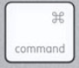 

In the appearing window type «Terminal» - double click the item highlighted in the below screenshot to bring up the system console…  
  
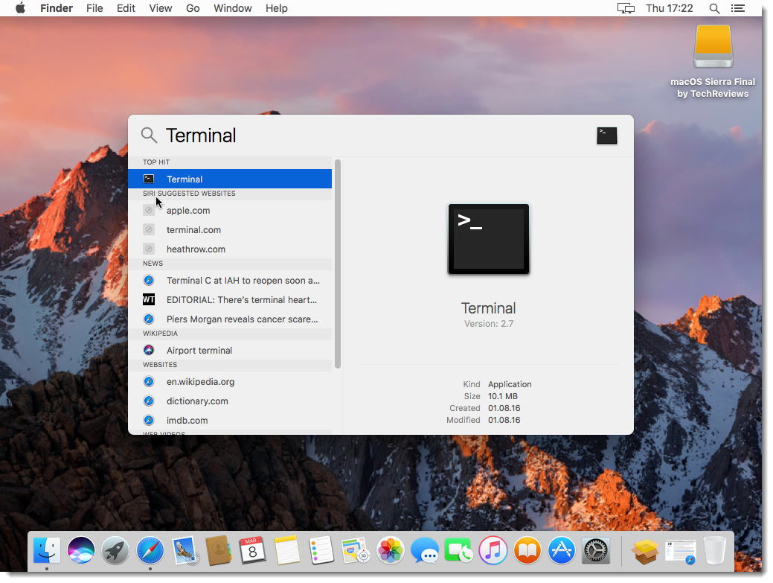

**Step 2** – Install the Apple XCode Toolkit by typing the following command:  
  
xcode-select --install  
  
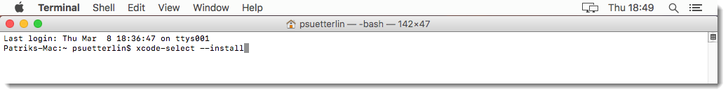

Confirm the popup and the disclaimer:  
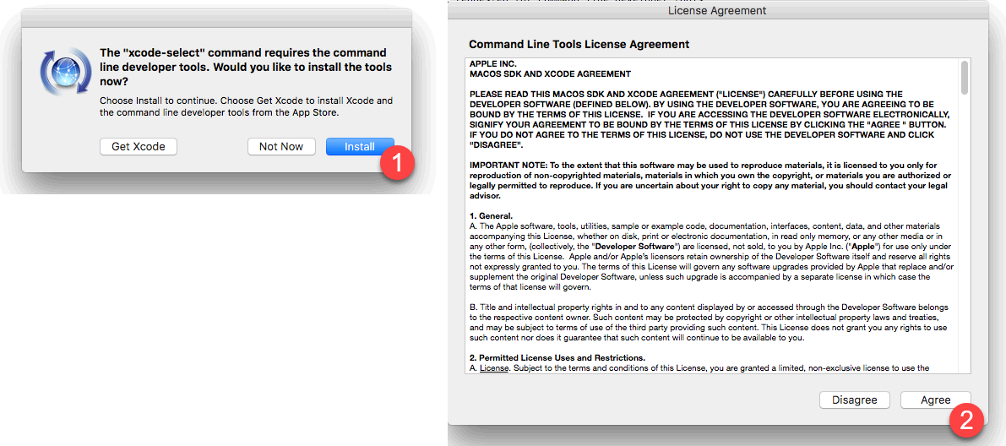

**Step 3** – “The software was installed.” Message appears:

Complete the installation by clicking on “Done”

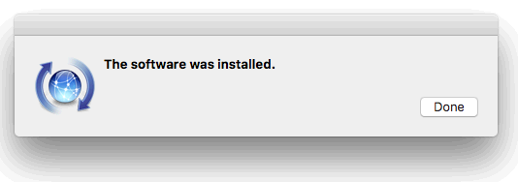

**Step 4** – Create “Development” folder:

Back in the Terminal – enter the commands below to create a development project folder…  
  
mkdir ~/Development

mkdir ~/Development/HelloWorld

cd ~/Development/HelloWorld

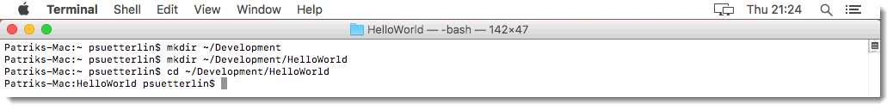

**Step 5 –** Write some C++ Code by using the “nano” editor:  
  
Type the following command… this will start the “nano” editor and draft the File “HelloWorld.cpp”…

nano HelloWorld.cpp

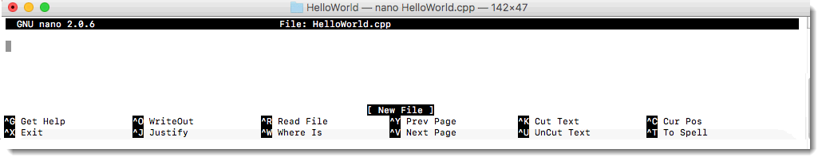

Type the listed Code from below into the editor panel:  
  
#include<iostream>  
using namespace std;  
  
int main()  
{  
 cout << "Hello World!" << endl;  
 return 0;  
}

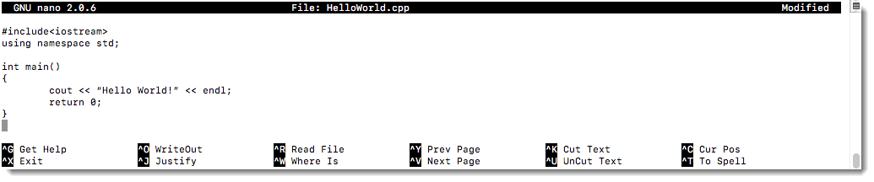

Save edited file by pressing the key combination…  
 

Confirm the Save operation with...  
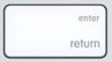

Quit «nano» by pressing the key combination:  
 

**Step 5 –** Compile your program > “HelloWorld.cpp”

In order to compile your program, enter the following instruction into the console:

g++ HelloWorld.cpp –o HelloWorld



Finally run your program with the command:

./HelloWorld

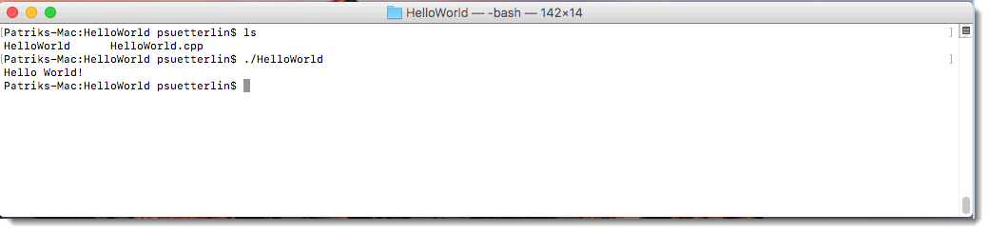

The output of your first program is:

Hello World!

# Install WINE and Notepad ++ (OPTIONAL FEATURE)

**Step 1** – Install Brew:

Run the below command in the “Terminal”…

ruby -e "$(curl -fsSL https://raw.githubusercontent.com/Homebrew/install/master/install)"

Confirm the installation with…  


When prompted provide your computer password in order to allow the installation !!  
  
**Step 2** – Verify Brew installation

Run the below command in the “Terminal” to check the installation of “brew”…

brew doctor

When everything is set up correctly, you'll see the message:

Your system is ready to brew

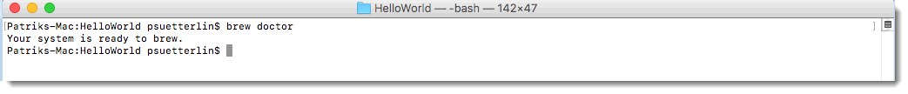

**Step 3 –** Brew XQuartz and Wine

Run the below command in the “Terminal” to install XQuartz…

brew cask install xquartz

When prompted provide your computer password in order to allow the installation!!

Next run the command below to install Wine

brew install wine

**Step 4** – Download Notepad ++ Windows executable:  
  
Use Safari to download the Notepad ++ Installer from the following web page: <https://notepad-plus-plus.org/download/v7.5.5.html>

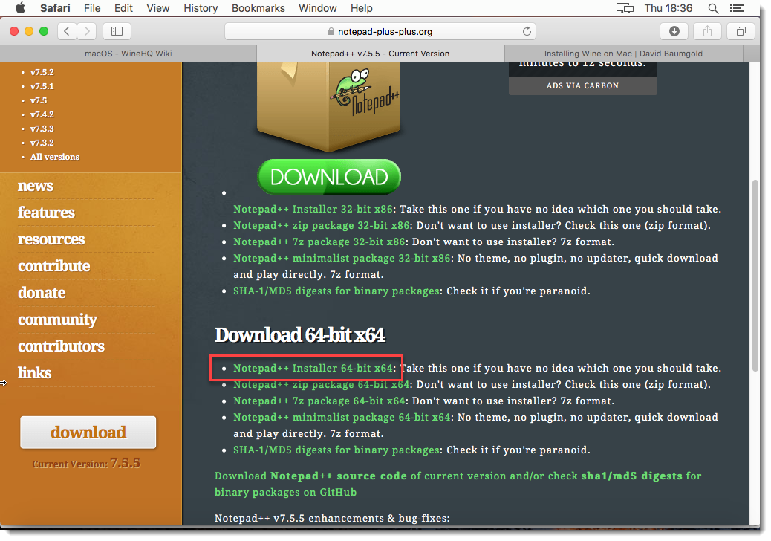

**Step 5** – Install Notepad ++ using Wine

Execute the following command in the “Terminal”…

wine ~/Downloads/npp.7.5.5.Installer.x64.exe

Step through the installation (keep the default installation settings) …

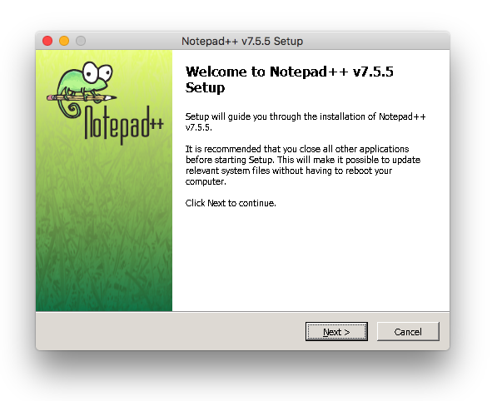

**Step 6** – Run the Apple Tool “Automator”

When the “Automator” you can choose from the below shown options:  
Select “Application”  
  
  
  
Lookup “shell” in the search bar of the “Automator” tool– this will locate the “Run Shell Script” item. Double click the item to bring up the editor as shown in the below picture:

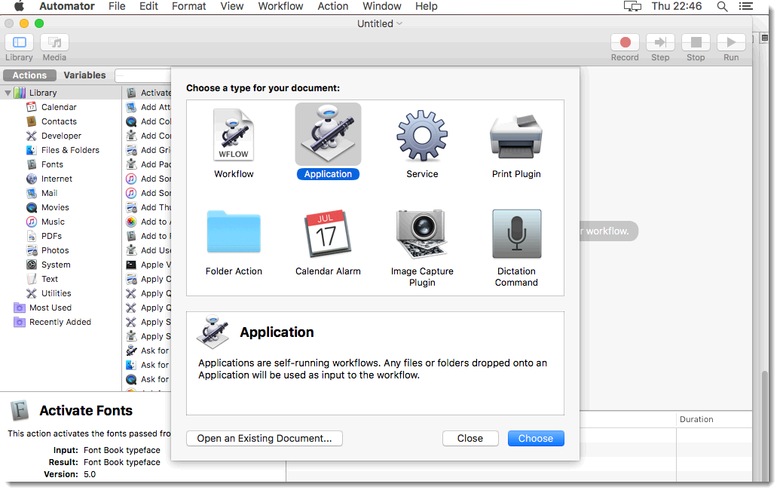

Put in the Script…

/usr/local/bin/wine "$HOME/.wine/drive_c/Program Files/Notepad++/notepad++.exe"

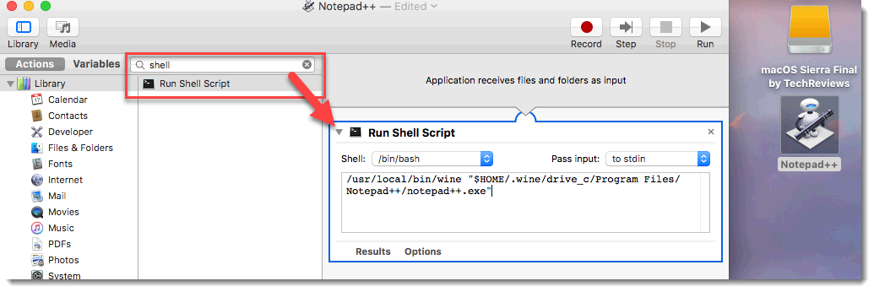

Finally save the written “Automator” Script to the Desktop with the following settings:

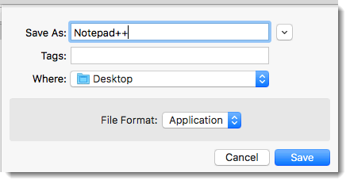

You’ll find an new icon on the Desktop – feel free to modify the Icon Picture for your convenience:   
  


Double click the icon to start Notepad++

Happy Coding ☺

