Vorkurs Informatik – C++ on Win10

# C++ Compiler and Notepad ++ installation and usage

**Step 1** – Download Notepad++

Use the Edge Browser to download the Notepad ++ Tool from:  
<https://notepad-plus-plus.org/download/v7.5.5.html>

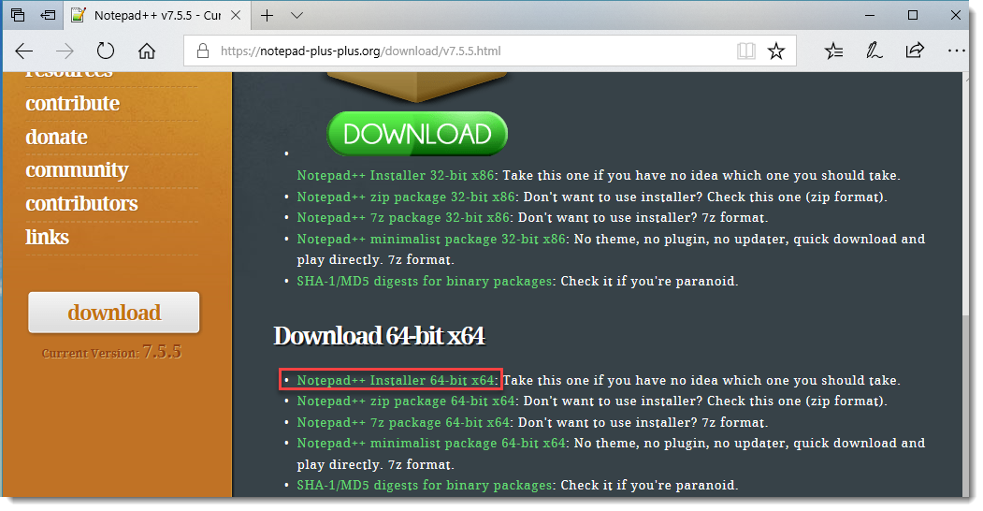

**Step 2 –** Download MinGW Installer

<https://sourceforge.net/projects/mingw/files/Installer/>

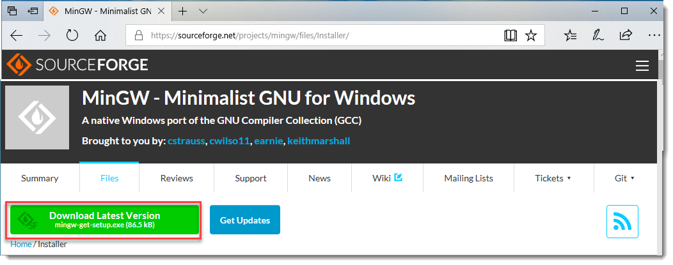

The two installers can now be found within the User Home Download folder:

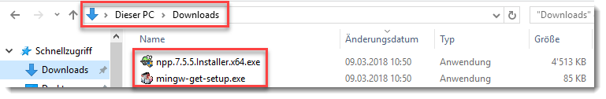

**Step 3** – Install Notepad ++ with the Installer

Step through the installation (keep the default installation settings)

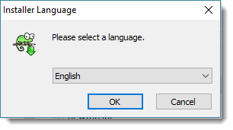

**Step 4** – Install MinGW with the Installer

Click on “Install” to proceed:  
  
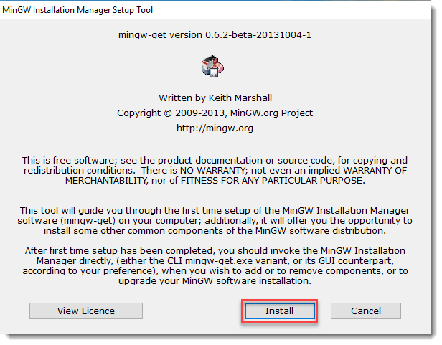

Keep the default installation Directory “C:\MinGW”

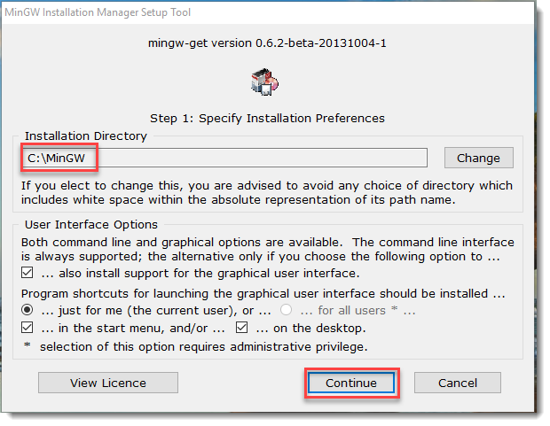

Some downloads will take place … when finished click on “Continue”…

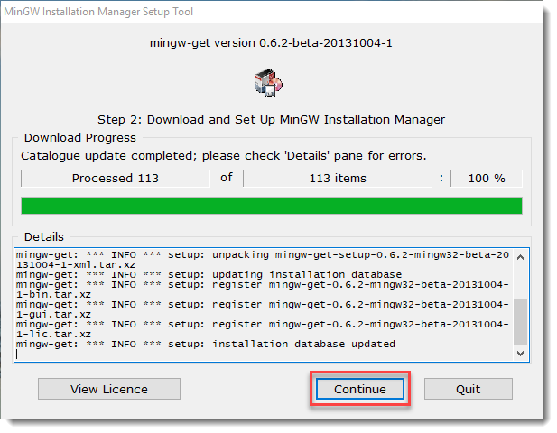

Next the feature selection pane appears – select the G++ Compiler by using the context menu option “Mark for Installation”:   
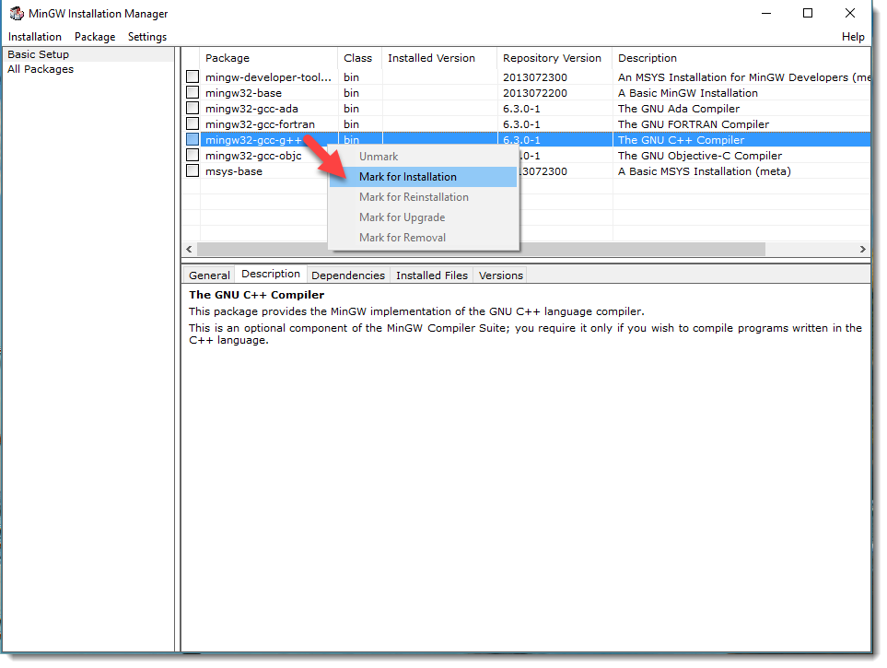

Complete and proceed with the selection … for that purpose use the option “Apply Changes” from the “Installation” menu…  
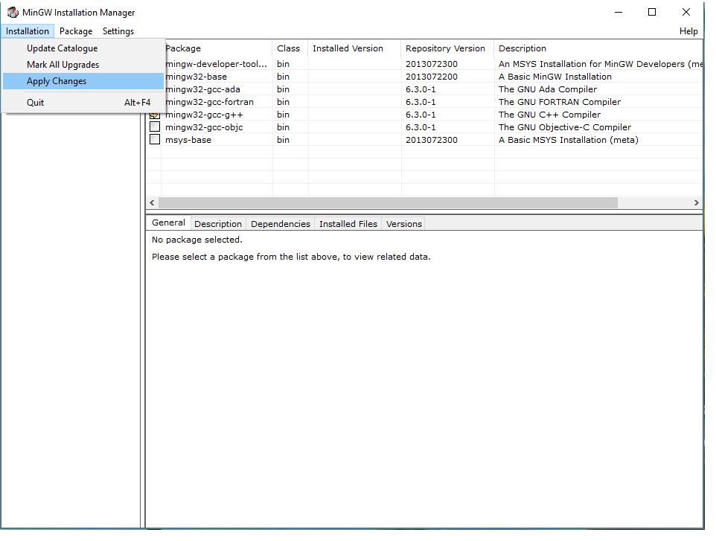

The installer downloads the selected items:  
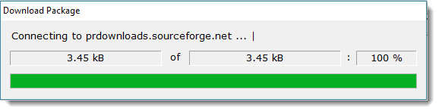

When done – the confirmation appears that all changes were applied successfully: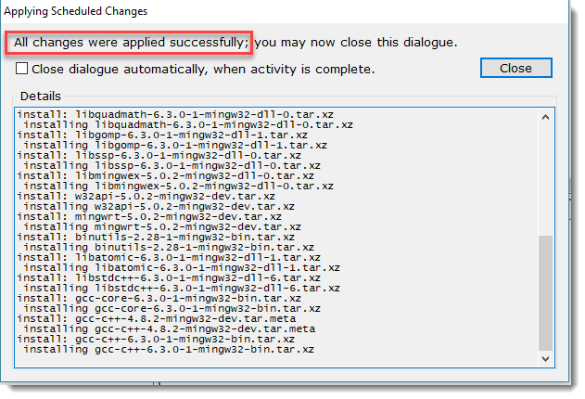  
Close all panels of the installer that are visible to complete the installation activities.

**Step 5 –** Extend Path System Variable:

In order to allow to access g++ (Gnu C++ Compiler) and notepad++ from any path in a console – it is recommended to alter the Path System Variable as followed:  
  
Open the extended system settings by looking up “sysdm.cpl” …  
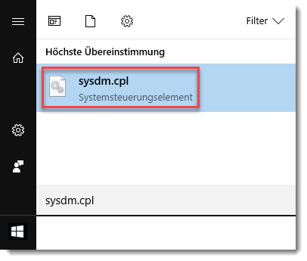

In the panel appearing swap to the tab “Advanced” – then hit the button “Environment Variables”…  
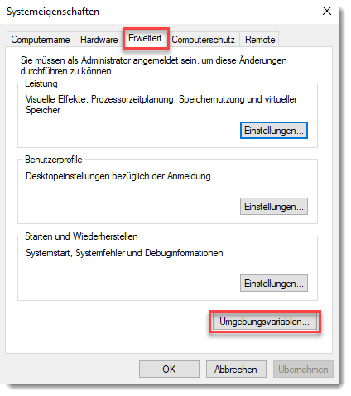

In the popup panel perform the following two actions:

**-1-**  Select the item “Path” in the lower section with the caption: “System variables”  
**-2-**  Click the button “Edit”

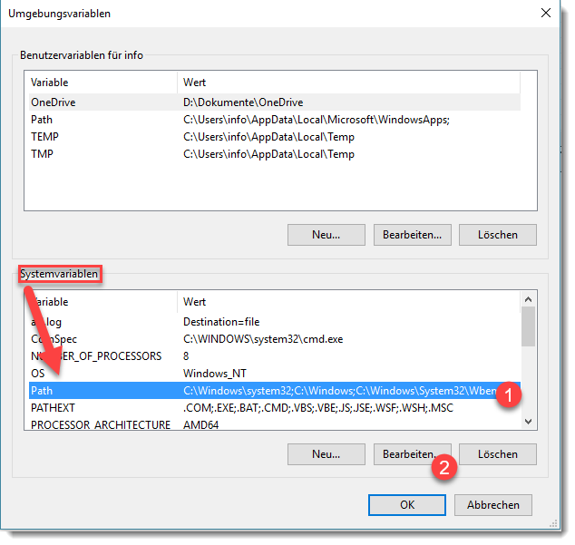

Another popup appears allowing to insert new properties to the Path System Variable…  
  
Add the following two new items by using the button “New”:

* C:\MinGW\bin
* C:\Program Files\Notepad++

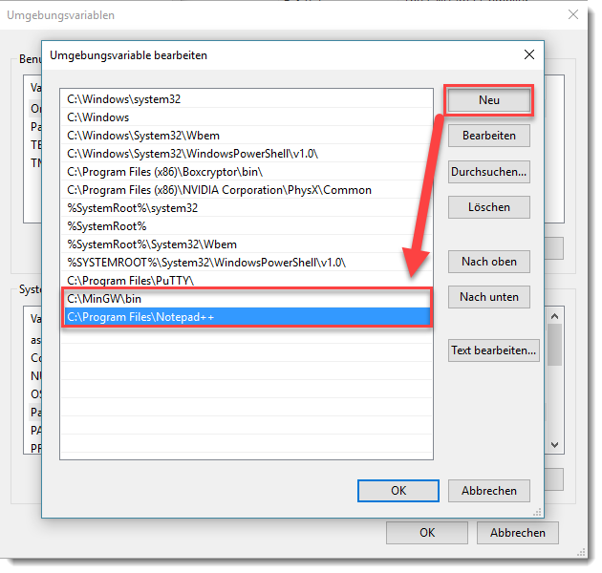

When done – close all open panels with the button “OK”.

**Step 6** – Create your personal “Development” folder:

Use the lookup feature to locate “cmd.exe”  
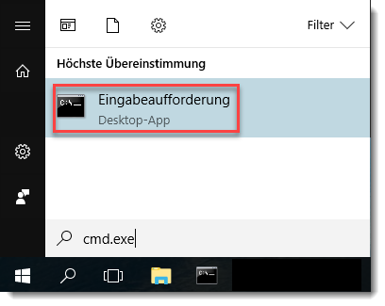

When launched the Windows Command Prompt appears – allowing you to enter the below commands:  
  
  
md Development\HelloWorld

cd Development\HelloWorld

notepad++ HelloWorld.cpp

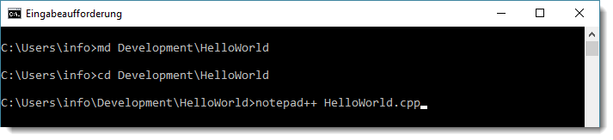

When the last command is being executed a popup appears asking you if you want to create the new File “HelloWorld.cpp”…  
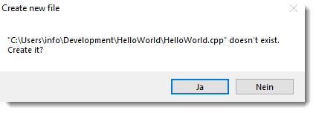

Confirm the Dialog by clicking the button “Yes”…

**Step 7 –** Write some C++ Code by using the “notepad++” editor:  
  
The notepad++ Editor appears with a blank document.

Type the listed Code from below into the editor panel:  
  
#include<iostream>  
using namespace std;  
  
int main()  
{  
 cout << "Hello World !" << endl;  
 return 0;  
}

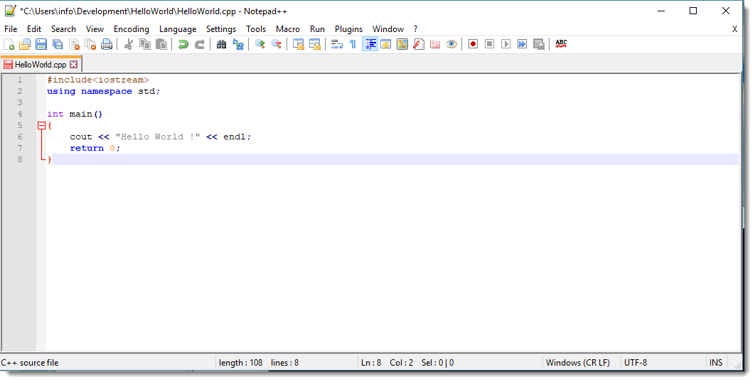

Save the edited file by pressing the key combination…  
C:\Users\suetterp\AppData\Local\Temp\SNAGHTML463f055.PNG

**Step 8 –** Compile your program > “HelloWorld.cpp”

In order to compile your program, enter the following instruction in the console:

g++ HelloWorld.cpp –o HelloWorld.exe

Finally run your program with the command:

HelloWorld.exe

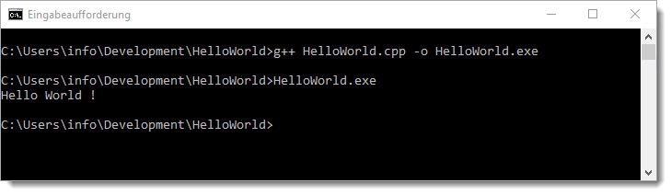

The output of your first program is:

Hello World !