COMP257

Assignment 1: Dimensionality Reduction using PCA

Question 1

It is hard to find a way to plot all digits. After research, I decided to create a method and send the combined compressed and original data into it to print(since it will print many, I # them in the video).

Question2

Linear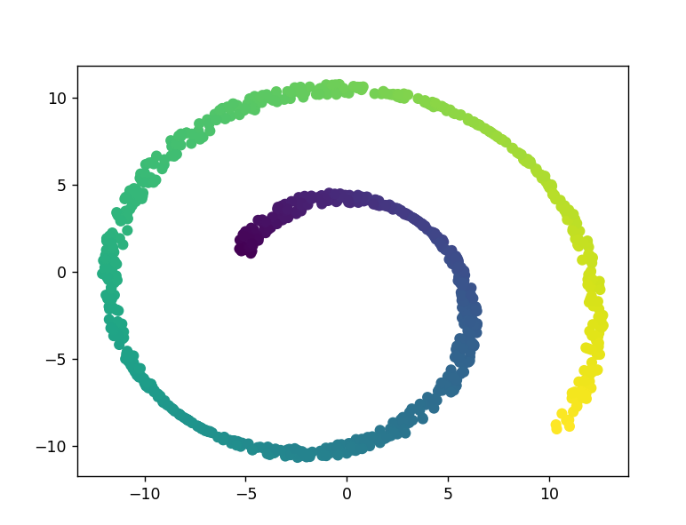

Rbf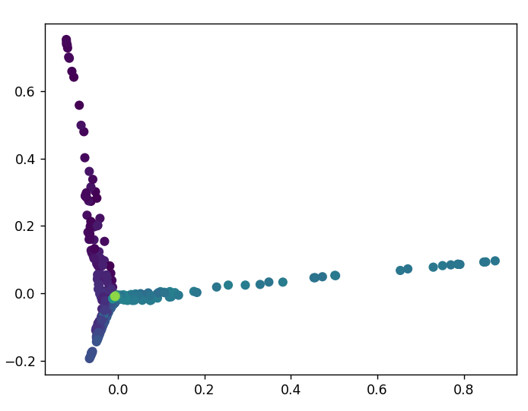

Sigmoid

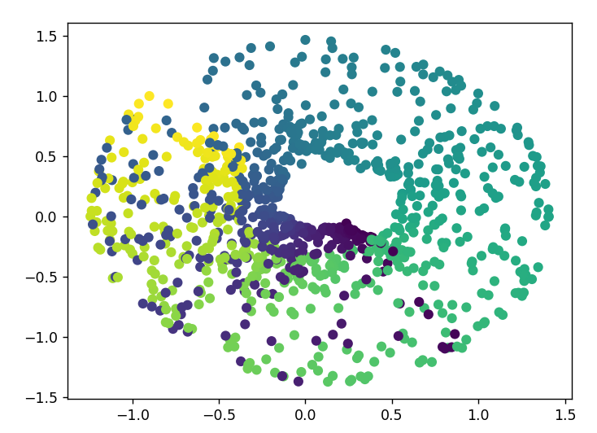

Linear and sigmoid is drawing a circle but RBF looks like drawing a corner, which is projected into twisted manifold.

The hardest part is set parameters to test for the best. Due to computer limitation, I only can test direction for gamma and two number for iter.