INTERNATIONAL COUNCIL FOR HARMONISATION OF TECHNICAL REQUIREMENTS FOR PHARMACEUTICALS FOR HUMAN USE

ICH HARMONISED GUIDELINE

Clinical electronic Structured Harmonised Protocol
(CeSHarP)

M11 LZZT Example_Added Estimand

Full Title: | Safety and Efficacy of the Xanomeline Transdermal Therapeutic System (TTS) in Patients with Mild to Moderate Alzheimer’s Disease
Sponsor Protocol Identifier: | H2Q-MC-LZZT
Original Protocol: | No
Version Number: | (c)
Amendment Identifier: | H2Q-MC-LXXT(c)
Amendment Scope: | Global
Compound Code(s): | LY246708
Compound Name(s): | Xanomeline
Trial Phase: | Phase 3
Short Title: | Safety and Efficacy of the Xanomeline Transdermal Therapeutic System (TTS) in Patients with Mild to Moderate Alzheimer’s Disease
Sponsor Name and Address: | Eli Lilly and Company  Lilly Corporate Center  Indianapolis, IN 46285
Regulatory Agency Identifier Number(s): | NCTA12313212
Sponsor Approval Date: | On file at Eli Lilly and Company

Sponsor Signatory: Signature block and date on file at Eli Lilly and Company
Medical Expert Contact: Medical Expert details on file at Eli Lilly and Company
SAE Reporting Method: Report Serious Adverse Events to the sponsor via provided forms. Refer to Section 9.4 for detailed reporting instructions.

Amendment Details:
This protocol has been amended previously. Details of prior amendments are presented in Prior Protocol Amendment(s).}
The table below describes the current amendment.
Approximate 66% Enrolled at time of Sponsor Approval: | Approximate 66% enrolled Globally (Example data only as exact details of amendment were not available for this text protocol.)
Reason(s) for Amendment: | Primary: Entry Criteria |  | Secondary: Administrative.
Amendment Summary: | (Example data only as exact details of amendment were not available for this test protocol.)amuuuSummStnent ementmmdmentmddndndmendment Summary
Is this amendment likely to have a substantial impact on the safety or rights of the participants? |  | No
Is this amendment likely to have a substantial impact on the reliability and robustness of the data generated in the clinical trial? |  | No

Overview of Changes in the Current Amendment:
Description of Change | Brief Rationale for Change | Section # and Name
Changed Entry Criteria | Example data only as exact details of amendment were not available for this test protocol. | 5.2 Inclusion Criteria

Table of Contents

1 Protocol Summary 10
1.1 Protocol Synopsis 10
1.1.1 Primary and Secondary Objectives and Estimands 10
1.1.2 Overall Design 10
1.2 Trial Schema 12
1.3 Schedule of Activities 14
2 Introduction 16
2.1 Purpose of Trial 16
2.2 Summary of Benefits and Risks 16
3 Trial Objectives and Estimands 16
3.1 Primary Objective(s) and Associated Estimand(s) 16
3.2 Secondary Objective(s) and Associated Estimand(s) 17
3.3 Exploratory Objective(s) 17
4 Trial Design 18
4.1 Description of Trial Design 18
4.2 Rationale for Trial Design 18
4.2.1 Rationale for Intervention Model 18
4.2.2 Rationale for Other Trial Design Aspects 19
4.3 Trial Stopping Rules 19
4.4 Start of Trial and End of Trial 19
4.5 Access to Trial Intervention After End of Trial 20
5 Trial Population 20
5.1 Description of Trial Population and Rationale 20
5.2 Inclusion Criteria 20
5.3 Exclusion Criteria 21
5.4 Contraception 29
5.4.1 Definitions Related to Childbearing Potential 29
5.4.2 Contraception Requirements 29
5.5 Lifestyle Restrictions 29
5.6 Screen Failure and Rescreening 29
6 Trial Intervention And Concomitant Therapy 30
6.1 Overview of Trial Interventions 31
6.2 Description of Investigational Trial Intervention 32
6.3 Rationale for Investigational Trial Intervention Dose and Regimen 32
6.4 Investigational Trial Intervention Administration 32
6.5 Investigational Trial Intervention Dose Modification 33
6.6 Management of Investigational Trial Intervention Overdose 34
6.7 Preparation, Storage, Handling and Accountability of Investigational Trial Intervention(s) 34
6.7.1 Preparation of Investigational Trial Intervention(s) 34
6.7.2 Storage and Handling of Investigational Trial Intervention 34
6.7.3 Accountability of Investigational Trial Intervention 34
6.8 Investigational Trial Intervention Assignment, Randomisation and Blinding 34
6.8.1 Participant Assignment to Investigational Trial Intervention 34
6.8.2 Randomisation 34
6.8.3 Blinding 34
6.8.4 Emergency Unblinding at the Site 34
6.9 Investigational Trial Intervention Compliance 35
6.10 Description of Non-Investigational Trial Intervention(s) 35
6.11 Concomitant Therapy 35
6.11.1 Prohibited Concomitant Therapy 36
6.11.2 Permitted Concomitant Therapy 36
7 Participant Discontinuation of Trial Intervention and Discontinuation or Withdrawal From trial 36
7.1 Discontinuation of Trial Intervention for Individual Participants 36
7.1.1 Permanent Discontinuation of Trial Intervention 36
7.1.2 Temporary Discontinuation of Trial Intervention 36
7.1.3 Rechallenge 36
7.2 Discontinuation or Withdrawal from the Trial 36
7.3 Lost to Follow-Up 37
8 Trial Assessments and Procedures 38
8.1 Trial Assessments and Procedures Considerations 38
8.2 Screening/Baseline Assessments and Procedures 38
8.3 Efficacy Assessments and Procedures 38
8.4 Safety Assessments and Procedures 39
8.4.1 Vital Signs 39
8.4.2 Electrocardiograms 39
8.4.3 Clinical Laboratory Assessments 42
8.5 Pharmacokinetics 44
8.6 Biomarkers 45
8.6.1 Genetics and Pharmacogenomics 45
8.6.2 Pharmacodynamic Biomarkers 45
8.7 Immunogenicity Assessments 45
8.8 Medical Resource Utilisation and Health Economics 45
9 Adverse Events, Serious Adverse Events, Product Complaints, Pregnancy and Postpartum Information 46
9.1 Definitions 46
9.1.1 Definitions of Adverse Events 46
9.1.2 Definitions of Serious Adverse Events 46
9.2 Timing and Mechanism for Collection and Reporting 47
9.3 Identification, Recording and Follow-Up 47
9.3.1 Identification 47
9.3.2 Severity 47
9.3.3 Causality 47
9.3.4 Follow-up 47
9.4 Reporting 47
9.4.1 Regulatory Reporting Requirements 47
9.4.2 Adverse Events of Special Interest 47
9.4.3 Disease-related Events or Outcomes Not Qualifying as AEs or SAEs 48
9.5 Pregnancy and Postpartum Information 48
10 Statistical Considerations 48
10.1 General Considerations 48
10.2 Analysis Sets 48
10.3 Analyses of Demographics and Other Baseline Variables 48
10.4 Analyses Associated with the Primary Objective(s) 48
10.4.1 Statistical Method of Analysis 48
10.4.2 Handling of Data in Relation to Primary Estimand(s) 49
10.4.3 Handling of Missing Data 49
10.4.4 Times of Analyses (adjusted heading for older protocol) 50
10.4.5 Statistical Methodology (adjusted heading for older protocol) 50
10.4.6 One Sided Justification(Added to accommodate older protocol layout) 51
10.4.7 Nominal p-Value Adjustments (Added to accommodate older protocol layout) 52
10.5 Analysis Associated with the Secondary Objective(s) 53
10.5.1 Statistical Method of Analysis 53
10.5.2 Handling of Data in Relation to Secondary Estimand(s) 53
10.5.3 Handling of Missing Data 53
10.6 Analysis Associated with the Exploratory Objective(s) 53
10.7 Safety Analyses 53
10.8 Other Analyses 54
10.8.1 Subgroup Analyses 54
10.8.2 Pharmacokinetic/Pharmacodynamic Analyses 54
10.9 Interim Analyses 54
10.9.1 Interim Efficacy Analyses 54
10.9.2 Interim Safety Analyses 55
10.10 Multiplicity Adjustments 55
10.11 Sample Size Determination 55
11 Trial Oversight and Other General Considerations 55
11.1 Regulatory and Ethical Considerations 55
11.2 Trial Oversight 56
11.2.1 Investigator Responsibilities 56
11.3 Informed Consent Process 56
11.4 Committees 57
11.5 Insurance and Indemnity 57
11.6 Risk Management 57
11.7 Data Governance 57
11.8 Source Data 57
11.9 Protocol Deviations 58
11.10 Early Site Closure 58
12 Appendix: Supporting Details 59
12.1 Clinical Laboratory Tests 59
12.2 Country/Region-Specific Differences 59
12.3 Prior Protocol Amendment(s) 60
13 Appendix: Glossary of Terms and Abbreviations 61
14 Appendix: References 61

- Protocol Summary
  - Protocol Synopsis
    - Primary and Secondary Objectives and Estimands
Objectives | Endpoints
Primary
- To determine if there is a statistically significant relationship (overall Type 1 error rate, α=.05) between the change in both ADAS-Cog (see Attachment LZZT.2) and CIBIC+ (see Attachment LZZT.3) scores, and drug dose (0, 50 cm2 [54 mg], and 75 cm2 [81 mg]). | - change in both ADAS-Cog (see Attachment LZZT.2) and CIBIC+ (see Attachment LZZT.3) scores,
- To document the safety profile of the xanomeline TTS. | - Various safety endpoints.
Secondary
- To assess the dose-dependent improvement in behavior. | - . Improved scores on the Revised Neuropsychiatric Inventory (NPI-X) will indicate improvement in these areas (see Attachment LZZT.4)
- To assess the dose-dependent improvements in activities of daily living. | - Improved scores on the Disability Assessment for Dementia (DAD) will indicate improvement in these areas (see Attachment LZZT.5).
- To assess the dose-dependent improvements in an extended assessment of cognition that integrates attention/concentration tasks. | - The Alzheimer’s Disease Assessment Scale-14 item Cognitive Subscale, hereafter referred to as ADAS-Cog (14), will be used for this assessment (see Attachment LZZT.2).
- To assess the treatment response as a function of Apo E genotype. | - TBD

    - Overall Design
Key aspects of the trial design are summarised below.
Intervention Model: | Parallel | Population Type: | With dxsixdisesease Dhhth tith
Control Type: | Placebo | Population Diagnosis or Condition: | Alzheimer’s Disease
Control Description: | N/A | Population Age: | Minimum: 50 years of age
Intervention Assignment Method: | Randomized, blinded | Site Distribution and Geographic Scope: | NA  Global
Number of Arms: [3]
Trial Blind Schema: Double blind
Blinded roles: The following roles indicated will not be made aware of the treatment group assignment during the trial: Investigator, Patient
Number of Participants:
Approximately 300 patients will be enrolled (see Schedule of Events for Protocol H2Q-MC-LZZT(c), Attachment LZZT.1).
Duration
Total planned duration of trial intervention for each participant:
24 weeks.
Total planned duration of trial participation for each participant:
26 weeks.
Patients with probable mild to moderate AD will be studied in a randomized, doubleblind, parallel (3 arm), placebo-controlled trial of 26 weeks duration. The study will be conducted on an outpatient basis.
Committees:
A Data Safety Monitoring Board (DSMB), chaired by an external cardiologist, will meet after 75, 150, 225, and 300 patients have completed 1 month of treatment. The DSMB will review cardiovascular findings to decide if discontinuation of the study or any treatment arm is appropriate, if additional cardiovascular monitoring is required, if further cardiovascular monitoring is unnecessary, or if adjustment of dose within a treatment arm (or arms) is appropriate (see Section 3.9.4).
  - Trial Schema
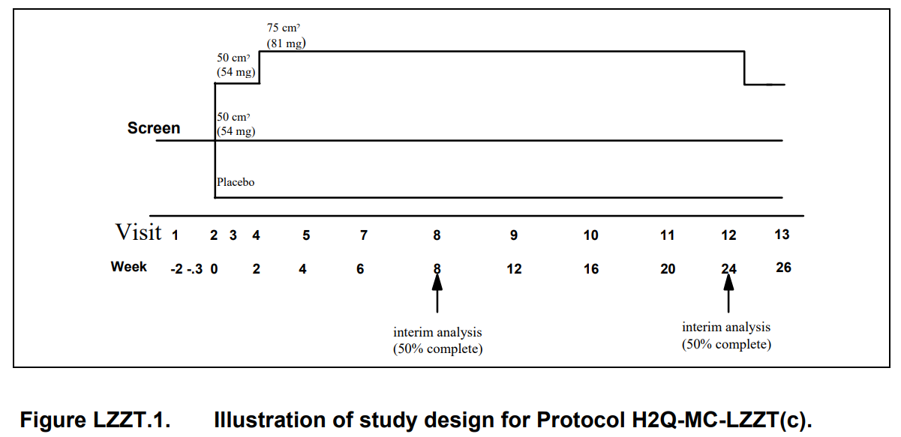Following informed consent, patients will be screened at Visit 1. At screening, patients will undergo complete neuropsychiatric assessment, psychometric testing, and general medical assessment (including medical history, pre-existing conditions, physical examination). In addition, vital signs, temperature, medication history, electrocardiogram (ECG), chest x-ray, and safety laboratories will be obtained. During the screening visit, patients will wear a placebo TTS to determine willingness and ability to comply with transdermal administration procedures. If patients have not had central nervous system (CNS) imaging in the previous 12 months, a computed tomography (CT) or magnetic resonance imaging (MRI) scan will be obtained. If patients are insulin dependent diabetics, a hemoglobin A1c will be obtained. Screening exams and procedures may be performed after Visit 1; however, their results must be completed and available prior to randomization. The screening process should occur within 2 weeks of randomization (Visit 3 of the study). Patients who meet enrollment criteria from Visit 1 will proceed to Visit 2 at which time they will undergo a 24-hour Ambulatory ECG. At Visit 3 the Ambulatory ECG will be removed and patients will be randomized to 1 of 3 treatment arms. The treatment arms will include a placebo arm, a low-dose xanomeline arm (50 cm2 TTS Formulation E, 54 mg xanomeline), and a high-dose xanomeline arm (75 cm2 TTS Formulation E, 81 mg xanomeline). All patients receiving xanomeline will be started at 50 cm2 TTS Formulation E. For the first 8 weeks of treatment, patients will be assessed at clinic visits every 2 weeks and, thereafter, at clinic visits every 4 weeks. Patients who discontinue prior to Visit 12 (Week 24) will be brought back for full efficacy assessments at or near to 24 weeks, whenever possible.
At Visits 3, 8, 10, and 12, efficacy instruments (ADAS-Cog, CIBIC+, and DAD) will be administered. NPI-X will be administered at 2-week intervals either at clinic visits or via a telephone interview. Vital signs, temperature, and an assessment of adverse events will be obtained at all clinic visits. An electrocardiogram (ECG), and chemistry/hematology safety labs will be obtained at Visits 4, 5, 7, 8, 9, 10, 11, 12, and 13. Urinalysis will be done at Visits 4, 9, and 12. Use of concomitant medications will be collected at Visits 3, 4, 5, 7, 8, 9, 10, 11, 12, and 13. Plasma levels of xanomeline and metabolites will be obtained at Visits 3, 4, 5, 7, 9, and 11. At Visits 3, 4, 5, 7, 8, 9, 10, 11, and 12, medications will be dispensed to the patients. Visits 1 through 13 should be scheduled relative to Visit 3 (Week 0 - randomization). Visits 4, 5, 7, 8, and 13 should occur within 3 days of their scheduled date. Visits 9, 10, 11, and 12 should occur within 4 days of their scheduled date. At Visit 13 patients will be given the option to enter the open-label extension phase (see Section 3.10.3. Study Extensions).
Visits 1 through 13 should be scheduled relative to Visit 3 (Week 0 - randomization). Visits 4, 5, 7, 8, and 13 should occur within 3 days of their scheduled date. Visits 9, 10, 11, and 12 should occur within 4 days of their scheduled date. At Visit 13 patients will be given the option to enter the open-label extension phase (see Section 3.10.3. Study Extensions).
  - Schedule of Activities
Schedule of Events for Protocol H2Q-MC-LZZT(c) 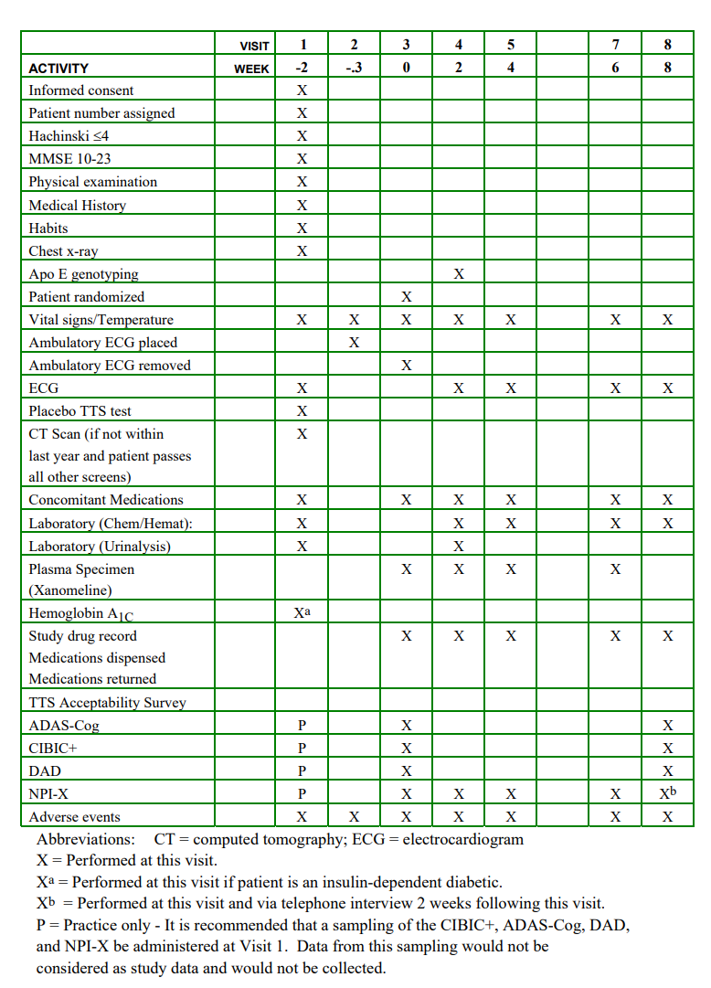
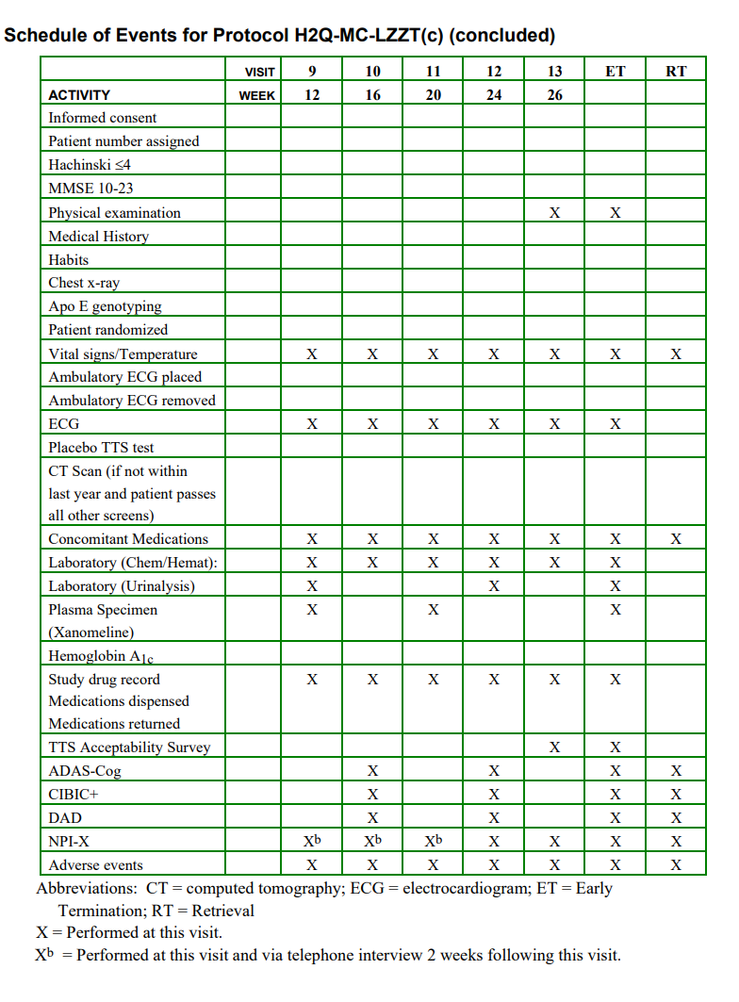
- Introduction
  - Purpose of Trial
Xanomeline is a novel M1 agonist which has shown high affinity for the M1 receptor subtype (in transfected cells), and substantially less or no affinity for other muscarinic subtypes. Positron emission tomography (PET) studies of 11C-labeled xanomeline in cynomolgus monkeys have suggested that the compound crosses the blood-brain barrier and preferentially binds the striatum and neocortex.
Clinical development of an oral formulation of xanomeline for the indication of mild and moderate AD was initiated approximately 4 years ago. A large-scale study of safety and efficacy provided evidence that an oral dosing regimen of 75 mg three times daily (TID) may be associated with enhanced cognition and improved clinical global impression, relative to placebo. As well, a dramatic reduction in psychosis, agitation, and other problematic behaviors, which often complicate the course of the disease, was documented. However, the discontinuation rate associated with this oral dosing regimen was 58.6%, and alternative clinical strategies have been sought to improve tolerance for the compound. To that end, development of a Transdermal Therapeutic System (TTS) has been initiated. Relative to the oral formulation, the transdermal formulation eliminates high concentrations of xanomeline in the gastrointestinal (GI) tract and presystemic (firstpass) metabolism.
  - Summary of Benefits and Risks
Xanomeline is a novel M1 agonist which has shown high affinity for the M1 receptor subtype (in transfected cells), and substantially less or no affinity for other muscarinic subtypes. Positron emission tomography (PET) studies of 11C-labeled xanomeline in cynomolgus monkeys have suggested that the compound crosses the blood-brain barrier and preferentially binds the striatum and neocortex. Clinical development of an oral formulation of xanomeline for the indication of mild and moderate AD was initiated approximately 4 years ago. A large-scale study of safety and efficacy provided evidence that an oral dosing regimen of 75 mg three times daily (TID) may be associated with enhanced cognition and improved clinical global impression, relative to placebo. As well, a dramatic reduction in psychosis, agitation, and other problematic behaviors, which often complicate the course of the disease, was documented. However, the discontinuation rate associated with this oral dosing regimen was 58.6%, and alternative clinical strategies have been sought to improve tolerance for the compound. To that end, development of a Transdermal Therapeutic System (TTS) has been initiated. Relative to the oral formulation, the transdermal formulation eliminates high concentrations of xanomeline in the gastrointestinal (GI) tract and presystemic (firstpass) metabolism
- Trial Objectives and Estimands
  - Primary Objective(s) and Associated Estimand(s)
    - Primary Objective & Associated Estimand(s)
The primary objectives of this study are:
- To determine if there is a statistically significant relationship (overall Type 1 error rate, α=.05) between the change in both ADAS-Cog (see Attachment LZZT.2) and CIBIC+ (see Attachment LZZT.3) scores, and drug dose (0, 50 cm2 [54 mg], and 75 cm2 [81 mg]).
- To document the safety profile of the xanomeline TTS.
Estimand Characteristic | Description
Population | Patients with Mild to Moderate Alzheimer’s Disease. (Added for Testing Purposes)
Treatment | The treatment arms will include a placebo arm, a low-dose xanomeline arm (50 cm2 TTS Formulation E, 54 mg xanomeline), and a high-dose xanomeline arm (75 cm2 TTS Formulation E, 81 mg xanomeline). (Added for Testing Purposes)
Endpoint | Change in both ADAS-Cog (see Attachment LZZT.2) and CIBIC+ (see Attachment LZZT.3) scores. (Added for Testing Purposes)
Population-Level Summary | Group mean changes from baseline in the primary efficacy parameters(Added for Testing Purposes)
Intercurrent Event | Strategy
Temporary Treatment Interruption | Treatment Policy – Continue to measure effect of treatment assignment regardless of interruption. (Added for Testing Purposes)

  - Secondary Objective(s) and Associated Estimand(s)
The secondary objectives of this study are
- To assess the dose-dependent improvement in behavior. Improved scores on the Revised Neuropsychiatric Inventory (NPI-X) will indicate improvement in these areas (see Attachment LZZT.4).
- To assess the dose-dependent improvements in activities of daily living. Improved scores on the Disability Assessment for Dementia (DAD) will indicate improvement in these areas (see Attachment LZZT.5).
- To assess the dose-dependent improvements in an extended assessment of cognition that integrates attention/concentration tasks. The Alzheimer’s Disease Assessment Scale-14 item Cognitive Subscale, hereafter referred to as ADAS-Cog (14), will be used for this assessment (see Attachment LZZT.2).
- To assess the treatment response as a function of Apo E genotype.
  - Exploratory Objective(s)
Not applicable.

- Trial Design
  - Description of Trial Design
Approximately 300 patients will be enrolled (see Schedule of Events for Protocol H2Q-MC-LZZT(c), Attachment LZZT.1).
Duration
Total planned duration of trial intervention for each participant:
24 weeks.
Total planned duration of trial participation for each participant:
26 weeks.Study Extensions Patients who successfully complete the study will be eligible for participation in an openlabel extension phase, where every patient will be treated with active agent. The patients who elect to participate in the open-label extension phase will be titrated to their maximally titrated dose. This open-label extension phase will continue until the time the product becomes marketed and is available to the public or until the project is discontinued by the sponsor. Patients may terminate at any time at their request.Study Extensions Patients who successfully complete the study will be eligible for participation in an openlabel extension phase, where every patient will be treated with active agent. The patients who elect to participate in the open-label extension phase will be titrated to their maximally titrated dose. This open-label extension phase will continue until the time the product becomes marketed and is available to the public or until the project is discontinued by the sponsor. Patients may terminate at any time at their request.Study Extensions Patients who successfully complete the study will be eligible for participation in an openlabel extension phase, where every patient will be treated with active agent. The patients who elect to participate in the open-label extension phase will be titrated to their maximally titrated dose. This open-label extension phase will continue until the time the product becomes marketed and is available to the public or until the project is discontinued by the sponsor. Patients may terminate at any time at their request. Study Extensions Patients who successfully complete the study will be eligible for participation in an openlabel extension phase, where every patient will be treated with active agent. The patients who elect to participate in the open-label extension phase will be titrated to their maximally titrated dose. This open-label extension phase will continue until the time the product becomes marketed and is available to the public or until the project is discontinued by the sponsor. Patients may terminate at any time at their request.
Patients with probable mild to moderate AD will be studied in a randomized, doubleblind (See Section 6.6), parallel (3 arm), placebo-controlled trial of 26 weeks duration. The study will be conducted on an outpatient basis.
At Visit 1, patients who meet the enrollment criteria of Mini-Mental State Examination (MMSE) score of 10 to 23 (Attachment LZZT.6), Hachinski Ischemia Score ≤4 (Attachment LZZT.8), a physical exam, safety labs, ECG, and urinalysis, will proceed to Visit 2 and Visit 3. At Visit 3, patients whose CNS imaging and other pending labs from Visit 1 satisfy the inclusion criteria (Section 3.4.2.1) will be enrolled in the study. Approximately 300 patients with a diagnosis of probable mild to moderate AD will be enrolled in the study.
  - Rationale for Trial Design
    - Rationale for Intervention Model
Previous studies of the oral formulation have shown that xanomeline tartrate may improve behavior and cognition. Effects on behavior are manifest within 2 to 4 weeks of initiation of treatment. The same studies have shown that 8 to 12 weeks are required to demonstrate effects on cognition and clinical global assessment. This study is intended to determine the acute and chronic effects of the TTS formulation in AD; for that reason, the study is of 26 weeks duration. Dosage specification has been made on the basis of tolerance to the xanomeline TTS in a clinical pharmacology study (H2Q-EW-LKAA), and target plasma levels as determined in studies of the oral formulation of xanomeline (H2Q-MC-LZZA). The parallel dosing regimen maximizes the ability to make direct comparisons between the treatment groups. The use of placebo allows for a blinded, thus minimally biased, study. The placebo treatment group is a comparator group for efficacy and safety assessment. Xanomeline (LY246708) H2Q-MC-LZZT(c) Copyright © 2006 Eli Lilly and Company Clinical Study Protocol Document Page 10 Two interim analyses are planned for this study. The first interim analysis will occur when 50% of the patients have completed Visit 8 (8 weeks). If required, the second interim analysis will occur when 50% of the patients have completed Visit 12 (24 weeks). (See Section 4.6, Interim Analyses.)
Approximately 100 patients will be randomized to each of the 3 treatment groups. Previous experience with the oral formulation of xanomeline suggests that this sample size has 90% power to detect a 3.0 mean treatment difference in ADAS-Cog (p<.05, two-sided), based on a standard deviation of 6.5. Furthermore, this sample size has 80% power to detect a 0.36 mean treatment difference in CIBIC+ (p<.05, two-sided), based on a standard deviation of 0.9.
    - Rationale for Other Trial Design Aspects
Appropriateness and Consistency of Measurements
The medications and efficacy measurements have been used in other studies in elderly subjects and patients.
  - Trial Stopping Rules
Not applicable.
  - Start of Trial and End of Trial
For Lilly studies, the following definitions are used:
Screen
- Screening is the act of determining if an individual meets minimum requirements to become part of a pool of potential candidates for participation in a clinical study.
- In this study, screening will include asking the candidate preliminary questions (such as age and general health status) and conducting invasive or diagnostic procedures and/or tests (for example, diagnostic psychological tests, x-rays, blood draws). Patients will sign the consent at Xanomeline (LY246708) H2Q-MC-LZZT(c) Copyright © 2006 Eli Lilly and Company Clinical Study Protocol Document Page 11 their screening visit, thereby consenting to undergo the screening procedures and to participate in the study if they qualify.
To enter
- Patients entered into the study are those from whom informed consent for the study has been obtained. Adverse events will be reported for each patient who has entered the study, even if the patient is never assigned to a treatment group (enrolled).
To enroll
- Patients who are enrolled in the study are those who have been assigned to a treatment group. Patients who are entered into the study but fail to meet criteria specified in the protocol for treatment assignment will not be enrolled in the study.
>

  - Access to Trial Intervention After End of Trial
Study Extensions
Patients who successfully complete the study will be eligible for participation in an open-label extension phase, where every patient will be treated with active agent. The patients who elect to participate in the open-label extension phase will be titrated to their maximally titrated dose. This open-label extension phase will continue until the time the product becomes marketed and is available to the public or until the project is discontinued by the sponsor. Patients may terminate at any time at their request.
- Trial Population
  - Description of Trial Population and Rationale
Probable AD will be defined clinically by NINCDS/ADRDA guidelines as follows:
• Diagnosis of probable AD as defined by National Institute of Neurological and Communicative Disorders and Stroke (NINCDS) and the Alzheimer’s Disease and Related Disorders Association (ADRDA) guidelines.
• Mild to moderate severity of AD will be defined by the Mini-Mental State Exam as follows:
• Mini-Mental State Examination (MMSE) score of 10 to 23.
• The absence of other causes of dementia will be performed by clinical opinion and by the following:
• Hachinski Ischemic Scale score of ≤4.
• CNS imaging (CT scan or MRI of brain) compatible with AD within past 1 year (see Section 3.4.2.1).Prospective approval of protocol deviations to recruitment and enrollment criteria, also known as protocol waivers or exemptions, is not permitted.

  - Inclusion Criteria
Patients may be included in the study only if they meet all the following criteria:
- Males and postmenopausal females at least 50 years of age.
- Diagnosis of probable AD as defined by National Institute of Neurological and Communicative Disorders and Stroke (NINCDS) and the Alzheimer’s Disease and Related Disorders Association (ADRDA) guidelines (Attachment LZZT.7).
- MMSE score of 10 to 23.
- Hachinski Ischemic Scale score of ≤4 (Attachment LZZT.8).
- CNS imaging (CT scan or MRI of brain) compatible with AD within past 1 year.
The following findings are incompatible with AD:
  - Large vessel strokes
    - Any definite area of encephalomalacia consistent with ischemic necrosis in any cerebral artery territory.
    - Large, confluent areas of encephalomalacia in parieto-occipital or frontal regions consistent with watershed infarcts.
The above are exclusionary. Exceptions are made for small areas of cortical asymmetry which may represent a small cortical stroke or a focal area of atrophy provided there is no abnormal signal intensity in the immediately underlying parenchyma. Only one such questionable area allowed per scan, and size is restricted to ≤1cm in frontal/parietal/temporal cortices and ≤2 cm in occipital cortex.
  - Small vessel ischemia
    - Lacunar infarct is defined as an area of abnormal intensity seen on CT scan or on both T1 and T2 weighted MRI images in the basal ganglia, thalamus or deep white matter which is ≤1 cm in maximal diameter. A maximum of one lacune is allowed per scan.
    - Leukoariosis or leukoencephalopathy is regarded as an abnormality seen on T2 but not T1 weighted MRIs, or on CT. This is accepted if mild or moderate in extent, meaning involvement of less than 25% of cortical white matter.
  - Miscellaneous
    - Benign small extra-axial tumors (ie, meningiomas) are accepted if they do not contact or indent the brain parenchyma.
    - Small extra-axial arachnoid cysts are accepted if they do not indent or deform the brain parenchyma.
- Investigator has obtained informed consent signed by the patient (and/or legal representative) and by the caregiver.
- Geographic proximity to investigator’s site that allows adequate follow-up.
- A reliable caregiver who is in frequent or daily contact with the patient and who will accompany the patient to the office and/or be available by telephone at designated times, will monitor administration of prescribed medications, and will be responsible for the overall care of the patient at home. The caregiver and the patient must be able to communicate in English and willing to comply with 26 weeks of transdermal therapy.

  - Exclusion Criteria
Patients will be excluded from the study for any of the following reasons:
- Persons who have previously completed or withdrawn from this study or any other study investigating xanomeline TTS or the oral formulation of xanomeline.
- Use of any investigational agent or approved Alzheimer’s therapeutic medication within 30 days prior to enrollment into the study.
- Serious illness which required hospitalization within 3 months of screening.
- Diagnosis of serious neurological conditions, including
  - Stroke or vascular dementia documented by clinical history and/or radiographic findings interpretable by the investigator as indicative of these disorders
  - Seizure disorder other than simple childhood febrile seizures
  - Severe head trauma resulting in protracted loss of consciousness within the last 5 years, or multiple episodes of head trauma
  - Parkinson’s disease
  - Multiple sclerosis
  - Amyotrophic lateral sclerosis
  - Myasthenia gravis.
- Episode of depression meeting DSM-IV criteria within 3 months of screening.
- A history within the last 5 years of the following:
  - Schizophrenia
  - Bipolar Disease
  - Ethanol or psychoactive drug abuse or dependence.
- A history of syncope within the last 5 years.
- Evidence from ECG recording at screening of any of the following conditions:
  - Left bundle branch block
  - Bradycardia ≤50 beats per minute
  - Sinus pauses >2 seconds
  - Second or third degree heart block unless treated with a pacemaker
  - Wolff-Parkinson-White syndrome
  - Sustained supraventricular tachyarrhythmia including SVT≥10 sec, atrial fibrillation, atrial flutter.
  - Ventricular tachycardia at a rate of ≥120 beats per minute lasting ≥10 seconds.
- A history within the last 5 years of a serious cardiovascular disorder, including
  - Clinically significant arrhythmia
  - Symptomatic sick sinus syndrome not treated with a pacemaker
  - Congestive heart failure refractory to treatment
  - Angina except angina controlled with PRN nitroglycerin
  - Resting heart rate 100 beats per minute, on physical exam
  - Uncontrolled hypertension.
- A history within the last 5 years of a serious gastrointestinal disorder, including
  - Chronic peptic/duodenal/gastric/esophageal ulcer that are untreated or refractory to treatment
  - Symptomatic diverticular disease
  - Inflammatory bowel disease
  - Pancreatitis
  - Hepatitis
  - Cirrhosis of the liver.
- A history within the last 5 years of a serious endocrine disorder, including
  - Uncontrolled Insulin Dependent Diabetes Mellitus (IDDM)
  - Diabetic ketoacidosis
  - Untreated hyperthyroidism
  - Untreated hypothyroidism
  - Other untreated endocrinological disorder
- A history within the last 5 years of a serious respiratory disorder, including
  - Asthma with bronchospasm refractory to treatment
  - Decompensated chronic obstructive pulmonary disease.
- A history within the last 5 years of a serious genitourinary disorder, including
  - Renal failure
  - Uncontrolled urinary retention.
- A history within the last 5 years of a serious rheumatologic disorder, including
  - Lupus
  - Temporal arteritis
  - Severe rheumatoid arthritis.
- A known history of human immunodeficiency virus (HIV) within the last 5 years.
- A history within the last 5 years of a serious infectious disease including
  - Neurosyphilis
  - Meningitis
  - Encephalitis.
- A history within the last 5 years of a primary or recurrent malignant disease with the exception of resected cutaneous squamous cell carcinoma in situ, basal cell carcinoma, cervical carcinoma in situ, or in situ prostate cancer with a normal PSA postresection.
- Visual, hearing, or communication disabilities impairing the ability to participate in the study; (for example, inability to speak or understand English, illiteracy).
- Laboratory test values exceeding the Lilly Reference Range III for the patient’s age in any of the following analytes: ↑ creatinine, ↑ total bilirubin, ↑ SGOT, ↑ SGPT, ↑ alkaline phosphatase, ↑ GGT, ↑↓ hemoglobin, ↑↓ white blood cell count, ↑↓ platelet count, ↑↓ serum sodium, potassium, or calcium.

If values exceed these laboratory reference ranges, clinical significance will be judged by the monitoring physicians. If the monitoring physician determines that the deviation from the reference range is not clinically significant, the patient may be included in the study. This decision will be documented.

- Central laboratory test values below reference range for folate, and Vitamin B12, and outside reference range for thyroid function tests.
  - Folate reference range 2.0 to 25.0 ng/mL. Patients will be allowed to enroll if their folate levels are above the upper end of the range if patients are taking vitamin supplements.
  - Vitamin B12 reference range 130 to 900 pg/mL. Patients will be allowed to enroll if their B12 levels are above the upper reference range if patients are taking oral vitamin supplements.
  - Thyroid functions
    - Thyroid Uptake reference range 25 to 38%. Patients will be allowed to enroll with results of 23 to 51% provided the remainder of the thyroid profile is normal and there are no clinical signs or symptoms of thyroid abnormality.
    - TSH reference range 0.32 to 5.0. Patients will be allowed to enroll with results of 0.03 to 6.2 if patients are taking stable doses of exogenous thyroid supplements, with normal free thyroid index, and show no clinical signs or symptoms of thyroid abnormality.
    - Total T4 reference range 4.5 to 12.5. Patients will be allowed to enroll with results of 4.1 to 13.4 if patients are taking stable doses of exogenous thyroid hormone, with normal free thyroid index, and show no clinical signs or symptoms of thyroid abnormality.
    - Free Thyroid Index reference range 1.1 to 4.6.
- Positive syphilis screening. Positive syphilis screening. As determined by positive RPR followed up by confirmatory FTA-Abs. Confirmed patients are excluded unless there is a documented medical history of an alternative disease (for example, yaws) which caused the lab abnormality.
- Glycosylated hemoglobin (A1C). Required only on patients with known diabetes mellitus or random blood sugar >200 on screening labs. Patients will be excluded if levels are >9.5%
- Treatment with the following medications washout periods prior to enrollment and during the study:
  - Anticonvulsants including but not limited to
Depakote® (valproic acid) 2 weeks
Dilantin® (phenytoin) 2 weeks
Felbatol® (felbamate) 1 month
Klonopin® (clonazepam) 2 weeks
Lamictal® (lamotrigine) 2 weeks
Mysoline® (primidone) 1 month
Neurontin® (gabapentin) 2 weeks
Phenobarbitol 1 month
Tegretol® (carbamazepine) 2 weeks b)
  - Alpha receptor blockers including but not limited to
Aldomet® (methyldopa) 2 weeks
Cardura® (doxazosin) 2 weeks
Catapres® (clonidine) 2 weeks
Hytrin® (terazosin) 2 weeks
Minipress® (prazosin) 2 weeks
Tenex® (guanfacine) 2 weeks
Wytensin® (guanabenz) 2 weeks

The use of low doses (2 mg daily) of either Hytrin® or Cardura® for relief of urinary retention for patients with prostatic hypertrophy will be considered on a case-by-case basis provided blood pressure is stable and the medication has not had demonstrable effect on dementia symptoms in the opinion of the treating physician. Contact CRO medical monitor.

  - Calcium channel blockers that are CNS active including but not limited to
Calan®, Isoptin®, Verelan® (verapamil) 2 weeks
Cardizem® (diltiazem) 2 weeks
Nimotop® (nimodipine) 2 weeks
Adalat®, Procardia XL® (nifedipine) 2 weeks

Cardene® (nicardipine), Norvasc®, (amlodipine), and DynaCirc® (isradipine) will be allowed during the study. If a patient is taking an excluded calcium channel blocker and is changed to an equivalent dose of an allowed calcium channel blocker, enrollment may proceed in as little as 24 hours though 1 week is preferred when possible.

  - Beta blockers including but not limited to
Betapace® (sotalol) 2 weeks
Inderal® (propranolol) 2 weeks
Lopressor®, Toprol XL® (metoprolol) 2 weeks
Corgard® (nadolol) 2 weeks
Sectral® (acebutolol) 2 weeks
Tenormin® (atenolol) 2 weeks
Visken® (pindolol) 2 weeks

Beta blocker eye drops for glaucoma will be considered on a case-by-case basis. Call medical monitor.

  - Beta sympathomimetics (unless inhaled) including but not limited to
Alupent® tablets (metaproterenol) 2 weeks
Brethine® tablets (terbutaline) 2 weeks
Dopamine 2 weeks
Proventil Repetabs®, Ventolin® tablets (albuterol tablets) 2 weeks
  - Parasympathomimetics (cholinergics) (unless opthalmic) including but not limited to
Antilirium® (physostigmine) 1 month
Aricept® (donepezil) 1 month
Cognex® (tacrine) 1 month
Mestinon® (pyridostigmine) 1 week
Reglan® (metoclopramide) 2 weeks
Urecholine®, Duvoid (bethanechol) 2 weeks

Cholinergic eye drops for treatment of glaucoma will be allowed during the study on a case-by-case basis. Please contact the CRO medical monitor.

  - Muscle relaxants-centrally active including but not limited to
Equanil® (meprobamate) 2 weeks
Flexeril® (cyclobenzaprine) 2 weeks
Lioresal® (baclofen) 2 weeks
Norflex® (orphenadrine) 2 weeks
Parafon Forte® (chlorzoxazone) 2 weeks
Robaxin® (methocarbamol) 2 weeks
Skelaxin® (metaxalone) 2 weeks
Soma® (carisoprodol) 2 weeks
  - Monamine oxidase inhibitors (MAOI) including but not limited to
Eldepryl®(selegiline) 1 month
Nardil® (phenelzine) 1 month
Parnate® (tranylcypromine) 1 month
  - Parasympatholytics including but not limited to
Antivert®, Bonine®, Dramamine II® (meclizine) 3 days
Artane® (trihexyphenidyl) 2 weeks
Bellergal-S® (alkaloids of belladonna and ergotamine) 2 weeks
Bentyl® (dicyclomine) 3 days
Cogentin® (benztropine) 2 weeks
Cystospaz®, Levsin®, Levsinex® (hyoscyamine) 2 weeks
Ditropan® (oxybutynin) 2 weeks
Donnatal®, Hyosophen® (atropine, scopolamine, hyoscyamine and phenobarbitol) 1 month
Dramamine® (dimenhydrinate) 3 days
Lomotil®, Lonox® (atropine, diphenoxylate) 2 weeks
Pro-Banthine® (propantheline) 2 weeks
Robinul® (glycopyrrolate) 3 days
Tigan® (trimethobenzamide) 3 days
Transderm-Scop® (scopolamine) 2 weeks
Urispas® (flavoxate) 2 weeks
  - Antidepressants including but not limited to
Anafranil® (clomipramine) 1 month
Asendin® (amoxapine) 1 month
Desyrel® (trazodone) 1 month
Effexor® (venlafaxine) 1 month
Elavil® (amitriptyline) 1 month
Ludiomil® (maprotiline) 1 month
Norpramin® (desipramine) 1 month
Pamelor®, Aventyl® (nortriptyline) 1 month
Paxil® (paroxetine) 1 month
Prozac® (fluoxetine) 1 month
Remeron® (mirtazapine) 1 month
Serzone® (nefazodone) 1 month
Sinequan® (doxepin) 1 month
Tofranil® (imipramine) 1 month
Vivactil® (protriptyline) 1 month
Wellbutrin® (bupropion) 1 month
Zoloft® (sertraline) 1 month
  - Systemic corticosteroids including but not limited to
Cortisone 2 weeks
Decadron® (dexamethasone) 2 weeks
Depo-Medrol® (methylprednisolone) 1 month
Prednisone 2 weeks
  - Xanthine derivatives including but not limited to
Aminophylline 2 weeks
Fioricet®, Esgic®, Phrenilin Forte® (caffeine, butalbital) 3 days
Theo-Dur® (theophylline) 2 weeks
Wigraine®, Cafergot® (caffeine, ergotamine) 3 days
  - Histamine (H2) antagonists including but not limited to
Axid® (nizatidine) 1 week
Pepcid® (famotidine) 1 week
Tagamet® (cimetidine) 1 week
Zantac® (ranitidine) 1 week

If an H2 antagonist is needed by the patient, Axid® will be allowed on a case-by-case basis. Please consult CRO medical monitor.

  - Narcotic Analgesics including but not limited to
Darvocet-N 100®, (propoxyphene) 1 week
Demerol® (meperidine) 1 week
Dilaudid® (hydromorphone) 1 week
Duragesic® (fentanyl) 1 week
MS Contin®, Roxanol®, Oramorph® (morphine) 1 week
Percocet®, Roxicet® (oxycodone with acetaminophen) 3 days
Percodan®, Roxiprin 1 week
Stadol® (butorphanol) 1 week
Talacen® (pentazocine) 1 week
Tylenol #2®, #3®, #4® (codeine and acetaminophen) 3 days
Tylox®, Roxilox® (oxycodone) 3 days
Vicodin®, Lorcet® (hydrocodone) 1 week

Percocet (oxycodone with acetaminophen) and Tylenol® with codeine #2, #3, #4 (acetaminophen + codeine) ARE allowed in the month prior to enrollment, but are not permitted in the 3 days prior to enrollment

  - Neuroleptics (antipsychotics) including but not limited to
Clozaril® (clozapine) 2 weeks
Haldol® (haloperidol) 2 weeks
Loxitane® (loxapine) 2 weeks
Mellaril® (thioridazine) 2 weeks
Moban® (molindone) 2 weeks
Navane® (thiothixene) 2 weeks
Orap® (pimozide) 2 weeks
Prolixin® (fluphenazine) 1 month
Risperdal® (risperidone) 2 weeks
Stelazine® (trifluoperazine) 2 weeks
Thorazine® (chlorpromazine) 2 weeks
Trilafon® (perphenazine) 2 weeks
Serentil® (mesoridazine) 2 weeks

The use of neuroleptics on a daily basis must be discontinued 2 to 4 weeks prior to enrollment. The use of neuroleptics on an as-needed basis is allowable during the screening period, but the last dose must be at least 7 days prior to enrollment.

  - Antianxiety agents including but not limited to
Atarax® (hydroxyzine) 2 weeks
BuSpar® (buspirone) 2 weeks
Librium® (chlordiazepoxide) 2 weeks
Serax® (oxazepam) 2 weeks
Tranxene® (clorazepate) 2 weeks
Valium® (diazepam) 2 weeks
Vistaril® (hydroxyzine pamoate) 2 weeks
Xanax® (alprazolam) 2 weeks

Ativan® (lorazepam) should be discontinued on a daily basis 2 weeks prior to enrollment. It may be used on an as-needed basis during the screening period, but is not permitted in the 24 hours prior to enrollment.

  - Hypnotics/Sedatives including but not limited to
Ambien® (zolpidem) 3 days
Dalmane® (flurazepam) 3 days
Doral® (quazepam) 3 days
Halcion® (triazolam) 3 days
Nembutal® 2 weeks
ProSom® (estazolam) 3 days
Restoril® (temazepam) 3 days
Seconal® 2 weeks

Chloral Hydrate is allowed on an as-needed basis during screening, but is not permitted in the 24 hours prior to enrollment.

  - Histamine (H1) antagonists including but not limited to
Actifed®, Actifed Plus® (triprolidine) 3 days
Benadryl®, Unisom®, Tylenol P.M.® (diphenhydramine) 3 days
Compazine® (prochlorperazine) 3 days
Contac®, Coricidin D®, Sinutab®, Novahistine®, Alka Seltzer Plus®, Naldecon®, Sudafed Plus®, Tylenol Cold®, Tylenol Cold and Flu® (chlorpheniramine) 3 days
Dimetapp® (brompheniramine) 3 days
Drixoral® (dexbrompheniramine) 3 days
Hismanal® (astemizole) 1 week
Phenergan® (promethazine) 3 days
Seldane® (terfenadine) 1 week
Tavist® (clemastine fumarate) 3 days
Zyrtec® (cetrizine) 1 week

Allegra® (fexofenadine hydrochloride) or Claritin® (loratadine) may be taken on as-needed basis during screening but must be discontinued within 24 hours of enrollment.

  - Stimulants including but not limited to
Cylert® (pemoline) 1 month
Ritalin® (methylphenidate) 1 month
  - Antiarrhythmics including but not limited to the following
Adenocard® (adenosine)
Cordarone® (amiodarone)
Ethmozine® (moricizine)
Mexitil® (mexiletine)
Norpace® (disopyramide)
Procan® (procainamide)
Quinaglute® (quinidine)
Rythmol® (propafenone)
Tambocor® (flecainide)
Tonocard® (tocainide)

Requirement of these drugs for control of cardiac arrhythmia indicates that the patient should be excluded from the study. If discontinuation of an antiarrhythmic is considered, please discuss case with CRO medical monitor.

  - Miscellaneous drugs including but not limited to
Coenzyme Q 2 weeks
Eskalith®, Lithobid® (lithium) 2 weeks
Ginkgo biloba 1 week
Lecithin 1 week
Lupron 2 weeks
Tamoxifen 1 month
  - v) Estrogen supplements are permitted during the study, but dosage must be stable for at least 3 months prior to enrollment.
  - Contraception
    - Definitions Related to Childbearing Potential
Males and postmenopausal females at least 50 years of age.
    - Contraception Requirements
Not applicable.
  - Lifestyle Restrictions
Not applicable. See Exclusions criteria.
  - Screen Failure and Rescreening
The criteria for enrollment must be followed explicitly. If there is inadvertent enrollment of individuals who do not meet enrollment criteria, these individuals should be discontinued from the study. Such individuals can remain in the study only if there are ethical reasons to have them continue. In these cases, the investigator must obtain approval from the Lilly research physician for the study participant to continue in the study (even if the study is being conducted through a contract research organization).
- Trial Intervention And Concomitant Therapy

  - Overview of Trial Interventions

Table of Trial Interventions

Arm Name | Arm Type | Intervention Name | Intervention Type | Dose Formulation | Unit Dose Strength(s) | Dosage Level(s) | Route of Administration | Regimen/‌Treatment Period/‌Vaccination Regimen | Use | IMP/NIMP  (AxMP) | Sourcing
Arm A | Experimental | Xanomeline | Drug | Patch | 50/75 cm2 | 54mg/81mg | Transdermal | Daily | Experimental Interventioin | IMP | Central
Arm B | Experimental | Xanomeline | Drug | Patch | 50 cm2 | 54mg | Transdermal | Daily | Experimental Interventioin | IMP | Central
Arm C | Control | Placebo | Placebo | Patch | NA | NA | Transdermal | Daily | Placebo | IMP | Central

IMP=investigational medicinal product; NIMP/AxMP=non-investigational/auxiliary medicinal product.
The classification of IMP and NIMP/AxMP in this table is based on guidance issued by the European Commission and applies to countries in the EEA. Country differences with respect to the definition/classification of IMP and NIMP/AxMP may exist. In these circumstances, local legislation is followed.
  - Description of Investigational Trial Intervention
Primary Study Material: Xanomeline TTS (adhesive patches) 50 cm2, 54 mg*
25 cm2, 27 mg*
Comparator Material: Placebo TTS Identical appearance
*All doses are measured in terms of the xanomeline base.

  - Rationale for Investigational Trial Intervention Dose and Regimen
Clinical development of an oral formulation of xanomeline for the indication of mild and moderate AD was initiated approximately 4 years ago. A large-scale study of safety and efficacy provided evidence that an oral dosing regimen of 75 mg three times daily (TID) may be associated with enhanced cognition and improved clinical global impression, relative to placebo. As well, a dramatic reduction in psychosis, agitation, and other problematic behaviors, which often complicate the course of the disease, was documented. However, the discontinuation rate associated with this oral dosing regimen was 58.6%, and alternative clinical strategies have been sought to improve tolerance for the compound.
To that end, development of a Transdermal Therapeutic System (TTS) has been initiated. Relative to the oral formulation, the transdermal formulation eliminates high concentrations of xanomeline in the gastrointestinal (GI) tract and presystemic (firstpass) metabolism. Three transdermal delivery systems, hereafter referred to as the xanomeline TTS Formulation A, xanomeline TTS Formulation B, and xanomeline TTS formulation E have been manufactured by Lohman Therapy Systems GmbH of Andernach Germany. TTS Formulation A is 27 mg xanomeline freebase in a 25-cm2 matrix. TTS Formulation B is 57.6 mg xanomeline freebase in a 40-cm2 matrix. Formulation E has been produced in 2 patch sizes: 1) 54 mg xanomeline freebase with 0.06 mg Vitamin E USP in a 50-cm2 matrix and 2) 27 mg xanomeline freebase with 0.03 mg Vitamin E USP in a 25-cm2 matrix. For a detailed description of the composition of these formulations please refer to Part II, Section 14 of the Xanomeline (LY246708) Clinical Investigator’s Brochure. For characterization of the safety, tolerance, and pharmacokinetics of xanomeline TTS Formulations A, B, and E, please refer to Part II, Sections 7, 8, and 10 of the Xanomeline (LY246708) Clinical Investigator’s Brochure. Formulation E will be studied in this protocol, H2Q-MC-LZZT(c).
  - Investigational Trial Intervention Administration
To test acute tolerance of transdermal formulation, patients will have a TTS (placebo) administered at the start of Visit 1, and removed at the conclusion of Visit 1. The patient’s and caregiver’s willingness to comply with 26 weeks of transdermal therapy should be elicited, and those patients/caregivers unwilling to comply should be excluded. Upon enrollment at Visit 3, and on the morning of each subsequent day of therapy , xanomeline or placebo will be administered with the application of 2 adhesive patches, one 50 cm2 in area, the other 25 cm2 in area. Each morning, prior to the application of the patches, hydrocortisone cream (1%) should be applied to the skin at the intended site of administration, rubbed in, and allowed to penetrate for approximately 30 minutes. Thereafter, excess cream should be wiped away and the patches applied. The patches are to be worn continuously throughout the day, for a period of approximately 12 to 14 hours, and removed in the evening. After removal of the patches, hydrocortisone cream (1%) should be applied locally to the site of administration. Patches should be applied to a dry, intact, non-hairy area. Applying the patch to a shaved area is not recommended. The application site of the patches should be rotated according to the following schedule:
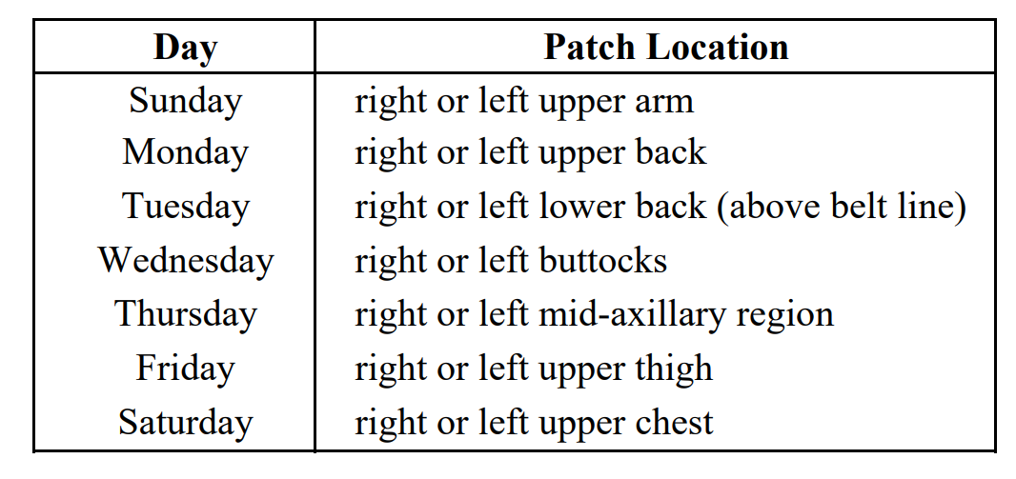
Patients and caregivers are free to select either the left or right site within the constraints of the rotation schedule noted above. Patches should be applied at approximately the same time each day. For patients who habitually bathe in the morning, the patient should bathe prior to application of new patches. Every effort should be taken to allow for morning administration of the patches. Exceptions allowing administration of TTS patches at night instead of in the morning will be made on a case-by-case basis by the CRO medical monitor. In the event that some adhesive remains on the patient’s skin and cannot be removed with normal bathing, a special solution will be provided to remove the adhesive. Following randomization at Visit 3, patients will be instructed to call the site if they have difficulty with application or wearing of patches. In the event that a patch becomes detached, a new patch of the same size should be applied (at earliest convenience) to an area of the dermis adjacent to the detachment site, and the rotation schedule should be resumed the following morning. If needed, the edges of the patch may be secured with a special adhesive tape that will be provided. If daily doses are reduced, improperly administered, or if a patch becomes detached and requires application of a new patch on three or more days in any 30-day period, the CRO research physician will be notified.
If the daily dose is reduced or improperly administered in the 24 hours prior to any scheduled clinic visit, the visit should be rescheduled (except for early termination and retrieval visits). Patients must be instructed to return all used and unused study drug to the investigator at each visit for proper disposal and CT reconciliation by the investigator.
  - Investigational Trial Intervention Dose Modification
Not applicable.
  - Management of Investigational Trial Intervention Overdose
Not applicable.
  - Preparation, Storage, Handling and Accountability of Investigational Trial Intervention(s)
    - Preparation of Investigational Trial Intervention(s)
Not applicable.
    - Storage and Handling of Investigational Trial Intervention
Patches should be stored at controlled room temperature, and all used patches must be handled and disposed of as biohazardous waste. For a detailed description of the composition of these formulations please refer to Part II, Section 14 of the Xanomeline (LY246708) Clinical Investigator’s Brochure.
    - Accountability of Investigational Trial Intervention
See investigator training materials & Section 6.9.
  - Investigational Trial Intervention Assignment, Randomisation and Blinding
    - Participant Assignment to Investigational Trial Intervention
Commencing at Visit 1, all patients will be assigned an identification number. This identification number and the patient’s three initials must appear on all patient-related documents submitted to Lilly.
    - Randomisation
When qualified for enrollment at Visit 3 the patient will be randomized to 1 of 3 treatment arms.
    - Blinding
The study will be double-blind. To further preserve the blinding of the study, only a minimum number of Lilly and CRO personnel will see the randomization table and codes before the study is complete.
Emergency codes generated by a computer drug-labeling system will be available to the investigator. These codes, which reveal the patients treatment group, may be opened during the study only if the choice of follow-up treatment depends on the patient’s therapy assignment.
    - Emergency Unblinding at the Site
The investigator should make every effort to contact the clinical research physician prior to unblinding a patient’s therapy assignment. If a patient’s therapy assignment is unblinded, Lilly must be notified immediately by telephone. After the study, the investigator must return all sealed and any opened codes.
  - Investigational Trial Intervention Compliance
Because patients enrolled in this study will be outpatients, the knowledge that patients have taken the medication as prescribed will be assured in the following ways:
- Investigators will attempt to select those patients and caregivers who have been judged to be compliant.
- Study medication including unused, partially used, and empty patch containers will be returned at each clinical visit so that the remaining medication can be counted by authorized investigator staff (nurse, pharmacist, or physician). The number of patches remaining will be recorded on the CRF.
- Following randomization at Visit 3, patients will be instructed to call the site if they have difficulty with application or wearing of patches.
If daily doses are reduced, improperly administered, or if a patch becomes detached and requires application of a new patch on three or more days in any 30-day period, the CRO research physician will be notified. If the daily dose is reduced or improperly administered in the 24 hours prior to any scheduled clinic visit, the visit should be rescheduled (except for early termination and retrieval visits).
  - Description of Non-Investigational Trial Intervention(s)
Hydrocortisone cream as described for use in Section 6.4.
  - Concomitant Therapy
Intermittent use of chloral hydrate, zolpidem, or lorazepam is permitted during this clinical trial as indicated for agitation or sleep. If medication is required for agitation for a period exceeding 1 week, a review of the patient’s status should be made in consultation with the CRO research physician. Caregivers and patients should be reminded that these medications should not be taken within 24 hours of a clinic visit (including the enrollment visit), and administration of efficacy measures should be deferred if the patient has been treated with these medications within the previous 24 hours.
If an antihistamine is required during the study, Claritin® (loratadine) or Allegra® (fexofenadine hydrochloride) are the preferred agents, but should not be taken within 24 hours of a clinic visit. Intermittent use (per package insert) of antitussives (containing antihistamines or codeine) and select narcotic analgesics (acetaminophen with oxycodone, acetaminophen with codeine) are permitted during the trial. Caregivers and patients should be reminded that antihistamines and narcotics should not be taken within 3 days of a clinic efficacy visit (including enrollment visit). If an H2 blocker is required during the study, Axid® (nizatidine) will be permitted on a case-by-case basis by the CRO medical monitor. For prostatic hypertrophy, small doses (2 mg per day) of Hytrin® (terazosin) or Cardura® (doxazosin) will be permitted on a case-by-case basis. Please consult the medical monitor. The calcium channel blockers Cardene® (nicardipine), Xanomeline (LY246708) H2Q-MC-LZZT(c) Copyright © 2006 Eli Lilly and Company Clinical Study Protocol Document Page 27 Norvasc® (amlodipine), and DynaCirc® (isradipine) are allowed during the study. If a patient has been treated with any medication within disallowed time periods prior to the clinic visit, efficacy measures should be deferred.
Other classes of medications not stated in Exclusion Criteria, Section 3.4.2.2, will be permitted. Patients who require treatment with an excluded medication (Section 3.4.2.2) will be discontinued from the study following consultation with the CRO research physician.
    - Prohibited Concomitant Therapy
See Exclusion Criteria.
    - Permitted Concomitant Therapy
See above and Exclusion Criteria.
- Participant Discontinuation of Trial Intervention and Discontinuation or Withdrawal From trial
  - Discontinuation of Trial Intervention for Individual Participants
Insert appropriate text from relevant library.

    - Permanent Discontinuation of Trial Intervention
Not applicable.
    - Temporary Discontinuation of Trial Intervention
Not applicable.
    - Rechallenge
Not applicable.
  - Discontinuation or Withdrawal from the Trial
Participation in the study shall be terminated for any patient who is unable or unwilling to comply with the study protocol or who develops a serious adverse event.
In addition, patients may be discontinued for any of the following reasons:
- In the opinion of the investigator, a significant adverse event occurs or the safety of the patient is otherwise compromised.
- The patient requests to be withdrawn from the study.
- The physician in charge of the study or Lilly, for any reason stops the patient’s participation in the study.
If a patient’s participation terminates early, an early termination visit should be scheduled. Upon decision to discontinue a patient from the study, the patient’s dose should be titrated down by instructing the patient to immediately remove the 25-cm2 patch. Patients should be instructed to continue to apply a 50-cm2 patch daily until the early termination visit, at which time the drug will be discontinued. Physical exam, vital signs, temperature, use of concomitant medications, chemistry/hematology/urinalysis labs, xanomeline plasma sample, TTS acceptability survey, efficacy measures, adverse events, and an ECG will be collected at the early termination visit.
In the event that a patient’s participation or the study itself is terminated, the patient shall return all study drug(s) to the investigator.
7.2.1. Retrieval of Discontinuations
If possible, patients who have terminated early will be retrieved on the date which would have represented Visit 12 (Week 24). Vital signs, temperature, use of concomitant medications, adverse events, and efficacy measure assessment will be gathered at this visit. If the patient is not retrievable, this will be documented in the source record.
7.2.2. Qualifications for Analysis
All patients who are enrolled in the study will be included in the efficacy analysis and the safety analysis. Patients will not be excluded from the efficacy analysis for reasons such as non-compliance or ineligibility, except for the time period immediately preceding the efficacy assessment (see Section 3.9.1.2).
  - Lost to Follow-Up
Not defined.

- Trial Assessments and Procedures
  - Trial Assessments and Procedures Considerations
Not applicable.
  - Screening/Baseline Assessments and Procedures
See Appendix 12.1 Clinical Laboratory Tests for Table LZZT.1 Test Performed at Visit 1.
  - Efficacy Assessments and Procedures
The following measures will be performed in the course of the study. At Visits 3, 8, 10, and 12, ADAS-Cog, CIBIC+, and DAD will be administered. NPI-X will be administered at 2-week intervals either at clinic visits or via a telephone interview. Efficacy measures will also be collected at early termination visits, and at the retrieval visit. The neuropsychological assessment should be performed first; other protocol requirements, such as labs and the physical, should follow.
  - Alzheimer’s Disease Assessment Scale - Cognitive Subscale (ADAS-Cog): ADAS-Cog is an established measure of cognitive function in Alzheimer’s Disease. This scale has been incorporated into this study by permission of Dr. Richard C. Mohs and the American Journal of Psychiatry and was adapted from an article entitled, “The Alzheimer’s Disease Assessment Scale (ADAS),” which was published in the American Journal of Psychiatry, Volume No.141, pages 1356-1364, November, 1984, Copyright 1984. The ADAS-Cog (11) and the ADAS-Cog (14): The ADAS-Cog (11) is a standard 11-item instrument used to assess word recall, naming objects, commands, constructional praxis, ideational praxis, orientation, word recognition tasks, spoken language ability, comprehension, word finding difficulty, and recall of test instructions. For the purposes of this study, three items (delayed word recall, attention/visual search task, and maze solution) have been added to the ADAS-Cog (11) to assess the patient’s attention and concentration. The 14 item instrument will be referred to as the ADAS-Cog (14). At each efficacy visit, all 14 items will be assessed, and in subsequent data analyses, performance on the ADAS-Cog (14) and performance on the subset ADAS-Cog (11) will be considered.
  - Video-referenced Clinician’s Interview-Based Impression of Change (CIBIC+): The CIBIC+ is an assessment of the global clinical status relative to baseline. The CIBIC+ used in this study is derived from the Clinical Global Impression of Change, an instrument in the public domain, developed by the National Institute on Aging Alzheimer’s Disease Study Units Program (1 U01 AG10483; Leon Thal, Principal Investigator). The instrument employs semi-structured interviews with the patient and caregiver, to assess mental/cognitive state, behavior, and function. These domains are not individually scored, but rather are aggregated in the assignment of a global numeric score on a 1 to 7 scale (1 = marked improvement; 4 = no change; and 7 = marked worsening). The clinician assessing CIBIC+ will have at least one year of experience with the instrument and will remain blinded to all other efficacy and safety measures.
  - Revised Neuropsychiatric Inventory (NPI-X): The NPI-X is an assessment of change in psychopathology in patients with dementia. The NPI-X is administered to the designated caregiver. This instrument has been revised from its original version (Cummings et al. 1994) and incorporated into this study with the permission of Dr. Jeffrey L. Cummings.
  - Disability Assessment for Dementia (DAD): The DAD is used to assess functional abilities of activities of daily living (ADL) in individuals with cognitive impairment. This scale has been revised and incorporated into this study by permission of Louise Gauthier, M.Sc., and Dr. Isabelle Gelinas. The DAD is administered to the designated caregiver.
For each instrument, each assessment is to be performed by the same trained health care professional. If circumstances preclude meeting this requirement, the situation is to be documented on the Clinical Report Form (CRF), and the CRO research physician is to be notified. In addition to the efficacy measures noted above, a survey form will be used to collect information from the caregiver on TTS acceptability (Attachment LZZT.9).
  - Safety Assessments and Procedures
    - Vital Signs
Patient should lie supine quietly for at least 5 minutes prior to vital signs measurement. Blood pressure should be measured in the dominant arm with a standardized mercury manometer according to the American Heart Association standard recommendations. Diastolic blood pressure will be measured as the point of disappearance of the Korotkoff sounds (phase V). Heart rate will be measured by auscultation. Patient should then stand up. Blood pressure should again be measured in the dominant arm and heart rate should be measured after approximately 1 and 3 minutes.
An automated blood pressure cuff may be used in place of a mercury manometer if it is regularly (at least monthly) standardized against a mercury manometer.
    - Electrocardiograms
Cardiovascular status will be assessed during the trial with the following measures:
- All patients will be screened by obtaining a 12-lead ECG, and will have repeat ECGs performed at Visits 4, 5, 7, 8, 9, 10, 11, 12, 13, and early termination (ET) (see Schedule of Events, Attachment LZZT.1).
- All patients will undergo a 24-hour Ambulatory ECG at Visit 2 (prior to the initiation of study medication). Although every effort will be made to obtain the entire 24-hour ambulatory ECG recording, this may not always be feasible because of patient behavior or technical difficulties. The minimal recording period for an ambulatory ECG to be considered interpretable will be 8 hours, of which at least 3 hours must be sleep.
- The incidence of syncope, defined as an observed loss of consciousness and muscle tone not attributable to transient ischemic attack or to seizure, will be closely monitored. Caregivers will be instructed to report any instance of syncopal episodes to the investigator within 24 hours. The investigator should immediately report such events to the CRO research physician. The CRO research physician will make a clinical assessment of each episode, and with the investigator determine if continuation of therapy is appropriate. These findings will be reported to the Lilly research physician immediately.
The CRO research physician will monitor safety data throughout the course of the study. Cardiovascular measures, including ECGs and 24-hour Ambulatory ECGs (see Section 3.9.3.4.2) will be monitored on an ongoing basis as follows:
- As noted in Section 3.9.3.4.2, all patients will be screened by obtaining a 12-lead ECG, and will have repeat ECGs performed at Visits 4, 5, 7, 8, 9, 10, 11, 12, 13, and early termination (ET) (see Schedule of Events for Protocol H2Q-MC-LZZT(c), Attachment LZZT.1). ECG data will be interpreted at the site and express mailed overnight to a central facility which will produce a report within 48 hours. The report will be forwarded to the investigator. At screening, the report of the central facility will be used to exclude patients according to criteria specified in Section 3.4.2.2. If, during the treatment phase of the study, review of ECG data (either at the site or at the central facility) reveals left bundle branch block, bradycardia ≤50 beats per minute, sinus pauses >2 seconds, second degree heart block, third degree heart block, Wolff-Parkinson-White syndrome, sustained supraventricular tachyarrhythmia, or ventricular tachycardia at a rate of ≥120 beats per minute lasting ≥10 seconds, the investigator, the Lilly research physician, the CRO research physician, and the cardiologist chairing the DSMB will be notified immediately, and discontinuation of the patient will be considered.
- As noted in Section 3.9.3.4.2, all patients will undergo a 24-hour Ambulatory ECG at Visit 2 (prior to the initiation of study medication). Ambulatory ECG data from Visit 2 will be express mailed overnight to a central facility which will produce a report within 24 hours. The report will be forwarded to the investigator. If a report documents sustained ventricular tachycardia with rate >120 beats per minute, third degree heart block, or sinus pauses of >6.0 seconds, the investigator, the Lilly research physician, the CRO research physician, and the cardiologist chairing the DSMB will be notified immediately, and the patient will be discontinued. If any report documents sinus pauses of >3.0 seconds or second degree heart block, the CRO research physician, and Lilly research physician, and cardiologist chairing the DSMB will be immediately notified and the record will be reviewed within 24 hours of notification by the cardiologist chairing the DSMB.
In addition to ongoing monitoring of cardiac measures, a comprehensive, periodic review of cardiovascular safety data will be conducted by the DSMB, which will be chaired by an external cardiologist with expertise in arrhythmias, their pharmacological bases, and their clinical implications. The membership of the board will also include two other external cardiologists, a cardiologist from Lilly, a statistician from Lilly, and the Lilly research physician. Only the three external cardiologists will be voting members.
After approximately 75 patients have completed 1 month of treatment, the DSMB will meet to decide:
- If discontinuation of the study or any treatment arm is appropriate
- If additional cardiovascular monitoring is required
- If further cardiovascular monitoring is unnecessary
- If adjustment of dose within a treatment arm (or arms) is appropriate.
If necessary, this analysis will be repeated after 150 patients have completed 1 month of treatment, after 225 patients have completed 1 month of treatment, and after 300 patients have completed 1 month of treatment. Primary consideration will be given to the frequency of pauses documented in Ambulatory ECG reports. The number of pauses greater than or equal to 2, 3, 4, 5, and 6 seconds will be tabulated. Primary analysis will focus on the number of pauses greater than or equal to 3 seconds.
In the event of a high incidence of patient discontinuation due to syncope, the following guideline may be employed by the DSMB in determining if discontinuation of any treatment arm is appropriate. If the frequency of syncope in a xanomeline treatment arm relative to the frequency of syncope in the placebo arm equals or exceeds the following numbers, then consideration will be given to discontinuing that treatment arm. The Type I error rate for this rule is approximately 0.032 if the incidence in each group is 0.04. The power of this rule is 0.708 if the incidence is 0.04 for placebo and 0.16 for xanomeline TTS.
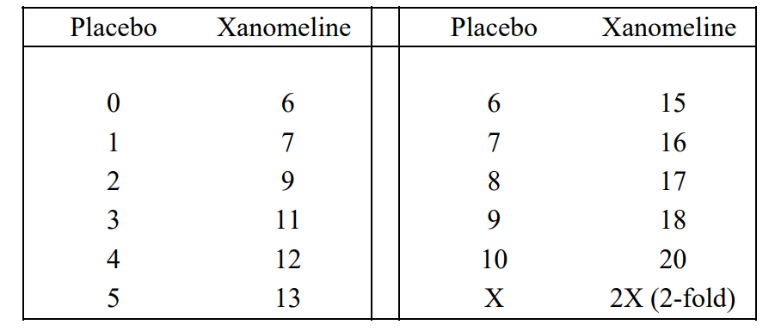
This rule has been used in other studies for monitoring spontaneous events with an incidence of less than 10%. This rule is constructed assuming a 2-group comparison with each group having a final sample size of 100. Unblinding which occurs during these analyses will be at the group level and will be documented.
The stopping rule based on Ambulatory ECG findings is as follows:
- If the number of patients experiencing a pause of ≥6 seconds in a xanomeline treatment arm relative to the number of patients in the placebo arm equals or exceeds the numbers in the following table, then that treatment arm will be discontinued. The Type I error rate for this rule is approximately 0.044 if the incidence in each group is 0.01. The power of this rule is 0.500 if the incidence is 0.01 for placebo and 0.04 for xanomeline TTS
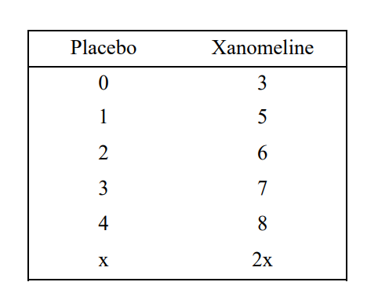
    - Clinical Laboratory Assessments
Table LZZT.1 lists the clinical laboratory tests that will be performed at Visit 1.
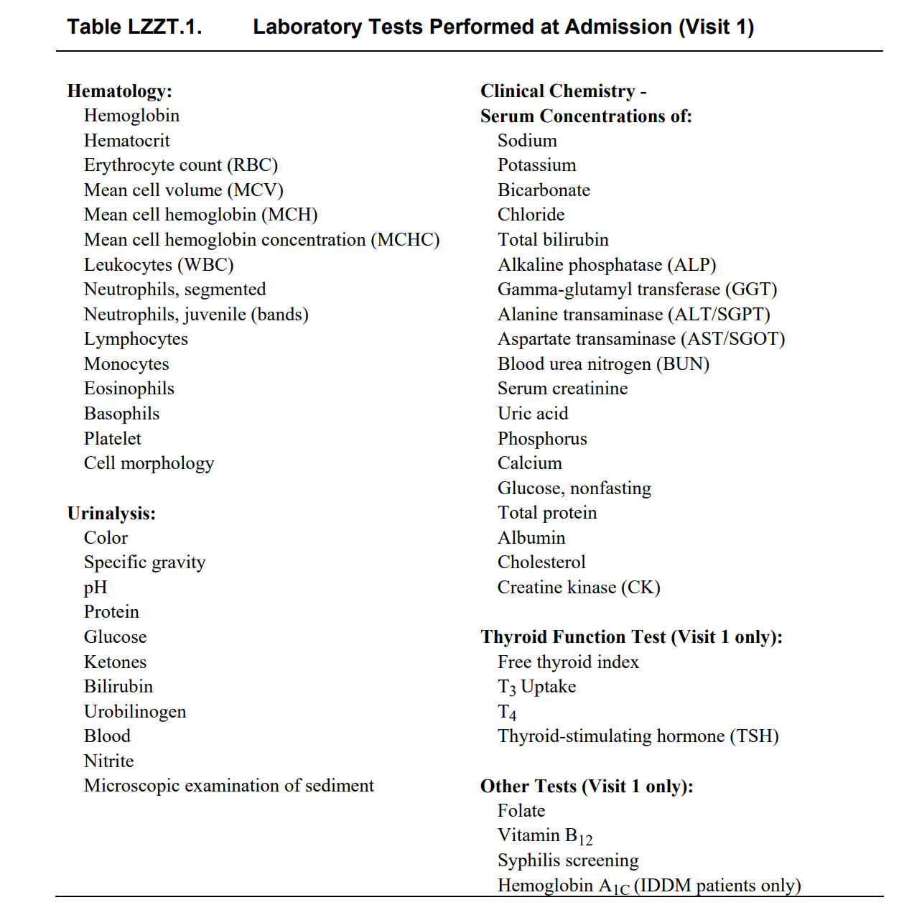
Laboratory values that fall outside a clinically accepted reference range or values that differ significantly from previous values must be evaluated and commented on by the investigator by marking CS (for clinically significant) or NCS (for not clinically significant) next to the values. Any clinically significant laboratory values that are outside a clinically acceptable range or differ importantly from a previous value should be further commented on in the clinical report form comments page.
Hematology, and clinical chemistry will also be performed at Visits 4, 5, 7, 8, 9, 10, 11, 12, and 13. Patients that experience a rash and/or eosinophilia may have additional hematology samples obtained as described in 3.9.3.4 (Other Safety Measures).
Urinalysis will also be performed at Visits 4, 9, and 12. The following criteria have been developed to monitor hepatic function.
- Patients with ALT/SGPT levels >120 IU will be retested weekly.
- Patients with ALT/SGPT values >400 IU, or alternatively, an elevated ALT/SGPT accompanied by GGT and/or ALP values >500 IU will be retested within 2 days. The sponsor’s clinical research administrator or clinical research physician is to be notified. If the retest value does not decrease by at least 10%, the study drug will be discontinued; additional laboratory tests will be performed until levels return to normal. If the retest value does decrease by 10% or more, the study drug may be continued with monitoring at 3 day intervals until ALT/SGPT values decrease to < 500IU.
8.4.4.1. Other Safety Measures
Patients experiencing Rash and/or Eosinophilia
The administration of placebo and xanomeline TTS is associated with a rash and/or eosinophilia in some patients. The rash is characterized in the following ways:
- The rash is confined to sites of application.
- The rash may be associated with pruritus.
- In 5% of cases of rash observed in the Interim Analysis, blistering has been observed.
- The onset of rash may occur at any time during the course of the study.
- A moderate eosinophilia (0.6-1.5 x 103 /microliter) is associated with rash and has been noted in approximately 10% of patients.
It does not appear that the rash constitutes a significant safety risk; however, it could affect the well-being of the patients. The following monitoring is specified:
Skin Rash Follow-up
For patients who exit the study or its extension with rash at the site(s) of application:
- Approximately 2 weeks after the last visit, the study site personnel should contact the patient/caregiver by phone and complete the skin rash questionnaire. (Note: those patients with rash who have previously exited the study or its extension should be contacted at earliest convenience.)
- If caregiver states unequivocally that skin problems have completely resolved, no further follow-up is needed.
- If caregiver reports scarring and/or other problems, patient should return to clinic for a follow-up visit. The skin rash questionnaire should again be completed. If in the opinion of the investigator, further follow-up is required, contact the CRO medical monitor.
Completed skin rash questionnaires should be faxed to CRO.
Completion of the questionnaires will create a separate data set for solicited adverse events. In completing these forms please note the following:
- Solicited events (events discovered as result of completion of follow-up questionnaires) should be reported on questionnaire page only.
- Spontaneously reported adverse events (events presented by the patient without direct questioning of the event) should be reported as described in 3.9.3.2.1 (Adverse Event Reporting Requirements).
Serious adverse events should be handled and reported as described in 3.9.3.2.1 without regard to whether the event is solicited or spontaneously reported.
Eosinophilia Follow-up
      - For patients that are currently in the study with eosinophil counts greater than 0.6x103/microliter:
        - Repeat hematology at each visit until resolved in the opinion of the investigator.
      - For patients that are currently in the study with eosinophil counts greater than 1.5x103/microliter:
        - Obtain hematology profile every 2 weeks until resolved or explained by other causes in the opinion of the investigator.
        - Notify CRO medical monitor.
      - For patients with eosinophil counts greater than 0.6x103/microliter at exit from the study or its extension:
        - Obtain hematology profile approximately every 2 weeks until resolved or, in the opinion of the investigator, explained by other causes. (Note: patients with eosinophil counts greater than 0.6x103/microliter who have previously exited the study or its extension should return for hematology profile at earliest convenience.)
  - Pharmacokinetics
Blood samples (7 mL) for the determination of xanomeline concentrations in plasma will be collected from each patient at Visits 3, 4, 5, 7, 9, and 11. The blood sample drawn at Visit 3 is a baseline sample. The remaining 5 clinic visits should be scheduled so that 1 blood sample is collected at any time during each of the following intervals: early AM visit (hold application of new patch until after blood sample is collected); 9AM to 11AM; 11AM to 1PM; 1PM to 3PM; and 3PM to 5PM. Collection of blood samples during each of these intervals should not occur in any particular order, nor should they occur in the same order for each patient. Every effort should be made to comply with the suggested sampling times. This blood-sampling schedule is based on a sparse sampling strategy where only a few samples will be collected from each patient. The most crucial aspect of the sampling design is to record the date and exact time the sample was drawn and to record the date and time of patch application on the day of the clinic visit and the previous 2 days.
If a patient is discontinued from the study prior to protocol completion, a pharmacokinetic blood sample should be drawn at the early discontinuation visit. The date and exact time the sample was drawn and the date of the last patch application should be recorded.
Immediately after collection, each sample will be centrifuged at approximately 177 × G for 15 minutes. The plasma will be transferred into a polypropylene tube bearing the identical label as the blood collection tube. Samples will be capped and frozen at approximately −20°C. Care must be taken to insure that the samples remain frozen during transit.
The samples will be shipped on dry ice to Central Laboratory.
  - Biomarkers
    - Genetics and Pharmacogenomics
Not applicable.
    - Pharmacodynamic Biomarkers
Not applicable.
  - Immunogenicity Assessments
Not applicable.
  - Medical Resource Utilisation and Health Economics
Not applicable.
- Adverse Events, Serious Adverse Events, Product Complaints, Pregnancy and Postpartum Information
  - Definitions
    - Definitions of Adverse Events
Lilly has standards for reporting adverse events that are to be followed, regardless of applicable regulatory requirements that are less stringent. For purposes of collecting and evaluating all information about Lilly drugs used in clinical trials, an adverse event is defined as any undesirable experience or an unanticipated benefit (see Section 9.1.1.1) that occurs after informed consent for the study has been obtained, without regard to treatment group assignment, even if no study medication has been taken. Lack of drug effect is not an adverse event in clinical trials, because the purpose of the clinical trial is to establish drug effect.
At the first visit, study site personnel will question the patient and will note the occurrence and nature of presenting condition(s) and of any preexisting condition(s). At subsequent visits, site personnel will again question the patient and will note any change in the presenting condition(s), any change in the preexisting condition(s), and/or the occurrence and nature of any adverse events.
    - Definitions of Serious Adverse Events
Study site personnel must report to CRO immediately, by telephone, any adverse event from this study that is alarming or that:
- Results in death
- Results in initial or prolonged inpatient hospitalization
- Is life-threatening
- Results in severe or permanent disability
- Results in cancer [(other than cancers diagnosed prior to enrollment in studies involving patients with cancer)]
- Results in a congenital anomaly
- Is a drug overdose
- Is significant for any other reason.
Definition of overdose: For a drug under clinical investigation, an overdose is any intentional or unintentional consumption of the drug (by any route) that exceeds the dose recommended in the Clinical Investigator's Brochure or in an investigational protocol, whichever dose is larger. For a marketed drug, a drug overdose is any intentional or unintentional consumption of the drug (by any route) that exceeds the dose listed in product labeling, even if the larger dose is prescribed by a physician.
- Grade 4 laboratory abnormalities
- [specify event] – see Section [X] for definition
- [specify event] leading to permanent discontinuation of study intervention

  - Timing and Mechanism for Collection and Reporting
All adverse events must be reported to CRO via case report form.
Study site personnel must report to CRO immediately, by telephone, any serious adverse event (see Section 3.9.3.2.2 below), or if the investigator unblinds a patient’s treatment group assignment because of an adverse event or for any other reason.
If a patient’s dosage is reduced or if a patient is discontinued from the study because of any significant laboratory abnormality, inadequate response to treatment, or any other reason, the circumstances and data leading to any such dosage reduction or discontinuation must be reported and clearly documented by study site personnel on the clinical report form.
An event that may be considered an unanticipated benefit to the patient (for example, sleeping longer) should be reported to CRO as an adverse event on the clinical report form. “Unanticipated benefit” is a COSTART classification term. In cases where the investigator notices an unanticipated benefit to the patient, study site personnel should enter the actual term such as “sleeping longer,” and code “unanticipated benefit” in the clinical report form adverse event section.
Solicited adverse events from the skin rash questionnaire (see Section 3.9.3.4) should be reported on the questionnaire only and not also on the adverse event clinical report form
  - Identification, Recording and Follow-Up
See details provided in Investigator Instructional materials.
    - Identification
See details provided in Investigator Instructional materials.
    - Severity
See details provided in Investigator Instructional materials.
    - Causality
See details provided in Investigator Instructional materials.
    - Follow-up
See details provided in Investigator Instructional materials.
  - Reporting
See Sections 9.1.1 & 9.1.2 above.
    - Regulatory Reporting Requirements
See Sections 9.1.1 & 9.1.2 above.
    - Adverse Events of Special Interest
Not applicable.
    - Disease-related Events or Outcomes Not Qualifying as AEs or SAEs
Not applicable.
  - Pregnancy and Postpartum Information
Not applicable.
- Statistical Considerations
  - General Considerations
In the event that the doses of xanomeline TTS are changed after the study starts, the analysis will be of three treatment groups (high dose, low dose, and placebo), even though patients within the high dose treatment group, for example, may not all be at exactly the same dose. Also, if the dose is changed midway through the study, the mean dose within each group will be used in the dose response analysis described in Section 4.3.3.
All analyses described below will be conducted using the most current production version of SAS® available at the time of analysis.
  - Analysis Sets
In general, all patients will be included in all analyses of efficacy if they have a baseline measurement and at least one postrandomization measurement. Refer to Section 3.9.1.2. for a discussion of which specific efficacy data will be included in the primary analysis.
  - Analyses of Demographics and Other Baseline Variables
All measures (for example, age, gender, origin) obtained at either Visits 1, 2, or 3, prior to randomization, will be summarized by treatment group and across all treatment groups. The groups will be compared by analysis of variance (ANOVA) for continuous variables and by Pearson’s chi-square test for categorical variables. Note that because patients are randomized to 1 of the 3 treatment groups, any statistically significant treatment group differences are by definition a Type I error; however, the resulting pvalues will be used as another descriptive statistic to help focus possible additional analyses (for example, analysis of covariance, subset analyses) on those factors that are most imbalanced (that is, that have the smallest p-values).
  - Analyses Associated with the Primary Objective(s)
    - Statistical Method of Analysis
Efficacy Criteria
Group mean changes from baseline in the primary efficacy parameters will serve as efficacy criteria. The ADAS-Cog (11) and the video-referenced CIBIC+ will serve as the primary efficacy instruments. Secondary efficacy instruments will include the DAD, the NPI-X, and the ADAS-Cog (14). The procedures and types of analyses to be done are outlined in Section 4.
The primary analysis of efficacy will include only the data obtained up to and including the visit of discontinuation of study drug. Furthermore, the primary analysis will not include efficacy data obtained at any visit where the study drug was not administered in the preceding
Efficacy measures are described in Section 3.9.1.1. As stated in Section 3.9.1.2, the primary outcome measures are the ADAS-Cog (11) and CIBIC+ instruments. Because both of these variables must reach statistical significance, an adjustment to the nominal p-values is necessary in order to maintain a .05 Type I error rate for this study. This adjustment is described in detail in Section 4.3.5.
The DAD will be analyzed with respect to the total score, as well as the subscores of initiation, planning and organization, and effective performance. This variable is considered a secondary variable in the US, but is a third primary variable in Europe.
The NPI-X is a secondary variable. The primary assessment of this instrument will be for the total score, not including the sleep, appetite, and euphoria domains. This total score is computed by taking the product of the frequency and severity scores and summing them up across the domains. Secondary variables derived from the NPI-X include evaluating each domain/behavior separately. Also, caregiver distress from the NPI-X will be analyzed.
ADAS-Cog (14) and each of the 14 individual components will also be analyzed. In addition, a subscore of the ADAS-Cog will be computed and analyzed, based on results from a previous large study of oral xanomeline. This subscore, referred to as ADAS-Cog (4), will be the sum of constructional praxis, orientation, spoken language ability, and word finding difficulty in spontaneous speech.
Any computed total score will be treated as missing if more than 30% of the items are missing or scored “not applicable”. For example, when computing ADAS-Cog(11), if 4 or more items are missing, then the total score will not be computed. When one or more items are missing (but not more than 30%), the total score will be adjusted in order to maintain the full range of the scale. For example, ADAS-Cog(11) is a 0-70 scale. If the first item, Word Recall (ranges from 0 to 10), is missing, then the remaining 10 items of the ADAS-Cog(11) will be summed and multiplied by (70 / (70-10) ), or 7/6. This computation will occur for all totals and subtotals of ADAS-Cog and NPI-X. DAD is a 40 item questionnaire where each question is scored as either “0” or “1”. The DAD total score and component scores are reported as percentage of items that are scored “1”. So if items of the DAD are “not applicable” or missing, the percentage will be computed for only those items that are scored. As an example, if two items are missing (leaving 38 that are scored), and there are 12 items scored as “1”, the rest as “0”, then the DAD score is 12/38=.316. >
    - Handling of Data in Relation to Primary Estimand(s)
Not applicable for this study.
    - Handling of Missing Data
Not applicable for this older study layout.
    - Times of Analyses (adjusted heading for older protocol)
Baseline data will be collected at Visit 3.
The primary analysis of ADAS-Cog (11) and CIBIC+ will be the 24-week endpoint, which is defined for each patient and variable as the last measurement obtained post randomization (prior to protocol defined reduction in dose).
Similar analyses at 24 weeks will be conducted for the secondary efficacy variables. Analysis of patients who complete the 24-week study will also be conducted for all efficacy variables; this is referred to as a “completer” analysis.
Additionally, each of the efficacy variables will be analyzed at each time point both as “actual cases,” that is, analyzing the data collected at the various time points, and also as a last-observation-carried-forward (LOCF). Note that the LOCF analysis at 24 weeks is the same as the endpoint analysis described previously.
Several additional analyses of NPI-X will be conducted. Data from this instrument will be collected every 2 weeks, and represent not the condition of the patient at that moment in time, but rather the worst condition of the patient in the time period since the most recent NPI-X administration. For this reason, the primary analysis of the NPI-X will be of the average of all post randomization NPI-X subscores except for the one obtained at Week 2. In the event of early discontinuations, those scores that correspond to the interval between Weeks 2 to 24 will be averaged. The reason for excluding Week 2 data from this analysis is that patients could be confused about when a behavior actually stops after randomization; the data obtained at Week 2 could be somewhat “tainted.” Also, by requiring 2 weeks of therapy prior to use of the NPI-X data, the treatment difference should be maximized by giving the drug 2 weeks to work, thereby increasing the statistical power. Secondary analyses of the NPI-X will include the average of all postrandomization weeks, including measures obtained at Weeks 2 and 26.>}
    - Statistical Methodology (adjusted heading for older protocol)
The primary method to be used for the primary efficacy variables described in Sections 4.3.1 and 4.3.2 will be analysis of covariance (ANCOVA), except for CIBIC+ which is a score that reflects change from baseline, so there is no corresponding baseline CIBIC+ score. Effects in the ANCOVA model will be the corresponding baseline score, investigator, and treatment. CIBIC+ will be analyzed by analysis of variance (ANOVA), with effects in the model being investigator and treatment. Investigator-by-treatment interaction will be tested in a full model prior to conducting the primary ANCOVA or ANOVA (see description below).
Because 3 treatment groups are involved, the primary analysis will be the test for linear dose response in the ANCOVA and ANOVA models described in the preceding paragraph. The result is then a single p-value for each of ADAS-Cog and CIBIC+.
Analysis of the secondary efficacy variables will also be ANCOVA. Pairwise treatment comparisons of the adjusted means for all efficacy variables will be conducted using a LSMEANS statement within the GLM procedure.
Investigator-by-treatment interaction will be tested in a full ANCOVA or ANOVA model, which takes the models described above, and adds the interaction term to the model. Interaction will be tested at α = .10 level. When the interaction is significant at this level, the data will be examined for each individual investigator to attempt to identify the source of the significant interaction. When the interaction is not significant, this term will be dropped from the model as described above, to test for investigator and treatment main effects. By doing so, all ANCOVA and ANOVA models will be able to validly test for treatment differences without weighting each investigator equally, which is what occurs when using Type III sums of squares (cell means model) with the interaction term present in the model. This equal weighting of investigators can become a serious problem when sample sizes are dramatically different between investigators.
For all ANOVA and ANCOVA models, data collected from investigators who enrolled fewer than 3 patients in any one treatment group will be combined prior to analysis. If this combination still results in a treatment group having fewer than 3 patients in any one treatment group, then this group of patients will be combined with the next fewestenrolling investigator. In the event that there is a tie for fewest-enrolling investigator, one of these will be chosen at random by a random-number generator.
The inherent assumption of normally distributed data will be evaluated by generating output for the residuals from the full ANCOVA and ANOVA models, which include the interaction term, and by testing for normality using the Shapiro-Wilk test from PROC UNIVARIATE. In the event that the data are predominantly nonnormally distributed, analyses will also be conducted on the ranked data. This rank transformation will be applied by ranking all the data for a particular variable, across all investigators and treatments, from lowest to highest. Integer ranks will be assigned starting at 1; mean ranks will be assigned when ties occur.
In addition, the NPI-X will be analyzed in a manner similar to typical analyses of adverse events. In this analysis, each behavior will be considered individually. This analysis is referred to as “treatment-emergent signs and symptoms” (TESS) analysis. For each behavior, the patients will be dichotomized into 1 of 2 groups: those who experienced the behavior for the first time postrandomization, or those who had the quotient between frequency and severity increase relative to the baseline period defines one group. All other patients are in the second group. Treatments will be compared for overall differences by Cochran-Mantel-Haentzel (CMH) test referred to in SAS® as “row mean scores differ,” 2 degrees of freedom. The CMH correlation statistic (1 degree of freedom test), will test for increasing efficacy with increasing dose (trend test).
    - One Sided Justification(Added to accommodate older protocol layout)
All comparisons between xanomeline and placebo with respect to efficacy variables should be one-sided. The justification for this follows.
The statistical hypothesis that is tested needs to be consistent with the ultimate data-based decision that is reached. When conducting placebo-controlled trials, it is imperative that the drug be demonstrated to be superior in efficacy to placebo, since equivalent or worse efficacy than placebo will preclude approvability. Consequently, a one-sided test for efficacy is required.
The null hypothesis is that the drug is equal or worse than placebo. The alternative hypothesis is that the drug has greater efficacy than placebo. A Type I error occurs only when it is concluded that a study drug is effective when in fact it is not. This can occur in only one tail of the distribution of the treatment difference. Further details of the arguments for one-sided tests in placebo-controlled trials are available in statistical publications (Fisher 1991; Koch 1991; Overall 1991; and Peace 1991).
The argument for one-sided tests does not necessarily transfer to safety measures, in general, because one can accept a certain level of toxicity in the presence of strong efficacy. That is, safety is evaluated as part of a benefit/risk ratio.
Note that this justification is similar to that used by regulatory agencies worldwide that routinely require one-sided tests for toxicological oncogenicity studies. In that case, the interest is not in whether a drug seems to lessen the occurrence of cancer; the interest is in only one tail of the distribution, namely whether the drug causes cancer to a greater extent than the control.
Different regulatory agencies require different type I error rates. Treatment differences that are significant at the .025 α-level will be declared to be “statistically significant.” When a computed p-value falls between .025 and .05, the differences will be described as “marginally statistically significant.” This approach satisfies regulatory agencies who have accepted a one-sided test at the .05 level, and other regulatory agencies who have requested a two-sided test at the .05 level, or equivalently, a one-sided test at the .025 level. In order to facilitate the review of the final study report, two-sided p-values will be presented in addition to the one-sided p-values.
    - Nominal p-Value Adjustments (Added to accommodate older protocol layout)
When there are multiple outcomes, and the study drug is declared to be effective when at least one of these outcomes achieves statistical significance in comparison with a placebo control, a downward adjustment to the nominal α-level is necessary. A well-known simple method is the Bonferroni method, that divides the overall Type I error rate, usually .05, by the number of multiple outcomes. So, for example, if there are two multiple outcomes, the study drug is declared to be effective if at least one of the two outcomes is significant at the .05/2 or .025 level.
However, when one has the situation that is present in this study, where there are 2 (or 3 for Europe) outcome variables, each of which must be statistically significant, then the adjustment of the nominal levels is in the opposite direction, that is upwards, in order to maintain an overall Type 1 error rate of .05.
In the case of two outcomes, ADAS-Cog (11) and CIBIC+, if the two variables were completely independent, then each variable should be tested at the nominal α-level of .051/2 = .2236 level. So if both variables resulted in a nominal p-value less than or equal to .2236, then we would declare the study drug to be effective at the overall Type 1 error rate of .05.
We expect these two outcome measures to be correlated. From the first large-scale efficacy study of oral xanomeline, Study MC-H2Q-LZZA, the correlation between CIBIC+ and the change in ADAS-Cog(11) from baseline was .252. Consequently, we plan to conduct a randomization test to combine these two dependent dose-response p-values into a single test, which will then be at the .05 Type I error level. Because there will be roughly 300!/(3 * 100!) possible permutations of the data, random data permutations will be sampled (10,000 random permutations).
Designate the dose response p-values as p1 and p2 (computed as one-sided p-values), for ADAS-Cog(11) and CIBIC+, respectively. The rejection region is defined as [ {p1 ≤ α and p2 ≤ α} ].
The critical value, α, will be determined from the 10,000 random permutations by choosing the value of α to be such that 2.5% of the 10,000 computed pairs of dose response p-values fall in the rejection region. This will correspond to a one-sided test at the .025 level, or equivalently a two-sided test at the .05 level. In addition, by determining the percentage of permuted samples that are more extreme than the observed data, a single p-value is obtained.
  - Analysis Associated with the Secondary Objective(s)
    - Statistical Method of Analysis
See Analysis Associated with Primary Objectives section.
    - Handling of Data in Relation to Secondary Estimand(s)
Not applicable for this older study layout.
    - Handling of Missing Data
See Analysis Associated with Primary Objectives section.
  - Analysis Associated with the Exploratory Objective(s)
Not applicable.
  - Safety Analyses
Although safety data is collected at the 24 week visit for retrieved dropouts, these data will not be included in the primary analysis of safety.
Pearson’s chi-square test will be used to analyze 3 reasons for study discontinuation (protocol completed, lack of efficacy, and adverse event), the incidence of abnormal (high or low) laboratory measures during the postrandomization phase, and the incidence of treatment-emergent adverse events. The analysis of laboratory data is conducted by comparing the measures to the normal reference ranges (based on a large Lilly database), and counting patients in the numerator if they ever had a high (low) value during the postrandomization phase.
Additionally, for the continuous laboratory tests, an analysis of change from baseline to endpoint will be conducted using the same ANOVA model described for the efficacy measures in Section 4.3. Because several laboratory analytes are known to be non-normally distributed (skewed right), these ANOVAs will be conducted on the ranks.
Several outcome measures will be extracted and analyzed from the Ambulatory ECG tapes, including number of pauses, QT interval, and AV block (first, second, or third degree). The primary consideration will be the frequency of pauses. The number of pauses greater than or equal to 2, 3, 4, 5 and 6 seconds will be tabulated. Primary analysis will focus on the number of pauses greater than or equal to 3 seconds. Due to possible outliers, these data will be analyzed as the laboratory data, by ANOVA on the ranks.
Treatment-emergent adverse events (also referred to as treatment-emergent signs and symptoms, or TESS) are defined as any event reported during the post randomization period (Weeks 0 - 26) that is worse in severity than during the baseline period, or one that occurs for the first time during the post randomization period.
  - Other Analyses
    - Subgroup Analyses
The effect of age, gender, origin, baseline disease severity as measured by MMSE, Apo E, and patient education level upon efficacy will be evaluated if sample sizes are sufficient to warrant such analyses. For example, if all patients are Caucasian, then there is no need to evaluate the co-factor origin. The ANCOVA and ANOVA models described above will be supplemented with terms for the main effect and interaction with treatment. Each co-factor will be analyzed in separate models. The test for treatment-bysubgroup interaction will address whether the response to xanomeline, compared with placebo, is different or consistent between levels of the co-factor.
    - Pharmacokinetic/Pharmacodynamic Analyses
Plasma concentrations of xanomeline will be determined from samples obtained at selected visits (Section 3.9.2). The plasma concentration data for xanomeline, dosing information, and patient characteristics such as weight, gender and origin will be pooled and analyzed using a population pharmacokinetic analysis approach (for example, NONMEM). This approach preserves the individual pharmacokinetic differences through structural and statistical models. The population pharmacokinetic parameters through the structural model, and the interindividual and random residual variability through the components of the statistical models will be estimated. An attempt will also be made to correlate plasma concentrations with efficacy and safety data by means of population pharmacokinetic/pharmacodynamic modeling.
  - Interim Analyses
    - Interim Efficacy Analyses
Two interim efficacy analyses are planned. The first interim analysis will occur when approximately 50% of the patients have completed 8 weeks; the second interim analysis is to be conducted when approximately 50% of the patients have completed 24 weeks of the study. The purpose of these interim analyses is to provide a rationale for the initiation of subsequent studies of xanomeline TTS, or if the outcome is negative to stop development of xanomeline TTS. The method developed by Enas and Offen (1993) will be used as a guideline as to whether or not to stop one treatment arm, or the study, to declare ineffectiveness. The outcome of the interim analyses will not affect in any way the conduct, results, or analysis of the current study, unless the results are so negative that they lead to a decision to terminate further development of xanomeline TTS in AD. Hence, adjustments to final computed p-values are not appropriate.
Planned interim analyses, and any unplanned interim analyses, will be conducted under the auspices of the data monitoring board assigned to this study. Only the data monitoring board is authorized to review completely unblinded interim efficacy and safety analyses and, if necessary, to disseminate those results. The data monitoring board will disseminate interim results only if absolutely necessary. Any such dissemination will be documented and described in the final study report. Study sites will not receive information about interim results unless they need to know for the safety of their patients.
    - Interim Safety Analyses
An analysis of the cardiovascular safety monitoring (see section 3.9.4) will be performed when approximately 25 patients from each treatment arm have completed at least 2 weeks at the treatment arms’ respective full dosage (Visit 5). If necessary, this analysis will be repeated every 25 patients per arm. This analysis will be conducted under the auspices of the DSMB. This board membership will be composed of 3 external cardiologists who will be the voting members of the board, a Lilly cardiologist, a Lilly statistician, and the Lilly research physician in charge of the study. Only the DSMB is authorized to review completely unblinded cardiovascular safety analyses and, if necessary, to disseminate those results. The outcome of the cardiovascular safety analyses will determine the need for further Ambulatory ECGs.
  - Multiplicity Adjustments
Not applicable.
  - Sample Size Determination
Approximately 100 patients will be randomized to each of the 3 treatment groups. Previous experience with the oral formulation of xanomeline suggests that this sample size has 90% power to detect a 3.0 mean treatment difference in ADAS-Cog (p>.05, two-sided) based on a standard deviation of .09.
- Trial Oversight and Other General Considerations
  - Regulatory and Ethical Considerations
This study will be conducted in accordance with the ethical principles stated in the most recent version of the Declaration of Helsinki or the applicable guidelines on good clinical practice, whichever represents the greater protection of the individual. After reading the protocol, each investigator will sign 2 protocol signature pages and return 1 of the signed pages to a Lilly representative (see Attachment LZZT.10).
The name and address of the ethical review board are listed on the Investigator/Contacts cover pages provided with this protocol.
The investigator will provide Lilly with documentation of ethical review board approval of the protocol and the informed consent document before the study may begin at the site or sites concerned. The ethical review board(s) will review the protocol as required.
The investigator must provide the following documentation:
- The ethical review board’s annual reapproval of the protocol
- The ethical review board’s approvals of any revisions to the informed consent document or amendments to the protocol.
  - Trial Oversight
    - Investigator Responsibilities
Investigators are responsible for monitoring the safety of patients who have entered this study and for alerting CRO to any event that seems unusual, even if this event may be considered an unanticipated benefit to the patient. See Section 3.9.3.2.1.
Investigators must ensure that appropriate medical care is maintained throughout the study and after the trial (for example, to follow adverse events).
  - Informed Consent Process
An Ethical Review Board (ERB) approved informed consent will be signed by the patient (and/or legal representative) and caregiver after the nature of the study is explained.
In the United States and Canada, the investigator is responsible for preparing the informed consent document. The investigator will use information provided in the current [Clinical Investigator's Brochure or product information] to prepare the informed consent document.
The informed consent document will be used to explain in simple terms, before the patient is entered into the study, the risks and benefits to the patient. The informed consent document must contain a statement that the consent is freely given, that the patient is aware of the risks and benefits of entering the study, and that the patient is free to withdraw from the study at any time.
As used in this protocol, the term “informed consent” includes all consent and/or assent given by subjects, patients, or their legal representatives.
In addition to the elements required by all applicable laws, the 3 numbered paragraphs below must be included in the informed consent document. The language may be altered to match the style of the informed consent document, providing the meaning is unchanged. In some circumstances, local law may require that the text be altered in a way that changes the meaning. These changes can be made only with specific Lilly approval. In these cases, the ethical review board may request from the investigator documentation evidencing Lilly’s approval of the language in the informed consent document, which would be different from the language contained in the protocol. Lilly shall, upon request, provide the investigator with such documentation.
- “I understand that the doctors in charge of this study, or Lilly, may stop the study or stop my participation in the study at any time, for any reason, without my consent.”
- “I hereby give permission for the doctors in charge of this study to release the information regarding, or obtained as a result of, my participation in this study to Lilly, including its agents and contractors; the US Food and Drug Administration (FDA) and other governmental agencies; and to allow them to inspect all my medical records. I understand that medical records that reveal my identity will remain confidential, except that they will be provided as noted above or as may be required by law.”
- “If I follow the directions of the doctors in charge of this study and I am physically injured because of any substance or procedure properly given me under the plan for this study, Lilly will pay the medical expenses for the treatment of that injury which are not covered by my own insurance, by a government program, or by any other third party. No other compensation is available from Lilly if any injury occurs.”
The investigator is responsible for obtaining informed consent from each patient or legal representative and for obtaining the appropriate signatures on the informed consent document prior to the performance of any protocol procedures and prior to the administration of study drug.
  - Committees
In addition to ongoing monitoring of cardiac measures, a comprehensive, periodic review of cardiovascular safety data will be conducted by the DSMB, which will be chaired by an external cardiologist with expertise in arrhythmias, their pharmacological bases, and their clinical implications. The membership of the board will also include two other external cardiologists, a cardiologist from Lilly, a statistician from Lilly, and the Lilly research physician. Only the three external cardiologists will be voting members.
  - Insurance and Indemnity
Not available in this older protocol sample.
  - Risk Management
See alternate reference document.
  - Data Governance
See alternate reference document.
  - Source Data
To ensure both the safety of participants in the study, and the collection of accurate, complete, and reliable data, Lilly or its representatives will perform the following activities:
- Provide instructional material to the study sites, as appropriate.
- Sponsor a start-up training session to instruct the investigators and study coordinators. This session will give instruction on the protocol, the completion of the clinical report forms, and study procedures.
- Make periodic visits to the study site.
- Be available for consultation and stay in contact with the study site personnel by mail, telephone, and/or fax.
- Review and evaluate clinical report form data and use standard computer edits to detect errors in data collection.
To ensure the safety of participants in the study and to ensure accurate, complete, and reliable data, the investigator will do the following:
- Keep records of laboratory tests, clinical notes, and patient medical records in the patient files as original source documents for the study.
Lilly or its representatives may periodically check a sample of the patient data recorded against source documents at the study site. The study may be audited by Lilly Medical Quality Assurance (MQA) and/or regulatory agencies at any time. Investigators will be given notice before an MQA audit occurs.
  - Protocol Deviations
Not applicable
  - Early Site Closure
See alternate reference document.
- Appendix: Supporting Details
  - Clinical Laboratory Tests

  - Country/Region-Specific Differences
Not applicable
  - Prior Protocol Amendment(s)
This protocol has been amended previously. The Protocol Amendment Summary of Changes for the current amendment is located directly before the Table of Contents. Prior amendment(s) to this protocol are listed in the table below, beginning with the most recent.
For this sample protocol, prior amendment information was unavailable.
- Appendix: Glossary of Terms and Abbreviations
Not Applicable
- Appendix: References
Bierer LM, Haroutunian V, Gabriel S, Knott PJ, Carlin LS, Purohit DP, et al. 1995. Neurochemical correlates of dementia severity in AD: Relative importance of the cholinergic deficits. J of Neurochemistry 64:749-760.
Cummings JL, Mega M, Gray K, Rosenberg-Thompson S, et al. 1994. The Neuropsychiatric Inventory: Comprehensive assessment of psychopathology in dementia. Neurology 44:2308-2314.
Enas GG, Offen WW. 1993. A simple stopping rule for declaring treatment ineffectiveness in clinical trials. J Biop Stat 3(1):13-32.
Fisher A, Barak D. 1994. Promising therapeutic strategies in Alzheimer’s disease based on functionally selective M1 muscarinic agonists. Progress and perspectives in new muscarinic agonists. DN&P 7(8):453-464.
Fisher LD. 1991. The use of one-sided tests in drug trials: an FDA advisory committee member’s perspective. J Biop Stat 1:151-6.
Koch GG. 1991. One-sided and two-sided tests and p-values. J Biop Stat 1:161-70.
Overall JE. 1991. A comment concerning one-sided tests of significance in new drug applications. J Biop Stat 1:157-60.
Peace KE. 1991. Oneside or two-sided p-values: which most appropriately address the question of drug efficacy? J Biop Stat 1:133-8.>

