**IT214: Database Management System**

**Commonwealth Games Database Management System**

**Group Number: 3.12**

**Group Members:**

1. **Keshvi Bhimani: 201701186**
2. **Rohinee Sarvaiya:201701172**
3. **Jaykumar Dave:201701204**
4. **Rohan Prajapati: 201701218**

**ER Diagram:-**

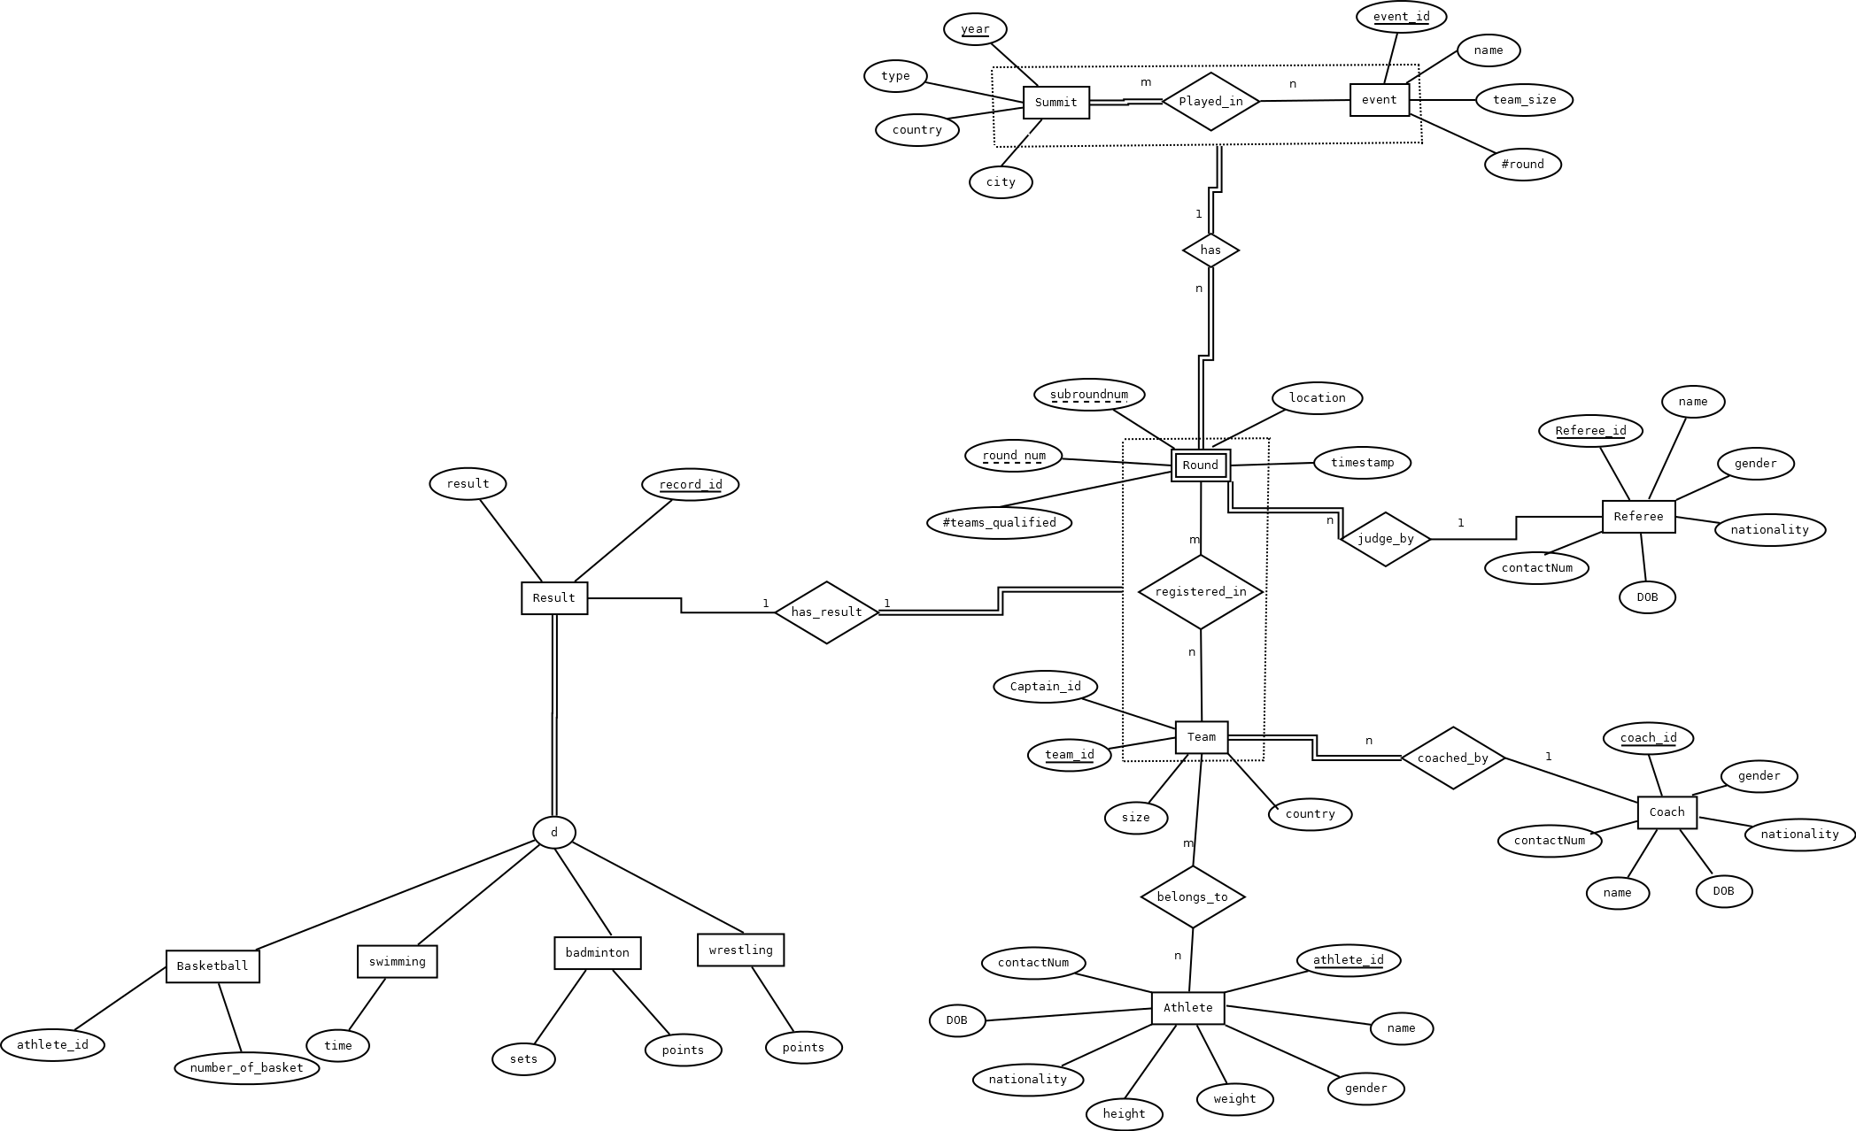

**Relational Schema:-**

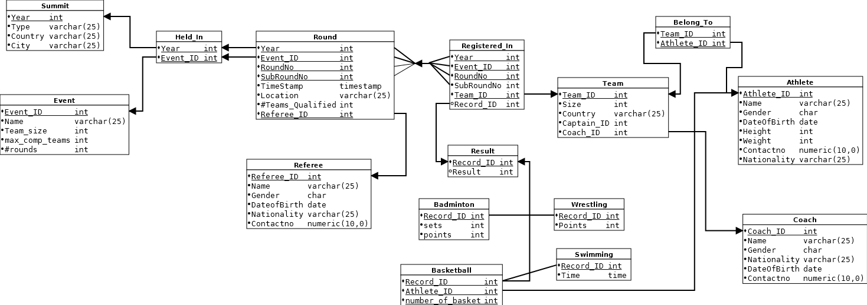

**Minimal FD Set:**

**Summit:-**

Primary Key: Year

Year🡪type

Year🡪Country

Year🡪city

**Event:-**

Primary Key: Event_id

Event_id🡪name

Event_id🡪team_size

Event_id🡪max_comp_teams

Event_id🡪#rounds

**Round:-**

Primary Key:- (year, event_id, roundno, subroundno)

(year, event_id, roundno, subroundno)🡪 timestamp

(year, event_id, roundno, subroundno)🡪 location

(year, event_id, roundno, subroundno)🡪 #teams_qualified

(year, event_id, roundno, subroundno)🡪 refree_id

**Registered_In:-**

Primary Key: (year, event_id, roundno, subroundno,team_id)

(year, event_id, roundno, subroundno,team_id)🡪 record_id

(year, event_id, roundno, subroundno,team_id)🡪 result

**Team:-**

Primary key:team_id

Team_id🡪size

Team_id🡪country

Team_id🡪captain_id

Team_id🡪coach_id

**Athlete:-**

Primary key: Athlete_id

Athlete_id🡪name

Athlete_id🡪gender

Athlete_id🡪dateofbirth

Athlete_id🡪height

Athlete_id🡪weight

Athlete_id🡪contactno

Athlete_id🡪nationality

**Coach:-**

Primary key: coach_id

coach_id 🡪name

coach_id 🡪gender

coach_id 🡪nationality

coach_id 🡪dateofbirth

coach_id 🡪contactno

**Referee:-**

Primary Key:- Referee_id

Referee_id🡪name

Referee_id🡪gender

Referee_id🡪dateofbirth

Referee_id🡪nationality

Referee_id🡪contactno

**BCNF Proof:**

Since in all relations there is no partial dependency and transitive dependency also every prime and non-prime attribute is

dependent upon the key, hence all table are in BCNF.