**One-time Matlab setup**

In the Home tab, choose “set path” so Matlab knows where to look for the code. If you choose the option to save this path for future use, you only have to do this once.

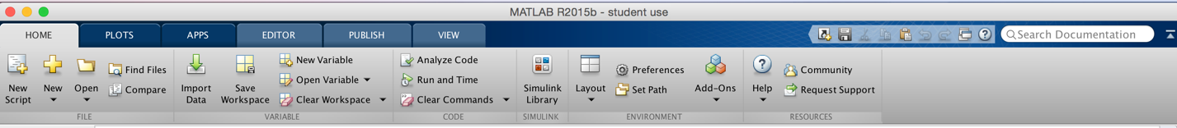

Set up your workspace layout (my preference is as below,

with the editor on the left and the command window on the right. Click the arrow head in the circle to access the dropdown menu and select “minimize” to move the workspace and the current folder out of the way.

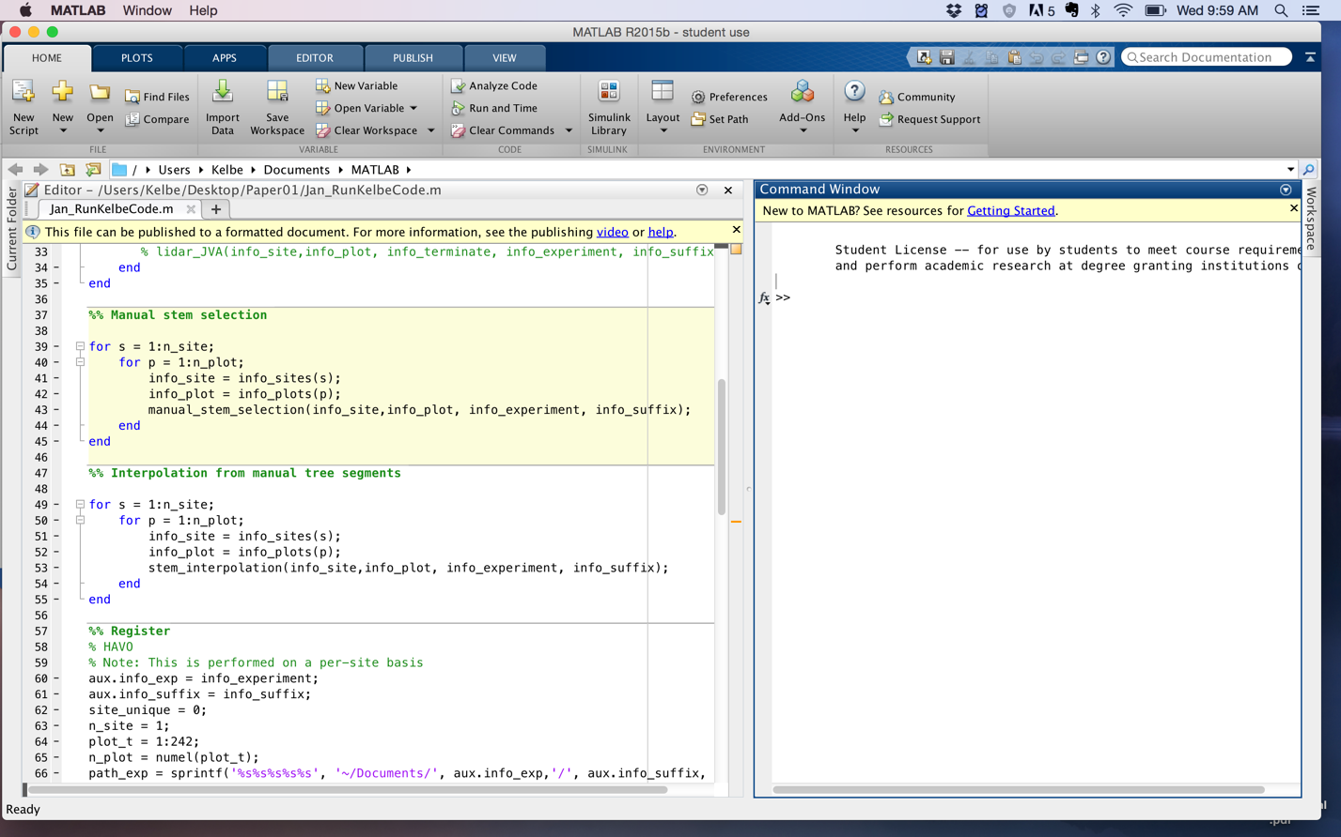

Switch to the editor window. Turn on “stop on errors” so you can get the status of variables if the program halts for some reason. This is helpful if you will be debugging (hopefully not though ☺). Open **Jan_RunKelbeCode.m** to bring the main script in the editor window. This is a wrapper that calls all the other functions. To change which plots you process, simply change the first block of code.

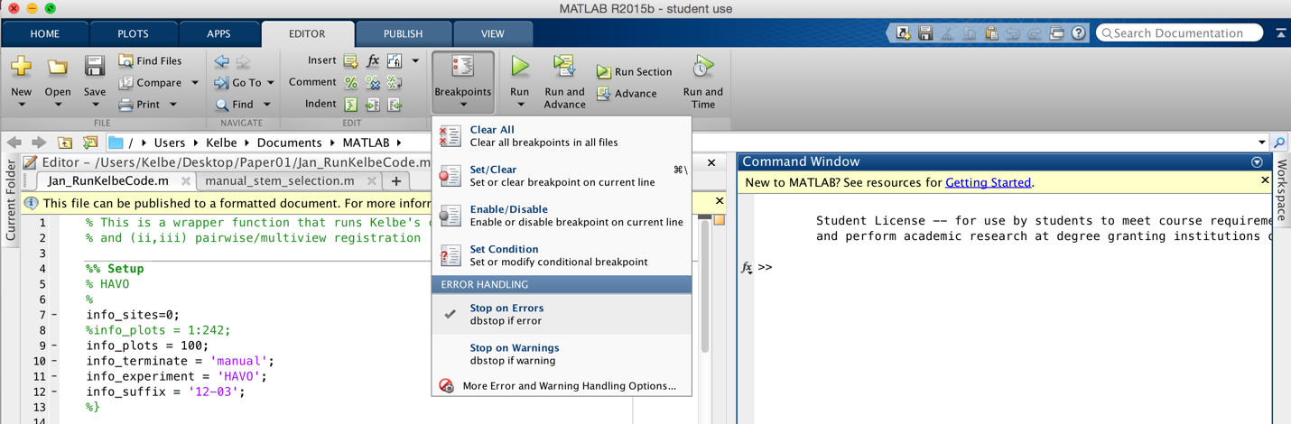

**A description of variables:**

The first are a series of hierarchical scan location identifications:

**info_experiment** – This corresponds to the rough geographic area, e.g., hectare-size, which contain multiple sites and represent a unique set of experiment(s). Acceptable values include:

**HAKT1, HAKT2, KIP3, KIP6, KIP9, KIP13, KIP18, KIP30** (these are grouped together as related to the bird ecology study)

**HAVO**

**MAT**

**info_site** – This corresponds to discrete regions of forest within an experiment’s geographic area, e.g., basketball court-size, but which are densely/fully sampled with multiple measurements. Acceptable values include: (See **A note on site renaming** for cross-referencing to original filenames)

**HAKT1**: 001, 002, 003, 004, 005, 006, 007, 008

**HAKT2**: 001, 002, 003, 004, 005, 006, 007, 008

**KIP3:** 001, 002, 003

**KIP6:** 001, 002, 003

**KIP9:** 001, 002, 003

**KIP13:** 001, 002, 003

**KIP18:** 001, 002, 003

**KIP30:** 001, 002, 003

**HAVO**: 000

**MAT**: 001, 002, 003, 004, 005, 006, 007, 008, 009

**info_plot –** This corresponds to individual scans. See **A note on plot renaming** for cross-referencing.

Additional variables:

**Info_suffix-** Additionally, you can add the date so that you can re-process the data (for example, with code modifications… this was used primarily while I was developing the algorithms) without wiping out your previous results. In general, for you: keep this constant for your full set of analyses. Example acceptable value: ‘12-03’ (The date this batch was processed in Hawaii).

**Info_terminate**

Finally, there is a terminate string so that you can automatically exit the code after completing one or more self-contained blocks of the full processing sequence. This was added so that I could streamline my whole thesis code into one unified function call. See flowchart below. Acceptable values include

**load** – load lidar data and perform initial preprocessing

**dem** – extract digital elevation model (DEM)

**detect_trees** – voxel-based tree stem segment detection (most computationally intensive)

**manual** – user-interface to correct bad segments for challenging sites like Hawaii

**tree** – interpolate and unify segments into bole models

**?register

Register_Wrapper

(Paper 2)

1. Load
2. Dem
3. Detect_trees
4. Manual
5. tree

Lidar_JVA

(Paper 1)

1. Load
2. Dem
3. Detect_trees
4. Manual
5. tree

Output: Processed files in folder:

Input: CBL files after Las_processor

**A note on site renaming:**

Sites: *Note the “info_experiment” is included in the filename for clarity, e.g., HAKT1 is the experiment and 001 is the site.

Bird sites:

**HAKT1-001** - *CBL-HAK-BIRDS-T1-9-30-15/ HAK-1-1*

**HAKT1-002** - *CBL-HAK-BIRDS-T1-9-30-15/ HAK-1-2*

**HAKT1-003** - *CBL-HAK-BIRDS-T1-9-30-15/ HAK-1-3*

**HAKT1-004** - *CBL-HAK-BIRDS-T1-9-30-15/ HAK-1-4*

**HAKT1-005** - *CBL-HAK-BIRDS-T1-9-30-15/ HAK-1-5*

**HAKT1-006** - *CBL-HAK-BIRDS-T1-9-30-15/ HAK-1-6*

**HAKT1-007** - *CBL-HAK-BIRDS-T1-9-30-15/ HAK-1-7*

**HAKT1-008** - *CBL-HAK-BIRDS-T1-9-30-15/ HAK-1-8*

**HAKT2-001** - *CBL-HAK-BIRDS-T2-12-1-15/ HAK-2-1*

**HAKT2-002** - *CBL-HAK-BIRDS-T2-12-1-15/ HAK-2-2*

**HAKT2-003** - *CBL-HAK-BIRDS-T2-12-1-15/ HAK-2-3*

**HAKT2-004** - *CBL-HAK-BIRDS-T2-12-1-15/ HAK-2-4*

**HAKT2-005** - *CBL-HAK-BIRDS-T2-12-1-15/ HAK-2-5*

**HAKT2-006** - *CBL-HAK-BIRDS-T2-12-1-15/ HAK-2-6*

**HAKT2-007** - *CBL-HAK-BIRDS-T2-12-1-15/ HAK-2-7*

**HAKT2-008** - *CBL-HAK-BIRDS-T2-12-1-15/ HAK-2-8*

**KIP3-001** – *KIP-3-1*

**KIP3-002** – *KIP-3-2*

**KIP3-003** – *KIP-3-3*

**KIP6-001** – *KIP-6-1*

**KIP6-002** – *KIP-6-2*

**KIP6-003** – *KIP-6-3*

**KIP9-001** – *KIP-9-1*

**KIP9-002** – *KIP-9-2*

**KIP9-003** – *KIP-9-3*

**KIP13-001** – *KIP-13-1*

**KIP13-002** – *KIP-13-2*

**KIP13-003** – *KIP-13-3*

**KIP18-001** – *KIP-18-1*

**KIP18-002** – *KIP-18-2*

**KIP18-003** – *KIP-18-3*

**KIP30-001** – *KIP-30-1*

**KIP30-002** – *KIP-30-2*

**KIP30-003** – *KIP-30-3*

MAT Sites are renamed in sequential numeric with increasing elevations, as follows

**MAT-001** - SPE800-9-11-15

**MAT-002** - SPE934-9-11-15

**MAT-003** - CBL-MAT-SPE-1064-10-30-15

**MAT-004** - CBL-MAT-SPE-1116-9-29-15

**MAT-005** - CBL-MAT-WPL-1116-11-3-15

**MAT-006** - WPL1204-9-24-15

**MAT-007** - WPL1274-9-24-15

**MAT-008** - MATHAK1468-Lidar

**MAT-009** - MATHAK1600-Lidar

HAVO: There is only one site,

**HAVO-000** – HAVO

**A note on plot renaming:**

For square sites KIP3, KIP6, KIP9, KIP13, KIP18, KIP30, the plot layout is as follows:

Original Renamed

|  |  |  |
| --- | --- | --- |
|  | N |  |
| W | C | E |
|  | S |  |

|  |  |  |
| --- | --- | --- |
|  | 1 |  |
| 4 | 0 | 2 |
|  | 3 |  |

For transect sites HAKT1 and HAKT2, plot layout is as follows:

Original:

|  |
| --- |
| 1 |
| 2 |
| 3 |
| 4 |
| 5 |
| 6 |
| 7 |
| 8 |

Renamed:

|  |
| --- |
| 1 |
| 2 |
| 3 |
| 4 |
| 5 |
| 6 |
| 7 |
| 8 |

**For MAT, the plots are as follows:**

Plot = 5*(row-1)+col

|  |  |  |  |  |  |
| --- | --- | --- | --- | --- | --- |
| **Row\col** | **1** | **2** | **3** | **4** | **5** |
| **1** | **1** | **2** | **3** | **4** | **5** |
| **2** | **6** | **7** | **8** | **9** | **10** |
| **3** | **11** | **12** | **13** | **14** | **15** |
| **4** | **16** | **17** | **18** | **19** | **20** |
| **5** | **21** | **22** | **23** | **24** | **25** |

**HAVO Plot Layout**

There is a single site with the following plot layout

*Plot = 11*row + col*

|  |  |  |  |  |  |  |  |  |  |  |  |
| --- | --- | --- | --- | --- | --- | --- | --- | --- | --- | --- | --- |
| ROW\COL | 1 | 2 | 3 | 4 | 5 | 6 | 7 | 8 | 9 | 10 | 11 |
| 0 | 1 | 2 | 3 | 4 | 5 | 6 | 7 | 8 | 9 | 10 | 11 |
| 1 | 12 | 13 | 14 | 15 | 16 | 17 | 18 | 19 | 20 | 21 | 22 |
| 2 | 23 | 24 | 25 | 26 | 27 | 28 | 29 | 30 | 31 | 32 | 33 |
| 3 | 34 | 35 | 36 | 37 | 38 | 39 | 40 | 41 | 42 | 43 | 44 |
| 4 | 45 | 46 | 47 | 48 | 49 | 50 | 51 | 52 | 53 | 54 | 55 |
| 5 | … | left | as | an | ex | er | cise | for | the | stu | dent |
| 6 |  |  |  |  |  |  |  |  |  |  |  |
| 7 |  |  |  |  |  |  |  |  |  |  |  |
| 8 |  |  |  |  |  |  |  |  |  |  |  |
| 9 |  |  |  |  |  |  |  |  |  |  |  |
| 10 |  |  |  |  |  |  |  |  |  |  |  |
| 11 |  |  |  |  |  |  |  |  |  |  |  |
| 12 |  |  |  |  |  |  |  |  |  |  |  |
| 13 |  |  |  |  |  |  |  |  |  |  |  |
| 14 |  |  |  |  |  |  |  |  |  |  |  |
| 15 |  |  |  |  |  |  |  |  |  |  |  |
| 16 |  |  |  |  |  |  |  |  |  |  |  |
| 17 |  |  |  |  |  |  |  |  |  |  |  |
| 18 |  |  |  |  |  |  |  |  |  |  |  |
| 19 |  |  |  |  |  |  |  |  |  |  |  |
| 20 |  |  |  |  |  |  |  |  |  |  |  |
| 21 |  |  |  |  |  |  |  |  |  |  | 242 |

*The code used to rename the files is included in ./ReadData/, e.g., Rename_BIRD_lidar.m. These can be used to verify naming convention if needed.

Changing paths

Register

Note on organization of output data

**Remove segments:**

Drag over polygons you wish to remove.

Only one vertex of polygon needs to be selected to remove the entire segment

Right click on selection and choose Set as NaN

Selected polygons will disappear from image. (Note some “orphan” edges may remain if not all 4 vertices were selected. That is okay. They will be removed in a further step.

Continue until you are satisfied with removal.

Then press any key to continue

For registration, we only care about the intersection of the trunk with the terrain. Therefore, the following guidelines should be observed for removal/addition of segments:

* Focus on lowest visible segment (i.e., closer to ground = higher accuracy in calculating intersection with terrain)
* Remove multiple/duplicate segments for a single tree but at higher heights above ground (You don’t want multiple tie points for a single tree)

**Digitize new segments:**

1. Select four vertices on edges of tree stem segment.

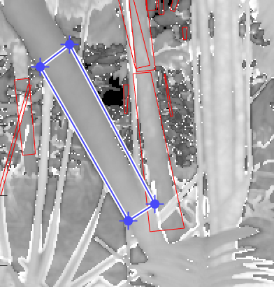

1. Cross-hairs will show up allowing you to select a point on the stem (e.g., near the middle) to compute the nominal range of the trunk.



**Finish**

When you are satisfied, click finish.

Registration process will commence.

If you get the following error message, the registration algorithm determined that an insufficient number of trees (tie points) were visible between all possible neighboring scans. You must then revert to manual registration.

