

**Group Name:** Artichoke

**Project Plan:**Waterfall

**Members:**

* Boaz Goldsteen
* Dave La Gordt Dillie: 434661
* Mary Joseph: 3814505
* Sebastian Bokkestijn: 437602

Table of Contents

**Client:** **2**

**Team:** **2**

**Current situation:** **2**

**Problem description:** **2**

**Project goal:** **3**

**Deliverables:** **3**

**Non-deliverables:** **3**

**Constraints:** **3**

**Phasing** **3**

1.Week One Project activities 4

2. Project Phases 4

3. Project Milestones 5

4. Client Planning. 5

4.1 First Meeting in Week 2. 6

4.2 Second Meeting Week 4. 6

4.3 Third Meeting Week 6 6

# **Client:**

Our client is Rafayel Avetyan. We can contact our client through Microsoft Teams and during in-person meetings. Our client represents Media Bazaar, a daughter company of Jupiter who is planning to open their first shop in Eindhoven to sell hardware.

# Team:

* The representative for our group is James.
* Our group representative can be contacted at s.bokkestijngrandez@student.fontys.nl
* This person represents team Artichoke.

# Current situation:

Currently at Media Bazaar they have a very unreliable system which consists of excel sheets and online calendars for employee scheduling. Due to a detail oriented documentation system, it is difficult to have a simplistic method for the employees and no easy way to request an action from the different departments within the store.

Further,the company has communication issues between its different departments ,due to lack of reliable communication channel.This has resulted in sustainability problems in restocking.

# Problem description:

In this project, Artichoke Developers,are looking into problems that a Media Bazaar company is facing.The company owns different shops that deal with selling hardware.The latest of its outlets is scheduled to be opened in EIndhoven.

However, Media Bazaar has foreseen a big challenge in the operations of its new outlet.

The company has no good way of scheduling employees and for employees to see their own timetables. The client also does not have a simple way of communicating restock requests between departments.

Moreover, another problem at hand is the lack of a proper communication channel between its different departments.

These problems therefore provide us with an opportunity to provide a software solution that can help the company fix all these problems.

# Project goal:

Currently,our goal for this project is to build a system that lets the administration handle everything from employees to stocks.The company will develop a software that will ease the communication between managers and employees. To give the managers the ability to keep track of the attendance performance and manage the inflow of new recruits and outflow employees of store staff. In regards to the stock, the company plans to deliver a simplistic interface to limit human error on stock management.

# 

# 

# **Deliverables:**

* C# application
  + Input:
    - Schedule manager feature: The manager is able to assign schedules for the employees based on the time of the day(morning, afternoon, evening).
    - Attendance sheet: Employees can check-In when arriving to work and the percentage they had of overall attendance.
    - Inter-manager request system: Managers can send requests between departments to address the needs of the store.
    - Staff inflow and outflow management: Managers can input details for new employees as well as terminating contracts of a former staff member.
    - GUI: Managers and other employees have a simplistic interface where they can interact with the system
  + Output: Software application
* Presentation:
  + Input: All activities
  + Output: Evaluation Report
  + Description: To showcase everything that has been implemented in the application.
* Documentation:
  + Input: All previous activities
  + Output:
    - Process report
    - URS
    - Test Plan

# **Non-deliverables:**

* User manual
* User training
* Mobile Application

# **Constraints:**

* On-hands team working due to corona regulations
* The main language to develop the backend of the application will be c#.
* Development of a retail management software.

# Phasing

## **1.Week One Project activities**

During the first week ,We as Group 2 have planned and spread our activities in various stages so as to ensure we launch and kick start our project preparations in best way possible.

First we have sought and resolved to work as a group, and taken a considerable amount of time to understand the project problem(Client requirements) and explored possible ways to offer the solution.

Below is a preview of how the preparations stage of the project activities are spread in the first week

*Figure 1: Week one activities*

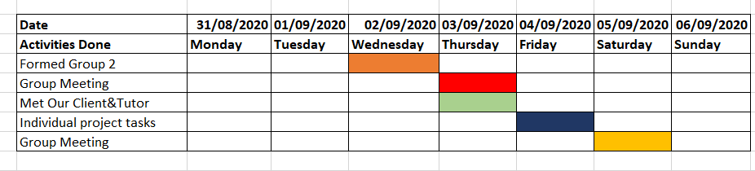

## **2. Project Phases**

Having understood the background of the client problem and the possible solution we can offer,

We have laid out a six week plan, divided in phases as shown below.

Figure 2: Phases for the project 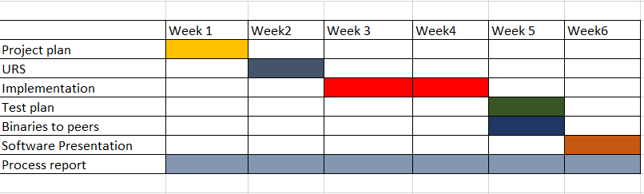

## **3. Project Milestones**

After deliberating on the possible solution to the problem, we came up with a Four main milestones that we feel will mark a considerable part of the project.

In some of these Milestones, we also plan to meet the client for reviews and feedback.

The chart below explains the milestones visually.

Figure 3: Milestones of the software

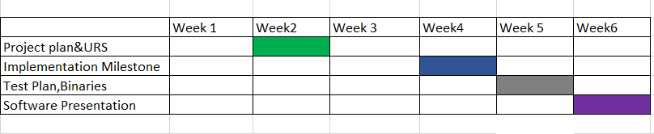

## **4. Client Planning.**

During our first 6 weeks ,we plan to meet our client at most three times where we wish to present a considerable part of the project.

We have projected to have the meeting scheduled as follow:

### **4.1 First Meeting in Week 2.**

We plan to present the software design to the client.

This is aimed to help us get some feedback from the client if we should continue with same design or we need to do some changes.

### **4.2 Second Meeting Week 4.**

In this meeting ,we plan to meet the client to show the client the functionalities we have in place.

This is aimed to receive further feedback from the client, on whether to go on or to change some functionalities

### **4.3 Third Meeting Week 6**

In this meeting ,we project to meet the client and present them a complete version of our software, to test it and give us general feedback.

We hope at this point the software meets the basic requirements for the client