individuals <- read.csv("./CSV files/individuals_data.csv", header = TRUE)  
individuals$diet = factor(individuals$diet,c("FSHSQ","FSH","FSQ","SHSQ","F","SH","SQ","PELL"))  
justinwt <- read.csv("./CSV files/justinwt_data.csv", header = TRUE)  
justinwt$diet = factor(justinwt$diet,c("FSHSQ","FSH","FSQ","SHSQ","F","SH","SQ","PELL"))  
allfish <- read.csv(file = "./CSV files/allfish_data.csv", header = TRUE)  
allfish$diet = factor(allfish$diet,c("FSHSQ","FSH","FSQ","SHSQ","F","SH","SQ","PELL"))  
  
plot(individuals$wt ~ individuals$tlmm, xlab = "Individual Total Length (mm)", ylab = "Individual Weight (g)", main = "Individual Weight vs Length Relationship", pch = 16, las = 1)  
lm01 <- lm(individuals$wt ~ individuals$tlmm)  
abline(lm01, col = "blue")

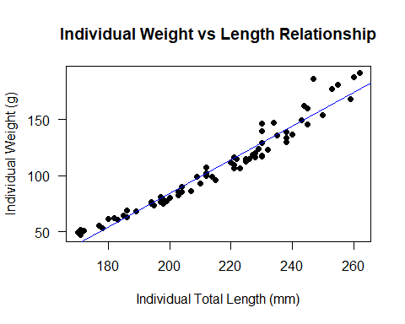

summary(lm01)

##   
## Call:  
## lm(formula = individuals$wt ~ individuals$tlmm)  
##   
## Residuals:  
## Min 1Q Median 3Q Max   
## -11.975 -5.783 -2.025 5.340 31.332   
##   
## Coefficients:  
## Estimate Std. Error t value Pr(>|t|)   
## (Intercept) -216.03706 8.86520 -24.37 <2e-16 ***  
## individuals$tlmm 1.49962 0.04094 36.63 <2e-16 ***  
## ---  
## Signif. codes: 0 '***' 0.001 '**' 0.01 '*' 0.05 '.' 0.1 ' ' 1  
##   
## Residual standard error: 8.366 on 70 degrees of freedom  
## Multiple R-squared: 0.9504, Adjusted R-squared: 0.9497   
## F-statistic: 1342 on 1 and 70 DF, p-value: < 2.2e-16

plot(individuals$tlmm, individuals$liverwt, xlab = "Individual Total Length (mm)", ylab = "Individual Liver Weight (g)", main = "Individual Total Length vs Liver Weight", pch = 16, las = 1)  
lm02 <- lm(individuals$liverwt ~ individuals$tlmm)  
abline(lm02, col = "blue")

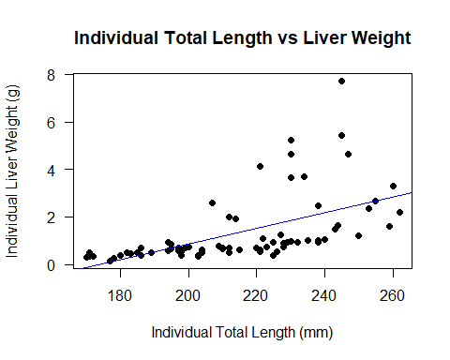

summary(lm02)

##   
## Call:  
## lm(formula = individuals$liverwt ~ individuals$tlmm)  
##   
## Residuals:  
## Min 1Q Median 3Q Max   
## -1.2952 -0.8048 -0.2617 0.2848 5.3643   
##   
## Coefficients:  
## Estimate Std. Error t value Pr(>|t|)   
## (Intercept) -5.736273 1.304062 -4.399 3.81e-05 ***  
## individuals$tlmm 0.033029 0.006022 5.485 6.18e-07 ***  
## ---  
## Signif. codes: 0 '***' 0.001 '**' 0.01 '*' 0.05 '.' 0.1 ' ' 1  
##   
## Residual standard error: 1.231 on 70 degrees of freedom  
## Multiple R-squared: 0.3006, Adjusted R-squared: 0.2906   
## F-statistic: 30.09 on 1 and 70 DF, p-value: 6.182e-07

plot(individuals$wt, individuals$liverwt, xlab = "Individual Weight (g)", ylab = "Individual Liver Weight (g)", main = "Individual Weight vs Liver Weight Relationship HSI", pch = 16, las = 1)  
lm03 <- lm(individuals$liverwt ~ individuals$wt)  
abline(lm03, col = "blue")

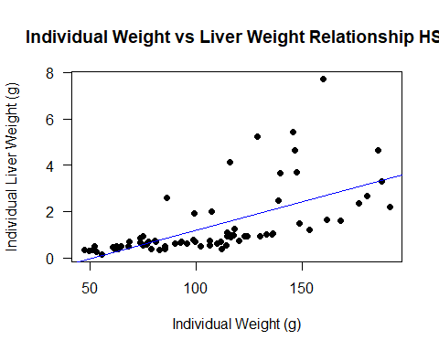

summary(lm03)

##   
## Call:  
## lm(formula = individuals$liverwt ~ individuals$wt)  
##   
## Residuals:  
## Min 1Q Median 3Q Max   
## -1.2934 -0.7483 -0.3249 0.2835 5.0394   
##   
## Coefficients:  
## Estimate Std. Error t value Pr(>|t|)   
## (Intercept) -1.247951 0.411934 -3.029 0.00343 **   
## individuals$wt 0.024553 0.003647 6.733 3.82e-09 ***  
## ---  
## Signif. codes: 0 '***' 0.001 '**' 0.01 '*' 0.05 '.' 0.1 ' ' 1  
##   
## Residual standard error: 1.146 on 70 degrees of freedom  
## Multiple R-squared: 0.3931, Adjusted R-squared: 0.3844   
## F-statistic: 45.33 on 1 and 70 DF, p-value: 3.816e-09

boxplot(justinwt$weight ~ justinwt$diet, xlab = "Diet", ylab = "Average Fish Weight (g)", main = "Average Fish Weight Across Diets", ylim = c(0,200), las = 1,par(cex.axis=0.70))

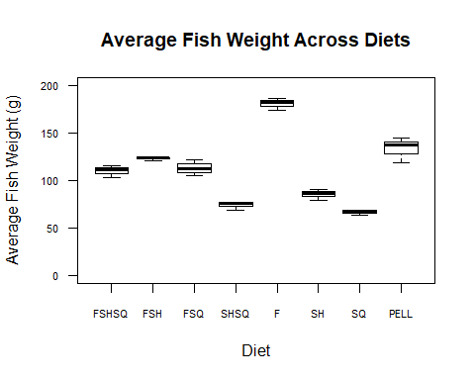

boxplot(individuals$wt ~ individuals$diet, xlab = "Diet", ylab = "Fish Weight (g)", main = "Average Fish Weight Across Diets", ylim = c(0,200), las = 1,par(cex.axis=0.70))

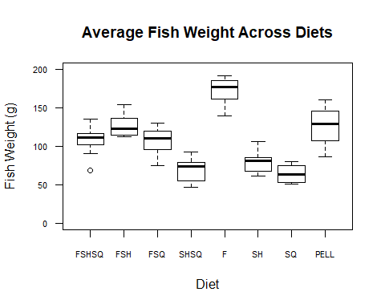

boxplot(individuals$liverwt ~ individuals$diet, xlab = "Diet", ylab = "Liver Weight (g)", main = "Average Fish Liver Weight Across Diets", las = 1,par(cex.axis=0.70))

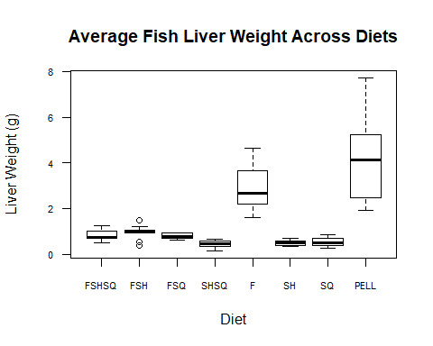

boxplot(individuals$percentviscera ~ individuals$diet, xlab = "Diet", ylab = "Percent Viscera (%)", main = "Average Fish Percent Viscera Across Diets", ylim = c(0,16), las = 1,par(cex.axis=0.70))

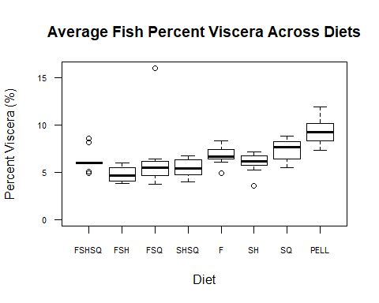

boxplot(individuals$tlmm ~ individuals$diet, xlab = "Diet", ylab = "Total Length (mm)", main = "Average Fish Total Length Across Diets", las = 1,par(cex.axis=0.70))

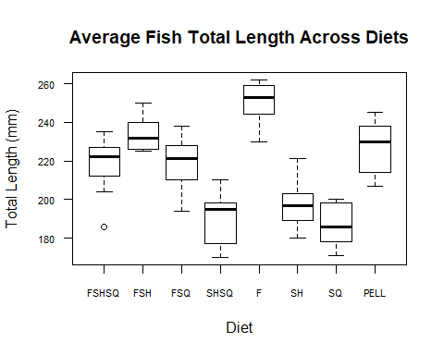

boxplot(individuals$evisceratedwt ~ individuals$diet, xlab = "Diet", ylab = "Eviscerated Weight (g)", main = "Average Fish Eviscerated Weights Across Diets", las = 1,par(cex.axis=0.70))

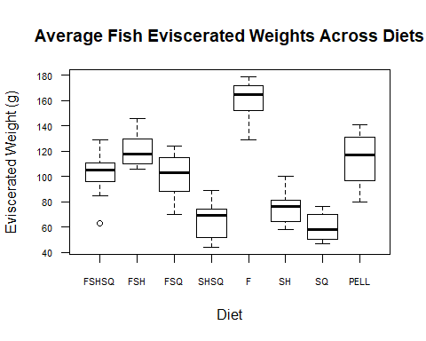

boxplot(individuals$conditionfactor ~ individuals$diet, xlab = "Diet", ylab = "Condition Factor (g/cm^3)", main = "Average Fish Condition Factor Across Diets", las = 1,par(cex.axis=0.70))

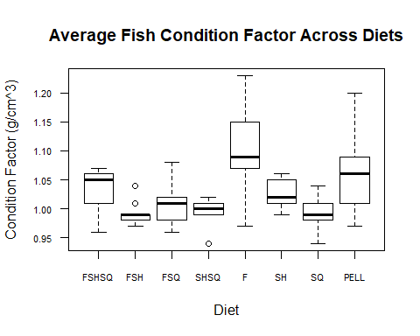

boxplot(individuals$hsi ~ individuals$diet, xlab = "Diet", ylab = "HSI", main = "Average Fish Hepatosomatic Index Across Diets", las = 1,par(cex.axis=0.70))

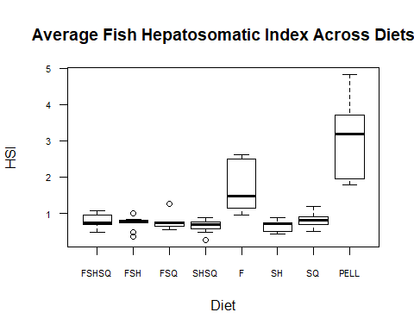

boxplot(individuals$wtdiff ~ individuals$diet, xlab = "Diet", ylab = "Weight Difference (g)", main = "Average Fish Total Weight - Eviscerated Weight", ylim = c(0,20), las = 1,par(cex.axis=0.70))

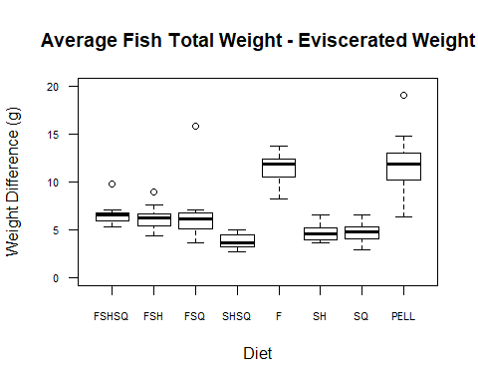

boxplot(allfish$wt ~ allfish$diet, xlab = "Diet", ylab = "Average Fish Weight (g)", main = "Average Fish Weight Across Diets", ylim = c(0,250), las = 1,par(cex.axis=0.75))

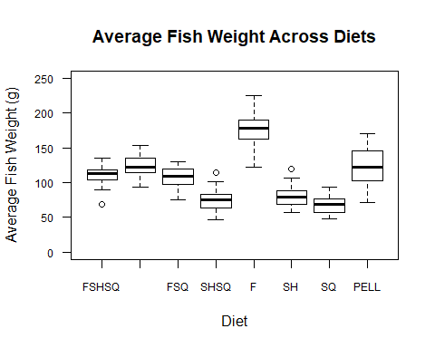

boxplot(allfish$tlmm ~ allfish$diet, xlab = "Diet", ylab = "Average Total Length (mm)", main = "Average Fish Total Length Across Diets", ylim = c(0,300), las = 1,par(cex.axis=0.70))

