# Safe Act Observation

**Overview**

RCR Tomlinson business unit Safety has their own Safe Act Observation (SAO) sub-site that allows its staff members to upload, check-in/out and maintain various documents and submit InfoPath forms with SharePoint 2010. Every changes made to a document will need to be easily found with the SharePoint portal Search Centre 2013.

SAO has an InfoPath form, which in particular has custom Meta data fields that needs to be searchable. This is achieved with developing the following solutions:

* [Custom display templates to render results as a table](http://devspoint.wordpress.com/2013/08/20/using-jquery-datatables-with-search-display-templates/) grid;
* Using [DataTable plug-in for JQuery](http://www.datatables.net/) to provide rich UI experience; and
* [Create button to show more search results](http://www.eliostruyf.com/create-a-load-more-results-link-button-for-the-content-search-web-part/) for OOTB Content Search Web Part

The above solutions are packaged for SAO as specified below. All two package solutions are required for successful deployment in order to run ASC.

|  |  |  |
| --- | --- | --- |
| **Title** | **Solution Package Filename** | **Description** |
| SharePoint Framework | rcr.sp.framework.wsp | DLL that contains the SharePoint services re-usable for many applications |
| SAO Solution Package | rcr.safeactobservation.wsp | Custom solution package that contains CSS, list and display templates content web part feature |

**TFS**

* SAO - $/SafeActObservation/RCR.SafeActObservation
* SharePoint 2013 Framework Project - $/RCR.SP2013.Framework/RCR.SP.Framework

# Installation

The following instructions in this section 2 are to be carried out only for a NEW installation of SAO solution package that has not yet exist on a SharePoint 2013 farm. For installation to existing ASC solution*, read Appendix 1.*

**Pre-requisite**

Prior to installing the ASC solution package, the SharePoint 2013 Framework Windows solution package (WSP) MUST be installed in Central Administration:

Run a PowerShell script that will deploy the Windows Solution Package (WSP) file called

* **rcr.sp.framework.wsp**

A successful installation on the SharePoint farm will deploy these WSP file below in Central Administration:



For more details, read: [http://webservices.rcrtom.com.au/corporate-it/spprojects/Solutions%20Documentation/SharePointFrameWork.docx](http://webservices.rcrtom.com.au/corporate-it/spprojects/Solutions%20Documentation/SharePointFrameWork-AsBuilt.docx)

**Installing SAO Solution Package**

Run a **installsao.ps1** PowerShell script that will deploy the Windows Solution Package (WSP) file called

* **rcr.safeactobservation.wsp**

A successful installation on the SharePoint 2013 farm will deploy this WSP file below in Central Administration:

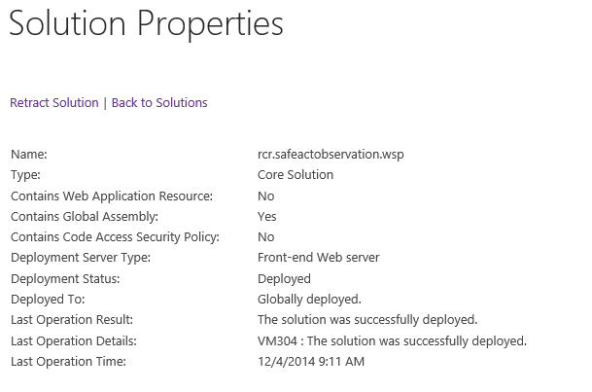

## Feature Activation

After installing the solution package in section 2.0, activate the feature from Search Centre site.

1. Go to the Search Centre site collection where the SAO feature will be activated.
2. Go to Site Site Settings->Site collection features
3. Activate **SAO** **Feature**



A successful SAO feature activation will install the following files:

* **Display Template files (/Display Templates/Content Web Parts/)** – Folder containing HTM, Jquery & JavaScript to run the search content web part on the search result page
* **SAO List** – Custom list containing some default configurations for running SAO
* **CSS** **(/Display Templates/Server Style Sheets)** – Custom CSS and image files.

## 2.2 Creating Search Result Page

After the feature has been activated in section 2.1, the next step is to edit the existing search result under SAO Search Centre site collection.

**NOTE:** Before doing this section 2.2, the **pre-requisite** is that you have already implemented custom search scope in appendix 3.1

1. Edit the SAO search result page results.aspx
2. Add content search web part on the result page

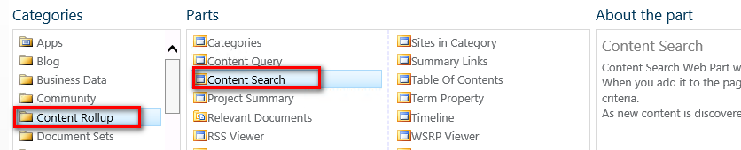

1. Configure the content search web part settings as follows:

* Click **Change Query** button
* Switch to advance mode
* Select SAO search scope (Site Collection)

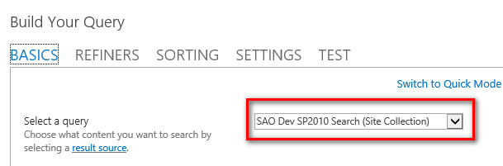

* Click on “Test query” button and should return some results



* If there are some return search results, click OK to exist the Build Your Query pop up window
* Setup the following:

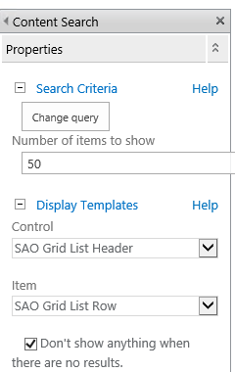

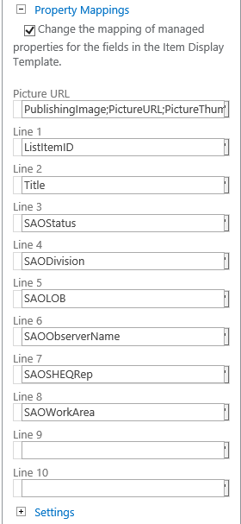

1. Click Ok to save the search content web part setting. Then save the page
2. Check the result page displays the correct results.
3. Check-in and publish the result page

## Setting up Security Permissions

TBA

# Appendix 1 – Upgrading Safe Act Observation

The following instructions is to how to perform existing SAO site upgrades with changes to existing **rcr.safeactobservation.wsp**

1. Get All the latest deployment files below from network shared folder \\vm304\SP Deployment\SAO

* installsao.ps1
* RCR.SafeActObservation.wsp

1. Copy the 2 files across to the test or production SharePoint farm
2. On the SharePoint farm, run PowerShell prompt command as Administrator
3. In PowerShell prompt go the directory where the 2 files has been copied in step 2
4. Run this command: **.\installsao.ps1**

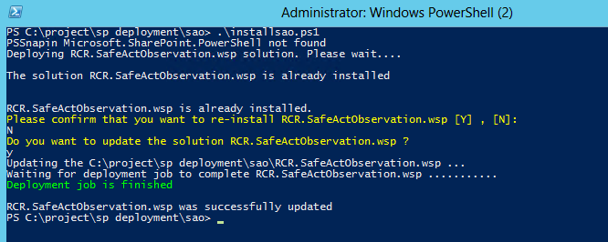

1. Go to Central Administration to check that the WSP file has successfully been upgraded

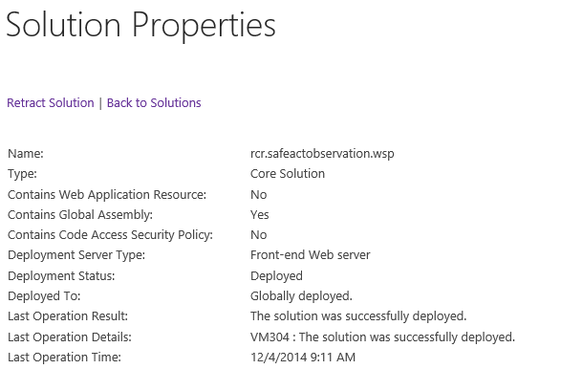

1. Check the SAO search centre site to confirm the site is back online after the application pool has been recycle.

|  |  |
| --- | --- |
| **Test SAO site** | <https://search.webservicestest.rcrtom.com.au/areas/corporate/Safety/sao/Pages/default.aspx> |
| **Live SAO site** | TBA |

# Appendix 2 – SAO Troubleshooting

## 2.1 Missing Server Side Dependencies

**Problem:**

You get this error in Central Admin SharePoint 2013:

[MissingFeature] Database [WSS_Search_Content] has reference(s) to a missing feature: Id = [49c69ac6-61e8-4dd8-80ee-6f5d79053ece], Name = [Safe Act Observation Custom Search], Description = [Deploys custom display templates content web parts to be used on search result specifically for SAO], Install Location = [RCR.SafeActObservation_Safe Act Observation]. The feature with Id 49c69ac6-61e8-4dd8-80ee-6f5d79053ece is referenced in the database [WSS_Search_Content], but is not installed on the current farm. The missing feature may cause upgrade to fail. Please install any solution which contains the feature and restart upgrade if necessary.  
[MissingSetupFile] File [Features\RCR.SafeActObservation_Safe Act Observation\DisplayTemplates\Control_SAO_ListHeader.html] is referenced [2] times in the database [WSS_Search_Content], but is not installed on the current farm. Please install any feature/solution which contains this file. One or more setup files are referenced in the database [WSS_Search_Content], but are not installed on the current farm. Please install any feature or solution which contains these files.  
[MissingSetupFile] File [Features\RCR.SafeActObservation_Safe Act Observation\DisplayTemplates\Item_SAO_ListRow.html] is referenced [2] times in the database [WSS_Search_Content], but is not installed on the current farm. Please install any feature/solution which contains this file. One or more setup files are referenced in the database [WSS_Search_Content], but are not installed on the current farm. Please install any feature or solution which contains these files.

**Solution:**

Re-installing the SAO solution package is required to clear this error.

1. Firstly **deactivate** the SAO feature (e.g. [here](https://search.webservicestest.rcrtom.com.au/_layouts/15/ManageFeatures.aspx?Scope=Site) ) from Search Centre 2013 site collection. Go to: Site settings->Site collection features



1. Go to SP2013 Central Administration site. Go to: Systems Settings->Manage farm solutions
2. Click on **rcr.safeactobservation.wsp** link and click on “Retract Solution” button.
3. Remote login to the SharePoint 2013 server farm.
4. Run **InstallSAO.ps1** (See section 2 for more details).
5. After SAO solution package has been successfully deployed, Activate the SAO feature (See section 2.1 for more details).
6. Go to SharePoint 2013 Central Administration site, and click on “Reanalyse Now” button on the issue.

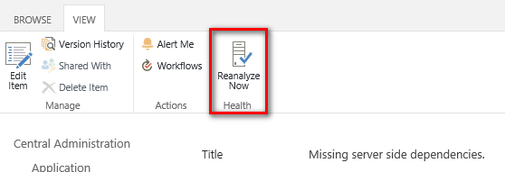

1. The error log should be clear after the update.

# Appendix 3 – Search Scope

## 3.1 Customising Search Scope

To create a scope search, use **Manage Result Sources** feature. After configure managed result source, the next step is to configure search result page (See appendix 3.2 for more detail instructions not related to SAO).

* 1. Go the search centre search site collection that was created in step 13 of section 2.6.0
  2. Go to **site settings** from top right side drop down menu

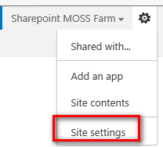

* 1. Click on **Result Sources** link under Site Collection Administrator

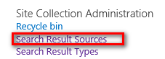

* 1. Click “New Result Source” button 
  2. Enter the following details below and click the **save** button when finish:

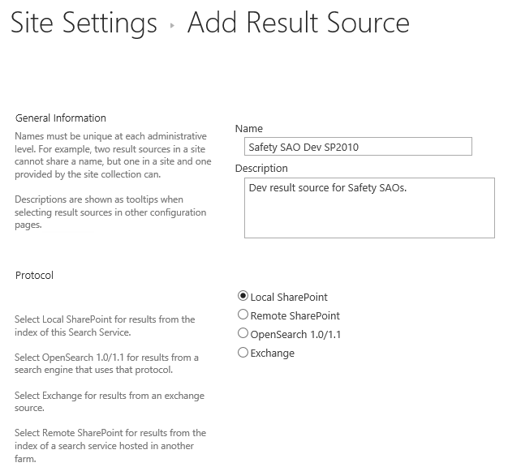

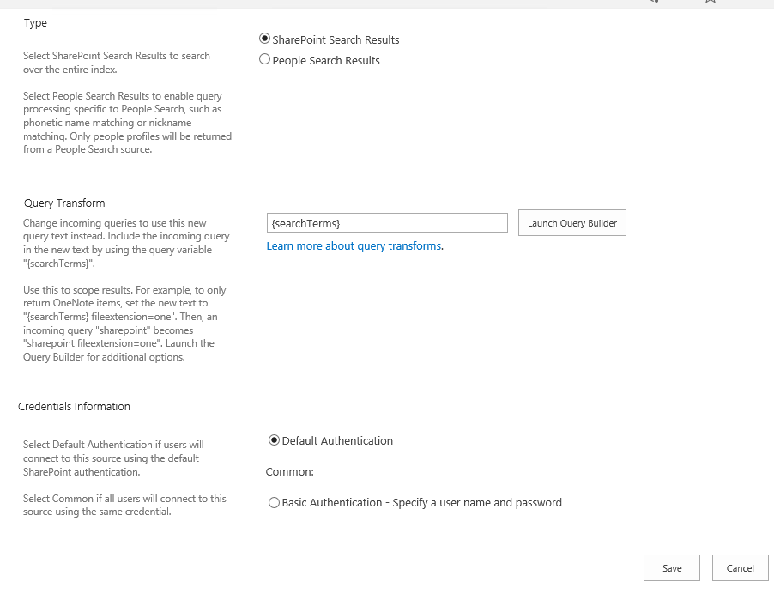

The query builder looks like this:

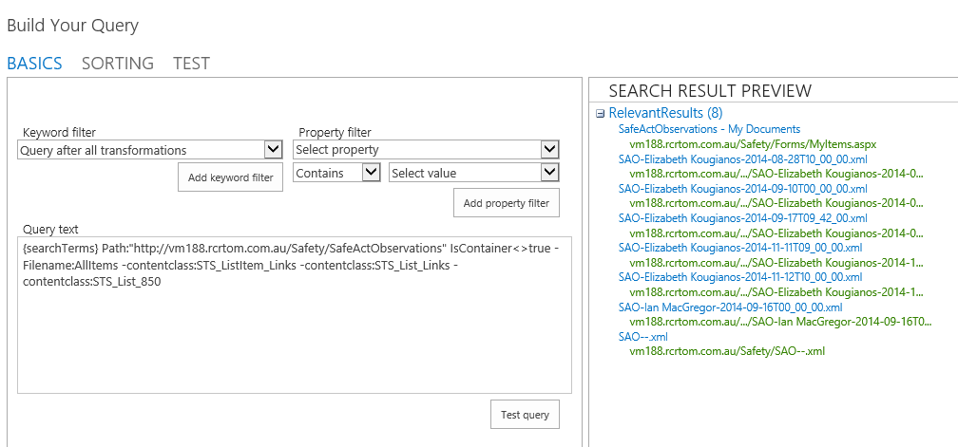

After saving the result source, it should look like this:

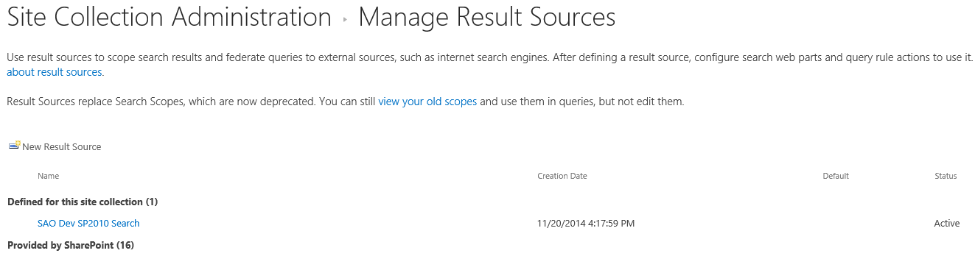

## Customising Search Result Page

**How search works in a few words**  
In case you’re not so familiar with how search works, here’s a high level representation that might be useful for this series.

[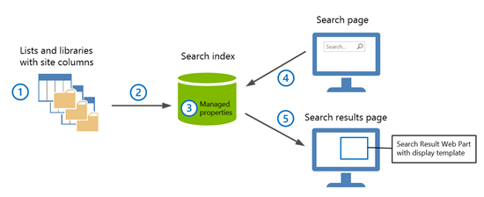](http://blogs.technet.com/cfs-file.ashx/__key/communityserver-blogs-components-weblogfiles/00-00-00-66-12/2084.SearchOverview.png)

1. Content is stored in lists and libraries. Site columns are used to store values, or in other words information, about each item in a list or library.
2. When lists and libraries are crawled, site columns and the site column values are added to the search index.
3. In the search index, site columns are “transformed” into managed properties. Site column values are “transformed” into managed property values
4. On a search page, a user enters a query in a Search Box Web Part. The query is sent to the search index.
5. Search results are sent from the search index to a search results page, and displayed in a Search Results Web Part.  The Search Results Web Part uses display templates that specify which managed property values should be displayed.

**Overview**

1. Introduction - [How search results are displayed in SP 2013](http://blogs.technet.com/b/tothesharepoint/archive/2013/09/04/understand-how-search-results-are-displayed-in-sharepoint-server-2013.aspx#ControllingDisplay)
2. [How to map network drive to display templates](http://blogs.technet.com/b/tothesharepoint/archive/2013/04/03/stage-6-upload-and-apply-a-new-master-page-to-a-publishing-site.aspx#MapNetworkDrive) (or see appendix 8.14)
3. Understand site column and managed property
   1. [Transforming site column to managed property](http://blogs.technet.com/b/tothesharepoint/archive/2013/03/06/from-site-column-to-managed-property-what-s-up-with-that.aspx)
   2. [Automatically created managed properties](http://technet.microsoft.com/library/jj613136.aspx)
4. [Understanding display templates](http://blogs.technet.com/b/tothesharepoint/archive/2013/09/05/understand-how-item-display-templates-and-hit-highlighting-work-in-sharepoint-server-2013.aspx) file
   1. [Understanding hit highlights](http://blogs.technet.com/b/tothesharepoint/archive/2013/09/05/understand-how-item-display-templates-and-hit-highlighting-work-in-sharepoint-server-2013.aspx#HowHitHighlightingWorks)
5. [How to create a new display template](http://blogs.technet.com/b/tothesharepoint/archive/2013/09/10/how-to-create-a-new-result-type-in-sharepoint-server-2013.aspx)
6. [How to create a new result type](http://blogs.technet.com/b/tothesharepoint/archive/2013/09/10/how-to-create-a-new-result-type-in-sharepoint-server-2013.aspx)

**Creating a New Custom Display Templates**

You can say goodbye (happily) to the need for using XSLT to modify the search results UI, and say hello to display templates, which control how an item is displayed. A display template consists of two files:

* an HTML file and
* JavaScript fi le.

The specific display pattern is contained in the HTML, and the JavaScript is generated automatically when you upload the HTML file. SharePoint 2013 provides several display templates, which you can copy and customize.

They are located in the Display Templates folder of the Master Page Gallery in the site collection. From this [result type table](http://technet.microsoft.com/EN-US/library/dn386874.aspx#BKMK_AboutSearchResults) (See Appendix 8.15), determine and decide which copy of a new item display template that you will need.

Therefore, the following example walks through the process of modifying a copy of the display template item_default.html so that custom lists are displayed in the search result. The user modifying the template requires at least Designer permissions:

1. Browse to the Master Page Gallery of your search centre site collection.

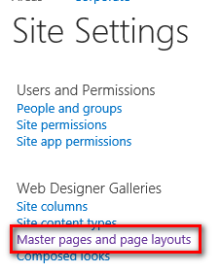

1. Click the folder labelled Display Templates. Note the different categories of templates.
2. On the Display Templates page, click the folder called Search.

1. Locate and download a copy of the Item_Default.html file.
2. Using your favourite text editor, update the following content:
   1. Change the <title> tag. This will later be reflected in the configuration of adding a new result type

[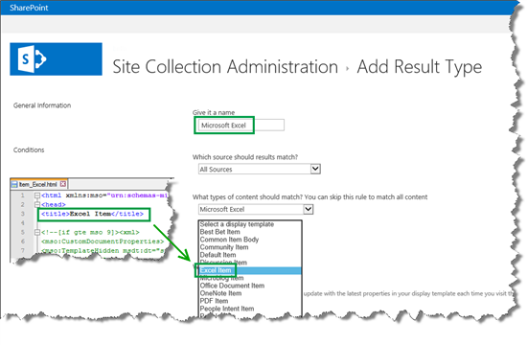](http://blogs.technet.com/cfs-file.ashx/__key/communityserver-blogs-components-weblogfiles/00-00-00-66-12/7028.ExcelItemTitle.png)

1. After changing the value, save the display template file with different filename (e.g. Item_Test.html).
2. Upload the file to the Display Templates and publish it. There are two ways to publish a display template:

7.1 Publish via Master Page Gallery:

* + Repeat step 1 to 3
  + Click on Files tab on the Ribbon toolbar -> Upload Document

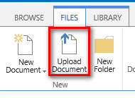

* + Uploading the HTML file will automatically generate its associated JavaScript file as well

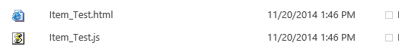

7.2 Upload via Window Explorer:

* Follow the instruction steps on how to map network drive to display template in appendix 8.13
* Copy the display template file to the map drive using Window Explorer. Refresh Window Explorer and in a few seconds SharePoint 2013 will also automatically generate JavaScript file associated with the uploaded display template file.

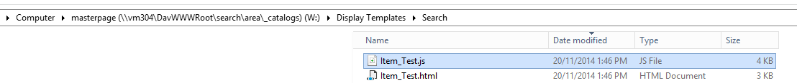

**Creating a New Result Type**

Depending on your permission level, you create a result type on two levels:

|  |  |
| --- | --- |
| **Permission level** | **Where the result type will be added** |
| Site collection administrator | To all sites within a site collection |
| Site collection owner | To a single site |

To save space, I will only show you how to create a result type as a Site collection administrator.

1. Go to **Site settings** --> **Search Result Types**.

[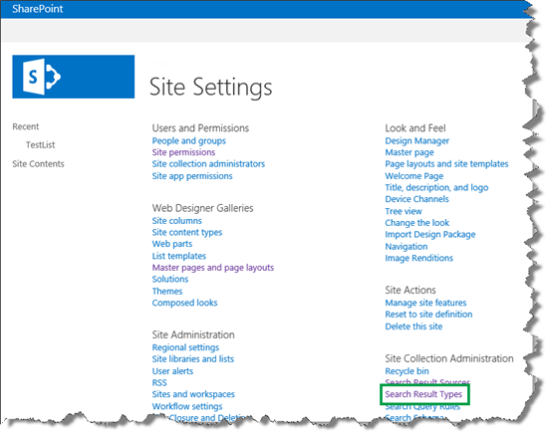](http://blogs.technet.com/cfs-file.ashx/__key/communityserver-blogs-components-weblogfiles/00-00-00-66-12/5287.SearchResultTypes.png)

Instead of creating a new result type from scratch, you could make your life a bit easier by copying an existing result type and modifying it to fit your new result type. If you do this, ensure that you copy a result type that closely resembles the new result type you want to create.

1. On the **Manage Result Types** page, from the result type menu field, select **Copy**.

In my scenario, I wanted to customize search results for SharePoint list items, so I copied the **SharePoint List Item** result type.

[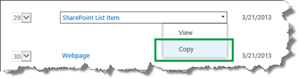](http://blogs.technet.com/cfs-file.ashx/__key/communityserver-blogs-components-weblogfiles/00-00-00-66-12/0876.CopySharePointListItem.png)

1. On the Add Result Type page, here's what you need to do:
2. In the **Give it a name** field, enter a name for your new result type.    
   In my scenario, I entered T*echNet content.*
3. From the **Which source should results match** menu, select the result source that you have used to configure the query in your Search Result Web Part.
4. In the **What types of content should match? You can skip this rule to match all content** menu, all the default result type are listed.   
   In my scenario, I chose **Select a value**.
5. Click **Show more conditions**.

[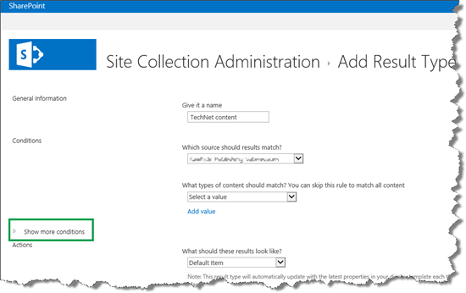](http://blogs.technet.com/cfs-file.ashx/__key/communityserver-blogs-components-weblogfiles/00-00-00-66-12/1362.ShowMoreConditions.png)

This opens up a menu where you can specify the result type based on managed property values.

In my scenario, all list items contain a site column called *Distribution Channel*. As I showed you at the beginning of this blog, this site column contains the publication platform value, for example *TechNet Library*. I wanted to use values from this site column to specify which list items should belong to my new result type

* 1. From the **Which custom properties should match** menu, I selected *DistributionChannelOWSCHCS*. *DistributionChannelOWSCHCS* is the managed property that represents the *Distribution Channel* site column. In the fields below, I entered all the values that should specify the new *TechNet content* result type.

[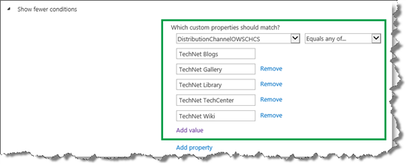](http://blogs.technet.com/cfs-file.ashx/__key/communityserver-blogs-components-weblogfiles/00-00-00-66-12/6862.AddProperties.png)

* 1. From the **What should these results look like** menu, select the display template that should be used by this result type.  
       
     In my scenario, I selected my newly created *TechNet content* display template.

[](http://blogs.technet.com/cfs-file.ashx/__key/communityserver-blogs-components-weblogfiles/00-00-00-66-12/5852.ApplyTechNetDisplayTemplate.png)

* 1. Click **Save**.

Your newly created result type is now listed on the **Managed Result Types** page.   
  
In my scenario, I could see that the *TechNet content* result type had been created.

[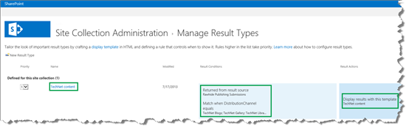](http://blogs.technet.com/cfs-file.ashx/__key/communityserver-blogs-components-weblogfiles/00-00-00-66-12/0523.TechNetCreated.png)

So now that we have a new result type, the next step is to modify the display template that is associated with this result type. There are different ways you can go about doing this, so in the next two steps, I'll explain two different options.

**Reference:**

1. [How to change the way search results are displayed in SharePoint Server 2013](https://profiles.webservices.rcrtom.com.au/personal/rcrtom_david_liong/Documents/Documents/How%20to%20change%20the%20way%20search%20results%20are%20displayed%20in%20SharePoint%20Server%202013)
2. <https://sharepoint2010search.codeplex.com/documentation>