**Appointment Module (done)**

-Block the schedule if taken

- patient receive sms notification 1 days before the set appointment

- patient receive email notification 2 day before the set appointment

**Patient page (done)**  
 - can set schedule

pag naka pili na po ng doctor or specialization(dropdown) lalabas na po ung schedule ng doctor para maka pili ng oras.  
 - can view schedule  
 - can cancel approve schedule (notify doctor page)

**Doctor page**

- can view his/her schedule  
 - status of appointment of patient (pending, decline, approved) Notify the patient in the system if his/her appointment has been decline or approved. Kapag approve ung notification sa patient page may kasamang room number.  
 - can cancel approve schedule (notify patient page)

**Medical History Module**

-can sort by month the history  
 - printable

**Patient page**

-can view medical history  
 -can download file

**Doctor page**

- upload file

- input findings  
 - input medicine (multiple dropdown)

**Payment Module**

**Patient page**

-can view the payment he/she made

**Doctor page**

-type the amount medical procedure

**Add doctor account (done)**

**Admin Page**  
 Last Name

First Name

Middle Name

Suffix Name

Gender

Year of Service

Contact Number

Email  
 Status : for example resident doctor  
 Specialization (Dropdown)

Availability  
 Username  
 Password

List of Specialization **(done)**

-adult pulmonary medicine -obstetrics gynecology

-allergology immunology -oncology

-anatomic pathology -ophthalmology

-anesthesiology -organ transplant

-cardiology -orthopedic surgery

-clinical epidemiology -otorhinolaryngology

-clinical nutrition -otorhinolaryngology and head and neck surgery

-clinical pathology -pain management

-clinical quality improvement -paramedical

-complementary medicine -pathology

-critical care -pediatrics

-dentistry & oral surgery -nuclear medicine

-dermatology -plastic & reconstructive surgery

-emergency medicine -physical medicine and rehabilitation

-endocrinology -psychology

-gastroenterology -pulmonary medicine

-geriatic medicine -radiation oncology

-hematology -radiology

-hyperbaric oxygen therapy -rheumatology

-infectious disease and tropical medicine -surgery

-internal medicine -toxicology

-legal medicine and jurisprudence -urology

-medical oncology -vascular medicine

-nephrology

-neurology

-neurosciences

-neurosurgery

-psychiatry

**Statistic Module**  
**Admin page only**  
 - Count number of appointments  
 - Count number of cancelation  
 - Count number of decline

**Search bar Module**

pwede mag search kahit hindi naka login.

Drop down ng specialization tapos pag nakapili ng specialization lalabas ung mga doctor na may specialization na napili.

Ito po ung mga makikita pag may na pili ng specialization:

-Name

-Specialization

-Availability

**Login Module (done)**

-3 attempts after 3 attempts block user ( ma uunblock account sa admin page)

-forgot password via email (link)

-Alphanumeric password

**Rating**

-Can rate doctor 1-5 star

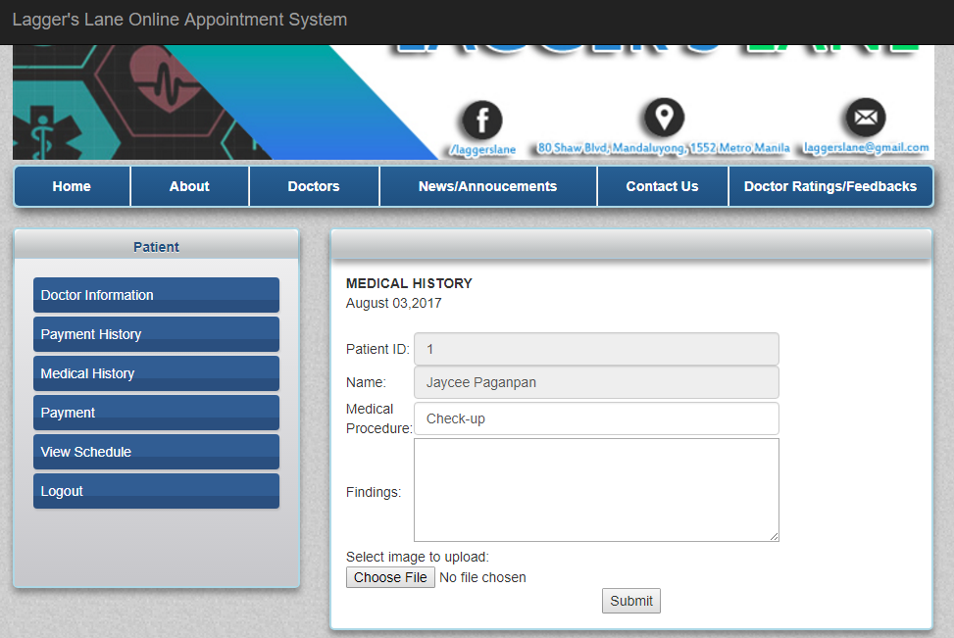Layout of Medical history in doctor page

ito po ung ginawa naming layout padagdagan nalang po ng Medicine(Dropdown multiple).

tapos po ung sa patient page viewing nalang po saka ung pwede ma download ung file.

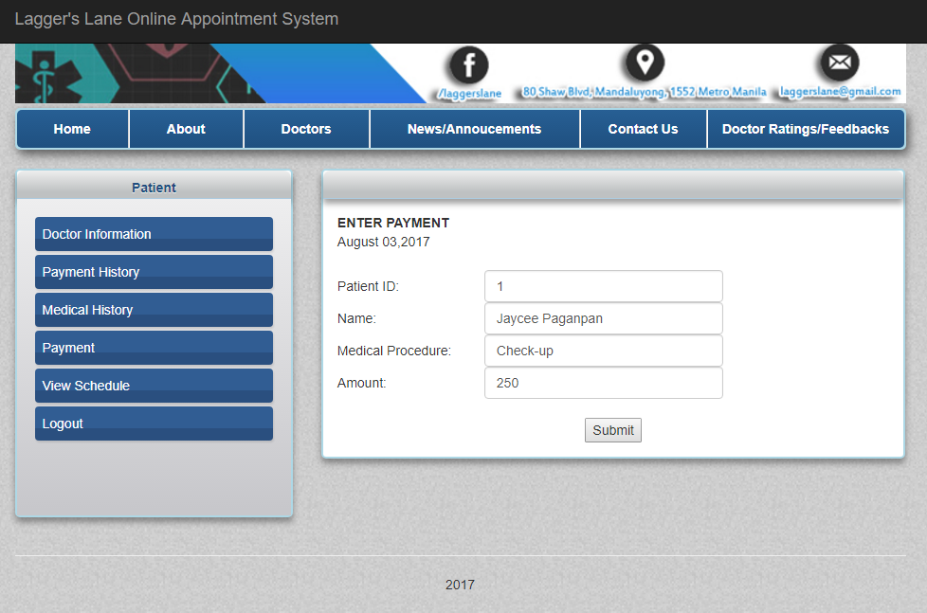Layout payment module for doctor page

Ito po ung ginawa naming layout ung Medical Procedure (dropdown multiple) tapos ung sa patient page viewing nalang din po.