

Republic of the Philippines

Western Mindanao State University

**College of Computing Studies**

DEPARTMENT OF COMPUTER SCIENCE

Zamboanga City

**SKIN DISEASE CAM: CLASSIFICATION OF SKIN RASHES USING CONVOLUTIONAL NEURAL NETWORKS WITH HOME REMEDY RECOMMENDATION**

A Thesis Presented to the Faculty of

Department of Computer Science

College of Computing Studies

In Partial Fulfillment of the Requirements for the Degree of

Bachelor of Science in Computer Science

**CASSANDRA MAE A. BACO**

**DAVE MATTHEW M. IGNACIO**

**JAZHEM M. HAMID**

**JEIKA BRYLL STEPHANNIE C. LAGO**

Researchers

MR. JAYDEE C. BALLAHO, MIT

Adviser

May 2026

Republic of the Philippines

Western Mindanao State University

**College of Computing Studies**

DEPARTMENT OF COMPUTER SCIENCE

Zamboanga City

# Approval Sheet

The Thesis attached hereto, entitled “**SKIN DISEASE CAM: CLASSIFICATION OF SKIN RASHES USING CONVOLUTIONAL NEURAL NETWORKS WITH HOME REMEDY RECOMMENDATION”**, prepared and submitted by **CASSANDRA MAE A. BACO, DAVE MATTHEW M. IGNACIO, JAZHEM M. HAMID, JEIKA BRYLL STEPHANNIE C. LAGO**, in partial fulfillment of the requirements for the degree of Bachelor of Science in Computer Science, is hereby recommended for Oral Examination.

**MR. JAYDEE C. BALLAHO, MIT**

Adviser

**APPROVED** by the Oral Examination Committee on **_______________** with a rating of **PASSED**.

<FIRST_NAME> <MI> <LAST_NAME PANEL 1>

Chairperson

<PANEL 2>

Member

<PANEL 3>

Member

**ACCEPTED** in partial fulfillment of the requirements for the degree of **BACHELOR OF SCIENCE IN COMPUTER SCIENCE**

MR. JAYDEE C. BALLAHO, MIT

Head, Department of Computer Science

ENGR. MARK L. FLORES, PhD

Dean, College of Computing Studies

# Acknowledgment

<This section recognizes the persons and organizations who assisted the researchers in the completion of the thesis. Acknowledgments should be expressed simply and tactfully.>

# Abstract

<A concise and factual abstract is required. The abstract should state briefly the research problem/gap, research objectives, methodology, the principal results with number values and major conclusions. An abstract is often presented separately from the manuscript; hence, it must be able to stand alone, preferably typed in one paragraph and should be at least 200 words but not to exceed 350 words and single space.>

**Keywords:** <Immediately after the abstract, a maximum of 5 keywords should be provided indicating the scope of the paper. They should be arranged in alphabetical order>

# Table of Contents

Approval Sheet i

Acknowledgment ii

Abstract iii

Table of Contents iv

List of Figures vi

List of Tables vii

List of Appendices viii

CHAPTER I INTRODUCTION 1

Background of the Study 1

Statement of the Problem 3

Objectives 3

Scope and Limitations 4

Significance of the Study 5

Definition of Terms 6

CHAPTER II REVIEW OF RELATED LITERATURE 8

Related Studies 8

Synthesis 9

Conceptual Framework 9

CHAPTER III METHODOLOGY 11

Research Design 11

Data Source 11

Data Gathering Instrument 12

Data Gathering Technique and Procedures 12

Data Analysis 13

Evaluation 14

Developmental Tools 14

CHAPTER IV RESULTS AND DISCUSSION 16

CHAPTER V CONCLUSION AND RECOMMENDATIONS 17

Conclusion 17

Recommendations 17

References 18

# List of Figures

Figure 1: Not a Conceptual Framework but a Guide 8

# List of Tables

Table 1: Definition of Terms 4

Table 2: Synthesis 7

Table 3: Developmental Tools and Cost 12

# List of Appendices

Appendix A: Data Collected 17

Appendix B: System Design 18

Appendix C: Evaluation Tool 19

Appendix D: Relevant Source Code 20

Appendix E: Ethical Clearance 21

Appendix F: Plagiarism Report 22

Appendix G: Research Critique and Editing Certificate 23

Appendix H: Curriculum Vitae 24

# CHAPTER I INTRODUCTION

## Background of the Study

People around the world struggle with skin diseases every day. Common conditions such as acne vulgaris, keratosis pilaris, psoriasis, leprosy, atopic dermatitis, and warts not only cause discomfort but also present significant challenges, particularly in tropical climates where warmth and humidity exacerbate skin irritability. In rural or low-income areas—such as Zamboanga City in the Zamboanga Peninsula, where the poverty incidence is around 30.1% [5]—access to specialized skin care is severely limited. Consequently, residents are often forced to rely on unvalidated online information and non–clinically proven remedies.

A recent study by Marasigan et al. [1] highlights that over 55% of primary care physicians in these settings have insufficient knowledge regarding common dermatological diseases. While only a small number of physicians have direct access to a dermatologist, the issue of achieving a timely diagnosis and treatment is more complex and multidimensional. This is particularly important in regions where there are gaps within the medical care system, which needs new ways to solve these problems.

New solutions for smartphones have surfaced, but these tools do not have contextualized guidance for culturally relevant offline use, which limits local customization. In addition, many diagnostic systems are developed from datasets that contain predominantly lighter skin tones, which are not useful to many people [2]-[4]. Furthermore, the National Objectives for Health 2023-2028 [5] highlight the need for strengthening the access of primary health care as well as the integration of digital health services to alleviate the inequalities in the country.

Recent advances in Convolutional Neural Networks (CNNs) have enabled high-quality image classification for medical images. However, different CNN architectures (e.g., MobileNetV2, EfficientNetB0, ResNet50, InceptionV3, DenseNet121) vary in accuracy, latency, and model size—trade-offs that are critical for on-device use. This study’s primary contribution is to fine-tune and compare multiple CNN architectures for skin rash classification, determine the best model for mobile deployment, and integrate that model into a prototype app, Skin Disease Cam. The app includes home remedy recommendations as an educational adjunct, not a clinical intervention.

This work aims to (1) address data/context gaps via diverse training sets including darker skin tones and locally prevalent conditions, and (2) deliver a reproducible model development pipeline suitable for resource-constrained mobile devices.

With the development of automated skin disease diagnoses, technologies like “Skin Disease Cam” have now become possible. This mobile application is built to not only capture, analyze, and classify skin rashes but also provide clinically validated home remedies in real-time. Even Sallam and Ba Alawi [6] demonstrated the practicality of a mobile-based system using convolutional neural networks (CNN) for rapid automated diagnosis, showcasing how such technology could easily be incorporated in smartphones within developing regions. Additionally, Nawar et al. [7] and ALKolifi and ALEnezi [8] used machine vision with image segmentation and feature extraction to accurately discern different skin conditions. Their work greatly aids the underserved populations such as the ones in Zamboanga City. Furthermore, Upadya et al. [9] classified rashes by analyzing textural features, increasing accuracy of rash detection and broadening the scope of these techniques. Moreover, Ali Shams Nafisa et al. (cited in [4]) tried solving the problem of ethnicity bias by adding skin tone color augmentations to ensure the diagnosis works on multiple skin colors.

As a result, this research will yield a mobile application called Skin Disease Cam which uses CNNs to provide real-time classification of skin rashes and offers region-specific, evidence-based home remedy suggestions. This solution tries to address existing limitations by providing offline access, greater accuracy across different skin types, and treatment recommendations appropriate to the user’s culture, thereby improving the availability of healthcare services in under-resourced regions.

While the application includes home remedy content for educational support, the primary scope of this thesis is the comparative evaluation of multiple CNN architectures for on-device skin rash classification. Specifically, the study fine-tunes and evaluates MobileNetV2, EfficientNetB0, ResNet50, InceptionV3, and DenseNet121 using stratified 5-Fold Cross-Validation, reports accuracy, precision, recall, macro-F1, inference time, and model size, and selects the optimal model for deployment in Skin Disease Cam. No clinical trials are conducted; dermatologist review is planned for expert validation of model outputs and remedy texts.

## Statement of the Problem

A large number of people face an issue with accurately and quickly diagnosing skin rashes, which can lead to improper self-treatment, increased discomfort, or a worsening condition due to delayed attention. Skin Disease Cam offers a solution by harnessing the power of on-device computer vision for instantaneous and accurate rash classification, and combining the results with clinically validated home remedies, helping users to efficiently address their skin concerns.

## Objectives

General Objective:

To evaluate and compare multiple CNN architectures for skin rash classification and deploy the best-performing model in a mobile application with supplementary home remedy recommendations.

**Specific Objectives**

* **Data collection & curation.** Collect and harmonize images for **acne vulgaris, keratosis pilaris, psoriasis, leprosy, atopic dermatitis, and warts** from publicly available sources and local dermatology records, ensuring diverse representation (including darker skin tones) and proper de-identification.
* **Model development (CNNs).** Build and fine-tune multiple CNN architectures using transfer learning, standardized preprocessing, and data augmentation—optimized for **mobile deployment** (e.g., TensorFlow Lite).
* **Model evaluation & comparison.** Evaluate each model with **5-Fold Cross-Validation** using **accuracy, precision, recall, macro-F1, per-class F1**, and analyze **confusion matrices**, **inference time on a mid-range device**, and **model size** to assess real-time feasibility.
* **Model selection & deployment.** Select the model that best balances accuracy and efficiency; convert to **TensorFlow Lite** and apply **post-training quantization**, verifying that any accuracy drop remains within acceptable bounds (≈1–2%).
* **App/interface integration.** Design a user interface that supports camera capture/gallery upload and delivers **offline** on-device predictions with clear safety disclaimers; ensure the flow is usable for non-specialist users.
* **Expert & user validation.** (Without clinical trials) have a **dermatologist** review a stratified sample of predictions and **remedy texts** (cross-checked with authoritative sources such as medical encyclopedias and published books), and conduct usability testing (e.g., SUS score, task completion rate, photo-capture success, perceived intuitiveness).

## Scope and Limitations

This study focuses on the development of a mobile-based skin disease classification system tailored for individuals in provincial and underserved areas of the Philippines, with particular attention to communities in Zamboanga City. The mobile application assists users in the preliminary identification and categorization of acne vulgaris, keratosis pilaris (chicken skin), psoriasis, leprosy, atopic dermatitis, and warts.

The application features an offline-capable CNN model, enabling users to capture images of skin rashes via a smartphone camera and receive immediate analysis without internet connectivity. Home remedies and over-the-counter treatment suggestions are provided from reputable sources (medical encyclopedias, published books, peer-reviewed articles) and are presented as educational guidance, not medical prescriptions. For expanded or specialized care, users are directed to consult medical professionals.

Despite its innovative approach, the system has important limitations that may affect its real-world application:

* Model comparison for mobile: Development and comparative evaluation of five CNN architectures (e.g., MobileNetV2, EfficientNetB0, ResNet50, InceptionV3, DenseNet121) for on-device skin-rash classification, using standardized preprocessing, augmentation, and 5-fold cross-validation.
* Prototype integration: Integration of the best-performing model into a prototype Android app with offline inference (TensorFlow Lite) and educational home-remedy suggestions.
* No clinical trials: The study does not conduct clinical trials. Evaluation is based on images (public + local) and expert review; dermatologist validation is planned for sampled outputs and remedy texts.
* Diagnostic scope: The CNN can only classify the six target conditions it was trained on; rare, atypical, newly emerging, or out-of-scope diseases may be misclassified or not detected.
* Underlying causes not assessed: The system identifies visible skin presentations only; it cannot determine etiology (e.g., allergy, autoimmune disease, infection) and cannot replace professional consultation.
* Risk of Misinterpretation: Users with limited medical literacy or limited digital literacy may misinterpret the application's results or neglect professional medical advice. In Zamboanga City, where education levels vary significantly across communities, there is a heightened risk that users may over-rely on the app instead of seeking professional care when necessary.

* Incomplete Offline Remedy Information: Although the system provides basic treatment suggestions offline, more detailed or specialized home remedies require internet access. In remote areas where internet connectivity is unreliable, users may have limited access to comprehensive care suggestions.

* Device Dependency and Performance Constraints: Older or lower-end smartphones common in less affluent areas may experience slower image processing times or compatibility issues with TensorFlow Lite models, potentially affecting usability.

* Language and Cultural Barriers: While the initial version of the app will primarily be in English, many residents in Zamboanga City speak Chavacano, Cebuano, or Tausug. Language barriers may hinder understanding of diagnoses and remedies, highlighting the need for future multilingual support.

While the Skin Disease Cam application offers an accessible tool for preliminary skin health assessment, it is intended to complement, not replace, traditional healthcare services. Users are advised to consult medical professionals for definitive diagnosis and treatment, especially for severe or persistent skin

## Significance of the Study

College of Computing Studies- This study is hereby taken not only to serve the need and interest of the researchers, but it also has a degree of another significance.

Primary care physicians - Primary care physicians, particularly those serving in rural and underserved areas through programs like the Doctors to the Barrios (DTTBs), often encounter a variety of dermatological conditions. However, studies have shown that many of these physicians have insufficient. Knowledge in diagnosing and managing common skin diseases, primarily due to limited training and resources. The development of the Skin Disease Cam mobile application aims to address these challenges by providing an AI-Powered tool capable of accurately classifying skin rashes and offering home remedies.

Students - By engaging with the knowledge presented in this study, students especially those in computing, medical, and health-related disciplines will gain insights into skin diseases, AI-driven image classification, and home remedies. This will enhance their critical thinking, problem-solving. And research skills.

Researchers – This study serves as a reference for researchers interested in advancing AI applications in healthcare, particularly in dermatology and mobile health solutions. It provides a foundation for further exploration of skin disease classification, deep learning models, and mobile-based healthcare interventions.

Healthcare Professional and Dermatologist - The study aids dermatologists and healthcare practitioners by providing an AI-powered preliminary diagnostic tool that can help in early detection of common skin diseases.

Patients and General Public - Individuals suffering from skin rashes, particularly those in remote or underserved areas with limited access to dermatologists, can benefit from instant classification and reliable home remedies.

Public Health Agencies – By gathering data or prevalent skin diseases, demographic patterns, and environmental triggers, this study supports public health initiatives in understanding and managing dermatological conditions in the Philippines. It may contribute to policy-making and awareness campaigns for better skin health management.

Mobile Application Developers and AI Enthusiasts – The study serves as an application and guide for developers interested in integrating AI-powered image recognition in mobile applications. It provides insights into implementing TensorFlow Lite for real-time classification and ensuring user-friendly design in healthcare apps.

## Definition of Terms

Table 1: Definition of Terms

| **Term** | **Definition** |
| --- | --- |
| 1. Convolutional Neural Networks | A deep learning algorithm that has been applied to process and make predictions of many different data that includes text and images. |
| 1. Home Remedy | To cure illnesses prepared at home. |
| 1. Image Classification | It is a fundamental task of computer vision that analyzes the images of skin diseases, color of skin, edges and texture |
| 1. Dataset | It is a collection of large data that includes the type of skin disease in tropical areas of the Philippines. |
| 1. Mobile Application | It is a computer program that is designed to run on mobile devices. |
| 1. Skin Diseases | It is a condition that affects the skin such as Acne vulgaris, keratosis pilaris (Chicken skin), psoriasis and other form diseases found in the Philippines. |
| 1. Dermatologist | It is a medical doctor that specializes in diagnosing and treating skin diseases. |
| 1. Deep Learning | A subset of machine learning that utilizes neural networks with multiple layers to analyze and process complex patterns in large datasets. |
| 1. Machine Learning | Is a branch of artificial intelligence (AI) that aims to give computers and other machines the ability to imitate human learning, carry out activities on their own, and enhance their accuracy and performance over time through experience and exposure to more data. |
| 1. Computer Vision | The branch of AI known as computer vision teaches machines to see and comprehend visual stimuli. Machines can recognize and categorize items with accuracy using deep learning models and digital images from cameras. They can respond to what they see. |
| 1. TensorFlow Lite | A lightweight version of TensorFlow designed for mobile and embedded devices, enabling efficient deep learning model deployment with optimized performance and lower computational requirements. |
| 1. Real-Time Classification | The process of analyzing and categorizing data instantly as it is captured, allowing for immediate feedback and decision-making. |
| 1. Offline Functionality | The ability of an application to operate without an active internet connection, ensuring accessibility and usability in areas with limited or no connectivity. |
| 1. Environmental Triggers | Factors in the surrounding environment, such as humidity, allergens, or pollutants that can exacerbate or cause skin conditions. |
| 1. Clinically Approved Remedies | Treatments or solutions for skin conditions that have been scientifically tested, validated, and recommended by medical professionals to ensure safety and effectiveness. |
| 1. Fungal Infections | A fungal disease affecting the skin, hair, and nails. |
| 1. Bacterial Infections | It is a common kind of disease that develops when harmful bacteria enter the body and begin to spread |
| 1. Viral Skin Infections | It involves a wide range of disorders that could be caused by an inside bacteria or an actual skin infection |
| 1. Parasitic Skin Conditions | Infectious disorders that involve parasite-host interactions only in the skin's outer layer are known as epidermal parasitic diseases (EPSDs) |
| 1. Allergic and Inflammatory Skin Conditions | It is the skin's response to irritations or allergies |
| 1. Acne and Oil-Related Conditions | A common skin disease where bacteria, skin oils, and hormones interact |
| 1. Pigmentation Disorders | It differs based on sun exposure and race of origin. |
| 1. Heat-Related Skin Conditions | It is a common skin condition that causes rash when you sweat a lot or feel hot |
| 1. Over-the-counter | A medication that is available for purchase without a prescription |

# CHAPTER II REVIEW OF RELATED LITERATURE

## Related Studies

The evolution of automated skin disease diagnosis has advanced significantly over the past decade, driven by the integration of deep learning techniques with digital imaging. Marasigan et al. [1] reported that a majority of primary care physicians in rural settings possess insufficient knowledge regarding common dermatological diseases, highlighting critical gaps in early diagnosis and referral processes. Building on this need, Kousis et al. [2] demonstrated that convolutional neural networks (CNNs) can automatically learn hierarchical features from medical images, achieving near-dermatologist performance in skin cancer recognition. Mathews [3] further extended these findings by developing a mobile-based early skin disease diagnosis system optimized for melanin-rich skins, thus addressing dataset biases prevalent in existing models.

Digital health interventions have progressively advanced to improve access to healthcare services in areas with limited resources. Ali et al. [4] designed a deep learning-based web system for mpox lesion detection which employs color augmentation methods to lessen bias. Simultaneously, the Philippine Department of Health’s National Objectives for Health 2023–2028 [5] highlight the need to strengthen access to primary healthcare services alongside the integration of digital health technologies, particularly in Zamboanga City, which suffers from a high poverty rate and has limited access to specialized dermatological services.

From a technical perspective, mobile-based diagnostic systems outcomes have been promising. Sallam and Ba Alawi [6] set the groundwork for on-device analyses in mobile resource-constrained environments by demonstrating the feasibility of a mobile-based skin disease rapid diagnostic system using CNNs. This was further built upon by Nawar et al. [7] and ALKolifi and ALEnezi [8], who used machine vision methods—including image segmentation and feature extraction—to identify a large number of skin diseases with high accuracy. The work of Upadya et al. [9], who applied textural feature analysis to increase the specificity of rash detection, further improved these approaches. Moreover, Gaurav et al. [10] reviewed literature on home remedies in dermatology, whereas Abellera et al. [11] chronicled the herbal horticultural practices of the Philippines in relation to skin disease—underscoring the cultural importance and cost-effectiveness of these remedies. Birudala et al. [12] discussed topical preparations among dermatology outpatients, while Shenefelt [13] reviewed herbal remedies for dermatologic disorders.

Recent advances in technology have helped incorporate machine learning to automatically classify skin diseases. Allugunti [14] studied a CNN model that achieved strong accuracy, and Khan and Al-Habsib [15] surveyed computer vision applications in medical diagnostics. Noting their findings, Genuino et al. [16] examined scabies treatment acceptability among Filipino patients and explored associated socio-economic obstacles. In addition, M. D. Sun [18] assessed digital skin imaging applications—focusing on image acquisition and post-acquisition utilization—which is crucial for establishing standardized diagnostic protocols. Shajirat et al. [19] developed a mobile-based teledermatology system in Iran, demonstrating the feasibility of remote skin-lesion diagnosis, and Magdy et al. [20] reported significant performance enhancements in skin-cancer classification using computer-vision techniques.

Complementing dermatology-specific studies, a substantial body of work guides how to fine-tune pre-trained CNNs for new domains. Evidence from medical imaging shows that fine-tuned models often match or outperform training from scratch while being more data-efficient [21]. Best-practice analyses recommend copying as many layers as possible from the pre-trained backbone and fine-tuning them, freezing layers mainly when the target domain is very similar and data are limited [22]. Furthermore, hyperparameters for fine-tuning—especially learning rate and momentum—should be retuned based on source–target similarity, with emphasis on the model’s effective learning rate [23]. Studies on how deeply to fine-tune indicate that the optimal depth can be architecture- and dataset-dependent, with partial unfreezing sometimes outperforming full unfreezing—particularly for shallower networks or smaller datasets [24]. Broader comparisons also find that linear probing (training the classification head) followed by progressive unfreezing and layer-wise smaller learning rates yields robust gains across tasks [25]. These findings directly motivate this thesis’s comparative evaluation of multiple CNN architectures and its emphasis on transparent documentation of fine-tuning settings, cross-validation, and on-device constraints (model size/latency) for deployment.

Collectively, these studies illustrate that while CNN-based diagnostic tools have achieved high accuracy and successful mobile deployment, several gaps remain. Current systems often lack local customization, offline functionality, and culturally relevant treatment advice challenges that are particularly acute in underserved regions like Zamboanga City. The output of this study, Skin Disease Cam, is envisioned as a comprehensive mobile application that leverages CNNs to provide real time classification of acne vulgaris, keratosis pilaris, psoriasis, leprosy, atopic dermatitis, and warts, while delivering region specific, evidence-based home remedy recommendations as educational guidance. By integrating advanced transfer learning practices (fine tuning depth, hyperparameter retuning), rigorous cross validation, and on device optimization (TensorFlow Lite), this work aims to overcome existing limitations and enhance healthcare accessibility in resource constrained settings.

## Synthesis

Table 2: Synthesis

| **Aspect/ Study** | **Deep Learning Methods for Accurate Skin Cancer Recognition and Mobile Application** | **Flexible, High Performance Convolutional Neural Networks for Image Classification** | **Skin Disease Classification using CNN** | **Skin Classification using Local Binary and CNN** | **A Web Based Skin Disease Diagnosis Using Convolutional Neural Networks)** | **Proposed Study (SKIN DISEASE CAM)** |
| --- | --- | --- | --- | --- | --- | --- |
| 1. Focus | Lightweight CNNs for mobile skin cancer detection. | Ensemble CNNs for multi class skin disease classification. | Mobile based diagnosis for melanin rich skins. | Dermatologist level skin cancer classification. | Hybrid MobileNet LSTM for skin disease classification. | Real time mobile classification of skin rashes + local remedy recommendations. |
| 2. Approach/ Method | DenseNet169 with data augmentation and transfer learning. | Ensemble of ResNet, DenseNet, and NASNet with disease taxonomy. | ResNet50v2 with preprocessing (CLAHE, YCbCr segmentation). | Inception v3 CNN trained on 129,450 clinical images. | MobileNet LSTM hybrid for improved accuracy. | Lightweight CNN (e.g., MobileNet) optimized for offline usage (TensorFlow Lite). |
| 3. Datasets/ Data Size | HAM10000 dataset (10,015 images, 7 classes). | DermNet (23,000 images, 23 classes) and ISIC Archive (24,000 images, 7 classes). | Fitzpatrick17k, DermNet, and Diverse Dermatology Images. | 129,450 clinical images, including dermoscopic images. | HAM10000 dataset (10,015 images, 7 classes). | Data from local clinics (Zamboanga City) + public datasets for broad coverage. |
| **Key Findings/ Results** | 92.25% accuracy, 93.59% recall, and 93.27% F1 score. | 80% accuracy for 23 classes, 67% for 622 sub classes. | F1 scores >0.8 for melanin rich skins. | 72.1% accuracy for 3 class classification, outperforming dermatologists. | 85.34% accuracy, 88.24% sensitivity, and 92% specificity. | Targets >90% accuracy, plus region specific remedy suggestions for immediate user guidance. |
| **Limitations** | Focuses on lighter skin tones; lacks diversity in dataset. | Underrepresentation of darker skin tones in datasets. | Small dataset sizes; limited real world validation. | Relies on non diverse datasets; perpetuates diagnostic disparities. | Limited localization for region specific rashes. | Must handle multiple rashes, local environmental factors, ensure robust offline classification. |
| **Relevance/ Gaps Addressed** | Demonstrates feasibility of mobile deployment for skin cancer detection. | Highlights importance of disease taxonomy for improved classification. | Addresses bias in AI models for melanin rich skins. | Pioneers AI in dermatology but lacks diversity in data. | Validates hybrid models for improved accuracy. | Expands to a broader set of rashes, integrates offline usability, and provides local remedy recommendations. |

## Conceptual Framework

An image captured with a smartphone camera will be entered into the system. The picture should be clear, well lit, and detailed sufficient to show the rash. The CNN Classification will be fed the preprocessed image. The primary component of the system that will categorize a variety of skin rashes is the Convolutional Neural Network (CNN). The performance of relevant data sets on images and diagnosis of skin diseases will determine the CNN classification. Appropriate home treatments are suggested based on the predicted diagnosis. There will be a safety notice with the recommended home remedies

. In addition to displaying the predicted skin rashes, the system highlights its limitations, such as the requirement for a professional medical evaluation in instance the sickness is serious or that home therapies prove ineffective. The list of home remedies will be provided, together with information on how to use them and what to avoid. The user will rate their level of satisfaction after utilizing the system in order to determine its efficacy.

Table 3

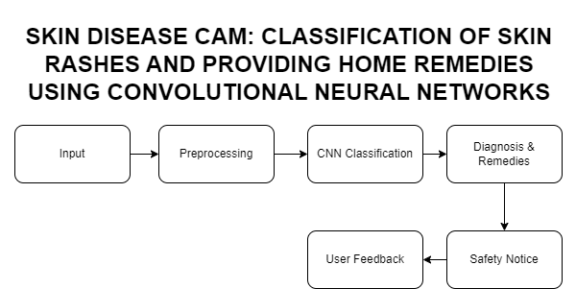

Figure 1: Conceptual Framework

1. **Input:** 
   1. A user captures a digital image of a skin rash using a smartphone camera.
   2. The image must be clear, well lit, and detailed enough to show the rash clearly.
2. **Preprocessing:**
   1. The image is preprocessed to enhance quality (e.g., resizing, noise reduction, contrast adjustment) using OpenCV.
   2. This ensures the image is suitable for analysis by the Convolutional Neural Network (CNN).
3. **Classification Using CNN:** 
   1. The preprocessed image is fed into a Convolutional Neural Network (CNN), the core component of the system.
   2. The CNN, trained on diverse datasets of skin rashes, classifies the rash into specific categories (e.g., eczema, psoriasis, fungal infections) based on visual patterns like color, texture, and shape.
4. **Diagnosis and Home Remedies:** 
   1. The system provides a predicted diagnosis along with a confidence score.
   2. Based on the diagnosis, it suggests evidence based home remedies, including:
      1. Step by step instructions for use.
      2. Precautions to avoid worsening the condition.
5. **Safety and Limitations:** 
   1. A safety notice is displayed, emphasizing that the system is not a substitute for professional medical evaluation.
   2. Users are advised to consult a doctor if:
      1. The rash is severe or worsening.
      2. Home remedies prove ineffective.
      3. Additional symptoms (e.g., fever, pain) are present.
6. **User Feedback:** 
   1. After using the system, the user is prompted to rate their satisfaction
   2. Feedback is collected to evaluate the system’s efficacy and identify

# CHAPTER III METHODOLOGY

## Research Design

This study adopts a developmental and applied research approach as it designs and develops a mobile-based system that classifies acne vulgaris, keratosis pilaris, psoriasis, leprosy, atopic dermatitis, and warts using Convolutional Neural Networks (CNNs), with educational home-remedy information. The work is intended to address real-world access gaps in underserved regions such as Zamboanga City by delivering offline on-device inference and clear guidance. The overall process follows the typical pipeline used in mobile CNN systems for dermatology [6] and integrates current transfer-learning fine-tuning practices to ensure fair comparison among architectures [21]–[25].

The development process involves obtaining and preparing datasets, training and evaluating multiple CNN architectures, selecting the best-performing model for on-device use, integrating it into the Android prototype, and conducting a structured (non-clinical) system evaluation with expert review and basic usability checks.

## Data Source

The dataset for this study consists of publicly available dermatological images supplemented by local contributions, restricted to the six target conditions.

* DermNet NZ Database – publicly accessible dermatology images.
* ISIC Archive – international repository; images mapped to the six target labels where applicable.
* Roboflow Collections – curated and cleaned sets relevant to the six diseases (annotations reviewed and standardized).
* Locally Gathered Images (Zamboanga City) – de-identified images collected in collaboration with clinicians/clinics (with permissions).

Images are harmonized to improve model consistency and robustness while avoiding leakage between training and validation data.

* Preprocessing: resize to 224×224 with center crop/pad as needed; normalize to ImageNet mean/std.
* Augmentations (train only): random horizontal flip, ±15° rotation, brightness/contrast jitter, mild Gaussian noise; class-balanced sampling when needed.
* Quality control: exclude blurred/low-resolution or duplicate images; ensure a single dominant lesion region is visible.
* Leakage control: for local images, keep photos from the same patient within the same split.
* Skin-tone annotation: where available, assign Fitzpatrick skin type (I–VI) labels to support fairness analysis across skin tones.

Five ImageNet-initialized CNN architectures are compared under a consistent training policy to ensure a fair evaluation, following best practices for fine-tuning depth, hyperparameters, and unfreezing strategy [21]–[25].

* Architectures compared: MobileNetV2, EfficientNetB0, ResNet50, InceptionV3, DenseNet121.
* Classifier head (uniform): global pooling → dropout (≈0.2–0.4) → Dense(#classes) + softmax.
* Training policy:
  + Linear probe: freeze the backbone and train only the classification head for ≈5–10 epochs.
  + Progressive unfreezing: unfreeze upper blocks and then all layers; apply a lower learning rate to the backbone than to the head.
  + Typical hyperparameters: Adam (lr ≈ 1e-3) or SGD+momentum (lr ≈ 1e-2, momentum 0.8–0.9); batch ≈ 32; early stopping based on validation macro-F1.
* Evaluation setup: Stratified 5-Fold Cross-Validation to preserve class balance; report mean ± SD.
* Metrics:
  + Primary: macro-F1 (to balance classes).
  + Secondary: accuracy, precision, recall, per-class F1, confusion matrices.
  + On-device constraints: model size (MB) and inference time (ms) on a mid-range Android device.

From cross-validated results, the model is selected based on a Pareto balance of macro-F1, latency, and size (favoring smaller/faster when accuracy differences are ≤ ~1% absolute). The chosen model is exported to TensorFlow Lite (.tflite) with post-training quantization (dynamic or int8), and any accuracy change after conversion is verified to remain within ~1–2% absolute on a held-out validation split. On-device latency and file size are re-measured post-quantization.

The Android prototype captures images via camera or gallery and performs offline inference using the TFLite Interpreter, returning the top-1 class with confidence. Educational home-remedy information from reputable sources (medical encyclopedias, published books, peer-reviewed articles) is shown with a clear medical disclaimer and guidance to consult professionals for severe, persistent, or uncertain cases.

To keep the study non-interventional, the evaluation consists of expert review and basic usability checks rather than clinical trials.

* Dermatologist review: a stratified sample of predictions and remedy texts is rated for appropriateness; discrepancies inform content or threshold adjustments.
* Usability (brief, non-clinical): small user test focusing on photo-capture success, task completion, time-to-result, and perceived clarity.

No clinical trials or prospective interventions are conducted. Locally gathered images are de-identified with appropriate permissions. The application includes an explicit statement that it is not a diagnostic tool and does not replace professional medical care.

**Skin Disease Includes**

|  |  |
| --- | --- |
| **Category** | **Examples** |
| 1.Fungal Infections | * Tinea Infection(Ringworm) |
| 2. Bacterial Infections | * Impetigo |
| 3. Viral Infections | * Warts (Kulugo) |
| 4.Allergic and Inflammatory Conditions | * Eczema (Atopic Dermatitis) |
| 5. Heat Related Conditions | * Prickly Heat (Bungang Araw) |
| 6. Parasitic Infestation | * Scabies (Sarcoptes scabiei) |

## Software Development

The software development phase focuses on integrating the selected CNN model into a fully functioning Android mobile application.

The selected model will then undergo:

*Fine tuning:* Retraining on the full training dataset (after cross validation) to maximize performance.

*Quantization:* Reducing the model size and improving inference speed by applying post training quantization techniques (such as 8 bit integer quantization) using TensorFlow Lite tools.

*Validation:* Final testing on unseen data to ensure stability and readiness for deployment.

The final model will be exported as a TensorFlow Lite (TFLite) format file (.tflite) for easy integration into Android applications.

Model Deployment in Mobile Application

The deployment involves embedding the .tflite model into the Android Studio project. TensorFlow Lite's interpreter will be used inside the app to:

* Load the model when the app starts.
* Pass preprocessed image input to the model for real time prediction.
* Interpret model output to display the predicted skin condition and its probability score.
* Handle errors and fallback scenarios if predictions fail.

Optimizations such as GPU acceleration and multi threaded inference will be considered to enhance prediction speed, especially for mid range mobile devices common in Zamboanga City.

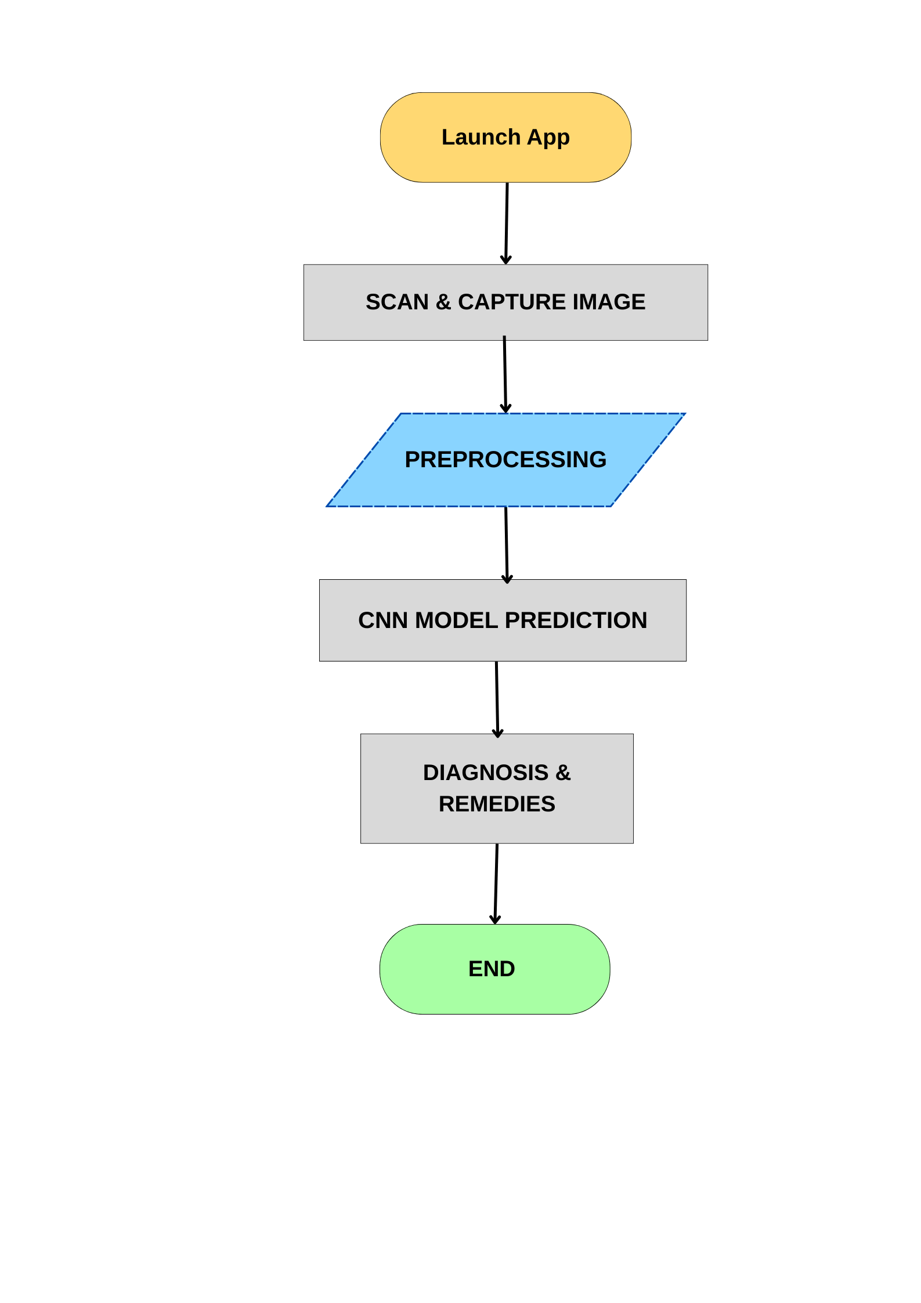

Features and Modules of the Mobile Application

The mobile app, Skin Disease Cam, will include the following core features:

|  |  |
| --- | --- |
| **Feature/Module** | **Description** |
| **Landing Page** | Displays app introduction and disclaimer about AI based diagnosis. |
| **Scan Page** | Options to capture or upload images of skin conditions. Allows retakes. |
| **Diagnosis Display** | Shows the AI predicted skin disease with a medical disclaimer. |
| **Home Remedies and Treatment Suggestions** | Lists over the counter treatments and verified home remedies. |
| **Records page** | View and manage past diagnoses. |

## Developmental Tools

The following software and frameworks will be utilized in the development and deployment of the Skin Disease Cam application:

Table 4: Developmental Tools and Cost

| **Name** | **Purpose** | **Price** | **Quantity** | **Total** |
| --- | --- | --- | --- | --- |
| TensorFlow & Keras | CNN model training and deployment |  |  |  |
| OpenCV | Image preprocessing |  |  |  |
| Python | Machine learning and backend scripting |  |  |  |
| Android Studio | Mobile app development |  |  |  |
| TensorFlow Lite | Deploying CNN model on mobile devices |  |  |  |
| Firebase | Storing user feedback and image data |  |  |  |
| **Grand Total** | | | |  |

# CHAPTER IV RESULTS AND DISCUSSION

<Results should be presented in a logical sequence, referencing the specific objectives and the execution of the proposed methodology, using text, tables, graphs, and figures. The discussion of results should include clear descriptions and explanations of observed phenomena, trends, and other relevant information. It is important to note that results and discussion should not be separated; each result must be immediately followed by its corresponding discussion.>

# CHAPTER V CONCLUSION AND RECOMMENDATIONS

## Conclusion

<The conclusion should present a summary of the important contributions of the study>

## Recommendations

<Future related works should be cited here>

# References

[1] T. P. A. Marasigan, M. A. Lavadia, and W. Salas Walinsundin, "Knowledge, attitude, perception and practices of primary care physicians regarding common dermatological diseases: A cross sectional study," J. Philippine Dermatol. Soc., Nov. 2022.

[2] I. Kousis, I. Perikos, I. Hatzilygeroudis, and M. Virvou, "Deep Learning Methods for Accurate Skin Cancer Recognition and Mobile Application," Electronics, vol. 11, no. 9, p. 1294, Apr. 2022, doi: 10.3390/electronics11091294.

[3] J. Mathews, "Improving Mobile Based Early Skin Disease Diagnosis for Melanin Rich Skins," University of Malawi, Zomba, Malawi, 2023.

[4] S. N. Ali et al., "A web based mpox skin lesion detection system using state of the art deep learning models considering racial diversity," Biomed. Signal Process. Control, vol. 98, p. 106742, 2024, doi: 10.1016/j.bspc.2024.106742.

[5] Department of Health, "National Objectives for Health, Philippines 2023 2028," DOH, Manila, Philippines, 2023.

[6] A. Sallam and A. E. Ba Alawi, "Mobile based Intelligent Skin Diseases Diagnosis System," in 2019 First International Conference of Intelligent Computing and Engineering (ICOICE), Hadhramout, Yemen, 2019, pp. 1–6, doi: 10.1109/ICOICE48418.2019.9035129.

[7] A. Nawar, N. K. Sabuz, S. M. T. Siddiquee, M. Rabbani, A. A. Biswas, and A. Majumder, "Skin Disease Recognition: A Machine Vision Based Approach," in 2021 7th International Conference on Advanced Computing and Communication Systems (ICACCS), Coimbatore, India, 2021, pp. 1029–1034, doi: 10.1109/ICACCS51430.2021.9441980.

[8] N. S. ALKolifi and A. LEnezi, "A Method Of Skin Disease Detection Using Image Processing And Machine Learning," Procedia Computer Science, vol. 163, pp. 85–92, 2019, doi: 10.1016/j.procs.2019.12.090.

[9] P. Upadya, S. Sampathila, N. Hebbar, and S. B. Pai, "Machine learning approach for classification of maculopapular and vesicular rashes using the textural features of the skin images," Cogent Engineering, vol. 9, no. 1, 2021, doi: 10.1080/23311916.2021.2009093.

[10] G. V. Gaurav, A. K. Bhoi, and N. Mehta, "Home Remedies in Dermatology," Indian Dermatol. Online J., vol. 14, no. 6, pp. 864 870, Nov. Dec. 2023, doi: 10.4103/idoj.idoj_166_23.

[11] C. A. V. Abellera, R. R. Fiscal, and S. P. Mesina, "Ethnopharmacological Survey of Medicinal Plants Used in Treating Skin Diseases in the Province of Laguna, Philippines," Asia Pac. J. Multidiscip. Res., vol. 7, no. 3, pp. 86 95, Aug. 2019.

[12] R. Birudala, S. H. Nagaraj, K. B. Bannala, and V. ShivaKumar, "Over the counter medication: a study among dermatology outpatients," Int. J. Res. Dermatol., vol. 5, no. 3, pp. 607 610, Jul. Sep. 2019, doi: 10.18203/issn.2455 4529.IntJResDermatol20193238.

[13] P. S. Shenefelt, "Herbal Treatment for Dermatologic Disorders," in Herbal Medicine: Biomolecular and Clinical Aspects, 2nd ed., Boca Raton, FL, CRC Press/Taylor & Francis, 2011. [Online]. Available: <https://www.ncbi.nlm.nih.gov/books/NBK92761/>.

[14] V. R. Allugunti, "A machine learning model for skin disease classification using convolution neural network," Int. J. Comput. Prog. Database Manag., vol. 3, no. 1, pp. 141 147, Dec. 2021, doi: [10.33545/27076636.2022.v3.i1b.53](https://doi.org/10.33545/27076636.2022.v3.i1b.53).

[15] A. S. Khan and S. Al Habsib, "Machine Learning in Computer Vision," Procedia Computer Sci., vol. 167, pp. 1444 1451, 2020, doi: 10.1016/j.procs.2020.03.355.

[16] R. F. Genuino et al., "Understanding Perceptions and Experiences on Acceptability of Oral Ivermectin, Topical Permethrin, and their Combination in the Treatment of Adult Filipino Patients with Scabies: A Multiple Case Study," AMP, vol. 58, no. 17, pp. 24 41, Sep. 2024, doi: 10.47895/amp.v58i17.9703.

[18] M. D. Sun, "Digital Skin Imaging Applications: Assessment of Image Acquisition Technique Features, Post Acquisition Image Utilization, and Technology Standards," Master's Thesis, Icahn School of Medicine at Mount Sinai, 2023, doi: 10.1111/srt.13195.

[19] Z. Shajirat, R. Parandeh, N. Pazyar, and A. A. Azizi, "Developing and Evaluating a Mobile Based Teledermatology System for Skin Lesion Diagnosis in Iran," Sci. Rep., vol. 14, p. 20320, 2024, doi: 10.1038/s41598 024 71340 3.

[20] A. Magdy, H. Hussein, R. F. Abdel Kader, and K. A. E. Salam, "Performance Enhancement of Skin Cancer Classification Using Computer Vision," IEEE Access, vol. 11, pp. 72120 72133, 2023, doi: 10.1109/ACCESS.2023.3294974.

[21] N. Tajbakhsh, J. Y. Shin, S. R. Gurudu, R. T. Hurst, C. B. Kendall, M. B. Gotway, and J. Liang, “Convolutional Neural Networks for Medical Image Analysis: Full Training or Fine Tuning?,” *IEEE Transactions on Medical Imaging*, vol. 35, no. 5, pp. 1299–1312, 2016.

[22] B. Chu, V. Madhavan, O. Beijbom, J. Hoffman, and T. Darrell, “Best Practices for Fine-Tuning Visual Classifiers to New Domains,” in *ECCV Workshops*, 2016, pp. 435–442.

[23] H. Li, P. Chaudhari, H. Yang, M. Lam, A. Ravichandran, R. Bhotika, and S. Soatto, “Rethinking the Hyperparameters for Fine-tuning,” in *Proc. ICLR*, 2020.

[24] I. Kandel and M. Castelli, “How Deeply to Fine-Tune a Convolutional Neural Network: A Case Study Using a Histopathology Dataset,” *Applied Sciences*, vol. 10, no. 10, 2020.

[25] A. Davila, J. Colan, and Y. Hasegawa, “Comparison of Fine-Tuning Strategies for Transfer Learning in Medical Image Classification,” *arXiv:2406.10050*, 2024.

**Appendix A: Data Collected**

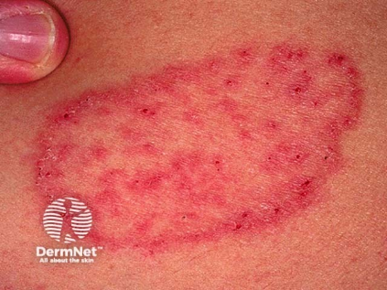Image 1.1: Tinea Corporis (or ringworm):

Image 1.2: Tinea Corporis (or ringworm):

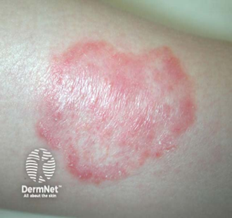

Image 2.1: Keratosis Pilaris

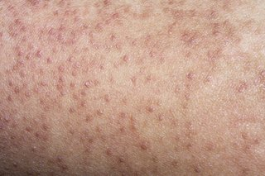

Image 2.2: Keratosis Pilaris

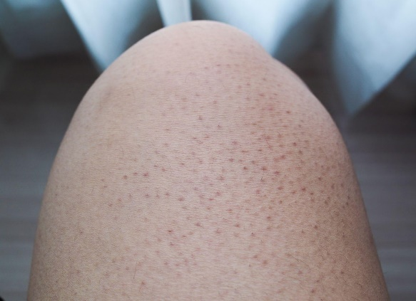

Image 3.1: Atopic Dermatitis

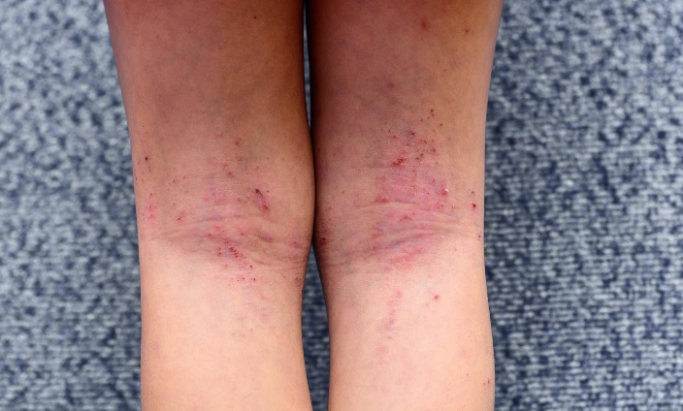

Image 3.2: Atopic Dermatitis

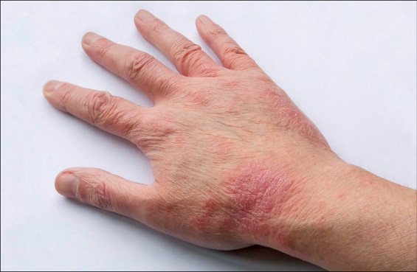

Image 4.1: Impetigo

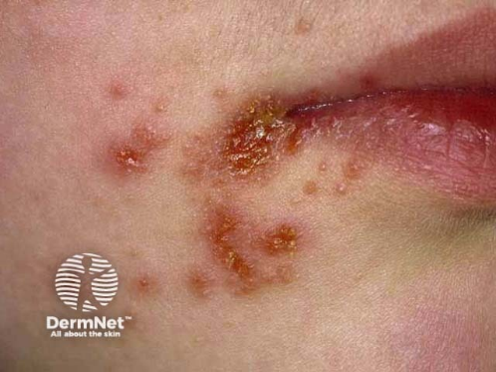

Image 4.2: Impetigo

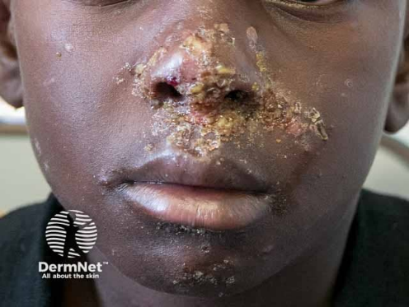

Image 5.1 : Prickly Heat (or Heat Rash)

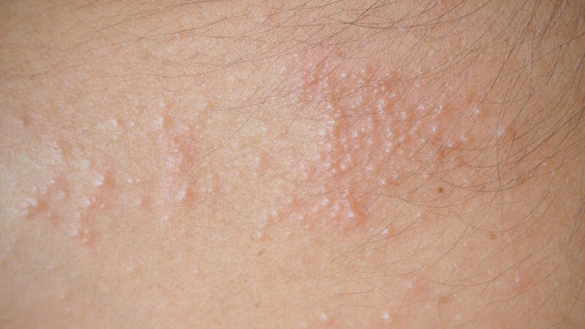

Image 5.2 : Prickly Heat (or Heat Rash)

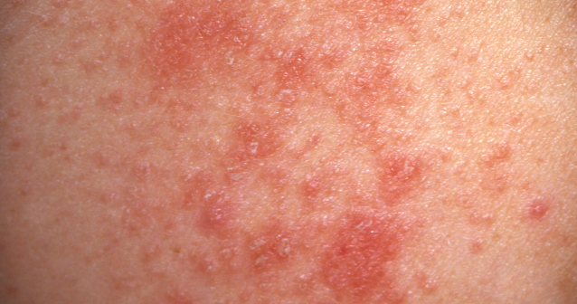

Image 6.1 : Warts

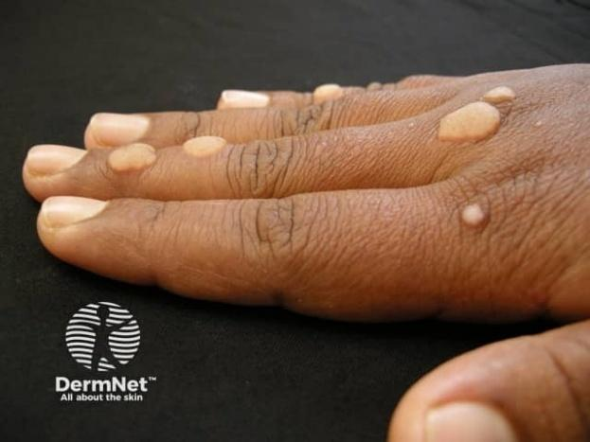

Image 6.2 : Warts

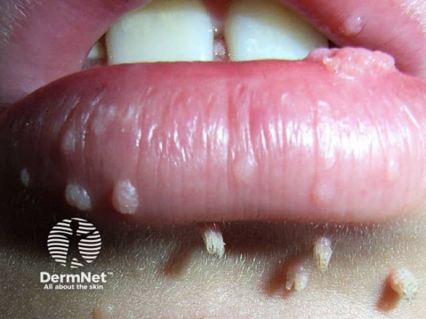

Image 7.1 : Sarcoptes Scabiei (or Scabies)

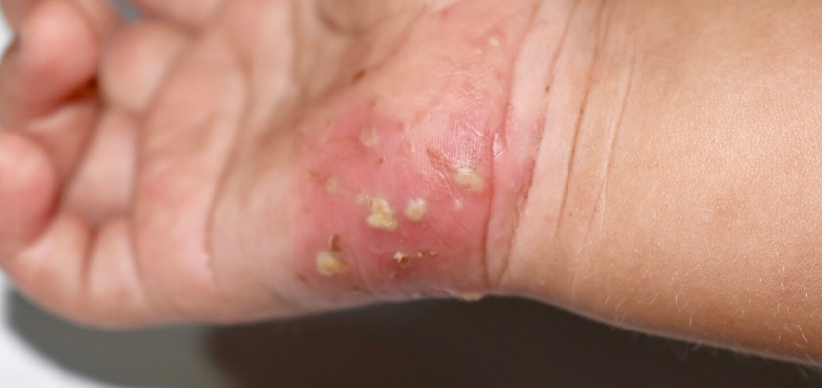

Image 7.2 : Sarcoptes Scabiei (or Scabies)

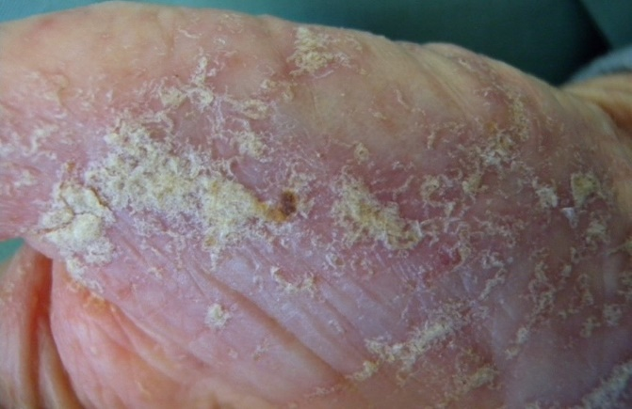

**Appendix B: System Design**

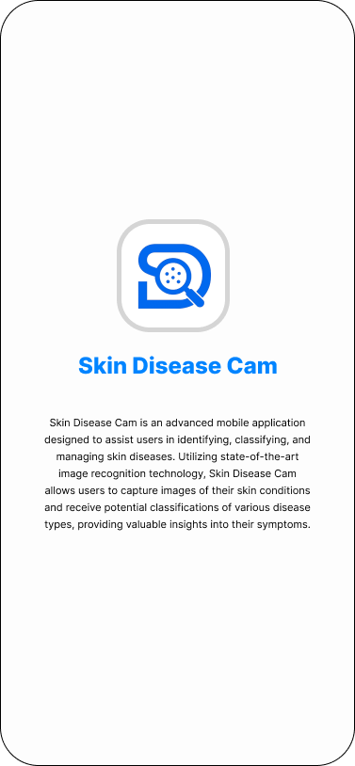

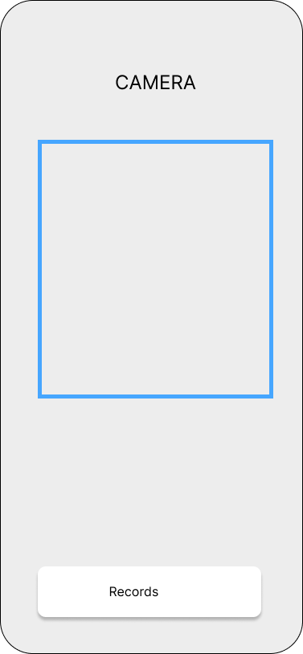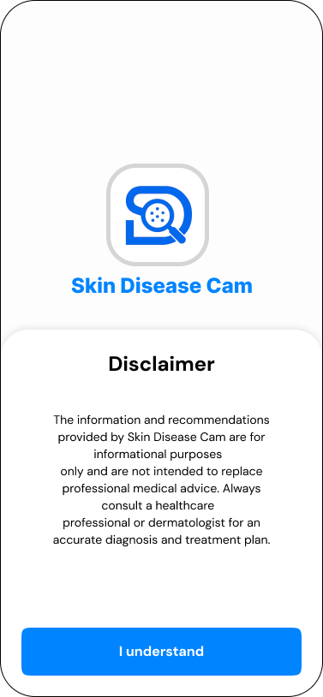

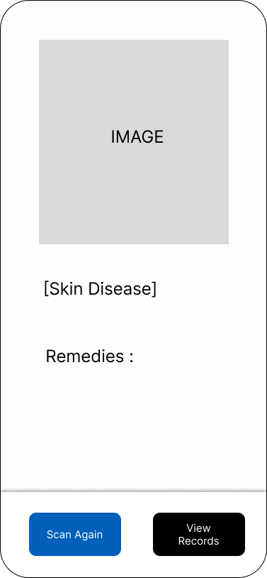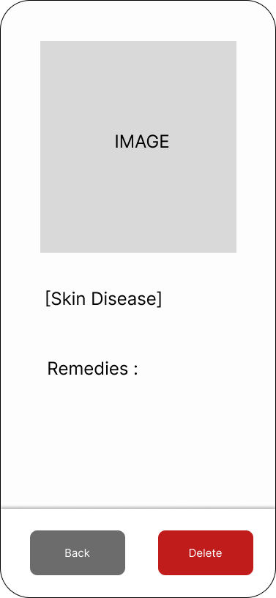

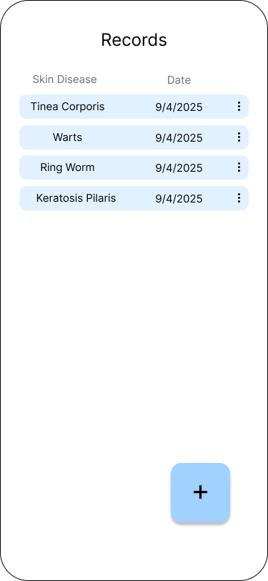

**Appendix C: Evaluation Tool**

**Model Performance Evaluation:**

This part focuses on comparing the five CNN models based on objective performance metrics.

|  |  |
| --- | --- |
| **Metric** | **Description** |
| **Accuracy** | Measures the proportion of correctly predicted cases overall predictions. |
| **Precision** | Measures how many of the positively predicted cases were actually correct. |
| **Recall** | Measures how many actual positive cases were correctly predicted. |
| **F1 Score** | Harmonic mean of precision and recall. |
| **Training Time** | Time taken to complete model training. |
| **Model Size** | Total file size of the trained model (for mobile deployment suitability). |
| **Inference Time** | Average time taken to classify a single image. |

These metrics will be recorded for each CNN model (MobileNetV2, EfficientNetB0, ResNet50, InceptionV3, DenseNet121) and the best will be chosen based on a combination of accuracy, speed, and efficiency.

**Mobile App Evaluation (Post Model Selection)**

This part assesses usability, accuracy, and satisfaction once the final model is integrated into the mobile app.

Evaluation Form (User Perspective)

* Rate each item from 1 (Strongly Disagree) to 5 (Strongly Agree)

|  |  |  |  |  |  |
| --- | --- | --- | --- | --- | --- |
| **Criteria** | **1** | **2** | **3** | **4** | **5** |
| The app is easy to use |  |  |  |  |  |
| The instructions are clear |  |  |  |  |  |
| The camera functionality works properly |  |  |  |  |  |
| The app accurately identified the skin rash |  |  |  |  |  |
| The remedies provided are helpful |  |  |  |  |  |
| The information is understandable |  |  |  |  |  |
| The results are displayed quickly |  |  |  |  |  |
| I would recommend this app to others |  |  |  |  |  |
| Overall satisfaction with the app |  |  |  |  |  |

**Expert Validation Checklist (Dermatologists)**

|  |  |  |  |
| --- | --- | --- | --- |
| **Evaluation Point** | **Yes** | **No** | **Comments** |
| Diagnoses are medically acceptable |  |  |  |
| Remedies align with clinical best practices |  |  |  |
| App handles ambiguous/uncertain cases responsibly |  |  |  |
| Disclaimers and safety notices are appropriate |  |  |  |

**Appendix D: Relevant Source Code**

**Appendix E: Ethical Clearance**

**Appendix F: Plagiarism Report**

**Appendix G: Research Critique and Editing Certificate**

**Appendix H: Curriculum Vitae**

