Republic of the Philippines

Western Mindanao State University

**College of Computing Studies**

DEPARTMENT OF COMPUTER SCIENCE

Zamboanga City

**SAMPLE THESIS TITLE   
SAMPLE THESIS TITLE**

A Thesis Presented to the Faculty of

Department of Computer Science

College of Computing Studies

In Partial Fulfillment of the Requirements for the Degree of

Bachelor of Science in Computer Science

**<FIRST_NAME> <MI> <LAST_NAME A>**

**<FIRST_NAME> <MI> <LAST_NAME B>**

Researchers

**<FIRST_NAME> <MI> <LAST_NAME ADVISER>**

Adviser

<Month and Year of Expected Graduation>

Republic of the Philippines

Western Mindanao State University

**College of Computing Studies**

DEPARTMENT OF COMPUTER SCIENCE

Zamboanga City

# Approval Sheet

The Thesis attached hereto, entitled **“<THESIS TITLE>”**, prepared and submitted by **<RESEARCHERS (FIRST NAME MI LAST NAME)>**, in partial fulfillment of the requirements for the degree of Bachelor of Science in Computer Science, is hereby **recommended for Oral Examination**.

**<ADVISER>**

Adviser

**APPROVED** by the Oral Examination Committee on **_______________** with a rating of **PASSED**.

**<PANEL 1>**

Chairperson

**<PANEL 2>**

Member

**<PANEL 3>**

Member

**Accepted** in partial fulfillment of the requirements for the degree of **Bachelor of Science in Computer Science**

**MS. LUCY FELIX-SADIWA, MSCS**

Head, Department of Computer Science

**RODERICK P. GO, Ph.D.**

Dean, College of Computing Studies

# Acknowledgment

This section recognizes the persons and organizations who assisted the proponents in the completion of the thesis. Acknowledgments should be expressed simply and tactfully.

# Abstract

This is a presentation of the thesis summary. Included in the thesis abstract is the statement of the problem, objective/s of the study, methodology, major findings, significance, and conclusions. The abstract should not be less than 200 words but not exceed 500 words and must be in single line. Normally the abstract does not include any reference to the literature.

**Keywords:** <provide at least 3 keywords, separated by a comma, which could be obtained from the research paper itself>

# Table of Contents

Approval Sheet i

Acknowledgment ii

Abstract iii

Table of Contents iv

List of Figures vi

List of Tables vii

List of Appendices viii

CHAPTER I INTRODUCTION 1

Background of the Study 1

Statement of the Problem 2

Objectives 2

Scope and Limitations 3

Significance of the Study 3

Definition of Terms 3

CHAPTER II REVIEW OF RELATED LITERATURE 6

Related Studies 6

Synthesis 6

Conceptual Framework 7

Theoretical Framework 11

CHAPTER III METHODOLOGY 12

Research Design 12

Respondents 12

Data Gathering Instruments, Techniques, and Procedures 12

Statistical Tools 13

Analytical Tools 13

Technical Tools 13

Software Process Model 14

System Architecture 14

Deployment and Testing 14

CHAPTER IV RESULTS AND DISCUSSION 15

CHAPTER V CONCLUSION AND RECOMMENDATIONS 16

Conclusion 16

Recommendations 16

References 18

# List of Figures

Figure 1: Sample Conceptual Framework 7

Figure 2: Sample Conceptual Framework 8

# List of Tables

Table 1: Definition of Terms 4

Table 2: Synthesis 6

# List of Appendices

Appendix A: Gantt Chart 18

Appendix B: Survey Form 19

Appendix C: User Interface 20

Appendix D: Test Cases 21

Appendix E: Evaluation Tool 22

Appendix F: Relevant Source Code 23

Appendix G: User Manual 24

Appendix H: Plagiarism Report 25

Appendix I: Research Critique and Editing Certificate 26

Appendix J: Curriculum Vitae 27

# CHAPTER I INTRODUCTION

## Background of the Study

The background of the study establishes the setting of the investigation. This section describes why this particular research subject is relevant and necessary to understand the key components of the study. Usually, the background constitutes the opening portion of a research article/thesis and justifies the need for performing the investigation, and outlines what the study wants to achieve.

It is customary for the author to provide a concise overview of the historical developments in the literature that led to the current area of research. The research should indicate how various disciplines are related as well as what features of each area will be explored if it is multidisciplinary.

Researchers should quickly summarize the most significant advancements in their study area and indicate the most significant gaps that need to be filled. In other words, this part should serve as a high-level summary of your research. The following is how the section should be organized:

* What exactly is known about the subject?
* What are the gaps or missing links that need to be filled to go forward?
* What is the relevance of filling in such gaps in knowledge?
* What is the purpose of your research and what are your hypotheses?

Consequently, the background section should include broad information on the topic of your research and should stress the primary objectives of your study to be effective. Please make certain that you just explain the most important and relevant components of the research that have led you to your goals. Do not go into detail about them because this should be done in the literature review part of the paper.

## Statement of the Problem

When writing a persuasive statement of the problem, it is common to break it down into three sections: Part A (The ideal): Describes the desired aim or ideal scenario; illustrates how things should be. Part B (The reality): Describes a condition that prevents the goal, state, or value in Part A from being achieved or realized at this time; explains how the current situation falls short of the goal or ideal. Part C (The consequences): Identifies the way you propose to improve the current situation and move it closer to the goal or ideal.

## Objectives

This section summarizes what is to be achieved by the study. This usually contains general and specific objectives.

The general objective of this study is to….

Specifically, the study will:

* Specific 1
* Specific 2
* Specific 3
* Specific 4

## Scope and Limitations

This section sets the parameters of the study. The scope should indicate what the system could do, while the limitation should state otherwise. The coverage and boundaries of the system implementation should be indicated here.

After the system has been developed, the proponent may also indicate the

inherent problems encountered in the development of the system.

## Significance of the Study

This section describes or explains the potential value of the study and findings. It should be clear here, the target audience for the study and how the results will be beneficial for them. It answers the question – Why is it important? To whom will it be beneficial?

## Definition of Terms

Only terms, words, or phrases which have special or unique meanings in the study are defined. Provide at least 15. Definitions may be taken from encyclopedias, books, magazines and newspaper articles, dictionaries, and other publications but the researcher must acknowledge his sources. Definitions taken from published materials are called conceptual or technical definitions.

*Note: To add table caption, go to References tab then click ‘Insert Caption’ and then change label to table. Once done go to List of Tables then Update Table.*

Table 1: Definition of Terms

| **Term** | **Definition** |
| --- | --- |
|  |  |
|  |  |
|  |  |
|  |  |
|  |  |
|  |  |
|  |  |
|  |  |
|  |  |
|  |  |
|  |  |
|  |  |
|  |  |
|  |  |
|  |  |

# CHAPTER II REVIEW OF RELATED LITERATURE

## Related Studies

Discuss at least 10, local and foreign literature and studies, combined. Do not forget to cite the references where these are taken. These should be within a five-year validity from the date of the project proposal.

**Foreign Literature**

1. E-Logic Trainer Kit : Development of an Electronic Educational Simulator and Quiz Kit for Logic Gate Combinational Circuit by using Arduino as Application (2019).

This study talks about how new technology is being used to improve education. Instead of just traditional teaching methods, schools are now using things like simulators and quiz kits in classrooms. These help teachers give better tests and show real-life examples of what they teaching. It’s especially helpful for making lectures more interesting to students. This study focuses on a specific example: a new training kit called the e-logic trainer kit (e-kit). It uses technology like Arduino mega 2560 microcontroller, a keypad, and a display to help students learn about logic gates. The kit lets students practice making different logic circuits and see how they work. Researchers tested the kit at a university in Malaysia.

Reference: <https://online-journals.org/index.php/i-joe/article/view/11410>

1. Development and Evaluation of an Educational Game to Practice the Truth Tables of Logic (2019).

Many students struggle with the logic course in the first year of a Computer Science Bachelor program. They find logic's formal and abstract concepts hard to grasp, leading to procrastination and a lack of understanding. Previous attempts to help students have been ineffective. To address this, the researchers developed an educational game based on an existing card game, adapted for proposition logic and turned into a mobile app. They iteratively improved the game based on feedback, finding it to be well-suited for students and a good replacement for some traditional exercises. However, they discovered that simply making the game available wasn't enough; it needed to be integrated into the course to ensure all students used it.

Reference: <https://ieeexplore.ieee.org/abstract/document/8820859>

1. A Gamified Approach on Learning Logic Gates to Improve Student's Engagement   
     
   Reference:  
   <https://iopscience.iop.org/article/10.1088/1757-899X/803/1/012007/meta>

## Synthesis

This is the summary of the related literature showing the gap and the need to develop/improve a system.

Table 2: Synthesis

| **Feature** | **Study 1** | **Study 2** | **Study 3** | **Study 4** | **Study 5** | **Proposed Study** |
| --- | --- | --- | --- | --- | --- | --- |
| 1. Online App | **🗸** |  | **🗸** | **🗸** |  | **🗸** |
|  |  |  |  |  |  |  |
|  |  |  |  |  |  |  |
|  |  |  |  |  |  |  |
|  |  |  |  |  |  |  |
|  |  |  |  |  |  |  |

## Conceptual Framework

This is an early phase of the design process, in which the broad outlines of the function and form of something are articulated. It includes the design of interactions, experiences, processes, and strategies. It involves an understanding of people's needs - and how to meet them with products, services, & processes. Common artifacts of conceptual design are concept sketches and models.

*Note: To add figure caption, go to References tab then click ‘Insert Caption’ and then change label to figure. Once done go to List of Figures then Update Table.*

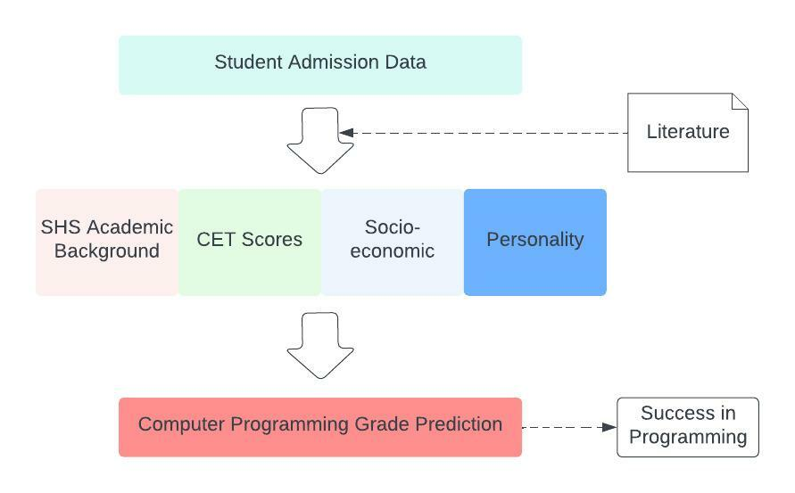

Figure 1: Sample Conceptual Framework

The researcher will be using students’ academic background, college entrance test scores, and socioeconomic status based on related admission data as predictors. The researcher will also include personality test based on RIASEC (Realistic, Investigative, Artistic, Social, Enterprising, and Conventional), psychologist John Holland’s model of career choice. Study habits will also be looked into as possible independent variables to predict students' success in Computer Programming 1 and 2. This result will be used to determine whether a student will pre-qualify or not to the program.

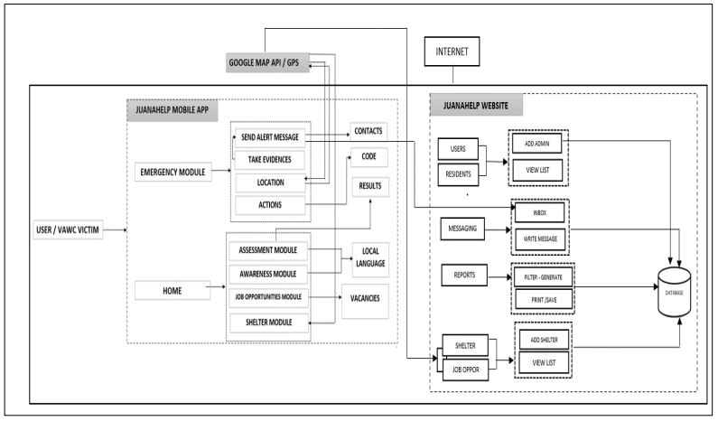

Figure 2: Sample Conceptual Framework

The developed system has user interface, which is the mobile application and administrator interface in the form of website as shown in figure 1. The figure shows that users are the VAWC victims and administrator is the official of Philippine National Police – Women’s Desk or the Gender and Development Official.

The "e-reporting mobile application for violence against women and their children" and "web application" were divided into two categories with different modules within the conceptual framework. The mobile application for e-reporting has five Modules: the emergency module, awareness module, assessment module, job opportunities module, and shelter module. The system features have administrators to track incidences of VAWC. The user must register in order to log in to the application.

The “emergency module” is the reporting portion of the mobile application for the user to send help to the pre-selected individuals in their contacts saved in the system. E-reporting has the capabilities to include pictures, getting the locations, and sending reports. It includes the “awareness module” which contains information about their legal rights, legal assistance, and legal defense. This module's content was translated into tagalog to make it simpler for them to understand. The user can evaluate whether they are being abused by their partner using the “assessment module”. To get the results, the user must choose a response to the application's provided question. The assistance services for VAWC victims are displayed in the “job opportunities” module. This element of the support program helps the victim begin to meet their financial needs again. The user of this feature may utilize the application to look for open positions. The “shelter module” is one of the mobile application's additional assistance features. In this module, the victim can hover on a map the location of the shelter that is offered to them if they need a place to remain temporarily away from their attacker.

The “website applications” allows the victim to be monitored by the appropriate

authorities. The officials (administration) can keep tabs on the VAWC incidents in a certain location, track the data by municipality, and update the victim assistance services. There are two different categories of administrators: the super administrator, who is a Gender and Development Provincial Official or PNP Laguna Women Desk Officer, and the Administrator, who is a Gender and Development Municipal PNP Women Desk Officer. The super admin can get the consolidated report of Laguna while the admin can only view the report for their municipalities.

The system's “home” page displays a dashboard with information on the number of registered admin user accounts, registered resident accounts, total messages received, and the number of account logs. Additionally, it views a graph showing the number of VAWC incidents on a daily and monthly basis, the number of incidents in each municipality, and commonly asked questions. The system's “user” interface allows users to view a list of administrators, add new administrators for certain towns, and archive. The “residents” option allows users to browse the list of existing inhabitants as well as add new ones. The user's ability to respond to messages and victim alert messages is provided through the “messaging” feature. The Provincial GAD official or Provincial PNP Women Desk Officer may generate reports using the “reports” option feature. The resulting report can be printed and saved, and it can be filtered by date. The Provincial PNP Women Desk Officer or Provincial GAD official can view reported occurrences using the “incident maps” option feature. It displays both the prior and the most recent reports to the locations where the incident is said to have occurred. The “add and confirm shelter” option features allow the Provincial PNP Officer or Provincial GAD official to verify the list of shelters in the region and add new shelter lists to the map. Through “job opportunities”, the Provincial PNP Women Desk Officer or Provincial GAD official can modify job data, add users, and update job openings.

## Theoretical Framework

This section discusses the theories and models other researchers have already developed. The goal of a theoretical framework is to present and explain this information.

There may be many different theories about your topic, so the theoretical framework also involves evaluating, comparing, and selecting the most relevant ones. Typically, you’ll present your theoretical framework in written form, although sometimes it will make sense to utilize some visuals to show how different theories relate to each other.

# CHAPTER III METHODOLOGY

## Research Design

The research design refers to the overall strategy that you choose to integrate the different components of the study coherently and logically, thereby, ensuring you will effectively address the research problem; it constitutes the blueprint for the collection, measurement, and analysis of data. Note that your research problem determines the type of design you can use, not the other way around.

The different types of research design could be obtained from the link specified here: (<https://library.sacredheart.edu/c.php?g=29803&p=185902>)

## Respondents

Discuss the profile of the people whom you have invited for a survey to validate the need for the system development and the people who evaluated the software. A copy of the questionnaire must be included in the Appendix B and E.

## Data Gathering Instruments, Techniques, and Procedures

This section describes the instruments (interviews, questionnaires, surveys, observation, experiments, or reports), techniques (face-to-face, online, mail, and/or phone), and procedures for data gathering.

This section also documents for secondary data collection is referred to as the gathering of second-hand data collected by an individual who is not the original user. It is the process of collecting data that is already existing.

## Statistical Tools

This section includes statistical tools used in planning, designing, collecting data, analyzing, drawing relevant interpretations, and reporting research findings throughout a research project. Examples include the F-test, the t-test, and regression analysis, to name a few.

## Analytical Tools

Use DFD, ERD, and any system flowchart/diagram for this section. The discussion of these diagrams will be written in this section.

## Technical Tools

Includes discussion of different tools or components (hardware and/or software) used for the development and completion of the system/project. This section also discusses the different libraries and/or frameworks used in the development.

## Software Process Model

Specify the software development methodology used by the proponent. For example, Scrum Methodology. Waterfall methodology is discouraged. Discuss first the characteristics of the methodology used, and then discuss in detail the activities done by the proponent for each of the stages of the methodology. The illustration should be shown in this section.

## System Architecture

Illustrate and discuss the conceptual model that defines the structure, behavior, and more views of a system. An architecture description is a formal description and representation of a system, organized in a way that supports reasoning about the structures and behaviors of the system. The illustration should be shown in this section.

## Deployment and Testing

In this section, you will outline the plan for deploying the project and putting it into use by the client or target users. Additionally, you will discuss the testing strategies employed to ensure the reliability and functionality of the system. The corresponding Test Cases should be included in the Appendix.

# CHAPTER IV RESULTS AND DISCUSSION

In this section, you provide a comprehensive discussion of the results obtained from the project/research, supported by figures that illustrate key findings. Your analysis centers around addressing the specific objectives outlined in Chapter 1 and understanding the implications of the achieved outcomes.

# CHAPTER V CONCLUSION AND RECOMMENDATIONS

## Conclusion

This section allows you to discuss the meaning of your results beyond what they mean statistically; that is, you interpret the findings and indicate what can be concluded from them. In your discussion, indicate whether the results confirm, totally or in part, your original expectations or predictions. For each hypothesis, indicate whether it was supported and why. Discuss any limitations inherent in your research procedures. What implications do these limitations have for the conclusions drawn from the results? You should also discuss the relationship of your results to the original problem description

4 Points of Conclusion

* Restate the thesis
* Reiterate key points of your work
* Explain why your work is relevant
* The take-home message for the reader

## Recommendations

In this section, you finally have the opportunity to present and discuss the actions that future researchers should take as a result of your Project. A well-thought-out set of recommendations makes it more likely that the organization will take your recommendations seriously. Ideally, you should be able to make a formal recommendation regarding the alternative that is best supported by the study. Present and discuss the kinds of additional research suggested by your Project. If the preferred alternative is implemented, what additional research might be needed?

# References

This is a list of works cited, as well as works consulted but not cited (for example, background reading not necessarily cited) in the construction of the research paper. For the format of the writing of references, the ACM style of documentation shall be followed.

ACM Style here: <https://www.acm.org/publications/authors/reference-formatting>

To ensure that references are added correctly, use the Mendeley tool for free. Follow this guide: <https://www.youtube.com/watch?v=OzFHGFnAM2Q> and change the citation style to Association for Computing Machinery (ACM).

**Appendix A: Gantt Chart**

**Appendix B: Survey Form**

**Appendix C: User Interface**

**Appendix D: Test Cases**

**Appendix E: Evaluation Tool**

**Appendix F: Relevant Source Code**

**Appendix G: User Manual**

**Appendix H: Plagiarism Report**

**Appendix I: Research Critique and Editing Certificate**

**Appendix J: Curriculum Vitae**

Note: 1 page per researcher