Test

eyeIntegration is an series of open databases with an extensive transcriptomic database containing over 30 GTEx human body tissues as well as major components of the eye: retina, RPE, RPE-choroid, and cornea. eyeIntegration also holds two WGCNA networks for retina and RPE-choroid. Web application.

# Introduction

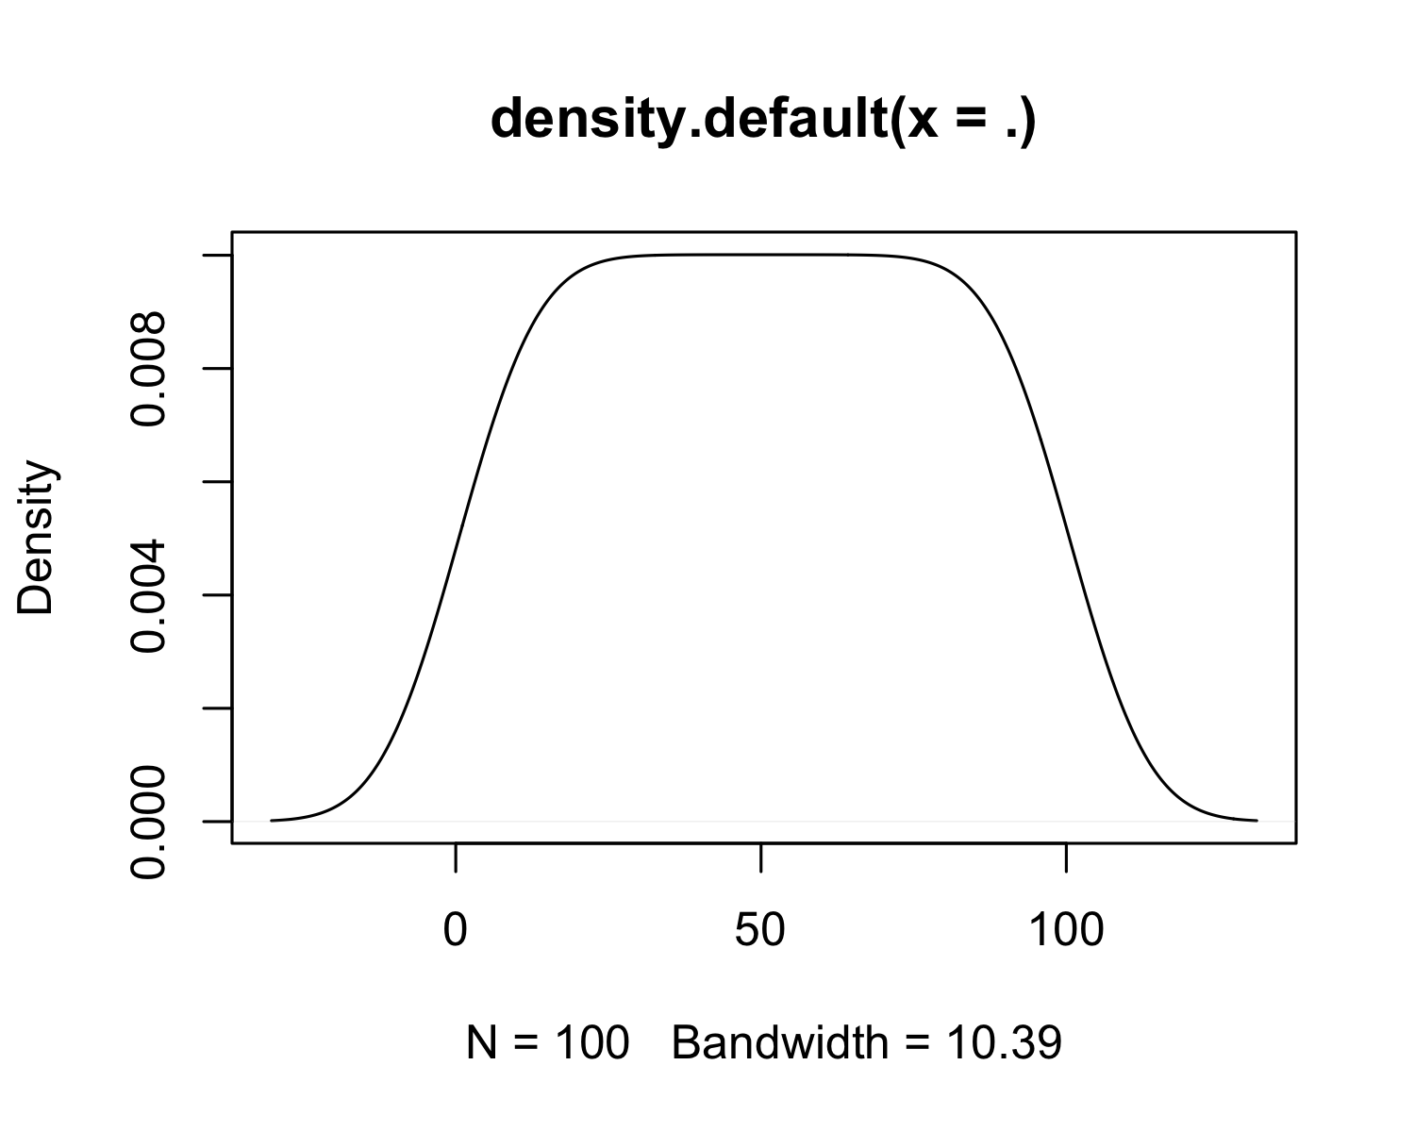 # Materials and Methods

|  |  |
| --- | --- |
| Cell | Number |
| RPE | 200 |
| Fibroblast | 30 |

## Single Cell RNA-Seq Data

[1]

# Results

# Conclusions

1. Macosko EZ, Basu A, Satija R, Nemesh J, Shekhar K, Goldman M, et al. Highly Parallel Genome-wide Expression Profiling of Individual Cells Using Nanoliter Droplets. Cell. 2015;161:1202–14.