**Results**

**Gene Expression Patterning of NR6A1**

To investigate in where NR6A1 is expressed we queried several human normal gene expression databases (eyeIntegration, Human Retina Cell Atlas (HRCA), Gene Tissue EXpression (GTEx)). The eyeIntegration resource contains bulk RNA-seq across the eye and GTEx non-ocular body tissues. The HRCA is a single nucleus RNA-seq dataset. We find in GTEx that NR6A1 is modestly expressed across most tissues (Figure DMd), with higher expression in testis, bone marrow, and thyroid. Across the eye tissues NR6A1 does not have noticeably higher expression relative to the body (Figure DMa). NR6A1 is notably higher in embryonic stem cell (ESC) and induced pluripotent stem cell (iPSC) lines. In the snRNA data from HRCA NR6A1 is more expressed in the horizontal cell population relative to the other major cell types of the retina and RPE (Figure DMb).

To determine whether NR6A1 has correlated expression patterns to previously identified coloboma associated genes (George et al. 2020) we used the previously mentioned databases to generate pairwise gene expression correlation scores between NR6A1 and all other expressed genes. We find over fivefold enrichment of correlation (where higher correlation is more correlated expression patterning) between NR6A1 and the George et al. gene set compared to all remaining genes (t.test, p = 0.0024) in eyeIntegration curated fetal retina and RPE tissues (Figure DMc). This strength of enrichment was not seen in the GTEx body tissues (p = 0.361) or the adult eye tissues (p = 0.452).

**Methods**

**Gene expression analysis of NR6A1**

The h5ad (d27a79a1-8a5f-404d-8063-52e19122ef49.h5ad for adult and 88444d73-7f55-4a62-bcfe-e929878c6c78.h5ad for fetal) from the HRCA project were downloaded from cellxgene.cziscience.com and the raw counts were summed at the sample and cell type level to create a pseudobulk matrix with the python package ADPBulk (<https://github.com/noamteyssier/adpbulk>). The eyeIntegration (which includes GTEx) gene counts and metadata were downloaded from eyeIntegration.nei.nih.gov (<https://hpc.nih.gov/~mcgaugheyd/eyeIntegration/2023/gene_counts.csv.gz> and <https://hpc.nih.gov/~mcgaugheyd/eyeIntegration/2023/eyeIntegration23_meta_2023_09_01.built.csv.gz>).

The pseudobulk and bulk RNA-seq counts were normalized with by CPM and transformed in R/4.3 to have a mean of zero and a standard deviation of one. The first four principal components were removed with the WGCNA tool removePrincipalComponents. The correlation matrix was created with the base R cor function. The correlation scores were expression transformed with the spqn package’s normalize_correlation function.

Plots of the expression of NR6A1 were created in R/4.3 with the ggplot2, cowplot, and ggbeeswarm packages.

**(Supplemental?) Figure DM**

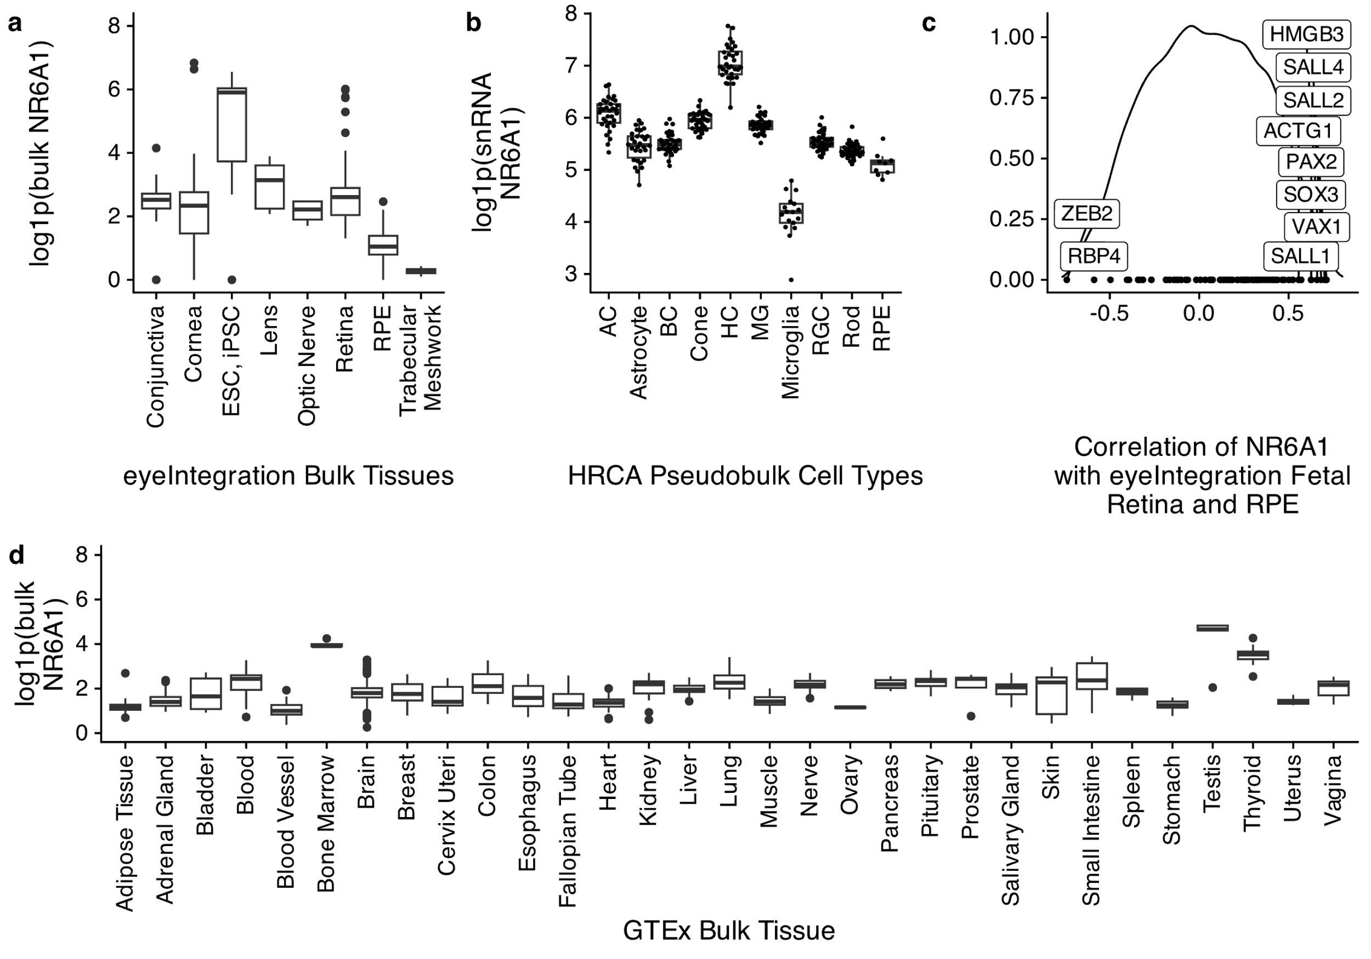

**Gene expression patterning analysis of NR6A1 in ocular and non-ocular tissues demonstrates modest expression differences and correlated expression patterns with known coloboma genes.** a. log1p scaled expression of NR6A1 across curated ocular tissues in the eyeIntegration resource, b. log1p pseudobulk summed counts of annotated cell types in the HRCA snRNA rresource, c. density plot of correlation scores of NR6A1 against all genes in fetal retina and RPE tissues. Annotated are the top 10 correlated known coloboma associated genes with NR6A1. d. Expression of NR6A1 in the GTEx resource.