Eye on a Disk: eyeIntegration version 1.00

David McGaughey

1/17/2019

# R Markdown

PURPOSE: To provide the eye community with a high quality RNA-seq based transcriptome reference set of healthy human eye tissues along with a reactive web application to query gene expression in eye and human body tissues.

This is an R Markdown document. Markdown is a simple formatting syntax for authoring HTML, PDF, and MS Word documents. For more details on using R Markdown see <http://rmarkdown.rstudio.com>.

When you click the **Knit** button a document will be generated that includes both content as well as the output of any embedded R code chunks within the document. You can embed an R code chunk like this:

summary(cars)

## speed dist   
## Min. : 4.0 Min. : 2.00   
## 1st Qu.:12.0 1st Qu.: 26.00   
## Median :15.0 Median : 36.00   
## Mean :15.4 Mean : 42.98   
## 3rd Qu.:19.0 3rd Qu.: 56.00   
## Max. :25.0 Max. :120.00

## Including Plots

You can also embed plots, for example:

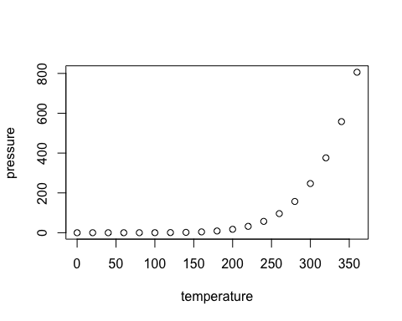

Note that the echo = FALSE parameter was added to the code chunk to prevent printing of the R code that generated the plot.

| Tissue | Count | Sub-Tissue Types |
| --- | --- | --- |
| Adipose Tissue | 37 | Subcutaneous, Visceral (Omentum) |
| Adrenal Gland | 20 | Adrenal Gland |

# Bibliography

1. Chen Y, Huang K, Nakatsu MN, Xue Z, Deng SX, Fan G. Identification of novel molecular markers through transcriptomic analysis in human fetal and adult corneal endothelial cells. *Hum Mol Genet*. 2013;22(7):1271-1279. doi:[10.1093/hmg/dds527](https://doi.org/10.1093/hmg/dds527)