Personas:


1. Stuart is a 49 year-old family physician living in Park City, UT. He is a former ski racer and is married with an 18 year-old son and a 22 year-old daughter. He has backcountry skied a few times and has touring gear. His family members are all strong, fit skiers. He has a complex work schedule and is not willing to sign up for a class. He wants to tour more often, weary of the resort scene and beginning to worry about the pounding skiing hardpack has put on an old knee injury. He is conservative in the backcountry and has experienced buddies to ski with but wants to be more than a passive partner constantly in doubt. He wants to share the sport with his wife and kids who are keen to join him. He regularly engages in online continuing medical education and is comfortable with that format and willing to commit some late nights to studying avalanche safety.

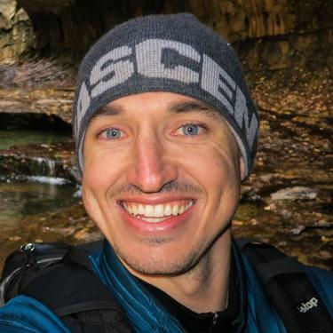
2. Colby is 24 years old, recently graduated from the University of Washington, and lives in Bellevue, Washington, where he works as a developer for a small start-up company developing health care-related software. He grew up skateboarding and snowboarding and has ridden the Alpental sidecountry countless times, usually carrying the beacon, probe, and shovel his parents gave him as a Christmas present several years ago. Several of his co-workers introduced him to splitboarding last year and he is all in with new gear. He recently took a short ride in a slide near Alpental and was unhurt but surprised and rattled. He’s a tech guy and the internet and social media is his go-to for news and information.


3. Beth grew up in New Hampshire nordic skiing and running cross country. She moved to Boulder 10 years ago after graduating from Middlebury. She is now the Executive Director of a small non-profit. She is an avid ski mo racer and regularly skis in the backcountry with a handful of friends. She knows she needs more avalanche education and has taken a Companion Rescue class and intends to take a Level 1 class but has not gotten around to it yet – life just seems too busy to schedule a 3 day weekend 2 months in advance.

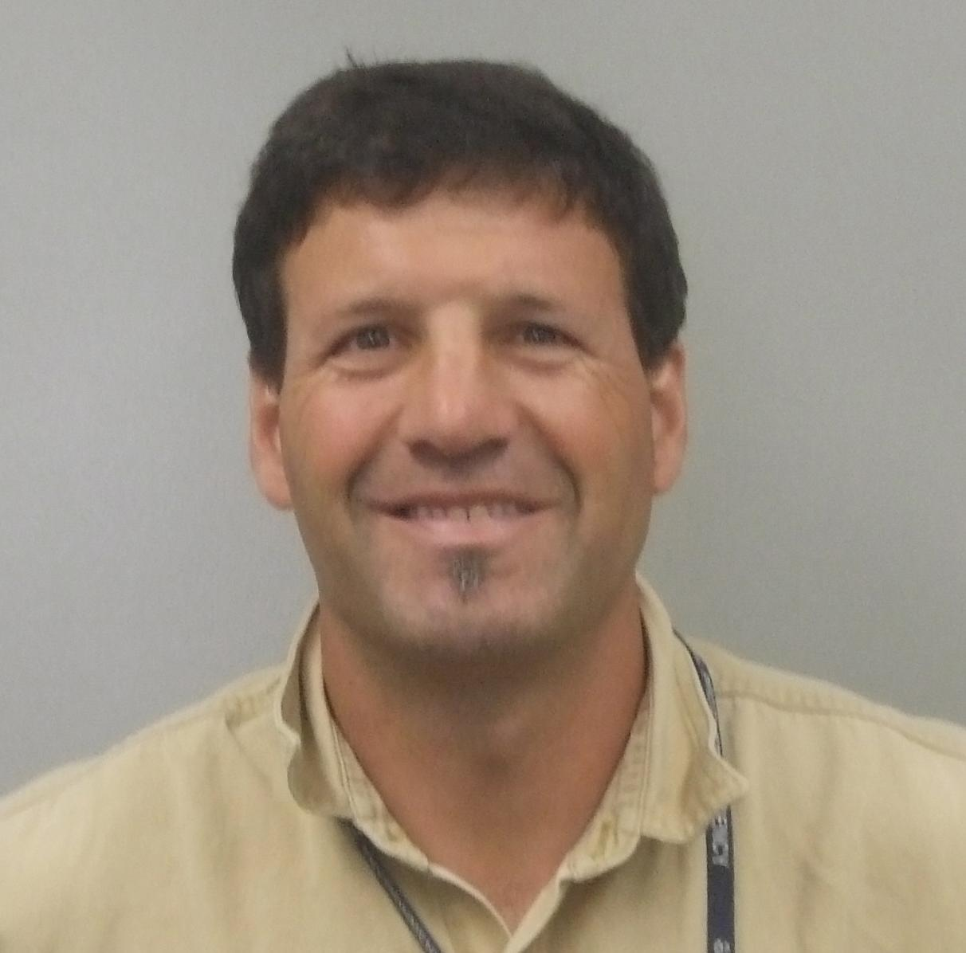
4. Mike is a 47 year old environmental scientist living in Cincinnati. He learned to ski in graduate school in Salt Lake City and as a post-doc in Switzerland. He has always dreamed of living in the mountains but a dream job with the EPA and a dual PhD family and child in middle school limits his ski reality to a British Columbia hut week each year with college buddies and a week in Utah staying with old roommates and trying to keep up on the skin track. He subscribes to the Utah Avalanche Center daily SLC email forecast and knows he needs more avalanche education, but his options in Cincinnati are limited. He spends a lot of time on the internet fantasizing about retirement 15 minutes from good skiing, buys new gear every few years, and has become a pretty good skier for a hockey kid from the Midwest.

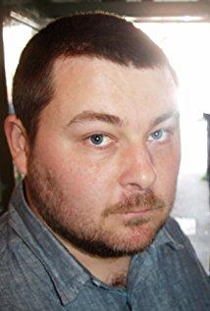
5. Ryan grew up in Seeley Lake, MT riding snowmobiles with his dad and brothers and now rides pretty much every weekend. He is 35 years old and co-owns a successful custom home construction company in Missoula with his brother. His best friend from high school died in an avalanche about 10 years ago near Cooke City and a buddy was caught by a slide last year and is still recovering from the resultant torn ACL and dislocated shoulder. His wife’s pestering has just reinforced what he already knows – a father of 3 small children who rides a mountain sled with aggressive buddies needs to think a bit more carefully about his actions. He plans to take a Level 1 class next winter and some friends have convinced him that doing some online studying over the summer will set him up well for that class and the road trip they are planning to BC in March.

