LAB-7

1. Which of the following statements are equivalent?

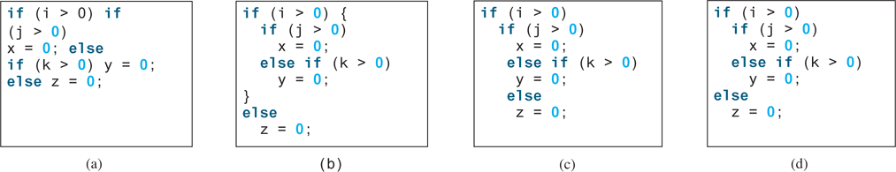

B) and D)

1. Rewrite the following statement using a Boolean expression:

if (count % 10 == 0)

newLine = true;

else

newLine = false;

newLine = count % 10 == 0 ? true : false;

1. Are the following statements correct? Which one is better?

a)

if (age < 16)

System.out.println

(“Cannot get a driver’s license");

if (age >= 16)

System.out.println

(“Can get a driver’s license");

b)

if (age < 16)

System.out.println

(“Cannot get a driver’s license");

else

System.out.println

(“Can get a driver’s license");

1. What is the output of the following code if **number** is **14**, **15**, or **30**?

if (number % 2 == 0)

System.out.println

(number + “ is even");

if (number % 5 == 0)

System.out.println

(number + “ is multiple of 5");

Number = 14 then “14 is even”

Number = 15 then “15 is multiple of 5”

Number = 30 then “ 30 is even” and “30 is multiple of 5”

5) Which of the following is a possible output from invoking Math.random()?

1. 323.4 b) 0.5 c) 34 d) 1.0 e) 0.0 f)0.234

6)

a) How do you generate a random integer i such that 0≤i<20?

Math.random() * 20;

b) How do you generate a random integer i such that 10≤i<20?

Math.random() * (20 – 10) + 10;

c) How do you generate a random integer i such that 10≤i≤50?

Math.random() * (50 – 10) + 10;

d) Write an expression that generates 0 or 1 randomly.

Math.round(Math.random());

7) Assuming that x is 1, show the result of the following Boolean expressions:

1. (true) && (3 > 4) ---- true
2. !(x > 0) && (x > 0) ---- false
3. (x > 0) || (x < 0) ---- true
4. (x != 0) || (x == 0) ---- true
5. (x >= 0) || (x < 0) ---- true
6. (x != 1) == !(x == 1) ---- true

8) Write a Boolean expression that evaluates to true if $|x-5|<4.5.$ In other words, you will get a x value from keyboard, then you will check if $|x-5|<4.5$ holds based on the value entered for x. If it holds then variable eval will hold true, if doesn’t hold then variable eval will hold false. Your code will have following line:  
  
boolean eval = x == 1 ? true : false;

9) Are a and b the same? - yes.

1. x % 2 == 0 && x % 3 == 0
2. x % 6 == 0

10)Run the following code for x= 2, y= 3, z= 6 and explain the result of each print statement

java.util.Scanner input = new java.util.Scanner(System.in);

double x = input.nextDouble(); //2

double y = input.nextDouble(); //3

double z = input.nextDouble(); //6

System.out.println("(x < y && y < z) is " + (x < y && y < z)); // Output: (x < y && y < z) is true

// both statements return true thus true

System.out.println("(x < y || y < z) is " + (x < y || y < z)); // Output: (x < y || y < z) is true

// first statement returns true thus true

System.out.println("!(x < y) is " + !(x < y)); // Output: !(x < y) is false

// initial statement is true but with ! Sign returns opposite thus false

System.out.println("(x + y < z) is " + (x + y < z)); // Output: (x + y < z) is true

// x + y is 5 while z is 6 therefore the expression is true

System.out.println("(x + y > z) is " + (x + y > z)); // Output: (x + y > z) is false

// since x + y is 5 and z is 6, the expression is false