Homework #1 David Nguyen

1. A. 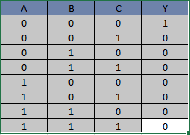

B. NOR Gate

C. 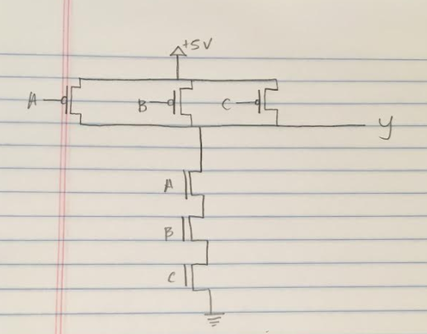

1. A. 20 = 0001 0100 = 0x14

B. 78 = 0100 1110 = 0x4E

C. -25 = 1110 0111 = 0xE7

D. -96 = 1010 0000 = 0xA0

1. A. 0x56 = 0101 0110 = 86

B. 0x14 = 0001 0100 = 20

C. 0xF8 = 1111 1000 = -8

D. 0xCC = 1100 1100 = -52