# Fridge Football 2017 Recap

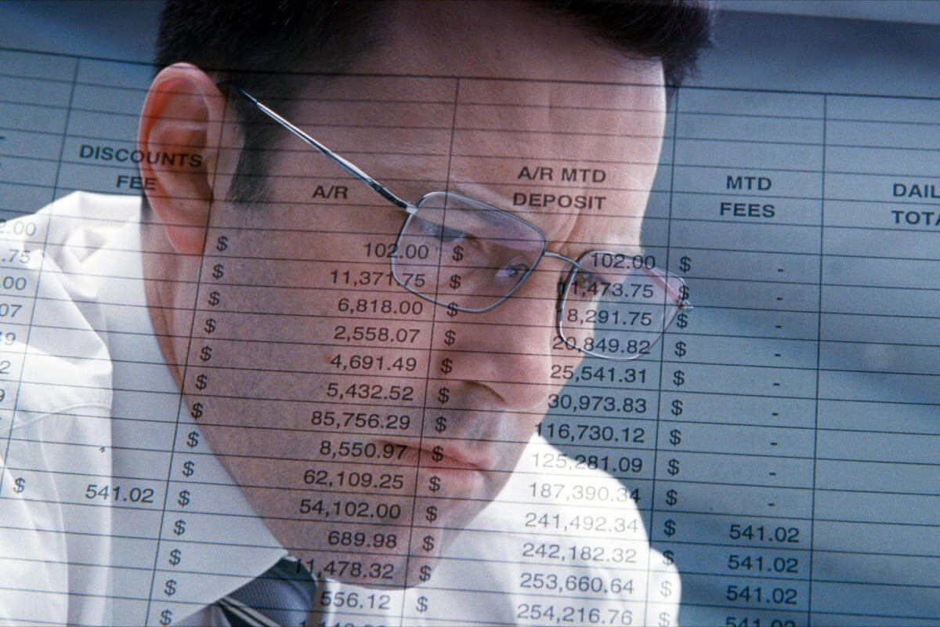

Your 2017 Fridge Football season is complete. Here are the takeaways:

* The Accountant! More than just an autistic super-vigilante and genius forensic accountant, Steve Miller wins the league again for the 4th time, 110-97. The win caps off a huge year for Steve with who also got engaged and bought a new house as well.
* Todd Gurley wins the Jared S. Fogle Playoff MVP trophy. Gurley put together the most dominant postseason by a Fridge running back, totaling 8 touchdowns and 591 combined yards.
* The resurgence of Todd Gurley after a terrible 2016 paired with holdover star Le’Veon Bell was the key to Miller’s success. DeAndre Hopkins also returned to all-pro form with 13 TD. Michael Thomas and Phil Rivers (who has 8 children) were reliable.
* Antonio Cromartie [overpowered his vasectomy](http://ftw.usatoday.com/2017/05/antonio-cromartie-vasectomy-children-urologist-explains-zero-count-recanalization-explained).
* When asked about his feelings following his unprecedented title victory, Miller said, “I didn’t choose the thug life, the thug life chose me.”
* I can see clearly now! The opthamologist Joe Hayek showed great vision in his first playoff run. Although unable to doctor up a championship, Hayek corrected his drafting myopia in 2017, showing acuity in acquiring Leonard Fournette, Travis Kelce, Mike Evans. A healthy Rob Gronkowski and the foresight to use Blake Bortles in week 15 allowed Hayek to focus on the finals.
* Many in the draft room felt George Hawke would win it all this year. But a week 1 wrist injury felled David Johnson for the entire season, and Ezekiel Elliot’s suspension was finally enforced during a critical stretch of games. Hawke missed a bye by 1 point, after the Rams were awarded a sack on the Thursday after Week 13, and the adjustment led to a tie for Dave and the 2nd overall seed.
* Mark Ingram and Keenan Allen really played great this year, and almost made up for the absence of Hawke’s stars. Hawke can take solace in that Alvin Kamara was the best running back find in 2017.
* Defending champ Pohlmann’s team never gelled. Quintorris Jones had approximately 84 near touchdowns and 3 actual touchdowns.
* Commissioner Dave Nickelsen’s season was both lucky and unlucky. Despite losing Allen Robinson, Dalvin Cook, Chris Carson and DeShaun Watson for the year, Dave limped to an 8-4-1 record and the 2 seed with several lucky wins.
* USA today has an [NFL arrest database](https://www.usatoday.com/sports/nfl/arrests/)
* It just didn’t come together for 2-time champ Meat. He did not score 100 points all season. Jay Ajayi, Lamar Miller, Matt Ryan and CJ Anderson disappointed. Everybody Hertz.
* Top seed Jeff Holda started out the year blistering behind UT star rookie Kareem Hunt. But as the Chiefs cooled off, so did Holda, who sputtered down the stretch and was topped by Steve in week 15.
* The current longest championship drought is now held by Jeff Holda at 11 years plus.
* Trevor appeared to have drafted very well, but his team was annihilated by injuries. Aaron Rodgers’ collarbone effectively took out teammate Jordy Nelson. Andrew Luck never returned to boost TY Hilton.
* Trevor has a very intriguing decision next year as he holds both Rodgers and Carson Wentz.
* The Fridge remembers [deranged Raiders Placekicker Cole Ford](http://www.espn.com/nfl/news/story?id=2441637)
* Jeff Heckler had a solid team that just couldn’t buy a win down the stretch. For 2017, he was correct in keeping Melvin Gordon over Ezekiel Elliott. He’s due to bounce back in 2018.
* Also due in 2018 is Baby Boy Nickelsen, who is slated to arrive in June.
* Thanks to everyone for a great season. I hope to see you all in September for the draft. Happy New Year!

## Payouts Owed

|  |  |  |
| --- | --- | --- |
| 2017 Champion | Steve Miller | 350 |
| 2017 Runner Up | Joe Hayek | 210 |
| Top Overall Seed | Jeff Holda | 70 |
| Top 2 Seed | Dave Nickelsen | 70 |
| Week 13 High Points | Trevor McAleer | 20 |
| 7th Place | Jeff Heckler | 20 |
| Picks League Even Up | Adam Lenin | 50.33 |
| Picks League Vs. Spread | Simin Nickelsen | 50.33 |
| Picks League Confidence | Dave Nickelsen | 50.33 |

## 2017 PlayoffsC:\Misc\images\Fridge\2017 Fridge Playoffs.PNG

## 2017 Regular Season

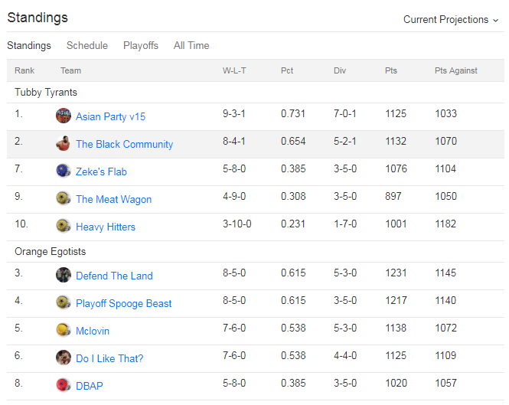

## 2017 Robert Blake Bowl

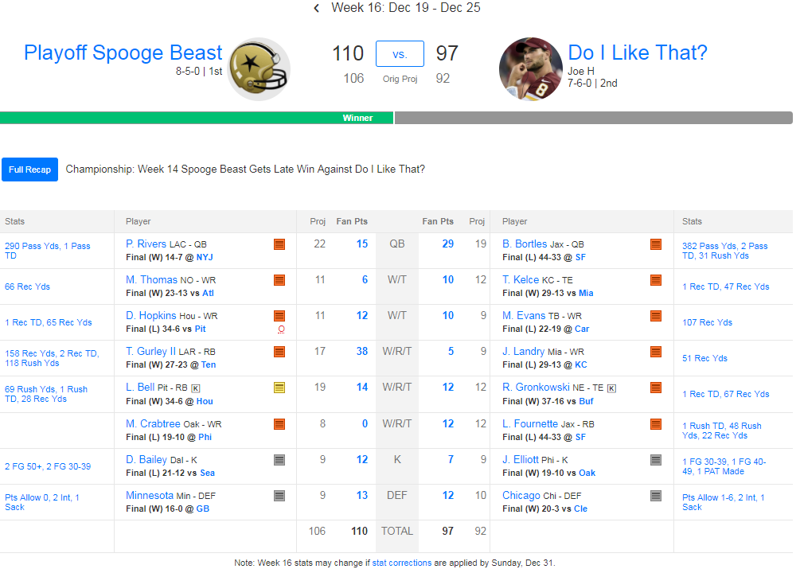

## Fridge Football Championships

|  |  |  |
| --- | --- | --- |
| Season | Champion | Runner-Up |
| 2017 | Steve Miller | Joe Hayek |
| 2016 | Jeff Pohlmann | Dave Nickelsen |
| 2015 | George Hawke | Jeremiah Yugulis |
| 2014 | Matt Robson | Jeff Heckler |
| 2013 | Steve Miller | Kara Paige Holda |
| 2013 | Steve Miller | Jeff Heckler |
| 2011 | Jeff Pohlmann | Jeff Holda |
| 2010 | Dave Nickelsen | Ryan Mitchell |
| 2009 | Dave Nickelsen | Trevor McAleer |
| 2008 | Greg Perry (Twitch) | Jeff Pohlmann |
| 2007 | Trevor McAleer | Steve Miller |
| 2006 | Jeff Holda | George Hawke |
| 2005 | Matt Robson | George Hawke |
| 2004 | Brent Fisher | Eric Doksa |
| 2003 | George Hawke | Adam Smith |
| 2002 | Dave Nickelsen | Brad Carey |
| 2001 | Shannon Anderson | Jeff Fathauer (Chief) |
| 2000 | Steve Miller | Brad Carey |