The C&C Alpha NR-XI and DH NR-XII

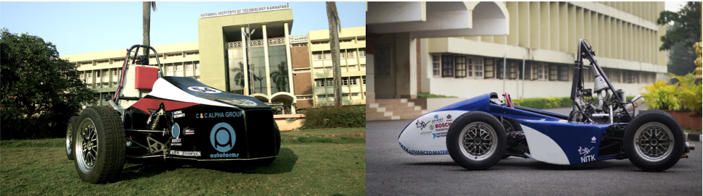

The DH NR-XII is a modified version of our first car, the C&C Alpha NR-XI. While NR-XI was intended to be used for FSAE Michigan ‘11, and later for FS Hungary ‘12, the car went through many changes between the two events, a re-christening was in order and the car was re-launched as the DH NR-XII in the summer of 2012.

Much of the transitional period was spent on testing the car and upgrading it as we went along. We gained familiarity with its performance and introduced additional features.

*The technical specifications common to both the C&C Alpha NR-XI and the DH NR-XII :*

|  |  |
| --- | --- |
| ***Parameter*** | ***Value*** |
| Chassis Material | SAE 4130 alloy Steel |
| Overall L | 2700 mm |
| Overall W | 1450 mm |
| Overall H | 1250 mm |
| Wheelbase | 1650 mm |
| Track (F) | 1250 mm |
| Track (R) | 1150 mm |
| Suspension | Double unequal length A-arms. Pull rod actuated dampers |
| Tyres (F/R) | 20.5x7R13 R25B Hoosier |
| Wheels (F/R) | 6x13, Keizer, 3 piece Al rim |
| Engine | 2009 Honda CBR 600 RR |
| Cylinders | 4 |
| Displacement | 599 cc |
| Fuel System | Semi-sequential fuel injection |
| Fuel | Petrol |
| Drive Type | 520 single row chain drive |
| Differential | Quaife Limited Slip Differential |
| Cooling | Custom Aluminium louvered fin radiator |
| Brake System | Wilwood master cylinder with Wilwood PS1 callipers |

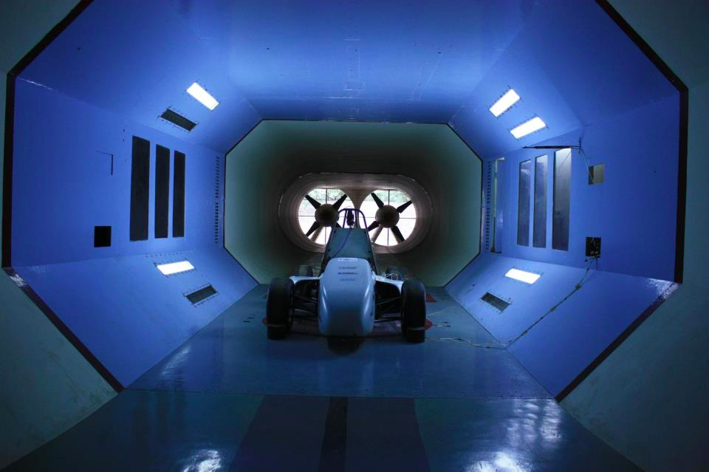

*The DH NR-XII during wind tunnel testing at Indian Institute of Science, Bangalore, June 2012*

The improvements in DH NR-XII can be summarized as:

1. ProShift solenoid automated gear shifter with ignition cut for clutchless upshifts, and steering mounted button shifters.
2. Smaller radiator fan: Cooling system wind-tunnel tested at Indian Institute of Science, Bangalore.
3. Fuel maps tuned for reliable engine starting and performance. Further tuning reduced fuel consumption and improved spark plug lifetime.
4. Ignition maps tuned to better acceleration. Lambda sensor used to calibrate AFR to optimum value.
5. Use of carbon fibre: seat, firewall were made of carbon fibre.
6. Improved aerodynamics: Redesigned body shell.