PREVIOUS SPONSORS

**

*C&C Aplha Group*

*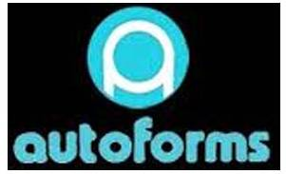*

*AutoForms*

*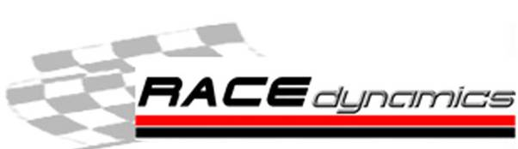*

*Race Dynamics*

*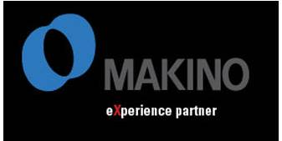*

*Makino*

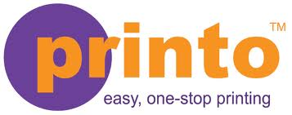

*Printo*

*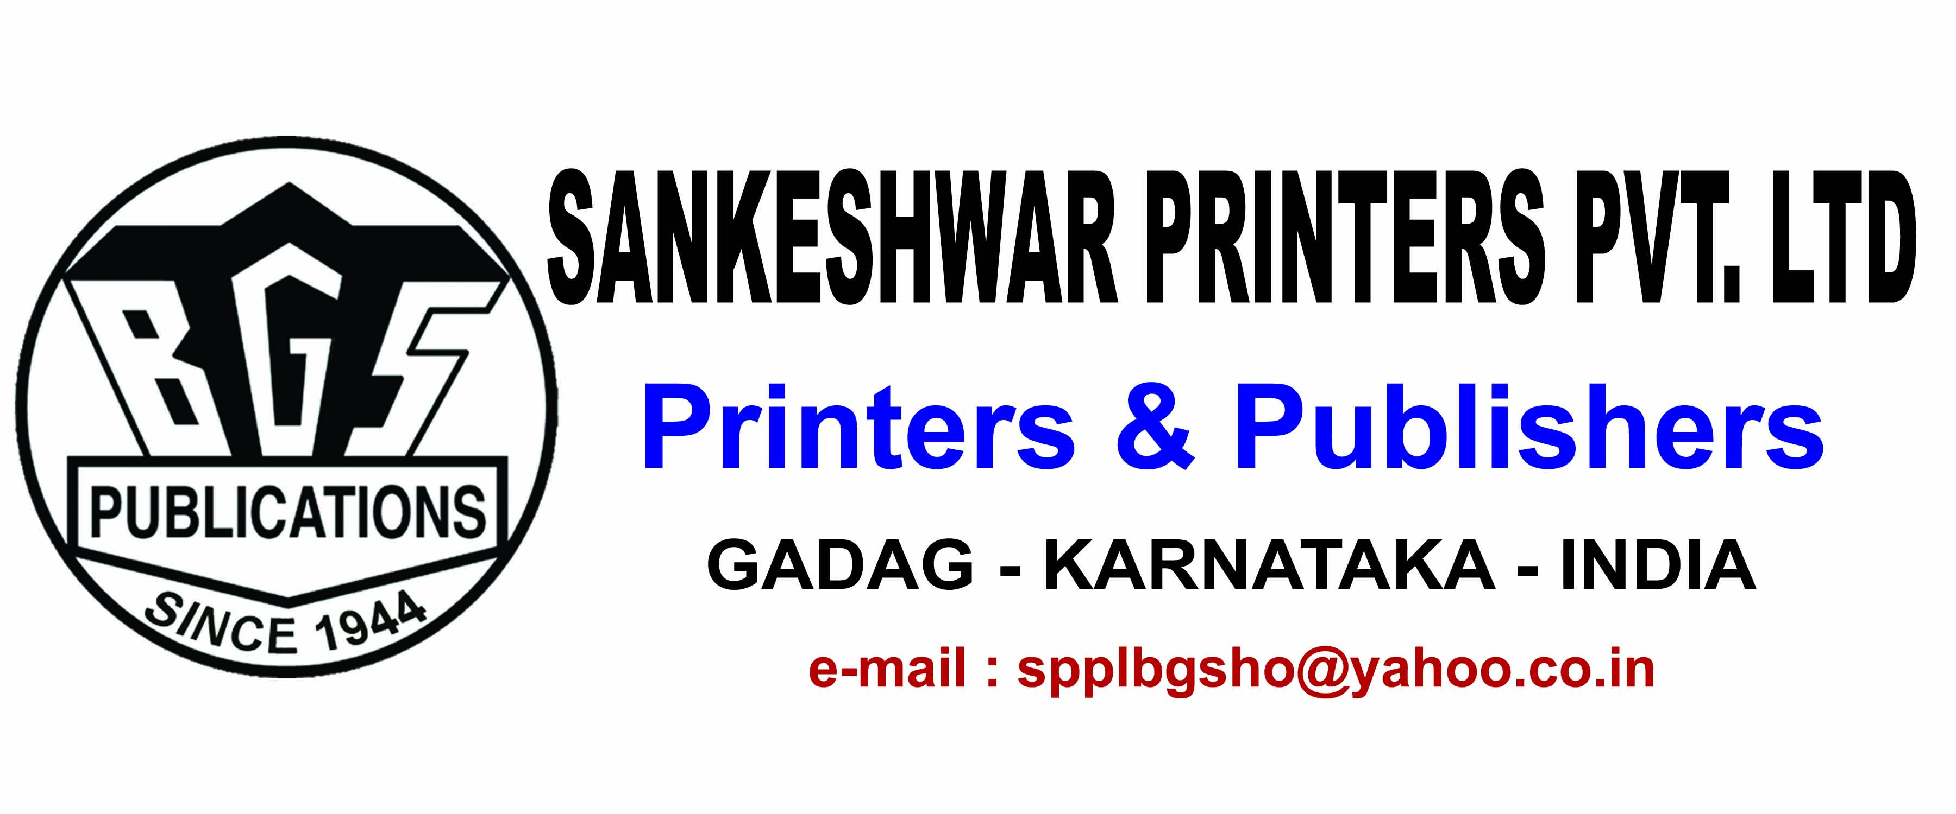*

*Sankeshwar Printers Pvt. Ltd.*

A Special Thank You To

Mr. Benedict Machado

Mr. Lawrence Mendonca

NITK Alumni Association Mumbai Chapter