CURRENT SPONSORS

*[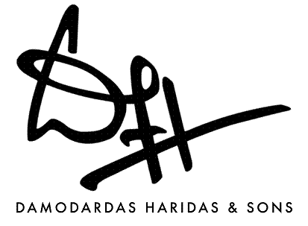](http://www.dhsons.com/)*

[*Damodardas Haridas and Sons*](http://www.dhsons.com/)

Location: Secunderabad, Bangalore and Belgaum, India

Founded in 1937, Damodardas Haridas and Sons is a pioneering company in the trade of dyes and chemicals for the textile, leather and paper industry in South India. As distributors and stockists for the highly reputed Clariant Chemicals Ltd. and Sandoz India Ltd., they have established themselves firmly in the markets of Andhra Pradesh and Karnataka over time.

Damodardas Haridas and Sons is the Title Sponsor for our endeavours in FS Hungary ’12 and we would like to wholeheartedly thank them for their support.

*[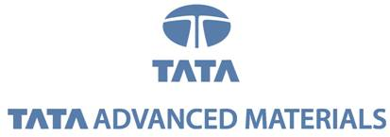](http://www.tamlindia.com/)*

[*Tata Advanced Materials Limited*](http://www.tamlindia.com/)

Location: Bangalore, India

Set up in 1990 & promoted by Tata Industries Ltd, TAML undertakes the design, application engineering, prototyping, testing and manufacturing of products in advanced composites for high-tech and industrial sectors. Being the largest manufacturer of personnel armour products in India and the only Indian manufacturer and exporter of composite parts for spacecraft and aircraft, TAML made its footprint in the industry with contracts from concept to product in defence & industrial sectors.  
Tata Advanced Material Limited is the Diamond Sponsor for our endeavours in FS Hungary ’12.

[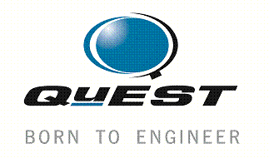](http://www.quest-global.com/)

[*QuEST Global*](http://www.quest-global.com/)

Location: Belgaum and Bangalore, India

Since its inception in 1997, QuEST Global has distinguished itself as a leading provider of outsourced engineering solutions. With integrated product development and build solutions across the entire engineering services value chain, QuEST Global is recognized as one of the largest pure play engineering services player in the world. Employing over 3400 professionals in its delivery centres across the world, QuEST Global caters to the needs of top notch clients like GE, United Technologies, Toshiba and Rolls Royce.

QuEST Global has been a Platinum Sponsor for our endeavours in FS Hungary ’12 and FS Michigan ’11.

*[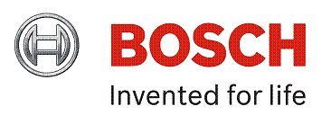](http://www.boschindia.com/)*

[*Bosch India Limited*](http://www.boschindia.com/)

Location: Bangalore, India

Bosch Limited is the flagship company of the Bosch Group in India. Needing no prior introduction, the company is a leading supplier of technology and services in the areas of automotive and industrial technology, consumer goods and building technology in the world. Additionally, Bosch also has, the largest development center, outside Germany, for end to end engineering and technology solutions in India.

Bosch India Limited is a Platinum Sponsor for our endeavours in FS Hungary ’12.

[](http://india.ni.com/)

[*National Instruments India*](http://www.ni.com/)

Location: Pune, Delhi and Bangalore, India

National Instruments has been a technology pioneer and leader in virtual instrumentation for the past 30 years. National Instruments India was set up in 1998 to propagate the revolutionary Virtual Instrumentation technology in the country. National Instruments believes in constant innovation and invests a large amount of its annual revenue in Research & Development. National Instruments India has a Research and Development wing in Bangalore which helps customers across the globe. It is perhaps to endorse this mission, the development of new technologies, that they have extended a helping hand to us.

National Instruments India is a Platinum Sponsor for our endeavours in FS Hungary ’12 and FS Michigan ’11.

[](http://www.alumni.nitk.ac.in/)

[*NITK Alumni Association*](http://www.alumni.nitk.ac.in/)

Location: Surathkal, India

Since its foundation in the year 1960, NITK Surathkal (formerly KREC) has seen many illustrious people graduate from its hallowed halls. The NITK Alumni Association is the official alumni association of the college. The Alumni Association has been very generous not only with their financial and technical support, but also with their constant encouragement. It is comforting to note that we can always count on the Alumni Association.

NITK Alumni Association is a Gold Sponsor for our endeavours in FS Hungary ’12 and FS Michigan ’11.

[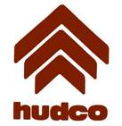](http://www.hudco.org/)

[*Housing and Urban Development Corporation Limited (HUDCO)*](http://www.hudco.org/)

Location: New Delhi, India

Incorporated in 1970 as a fully owned enterprise of the Government of India, HUDCO is vested with the responsibility of building affordable housing and carrying out urban development. It aims to be one of the world’s leading knowledge hubs and financial facilitating organizations for housing development, urban infrastructure, research, training and consulting. It has lived up to its lofty aims by providing techno financial assistance to 1835 cities and towns in 33 states and union territories.

HUDCO is a Gold Sponsor for our endeavours in FS Hungary ’12.

*[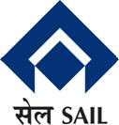](http://www.sail.co.in/)*

[*Steel Authority of India Limited (SAIL)*](http://www.sail.co.in/)

Location: New Delhi, India

Incorporated in 1973, SAIL is one of the largest steel makers in the world and amongst India’s top profit-making companies. Most of this Public Sector Undertaking’s plants have fully integrated iron and steel functionality, producing both basic and special steels for domestic construction, engineering, power, railway, automotive and defence industries and for sale in export markets. The company also has the distinction of being India’s second largest producer of iron ore and of having the country’s second largest mines network.

SAIL is a Bronze Sponsor for our endeavours in FS Hungary ’12.

[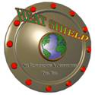](http://www.heatshielddubai.com/)

[*Heat Shield*](http://www.heatshielddubai.com/)

Location: Dubai, UAE

Established in 1998 in Dubai, UAE, the company caters to all insulation needs for industrial and commercial purposes. They also offer technical expertise on complex thermal, acoustical and fire barrier insulation contracts. Heat Shield also deals in rockwool, ceramic fibre, polyurethane foam and polysocyanurate foam amongst other materials.

Heat Shield is a Bronze Sponsor for our endeavours in FS Hungary ’12.

[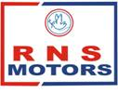](http://www.rnsmaruti.com/)

[*RNS Motors*](http://www.rnsmaruti.com/)

Location: Bangalore, India

RNS Motors is Karnataka’s largest Maruti Suzuki dealer network offering one stop services solutions. Some of the facilities offered by the company include sales, services, spares, accessories, pre-owned cars, insurance, body repair, hour long quick repair, extended warranties, on-road service and a Maruti Driving School. RNS Motors caters majorly in the areas of Bangalore, Hubli, Murudeshwar, Bijapur, Gadag andSirsi.

RNS Motors is a Bronze Sponsor for our endeavours in FS Hungary ’12.

A Special Thank You To

Mr. Jaykumar Shah

Mr. Pramod Gandhi

Mr. Yatin Shah

A Special Mention To

|  |  |
| --- | --- |
| Mr. Ajit Shah | RNS Motors Limited |
| Mr. Ramanujam | Karnataka Apex Bank |
| Mr. Narasimhan Mandayam | Mr. Sunil Hindja |
| Mr. Ravinder Mandayam | Mr. Vivek Agrawal |
| Mr. Vasudev Avadhani | Mr. Shubash Punja |
| Mr. Prakash Shah | Mr. Harishankar Manikantan |
| Mr. Archit Koti | Mr. Rajendra Rai |
| Mr. Anupam Krishnamurthy | Mr. Ramgopal |
| Mr. Aditya Sridhar | Mr. Balasubramanyam |
| Mr. Hemant Shah | Engineer- NITK Surathkal |
| Mrs. Vimal Shah | Mrs. Aditi Chakravarthi |