SUPPORT US

**Why?**

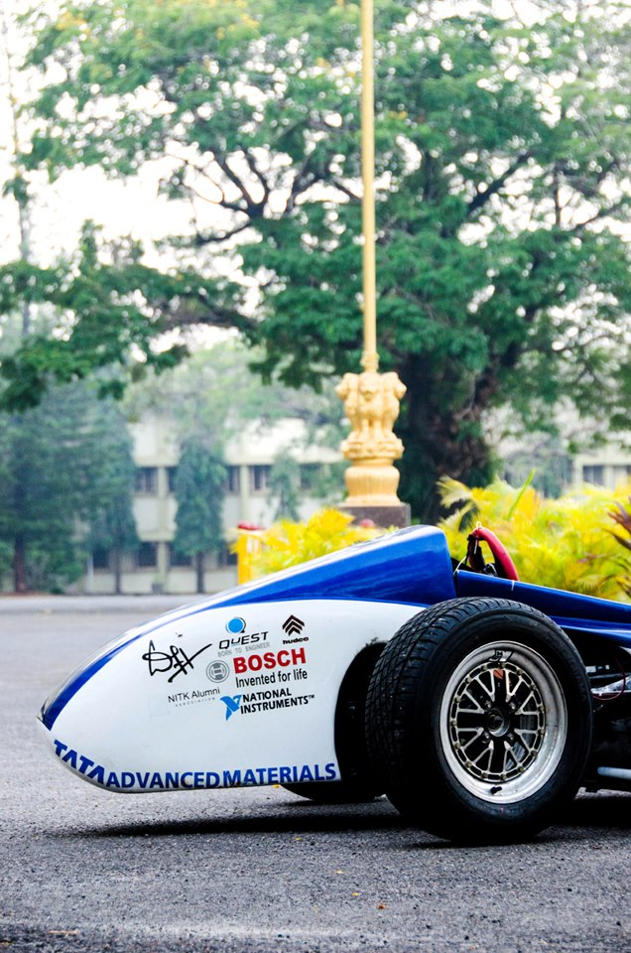We are undergraduates – all under the age off 22 – and have set out to build a high performance car, worthy of representing India globally. In the last year alone, over 60,000 man-hours were put in to the project.

Our achievements:

* Lightest Indian FS car in 2012, a feat achieved within 2 years of existence.
* Top 10 spot in two events out of seven at Formula Student Hungary, 2012
* Best Asian team at Formula Student Hungary, 2012
* Only Asian team to have the car wind-tunnel tested
* Research paper in SAE International journal of the work done on optimization of the cooling system
* Cabinet of trophies from performances at the Baja series

NITK Racing believes in developing a trend to shift outside the classroom learning paradigm. Supporting an international engineering project of this magnitude, helps facilitate industry- institute interaction, besides promoting innovation.

Find 10 reasons to support NITK Racing, here.

**How?**

1. As an Individual
   1. *Be a patron - Goodwill Sponsor*Support by sponsoring a small amount towards the building of the car
   2. *Recommend us to a friend*Introduce us to a friend whom appreciates hard work, innovation, engineering and just a tiny bit of motorsport
   3. *Promote us on social media (facebook, twitter, etc. )*
   4. *Buy NITK Racing merchandise*Wear your support.
2. As a firm / organization
   1. *Financial Sponsorship*We offer comprehensive packages with sponsorship benefits that cover on-site, off-site publicity in a year long campaign. Logos on the car, International publicity, CSR benefits and more.
   2. *Technical Sponsorship*Sponsorship of components, materials, manufacturing facilities and / or provide technical consulting in exchange of publicity benefits.
   3. *Sponsor an event*Sponsor an event organized by NITK Racing during the 2 annual national level fests at NITK Surathkal

For further infornmation, drop us a mail: [marketing@nitkracing.com](mailto:marketing@nitkracing.com),