Fee’s p

Elizabeth Davenport

2024-04-28

# Initial stuff, including loading packages and importing data

##loading packages

library(tidyverse)  
library(here)  
library(ggpubr)  
library(ggplot2)  
library(dplyr)  
library(lubridate)  
library(scales)  
library(reshape2)

## loading files

# Tell R where files are stored  
here::i_am("scripts/Fee's_p_plot.Rmd")  
  
# Load Files  
a <- readr::read_csv(here("data/FeeP.csv"))

##Format date  
date <- a$Date  
strptime(date, format = "%m/%d/%y")

## [1] "2021-06-14 EDT" "2021-06-28 EDT" "2021-07-12 EDT" "2021-07-26 EDT"  
## [5] "2021-08-09 EDT" "2021-08-23 EDT" "2021-09-07 EDT" "2021-09-20 EDT"  
## [9] "2021-10-04 EDT" "2021-10-18 EDT" "2021-11-01 EDT" "2021-11-12 EST"  
## [13] "2021-06-14 EDT" "2021-06-28 EDT" "2021-07-12 EDT" "2021-07-26 EDT"  
## [17] "2021-08-09 EDT" "2021-08-23 EDT" "2021-09-07 EDT" "2021-09-20 EDT"  
## [21] "2021-10-04 EDT" "2021-10-18 EDT" "2021-11-01 EDT" "2021-11-12 EST"  
## [25] "2021-06-11 EDT" "2021-06-21 EDT" "2021-07-06 EDT" "2021-07-23 EDT"  
## [29] "2021-08-02 EDT" "2021-08-16 EDT" "2021-08-30 EDT" "2021-09-13 EDT"  
## [33] "2021-09-27 EDT" "2021-10-11 EDT" "2021-10-25 EDT" "2021-11-08 EST"  
## [37] "2021-06-09 EDT" "2021-06-23 EDT" "2021-07-07 EDT" "2021-07-21 EDT"  
## [41] "2021-08-04 EDT" "2021-08-18 EDT" "2021-09-01 EDT" "2021-09-15 EDT"  
## [45] "2021-09-29 EDT" "2021-10-13 EDT" "2021-10-27 EDT" "2021-11-10 EST"  
## [49] "2021-06-09 EDT" "2021-06-23 EDT" "2021-07-07 EDT" "2021-07-21 EDT"  
## [53] "2021-08-04 EDT" "2021-08-18 EDT" "2021-09-01 EDT" "2021-09-15 EDT"  
## [57] "2021-09-29 EDT" "2021-10-13 EDT" "2021-10-27 EDT" "2021-11-10 EST"  
## [61] "2021-06-11 EDT" "2021-06-21 EDT" "2021-07-06 EDT" "2021-07-23 EDT"  
## [65] "2021-08-02 EDT" "2021-08-16 EDT" "2021-08-30 EDT" "2021-09-13 EDT"  
## [69] "2021-09-27 EDT" "2021-10-11 EDT" "2021-10-25 EDT" "2021-11-08 EST"

l <- as.POSIXct(date,format="%m/%d/%y",tz=Sys.timezone())  
  
Fee <- a$FeeP  
lake <- a$Lake  
color.lake <- c("CrookedW"="#D55E00",  
 "Bishop"= "#0072B2",  
 "Mill"= "#CC79A7",   
 "Little Appleton"="#009E73",  
 "Walsh"="yellow3",  
 "Cedar"="#E69F00")  
  
FeeP <- ggplot(a, aes(x=l,y=Fee, group=lake, color=lake)) +  
 geom_point(size=2) +  
 geom_line(size=1)+  
 scale_colour_manual(values = color.lake)+  
 labs(x = "Date", y = "Fee's p", color = "Lake") +  
 theme_bw() +  
 theme(panel.border = element_blank(),   
 panel.grid.major = element_blank(),  
 panel.grid.minor = element_blank(),   
 axis.line = element_line(colour = "black"),  
 axis.text=element_text(size=8, face = "bold"),   
 axis.title=element_text(size=10,face="bold"),  
 legend.title = element_text(face = "bold",size = 10),  
 legend.text=element_text(size=8,face="bold"),  
 legend.position = "bottom")  
  
FeeP

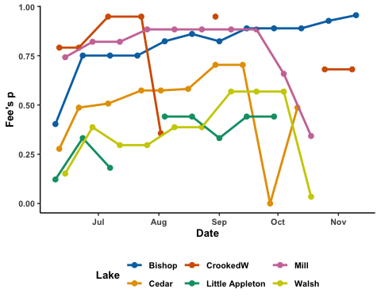

ggsave(here("figures", "Fee's_p_Plot.jpg"), FeeP, width = 8, height = 5, dpi = 600)