MixingDepthRegression

Elizabeth Davenport

2024-05-21

# Initial stuff, including loading packages and importing data

##loading packages

library(here)  
library(rstatix)  
library(ggplot2)  
library(tidyverse)  
library(dplyr)  
library(ggpubr)

## loading files

# Tell R where files are stored  
here::i_am("scripts/MixingDepthRegression.Rmd")  
  
# Load Files  
a <- readr::read_csv(here("data/MillMixingDepthCV.csv"))  
b <- readr::read_csv(here("data/BishopMixingDepthCV.csv"))  
c <- readr::read_csv(here("data/CedarMixingDepthCV.csv"))  
d <- readr::read_csv(here("data/CrookedWMixingDepthCV.csv"))  
e <- readr::read_csv(here("data/LilApMixingDepthCV.csv"))  
f <- readr::read_csv(here("data/WalshMixingDepthCV.csv"))

mill.mix <- a$MixingDepth  
mill.cv <- a$CV  
  
mill.CV.plot <- ggplot(a, aes(x=mill.mix, y=mill.cv, group=1)) +  
 geom_point(size=1) +  
 ggtitle("Mill (0.821)") +  
 scale_y_continuous(limits = c(0,3), breaks = seq(0,3,1))+  
 theme_bw() +  
 theme(panel.border = element_blank(),   
 panel.grid.major = element_blank(),  
 panel.grid.minor = element_blank(),   
 axis.line = element_line(colour = "black"),  
 plot.title = element_text(face = "bold", size = 10),  
 axis.text=element_text(size=8),   
 axis.title=element_text(face = "bold", size=8))+  
 labs(x = ("Mixing Depth (m)"), y = "")+  
 stat_smooth(method = "lm", formula = y ~ x, geom = "smooth", linetype="dashed")  
  
mill.CV.plot

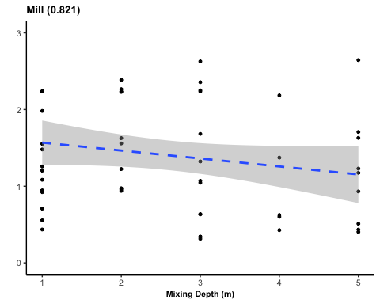

mill.model <- lm(mill.cv ~ mill.mix, data = a)  
  
summary(mill.model)

##   
## Call:  
## lm(formula = mill.cv ~ mill.mix, data = a)  
##   
## Residuals:  
## Min 1Q Median 3Q Max   
## -1.13306 -0.63351 -0.03876 0.66715 1.49147   
##   
## Coefficients:  
## Estimate Std. Error t value Pr(>|t|)   
## (Intercept) 1.6726 0.1983 8.434 3.07e-11 ***  
## mill.mix -0.1037 0.0666 -1.557 0.126   
## ---  
## Signif. codes: 0 '***' 0.001 '**' 0.01 '*' 0.05 '.' 0.1 ' ' 1  
##   
## Residual standard error: 0.7006 on 51 degrees of freedom  
## (7 observations deleted due to missingness)  
## Multiple R-squared: 0.04535, Adjusted R-squared: 0.02663   
## F-statistic: 2.423 on 1 and 51 DF, p-value: 0.1258

bishop.mix <- b$MixingDepth  
bishop.cv <- b$CV  
  
bishop.CV.plot <- ggplot(b, aes(x=bishop.mix, y=bishop.cv, group=1)) +  
 geom_point(size=1) +  
 scale_x_continuous(limits = c(1,10), breaks = seq(1,10,1))+  
 scale_y_continuous(limits = c(0,4.5), breaks = seq(0,4,1))+  
 ggtitle("Bishop (0.751)") +  
 theme_bw() +  
 theme(panel.border = element_blank(),   
 panel.grid.major = element_blank(),  
 panel.grid.minor = element_blank(),   
 axis.line = element_line(colour = "black"),  
 plot.title = element_text(face = "bold", size = 10),  
 axis.text=element_text(size=8),   
 axis.title=element_text(face = "bold", size=8))+  
 labs(x = ("Mixing Depth (m)"), y = "Patchiness")+  
 stat_smooth(method = "lm", formula = y ~ x, geom = "smooth", linetype="dashed")  
  
bishop.CV.plot

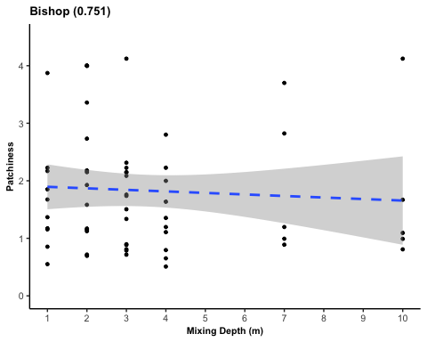

bishop.model <- lm(bishop.cv ~ bishop.mix, data = b)  
  
summary(bishop.model)

##   
## Call:  
## lm(formula = bishop.cv ~ bishop.mix, data = b)  
##   
## Residuals:  
## Min 1Q Median 3Q Max   
## -1.3445 -0.7436 -0.2531 0.3439 2.4670   
##   
## Coefficients:  
## Estimate Std. Error t value Pr(>|t|)   
## (Intercept) 1.92179 0.23708 8.106 4.07e-11 ***  
## bishop.mix -0.02657 0.05512 -0.482 0.632   
## ---  
## Signif. codes: 0 '***' 0.001 '**' 0.01 '*' 0.05 '.' 0.1 ' ' 1  
##   
## Residual standard error: 1.067 on 58 degrees of freedom  
## Multiple R-squared: 0.00399, Adjusted R-squared: -0.01318   
## F-statistic: 0.2323 on 1 and 58 DF, p-value: 0.6316

cedar.mix <- c$MixingDepth  
cedar.cv <- c$CV  
  
cedar.CV.plot <- ggplot(c, aes(x=cedar.mix, y=cedar.cv, group=1)) +  
 geom_point(size=1) +  
 ggtitle("Cedar (0.507)") +  
 scale_x_continuous(limits = c(1,6), breaks = seq(1,6,1))+  
 scale_y_continuous(limits = c(0,3), breaks = seq(0,3,1))+  
 theme_bw() +  
 theme(panel.border = element_blank(),   
 panel.grid.major = element_blank(),  
 panel.grid.minor = element_blank(),   
 axis.line = element_line(colour = "black"),  
 plot.title = element_text(face = "bold", size = 10),  
 axis.text=element_text(size=8),   
 axis.title=element_text(face = "bold", size=8))+  
 labs(x = ("Mixing Depth (m)"), y = "")+  
 stat_smooth(method = "lm", formula = y ~ x, geom = "smooth", linetype="dashed")  
  
cedar.CV.plot

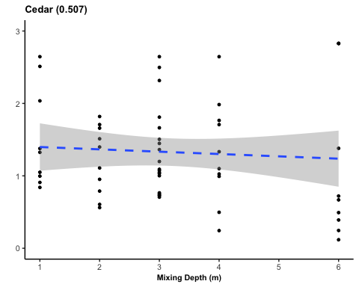

cedar.model <- lm(cedar.cv ~ cedar.mix, data = c)  
  
summary(cedar.model)

##   
## Call:  
## lm(formula = cedar.cv ~ cedar.mix, data = c)  
##   
## Residuals:  
## Min 1Q Median 3Q Max   
## -1.1194 -0.5661 -0.2225 0.3901 1.5912   
##   
## Coefficients:  
## Estimate Std. Error t value Pr(>|t|)   
## (Intercept) 1.43024 0.21547 6.638 1.37e-08 ***  
## cedar.mix -0.03216 0.06032 -0.533 0.596   
## ---  
## Signif. codes: 0 '***' 0.001 '**' 0.01 '*' 0.05 '.' 0.1 ' ' 1  
##   
## Residual standard error: 0.7227 on 56 degrees of freedom  
## (2 observations deleted due to missingness)  
## Multiple R-squared: 0.00505, Adjusted R-squared: -0.01272   
## F-statistic: 0.2842 on 1 and 56 DF, p-value: 0.5961

cw.mix <- d$MixingDepth  
cw.cv <- d$CV  
  
cw.CV.plot <- ggplot(d, aes(x=cw.mix, y=cw.cv, group=1)) +  
 geom_point(size=1) +  
 ggtitle("Crooked W (0.949)") +  
 scale_x_continuous(limits = c(1,5), breaks = seq(1,5,1))+  
 scale_y_continuous(limits = c(0,3), breaks = seq(0,3,1))+  
 theme_bw() +  
 theme(panel.border = element_blank(),   
 panel.grid.major = element_blank(),  
 panel.grid.minor = element_blank(),   
 axis.line = element_line(colour = "black"),  
 plot.title = element_text(face = "bold", size = 10),  
 axis.text=element_text(size=8),   
 axis.title=element_text(face = "bold", size=8))+  
 labs(x = ("Mixing Depth (m)"), y = "")+  
 stat_smooth(method = "lm", formula = y ~ x, geom = "smooth", linetype="dashed")  
  
cw.CV.plot

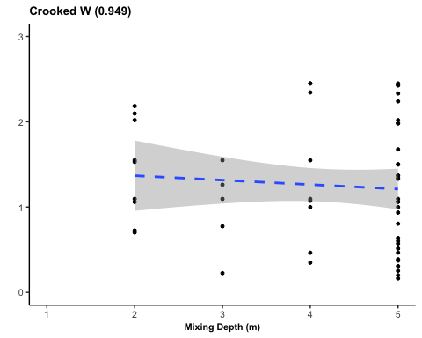

cw.model <- lm(cw.cv ~ cw.mix, data = d)  
  
summary(cw.model)

##   
## Call:  
## lm(formula = cw.cv ~ cw.mix, data = d)  
##   
## Residuals:  
## Min 1Q Median 3Q Max   
## -1.0907 -0.6231 -0.1482 0.5585 1.2381   
##   
## Coefficients:  
## Estimate Std. Error t value Pr(>|t|)   
## (Intercept) 1.47312 0.36300 4.058 0.000164 ***  
## cw.mix -0.05235 0.08409 -0.623 0.536268   
## ---  
## Signif. codes: 0 '***' 0.001 '**' 0.01 '*' 0.05 '.' 0.1 ' ' 1  
##   
## Residual standard error: 0.7111 on 53 degrees of freedom  
## (5 observations deleted due to missingness)  
## Multiple R-squared: 0.007259, Adjusted R-squared: -0.01147   
## F-statistic: 0.3875 on 1 and 53 DF, p-value: 0.5363

LilAp.mix <- e$MixingDepth  
LilAp.cv <- e$CV  
  
LilAp.CV.plot <- ggplot(e, aes(x=LilAp.mix, y=LilAp.cv, group=1)) +  
 geom_point(size=1) +  
 ggtitle("Little Appleton (0.181)") +  
 scale_y_continuous(limits = c(0,3), breaks = seq(0,3,1))+  
 theme_bw() +  
 theme(panel.border = element_blank(),   
 panel.grid.major = element_blank(),  
 panel.grid.minor = element_blank(),   
 axis.line = element_line(colour = "black"),  
 plot.title = element_text(face = "bold", size = 10),  
 axis.text=element_text(size=8),   
 axis.title=element_text(face = "bold", size=8))+  
 labs(x = ("Mixing Depth (m)"), y = "Patchiness")+  
 stat_smooth(method = "lm", formula = y ~ x, geom = "smooth")  
  
LilAp.CV.plot

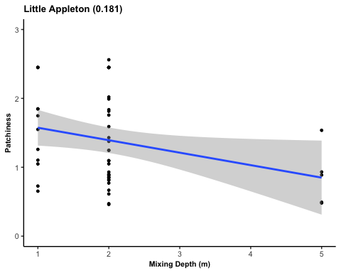

lilap.model <- lm(LilAp.cv ~ LilAp.mix, data = e)  
  
summary(lilap.model)

##   
## Call:  
## lm(formula = LilAp.cv ~ LilAp.mix, data = e)  
##   
## Residuals:  
## Min 1Q Median 3Q Max   
## -0.9327 -0.5208 -0.1457 0.4429 1.1677   
##   
## Coefficients:  
## Estimate Std. Error t value Pr(>|t|)   
## (Intercept) 1.75507 0.19850 8.841 1.46e-11 ***  
## LilAp.mix -0.18105 0.08536 -2.121 0.0392 *   
## ---  
## Signif. codes: 0 '***' 0.001 '**' 0.01 '*' 0.05 '.' 0.1 ' ' 1  
##   
## Residual standard error: 0.6434 on 47 degrees of freedom  
## (11 observations deleted due to missingness)  
## Multiple R-squared: 0.08736, Adjusted R-squared: 0.06794   
## F-statistic: 4.499 on 1 and 47 DF, p-value: 0.03922

walsh.mix <- f$`Mixing Depth`  
walsh.cv <- f$CV  
  
walsh.CV.plot <- ggplot(f, aes(x=walsh.mix, y=walsh.cv, group=1)) +  
 geom_point(size=1) +  
 ggtitle("Walsh (0.296)") +  
 scale_y_continuous(limits = c(0,3), breaks = seq(0,3,1))+  
 theme_bw() +  
 theme(panel.border = element_blank(),   
 panel.grid.major = element_blank(),  
 panel.grid.minor = element_blank(),   
 axis.line = element_line(colour = "black"),  
 plot.title = element_text(face = "bold", size = 10),  
 axis.text=element_text(size=8),   
 axis.title=element_text(face = "bold", size=8))+  
 labs(x = ("Mixing Depth (m)"), y = "")+  
 stat_smooth(method = "lm", formula = y ~ x, geom = "smooth")  
  
walsh.CV.plot

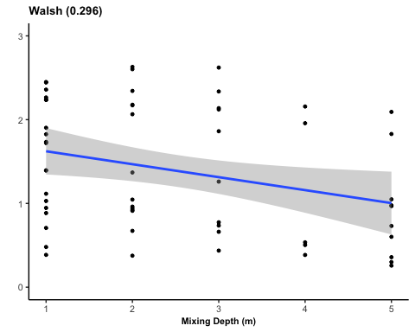

walsh.model <- lm(walsh.cv ~ walsh.mix, data = f)  
  
summary(walsh.model)

##   
## Call:  
## lm(formula = walsh.cv ~ walsh.mix, data = f)  
##   
## Residuals:  
## Min 1Q Median 3Q Max   
## -1.2369 -0.6158 -0.0759 0.7081 1.3081   
##   
## Coefficients:  
## Estimate Std. Error t value Pr(>|t|)   
## (Intercept) 1.77739 0.19110 9.301 5.91e-13 ***  
## walsh.mix -0.15468 0.06542 -2.365 0.0215 *   
## ---  
## Signif. codes: 0 '***' 0.001 '**' 0.01 '*' 0.05 '.' 0.1 ' ' 1  
##   
## Residual standard error: 0.7238 on 56 degrees of freedom  
## (2 observations deleted due to missingness)  
## Multiple R-squared: 0.09078, Adjusted R-squared: 0.07454   
## F-statistic: 5.591 on 1 and 56 DF, p-value: 0.02154

################  
combined = ggarrange(bishop.CV.plot,cedar.CV.plot, cw.CV.plot, LilAp.CV.plot, mill.CV.plot, walsh.CV.plot,  
 nrow = 2, ncol = 3)  
  
#### saving combined plot  
ggsave(here("figures", "CombinedMixingDepthRegression.jpg"), combined, width = 8, height = 6, dpi = 600)