SporeByDepthTimeCV

Elizabeth Davenport

2023-11-22

# Initial stuff, including loading packages and importing data

##loading packages

library(here)  
library(rstatix)  
library(ggplot2)  
library(tidyverse)  
library(dplyr)  
library(ggpubr)  
library(lubridate)  
library(scales)  
library(reshape2)  
library(RColorBrewer)  
library(ggsignif)

## loading files

# Tell R where files are stored  
here::i_am("scripts/SporeByDepthTimeCV.Rmd")  
  
# Load Files  
a <- readr::read_csv(here("data/CV_Depth_All_Parasites.csv"))

col <- c("0"= "#C6DBEF", "1"= "#9ECAE1", "2"="#6BAED6", "3"="#4292C6","4"= "#2171B5","5"= "#08519C","6"= "#08306B")  
col2 <-c("0"= "#F7FBFF", "1"= "#DEEBF7", "2"="#C6DBEF", "3"="#9ECAE1","4"= "#6BAED6","5"= "#4292C6","6"= "#2171B5", "7"="#084594")  
  
o = a %>%  
 filter(Parasite== "Ordospora")  
  
lo<-o$Lake  
cvo <- o$CV  
do <- as.numeric(o$Depth)  
  
df1<- data.frame(lo,do, cvo)  
  
wtest<-compare_means(cvo ~ do, data = df1, method="wilcox.test", paired = FALSE)  
  
my_comparisons1<- list( c("0", "6"))  
##significant difference 0 vs 6m  
  
  
CVordo <- ggplot(data=df1,mapping=aes(y=do,x=cvo, fill = as.factor(do))) +  
 geom_boxplot()+  
 scale_y_reverse(limits = c(7.5, -0.5), breaks = seq(7,0,-1))+  
 scale_x_continuous(limits = c(0,3.5), breaks = seq(0,3.5,0.5))+  
 scale_fill_manual(values = col2)+  
 theme_bw() +  
 theme(panel.border = element_blank(),   
 panel.grid.major = element_blank(),  
 panel.grid.minor = element_blank(),   
 axis.line = element_line(colour = "black"))+  
 ggtitle(expression(paste(bolditalic("O. pajunii")))) +  
 labs(x = ("Coefficient of Variation"), y=("Depth (m)"))+  
 theme(plot.title = element_text(face = "bold",size = 12)) +  
 theme(axis.text=element_text(size=10, face = "bold"),   
 axis.title=element_text(size=10,face="bold")) +  
 theme(legend.position = "none")  
  
  
CVordo

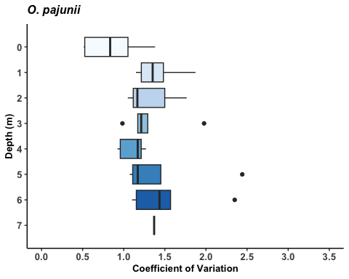

b = a %>%  
 filter(Parasite== "Blastulidium")  
  
cvb <- b$CV  
db <- b$Depth  
  
df2<- data.frame(db, cvb)  
  
wtest2<-compare_means(cvb ~ db, data = df2, method="wilcox.test", paired = FALSE)  
##no significant difference  
  
CVbrood <- ggplot(data=b,aes(x=cvb,y=db, fill = as.factor(db))) +  
 geom_boxplot()+  
 scale_y_reverse(limits = c(7.5, -0.5), breaks = seq(7,0,-1))+  
 scale_x_continuous(limits = c(0,3.5), breaks = seq(0,3.5,0.5))+  
 scale_fill_manual(values = col2)+  
 theme_bw() +  
 theme(panel.border = element_blank(),   
 panel.grid.major = element_blank(),  
 panel.grid.minor = element_blank(),   
 axis.line = element_line(colour = "black"))+  
 ggtitle(expression(paste(bolditalic("B. paedophthorum")))) +  
 labs(x = ("Coefficient of Variation"), y=("Depth (m)"))+  
 theme(plot.title = element_text(face = "bold",size = 12)) +  
 theme(axis.text=element_text(size=10, face = "bold"),   
 axis.title=element_text(size=10,face="bold")) +  
 theme(legend.position = "none")  
  
CVbrood

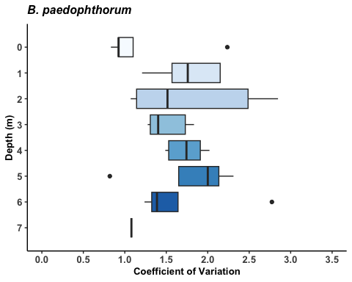

m = a %>%  
 filter(Parasite== "Metschnikowia")  
  
cvm <- m$CV  
dm <- m$Depth  
  
df3<- data.frame(dm, cvm)  
  
wtest3<-compare_means(cvm ~ dm, data = df3, method="wilcox.test", paired = FALSE)  
##no significant difference  
  
CVmetsch <- ggplot(data=m,aes(x=cvm,y=dm, fill = as.factor(dm))) +  
 geom_boxplot()+  
 scale_y_reverse(limits = c(7.5, -0.5), breaks = seq(7,0,-1))+  
 scale_x_continuous(limits = c(0,3.5), breaks = seq(0,3.5,0.5))+  
 scale_fill_manual(values = col2)+  
 theme_bw() +  
 theme(panel.border = element_blank(),   
 panel.grid.major = element_blank(),  
 panel.grid.minor = element_blank(),   
 axis.line = element_line(colour = "black"))+  
 ggtitle(expression(paste(bolditalic("M. bicuspidata")))) +  
 labs(x = ("Coefficient of Variation"), y=("Depth (m)"))+  
 theme(plot.title = element_text(face = "bold",size = 12)) +  
 theme(axis.text=element_text(size=10, face = "bold"),   
 axis.title=element_text(size=10,face="bold")) +  
 theme(legend.position = "none")  
  
CVmetsch

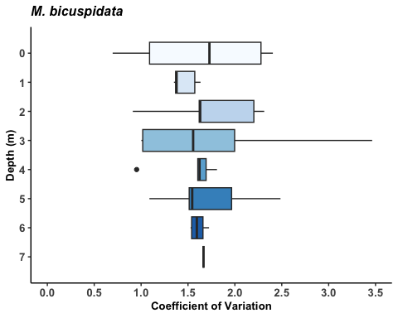

p = a %>%  
 filter(Parasite== "Pasteuria")  
  
cvp <- p$CV  
dp <- p$Depth  
  
df4<- data.frame(dp, cvp)  
  
wtest4<-compare_means(cvp ~ dp, data = df4, method="wilcox.test", paired = FALSE)  
##no significant difference  
  
CVpast <- ggplot(data=p,aes(x=cvp,y=dp, fill = as.factor(dp))) +  
 geom_boxplot()+  
 scale_y_reverse(limits = c(7.5, -0.5), breaks = seq(7,0,-1))+  
 scale_x_continuous(limits = c(0,3.5), breaks = seq(0,3.5,0.5))+  
 scale_fill_manual(values = col2)+  
 theme_bw() +  
 theme(panel.border = element_blank(),   
 panel.grid.major = element_blank(),  
 panel.grid.minor = element_blank(),   
 axis.line = element_line(colour = "black"))+  
 ggtitle(expression(paste(bolditalic("P. ramosa")))) +  
 labs(x = ("Coefficient of Variation"), y=("Depth (m)"))+  
 theme(plot.title = element_text(face = "bold",size = 12)) +  
 theme(axis.text=element_text(size=10, face = "bold"),   
 axis.title=element_text(size=10,face="bold")) +  
 theme(legend.position = "none")  
  
CVpast

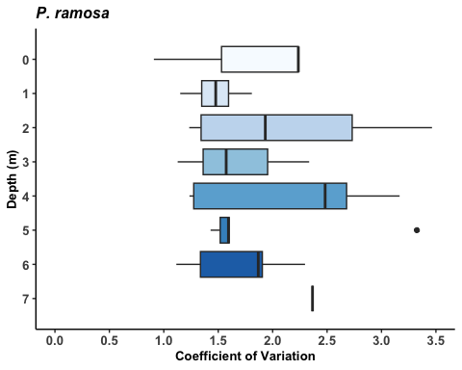

s = a %>%  
 filter(Parasite== "Spirobacillus")  
  
cvs <- s$CV  
ds <- s$Depth  
  
df5<- data.frame(ds, cvs)  
  
wtest5<-compare_means(cvs ~ ds, data = df5, method="wilcox.test", paired = FALSE)  
## significant difference 0 to 1,2,3  
  
CVspiro <- ggplot(data=s,aes(x=cvs,y=ds, fill = as.factor(ds))) +  
 geom_boxplot()+  
 scale_y_reverse(limits = c(7.5, -0.5), breaks = seq(7,0,-1))+  
 scale_x_continuous(limits = c(0,3.5), breaks = seq(0,3.5,0.5))+  
 scale_fill_manual(values = col2)+  
 theme_bw() +  
 theme(panel.border = element_blank(),   
 panel.grid.major = element_blank(),  
 panel.grid.minor = element_blank(),   
 axis.line = element_line(colour = "black"))+  
 ggtitle(expression(paste(bolditalic("S. cienkowskii")))) +  
 labs(x = ("Coefficient of Variation"), y=("Depth (m)"))+  
 theme(plot.title = element_text(face = "bold",size = 12)) +  
 theme(axis.text=element_text(size=10, face = "bold"),   
 axis.title=element_text(size=10,face="bold")) +  
 theme(legend.position = "none")  
  
CVspiro

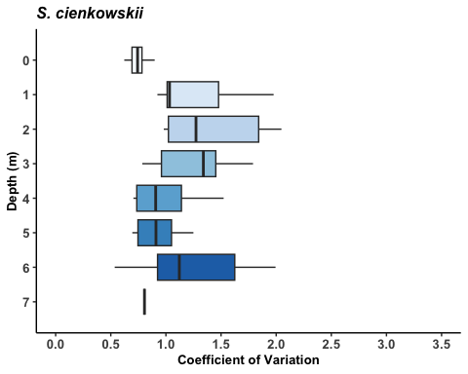

all.combined = ggarrange(CVmetsch,CVpast,CVbrood,  
 CVordo,CVspiro,  
 nrow = 3, ncol = 2)  
all.combined=annotate_figure(all.combined,top = text_grob("Coefficient of Variation: Time", color = "black", face = "bold", size = 14))  
  
all.combined

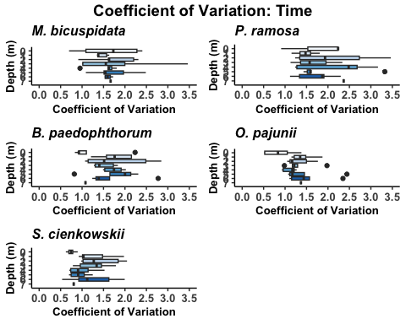

#### saving combined plot  
ggsave(here("figures", "Combo_Plot_CV_By_Depth.jpg"), all.combined, width = 6, height = 10, dpi = 300)