SporePatchinessNearshoreOffshore

Elizabeth Davenport

2023-11-22

# Initial stuff, including loading packages and importing data

##loading packages

library(here)  
library(rstatix)  
library(ggplot2)  
library(tidyverse)  
library(dplyr)  
library(ggpubr)

## loading files

# Tell R where files are stored  
here::i_am("scripts/WalshTemperatureProfileAndMixing.Rmd")  
  
# Load Files  
a <- readr::read_csv(here("data/CV_Walsh_Locations.csv"))  
b <- readr::read_csv(here("data/CV_LilAp_Locations.csv"))  
c <- readr::read_csv(here("data/CV_Cedar_Locations.csv"))

r <- a$Round  
p <- a$Parasite  
loc <- a$Location  
cv <- a$CV  
  
  
cols <- c("Basin"= "#0072B2",  
 "Intermediate"="#009E73",  
 "Nearshore"= "yellow3")  
  
  
CVLocation <- ggplot(data=a,aes(x=as.factor(r),y=CV, fill=loc)) +  
 geom_boxplot()+  
 scale_y_continuous(limits = c(0,3), breaks = seq(0,3,.5))+  
 ##scale_x_discrete(c("Nearshore","Intermediate","Basin"))+  
 scale_fill_manual(values = cols)+  
 theme_bw() +  
 theme(panel.border = element_blank(),   
 panel.grid.major = element_blank(),  
 panel.grid.minor = element_blank(),   
 axis.line = element_line(colour = "black"))+  
 ggtitle("Walsh") +  
 labs(x = ("Round"), y=("Coefficient of Variation"), fill = ("Location"))+  
 theme(plot.title = element_text(face = "bold",size = 12)) +  
 theme(axis.text=element_text(size=10, face = "bold"),   
 axis.title=element_text(size=10,face="bold")) +  
 theme(legend.position = "bottom")  
  
CVLocation

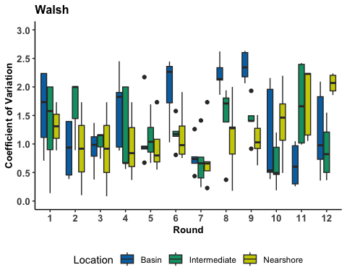

### LilAp

rla <- b$Round  
pla <- b$Parasite  
locla <- b$Location  
cvla <- b$CV  
  
  
  
CVLocationLA <- ggplot(data=b,aes(x=as.factor(rla),y=cvla, fill=locla)) +  
 geom_boxplot()+  
 scale_y_continuous(limits = c(0,3), breaks = seq(0,3,.5))+  
 ##scale_x_discrete(c("Nearshore","Intermediate","Basin"))+  
 scale_fill_manual(values = cols)+  
 theme_bw() +  
 theme(panel.border = element_blank(),   
 panel.grid.major = element_blank(),  
 panel.grid.minor = element_blank(),   
 axis.line = element_line(colour = "black"))+  
 ggtitle("Little Appleton") +  
 labs(x = ("Round"), y=("Coefficient of Variation"), fill = ("Location"))+  
 theme(plot.title = element_text(face = "bold",size = 12)) +  
 theme(axis.text=element_text(size=10, face = "bold"),   
 axis.title=element_text(size=10,face="bold")) +  
 theme(legend.position = "bottom")  
  
CVLocationLA

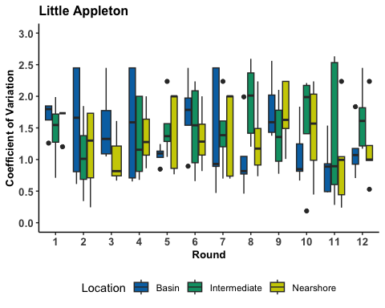

### Cedar

rc <- c$Round  
locc <- c$Locations  
cvc <- c$CV  
  
CVLocationC <- ggplot(data=c,aes(x=as.factor(rc),y=cvc, fill=locc)) +  
 geom_boxplot()+  
 scale_y_continuous(limits = c(0,3), breaks = seq(0,3,.5))+  
 ##scale_x_discrete(c("Nearshore","Intermediate","Basin"))+  
 scale_fill_manual(values = cols)+  
 theme_bw() +  
 theme(panel.border = element_blank(),   
 panel.grid.major = element_blank(),  
 panel.grid.minor = element_blank(),   
 axis.line = element_line(colour = "black"))+  
 ggtitle("Cedar") +  
 labs(x = ("Round"), y=("Coefficient of Variation"), fill = ("Location"))+  
 theme(plot.title = element_text(face = "bold",size = 12)) +  
 theme(axis.text=element_text(size=10, face = "bold"),   
 axis.title=element_text(size=10,face="bold")) +  
 theme(legend.position = "bottom")  
  
CVLocationC

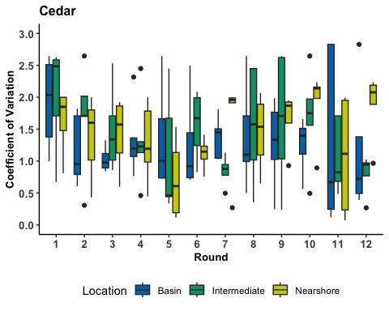

### combo

combined = ggarrange(CVLocation,CVLocationLA,CVLocationC,  
 nrow = 3, ncol = 1,  
 common.legend = TRUE,  
 legend="bottom")  
  
combined=annotate_figure(combined,top = text_grob("Patchiness", color = "black", face = "bold", size = 14))  
  
combined

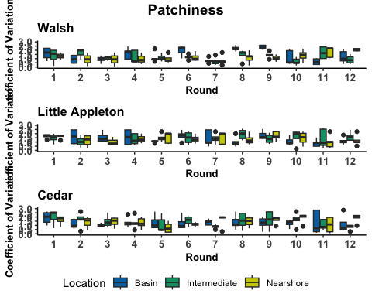

#### saving combined plot  
ggsave(here("figures", "Combo_Plot_Patchiness_Location.jpg"), combined, width = 10, height = 10, dpi = 300)