SupportingInformationSporeViability

Elizabeth Davenport

2024-05-27

# Initial stuff, including loading packages and importing data

##loading packages

library(here)  
library(rstatix)  
library(ggplot2)  
library(tidyverse)  
library(dplyr)  
library(ggpubr)

## loading files

# Tell R where files are stored  
here::i_am("scripts/SupportingInformationSporeViability.Rmd")  
  
# Load Files  
a <- readr::read_csv(here("data/SupportingInformationSporeViability.csv"))

### defining factors and values  
treatment <- as.factor(a$Treatment)  
conc <- a$Concentration  
sample <- a$SampleID  
infection <- a$PercentInfection  
  
##### Color scheme  
col <- c("Control"="#009E73", "Frozen"="#0072B2", "UV"="#D55E00")  
  
  
## creating a data frame  
df1<- data.frame(sample,treatment,conc, infection)  
  
#### setting comparisons for wilcox test  
my_comparisons <- list( c("Control", "UV"),c("Control", "Frozen"),c("Frozen", "UV"))  
  
## Wilcoxon Test  
wtest<-compare_means(conc ~ treatment, data = df1, method="wilcox.test", paired = FALSE)  
  
sv.plot <- ggplot(data=df1) +  
 geom_boxplot(aes(x=infection,y=conc, fill = as.factor(treatment)))+  
 geom_point(aes(x=infection,y=conc))+  
 scale_y_continuous(limits = c(-1, 8), breaks = seq(0,8,2))+  
 scale_x_continuous(limits = c(-10,100), breaks = seq(0,100,10))+  
 scale_fill_manual(values = col)+  
 theme_bw() +  
 theme(panel.border = element_blank(),   
 panel.grid.major = element_blank(),  
 panel.grid.minor = element_blank(),   
 axis.line = element_line(colour = "black"))+  
 ggtitle("Spore Viability") +  
 labs(fill = "Treatment", x = ("Infection Prevalence"), y=("Concentration (copies/uL)"))+  
 theme(plot.title = element_text(face = "bold",size = 12)) +  
 theme(axis.text=element_text(size=10, face = "bold"),   
 axis.title=element_text(size=10,face="bold")) +  
 theme(legend.position = "bottom")  
  
sv.plot

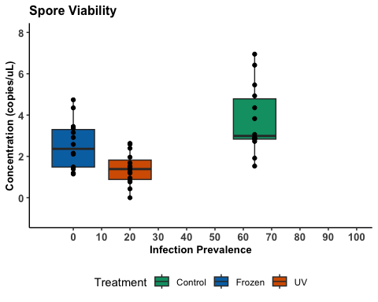

#### saving plot  
ggsave(here("figures", "SupportingInformationSporeViability.jpg"), sv.plot, width = 6, height = 6, dpi = 600)