WalshTemperatureProfileAndMixing

Elizabeth Davenport

2023-11-20

# Initial stuff, including loading packages and importing data

##loading packages

library(here)  
library(rstatix)  
library(ggplot2)  
library(tidyverse)  
library(dplyr)  
library(lubridate)  
library(scales)  
library(ggpubr)  
library(reshape2)  
library(RColorBrewer)

## loading files

# Tell R where files are stored  
here::i_am("scripts/WalshTemperatureProfileAndMixing.Rmd")  
  
# Load Files  
a <- readr::read_csv(here("data/WalshMixingDepthCV.csv"))  
c <- readr::read_csv(here("data/Walsh_Basin_Thermal_Profile_2021.csv"))

##Walsh Thermal Profile

z <- strptime(c$Date, format = "%m/%d/%y %H:%M")  
##strptime(z, format = "%m/%d/%y %H:%M")  
l <- as.POSIXct(z,format="%m/%d/%y %H:%M",tz=Sys.timezone())  
  
W.1 <- c$B1  
W.2 <- c$B2  
W.3 <- c$B3  
W.4 <- c$B4  
W.5 <- c$B5  
W.SWI <- c$SWI  
W.surf <- c$Surface  
  
df.WB <- data.frame(check.names = FALSE, time = l,  
 "1m" = W.1,  
 "2m" = W.2,  
 "3m" = W.3,  
 "4m" = W.4,  
 "5m" = W.5,  
 "Surface" = W.surf)  
df.WB <- melt(df.WB , id.vars = 'time', variable.name = 'series')  
  
colsB<- brewer.pal(9,"Blues")  
colsB2 <- c("Surface"= "#C6DBEF", "1m"= "#9ECAE1", "2m"="#6BAED6", "3m"="#4292C6","4m"= "#2171B5","5m"= "#08519C","6m"= "#08306B")  
colsB <- c("0"= "#C6DBEF", "1"= "#9ECAE1", "2"="#6BAED6", "3"="#4292C6","4"= "#2171B5","5"= "#08519C","6"= "#08306B")  
  
  
WB.combined = ggplot() + geom_line(df.WB,mapping=aes(x=time,y=value, colour = factor(series)), size=1) +  
 scale_colour_manual(values = colsB2)+  
 geom_vline(xintercept = as.POSIXct(as.Date("2021-06-14")), linetype="dotted",   
 color = "black", size=1)+  
 geom_vline(xintercept = as.POSIXct(as.Date("2021-06-28")), linetype="dotted",   
 color = "black", size=1)+  
 geom_vline(xintercept = as.POSIXct(as.Date("2021-07-12")), linetype="dotted",   
 color = "black", size=1)+  
 geom_vline(xintercept = as.POSIXct(as.Date("2021-07-26")), linetype="dotted",   
 color = "black", size=1)+  
 geom_vline(xintercept = as.POSIXct(as.Date("2021-08-09")), linetype="dotted",   
 color = "black", size=1)+  
 geom_vline(xintercept = as.POSIXct(as.Date("2021-08-23")), linetype="dotted",   
 color = "black", size=1)+  
 geom_vline(xintercept = as.POSIXct(as.Date("2021-09-07")), linetype="dotted",   
 color = "black", size=1)+  
 geom_vline(xintercept = as.POSIXct(as.Date("2021-09-20")), linetype="dotted",   
 color = "black", size=1)+  
 geom_vline(xintercept = as.POSIXct(as.Date("2021-10-04")), linetype="dotted",   
 color = "black", size=1)+  
 geom_vline(xintercept = as.POSIXct(as.Date("2021-10-18")), linetype="dotted",   
 color = "black", size=1)+  
   
 geom_vline(xintercept = as.POSIXct(as.Date("2021-11-01")), linetype="dotted",   
 color = "black", size=1)+  
   
 geom_vline(xintercept = as.POSIXct(as.Date("2021-11-12")), linetype="dotted",   
 color = "black", size=1)+  
 geom_vline(xintercept = as.POSIXct(as.Date("2021-09-22")), linetype="dotted",   
 color = "#009E73", size=1)+  
 geom_vline(xintercept = as.POSIXct(as.Date("2021-10-22")), linetype="dotted",   
 color = "#D55E00", size=1)+  
 theme_bw() +  
 theme(panel.border = element_blank(),   
 panel.grid.major = element_blank(),  
 panel.grid.minor = element_blank(),   
 axis.line = element_line(colour = "black")) +  
 scale_y_continuous(limits = c(5, 30), breaks = seq(5, 30, 5))+  
 labs(x = "",  
 y = (expression(bold("Temperature " ( degree*C))))) +  
 ggtitle("Thermal Profile") +  
 theme(plot.title = element_text(face = "bold",size = 14)) +  
 theme(axis.text=element_text(size=10, face = "bold"),   
 axis.title=element_text(size=12,face="bold")) +  
 theme(legend.title = element_text(face = "bold",size = 12),  
 legend.text=element_text(size=10,face="bold"),  
 legend.position = "bottom") +   
 scale_x_datetime(breaks = date_breaks("21 days"), labels = date_format("%m/%d/%y")) +  
 labs(colour = "Depth")  
WB.combined

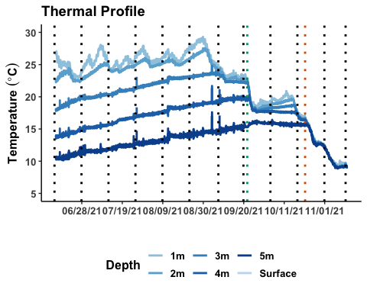

#### Boxplot of coefficient of variation

Walsh <- na.omit(a)  
  
r <- as.factor(Walsh$Round)  
CV<-Walsh$CV  
mix<-as.factor(Walsh$`Mixing Depth`)  
  
##my_comparisons <- list( c("9", "10"),c("9", "11"),c("9", "12"))  
  
CVwalsh <- ggplot(data=Walsh,aes(x=r,y=CV, fill=mix)) +  
 geom_boxplot()+  
 scale_y_continuous(limits = c(0,3.5), breaks = seq(0,3.5,.5))+  
 geom_vline(xintercept = 10.5, color="#D55E00", size=1)+  
 geom_vline(xintercept = 8.5, color="#009E73", size=1)+  
 scale_fill_manual(values = colsB)+  
 theme_bw() +  
 theme(panel.border = element_blank(),   
 panel.grid.major = element_blank(),  
 panel.grid.minor = element_blank(),   
 axis.line = element_line(colour = "black"))+  
 ggtitle("Patchiness over Time") +  
 labs(x = ("Sampling Round"), y=("Coefficient of Variation"),fill=("Depth"))+  
 theme(plot.title = element_text(face = "bold",size = 14)) +  
 theme(axis.text=element_text(size=10, face = "bold"),   
 axis.title=element_text(size=12,face="bold")) +  
 theme(legend.position = "bottom")  
  
CVwalsh

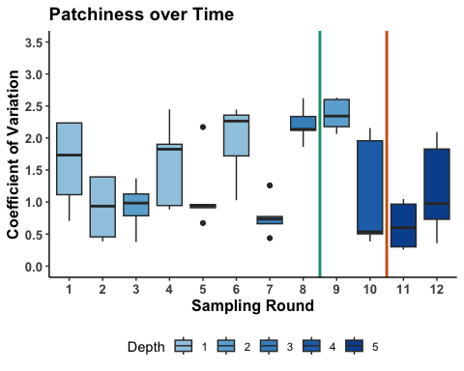

### Mixing Depth

## creating a data frame  
df1<- data.frame(r, mix, CV)  
  
#### setting comparisons for wilcox test  
my_comparisons <- list(c("1", "5"))  
  
## Wilcoxon Test  
wtest<-compare_means(CV ~ mix, data = df1, method="wilcox.test", paired = FALSE)  
  
  
CVwalshMix <- ggplot(data=df1,aes(x=mix,y=CV, fill=mix)) +  
 geom_boxplot()+  
 scale_y_continuous(limits = c(0,3.5), breaks = seq(0,3.5,.5))+  
 scale_x_discrete(breaks=seq(0,5,1))+  
 scale_fill_manual(values = colsB)+  
 theme_bw() +  
 theme(panel.border = element_blank(),   
 panel.grid.major = element_blank(),  
 panel.grid.minor = element_blank(),   
 axis.line = element_line(colour = "black"))+  
 ggtitle("Mixing Depth and Patchiness") +  
 labs(x = ("Mixing Depth (m)"), y=("Patchiness"), fill=("Depth"))+  
 theme(plot.title = element_text(face = "bold",size = 14)) +  
 theme(axis.text=element_text(size=10, face = "bold"),   
 axis.title=element_text(size=12,face="bold")) +  
 theme(legend.position = "bottom")+  
 guides(fill = guide_legend(override.aes = list(size = 0.15)))+  
 theme(legend.title = element_text(face = "bold"))+  
 stat_compare_means(method="wilcox.test", paired=FALSE, comparisons = my_comparisons, hide.ns=FALSE) # Add pairwise comparisons p-value  
  
  
CVwalshMix

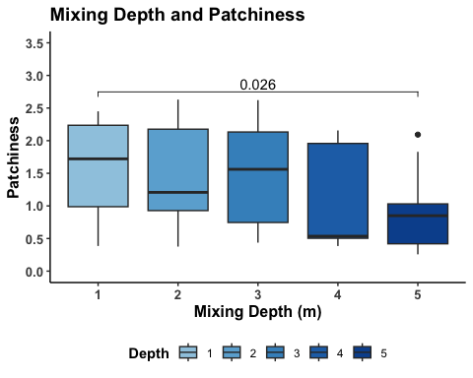

###Combined Plot

leg <- get_legend(CVwalshMix)  
CVwalshMix <- CVwalshMix + theme(legend.position = "none")  
combined = ggarrange(WB.combined, CVwalsh, ggarrange(CVwalshMix, leg, ncol=2),  
 nrow = 3, labels = c("A.","B.","C."),  
 heights = c(1.5,1,1),  
 common.legend = FALSE,  
 legend="none")  
  
  
combined=annotate_figure(combined,top = text_grob("Walsh Lake", color = "black", face = "bold", size = 16))  
  
combined

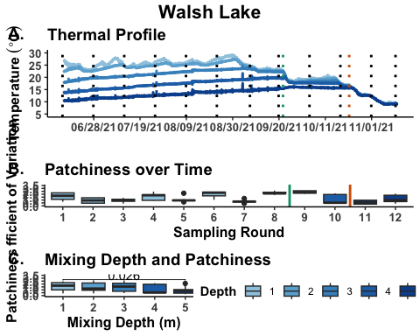

#### saving combined plot  
ggsave(here("figures", "Walsh_Combined_TemperatureProfile_Patchiness_Mixing_v4.jpg"), combined, width = 10, height = 12, dpi = 300)