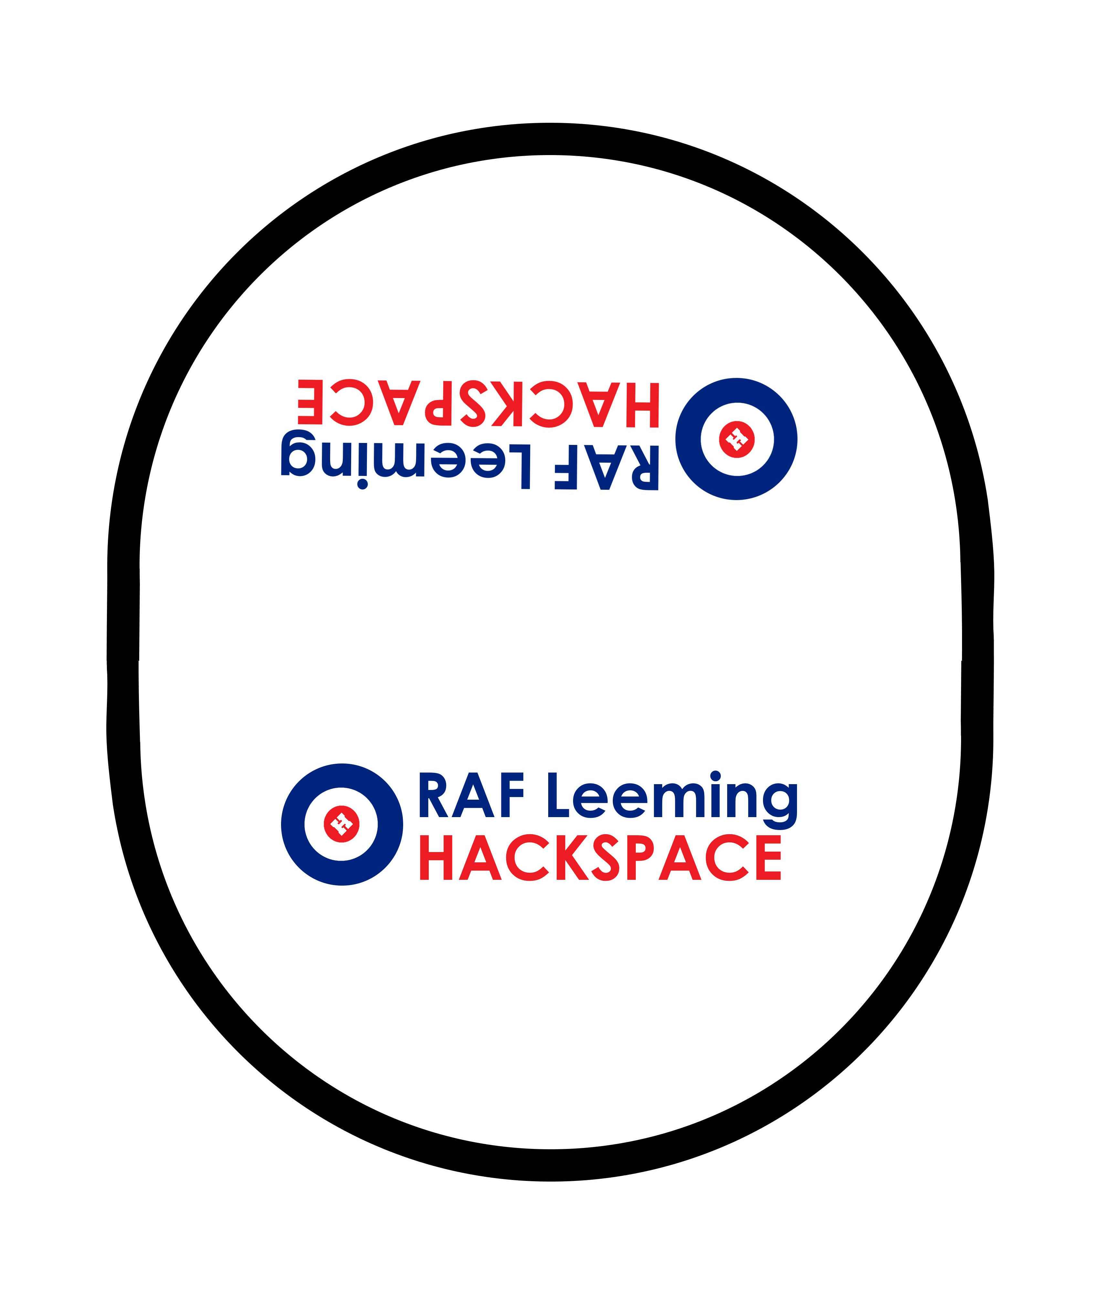

**90SU Cross-Brief Hackathon**

**Rules**

You have until 1615 to modify and develop the basic line following Robot Car to score as highly as possible against the scoring criteria. Judging will be carried out by CO 90SU.

Directing Staff are available to provide advice/guidance but are NOT allowed to touch any of the resources listed below.

The Robot Car will complete three timed laps of the RAF Leeming HACKSPACE circuit and the fastest lap time will count towards final scoring. The Robot may be worked on in between the three timed laps back on the team table. The last timed lap will be at 1640.

A speed trap will be incorporated on the track and teams will be ranked by the top speed in the speed trap (from any of the three laps).

CO 90SU will score the teams on smoothness and style.

Touching of the Robot during the timed laps will incur a 2 second penalty per offence – lifting the Robot off the track voids the lap time (but the lap still counts as 1 of 3).

Additional equipment is available from the DS table and may be used.

Style points will be awarded for adding additional functions to the Robot and making it personal to the team against the scoring sheet.

Smoothness points will be awarded based on the decision of the judge on how smooth the Robot navigates around the lap.

**Resources**

1x Robot Car

2x Batteries

1x Battery Charger

1x Blue USB Cable

1x Pink screwdriver (crosshead)

1x Blue screwdriver (crosshead)

1x Blue screwdriver (flathead)

2x Allen key

5x long wires

5x short wires

1x Laptop

1x Easel

4x Pens

Additional equipment from DS table

Please make sure not equipment is taken away from the team table apart from the Robot Car.

**TIPS**

Keep the batteries charged

Sometimes the wheels come off after heavy use

Sometimes the wheel motors come out of alignment and come loose

Keep workspace organised

Comment your code (//) to make it easy to understand / see changes you’ve made

Ask questions to DS