ECE 322

SOFTWARE TESTING AND MAINTENANCE

REVIEW SESSION

1.
Brief answers: please be concise. A few lines of reply and sound justification (if required) are just fine.

(1) What software complexity measure describing code could you consider as a sound descriptor of the process of software maintenance?

(2) Identify the fundamental difference between the control flow testing and data flow testing. In which sense are these two categories of testing complementary?

(3) The software is to be developed in a very unstable environment. Which integration strategy would you recommend? Why?

(4) A suite of tests developed through metamorphic testing have passed. Is the software being tested free of faults?

(5) We are predicting a cost of software maintenance. At the testing of the original software system, which testing (black box or glass box) could offer some guidance about the maintenance costs.

(6) Does integration testing fall under the category of black box or white box testing? Justify your response.

(7) Why, in general, one cannot achieve a 100% decision/branch coverage criterion.

2.
Circle only one answer for each of the questions posed below. If you find any question that appears to have more than one correct answer, choose the one that is the most specific or appropriate.

1.Which of the following is a well-known maxim regarding program testing:
- only incompetent programmers need to do testing
- an exhaustive test is the only practical way of constructing a correctness proof
- program testing can be used to discover the presence of errors but not their absence
- none of the above is a correct answer.

2.The essence of program testing is to choose certain components of the program to be exercised during the test. In data-flow testing, the components to be exercised are:
- data structures in the program
- paths in the data-flow diagram
- segments of an execution path that starts with a definition of some datum and ends with the use of that definition
- segments of an execution path that starts with a definition of some datum and ends with the next definition of that datum
- none of the above is a correct answer

3.In practice, existing program testing methods are such that
- their capabilities complement one another
- some have error-detection capabilities identical to others
- some can be used to obtain a direct proof of program correctness
- they are easy to implement and economical to use
- none of the above is a correct answer

4.A stub used in integration testing is:
- a driver used in a unit test
- a subprogram designed to generate and feed the test cases
- a simulator of a called program (dummy program unit) used in a top-down integration testing
- a program segment designed to prevent a “runaway” program from damaging other programs during a test
- a simulator of a calling program (dummy program unit) used in a bottom-up integration test

3.
The software system is composed of four modules and the interaction between them is modeled by a Markov model with the transition values shown below. If you were to test the modules, what would be an order in which they are to be tested. Justify your choice.

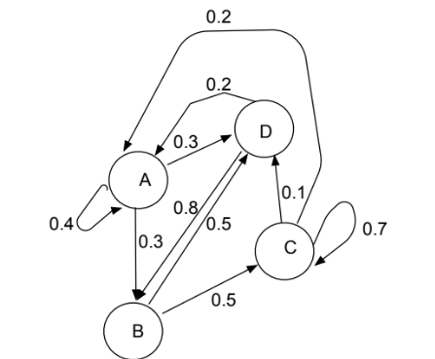

4.
The flowchart of a triangle program is shown below.
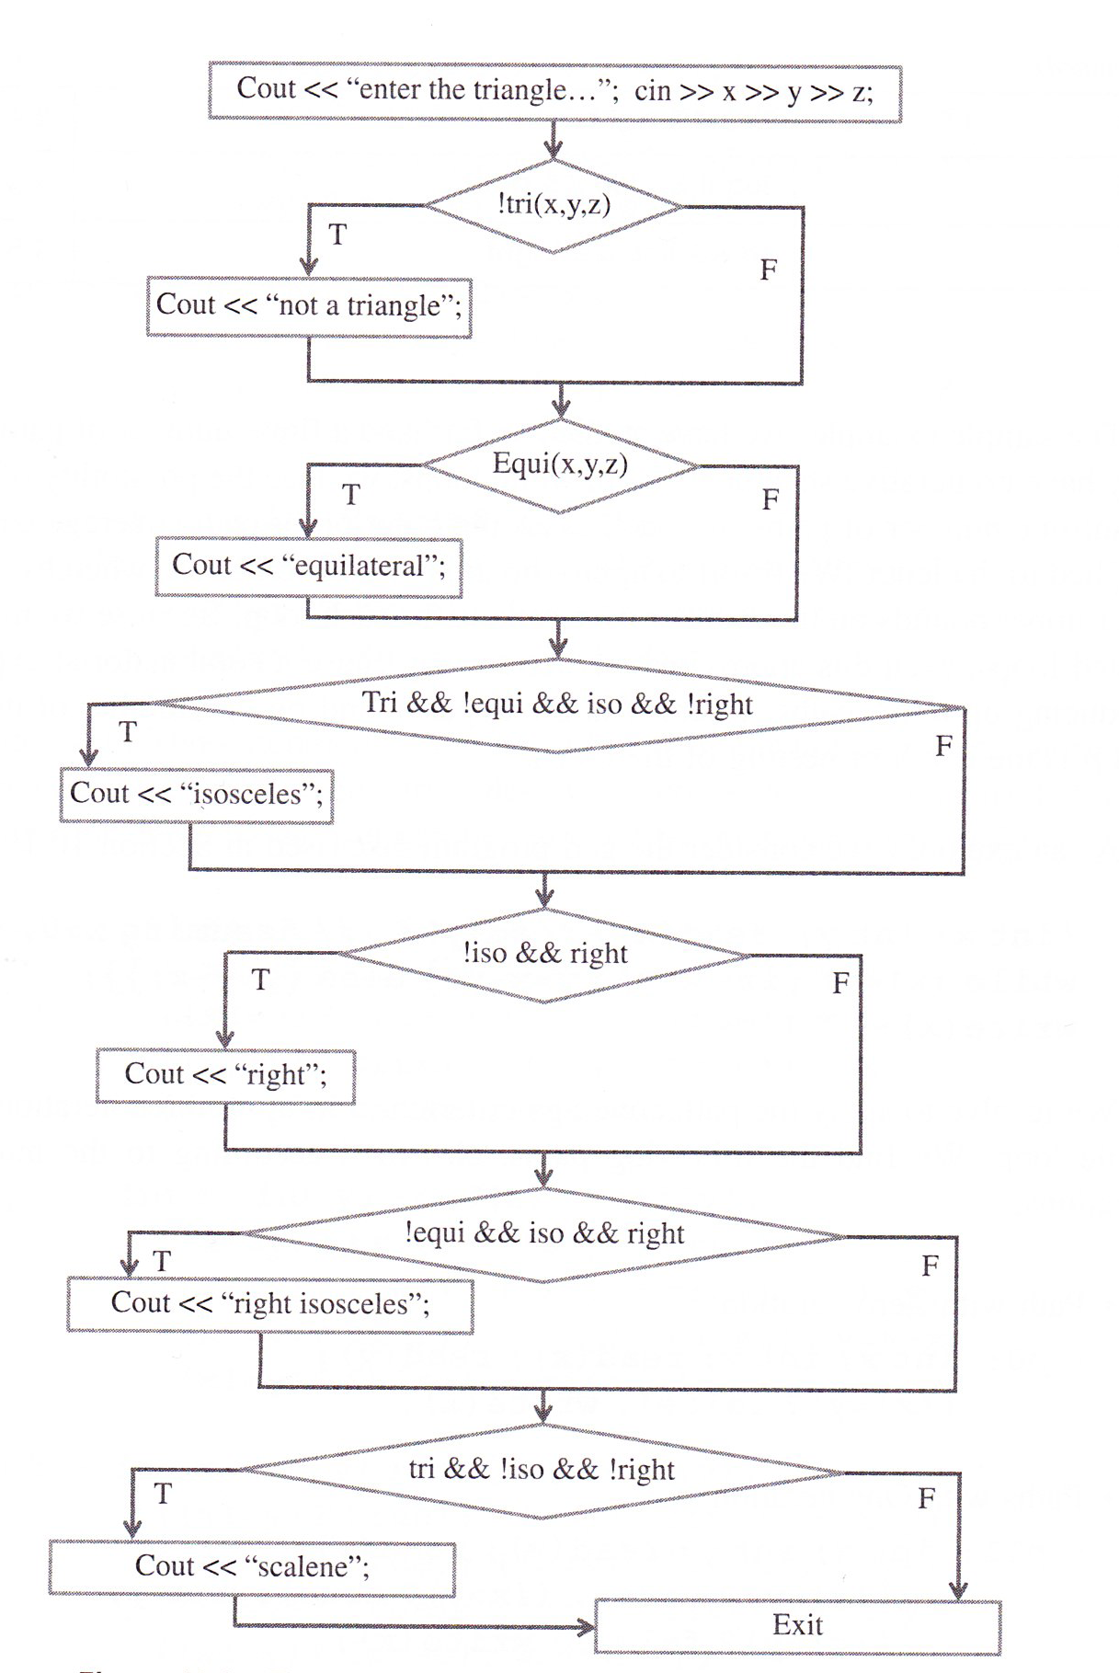

Do the following:
(i)determine its cyclomatic complexity
(ii)determine how many paths are in this graph
(iii)enumerate the number of executable paths and show them in the following tabular format

path | !tri | equi | …
P1
P2
….

The entries of this table are either true (T) or false (F). The binary predicates show in the flowchart are defined in the following way

equi(x,y,z) 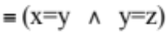
iso(x,y,z) 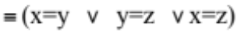
right(x,y,z)
tri(x,y,z) 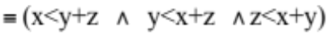

5.

Given is the following code
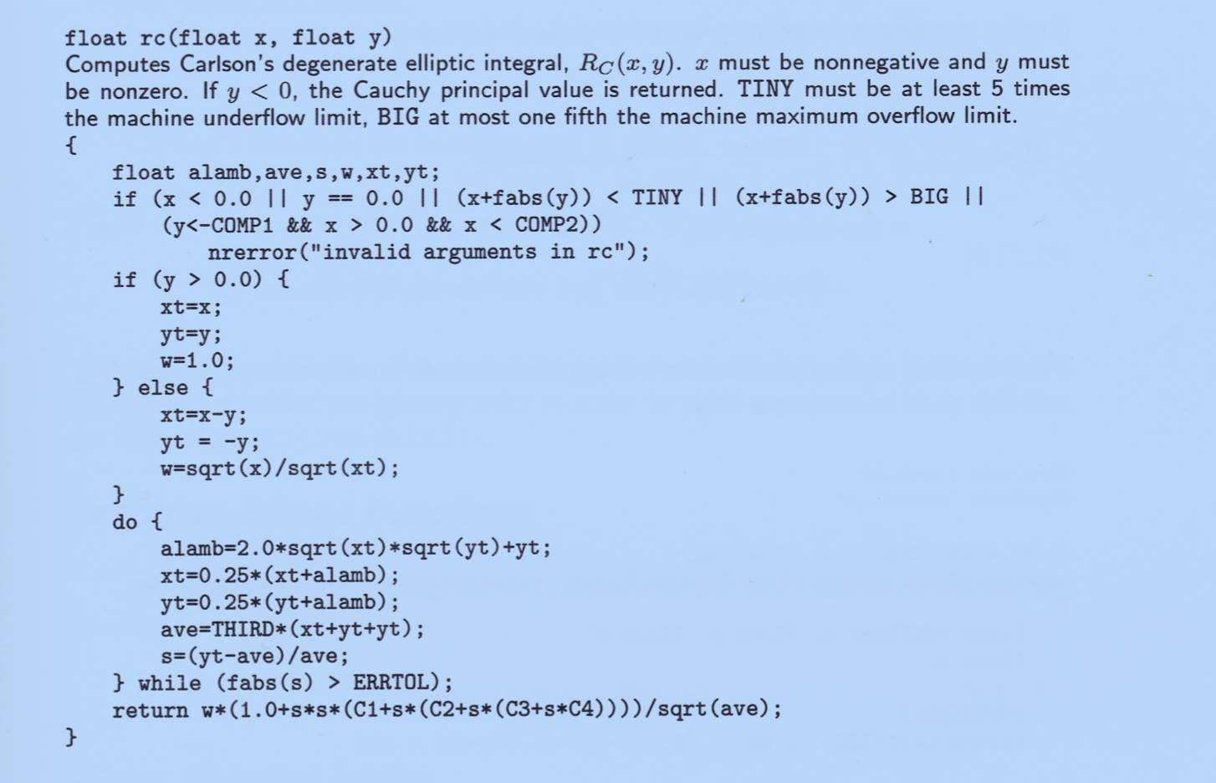
Draw a control flow graph. In your graph, include all subconditions present in the decision statements. What is its cyclomatic complexity.

