J40 PARTS TO SEND FOR REFURBISHMENT
A simple photo guide for selecting the correct parts
Purpose: Every photographed item in this guide should be selected, labelled and taken for refurbishment, specialist assessment or reconstruction.
Not included: Parts planned for replacement or interior modernisation have been removed, including wiper arms/blades, lights, washer pump/bottles, failed lock, old interior pulls and padded trim, window crank and pedal rubber.
Uncertain items: Send them, but attach an IDENTIFY FIRST label. The workshop should identify and assess them before blasting, dismantling or coating.

Simple rule for the workshop
Mechanical/electrical work: Route the pedal switches, latch sets, handbrake linkage, window regulator and wiper motor to the appropriate specialist before cosmetic work.
Before painting: Label where every part came from and check that it is not cracked, badly worn, bent or rusted too thin.
During painting: Do not paint threads, pivots, gear teeth, latch faces, seals, electrical contacts, fluid passages or mounting faces.
After painting: Fit new clips, bushes, seals or screws where needed, lubricate moving parts and test them before installation.
Bump stops: They are included because the metal fixtures need rust treatment and preparation. Protect the new rubber throughout the work.

Select and send these parts
Photo | Item | What to do
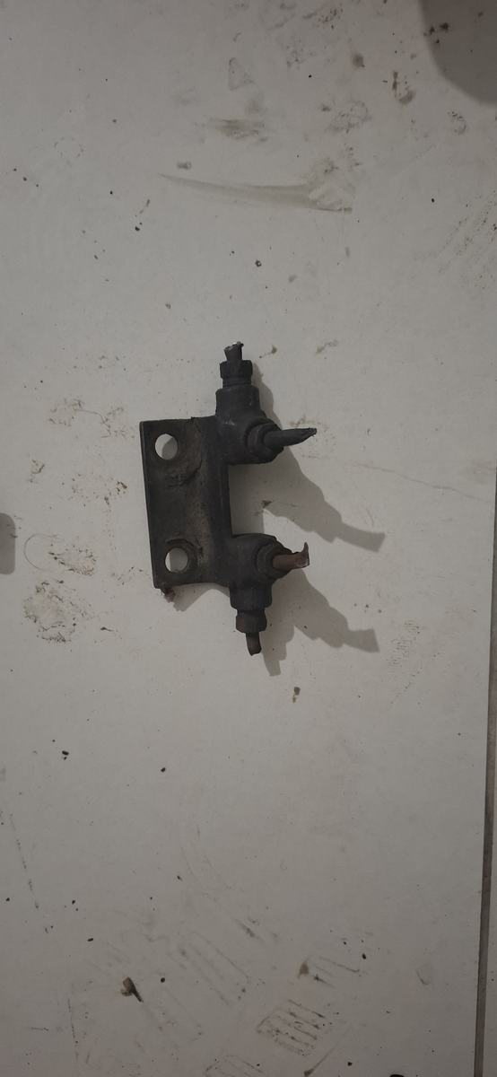 | Pedal-area plunger-switch bracket | Owner identifies the location as the brake/clutch pedal area. It looks like two adjustable plunger switches rather than a hydraulic junction. Label its position; test the switches and wiring; replace failed electrical parts; derust and refinish only the bracket.
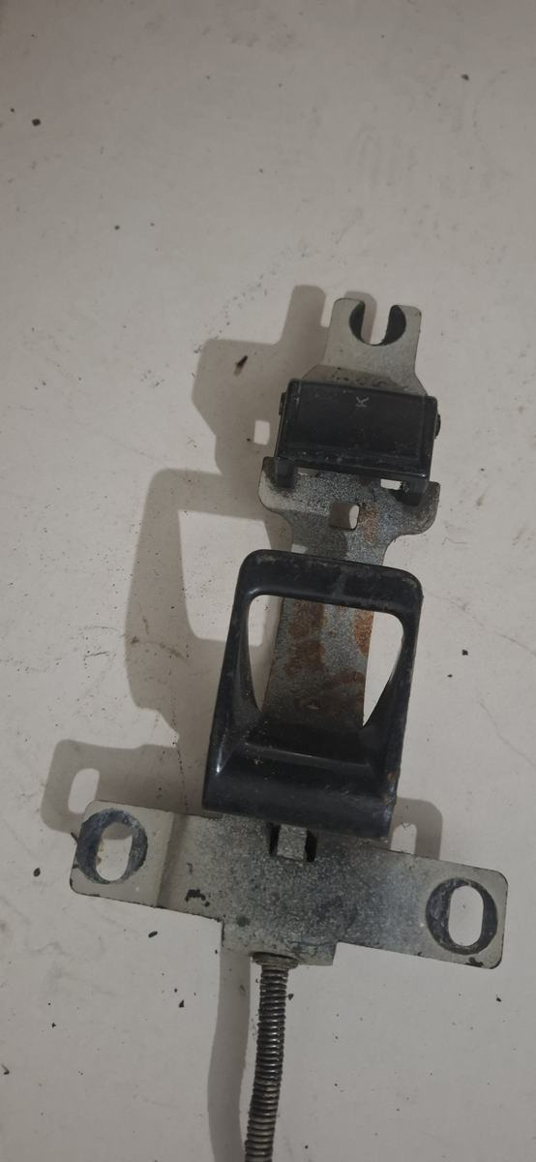 | Single stamped latch / adjuster bracket | Not a seatbelt. Send it with an IDENTIFY FIRST tag. It may be a bonnet/hood or other single control latch. Confirm its function and safe operation before cleaning, lubricating and refinishing reusable metal.
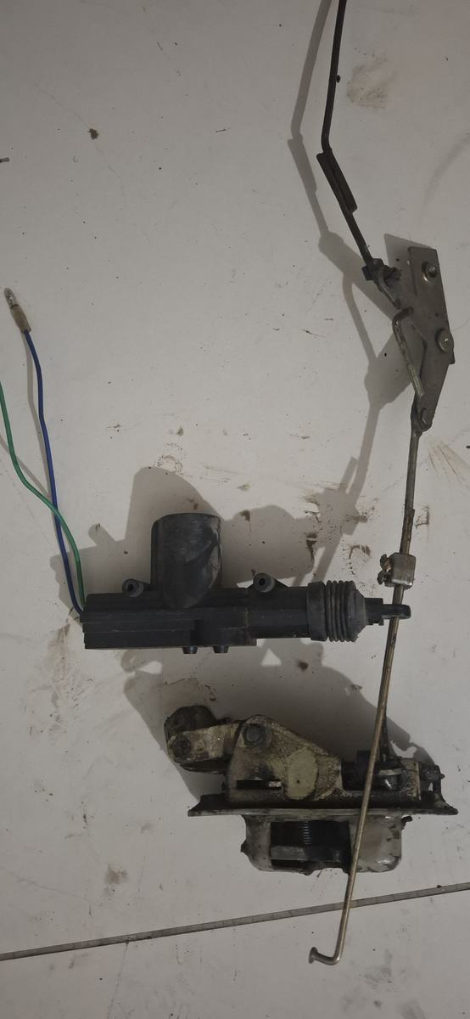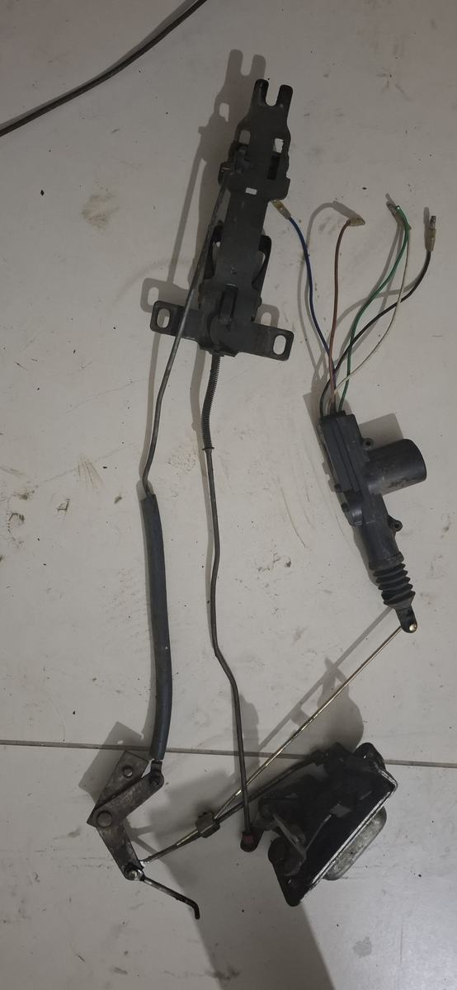 | Likely front-door latch and central-locking sets | These appear to be two separate door sets: each has latch rods and an aftermarket electric lock actuator. Keep them separate as LH/RH candidates. Preserve the mechanical latches as fitment samples; replace old actuators if central locking is modernised; do not blast or paint motors, rods, pivots, catches or plated faces.
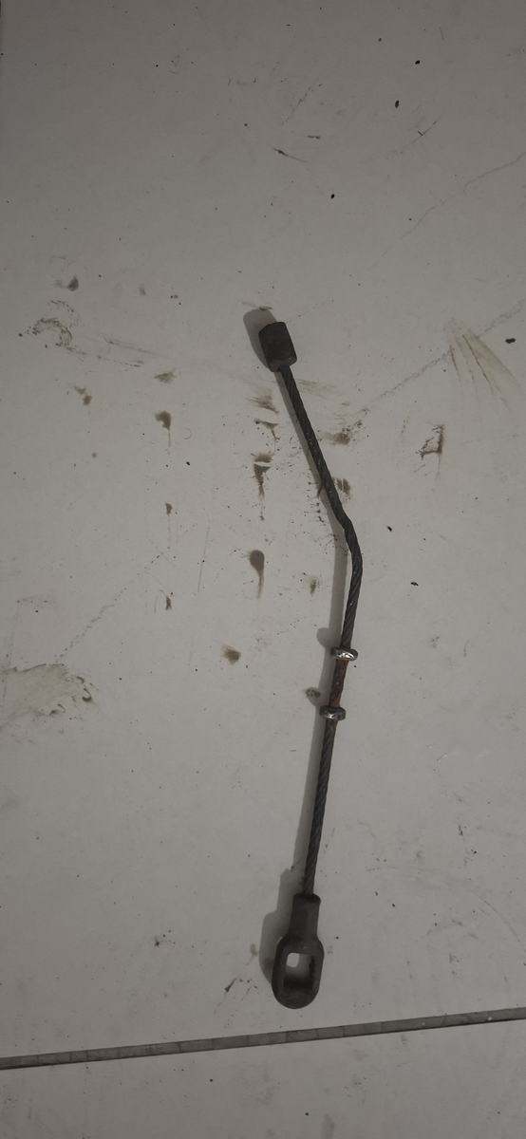 | Parking-brake cable / linkage sample | Use this to reconstruct the complete handbrake system. Send to a brake/cable specialist, not just a painter. Record length, bends and both end fittings; inspect or reproduce the cable/linkage; renew adjusters, clevises, pins and clips as needed; prove full application and free return.
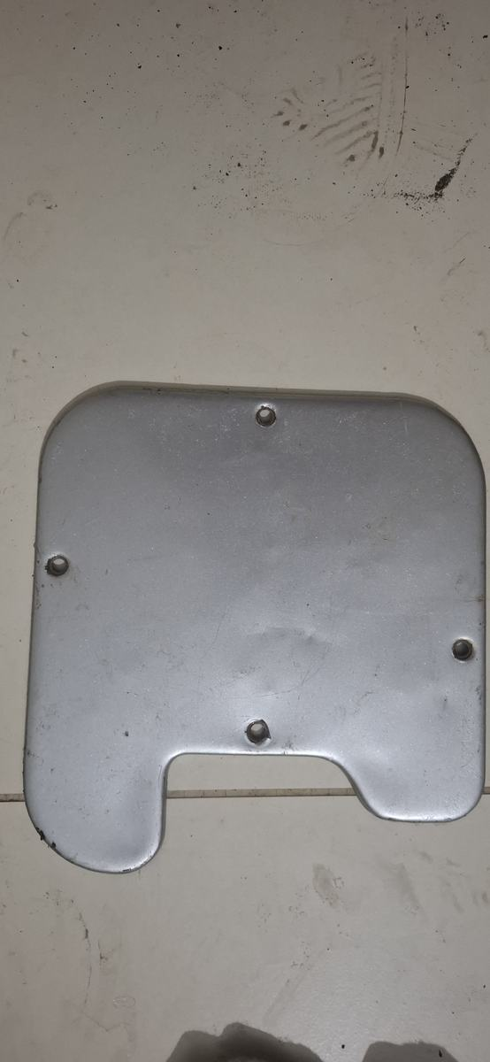 | Glove-box lid | Dry-fit first. Repair dents, remove rust, epoxy-prime and paint in the chosen interior colour. Renew the hinge, latch and buffers if worn.
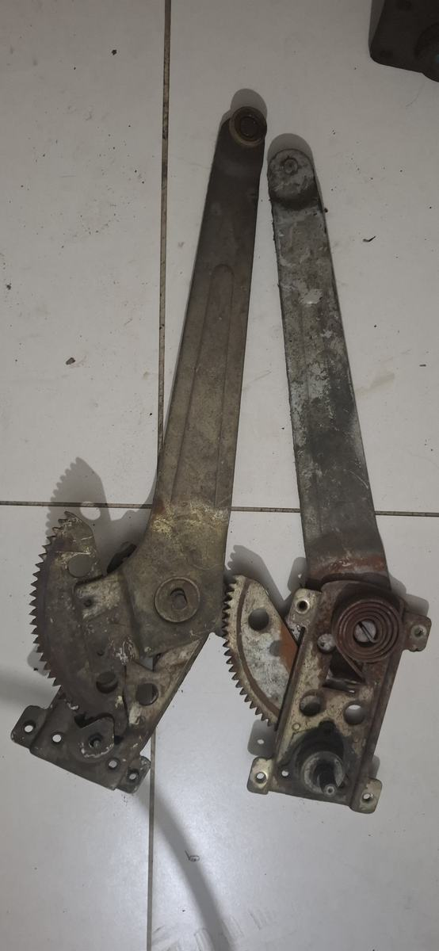 | Manual window regulator | Clean out old grease. Check sector teeth, arms, rivets and rollers. Refinish exposed metal only, lubricate after the coating cures and bench-cycle through its full travel.
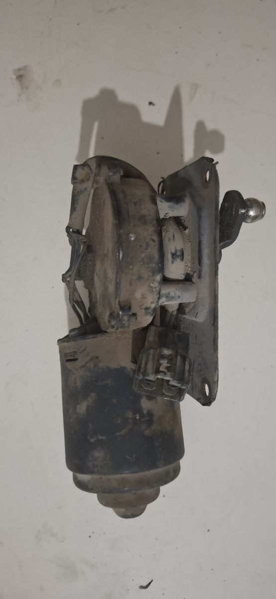 | Likely windscreen-wiper motor and crank | This is a one-per-vehicle powered mechanism and its motor/gearbox/crank layout is consistent with a wiper motor, not steering. Send to an auto-electric specialist for identification and bench test. Rebuild only if worthwhile; do not blast or paint the motor, gearbox, connector, shaft or ball joint.
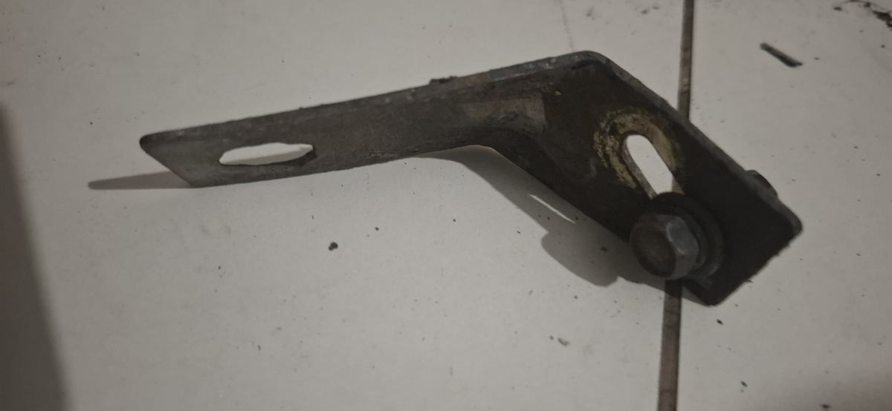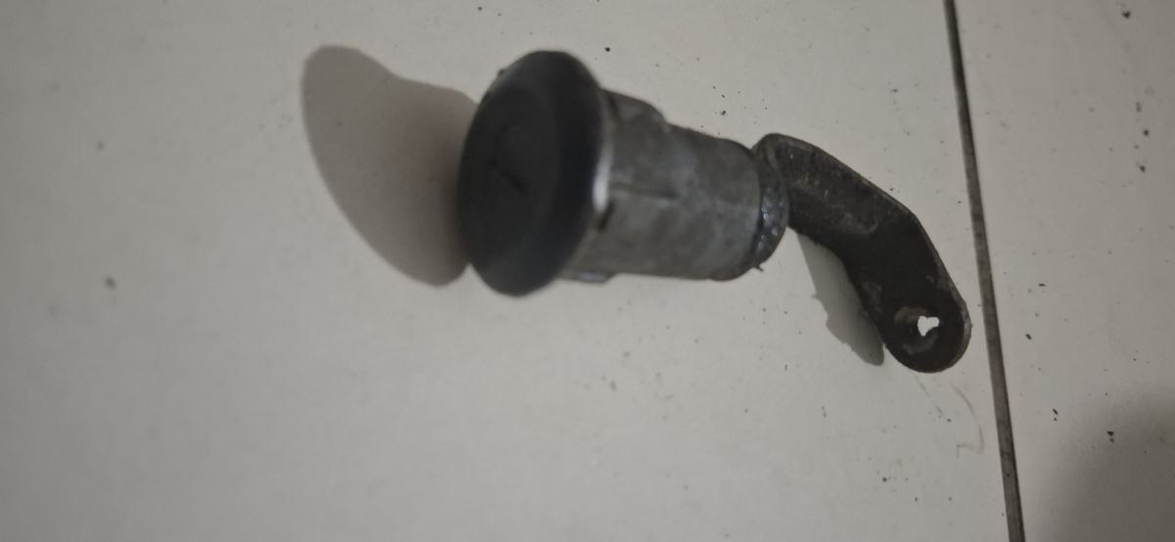 | Unidentified lever pieces | Send with IDENTIFY FIRST tags. If the refurbisher confirms they are useful and sound, clean, derust and refinish the non-working surfaces. Mask pivots, bushes, shafts, holes and mating faces.
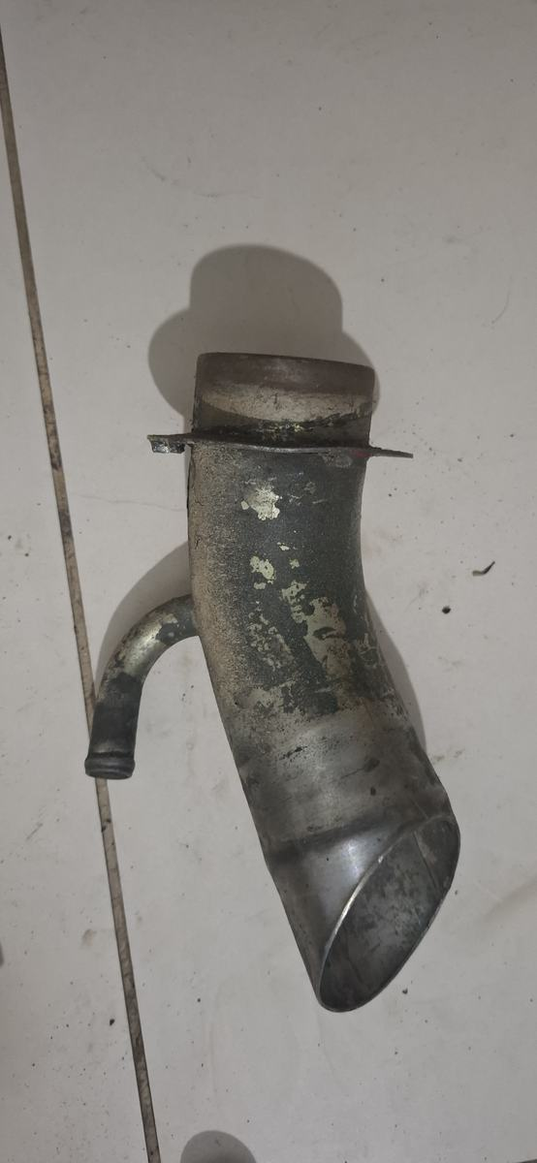 | Likely engine oil-filler / breather tube | Origin is not proven, but the large neck and small side breather are consistent with an engine filler/breather tube. Identify first. Degrease internally, inspect for deep pitting or cracks, preserve all sealing faces and coat only the sound exterior.
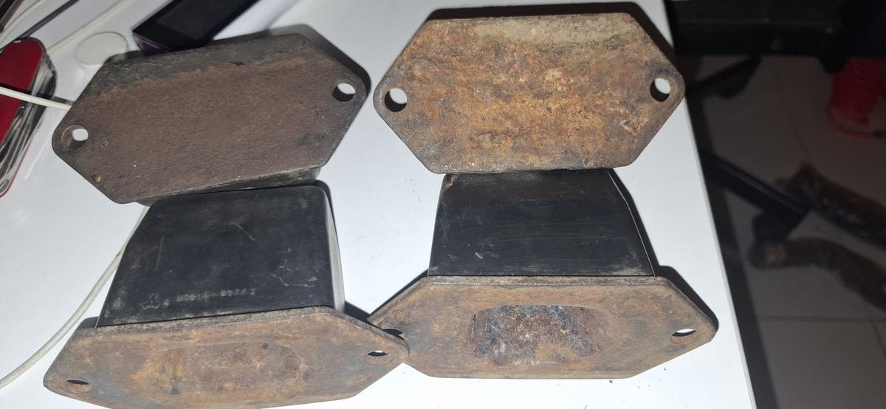 | New bump-stop metal fixtures | Label all four positions. Protect the new rubber from solvent, heat and abrasives. Remove loose rust from the metal plates, inspect for pitting/cracks/distortion, apply compatible rust treatment, epoxy-prime and paint the metal, then trial-fit.

Workshop sign-off
Instruction: Record what was accepted, rejected and completed. Return every unidentified or rejected piece with its original label.
Sent to: __________________________________________________________
Date: __________________________________________________________
Items rejected: __________________________________________________________
Items completed: __________________________________________________________
Checked by: __________________________________________________________

