WORKSHOP REFERENCE GUIDE
Removed Spare Parts
Identification, function and refurbishment guidance
Vehicle | Toyota Land Cruiser J40 restoration project
Photo intake | Google Photos picker - 42 items imported 23 July 2026
Use | Workshop triage before cleaning, replacement purchasing and refit
Safety note: photo identification does not release any brake, steering, wheel-retention, restraint or structural component for service. Physical measurements and functional tests remain mandatory.

How to use this guide
Each component entry combines the selected photographic evidence with the current procurement ledger. The replacement status is not an installation release: compare every replacement against the removed sample and actual vehicle mounting before use.
- Keep left/right and front/rear parts separated and labelled during cleaning.
- Photograph markings, dimensions and installed location before discarding anything.
- Replace safety-critical wear items instead of relying on cosmetic refurbishment.
- Use old rubber, seals, hoses, webbing and damaged fasteners as samples only.

Priority summary
Priority | Components | Direction
Replace | Seat belts; aged body-mount rubber; worn pedal rubber; damaged wheel studs/nuts | Use new rated/matched components. Preserve originals only as samples.
Purchased candidate | ULTIMA UFM-1041 brake master cylinder | Directly compare ports, bore, pushrod and mounting before installation.
Refurbish first | Door/window hardware; wiper system; glove-box lid; tail-lamp housing | Clean, inspect, renew wear pieces and bench-test before refit.
Identify/test | Control cable; dual switches; high-current solenoid; loose lever controls | Trace installed function and markings before purchasing.

1. Mechanical control cable
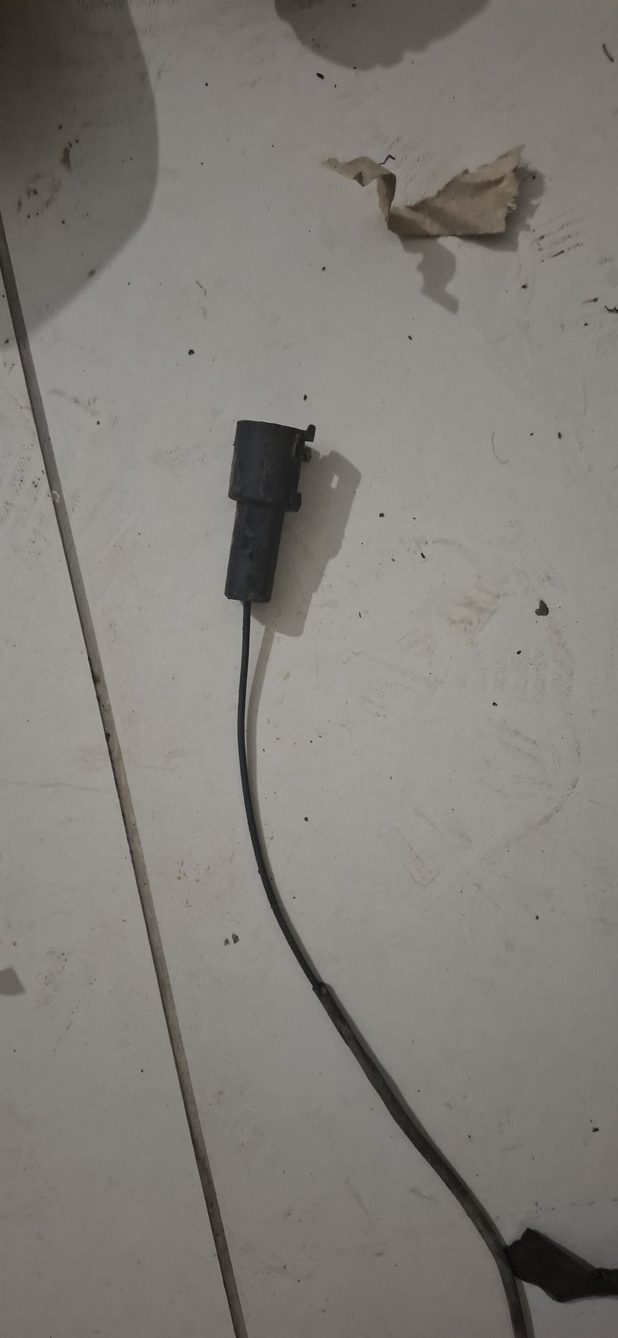
Photo evidence: 20260723_013017_gp_nBbqcMXA
Where it is from / what it does. A manually operated vehicle control cable. The exact circuit is not proven from the loose-part photograph; likely candidates are the choke, hand-throttle or bonnet-release control.
Replacement status. No matched replacement purchase is recorded.
WORKSHOP DECISION: IDENTIFICATION HOLD

Refurbishment guidance
- Label both endpoints before any decision; identify the dash/lever end and the device or latch end.
- Inspect the inner wire for broken strands, corrosion and stretch; inspect the sheath for kinks, heat damage and splits.
- Flush and lubricate only if the cable is structurally sound, then confirm full travel and positive return without binding.
- Replace by endpoint and effective-length match if frayed, seized or unable to hold adjustment.

2. Dual electrical plunger-switch bracket
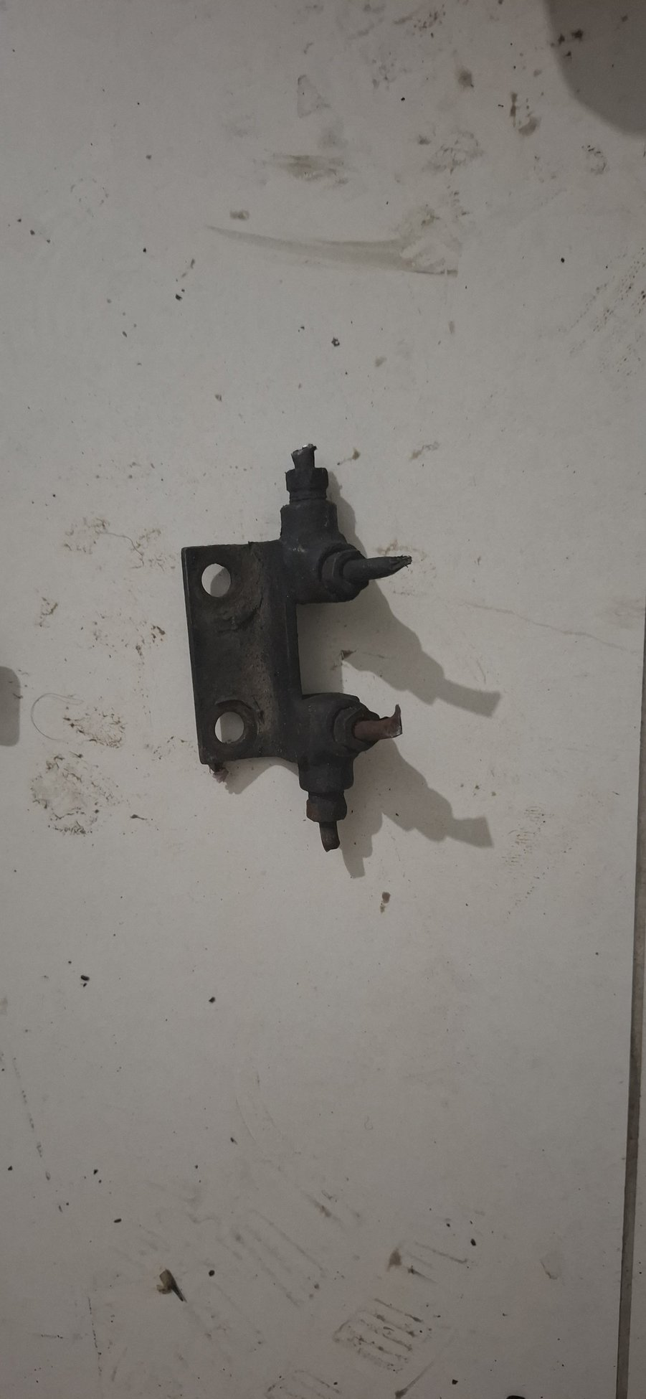
Photo evidence: 20260723_013021_gp_UGFfrBkw
Where it is from / what it does. A bracket carrying two wired plunger switches, probably at the pedal box. Likely functions include the brake-light switch and a clutch/start-interlock or pedal-position switch. It is electrical, not a hydraulic splitter: brake and clutch fluid circuits must remain separate.
Replacement status. No matched switch replacement is recorded.
WORKSHOP DECISION: TEST AND TRACE

Refurbishment guidance
- Trace the cut wires and compare each plunger position with the brake and clutch pedal stops.
- Check normally-open/normally-closed continuity through full plunger travel and inspect the terminals for heat or corrosion.
- Clean and refinish the bracket; preserve switch depth and locknut adjustment.
- Replace failed switches and damaged terminals with voltage/current-rated equivalents before loom closure.

3. Front seat-belt assemblies, buckles and retractors
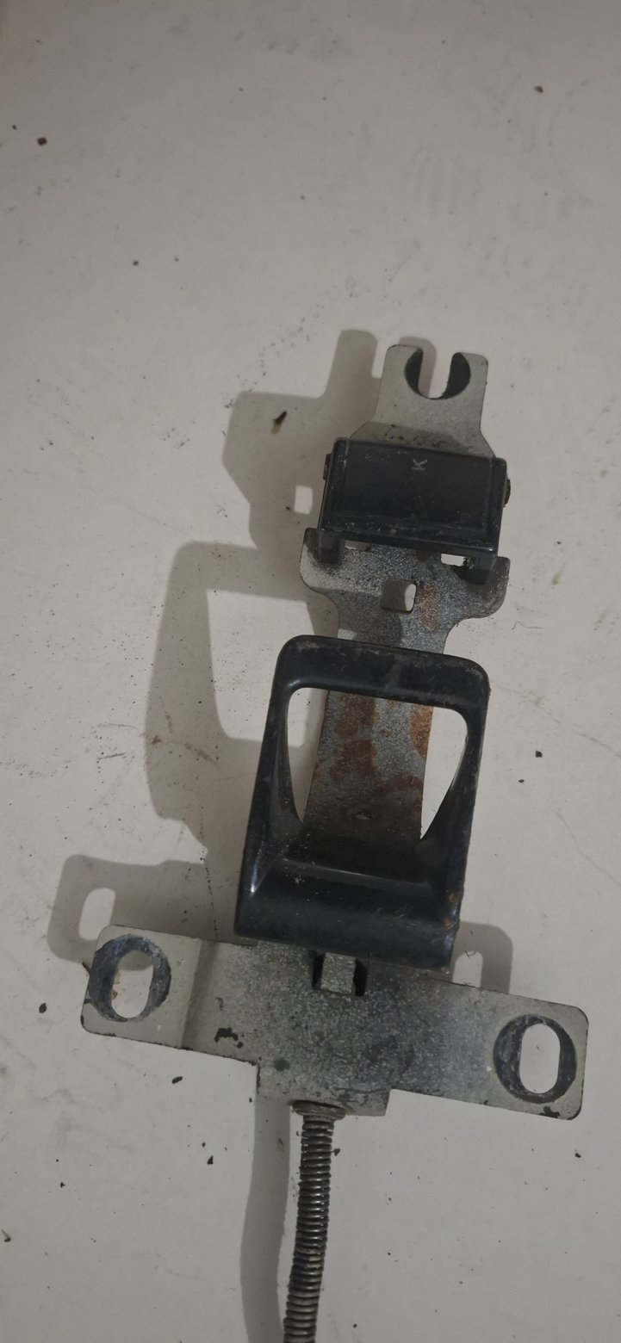 | 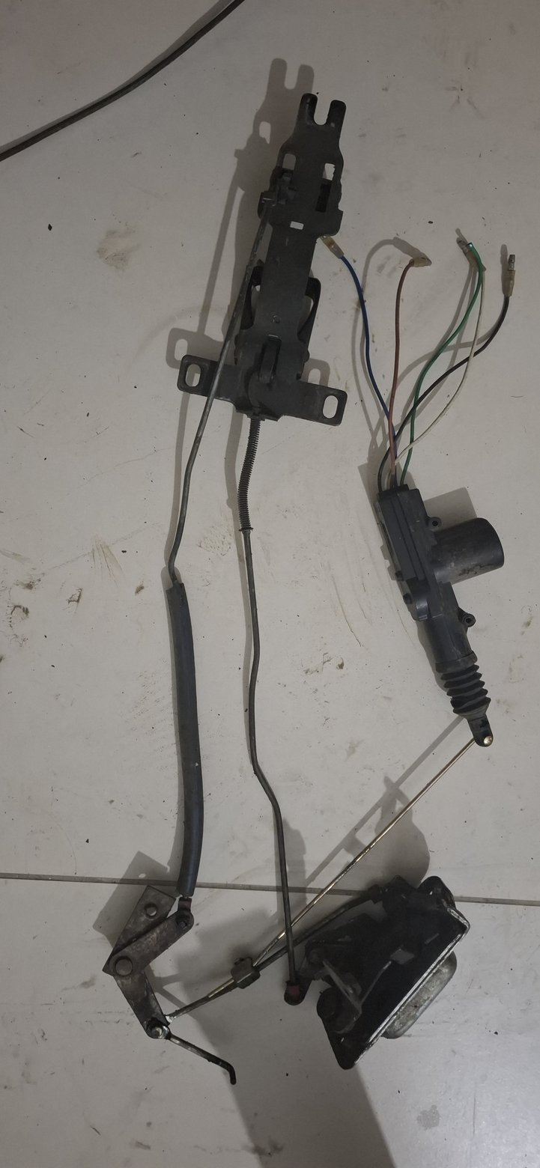
Photo evidence: 20260723_013033_gp_l8ZqIJ6Q, 20260723_013103_gp_24hNTQNQ
Where it is from / what it does. Occupant-restraint assemblies for the front seating positions. They restrain occupants through certified webbing, buckles, retractors and structural anchor points.
Replacement status. No certified front-seat-belt replacement purchase was found. A later project row covers side-bench restraints only.
WORKSHOP DECISION: REPLACE - SAFETY CRITICAL

Refurbishment guidance
- Do not cosmetically refurbish old webbing or retractors for road use.
- Preserve these assemblies only as references for mounting position, buckle stalk length and retractor orientation.
- Inspect anchor plates, threads and surrounding body structure for rust, elongation and inadequate reinforcement.
- Install new certified belts with correct graded anchor bolts, spacers and load-spreading plates.

4. Door latch, lock and linkage assemblies
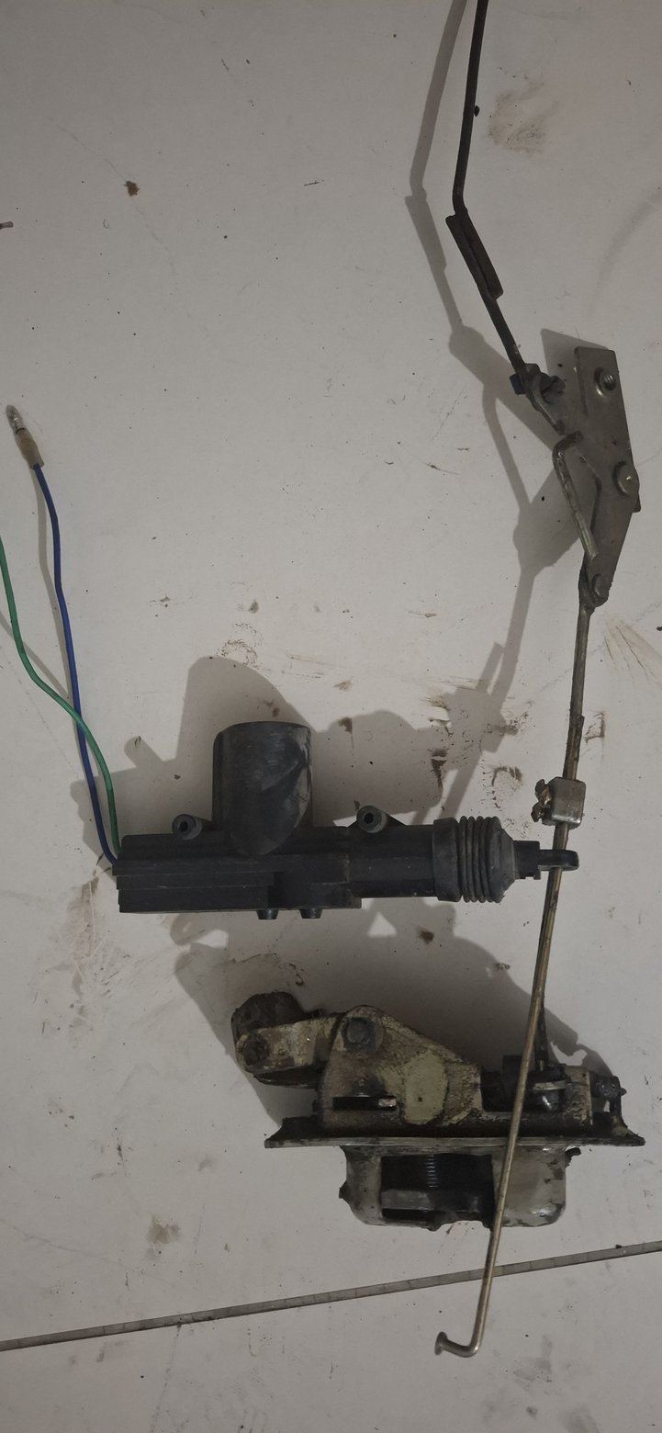 | 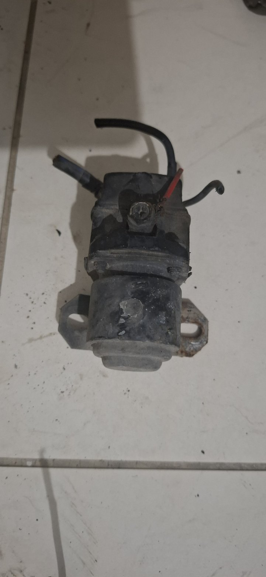 | 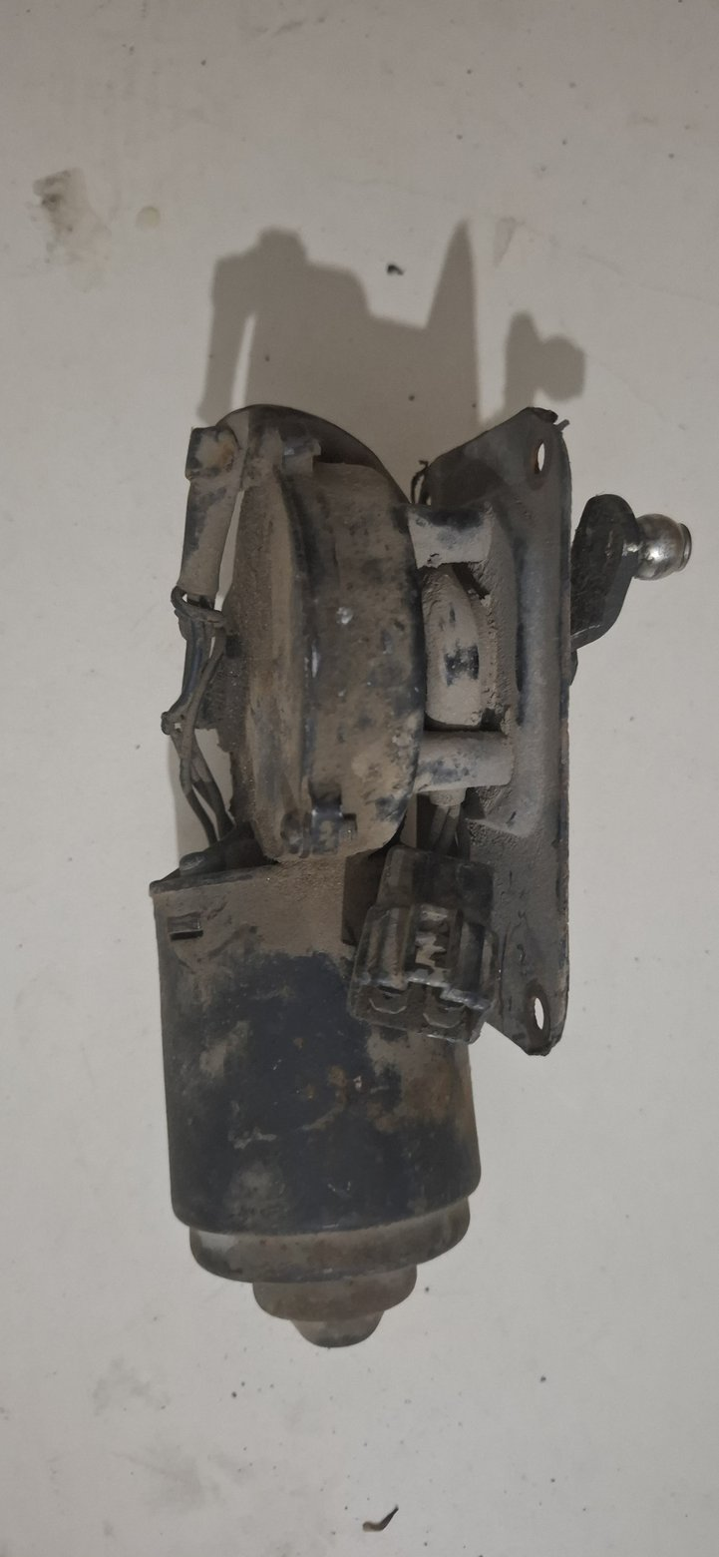
Photo evidence: 20260723_013044_gp_nVUdz9dQ, 20260723_013123_gp_JLEfOezg, 20260723_013303_gp_ZzbvMf2A
Where it is from / what it does. Inside the side doors, these mechanisms connect the inner/outer handles and lock controls to the rotary latch that retains the door on the body striker.
Replacement status. No complete replacement assemblies are recorded as purchased.
WORKSHOP DECISION: REFURBISH FIRST

Refurbishment guidance
- Keep left- and right-hand components separated and photograph linkage orientation before disassembly.
- Degrease, remove loose corrosion and inspect latch jaws, springs, pins and lever holes for wear or cracking.
- Plate or paint only non-working surfaces; keep latch faces and pivots free of coating buildup.
- Lubricate with suitable latch grease and bench-test both primary and secondary retention before door fitting.
- Replace worn pins, springs or strikers only after the doors are aligned to the painted aperture.

5. Parking-brake linkage rod / connecting stay
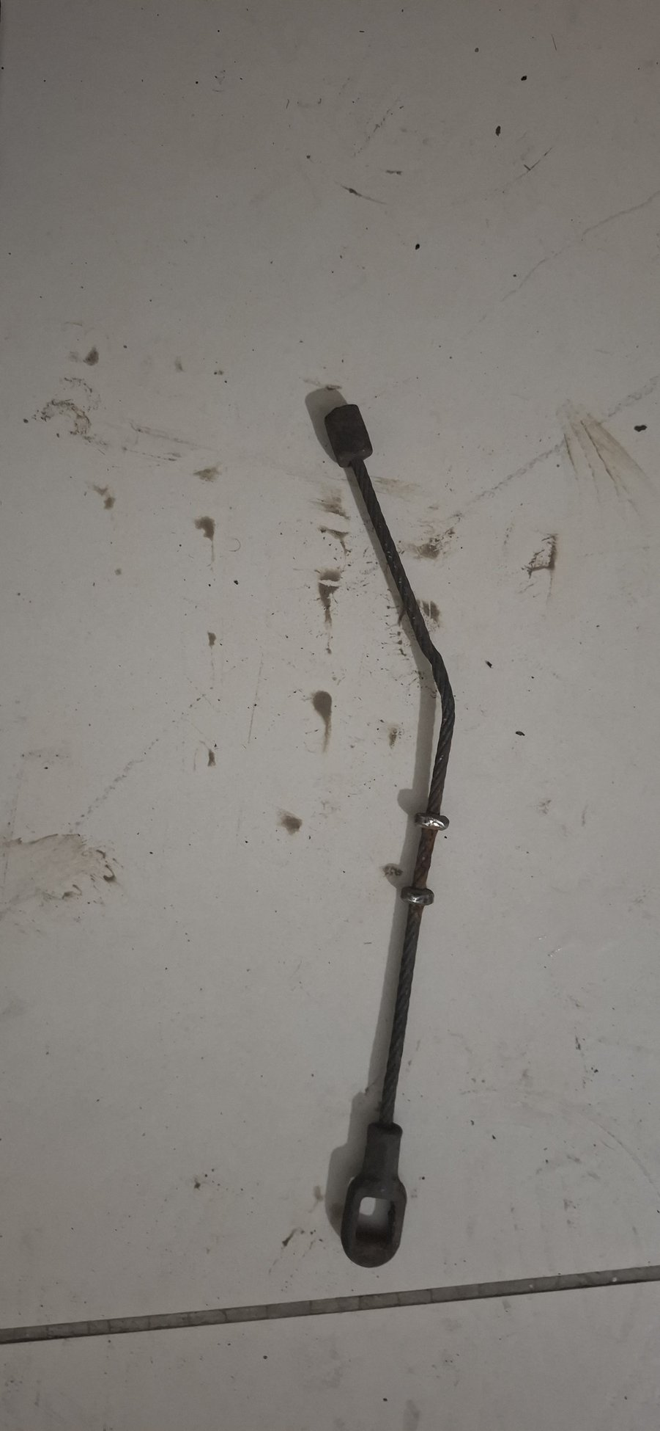
Photo evidence: 20260723_013050_gp_rSLoiGNw
Where it is from / what it does. Part of the mechanical handbrake system, linking a cable, lever or equalizer element. It transfers hand-lever pull into the rear parking-brake mechanism.
Replacement status. A long replacement handbrake cable is received, but complete coverage of this rod and the rear splitter/equalizer remains unproven.
WORKSHOP DECISION: REFURBISH OR REPRODUCE BY SAMPLE

Refurbishment guidance
- Preserve the bends, eye sizes and effective length as the fabrication pattern.
- Inspect both eyes for elongation, the rod for deep corrosion and bends for previous straightening or fatigue.
- Derust and plate/paint a sound rod; renew bushes, clevis pins and retaining clips.
- Reproduce by sample if worn or distorted, then prove equal left/right application and complete release without drag.

6. Fuel-filler cap
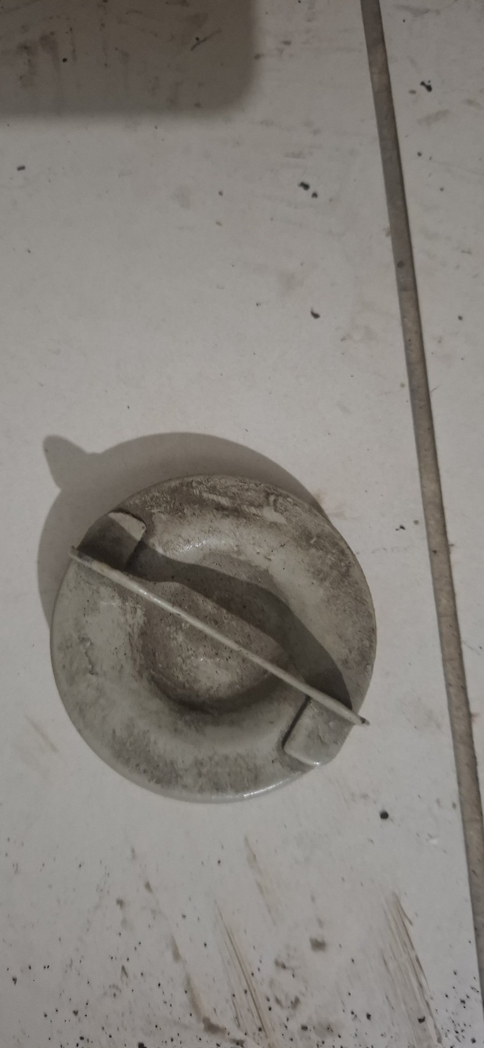
Photo evidence: 20260723_013111_gp_8RhmGzNw
Where it is from / what it does. Closes the fuel-filler neck and controls sealing or venting of the tank, depending on the vehicle vent design.
Replacement status. No replacement cap purchase is recorded.
WORKSHOP DECISION: REPLACE SEALING COMPONENT

Refurbishment guidance
- Confirm that this is the fuel cap and record neck diameter, locking tabs/threads and vent arrangement.
- Use the old cap as a fit and venting sample; do not rely on its aged sealing washer.
- Inspect the filler neck for corrosion, deformation and a damaged sealing face.
- Fit a new correctly vented or sealed cap that matches the verified tank-breather system.

7. High-current electrical solenoid / contactor
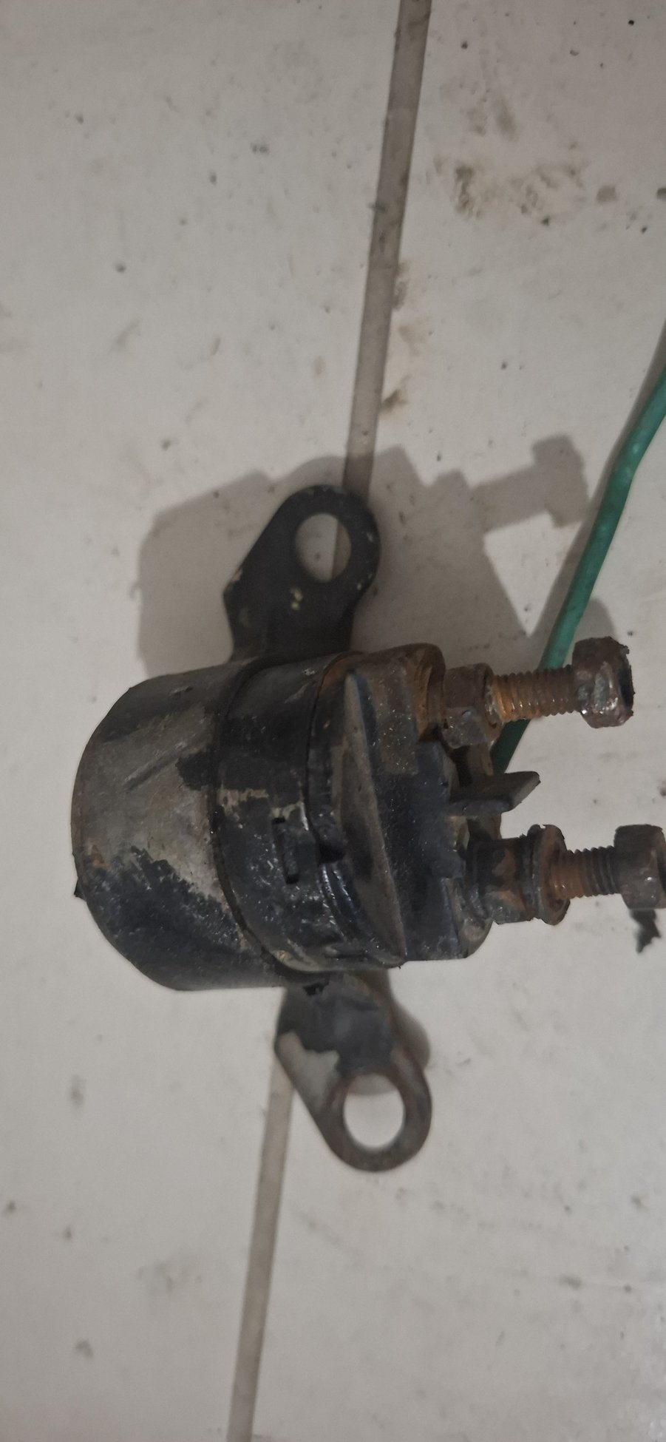
Photo evidence: 20260723_013116_gp_Wa9GzX0Q
Where it is from / what it does. A heavy-current switching device, likely for starter, glow-plug or battery-current duty. The two large studs carry the switched current; the smaller terminals energize the coil.
Replacement status. No matched replacement is recorded.
WORKSHOP DECISION: IDENTIFY AND LOAD-TEST

Refurbishment guidance
- Identify terminal markings, original wires and whether the final electrical system is 12 V or 24 V.
- Bench-test coil pull-in/drop-out, insulation and contact voltage drop under an appropriate load.
- Clean mounting ears and protect the body, but do not open or reuse a sealed unit that shows overheating or internal arcing.
- Replace with a correctly rated continuous/intermittent-duty unit if voltage, circuit or performance cannot be proven.

8. Glove-box lid
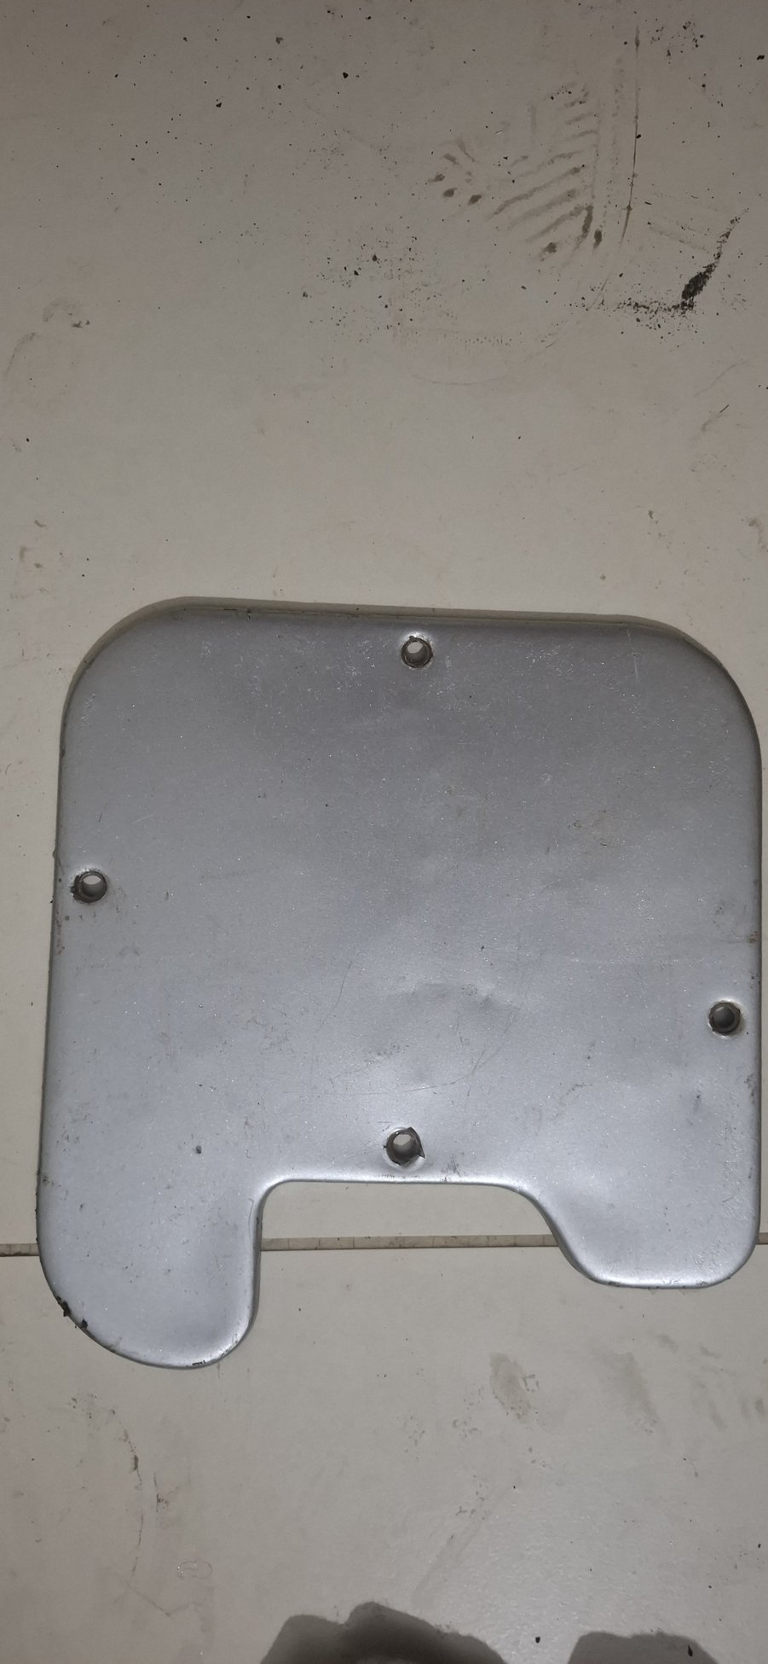
Photo evidence: 20260723_013148_gp_AK0sjJJw
Where it is from / what it does. The dashboard storage-compartment door. It carries the hinge and latch interface and should close flush without rattling.
Replacement status. No replacement is recorded or presently required.
WORKSHOP DECISION: REFURBISH

Refurbishment guidance
- Check flatness, hinge holes and latch engagement before paint.
- Repair minor dents without stretching the panel, then clean, epoxy-prime and paint both faces.
- Renew felt/rubber buffers and corroded screws; lubricate the latch lightly.
- Trial-fit against the finished dashboard before final coating if hinge geometry needs correction.

9. Window channels and glass guides
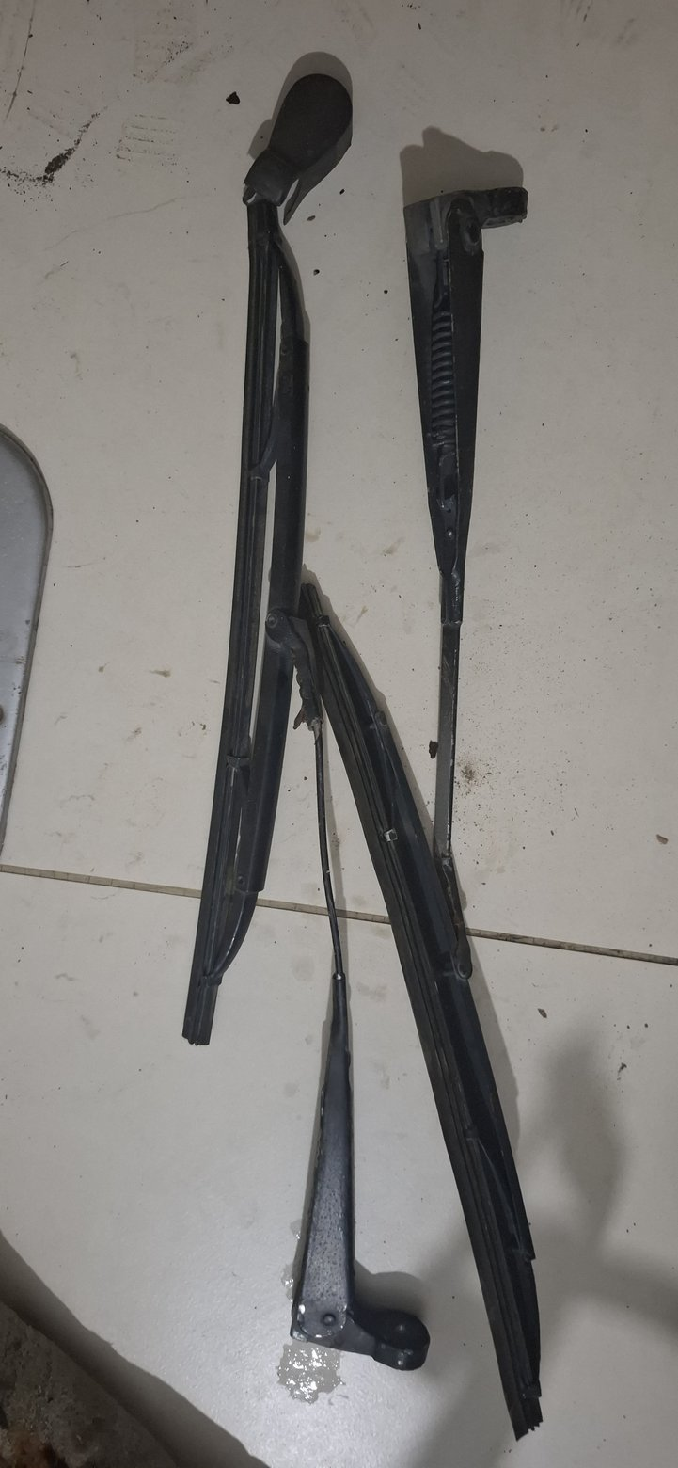 | 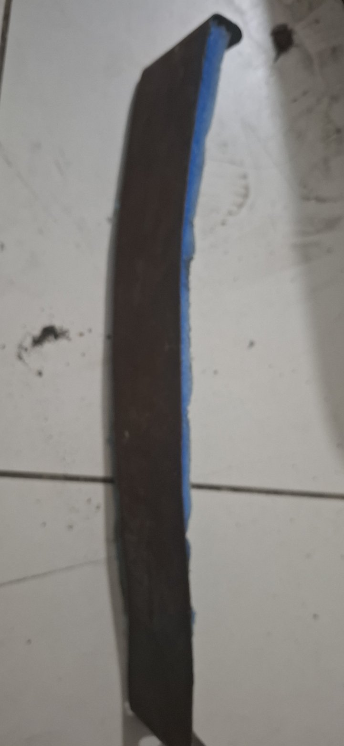
Photo evidence: 20260723_013155_gp_k26a3Rpw, 20260723_013511_gp_8BN3n86Q
Where it is from / what it does. Located inside the doors and around the window opening, these channels guide the moving glass and carry felt/rubber run material that prevents rattles and water entry.
Replacement status. No matched channel or run-material purchase is recorded.
WORKSHOP DECISION: REFURBISH METAL; RENEW FELT/RUBBER

Refurbishment guidance
- Refurbish metal channels only if straight and not rusted through.
- Remove old felt/rubber, derust, epoxy-prime and paint the exterior metal surfaces.
- Install new automotive glass-run felt/rubber matched to channel width and glass thickness.
- Trial-cycle the glass through its full travel before final door trim and weather sealing.

10. Rear combination / tail-lamp housing
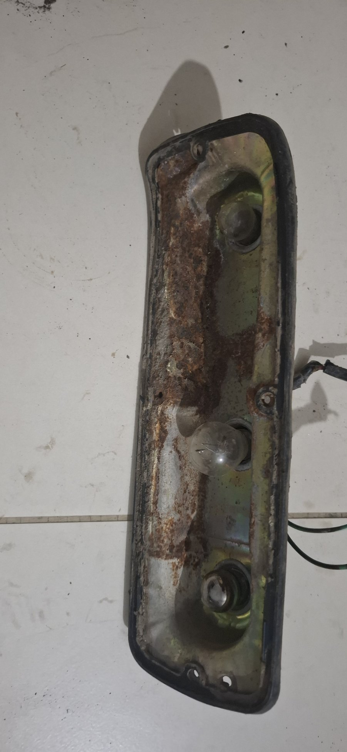
Photo evidence: 20260723_013210_gp_DXsn0EoQ
Where it is from / what it does. Mounts at the rear body and carries the tail, brake and indicator/reverse lamp sockets, lens and earth path.
Replacement status. No exact replacement housing is recorded as purchased.
WORKSHOP DECISION: REFURBISH; REPLACE CONSUMABLES

Refurbishment guidance
- Disassemble and label sockets, wires and lens orientation.
- Derust and refinish the metal housing; restore a clean dedicated earth rather than relying only on painted body contact.
- Replace cracked lenses, hardened gaskets, corroded bulb holders and brittle wiring/connectors.
- Function-test every circuit and water-test the assembled housing before installation.

11. Manual window regulators
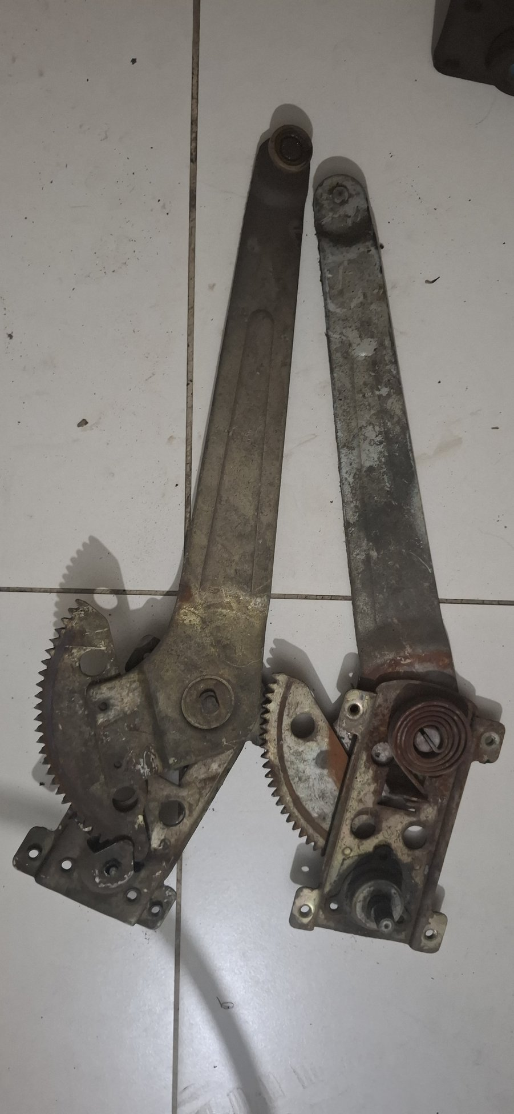
Photo evidence: 20260723_013218_gp_gz4eGcoQ
Where it is from / what it does. Inside each door, the regulator converts window-crank rotation into controlled vertical glass movement through geared arms and rollers.
Replacement status. No replacement regulators are recorded as purchased.
WORKSHOP DECISION: REFURBISH FIRST

Refurbishment guidance
- Keep left and right mechanisms identified; do not interchange them.
- Remove old hardened grease and inspect sector teeth, crank shafts, pivots, rivets, arms and rollers.
- Replace worn rollers/bushes and any stripped regulator; correct only minor arm distortion against a proven sample.
- Lubricate gears and pivots, then bench-cycle and test with glass before final door assembly.

12. Body-mount and isolator components
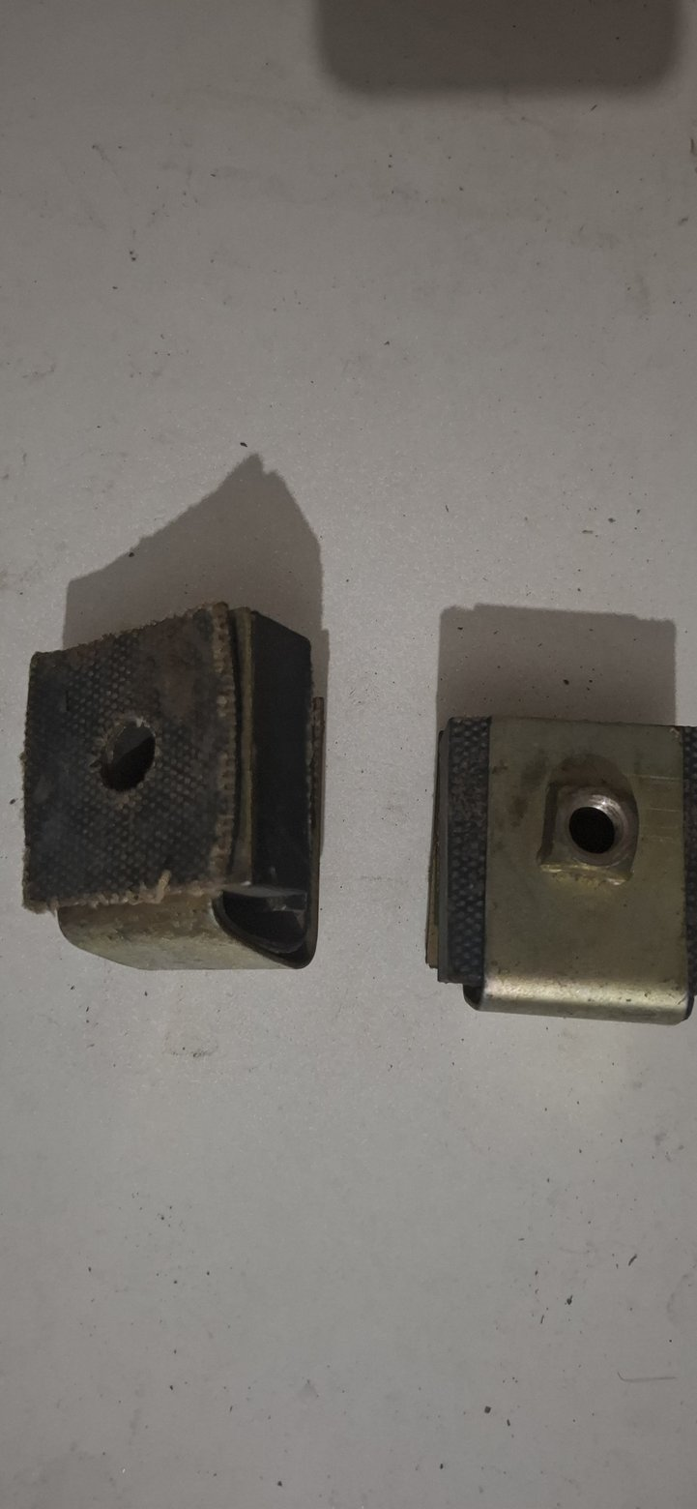 | 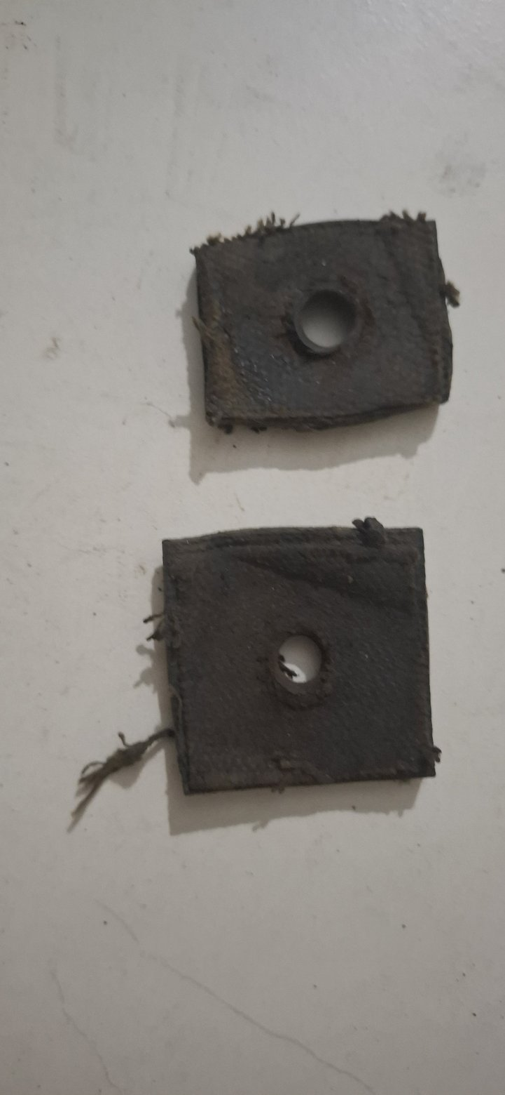 | 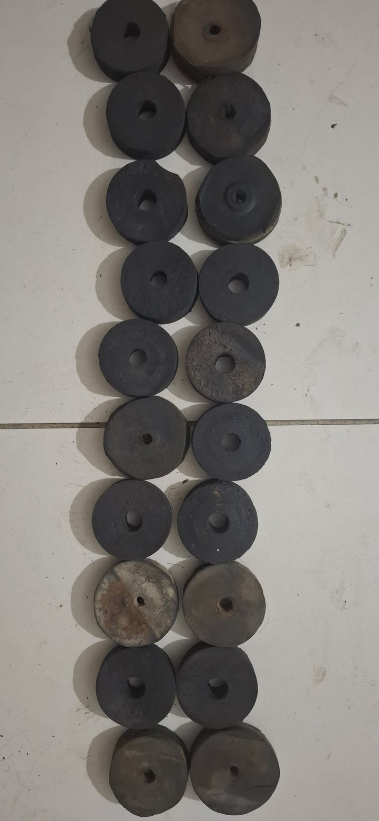
Photo evidence: 20260723_013227_gp_h8BI5SKw, 20260723_013724_gp_TNgAALDw, 20260723_013730_gp_WYzLlprg, 20260723_013734_gp_VtoM1N1Q, 20260723_013737_gp_4rfk3FdQ
Where it is from / what it does. These rubber blocks, cushions, cups and spacers sit between the body/tub and chassis at specific mounting stations. They control body height, isolation and load transfer.
Replacement status. Generic graded M10/M12 Millat fasteners are received. A complete matched rubber/cup/sleeve/shim system is not confirmed as purchased.
WORKSHOP DECISION: REPLACE RUBBER - STRUCTURAL FITMENT

Refurbishment guidance
- Do not reuse aged, cracked or compression-set rubber; keep every old piece as a numbered station sample.
- Measure free height, loaded stack, diameter/profile, sleeve length and bolt size at every chassis station.
- Use one matched batch of automotive mount-grade rubber with controlled cups, sleeves and shims; do not mix hardnesses.
- Dry-stack and level the tub before final bolts and torque. Generic received fasteners are usable only where grade, thread and length match the released design.

13. Brake master-cylinder and reservoir assembly
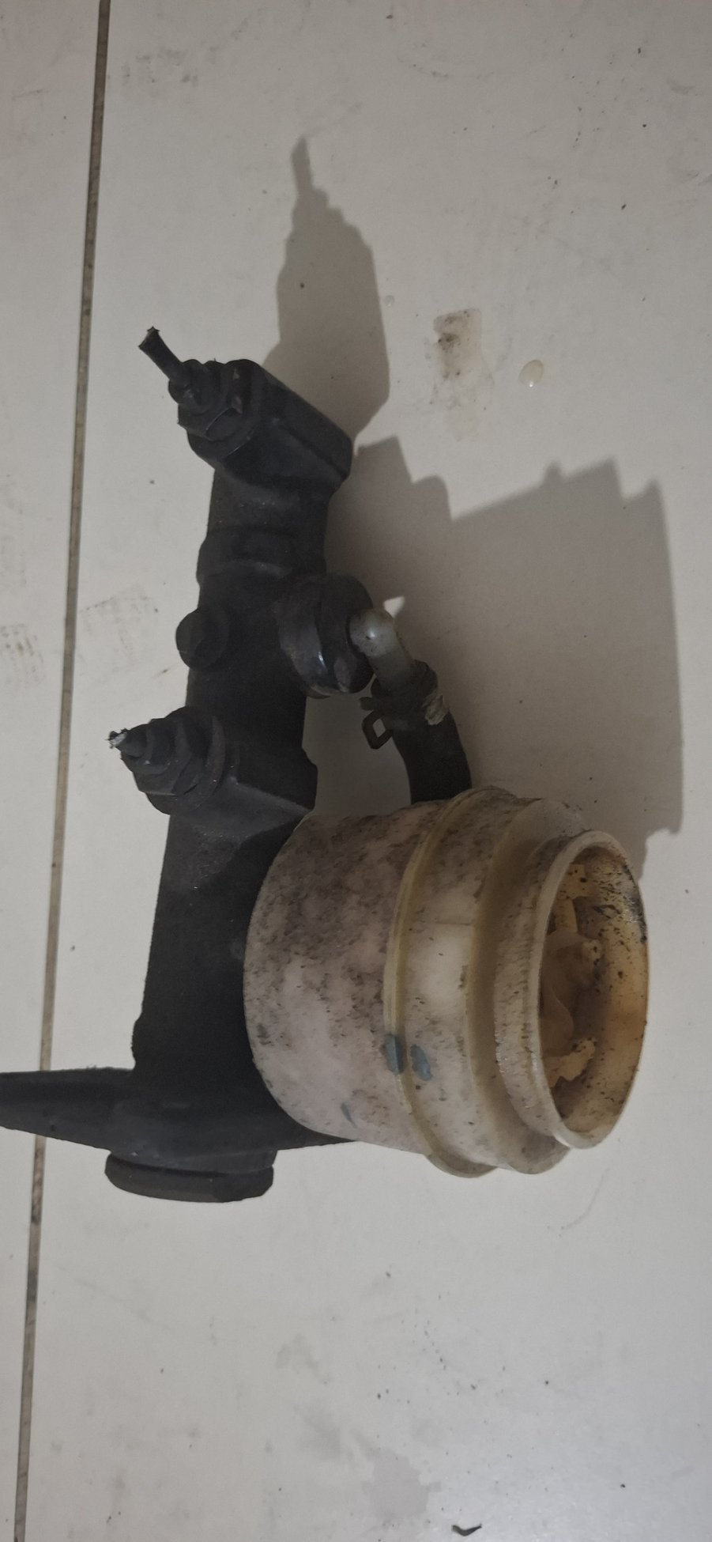
Photo evidence: 20260723_013243_gp_Y6RD1l0Q
Where it is from / what it does. The hydraulic brake master cylinder converts pedal movement into pressure for the vehicle brake circuits. The reservoir stores and supplies brake fluid.
Replacement status. Replacement candidate purchased: PakWheels order 1075298, ULTIMA UFM-1041 x1.
WORKSHOP DECISION: USE PURCHASED CANDIDATE AFTER FIT CHECK

Refurbishment guidance
- Do not rebuild this visibly aged/corroded unit for baseline road use; retain it as the dimensional and port-layout sample.
- Compare new and old bore/markings, mounting pattern, pushrod depth, port threads and flare seats, reservoir clearance and circuit order.
- Use new brake-fluid-compatible seals, grommets and hoses; bench-bleed the new master.
- After installation, pressure-test for external leaks and internal bypass and validate front/rear brake balance.

14. Radiator filler neck / coolant outlet neck
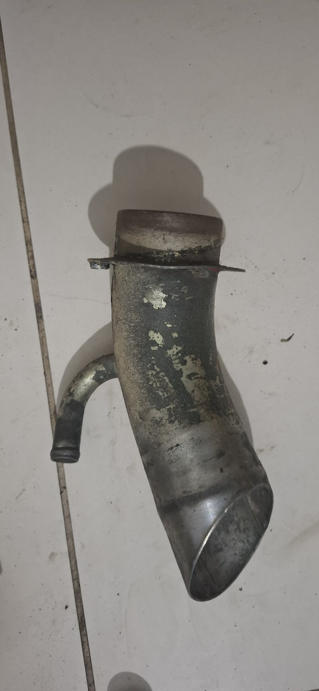
Photo evidence: 20260723_013311_gp_51vqP4uQ
Where it is from / what it does. Part of the engine cooling circuit. It provides a hose connection and may carry the radiator-cap seat or thermostat/outlet path, depending on its installed location.
Replacement status. No matched replacement is recorded. Radiator cap and hoses remain planned service items.
WORKSHOP DECISION: INSPECT AND REFURBISH CONDITIONALLY

Refurbishment guidance
- Confirm exact installed location, hose size and whether the cap seals directly on this neck.
- Chemically descale without attacking sound metal; inspect flange flatness, hose bead, pitting and cap sealing surfaces.
- Pressure-test after any repair. Replace or professionally rebuild if deeply pitted, cracked or unable to seal.
- Use a new correct-pressure cap, gasket and hose during final assembly.

15. Small rubber grommet / isolator
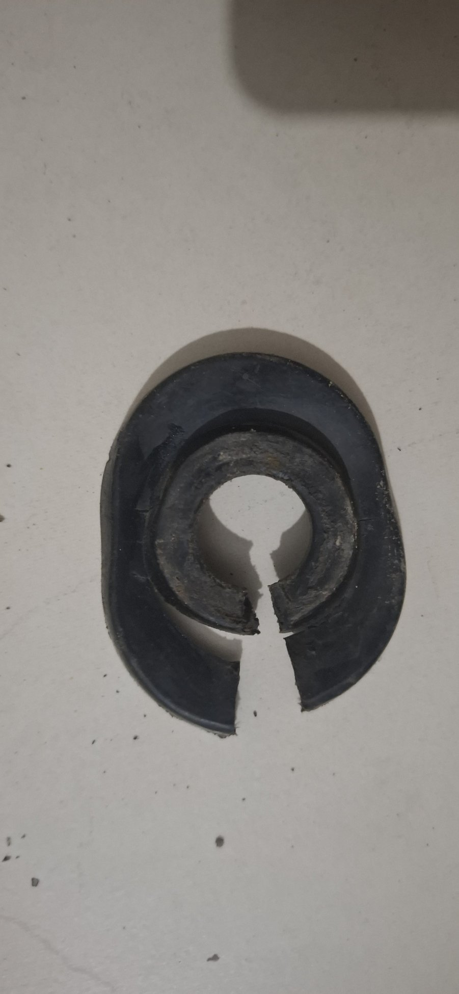
Photo evidence: 20260723_013315_gp_1NDL6h1g
Where it is from / what it does. A rubber pass-through or isolation piece used where a wire, pipe, shaft or bracket passes through a panel or mount.
Replacement status. A general grommet assortment is received, but project records flag the mix as unverified for exact profiles.
WORKSHOP DECISION: SAMPLE-MATCH NEW RUBBER

Refurbishment guidance
- Identify the installed hole and carried item, then measure panel hole, groove width, bore and material thickness.
- Do not reuse hardened, swollen, split or compression-set rubber.
- Select a new automotive grommet compatible with local heat, oil/fuel or brake-fluid exposure as applicable.
- Confirm no cutting edge contacts the carried wire/pipe through full vehicle movement.

16. Wheel stud and lug nut
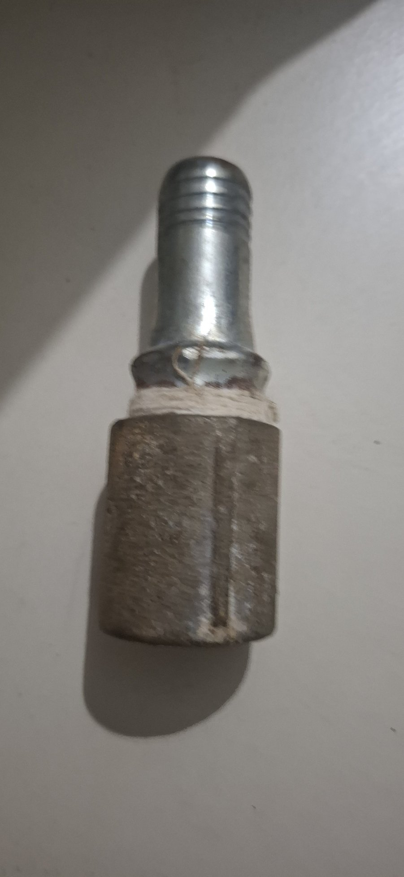
Photo evidence: 20260723_013324_gp_WjR2z9cQ
Where it is from / what it does. A structural wheel-retention fastener pressed into the hub or axle flange; the lug nut clamps the wheel against its mounting face.
Replacement status. No wheel-specific replacement purchase is recorded.
WORKSHOP DECISION: REPLACE IF DAMAGED - SAFETY CRITICAL

Refurbishment guidance
- Measure thread, stud length, knurl diameter and seat type; inspect the hub hole for fretting or enlargement.
- Do not chase and reuse badly damaged threads, stretched studs or distorted nut seats.
- Fit a new matched stud/nut if any structural doubt exists; press the stud correctly rather than drawing it in solely with a nut.
- Torque to the verified wheel/hub specification and recheck after initial road use.

17. Door pull / armrest and interior handles
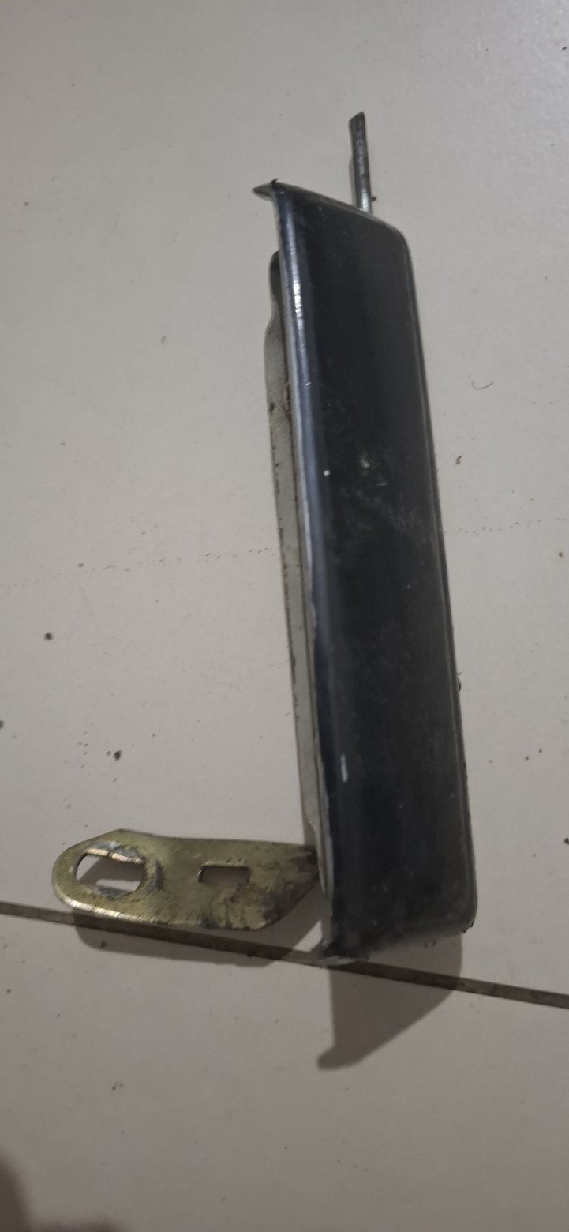 | 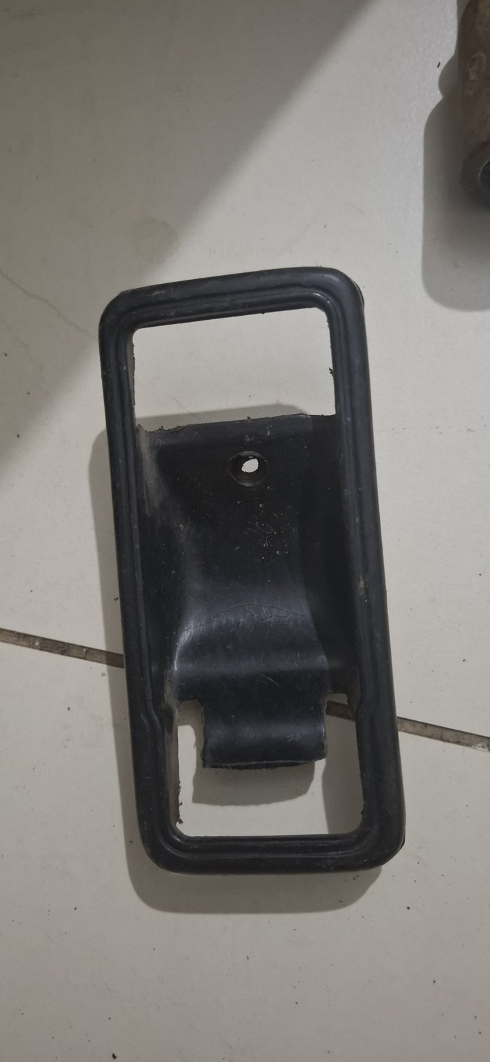 | 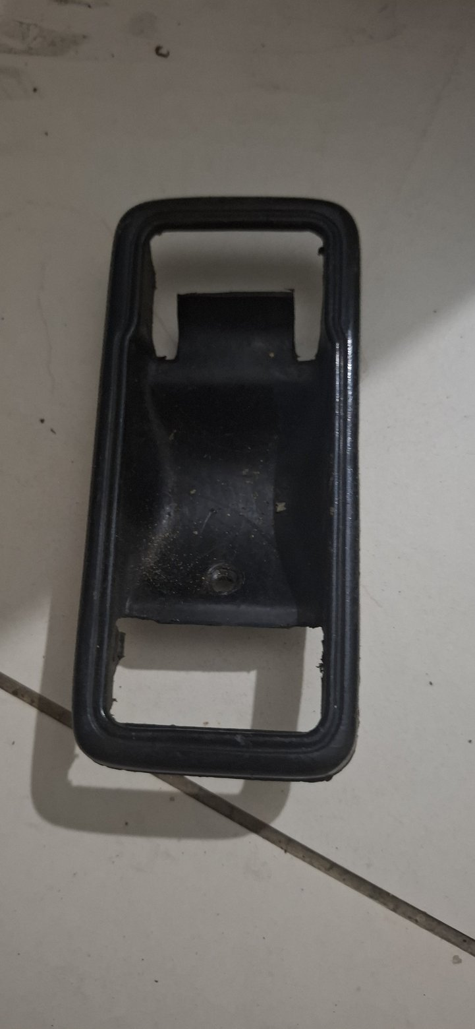
Photo evidence: 20260723_013331_gp_wJ1wGBzg, 20260723_013357_gp_r5068tWQ, 20260723_013420_gp_SclaaDYg
Where it is from / what it does. Interior door furniture used to pull the door closed and operate or trim the inner latch area.
Replacement status. No replacement purchase is recorded.
WORKSHOP DECISION: REFURBISH

Refurbishment guidance
- Clean and inspect the substrate, mounting bosses and captive-nut locations for cracks or stripping.
- Repair/refinish sound parts and retrim padded pieces where required.
- Renew corroded screws, finishing washers and rubber buffers after final door-trim fit.
- Replace only pieces that are cracked, missing or unable to retain securely.

18. Window-crank handles
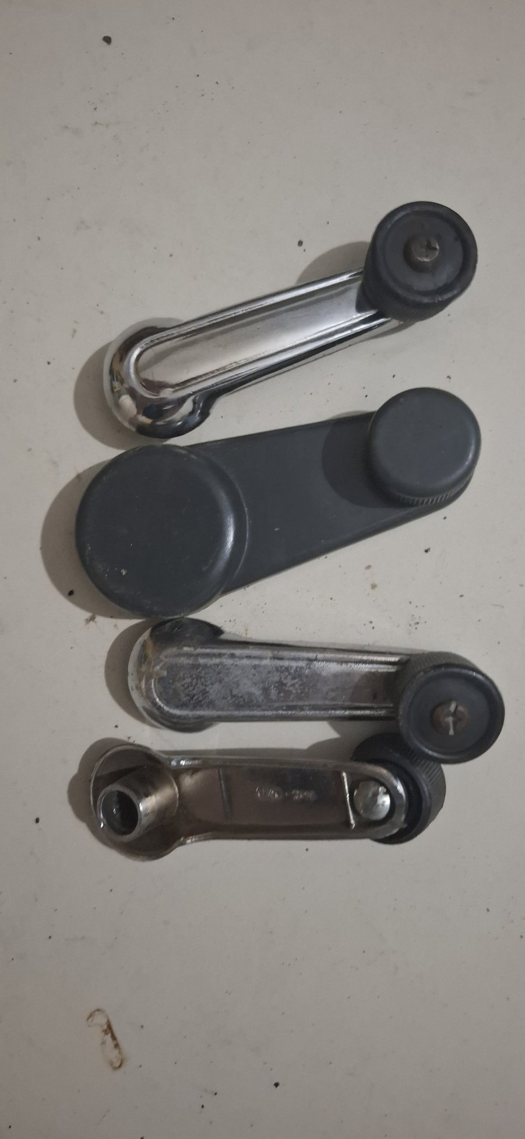
Photo evidence: 20260723_013349_gp_StIZA9xA
Where it is from / what it does. Attach to the manual window-regulator shafts and let the occupant raise or lower the side glass.
Replacement status. No replacement purchase is recorded.
WORKSHOP DECISION: REFURBISH CONDITIONALLY

Refurbishment guidance
- Inspect internal splines, retaining grooves and rotating knobs.
- Clean, polish or replate sound handles; lubricate knob pivots without contaminating trim.
- Replace handles with rounded splines, loose knobs or cracks, and install new retaining clips where required.
- Trial-fit only after regulator shafts are confirmed sound.

19. Wiper motor, linkage and spindle parts
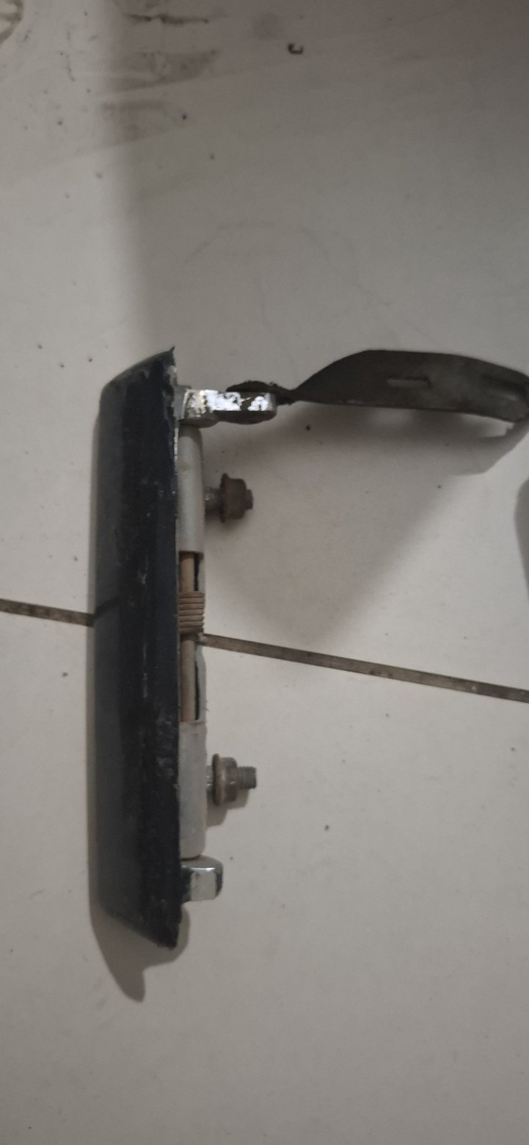 | 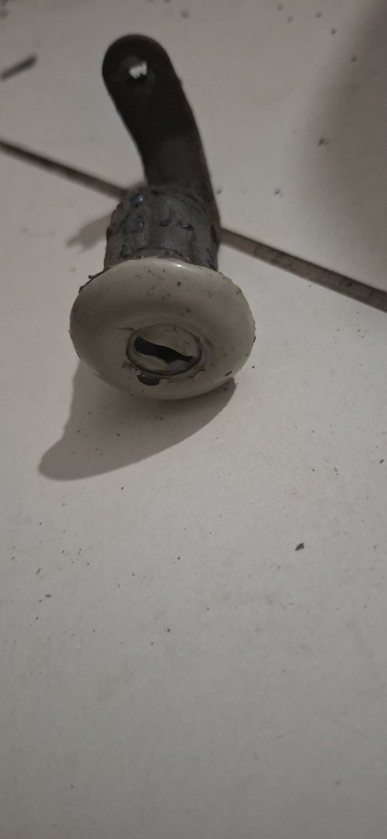
Photo evidence: 20260723_013405_gp_bkbDX7gQ, 20260723_013440_gp_bFh4nlWQ
Where it is from / what it does. Mounted behind/under the windscreen area, the electric motor and linkage convert rotary motor motion into synchronized wiper-arm sweep and park control.
Replacement status. No replacement motor or linkage is recorded as purchased.
WORKSHOP DECISION: BENCH-TEST AND REFURBISH

Refurbishment guidance
- Strip and clean linkage pivots; inspect rods, spindle bushes, seals and mounting grommets for play.
- Bench-test the motor at the final system voltage for speed, current draw, heat, noise and reliable park operation.
- Renew bushes/grommets and grease pivots with a water-resistant lubricant.
- Rebuild or replace the motor if slow, noisy, hot, intermittent or unable to park consistently.

20. Windscreen handle (new packaged part)
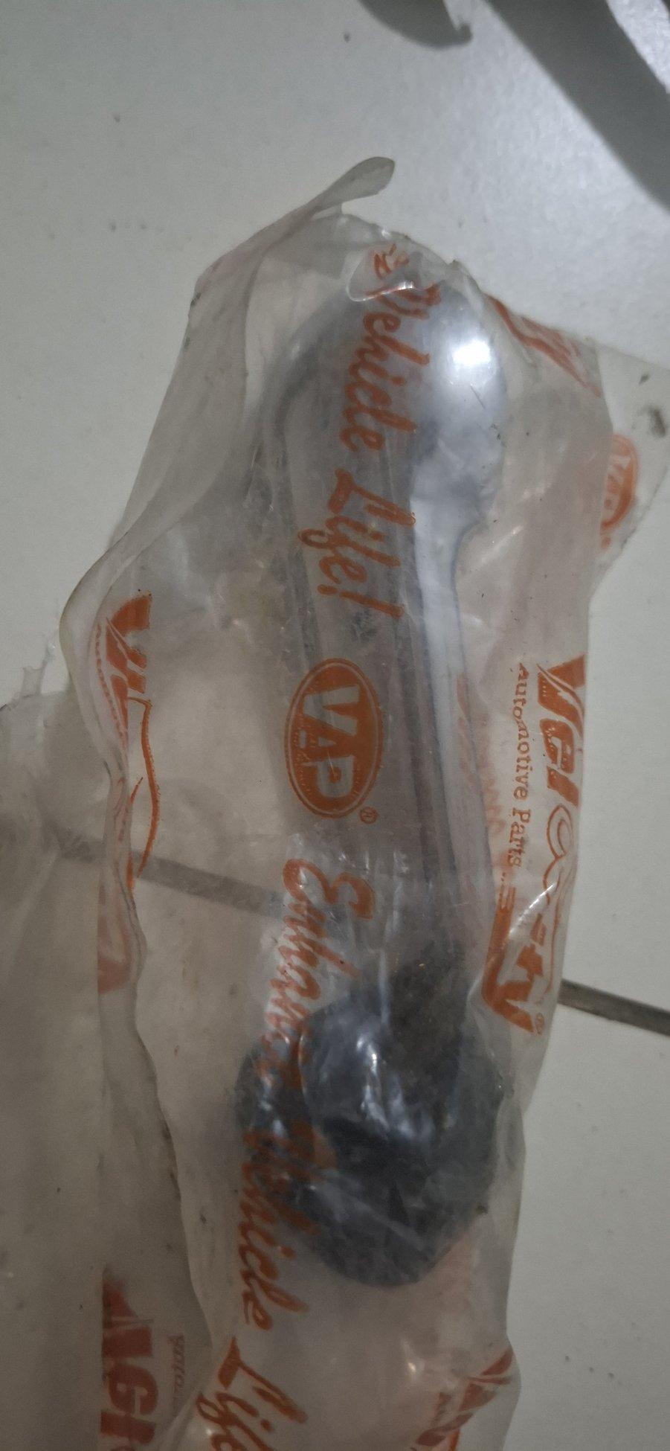
Photo evidence: 20260723_013430_gp_LkWinQ0w
Where it is from / what it does. A grab/operating handle associated with the windscreen assembly. The owner confirmed the identity from the packaged part.
Replacement status. The photographed replacement is already on hand in new packaging; no separate receipt match was found.
WORKSHOP DECISION: ON HAND - TRIAL FIT

Refurbishment guidance
- Keep packaged until the windscreen frame and mounting points are ready for trial fit.
- Confirm side, quantity, hole spacing, screw thread and operating clearance against the frame.
- Use new plated/stainless non-structural fasteners of the correct head style and protect drilled/painted interfaces.
- Buy another only if the required pair/count is short or this part fails the sample fit.

21. Lever bracket and knob-and-shaft control
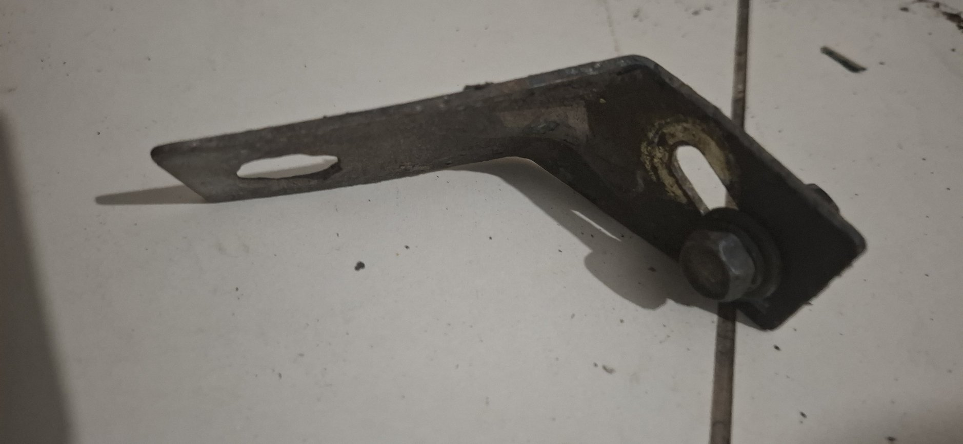 | 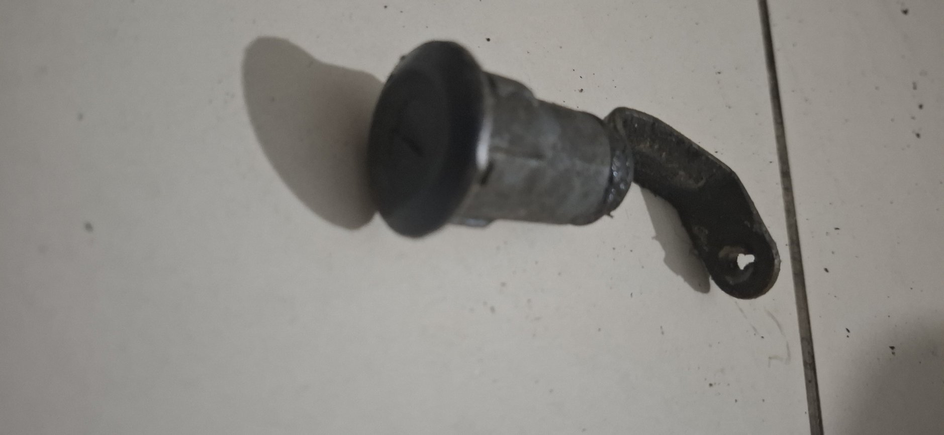
Photo evidence: 20260723_013447_gp_mzaP0yGQ, 20260723_013456_gp_DSWTd2FA
Where it is from / what it does. Loose mechanical control hardware. The exact body/dash location and controlled function cannot be proven from the photographs alone.
Replacement status. No matched replacement purchase is recorded.
WORKSHOP DECISION: IDENTIFICATION HOLD

Refurbishment guidance
- Do not discard: mark both parts as location-unknown and compare mounting holes with the dash, windscreen frame, heater and body apertures.
- Inspect pivot holes, shaft wear, threads and bends; straighten only against a proven installation or mirror-side sample.
- Derust and refinish sound metal, renew bushes/clips and lubricate moving contact points.
- Replace or fabricate only after function and geometry are confirmed.

22. Pedal rubber pad
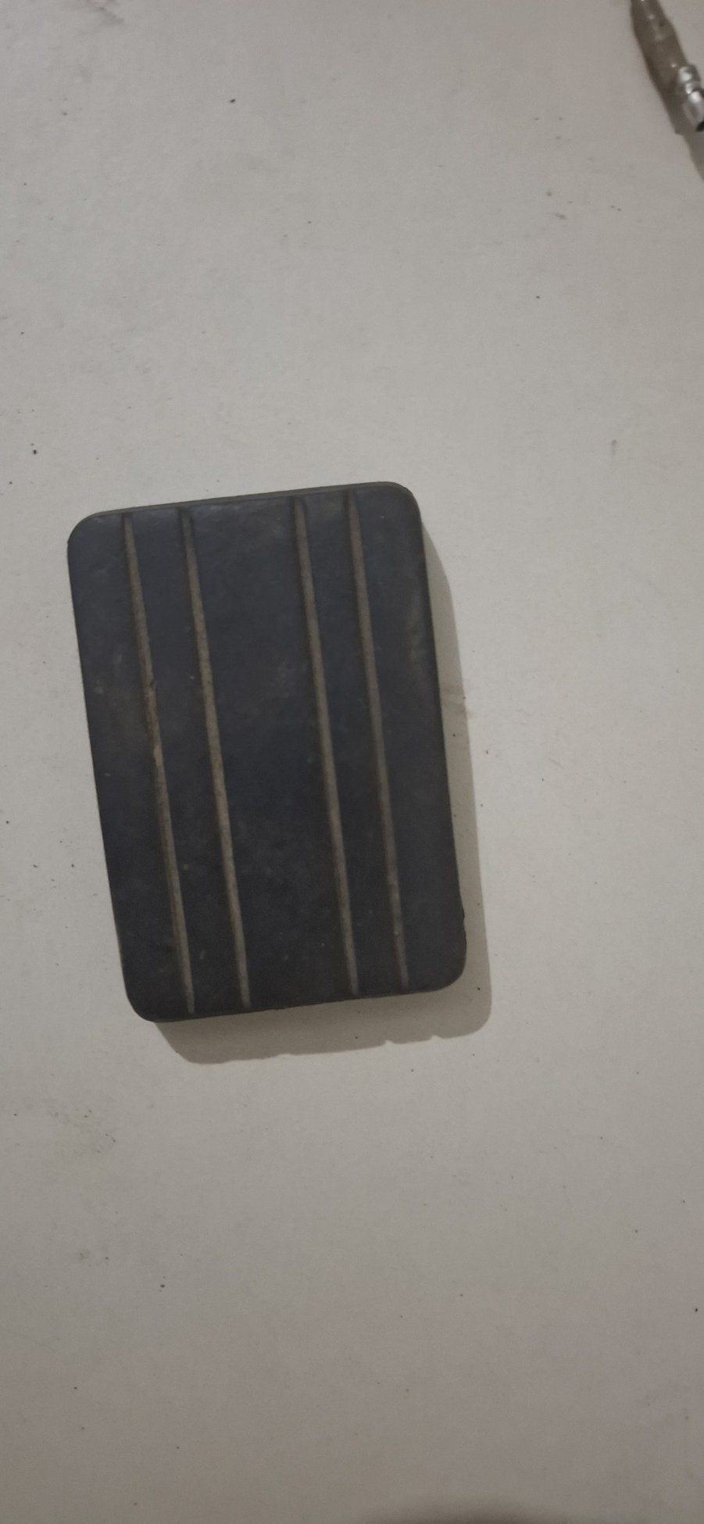
Photo evidence: 20260723_013740_gp_PDMfr5IQ
Where it is from / what it does. Fits over a brake, clutch or accelerator pedal plate to provide a high-friction foot surface.
Replacement status. No replacement pedal rubber purchase is recorded.
WORKSHOP DECISION: REPLACE RUBBER

Refurbishment guidance
- Identify the pedal and measure plate width, height, thickness and retaining-lip profile.
- Use the old pad only as a dimensional/pattern sample.
- Replace if hard, polished, cracked, oil-swollen or loose; a slipping brake/clutch pedal pad is unsafe.
- Fit a new molded automotive pad and confirm it cannot peel off under side loading.

23. Fluid-reservoir strainer / filter cup
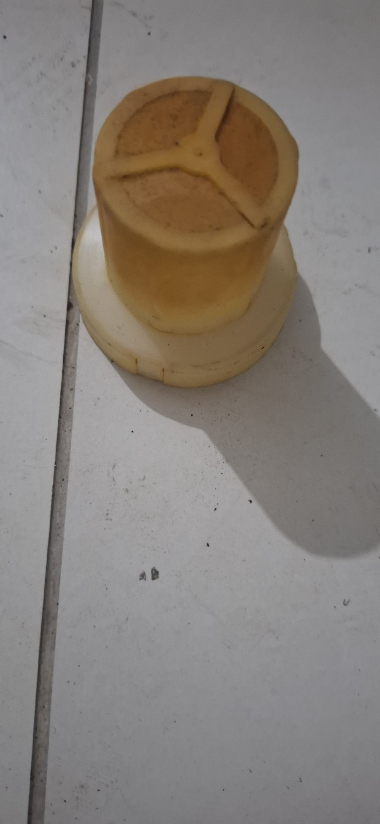
Photo evidence: 20260723_014842_gp_77vbWMeA
Where it is from / what it does. An internal slotted filter cup from one of the vehicle fluid reservoirs. Its shape is consistent with a reservoir strainer, possibly the brake-master reservoir, but the exact container must be confirmed by diameter and seating flange.
Replacement status. The UFM-1041 replacement brake master is purchased-candidate; confirm whether its reservoir includes a new matching strainer.
WORKSHOP DECISION: CONFIRM RESERVOIR; RENEW IF HYDRAULIC

Refurbishment guidance
- Keep this insert beside the old master/reservoir assembly and trial-match it without forcing.
- Inspect for embedded contamination, cracking, distortion and brittleness.
- Prefer the new reservoir manufacturer’s clean matched insert if supplied.
- Do not transfer a contaminated or damaged strainer into a rebuilt/new hydraulic system.

24. Windscreen-washer bottle, bracket and pump
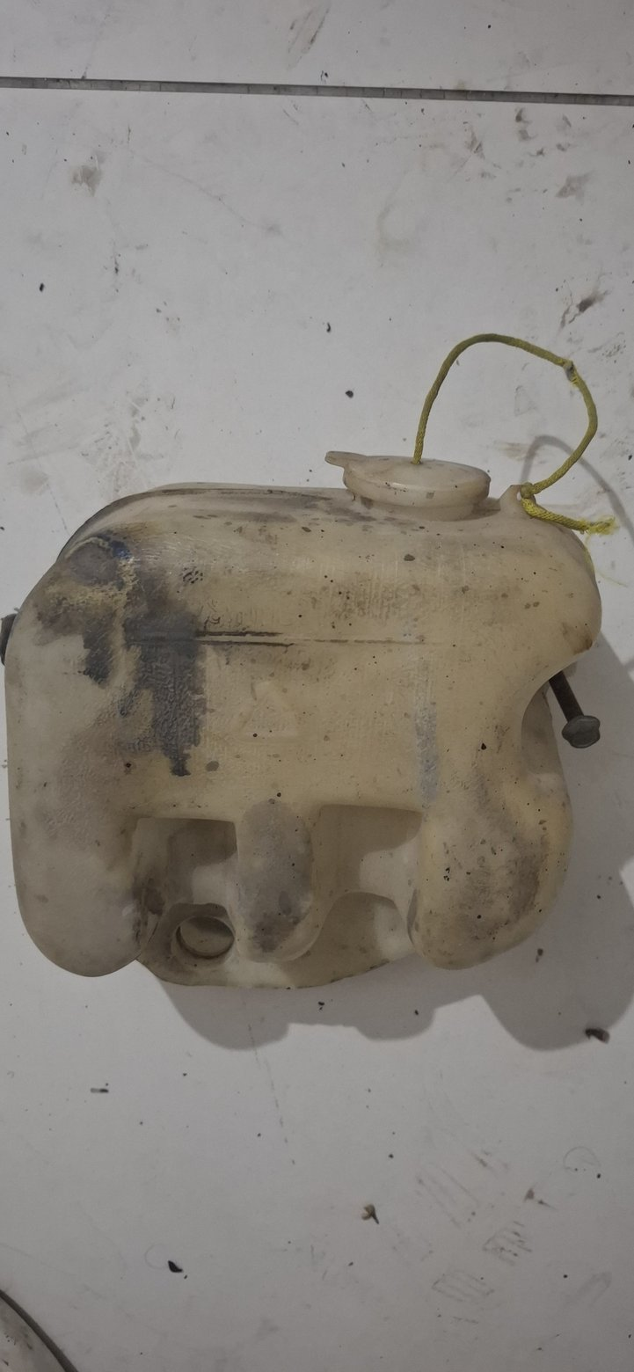 | 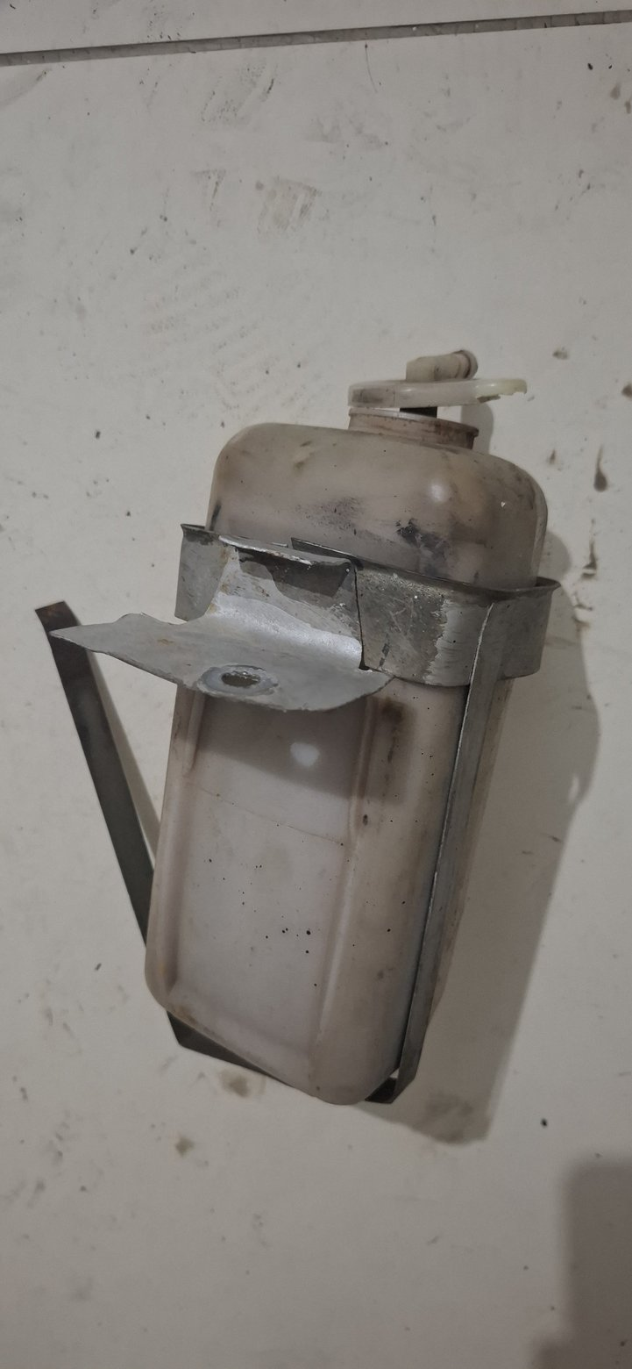
Photo evidence: 20260723_014847_gp_yhu1WZWQ, 20260723_014852_gp_aWxFuqNw
Where it is from / what it does. Mounted in the engine bay, the bottle stores washer fluid and the pump sends it through hoses to windscreen jets.
Replacement status. No replacement bottle or pump purchase is recorded.
WORKSHOP DECISION: REFURBISH CONDITIONALLY

Refurbishment guidance
- Wash internally with compatible cleaner and leak-test the bottle, cap and outlet grommet.
- Inspect for UV brittleness, cracks and stripped cap threads; replace a degraded bottle rather than patching it.
- Bench-test the pump for flow, current draw and leakage; replace old hose and blocked jets.
- Derust and refinish the mounting bracket and add sound isolation pads where originally fitted.

25. Power-steering / hydraulic reservoir
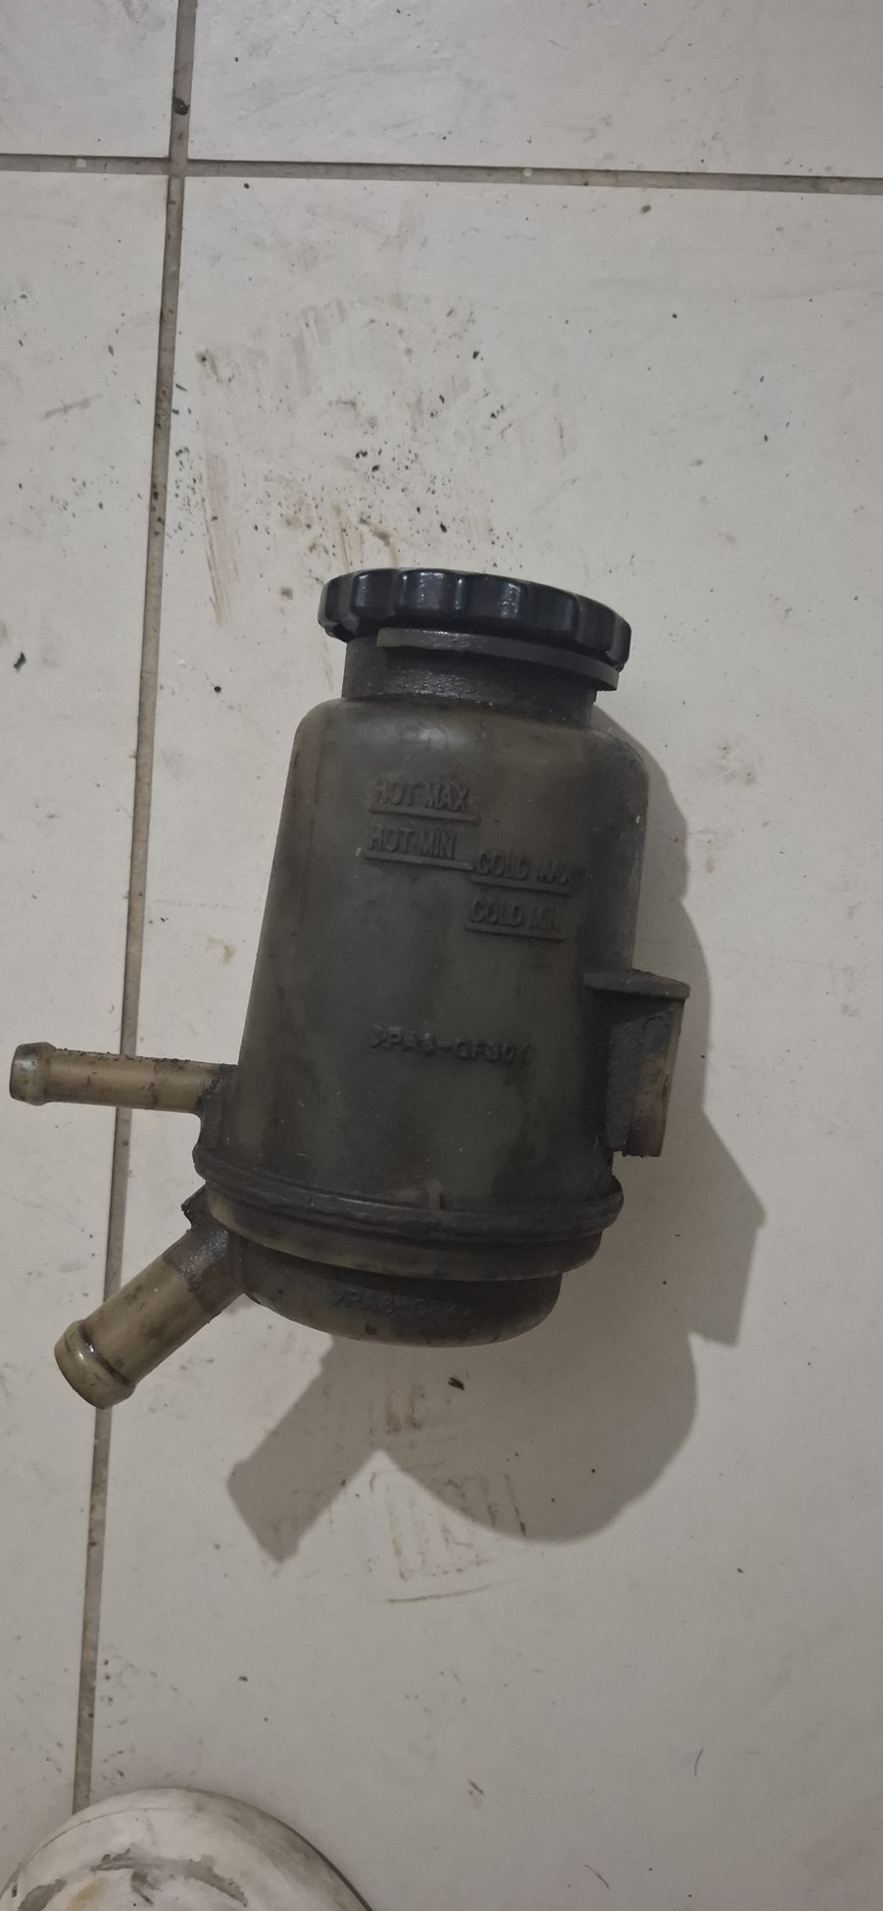
Photo evidence: 20260723_014855_gp_WgIPqcIQ
Where it is from / what it does. A remote hydraulic-fluid reservoir with two hose connections, most likely serving the power-steering circuit. Final identity must be confirmed by tracing its hoses.
Replacement status. No replacement reservoir purchase is recorded.
WORKSHOP DECISION: CONFIRM, CLEAN AND LEAK-TEST

Refurbishment guidance
- Trace both hoses and confirm the circuit before cleaning or ordering parts.
- Flush and inspect internally for sludge, rust and degraded plastic; inspect cap seal and any internal screen/filter.
- Replace every old hydraulic hose and use the fluid specification required by the confirmed steering system.
- Replace the reservoir if cracked, brittle, internally corroded or impossible to clean completely.

Workshop close-out checklist
- Every removed item has a component name, side/location label and photo reference.
- Old samples remain available until every replacement has passed physical trial fit.
- Safety-critical items have a new-part record, inspection result and installation test.
- Refurbished mechanisms move freely, latch positively and return without binding.
- All rubber, seals, hoses, grommets and fluid-contact pieces are chemically compatible and undamaged.
- Electrical parts have confirmed system voltage, terminal functions, continuity/current tests and protected connections.
- Final assembly photographs and test results are added to the project record before road release.
Source note. This guide is based on the 42-photo Google Photos intake imported on 23 July 2026, the project parts/procurement ledger and owner clarifications. Medium-confidence identifications remain explicitly labelled and must be confirmed against the vehicle.

