PAKISTAN FABRICATOR SPECIFICATION
J40 Integrated Radiator
and Cooling System
Toyota 2H • R134a A/C • 50°C continuous design ambient • separate charge-air path
REV D | 30 JULY 2026 | ALL DIMENSIONS IN mm
DESIGN REQUIREMENT — NOT YET A PROVEN RATING
Final manufacture remains HOLD. The installed vehicle may be described as 50°C-capable only after the component evidence, fit gates and full Rev D acceptance test pass.
KARIGAR KE LIYE: 50°C grille-air, A/C ON aur approved full-load fuelling par coolant stable rehna chahiye. Sirf “4-row” ya free-air CFM claim pass nahin. Pehle complete dummy fit aur written approval.
DESIGN CEILING | MAIN PACK | CHARGE-AIR PACK
150 bhp / 112 kW crankshaft cooling envelope; not an approved engine output | pusher(s) → condenser → radiator → full shroud → mechanical puller | separate side fresh-air duct → charge cooler → dedicated fan → separate hot outlet

1. Rev D packaging clarification — fixed front width
CONTROLLED PACKAGING RULE
The central radiator / condenser / front-fan stack stays at its fixed width between the two existing uprights. The independent charge-air module starts aft and outboard of the RIGHT upright; keep its core approximately 90° to the central stack. Do not add front width. M8 is a full-size-template gate, not an estimated clearance check.
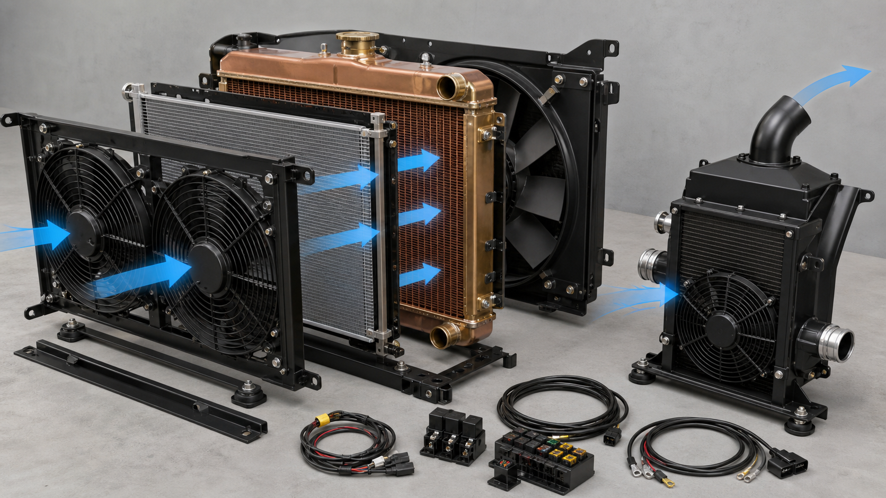
PH01 — Split-out component visual: central pusher-fan / condenser / radiator / puller-shroud layers, independent side charge-air module, removable mounts and required electrical parts. This is a generated layout aid; D01–D07 and the accepted full-size templates control manufacture.

1.1 Rev D assembly and proposed vehicle packaging
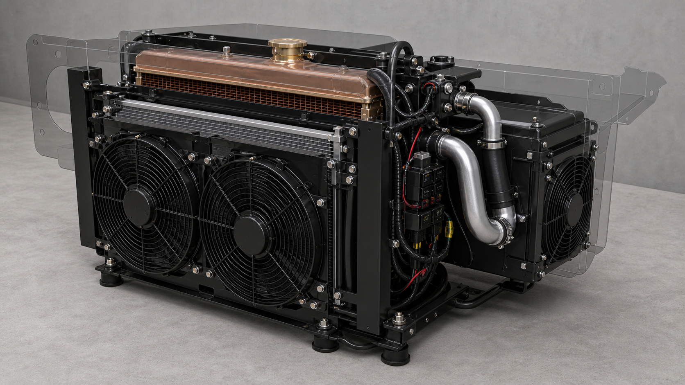
PH02 — Fully assembled component-pack visual: the central layers stack only front-to-rear, while the charge-air module mounts aft/outboard on its own fresh-air and hot-air paths.
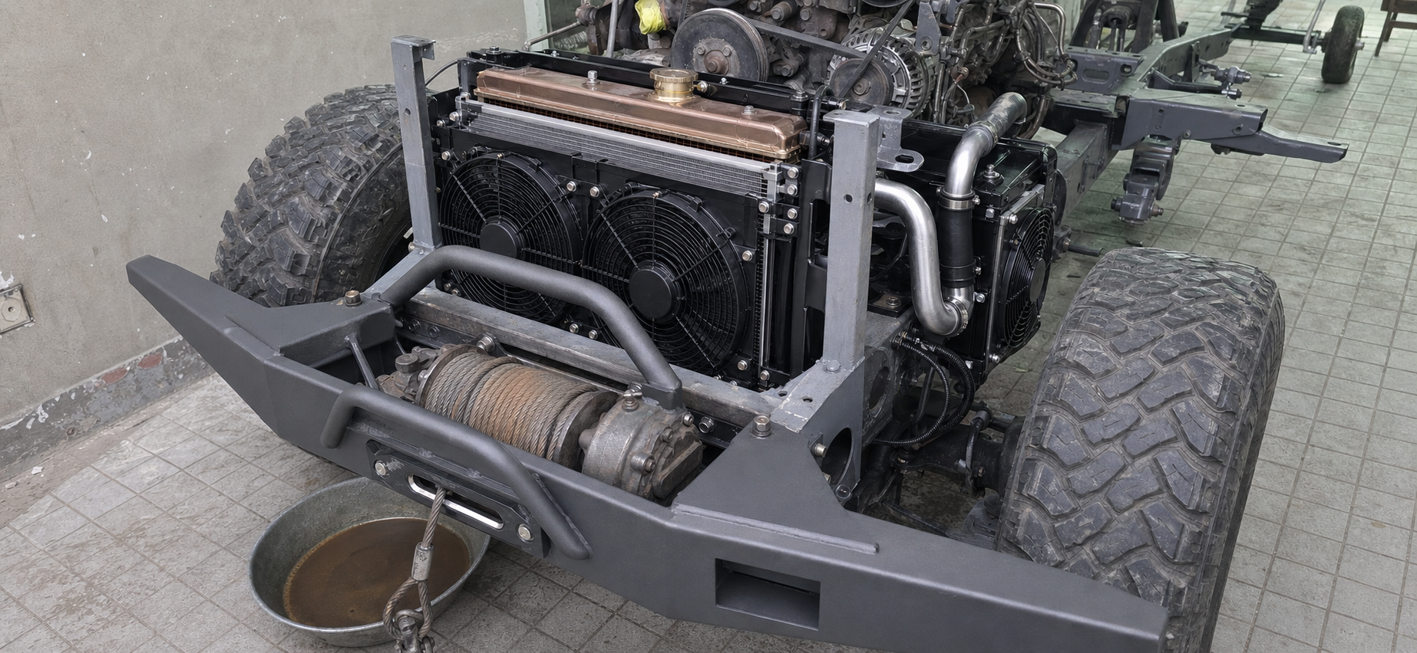
PH03 — Proposed later-stage composite using latest winch/crossmember evidence and documented new-bumper reference. This is a generated design visual, not evidence of completed fabrication/installation.

1. Rev D decision and release status
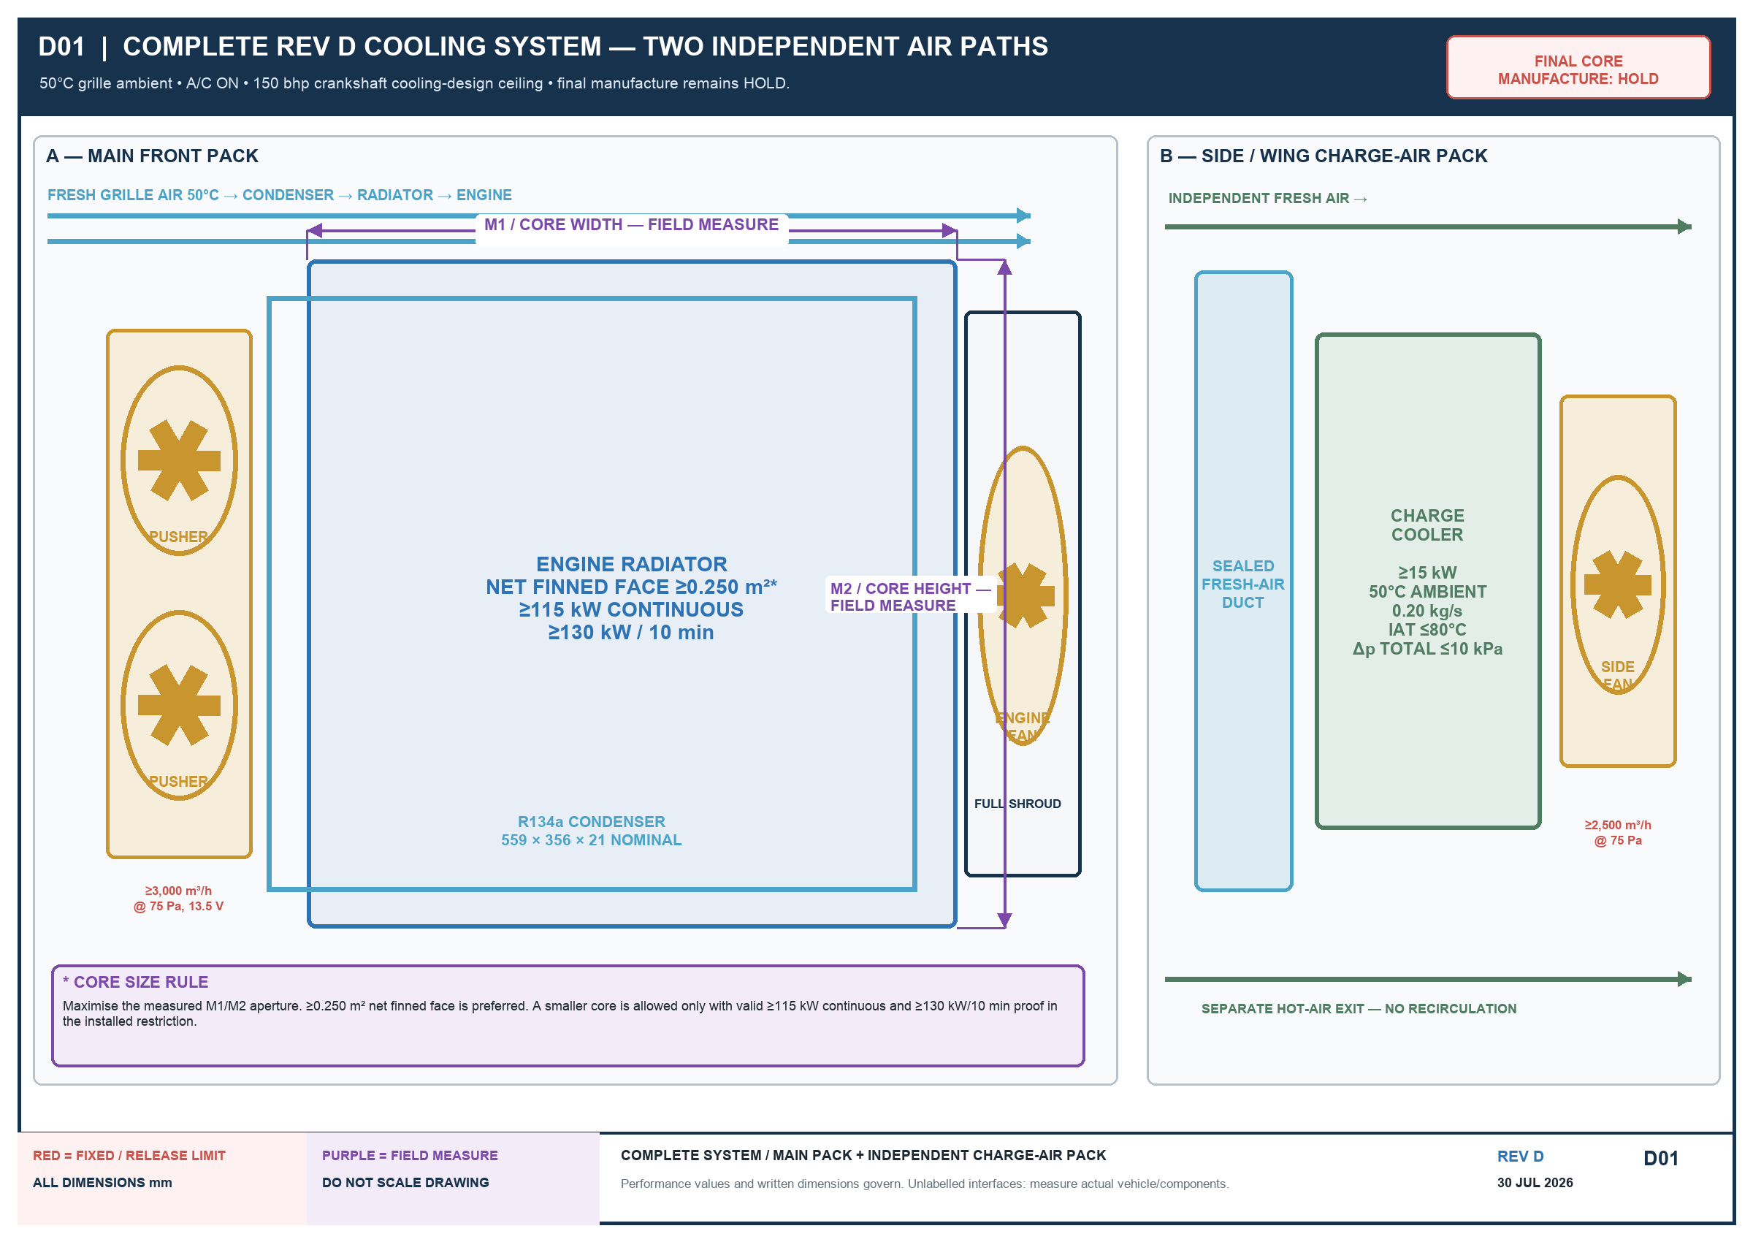
Rev D removes the intercooler from the radiator/condenser stack. The previous lower-front core masked about 39% of the nominal radiator face and made a 50°C/A/C claim indefensible. The side/wing charge cooler now has its own sealed fresh inlet, fan and hot-air exit.
SUPERSEDES OLD FAN INSTRUCTIONS
Do not use the older one 12-inch, one 14-inch, optional 12–14-inch or two nominal 9-inch instructions. Fan selection now follows installed airflow at static pressure and the complete mock-up.

Released now
- Vehicle measurement/evidence, supplier quotation and curve review.
- Full-size dummies and removable bracket/duct tack fitting.
- Instrument and controlled-test planning.

Final manufacture remains HOLD until
1. M1–M8 and F1–F7 pass on the actual vehicle.
2. The actual parts/dummies fit with bonnet, grille, guard and accessories represented.
3. Radiator and fan performance evidence is accepted.
4. The owner signs the as-measured drawing.
5. The completed vehicle passes the 50°C acceptance test.

2. Duty and turbo non-derate requirement
ITEM | CONTROLLED REQUIREMENT
Ambient | 50°C dry-bulb air measured at the grille/cooling-pack inlet; this is air, not coolant
Vehicle | bonnet closed; final grille/guard/bumper/winch/seals; loaded operating weight
Engine | final approved turbo/fuelling, up to 150 bhp crankshaft cooling-design ceiling
A/C | ON and stabilised with final condenser, charge and cabin blower
Continuous | ≥60 min after stabilisation with no continuing coolant-temperature rise
Radiator duty | ≥115 kW continuous; ≥130 kW for 10 min beginning from the stable condition
Heat soak | 52°C controlled inlet for 10 min followed by hot restart
TURBO WORDING
No cooling-related boost reduction or derate is permitted inside the approved 150 bhp crankshaft thermal-design envelope. This does not approve 150 bhp or 8–10 psi. Start at 5–7 psi; engine health, maps, EGT, drive pressure, oil, smoke, fuelling, clutch and driveline still govern.

3. One-page shop specification
PART | REQUIRED
Radiator | largest practical M1/M2 core; ≥0.250 m² net finned face preferred; smaller only with valid duty proof
Radiator capacity | ≥115 kW continuous at stated point; ≥130 kW/10 min
Condenser | 559 × 356 × 21 nominal R134a basis; actual part measured
Front pusher(s) | ≥3,000 m³/h installed at 75 Pa, 13.5 V; close full-face frame
Mechanical fan | retain/rebuild + sealed full shroud; ≥9,000 m³/h installed at 125 Pa, 1,500 engine rpm
Charge cooler | separate side/wing path; ≥15 kW; IAT ≤80°C; complete route Δp ≤10 kPa
Charge fan | dedicated sealed unit; ≥2,500 m³/h installed at 75 Pa through complete duct/core/outlet

4. Engine radiator
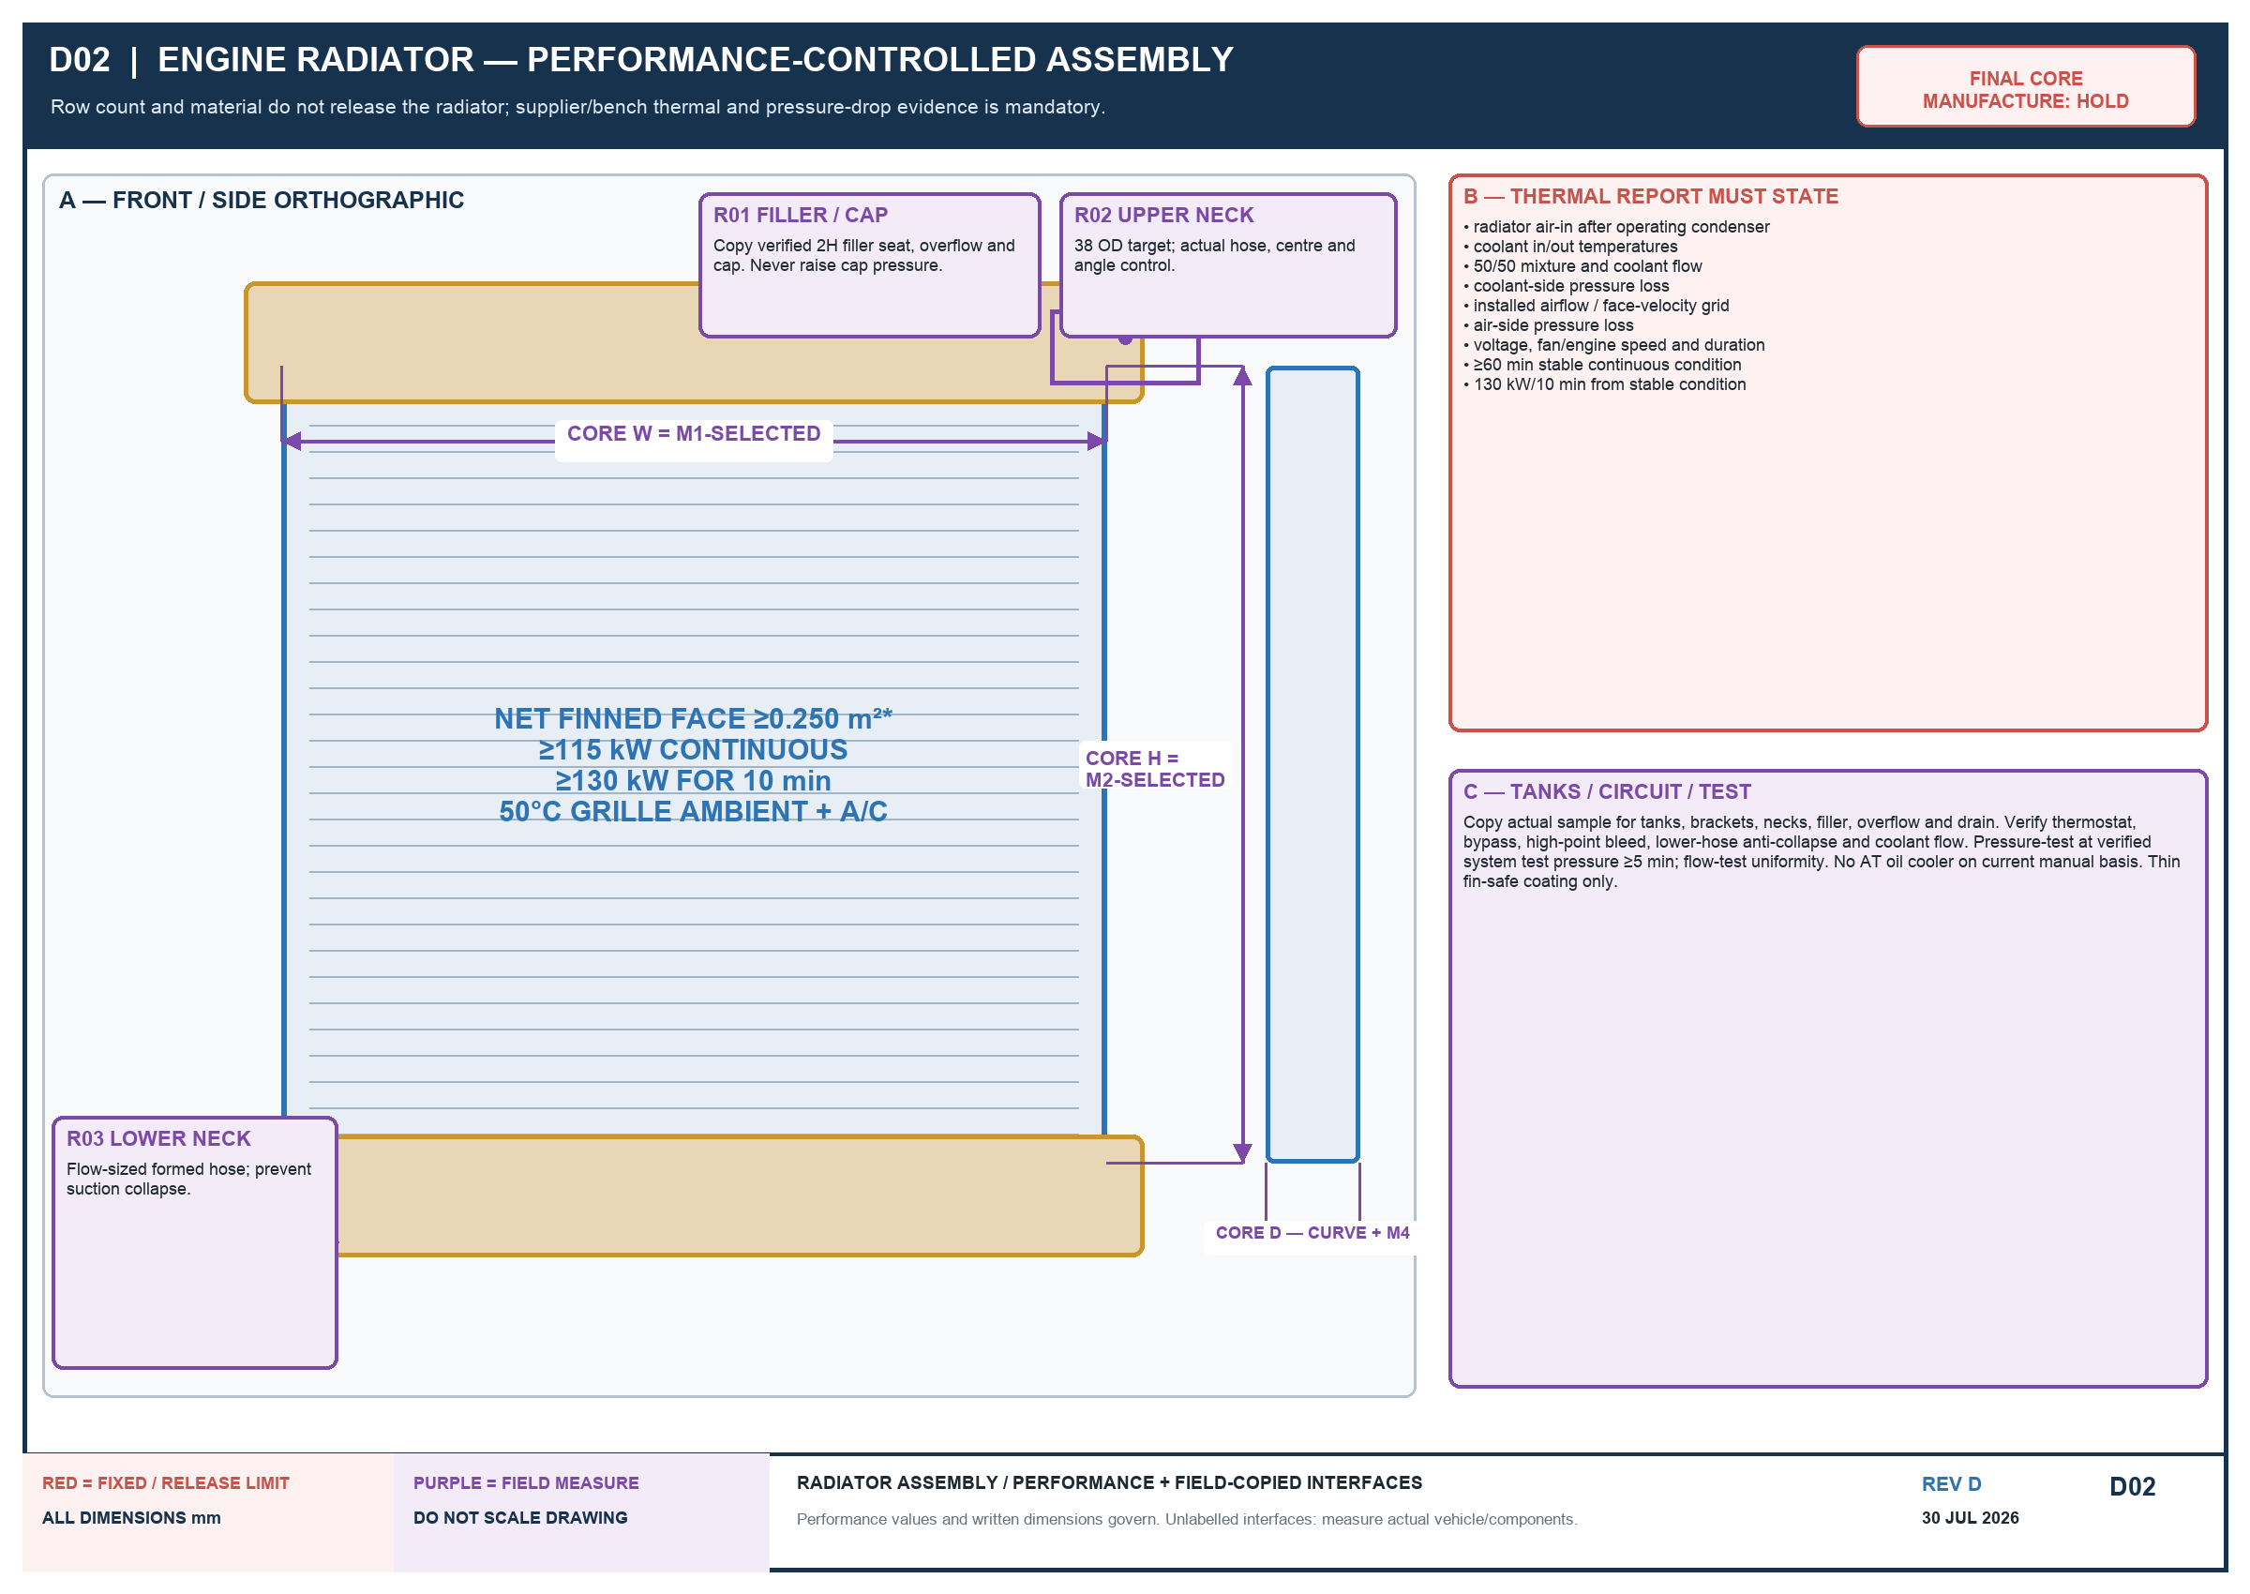
Recore the original copper/brass unit first only if its tanks/interfaces pass inspection and the completed radiator meets the duty. Copper/brass or serviceable aluminium is acceptable. Row count and material alone are not acceptance.
PARAMETER | REQUIREMENT
Core face | ≥0.250 m² net finned face preferred; maximise measured M1/M2
Smaller core | allowed only with valid ≥115 kW continuous and ≥130 kW/10 min installed-condition proof
Interfaces | copy physical sample for tank, 38 OD target necks, centres/angles, filler, overflow, drain and brackets
Cap | verified 2H pressure/seat only; a higher-pressure cap is not an upgrade
Coolant circuit | verify thermostat/bypass, high-point bleed, flow, pressure drop and lower-hose anti-collapse
Dust margin | normal grille/guard/screens fitted; ≥10% clean-core thermal/airflow margin
Bench tests | verified system pressure ≥5 min, no leak/loss; uniform flow; record result

4.1 Required radiator curve/report
- 50°C grille ambient and actual radiator air-in temperature behind operating condenser.
- Coolant in/out temperatures, mixture, flow and coolant-side pressure loss.
- Installed airflow or face-velocity grid and air-side pressure loss.
- Fan/engine speed, voltage, clean-core condition and duration.
- ≥60 min stable at 115 kW; then ≥130 kW for 10 min with no continuing rise.
NO CURVE?
Do not invent a rating. Build an instrumented prototype and pass the complete vehicle test.

5. Main airflow, A/C and electrical
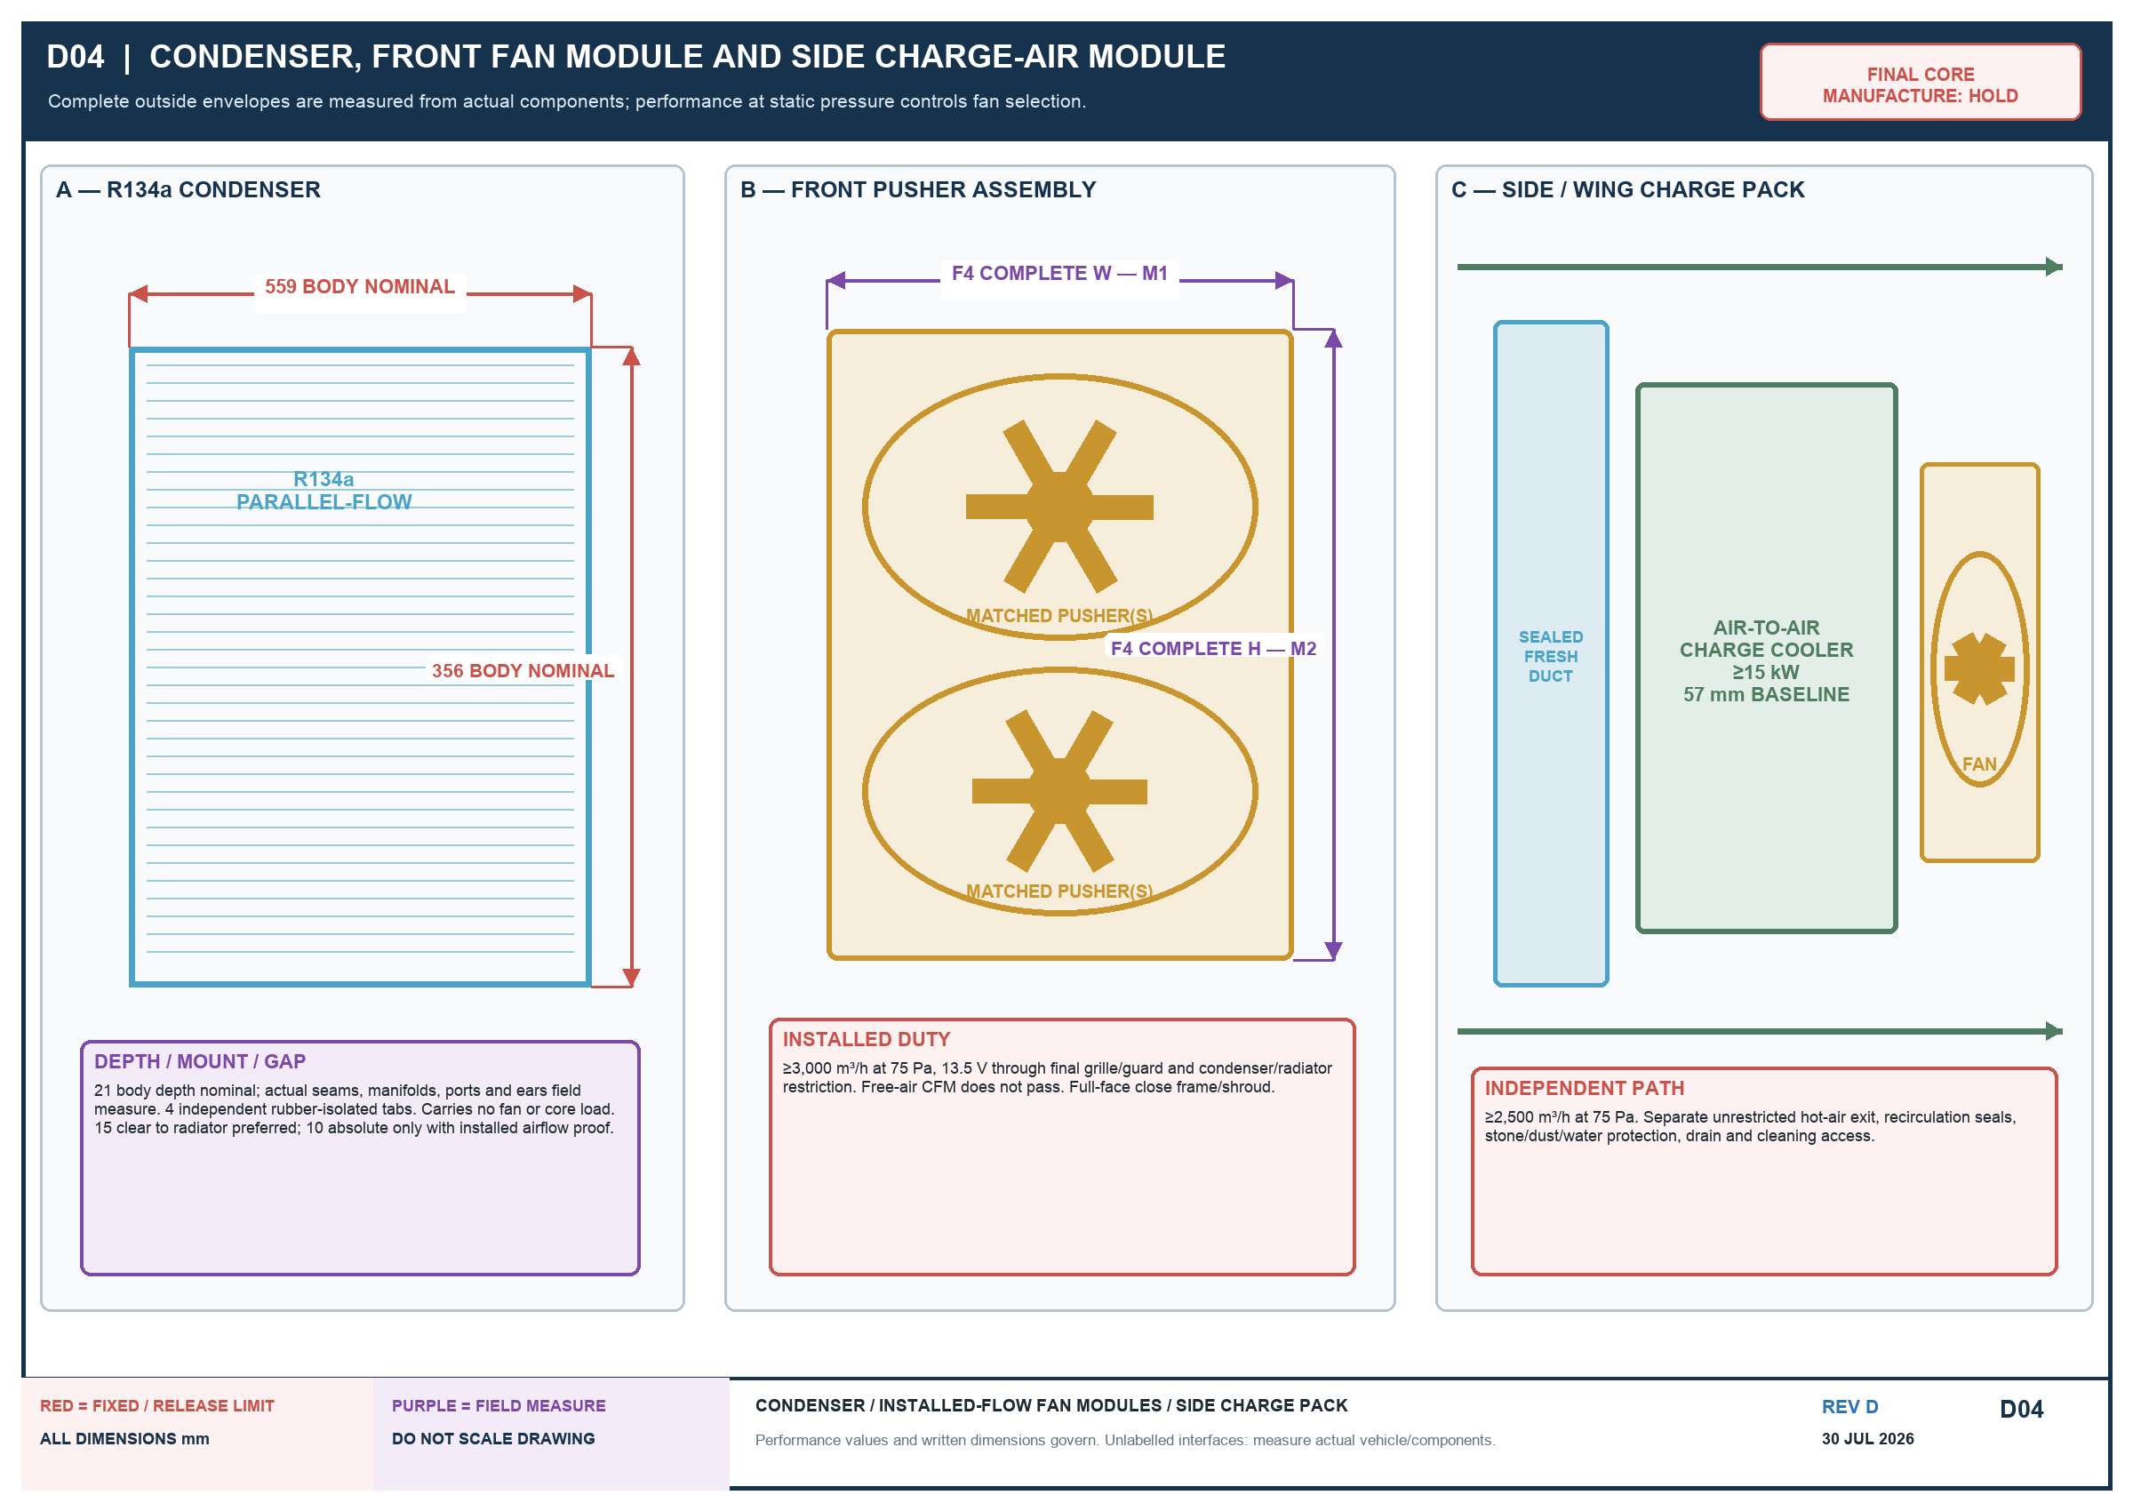

5.1 Mechanical puller
- Reject cracked, loose, distorted, contact-marked or weld-repaired blades; inspect hub, water pump and mounts.
- Record OD, swept circle, blade depth, centre X/Y and nearest point through rotation/movement.
- Rigid full-face perimeter-sealed shroud; 35–50% blade depth inside; ≥15 radial movement clearance.
- Radiator rear to fan ≥20 static, 25–30 preferred.
- ≥9,000 m³/h installed at 125 Pa at 1,500 engine rpm; record a face-velocity grid.

5.2 Front electric pusher assembly
- One full-width assembly or multiple matched sealed pushers; use practical condenser face area.
- ≥3,000 m³/h installed at 75 Pa and 13.5 V through final restriction. Free-air CFM does not pass.
- Independent close frame/shroud; no core ties and no fan load on condenser.
- Multiple motors use separately fused/relayed branches; A/C/trinary control and fail-safe pressure protection.
- One-fan-failed test must warn and fail safe; full 50°C A/C performance is not required with a fault.

5.3 Condenser and drier
559 × 356 × 21 nominal parallel-flow condenser; measure all seams, manifolds, ports and ears. Four independent isolated tabs. Keep 15 clear to radiator preferred; 10 absolute only with proof. Fit the drier vertical/outside airflow and have the A/C technician verify charge, pressures and 50°C performance.

6. Separate side/wing charge-air pack
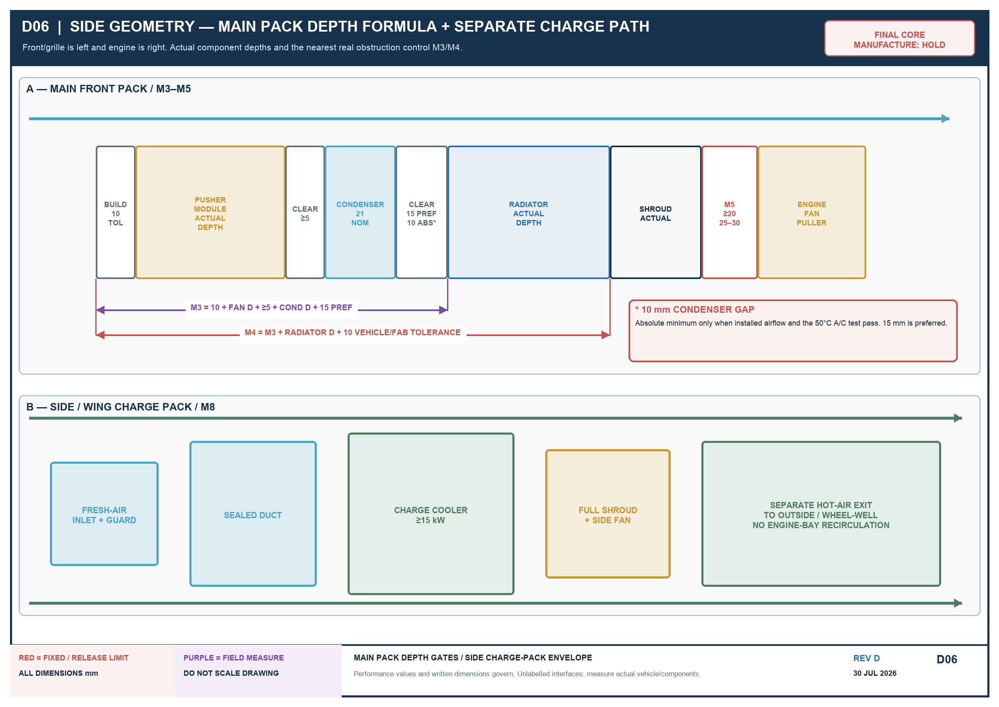
Select the side only after the actual turbo, steering, battery, air cleaner, A/C compressor, bonnet, wing, downpipe and tool paths are trial-fitted. The pack requires a protected fresh-air inlet, sealed duct, charge cooler, full-core shroud/fan, separate unrestricted hot-air exit, recirculation seals, drain and cleaning access. It begins aft and outboard of the RIGHT upright, with the core approximately 90° to the fixed-width central radiator/condenser/fan stack; it must not increase front-pack width.
PARAMETER | REQUIREMENT
Heat rejection | ≥15 kW continuous after heat soak
Test point | 50°C fresh-air inlet; 0.20 kg/s charge flow; 130°C nominal compressor discharge; record boost/pressure ratio
Manifold IAT | ≤80°C during stabilised rated full load at 50°C; idle heat soak recorded separately
Complete route Δp | ≤10 kPa / 1.45 psi compressor outlet to plenum; target ≤7 kPa
Core Δp | target ≤5 kPa at rated flow
Fan | ≥2,500 m³/h installed at 75 Pa through complete inlet/guard/core/shroud/outlet
Proof test | ≥2 × declared maximum boost and never less than 30 psi, using guarded safe method
M8 template gate | full-size core, fan/shroud, inlet/outlet ducts, clamps, mounts and service-tool envelope; trial-fit aft/outboard of RIGHT upright before manufacture
Connections | 57 mm / 2.25 in beaded baseline; larger only by approved flow/fit review
NO RECIRCULATION
Do not use engine-bay air as the normal inlet and do not discharge onto turbo/exhaust, battery, wiring, brakes or main radiator inlet.

7. Mounting, shroud and packaging
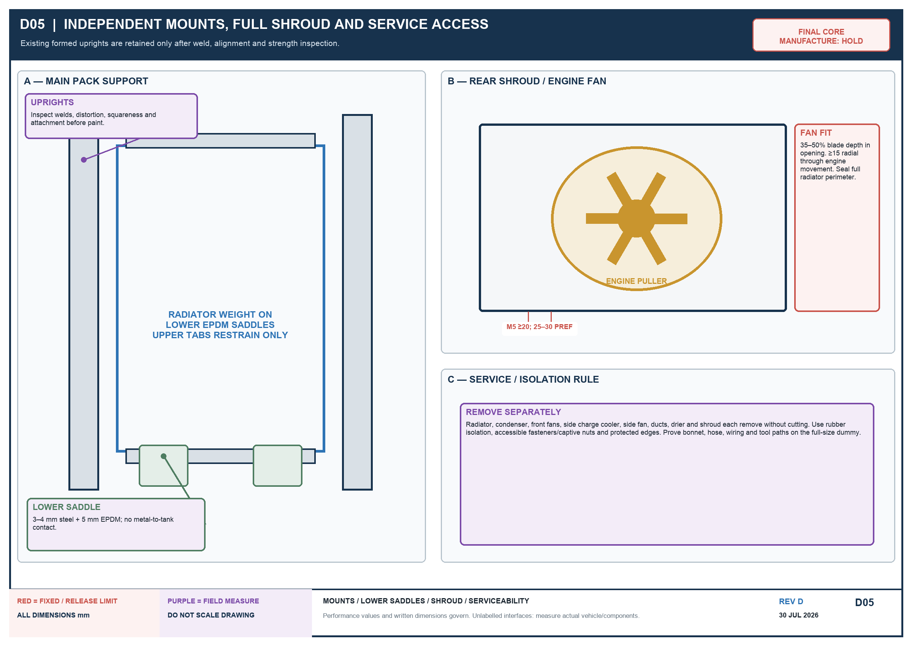
- Inspect existing formed uprights and their welds/alignment/strength before reuse.
- Use removable rails, weight-bearing lower saddles and rubber/EPDM isolation; upper tabs restrain only.
- Every exchanger, fan, shroud, duct and drier removes separately without cutting.
- No drilling/welding a pressure part or core; no plastic core ties; no forced bolt alignment.
- Protect final cores from welding/grinding and all edges from tanks, hoses, wires and fins.

7.1 M3/M4 depth formula
GATE | FORMULA / PASS
M3 | 10 build + actual front fan depth + ≥5 fan/condenser clear + actual condenser depth + 15 preferred gap
M4 | M3 + actual radiator depth + 10 vehicle/fabrication tolerance
M5 | radiator rear to nearest mechanical-fan point ≥20 static; 25–30 preferred
M8 | full-size template proves complete side inlet/core/fan/outlet path aft/outboard of RIGHT upright; core ~90° to main stack; no added front width

8. Electric fan power and controls
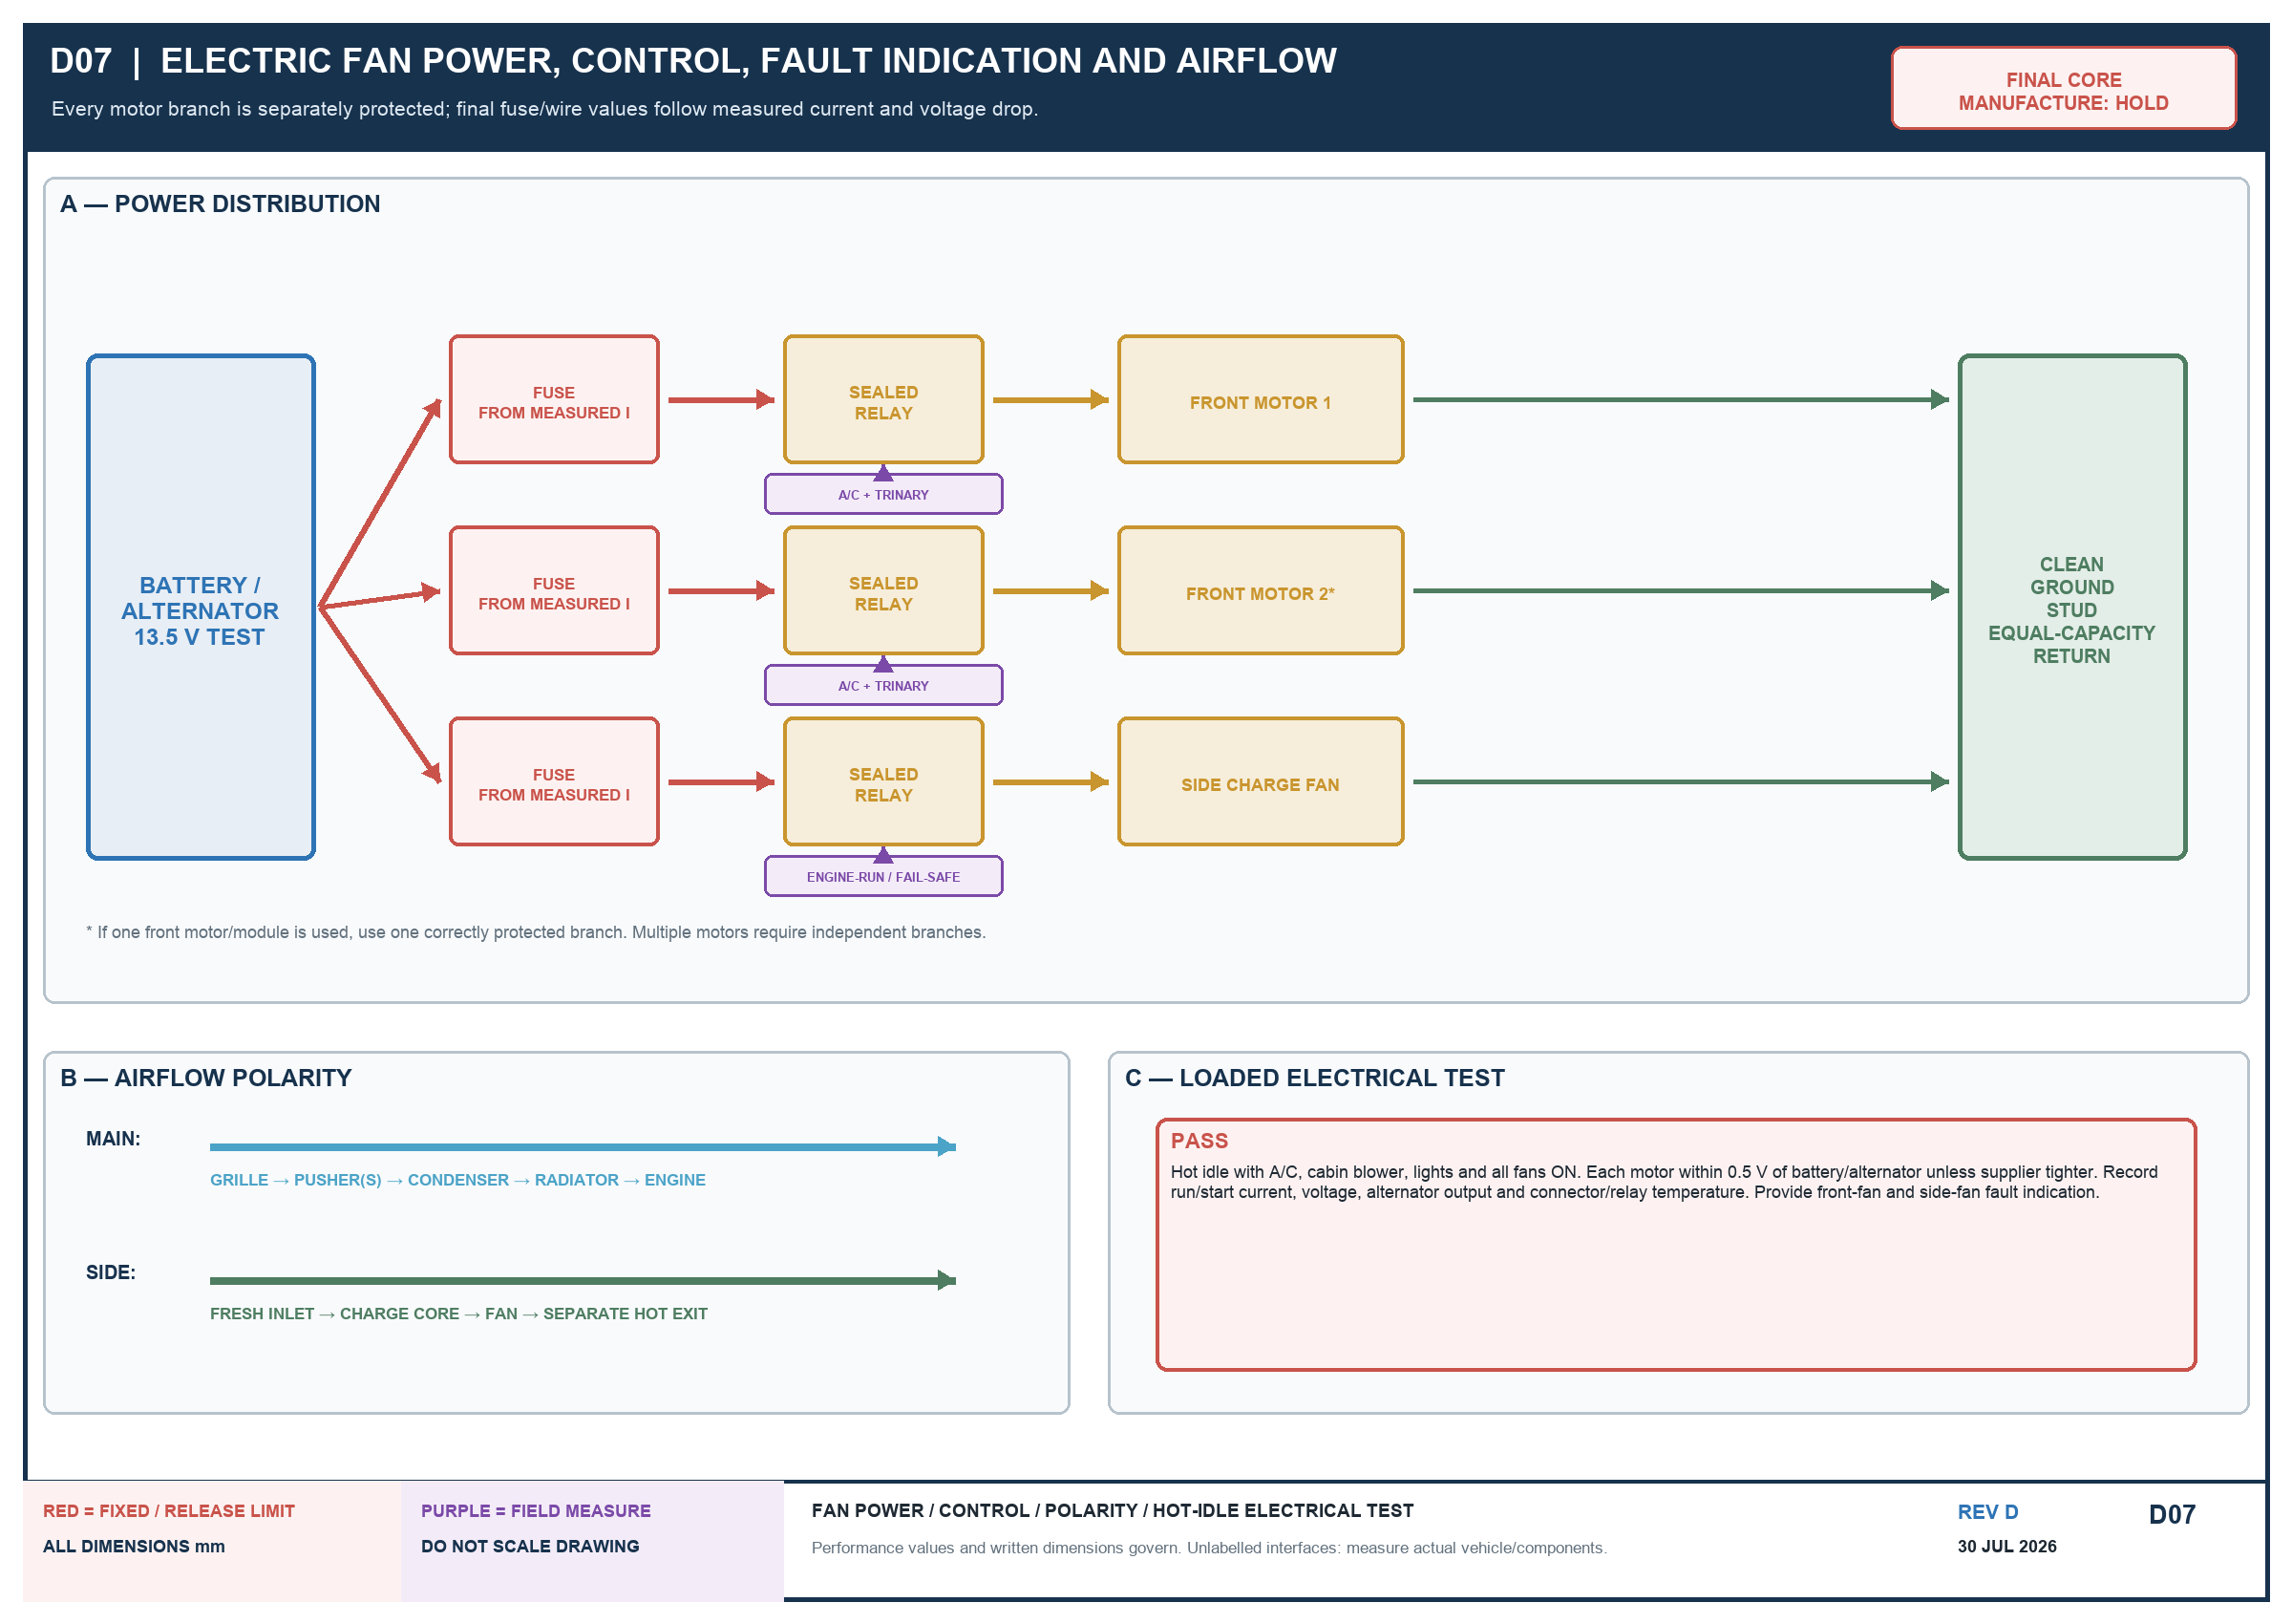
- Each motor has a correctly sized fuse, sealed relay, weatherproof connector and equal-capacity ground.
- Fuse/wire from measured run/start current, temperature rating and voltage drop; do not copy a generic value.
- Side charge fan runs whenever the engine runs unless a documented fail-safe boost/IAT controller passes testing; manual override and fault indication required.
- Bench-test polarity: main grille → engine; side fresh inlet → core → separate hot outlet.
- Hot idle with A/C, blower, lights and all fans: motor voltage within 0.5 V of battery/alternator unless supplier tighter.
- Record alternator output, fan current, voltage and relay/connector temperature; protect wiring from heat/movement/water.

9. Mandatory measurement and performance gates
ID | MEASURE | PASS
M1 | main clear width | largest practical core; ≥0.250 m² face preferred; tanks/ports/removal fit
M2 | saddle to bonnet/latch | radiator overall H + 10; filler/hose/service paths fit
M3 | front obstruction to radiator front | formula in section 7.1 using actual component depths
M4 | front obstruction to radiator rear | M3 + actual radiator D + 10 tolerance
M5 | radiator rear to fan | ≥20 static; 25–30 preferred through movement
M6 | lowest main-pack edge | ≥25 above protected line unless stronger guard approved
M7 | main-pack service path | each component removes separately without cutting
M8 | side pack + ducts | full-size template: aft/outboard of RIGHT upright, core ~90° to main stack, no added front width; no conflict and separate fresh inlet/hot outlet proven
F1 | mechanical fan sweep | record OD/full sweep
F2 | blade insertion/clear | 35–50%; ≥15 radial through movement
F3 | main fan centre | record X/Y on as-built
F4 | front fan envelope | complete frame/guards/plugs/wires fit M1–M4
F5 | front installed flow | ≥3,000 m³/h at 75 Pa, 13.5 V
F6 | mechanical installed flow | ≥9,000 m³/h at 125 Pa, 1,500 engine rpm
F7 | side installed flow | ≥2,500 m³/h at 75 Pa through complete path
FIT REMAINS CONDITIONAL
The current front-opening estimate is not a manufacture dimension. Put a tape/ruler in every evidence photo and issue an as-measured drawing before buying cores or fans.

10. Required fabrication sequence
1. Inspect/measure the vehicle, accessories and fan; complete M1–M8 and F1–F3.
2. Obtain radiator, fan and charge-cooler performance curves.
3. Select the largest practical radiator and side-pack location.
4. Make complete full-size dummies including tanks, ports, fan motors, guards, plugs, wires, ducts and tools.
5. Fit main radiator/condenser/fans and side charge pack independently.
6. Close bonnet and represent final grille/guard/bumper/winch, A/C, battery, intake, steering, turbo and downpipe.
7. Prove movement, protection, cleaning and separate removal paths.
8. Photograph gates; issue as-measured/as-selected drawing and evidence pack.
9. Obtain written owner release; manufacture/recore, bench-test, install and instrument.
10. Perform section 11. Do not call the system 50°C-rated until every acceptance item passes.

11. 50°C commissioning and acceptance
A competent vehicle/turbo/A/C technician must supervise testing on a controlled dyno, proving ground or safe loaded route. Do not improvise a full-load public-road test.

11.1 Log at least once per second
- Grille ambient and radiator air-in behind the operating condenser.
- Engine-out/head coolant, radiator in/out, coolant pressure where practical.
- Oil temperature and hot oil pressure.
- Compressor-out, post-intercooler and manifold IAT; boost/plenum pressure.
- Pre-turbine EGT and turbine drive pressure.
- Fan voltage/current/speed, alternator voltage, A/C pressures/vent temperature.
- Engine/road speed, load, vehicle weight and smoke/fault observations.

11.2 Test sequence
TEST | CONDITION
Hot idle | 50°C, A/C/blower maximum, lights/normal loads, bonnet closed, 30 min
Low-speed climb | 50°C, A/C ON, loaded vehicle, final approved tune, 20 min after stabilisation
Sustained load | 50°C, A/C ON, repeatable high load including nominal 60 km/h pull where safe, 20 min
Continuous proof | ≥60 min stable at 115 kW radiator duty or equivalent instrumented vehicle load
Overload | from stable state, 130 kW equivalent for 10 min
Heat soak/restart | 52°C inlet for 10 min per plan, then hot restart and 5 min stabilisation

11.3 PASS / FAIL limits
PARAMETER | PASS
Coolant | stable/no upward trend; ≤100°C continuous and ≤105°C transient, or verified lower engine limit
Boiling margin | ≥10°C below pressure-adjusted boiling point; no loss/boil/hose collapse
Manifold IAT | ≤80°C at stabilised rated full load, 50°C ambient
Charge Δp | ≤10 kPa compressor outlet to plenum at rated flow
Turbo/oil | EGT, drive pressure, oil temperature/pressure within exact engine/turbo agreed limits
A/C | pressures inside component limits and agreed vent/cabin performance
Power | no cooling-related boost reduction/derate inside approved 150 bhp cooling envelope
Electrical | installed fan duties achieved; no abnormal current, drop or hot relay/connector
Structure | no leak, rubbing, fan contact, abnormal movement or fin damage
AUTOMATIC FAIL
Coolant or manifold-air temperature continues to rise after the stated stabilisation period, even if coolant has not boiled.

12. Handover record and signatures
CHECK | RECORD | RESULT / EVIDENCE
[ ] | M1–M8 / F1–F7 as-measured sheet
[ ] | Radiator make/model/envelope
[ ] | 115/130 kW report + water/air Δp
[ ] | Coolant flow/mix/cap/thermostat/bleed/hose
[ ] | Condenser model/envelope
[ ] | Front fans: installed flow/static/current
[ ] | Mechanical installed airflow
[ ] | Charge cooler: heat rejection/Δp/proof
[ ] | Side fan/duct installed flow/no-recirculation
[ ] | Alternator hot-idle output/voltage drop
[ ] | 50°C + 52°C raw logs/graphs/report
[ ] | A/C pressures/vent performance
[ ] | As-built drawings/photos
Radiator fabricator: __________________________________ Date: __________
A/C technician: _______________________________________ Date: __________
Turbo/engine tuner: ___________________________________ Date: __________
Owner final release: __________________________________ Date: __________

Controlled references
- docs/J40-integrated-cooling-pack-fabricator-specification-rev-c.md (controlled Rev D text)
- docs/2h-turbo-suitability-and-options-20260717.md
- SAE J1994 heat-exchanger heat-transfer/pressure-drop testing.
- SAE J1339 engine-cooling fan performance.
- SAE J1393 heavy-duty vehicle cooling test procedures.
- SAE J819 engine cooling field test.
- Pakistan Meteorological Department, Pakistan Climate 2024.

Appendix A. Controlled Rev D drawing sheets
These seven sheets show the Rev D architecture. Red values are fixed performance/release limits. Purple dimensions and interfaces are measured from the vehicle or actual component. Written values control; do not scale the images.

D01 — Complete Rev D cooling system

Written requirements govern; red = fixed/release limit; purple = field measure / owner approval.

D02 — Performance-controlled radiator

Written requirements govern; red = fixed/release limit; purple = field measure / owner approval.

D03 — Radiator component breakdown
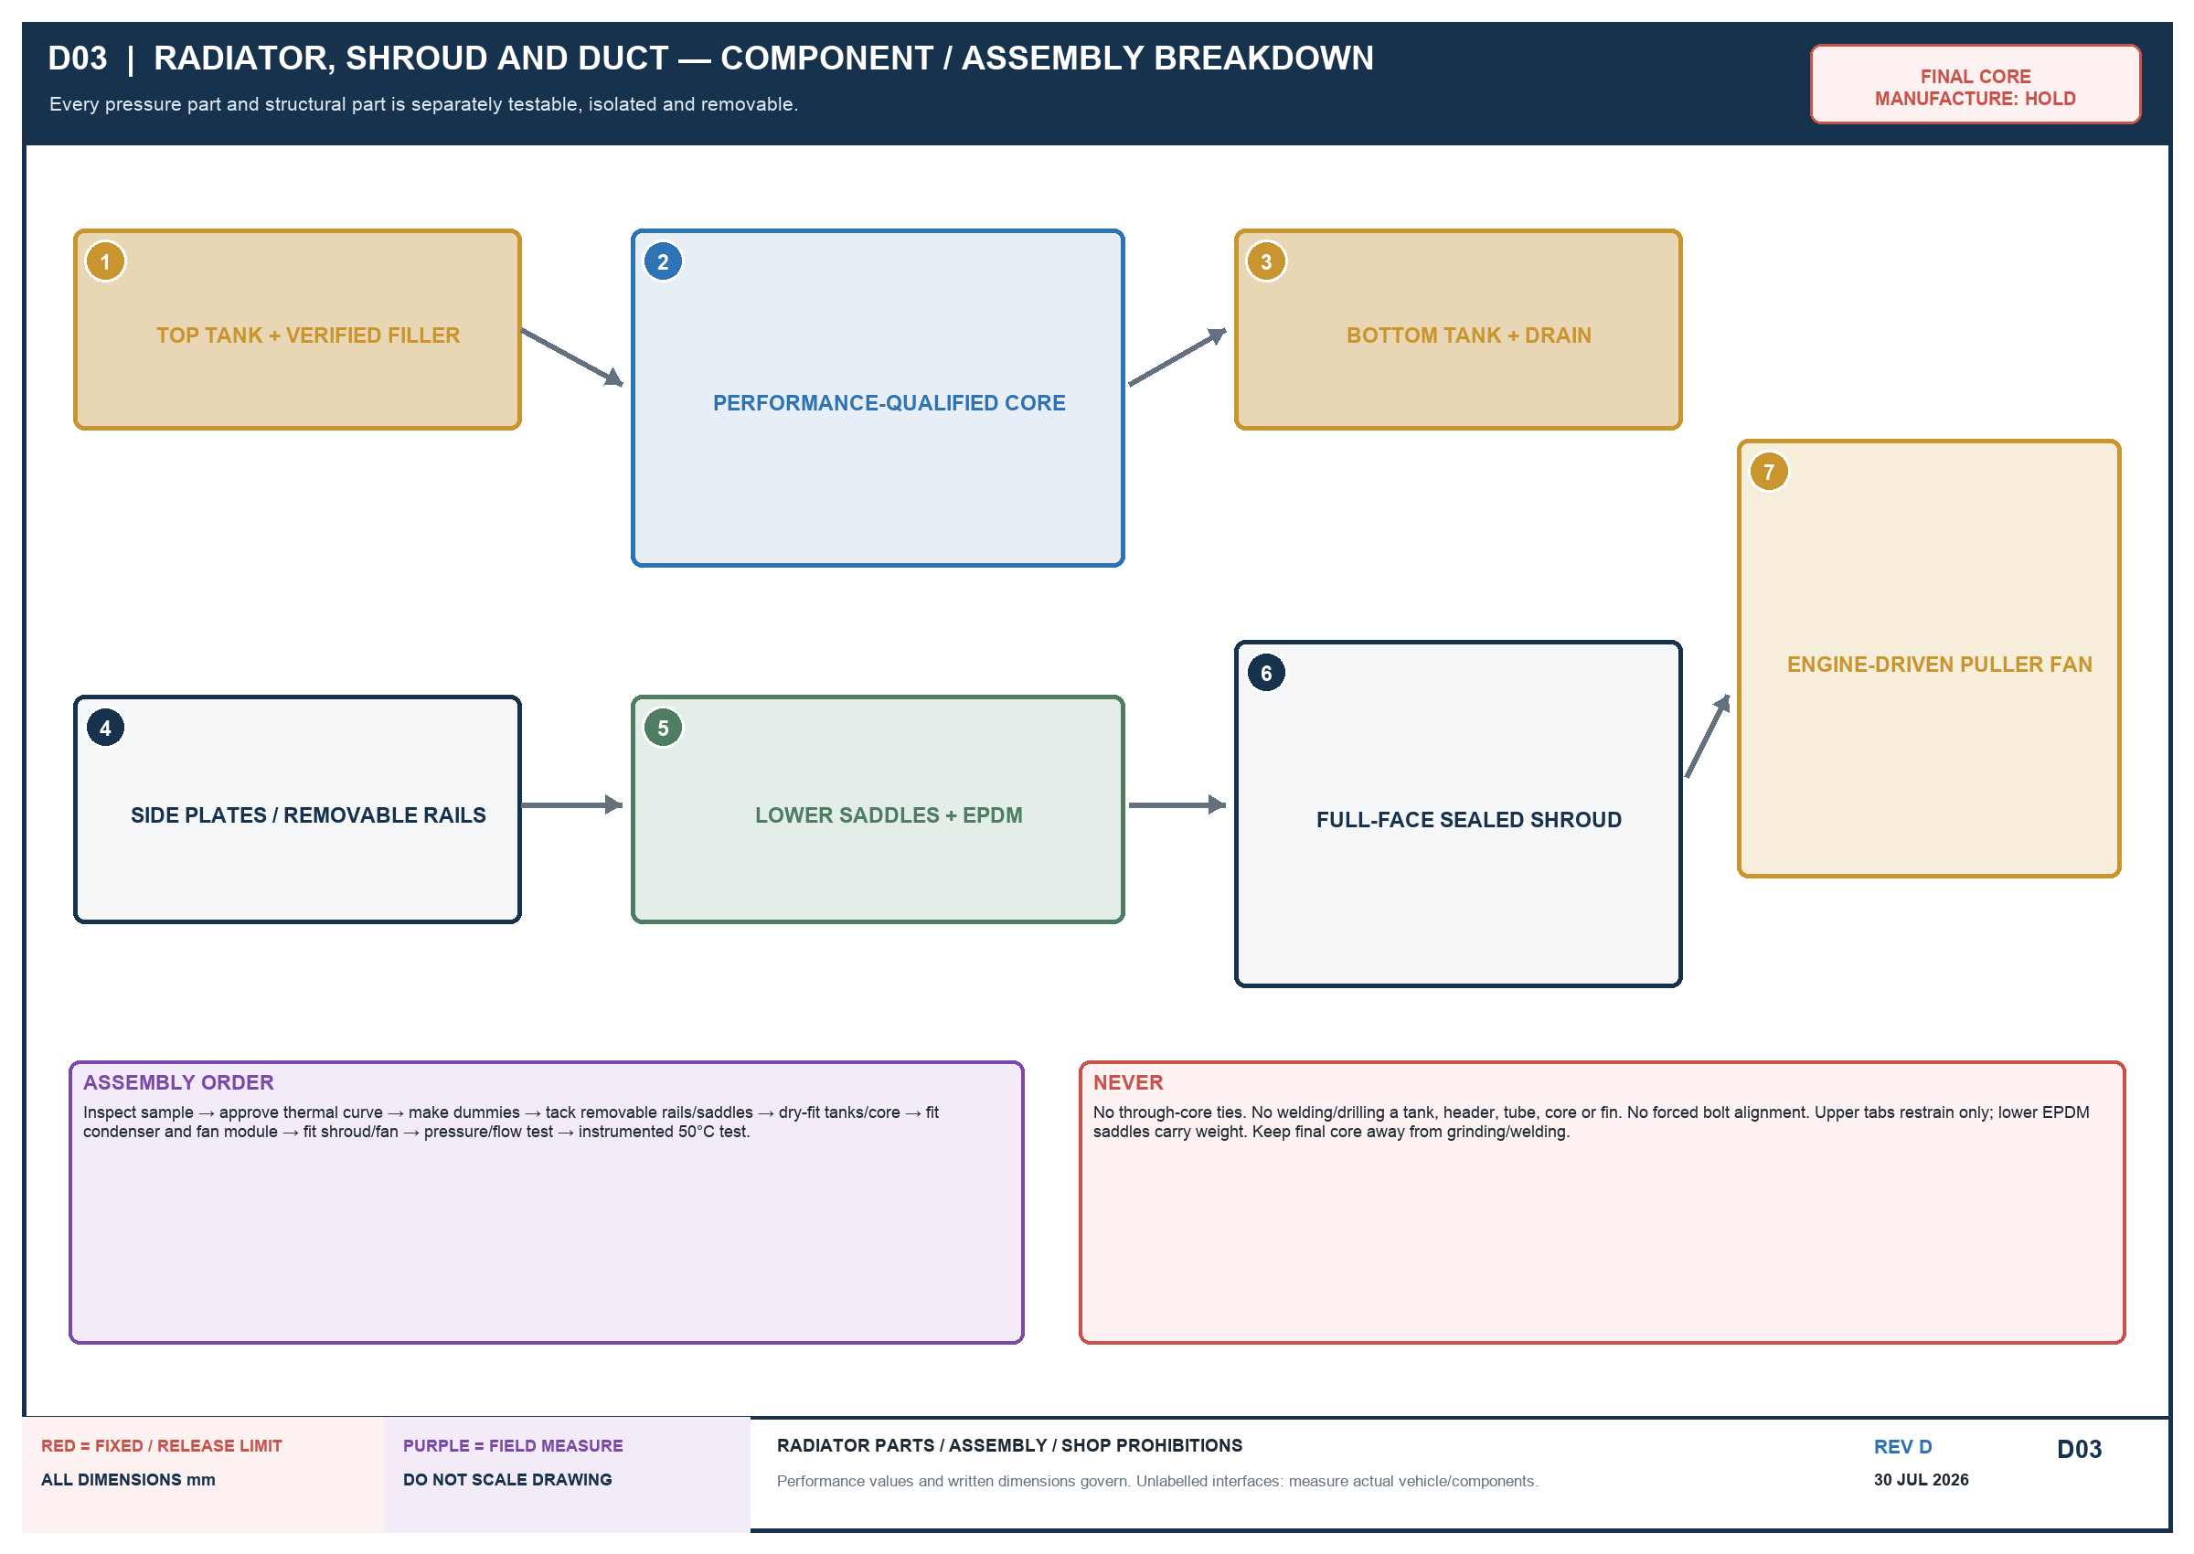
Written requirements govern; red = fixed/release limit; purple = field measure / owner approval.

D04 — Condenser and electric-fan modules

Written requirements govern; red = fixed/release limit; purple = field measure / owner approval.

D05 — Mounting, shroud and service access

Written requirements govern; red = fixed/release limit; purple = field measure / owner approval.

D06 — Main depth and side-pack gates

Written requirements govern; red = fixed/release limit; purple = field measure / owner approval.

D07 — Fan power and control

Written requirements govern; red = fixed/release limit; purple = field measure / owner approval.

