FABRICATION & INSTALLATION GUIDE
J40 Integrated Cooling Pack
Engine radiator • Turbo intercooler • A/C condenser • Receiver-drier • Fans
REV B | 23 JULY 2026 | MOCK-UP AND QUOTATION RELEASE
STATUS | STRUCTURAL DECISION | FINAL-CORE RELEASE
Mock-up approved | Retain existing upright; weld a mirrored upright on the left | HOLD until M1–M7 are recorded

DESIGN INTENT
Build one modular front cooling package. Keep all pressure circuits separate and every component individually removable. No exchanger carries another exchanger’s weight.
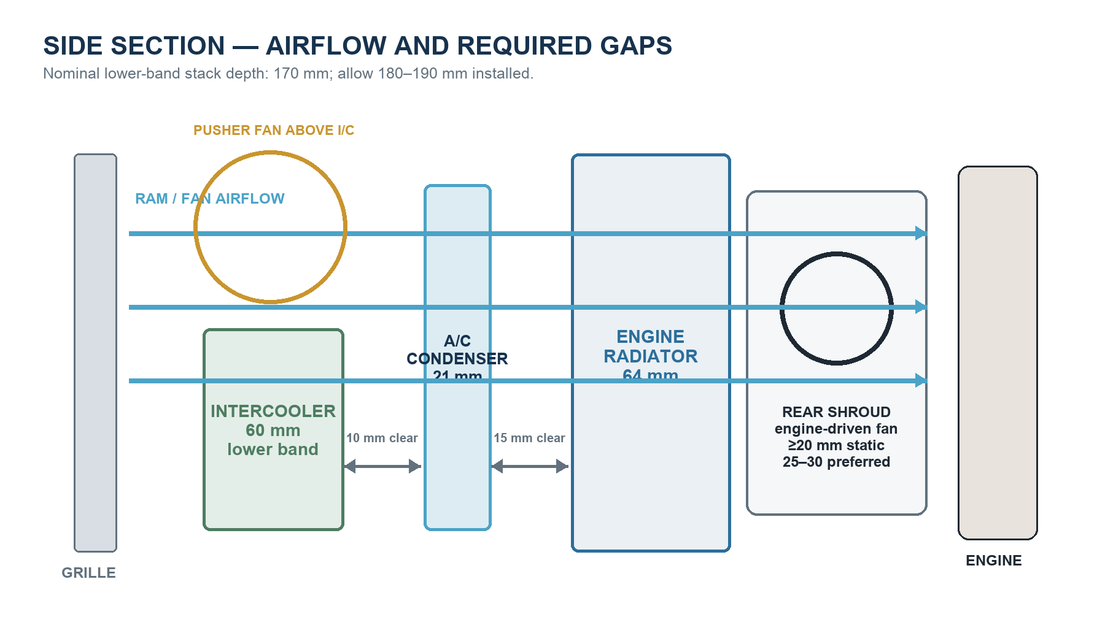

1. Assembly at a glance
The front pack has three heat-exchanger cores and two nearby A/C/fan auxiliaries. The receiver-drier is not a fourth radiator. The turbo itself remains on the engine; only its charge-air intercooler is in the front stack.
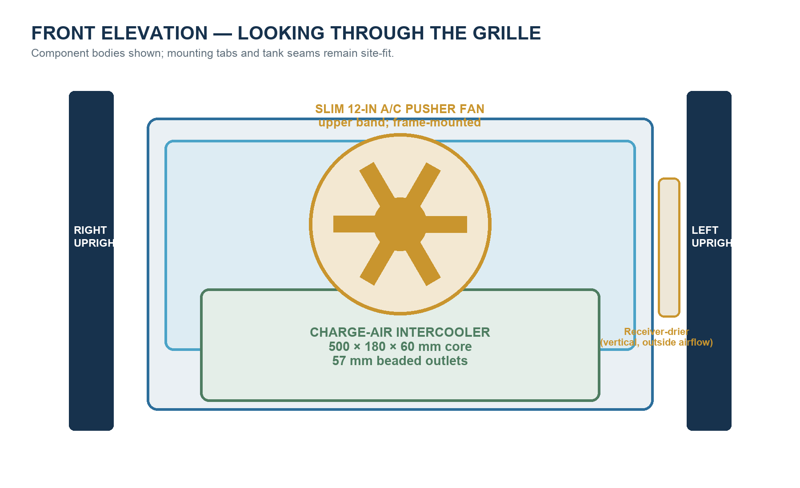

What must be independently removable
- Engine radiator, rear shroud and their rubber-isolated saddles/tabs.
- A/C condenser, receiver-drier and slim pusher fan.
- Turbo charge-air intercooler and its four isolated mounting tabs.
- Side rails and any crossrails needed for component removal or service.

2. Dimensioned fabrication sheets
Dimension authority: red dimensions are the Rev B manufacture targets. Purple M-dimensions are mandatory vehicle measurements and override assumptions. Do not scale the printed drawing; use the written dimensions.
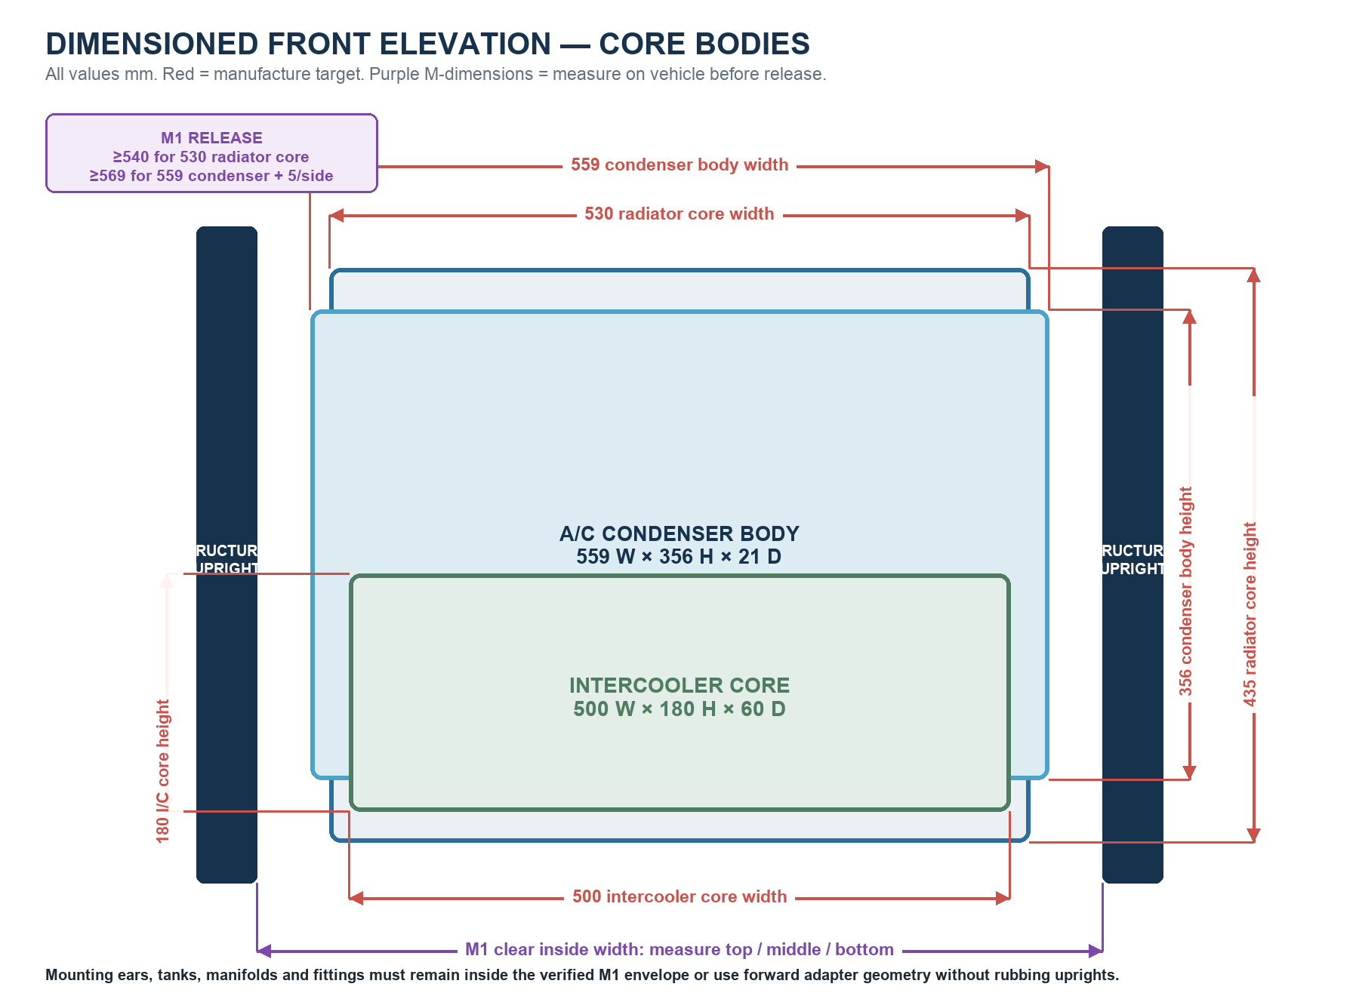
FRONT-ELEVATION RELEASE | REQUIREMENT
Radiator | 530 × 435 core; overall width ≤ M1 − 10
Condenser | 559 × 356 body nominal; verify M1 ≥569 or use proven forward adapter geometry
Intercooler | 500 × 180 core; overall width ≤ M1 − 10
Vertical placement | Site-fit from M2, M6, bonnet/latch and service-removal checks

2A. Dimensioned side section
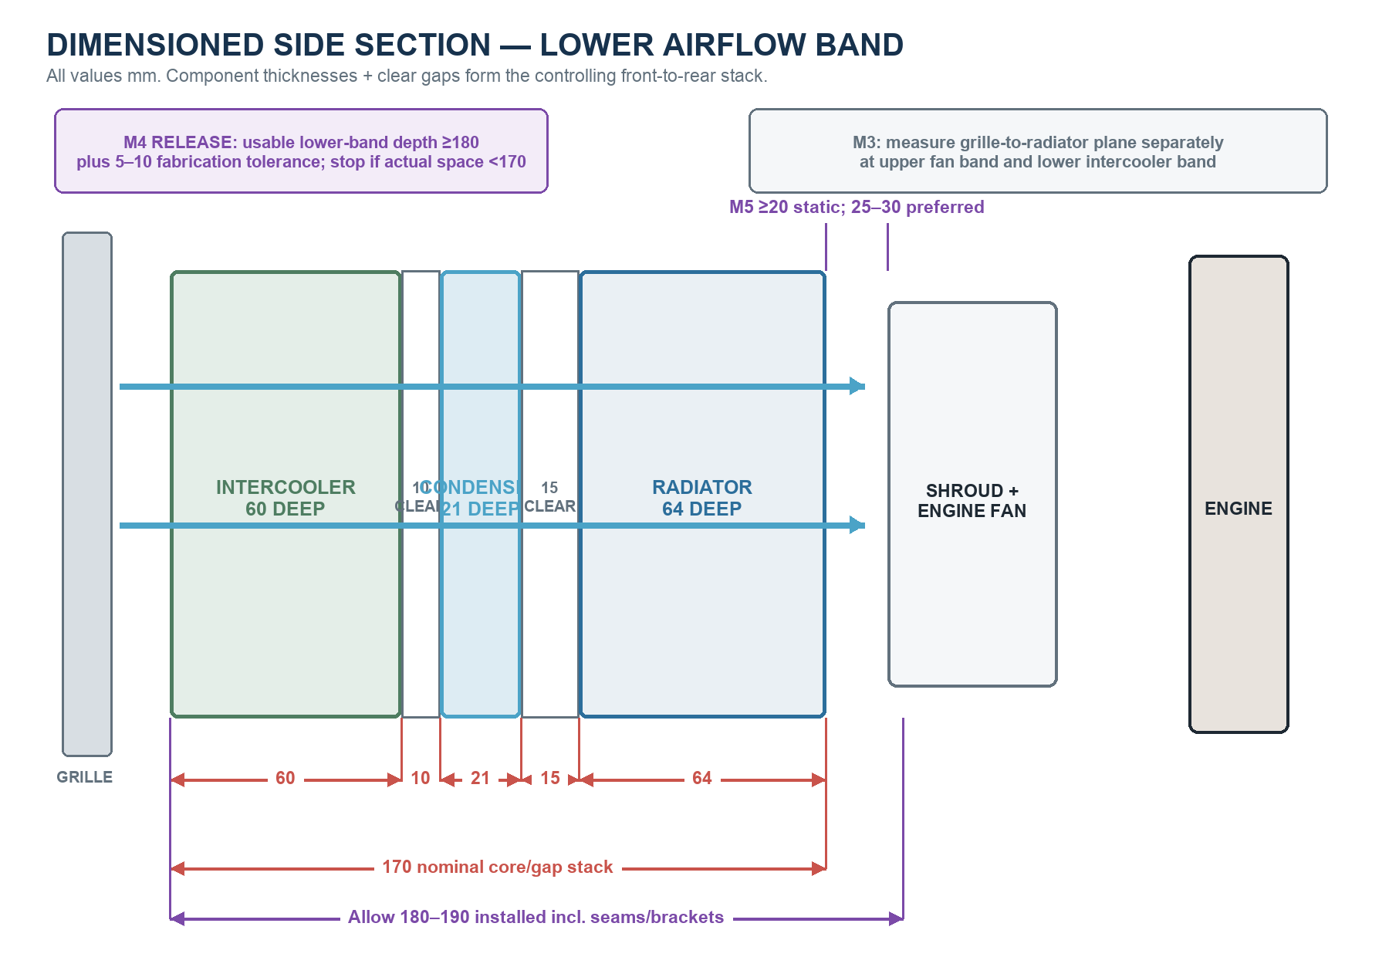
Controlling arithmetic: 60 intercooler + 10 clear + 21 condenser + 15 clear + 64 radiator = 170 mm nominal. Allow 180–190 mm for seams, brackets and imperfect planes. The fan and shroud sit behind the radiator and are controlled separately by M5.

2B. Dimensioned mounting details
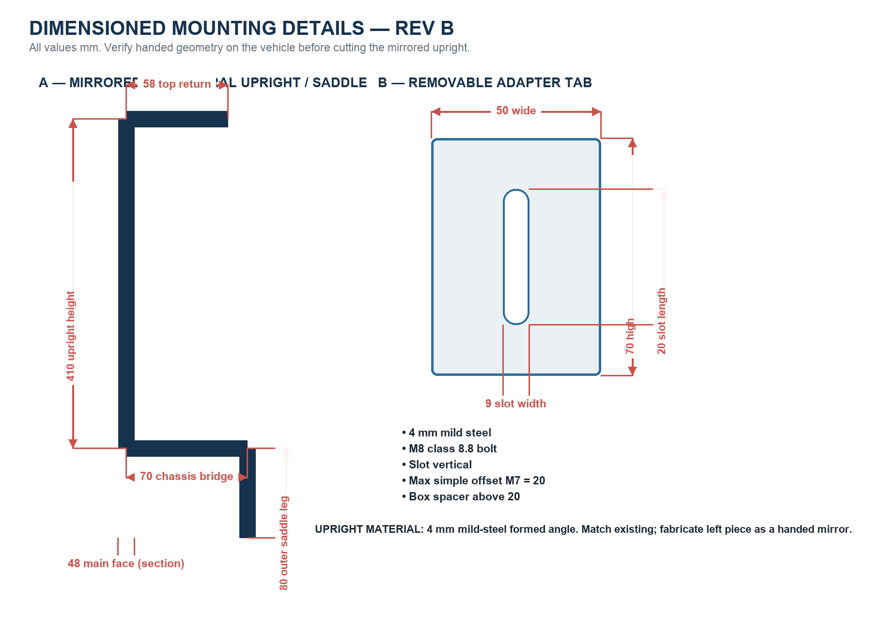
DETAIL | DIMENSION / MATERIAL
Removable side rail | 30 × 3 flat OR 25 × 25 × 3 angle; cut length M2 − 10; keep 5 top and bottom clearance
Radiator lower saddle | 3–4 plate with 5 EPDM pad; upper tabs restrain only
Condenser tabs | 3 plate, rubber washers and M6 bolts
Intercooler tabs | 4 plate, M8 isolators; 2–3 thermal-movement slot at one upper point
The upright dimensions reproduce the measured existing-side bracket basis. Mirror and verify the left part against the chassis before welding. Slots belong in removable adapter tabs, never in structural uprights.

3. Front-to-rear package

ORDER | COMPONENT | DESIGN ENVELOPE / RULE
1 — front upper | Slim A/C pusher fan | 12 in nominal; ≤330 mm diameter × 65 mm deep; upper band
1 — front lower | Charge-air intercooler | 500 W × 180 H × 60 D mm; 57 mm OD outlets
2 | Clear air gap | 10 mm minimum between intercooler and condenser
3 | R134a condenser | 559 W × 356 H × 21 D mm nominal; ≤600 × 370 × 25
4 | Clear air gap | 15 mm target; 10 mm absolute minimum to radiator
5 — rear | Engine radiator | 530 W × 435 H × 64 D mm core; high-efficiency four-row pattern
6 — engine side | Rear shroud and mechanical fan | ≥20 mm static tip clearance; 25–30 mm preferred

4. Separate circuits and connections
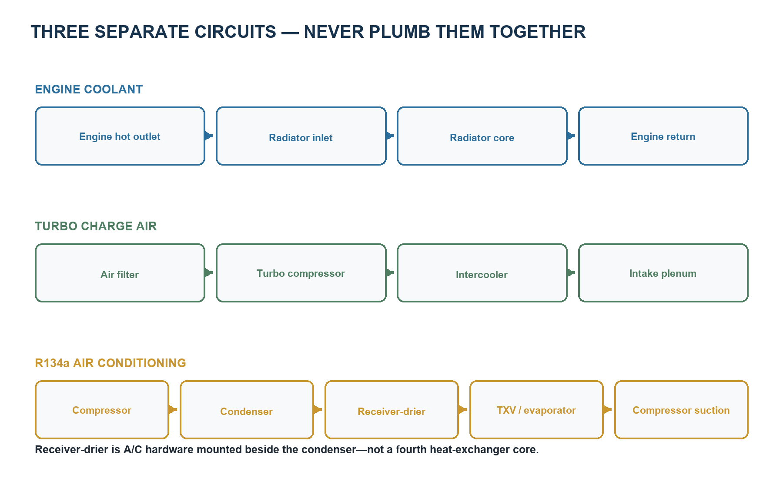

Interface holds
- Copy radiator neck side, angle and centre position from the old radiator and installed hose mock-up; target neck OD is 38 mm.
- Do not finalize intercooler outlet direction until turbo compressor outlet and intake-plenum inlet are marked on the vehicle.
- Confirm condenser #8 inlet and #6 outlet threads before crimping hoses; mount the receiver-drier vertically after the condenser outlet.
- Do not open the new receiver-drier to atmosphere until final A/C assembly and charging preparation.

5. Structure and mounting
Fixed structural decision: retain the measured right-side formed upright and fabricate a handed/mirrored upright on the left. Dry-fit the complete pack before final welding or drilling.
ITEM | FABRICATION REQUIREMENT
Structural uprights | 410 mm high; 48 mm main face; 4 mm mild steel; mirror existing 58 mm top return, 70 mm bridge and 80 mm saddle leg.
Removable side rails | 30 × 3 mm flat or 25 × 25 × 3 mm angle; final length M2 − 10 mm.
Rail attachment | Two M8 class 8.8 bolts per upright; four total. Put 9 × 20 mm vertical slots in adapter tabs—not structural uprights.
Radiator | Weight on two 3–4 mm lower saddles with 5 mm EPDM pads. Upper tabs restrain only.
Condenser | Four independent 3 mm tabs, rubber washers and M6 bolts.
Intercooler | Four independent 4 mm tabs and M8 isolators; one upper point gets 2–3 mm horizontal thermal-movement slot.
Fan | Removable hoop/crossrail. Never use through-core plastic rods.
Receiver-drier | Rubber-lined removable vertical clamp outside the primary airflow.

Absolute no-go conditions
- No welding, drilling or hard clamping through tanks, tubes, cores or fins.
- No radiator carrying the condenser, intercooler or fan.
- No condenser carrying the fan or intercooler.
- No forced bolts that twist a core or pull the radiator toward the engine fan.
- No permanent crossrail across the radiator core face.

6. Mandatory vehicle measurements — M1 to M7
Record these with the second upright tacked in place and the grille/front panel, bonnet latch, engine fan and body position represented. Final core manufacture remains on hold until all seven are complete.
ID | MEASUREMENT | METHOD | PASS / RELEASE CRITERION
M1 | Minimum clear inside width | Top / middle / bottom; use smallest | ≥540 for 530 core; ≥569 for unmodified 559 condenser + clearance
M2 | Clear vertical opening | Lower pad plane to bonnet/latch obstruction | Radiator overall height + 10 mm
M3 | Grille to radiator front plane | Upper fan band and lower I/C band | Must accept chosen front components
M4 | Usable lower-band stack depth | Grille/guard to radiator rear-component datum | ≥180 mm plus 5–10 mm tolerance
M5 | Radiator rear face to fan tips | Closest blade through full rotation | ≥20 mm; 25–30 preferred
M6 | Lowest safe intercooler edge | Relative to protected frame/bumper line | ≥25 mm above lowest protected line
M7 | Upright face to side-rail offset | All four corners | 0–20 simple tab; boxed spacer above 20

Also capture
- Coolant-neck centres, OD and angles; cap, overflow and drain positions.
- Condenser port side and actual threads.
- Turbo compressor outlet and intake-plenum inlet locations.
- Bonnet closure, steering/body clearance and service-removal path.
- A ruler/tape visible in every measurement photograph.

7. Fabricator sequence
- Duplicate the existing upright as a left-hand mirror; tack it and remeasure the opening.
- Make full-size radiator, condenser, intercooler and fan envelopes from cardboard or plywood.
- Set the radiator plane from rear fan clearance and coolant-hose sweep.
- Position the condenser with its clear air gap, then place the intercooler only in the lower frontal band.
- Place the pusher fan principally in the upper band and verify grille/bonnet-latch clearance.
- Mark removable rails, tabs, saddles and the vertical receiver-drier clamp from the real components.
- Confirm charge-pipe and A/C hose routes before outlet welding or hose crimping.
- Record M1–M7, photograph the mock-up, and obtain owner release for final cores.
- Bench pressure/flow-test the radiator; leak-test the intercooler at 20 psi; obtain A/C-shop condenser evidence.
- Final-fit, corrosion-protect, install and validate at warm idle with A/C on.

Decision rules if depth is short
- Protect radiator size and rear fan clearance first.
- Reduce intercooler thickness from 60 to 50 mm only with a reputable high-efficiency core.
- Move or split the pusher fan before reducing radiator area.
- If lower-band usable depth is under 170 mm, stop and review a remote/water-to-air charge cooler.

8. Inspection and handover record
CHECK | ACCEPTANCE ITEM
☐ | M1–M7 sheet complete with ruler photographs
☐ | Front and side full-size mock-up photographs
☐ | Grille, bonnet/latch and fan represented during tack-fit
☐ | As-built sketch: cores, tanks, ports, holes and offsets
☐ | Radiator pressure and flow result recorded
☐ | Intercooler 20 psi leak-test result recorded
☐ | Condenser/A/C pressure-test evidence recorded
☐ | Bare-metal bracket and weld photographs
☐ | No core carries another component
☐ | Fan airflow direction confirmed with paper-strip test
☐ | Warm-idle and A/C-on validation complete
☐ | All exchangers removable without cutting welded parts

Release note
This document releases mock-up, quotation and measurement capture. It does not release final core manufacture until M1–M7 and the actual component interfaces have been approved.

Controlled project references
- docs/j40-integrated-cooling-pack-fabricator-handoff-20260717.md
- data/manual/fabrication/front_cooling_stack_rev_a/integrated_cooling_pack_dimensions_rev_b.csv
- docs/engine-radiator-recore-release-20260529.md
- docs/2h-turbo-suitability-and-options-20260717.md
- docs/ac-hvac-workstream.md

