PAKISTAN FABRICATOR SPECIFICATION
J40 Integrated Radiator
and Cooling System
Toyota 2H • R134a A/C • Rev H Toyota-donor-led all-front stack • best-effort / test-gated
REV H | 01 AUGUST 2026 | ALL DIMENSIONS IN mm
DESIGN BASIS — NOT A GUARANTEED 50°C OR NO-DERATE RATING
Rev H is a simple best-effort all-front architecture using standard service parts where they are locally obtainable or sourceable. Vehicle centreline C0—not a radiator, photograph or accessory—controls the two front fan positions. It may be described as 50°C-capable or no-derate only after measured fit, component evidence and the complete-vehicle acceptance test pass.
START HERE — WHAT TO BUY, RETAIN AND FABRICATE
This is not a Prado radiator conversion or a catalogue direct-fit kit. Prado 120/GX470 donor scope is limited to two matched Toyota/Denso front-fan motor, 248 mm blade and plug/pigtail sets.
SOURCE CLASS | QTY / ITEM | EXACT ITEM / SEARCH REFERENCE | PAKISTAN ACTION
BUY USED TOYOTA DONOR | 2 matched front-fan sets | Prado 120/GX470 Toyota/Denso: assemblies 88590-60040 / -60050 / -60051 / -60060; motor 88550-12160; 248 mm blade 88453-60010; plugs/pigtails | Breaker/Bilal Ganj route. Match, check hand/depth/rotation and bench-test. No Prado radiator or complete donor shroud.
RETAIN / REBUILD EXISTING | 1 rear fan/hub + 2 boxes | Existing Toyota 2H puller/hub; blade 16361-68030 / -68031. Existing covered Relay Rev D and closed MIDI Rev D boxes | Already held. Inspect/rebuild and trial-fit the actual closed boxes; replace only if rejected.
SAMPLE, THEN LOCAL RECORE | 1 radiator | HJ47/2H pattern 16400-68030 or sound original tanks. 530 × 435 × 64 is active-core basis only—not finished size | Local stock unconfirmed. Sample, record complete R0, then release local recore only after hole fixture and dummy pass.
SOURCE NEW STANDARD — VERIFY STOCK | 1 each + service hardware | Condenser 559 × 356 × 21; charge cooler 500 × 180 × 50, 57 mm outlets; drier 88471-34010 only if ports fit; hoses, relays/connectors, M6/M8 hardware, EPDM | Use local A/C, turbo and hardware suppliers. Stock changes; complete envelopes and ports remain physical-sample first.
FABRICATE LOCALLY | Measured interfaces only | C0 datum fixture; 2 side rails; 2 direct 4 mm top ears; 2 lower saddles; vehicle-centred twin-pusher shroud; rear shroud if needed; tabs, seals/screen; 2 separate electrical brackets/hoods and adapters | Only after real parts, chassis-derived C0, rigid top-hole template and full-size dummy pass. No fan offset, crossbar, shared tray, new chassis hole, slot or forced alignment.
PURCHASING STATUS — Part numbers identify candidates; Pakistan sourcing describes the expected route, not guaranteed live stock or direct fit. Source samples and make the fixture now. Final parts, drilling and coating remain on HOLD until their physical-fit gates pass.

1. Rev H packaging — Toyota donor parts, bracket-first measured fit
CONTROLLED ARCHITECTURE
Survey vehicle longitudinal centreline C0 from paired chassis references. Grille → matched Prado 120/GX470-family Denso pusher hubs at C0 − 133 mm and C0 + 133 mm in a custom shroud → 500 × 180 × 50 charge cooler → ≥10 mm gap → 559 × 356 × 21 condenser → 15 mm target gap (10 mm absolute minimum) → HJ47/2H-pattern recored/custom radiator using a 530 × 435 × 64 active-core thermal basis only, with complete envelope controlled by R0 → sealed full-face mechanical puller shroud. Rev H has exactly three fans: two front electric pushers and one retained rear engine-driven puller. Prado/GX sourcing is for matched fan motors, blades, connectors and pigtails only; no Prado radiator or direct-fit donor-shroud assumption.
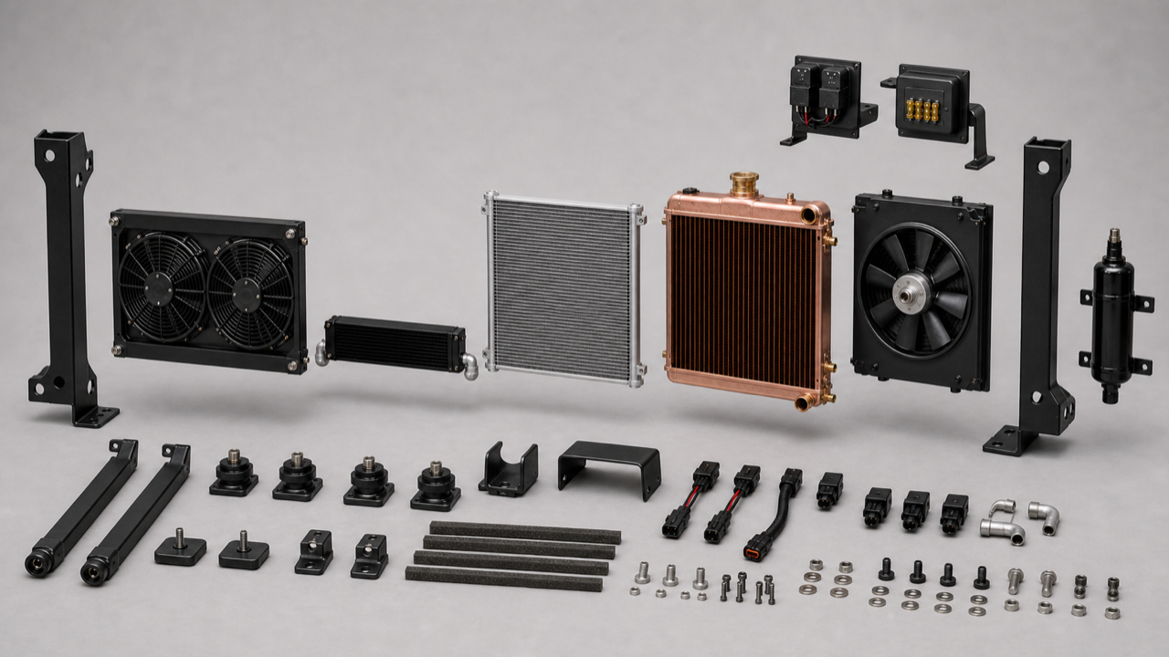
PH01 — Retained Rev G complete wide split visual. Read the main row from left to right as the installed front-to-rear order: twin Toyota/Denso electric-pusher module, short central charge cooler, condenser, engine radiator, then the sealed rear shroud and large retained mechanical puller. Uprights, rails, direct ears, lower saddles, drier, protected electrical enclosures, seals, connectors and fasteners are also separated for identification. Exploded positions do not authorise installed side placement or extra width. D10/C0 controls final front-fan centring; PH05/D09 and E2/E2a control the electrical installation. This is an AI layout aid only; signed measurements, actual components and the accepted full-size dummy govern manufacture.

1.1 Rev H component assembly
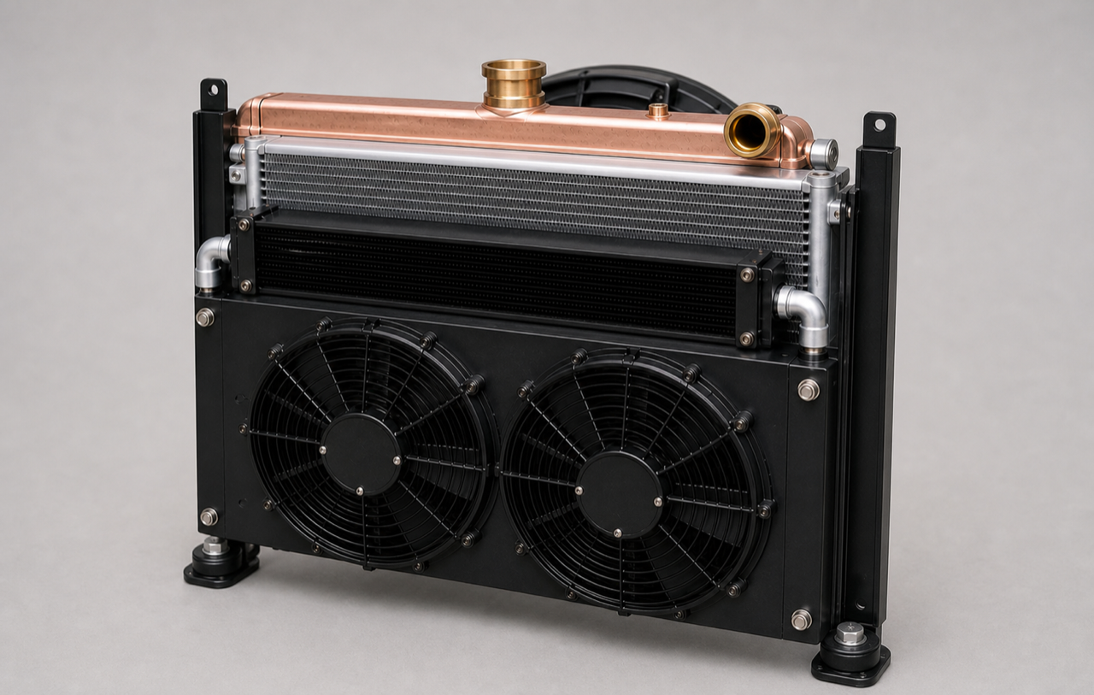
PH02 — Retained Rev G off-vehicle central cooling-module assembly. It shows two equal Toyota/Denso 248 mm electric pushers and the retained engine-driven puller behind the radiator: exactly three fans total. Because the chassis is absent, PH02 does not establish vehicle centring. D10/C0 and F1 control the final hub coordinates. The side rails, direct top ears and lower saddles belong to the removable radiator module. PH03C/PH04 illustrate the original-hole attachment; PH05/D09 and E2/E2a control the separate upper/rear electrical installation.

1.2 Normal opaque front-installed appearance
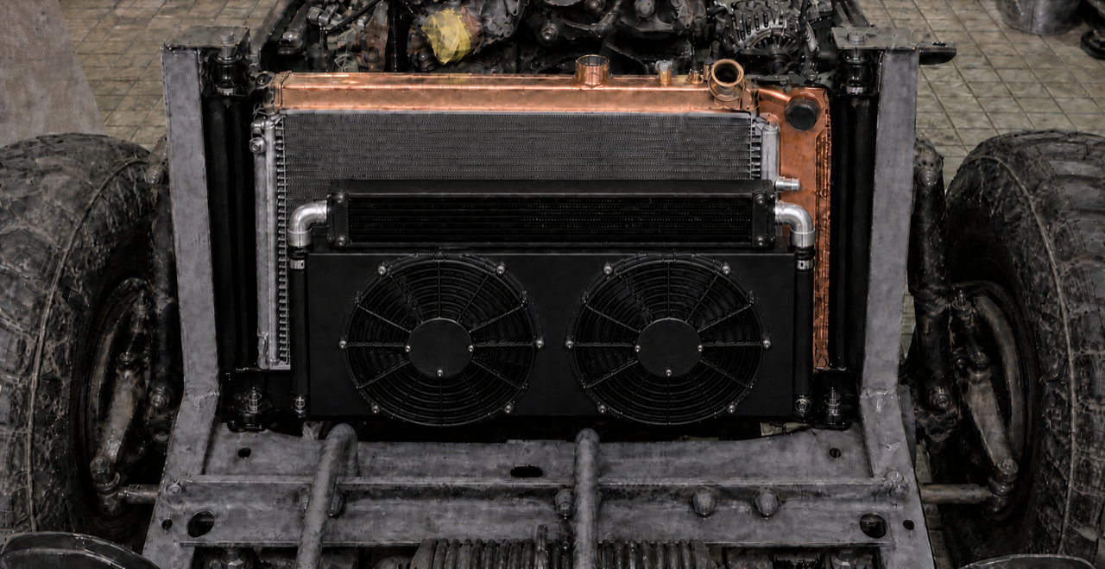
PH03A — Fully opaque Rev H front-installed appearance on the later J40 structure. There is no transparent or cutaway area. The two equal electric pusher fans and compact front stack are visible between the existing uprights; the retained engine-driven mechanical puller remains installed behind the opaque radiator and is therefore correctly hidden from this direction. PH03A is contextual only. It does not prove the ±2 mm centring tolerance or release mounting geometry; D10/F1, the chassis-derived C0, signed measurements and full-size dummy control.

1.3 Fully opaque engine-side rear view
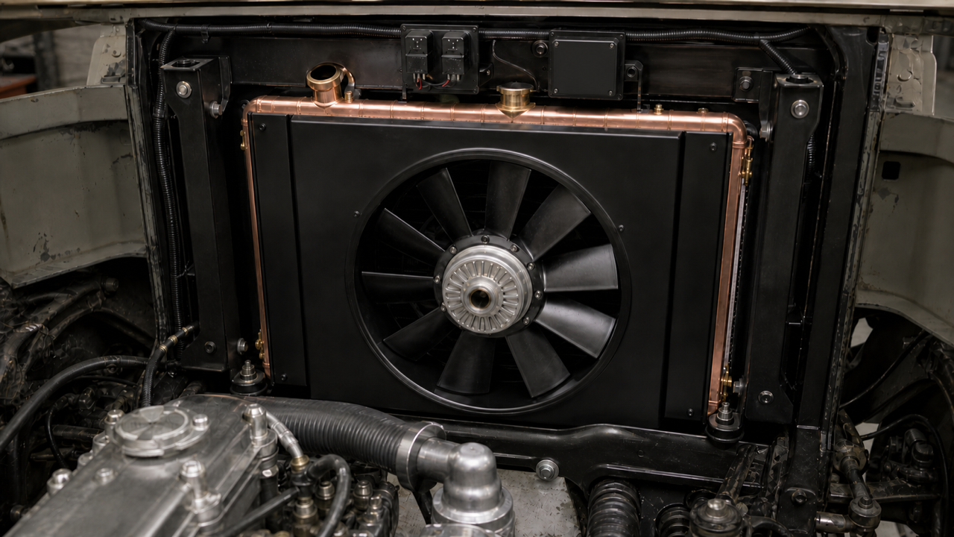
PH03B — Fully opaque view looking forward from the engine bay. It plainly shows the one large retained Toyota 2H engine-driven mechanical puller centred in a sealed full-face rear shroud, with the copper/brass radiator immediately ahead. The two 248 mm electric pushers, charge cooler and condenser are on the grille side and are correctly hidden by the opaque radiator. The Relay and MIDI enclosures are closed; no fuse, holder or live stud is exposed. This is an illustrative appearance view only; do not derive exact fan diameter, hose routing, connector placement or mounting dimensions from it.

1.4 Controlled interface cutaway — centring and hidden layers
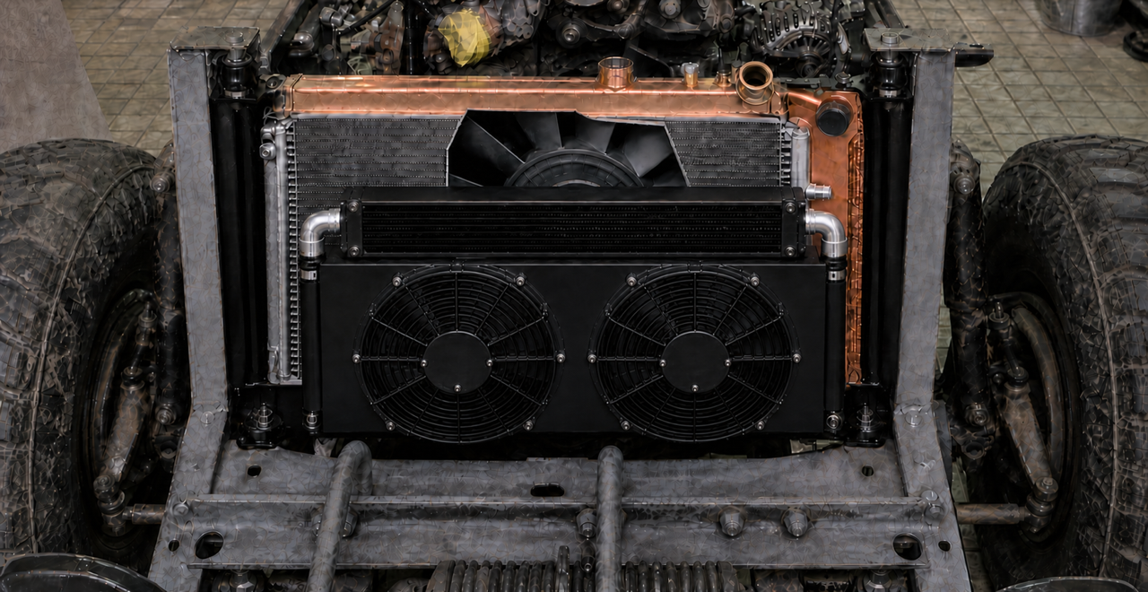
PH03C — Corrected Rev H installed interface cutaway on the later J40 front structure. The midpoint between the two equal, level front-pusher hubs visibly coincides with the centred rear mechanical-fan hub and the car/chassis longitudinal centreline. D10/F1 controls fabrication at C0 − 133 mm and C0 + 133 mm, 266 mm centre-to-centre, with pair midpoint and hub heights each within ±2 mm. The cutaway visibly accounts for the short black charge cooler with two large 57 mm charge-air ports, silver condenser with two smaller A/C fittings, copper/brass engine radiator with upper and lower coolant necks plus filler/cap, overflow and drain, sealed rear shroud and large engine-driven mechanical puller as separate layers. At each side, the M8/washer stack passes through the original top-return hole and sleeved EPDM isolator into one independent 4 mm ear connected directly to that radiator side rail; the lower saddle beneath the same rail carries weight. No transverse carrier or intermediate bracket. This AI image is illustrative only; C0, the rigid two-hole template, B0/H0-L/H0-R/W0/P0/R0 measurements and full-size dummy govern fit.

1.5 Existing-hole attachment close-up
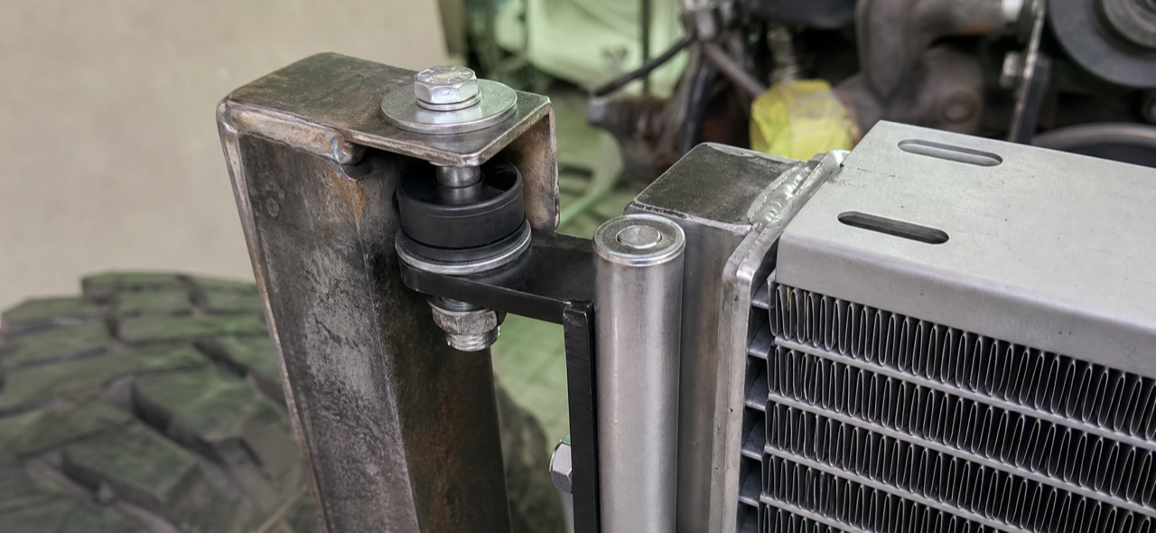
PH04 — Direct side-ear concept at one original top hole. D08 and the signed B0/H0-L/H0-R/W0/P0/R0 sheet retain full control of hole transfer, isolator stack, zero-pull bolt hand-entry and bonnet/tool clearance.

1.6 Closed fuse/relay boxes on independent brackets
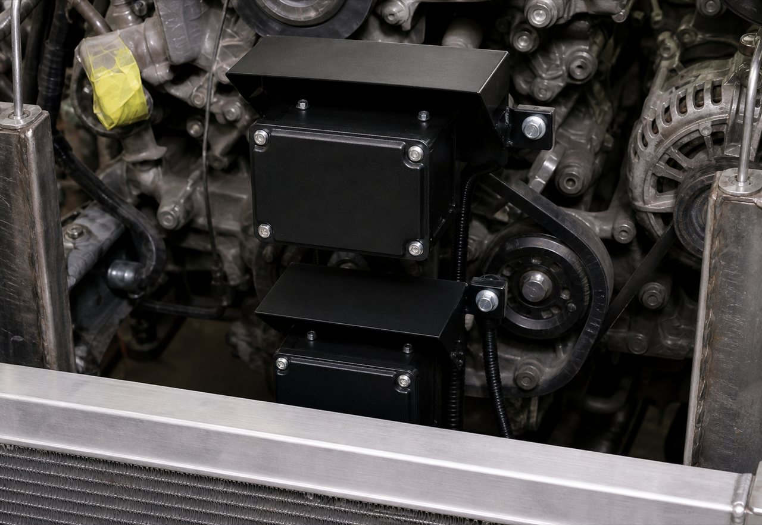
PH05 — Tight electrical-placement detail only: the larger Relay box is upper/forward and the smaller MIDI box lower/rear, centred one behind the other above and behind the radiator top tank. Each closed box has its own local non-radiator structural bracket and rain hood; the visible gap separates the brackets. Both complete envelopes stay inside W0/upright width and clear of the active fin/fan aperture. No common plate is used. Every fuse, holder and live fuse stud stays inside MIDI. D09 and the actual parts at E2/E2a control dimensions, exact positions and service sweeps.

2. Duty, claim and release logic
ITEM | REV H CONTROL
50°C / A/C basis | A demanding best-effort design and test condition, not a present guarantee.
Engine basis | Final approved turbo/fuelling up to the 150 bhp cooling-design ceiling; engine, turbo, EGT, oil, smoke, clutch and driveline still govern.
No-derate wording | Permitted only after the complete vehicle passes the logged acceptance test at the agreed condition. No claim before then.
Charge air | ≥15 kW heat-rejection target; IAT ≤80°C and complete route Δp ≤10 kPa targets. All require representative installed test evidence.
Total fans | Exactly 3: two vehicle-centred front electric pushers plus one retained rear engine-driven mechanical puller. No third electric or fourth fan in Rev H.
Front pusher geometry | Survey chassis C0; hubs at C0 − 133 / C0 + 133 mm; 266 mm C-C; pair midpoint and hub-height mismatch each ≤2 mm.
Front pusher airflow | Two matched Toyota/Denso 248 mm candidates in one sealed module; prove ≥3,000 m³/h installed through the complete three-core stack at 13.5 V.
Six main circuit connections | Radiator: 2 large coolant necks. Condenser: 2 smaller refrigerant fittings. Charge cooler: 2 large 57 mm charge-air ports. Do not interchange circuits.
Mechanical puller | Retain/rebuild with sealed full-face shroud; prove ≥9,000 m³/h installed through the complete stack at 1,500 rpm.

3. One-page shop specification
PART | REQUIRED
Radiator mounts | Retain the two existing chassis posts: 48 mm face, 410 mm upright and 58 mm inward top return are reference dimensions only. Fit one removable side rail and one short 4 mm direct ear per radiator side beneath the original top hole; put one lower saddle under each same side rail. No transverse top carrier, new chassis hole, slot or reaming.
Twin pusher module | Two matched Prado 120/GX470-family Denso 248 mm motor/blade/connector sets; ≥258 mm rings. Establish C0 from paired chassis references; hubs C0 − 133 / C0 + 133 mm; 266 mm C-C; midpoint and height mismatch each ≤2 mm. Custom sealed symmetric shroud; independent fuse/relay branches.
Charge-air cooler | New universal bar-and-plate body exactly 500 W × 180 H × 50 D with exactly two 57 mm beaded charge-air ports; ≥15 kW, IAT ≤80°C and route Δp ≤10 kPa are installed-test targets.
Condenser | New 14 × 22 nominal R134a parallel-flow body 559 W × 356 H × 21 D with exactly two smaller refrigerant fittings (#8 inlet / #6 outlet preferred) on isolated removable tabs; ≥10 mm ahead and 15 mm target / 10 mm absolute minimum behind.
Radiator / puller | HJ47/2H-pattern recore/custom radiator with exactly two large engine-coolant hose necks (upper and lower), plus filler/cap, overflow nipple and lowest drain. 530 W × 435 H × 64 D is the active-core thermal basis, not the finished radiator size. Record R0 as complete W × H × D including tanks, seams, necks, filler, overflow, drain, ears and lower locators. Build only if complete R0 fits signed W0/H0-L/H0-R/P0 and bonnet/bridge. Retain the Toyota mechanical puller and sealed full-face shroud. Do not buy a Prado radiator.
Electrical boxes | Reuse the covered Relay Rev D box and closed gasketed MIDI Rev D fuse box. Give each box its own local structural accessory bracket and rain hood. Keep both complete envelopes inside W0 / the existing upright front-view silhouette; stagger vertically and/or in depth so the combined projected width is no greater than the Relay box's 360 mm base envelope. Never arrange them side-by-side across vehicle width. No common cross-car plate; no radiator, post-return or battery-stand load. Keep every fuse, holder and live stud inside MIDI; covers shut in operation.
Custom work | Two radiator side rails/direct ears, two lower saddles, exchanger rails, shrouds, tabs, two local electrical brackets/hoods, seals/ducts and measured adapters only. Heat exchangers, motors, blades, drier, controls, hoses, seals, clamps and fasteners stay service parts.

3.1 Purchase list — release in three phases
BUY SAMPLES FIRST
Do not buy the final radiator or cut radiator ears from catalogue dimensions. First survey C0 from paired chassis references, make one rigid template of both original top holes and record C0/B0/H0-L/H0-R/W0/P0. Source physical fan, radiator-pattern and electrical-box samples; record complete R0 and service envelopes; then prove the full-size dummy, the C0-centred shroud and both top bolts entering fully by hand with zero pull.
PHASE | ITEMS TO PURCHASE | RELEASE CHECK
A — sample / mock-up now | 2 matching Prado 120/GX470-family Denso motor + 248 mm blade + plug/pigtail sets; HJ47/2H radiator/tank pattern or original tanks; cap and hose samples; actual Relay Rev D and MIDI Rev D boxes; template and dummy material | Record donor identity and complete outside envelopes. Confirm the two motors match. Record B0/H0-L/H0-R/W0/P0/R0. Do not assume a Prado radiator or complete donor shroud fits.
B — after bracket fixture | HJ47-pattern recore/custom radiator using the 530 × 435 × 64 active-core basis only if complete R0 fits; 559 × 356 × 21 condenser; 500 × 180 × 50 charge cooler with 57 mm outlets; new port-matched drier; 57 mm pipe/couplers; barrier hose/HNBR seals; metric hardware/isolation | Rigid hole template and lower-saddle fixture pass; both top bolts hand-enter with zero pull; complete R0 fits signed W0/H0-L/H0-R/P0; approved full-size dummy closes with bonnet/grille/bumper.
C — electrical / finish | 2 current-rated relays; branch fuses/holders/bus/cable/terminals wholly inside MIDI; sealed connectors/glands; aluminium for two independent local brackets and two hoods; stone screen; finish and test materials | Measure hot run/start current. E1/E2/E2a prove each box's own bracket, lid/cover/tool sweep, ≥25 mm cable/cover clearance, downward/rearward exits and dry/clean weather check before drilling/coating.
Full seller-facing list: docs/j40-rev-h-toyota-donor-cooling-pack-purchase-list-20260801.md. Machine-readable schedule: data/manual/fabrication/front_cooling_stack_rev_c/rev_h_toyota_donor_purchase_list.csv.
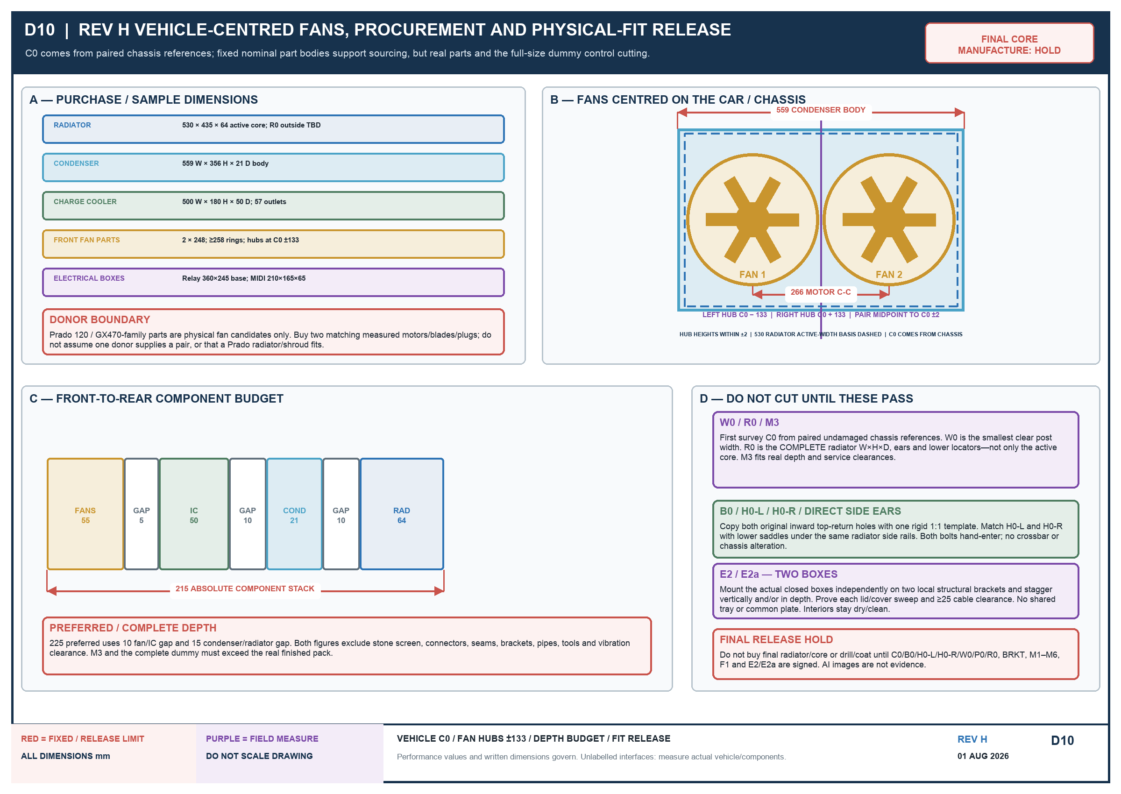
D10 — Vehicle-centreline, procurement and fit control. Survey C0 from the chassis and locate the front fan hubs at C0 − 133 mm / C0 + 133 mm; actual complete parts, signed vehicle dimensions and the accepted dummy still control fabrication.

4. Airflow, charge-air and A/C requirements
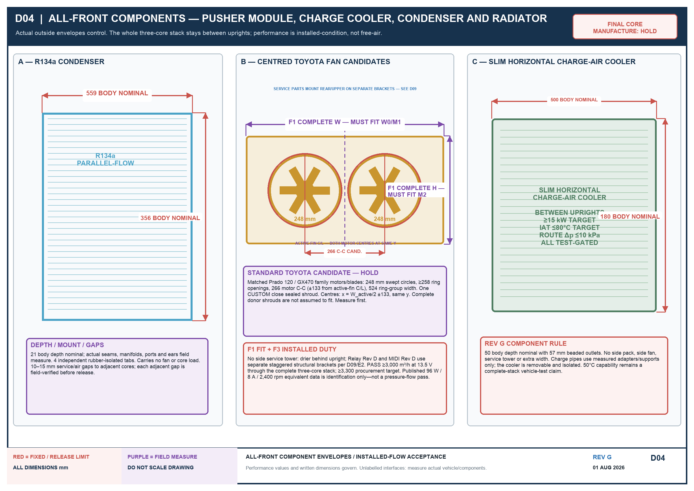
- Rev H has exactly three fans: two electric pushers symmetric about chassis-derived C0 at −133/+133 mm and the retained engine-driven mechanical puller behind the radiator. No additional fan is released.
- The charge cooler has exactly two large 57 mm charge-air ports, the condenser exactly two smaller refrigerant fittings, and the radiator exactly two large engine-coolant necks plus filler/cap, overflow and drain. These are three different circuits.
- Keep the full stack between the uprights; no part may add front-view width.
- Seal the pusher module to the charge-air cooler and seal core perimeters to prevent bypass. Do not use core ties or put fan load on an exchanger.
- Use ≥10 mm actual clearance from charge-air cooler to condenser and 15 mm target / 10 mm absolute minimum from condenser to radiator, after isolators and movement allowance.
- Toyota/Denso part numbers identify candidates only. Published free-air data is not an installed-flow pass.
- The F3 pusher acceptance is ≥3,000 m³/h at 13.5 V through the complete final grille, stone screen and three-core stack.
- The F4 mechanical-puller acceptance is ≥9,000 m³/h through the complete final stack at 1,500 engine rpm.
- The charge-air targets are ≥15 kW, IAT ≤80°C and complete compressor-outlet-to-plenum Δp ≤10 kPa at the agreed representative load; log the result before claiming them.

4.1 Drier and electrical service parts
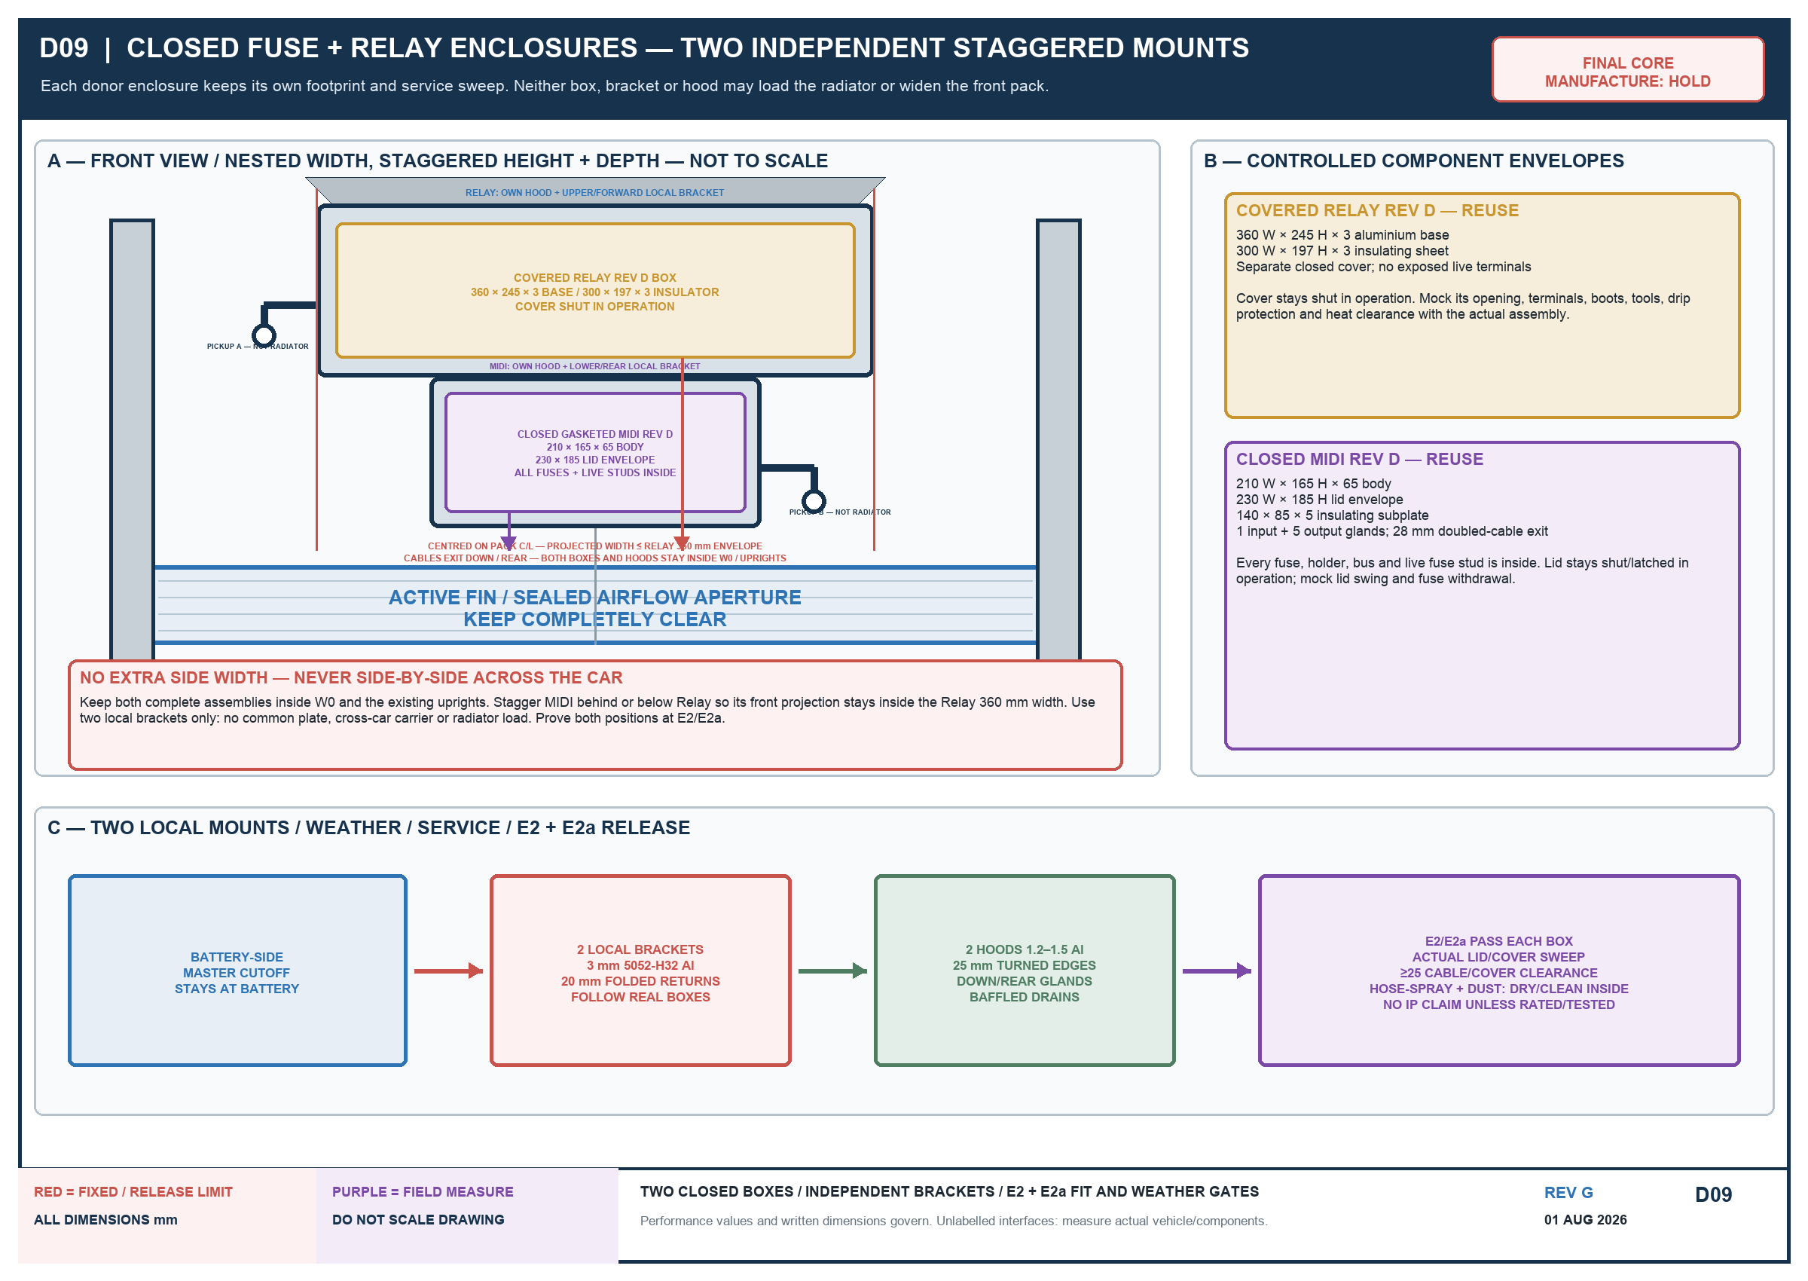
Place the drier behind or in the shadow of one chassis upright. Mount the covered Relay Rev D box and the closed, gasketed MIDI Rev D fuse box on two independent local accessory brackets attached only to verified non-radiator structure. Keep each complete box, hood, bracket, cable bend and service sweep inside W0 and the existing uprights' front-view silhouette. Stagger the boxes vertically and/or in depth so the MIDI projected width lies wholly within the Relay box's 360 mm base envelope; never place the two boxes side-by-side across vehicle width. Neither box, A/C fitting nor drier may move either front fan away from C0 ±133 mm. Neither bracket may cross the radiator, load a top return, cover an active fin or block module removal. Relay Rev D keeps its 360 × 245 × 3 mm base and 300 × 197 × 3 mm insulating sheet. MIDI Rev D keeps its 210 × 165 × 65 mm body, 230 × 185 mm lid envelope and 140 × 85 × 5 mm insulating subplate; every fuse, holder, bus and live fuse stud stays inside it. Fabricate each local bracket from 3 mm 5052-H32 aluminium with 20 mm folded returns after transferring the real box footprint. Give each box its own shallow 1.2–1.5 mm aluminium hood with 25 mm turned edges and a baffled lower drain. Keep covers shut in operation; allow the actual cover/lid/tool sweep and at least 25 mm around cable bends and covers. Route cables down/rear through correctly sized glands and drip loops. E2/E2a are separate per-box fit, service and weather gates and must establish the exact final positions. After hose-spray and dust exposure, both interiors must be dry and clean. Do not claim a formal IP rating unless the purchased boxes carry it or the completed installation is tested to it.

5. Mounting, shrouds and D08 direct radiator ears
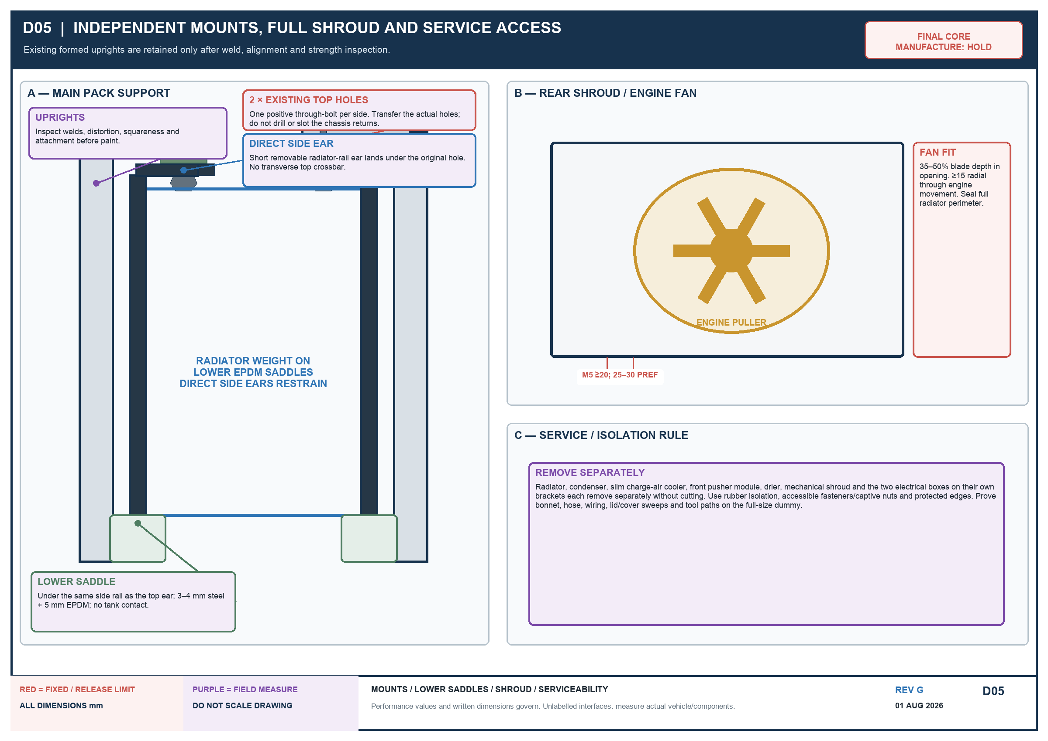
- Every exchanger, both shrouds, the drier and both electrical boxes with their own local brackets remove separately without cutting; each exchanger is rubber-isolated.
- Transfer chassis-derived C0 to the rigid aperture fixture and fan-shroud template before cutting the shroud. C0 does not move if a core, drier, A/C fitting or electrical box is asymmetric.
- Use the retained two chassis posts as found: 48 mm face, 410 mm upright and 58 mm inward return are reference geometry, not radiator dimensions. Verify B0/H0-L/H0-R/W0/P0 on the vehicle.
- Lower saddles carry radiator mass directly beneath the same removable side rails that carry the short upper ears. Upper D08 bolts locate/restrain only; both enter fully by hand with zero pull and at least 5 mm rail-to-post hard clearance.
- No transverse radiator carrier and no new chassis hole, slot or reaming. Copy both original holes with one rigid 1:1 template; an independent transfer plate per side is allowed only if the physical radiator sample requires it.
- No drilling/welding a pressure part, header, tube, core or fin; protect finished cores from welding/grinding.

5.1 M3 complete-depth formula
ITEM | FORMULA / PASS
M3 | actual pusher depth + fan/charge-cooler clearance + actual charge-cooler depth + ≥10 gap + actual condenser depth + 15 target / 10 absolute-minimum gap + actual radiator depth
Absolute component basis | 55 + 5 + 50 + 10 + 21 + 10 + 64 = 215 mm
Preferred component basis | 55 + 10 + 50 + 10 + 21 + 15 + 64 = 225 mm
Excluded extras | stone screen, guards, plugs, seams, brackets, pipe bends, tools and vibration clearance; add their measured envelopes to M3
M5 | radiator rear to nearest mechanical-fan point ≥20 mm static; 25–30 mm preferred, with ≥15 mm radial clearance through engine movement

6. Fan power, controls and installed-airflow tests
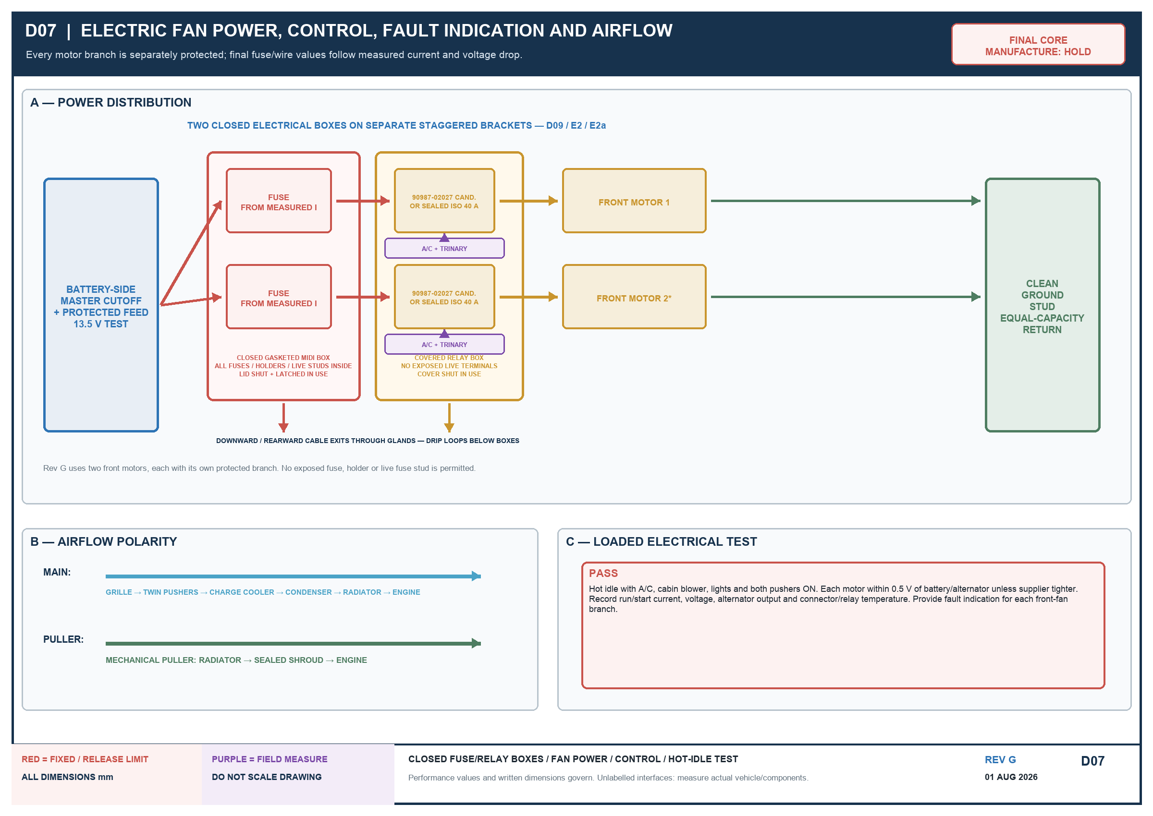
- Rev H uses exactly two front electric motors plus the retained rear mechanical puller. Do not substitute one pusher or add a third electric/fourth fan without a new controlled revision.
- Each Toyota/Denso front motor has a correctly sized fuse, sealed relay, weatherproof connector and equal-capacity ground. Every fuse, holder and live fuse stud is inside the closed MIDI box; none may be exposed.
- Toyota/Denso 90987-02027 is a relay candidate only; verify its rating against measured hot run/start current or use sealed ISO 40 A relays.
- Bench-test polarity: grille → pushers → charge-air cooler → condenser → radiator → mechanical puller → engine.
- At hot idle with A/C, blower, lights and both pushers on, each motor must be within 0.5 V of battery/alternator unless supplier tighter; log voltage/current and relay/connector temperature.
- F3 and F4 test the completed, sealed three-core stack—not a bare core, a free-air fan or an assumed static-pressure point.
- The covered Relay Rev D box and closed MIDI Rev D box use the two independent local structural brackets shown by D09/E2/E2a. Keep lids shut, cable exits downward/rearward and the battery-side master cutoff feeding them through a protected main cable and accessible disconnect.

7. Mandatory measurement and performance gates
ID | MEASURE | PASS
C0 | vehicle longitudinal centreline | establish from paired undamaged chassis/frame references; record left/right survey values; mark on aperture, rigid fixture and shroud template; do not derive from a core, photograph or accessory
B0 | original top-hole pattern | record both hole diameters/condition/edge distance/tab thickness and centre-to-centre with one rigid 1:1 two-hole template; chassis holes remain unchanged
H0-L / H0-R | left/right hole plane to lower saddle seat | measure each side after saddles are established; complete radiator side rails and ears fit without preload; 410 mm post upright is not radiator height
W0 | minimum post clear width | measure top/middle/bottom including weld beads; complete R0 radiator, rails and at least 5 mm hard clearance per side fit
P0 | top-return/post plane to radiator rail | record left/right depth and bonnet/bridge/cap/tool clearances; direct ears land flat beneath returns without a cross-car bar
R0 | complete radiator envelope | record W × H × D including tanks, seams, filler, drain, ears and lower locators; 530 × 435 × 64 is active-core basis only; final radiator remains HOLD until R0 fits W0/H0-L/H0-R/P0
M1 | clear width | ≥569 mm for the 559 mm condenser plus 5 mm each side; every complete core/tank/bracket/plug/wire bend still fits between uprights
M2 | clear height | complete radiator including tanks, filler and brackets—not only the 435 mm active core—fits with bonnet latch, grille and lower protection represented
M3 | complete front-to-rear depth | full formula in section 5.1 plus guards, plugs, seams, brackets, pipe bends, tools and vibration clearance fits
M4 | pipe and service routes | charge pipes turn rearward/inboard at lower corners; A/C fittings and tools remain accessible without extra width or rubbing
M5 | rear fan clearance | ≥20 mm static axial and ≥15 mm radial through engine movement; 25–30 mm axial preferred
M6 | full-size vehicle dummy | bonnet, grille and bumper/guard close; assembly is central/symmetric and every module removes separately
BRKT | direct-ear fixture/dummy | lower saddles sit under the same radiator side rails; each short ear lands beneath its original hole; both provisional M8 bolts enter fully by hand with zero pull; no transverse carrier
F1 | twin pusher envelope and vehicle centring | equal 248 mm candidates; ≥258 mm rings; hubs C0 − 133 / C0 + 133 mm; exactly 266 mm C-C; pair midpoint within ±2 mm of C0; hub heights within ±2 mm; no sideways offset or contact
F2 | mechanical fan/shroud | full-face seal, 35–50% blade insertion and all movement clearances pass
F3 | pusher installed flow | ≥3,000 m³/h at 13.5 V through final grille, screen and complete sealed three-core stack
F4 | mechanical installed flow | ≥9,000 m³/h through complete sealed stack at 1,500 engine rpm
E1 | electric supply | correct polarity and independent branches; record run/start A, fuses, relays, cable, loaded voltage, temperatures and hot-idle alternator output
E2 | two local electrical mounts | actual Relay and MIDI boxes each have their own non-radiator structural bracket and hood; complete envelopes stay inside W0/upright silhouette, are vertically/depth staggered with MIDI projected width wholly within the Relay 360 mm envelope, never side-by-side across vehicle width; brackets do not cross the radiator or load a post return, and each box remains independently removable
E2a | per-box service / weather | actual cover/lid/tool sweeps pass with ≥25 mm cable/cover clearance; all MIDI fuses/live studs are inside; lids shut; glands exit down/rear; after hose-spray/dust check both interiors are dry and clean; no unverified IP claim
T1 | 50°C hot idle | A/C and cabin blower maximum for 30 min; coolant/A/C pressures stable; no recirculation, leak or electrical heating
T2 | 50°C loaded operation | low-speed climb and sustained load pass; 115 kW equivalent stable for 60 min and 130 kW equivalent for 10 min
T3 | charge-air proof | ≥15 kW target; manifold IAT ≤80°C; turbo-to-manifold Δp ≤10 kPa; no leak
FIT AND PERFORMANCE REMAIN CONDITIONAL
Do not claim 50°C capability or no cooling-related derate from drawings, catalogue data, a dummy or a single isolated component test. The completed vehicle test is the release gate.

8. Fabrication, commissioning and handover
1. Source only Phase A physical samples. Establish chassis-derived C0; measure B0/H0-L/H0-R/W0/P0/R0 and M1–M6; prove the BRKT, F1–F2 and separate E2/E2a dummies before buying Phase B final cores.
2. Mark C0 on the aperture, rigid fixture and fan-shroud template. Set the two front fan hubs at C0 − 133 mm and C0 + 133 mm; prove pair midpoint and hub-height tolerances within ±2 mm. Make one rigid 1:1 template that captures both original top holes. Make a full-size radiator dummy including complete tanks, seams, both coolant necks, filler, overflow, drain, ears, lower locators, cap/tool sweep and hose routes. Also mock each real electrical box separately with its own cover/lid sweep, cable bends, hood and removal path.
3. Set the two lower saddles under the proposed radiator side rails. Tack one short ear per side directly beneath its original top return; prove both top bolts enter fully by hand with zero pull and at least 5 mm rail/post clearance. Finish-weld off the vehicle only after the dummy passes.
4. Trial-fit the three exchangers with the specified ≥10 mm and 15 mm target / 10 mm minimum gaps, isolation, seals and actual mechanical-fan clearance; no side additions are allowed.
5. Photograph E2/E2a for each real closed enclosure with its own bracket/hood, lid/cover sweeps, ≥25 mm cable/cover clearance, downward/rearward glands and tools. Only after each passes may its local bracket be drilled and finished.
6. Fabricate only the radiator side rails/direct ears/lower saddles, exchanger rails, shrouds, tabs, seals/ducts, two local electrical brackets/hoods and measured adapters. Retain service components as replaceable parts. Put every fuse, holder, bus and live fuse stud inside MIDI and keep both covers shut in operation.
7. Perform the hose-spray/dust check and inspect both boxes dry and clean inside. Complete F3/F4/E1/E2/E2a, then instrument the vehicle. Log grille/post-cooler/post-condenser air, coolant, oil, compressor-out/post-cooler/manifold IAT, boost, EGT, fan electrical data, A/C pressures and load once per second where practical.
8. Complete T1–T3 at the stated ambient/load/A/C conditions. Any 50°C or no-derate statement is withheld unless the full acceptance pass is documented.

8.1 Handover record
CHECK | RECORD | RESULT / EVIDENCE
[ ] | C0 / B0 / H0-L / H0-R / W0 / P0 / R0 / M1–M6 / BRKT / F1–F4 / E1–E2a / T1–T3 as-measured sheet
[ ] | C0 survey evidence and fan-hub coordinates: left −133 mm / right +133 mm; midpoint and height tolerances
[ ] | Three exchanger models/envelopes and isolation/removal evidence
[ ] | Pusher F3 and mechanical-puller F4 complete-stack test reports
[ ] | Charge-air heat-rejection / IAT / Δp test report
[ ] | Electrical hot-idle test and A/C report
[ ] | Two independent electrical-bracket E2/E2a fit, closed lids/covers, clearance, glands, protected feed/disconnect and separate-removal photographs
[ ] | Hose-spray/dust result with both electrical-box interiors photographed dry and clean
[ ] | Complete vehicle acceptance logs / graphs / owner release
Radiator fabricator: __________________________________ Date: __________
A/C technician: _______________________________________ Date: __________
Turbo/engine tuner: ___________________________________ Date: __________
Owner final release: __________________________________ Date: __________

Controlled references
- docs/J40-integrated-cooling-pack-fabricator-specification-rev-h.md (controlled Rev H source specification)
- docs/j40-rev-h-toyota-donor-cooling-pack-purchase-list-20260801.md (seller-facing purchase and receiving list)
- data/manual/fabrication/front_cooling_stack_rev_c/rev_h_cooling_pack_visual_prompts.md (AI visual prompt/output record; illustrative only)
- SAE J1994 heat-exchanger heat-transfer/pressure-drop testing.
- SAE J1339 engine-cooling fan performance.
- SAE J1393 heavy-duty vehicle cooling test procedures.

Appendix A. Rev H control and retained layout-reference drawings
D10 is the new Rev H vehicle-centreline and release-control sheet. D01–D09 are retained Rev G layout-reference sheets. Red values are fixed performance/release limits. Purple dimensions and interfaces are measured from the vehicle or actual component. The Rev H written requirements and D10 control; do not scale the images.

D01 — Retained Rev G complete all-front stack
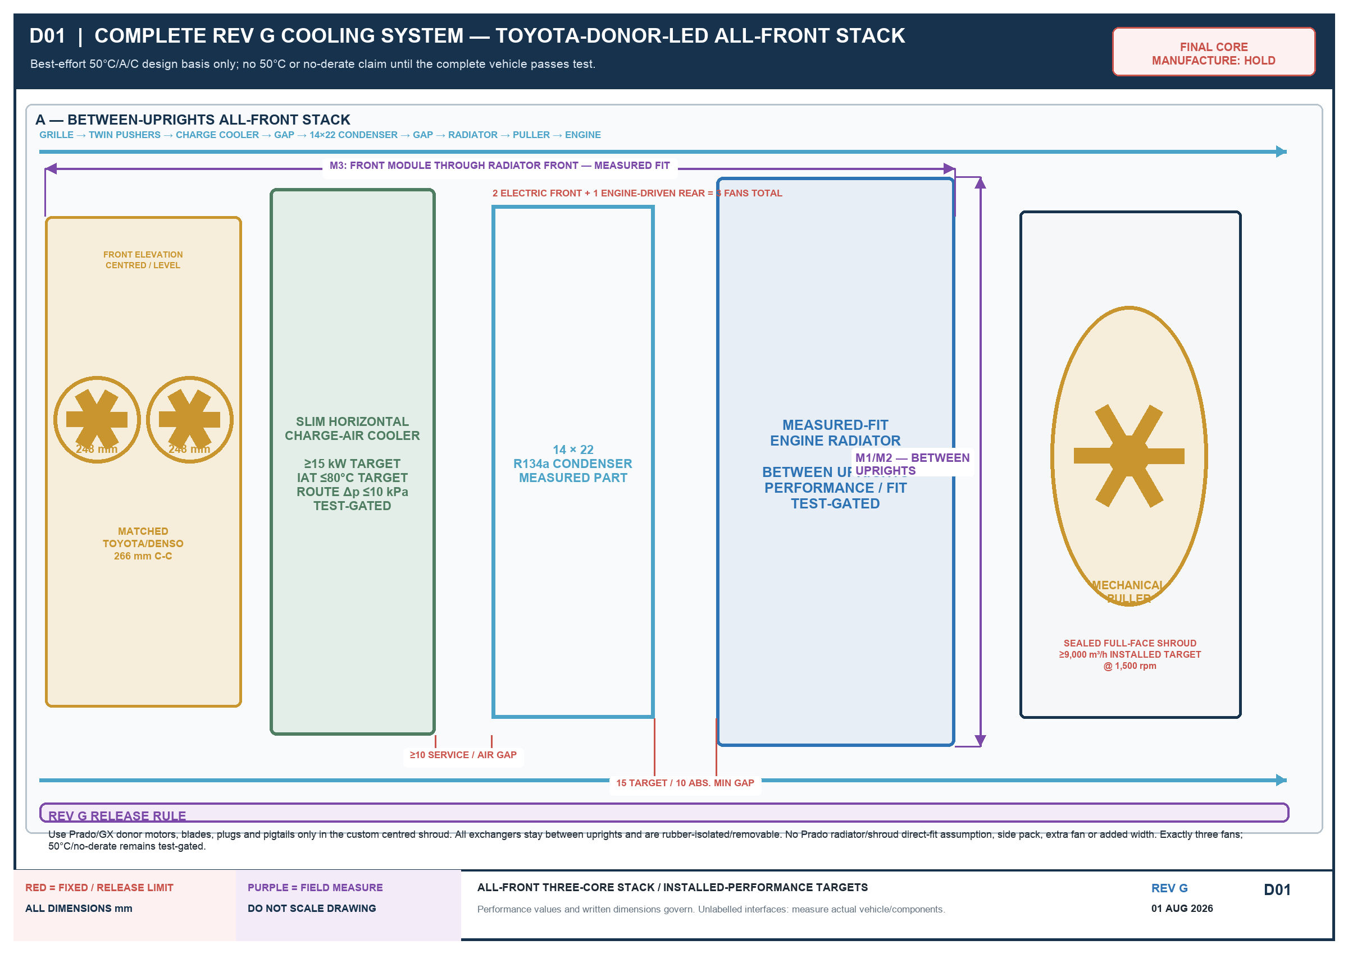
Written requirements govern; red = fixed/release limit; purple = field measure / owner approval.

D02 — Performance-controlled radiator
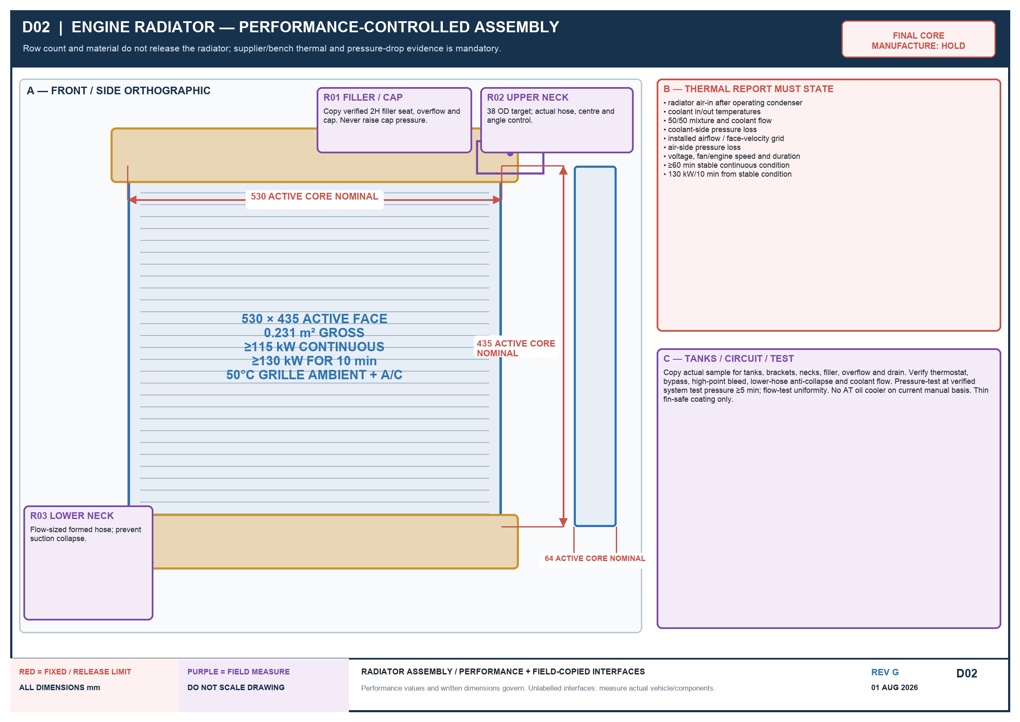
Written requirements govern; red = fixed/release limit; purple = field measure / owner approval.

D03 — Radiator component breakdown
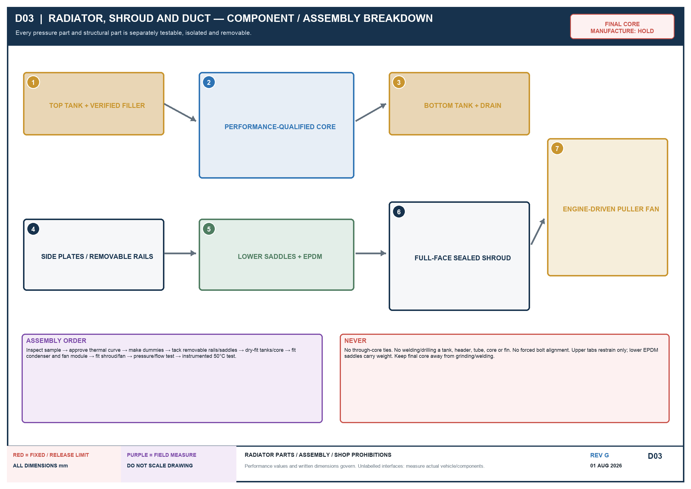
Written requirements govern; red = fixed/release limit; purple = field measure / owner approval.

D04 — All-front component envelopes

Written requirements govern; red = fixed/release limit; purple = field measure / owner approval.

D05 — Mounting, shroud and service access

Written requirements govern; red = fixed/release limit; purple = field measure / owner approval.

D06 — All-front depth and gap gates
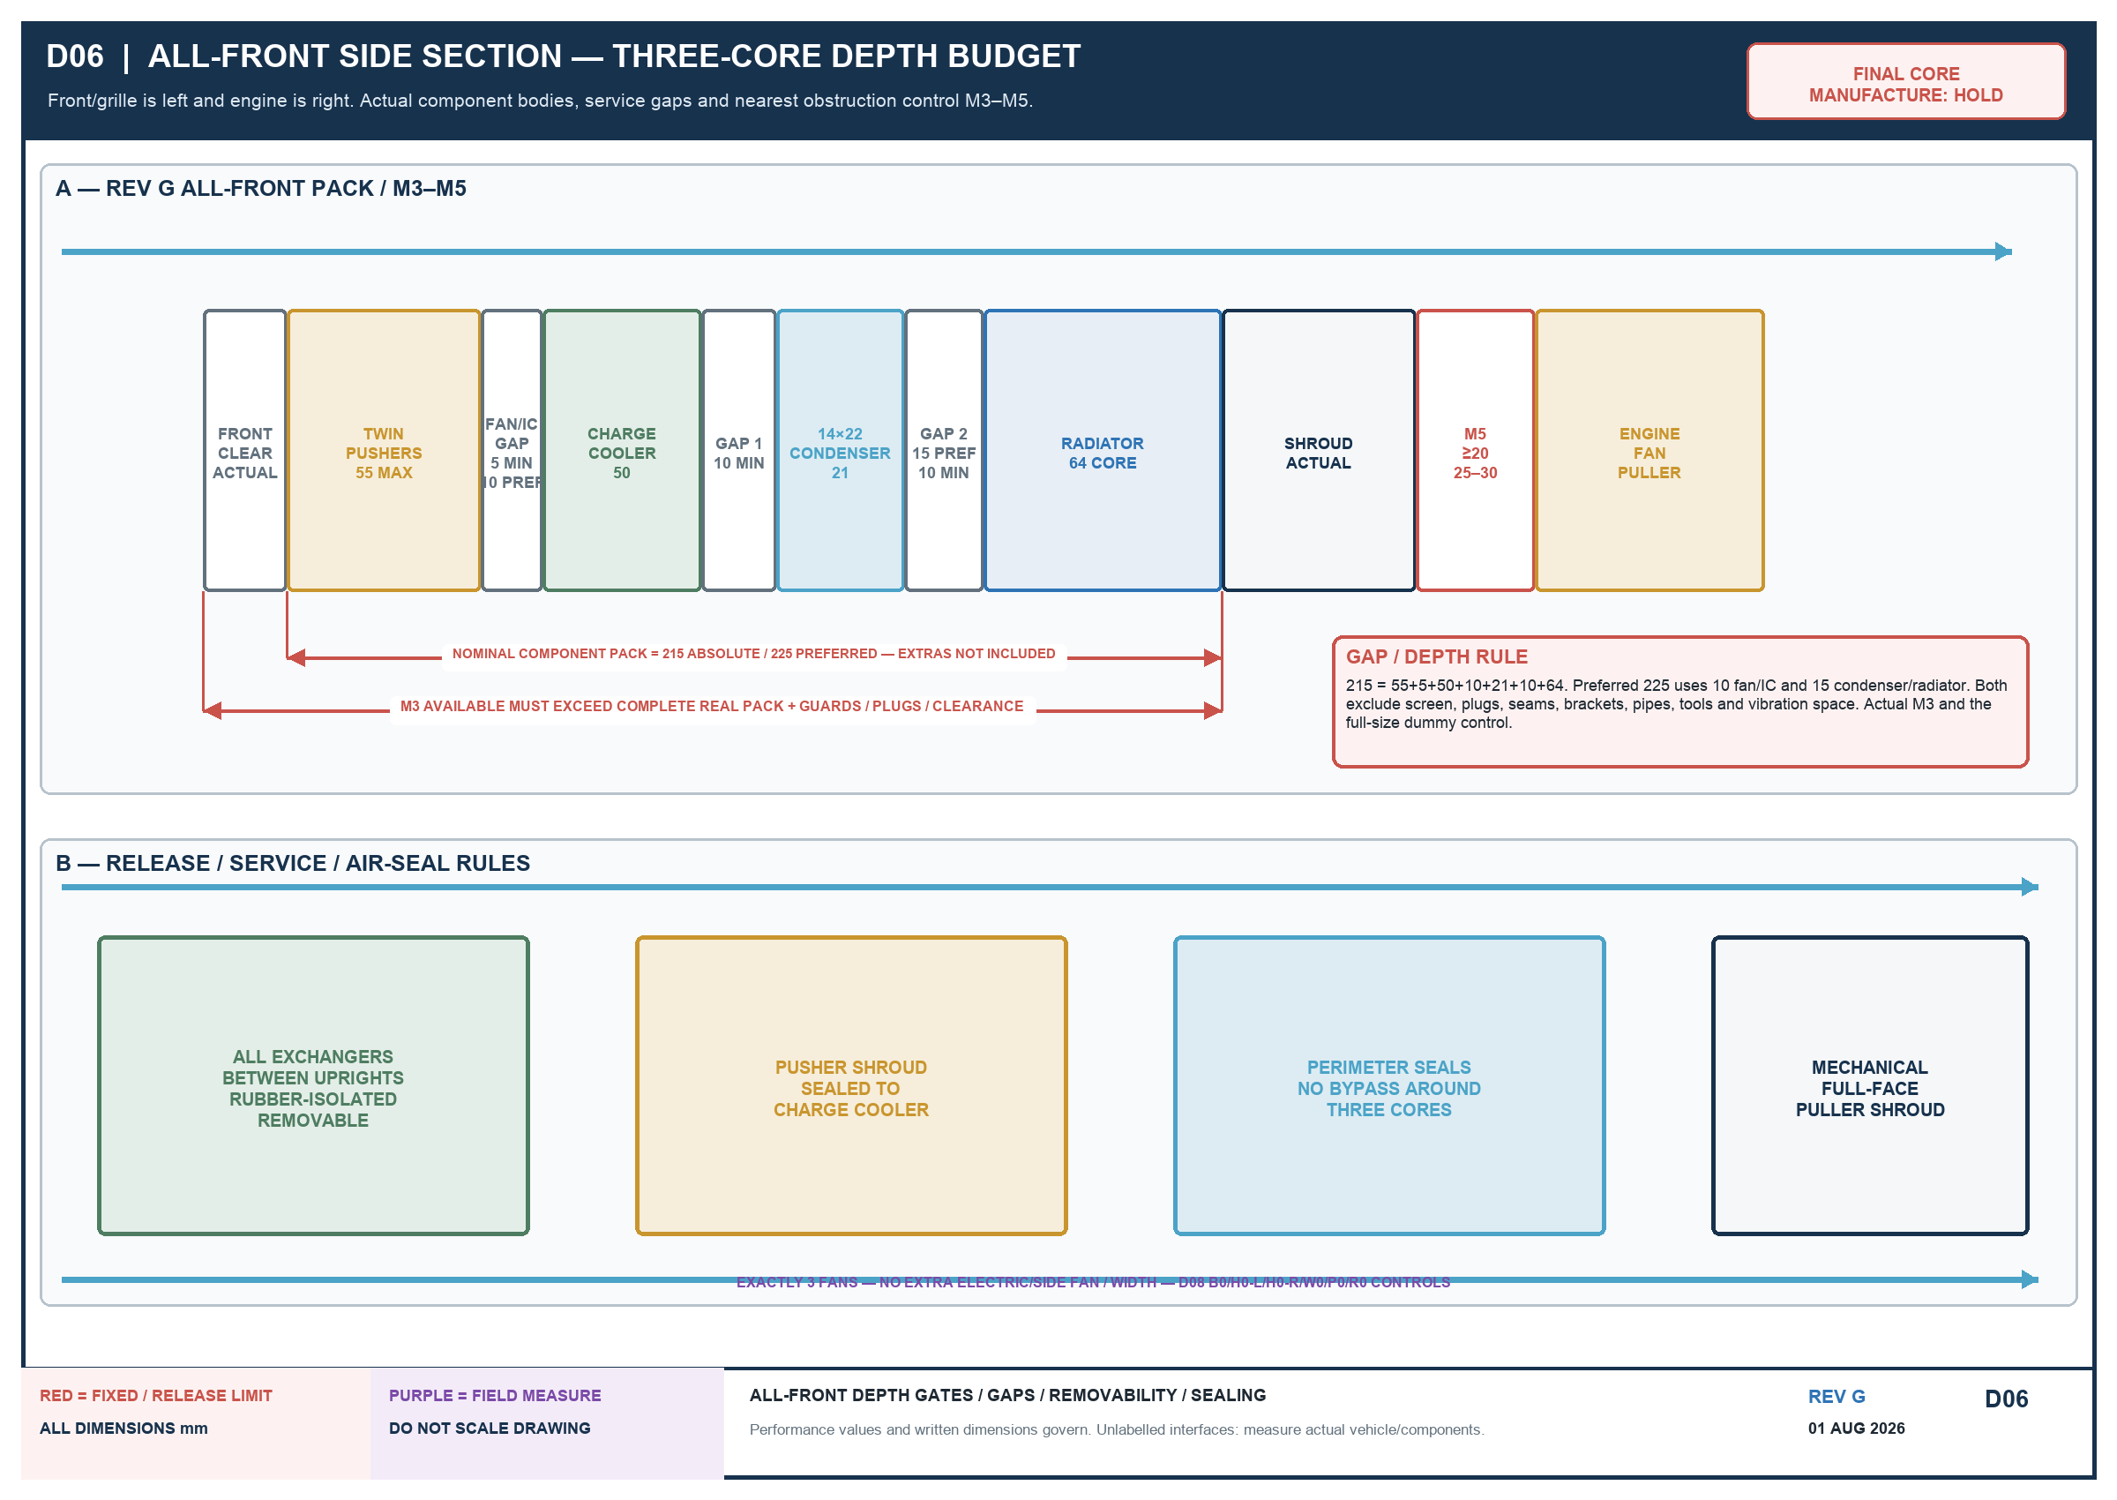
Written requirements govern; red = fixed/release limit; purple = field measure / owner approval.

D07 — Fan power and control

Written requirements govern; red = fixed/release limit; purple = field measure / owner approval.

D08 — Direct side-ear bracket interface
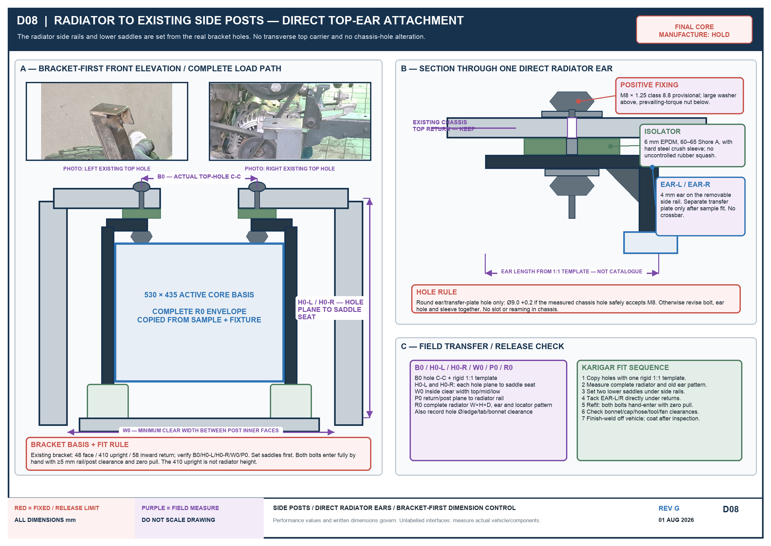
Written requirements govern; red = fixed/release limit; purple = field measure / owner approval.

D09 — Closed boxes on independent brackets

Written requirements govern; red = fixed/release limit; purple = field measure / owner approval.

D10 — Vehicle-centreline and physical-fit control

Written requirements govern; red = fixed/release limit; purple = field measure / owner approval.

