HJ60 Power Steering: What to Buy
  - RHD J40 with 2H diesel | Bilal Ganj donor-set guide
The buying rule
Buy all five groups shown below from one right-hand-drive HJ60 with a 2H diesel. Group 5 is the original HJ60 power-steering reservoir assembly; do not substitute a brake or clutch reservoir.

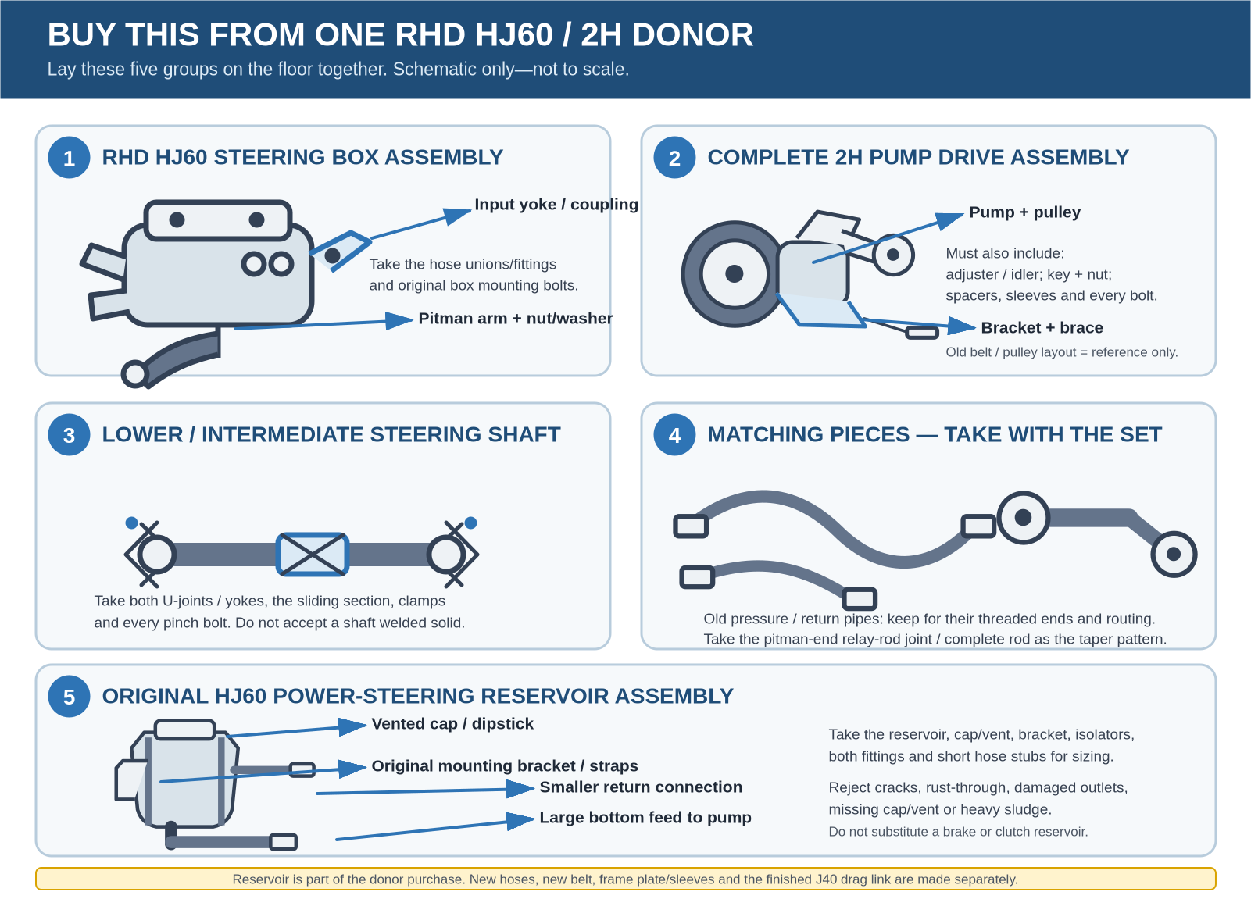
Required breaker purchase — deliberately shown as one clean schematic, not a rebuild-parts diagram.

What is not being bought from the breaker
- No old rubber hoses or belt: use new hoses and a new belt; retain donor hose ends and the old belt only as patterns.
- No donor frame mount or final drag link: those are engineered and made for the J40.

What the five groups actually are
Keep each assembly together. The brackets, joints, spacers and small bolts are harder to replace than the obvious large parts.
1 | RHD HJ60 steering box assembly  What it is: The hydraulic steering gearbox that mounts to the chassis and turns the steering linkage. It must be a right-hand-drive box.  Take with it: Pitman arm with nut/washer; box input yoke/coupling or U-joint with pinch bolt; pressure/return unions; original box mounting bolts.

2 | Complete 2H pump drive assembly  What it is: The engine-driven hydraulic pump and its 2H-specific mounting and belt-tensioning hardware.  Take with it: Pump and pulley; correct 2H bracket plus support brace; adjuster/idler/tensioner; pulley key and retaining nut; every spacer, sleeve and mounting bolt. Take the old belt and note the pulley layout as references only.

3 | Lower / intermediate steering shaft  What it is: The link between the J40 steering column and the HJ60 box; it supplies the correct box-end spline/yoke and articulating joints.  Take with it: Both U-joints/yokes; sliding or collapsible section; clamps and every pinch bolt. Reject a shaft that has been welded solid.

4 | Matching fittings and pattern pieces  What it is: Parts retained so the hydraulic shop and fabricator have the correct threads, tapers and routing references.  Take with it: Old pressure and return pipes intact with their threaded ends; pitman-end relay-rod/drag-link joint or complete donor rod as a taper and dimension pattern. These are patterns, not the final old hoses or final J40 drag link.

5 | Original HJ60 power-steering reservoir assembly  What it is: The low-pressure fluid tank that gravity-feeds the pump and receives returning fluid. It must be the power-steering reservoir from the same donor set.  Take with it: Reservoir body; cap and open vent; dipstick/internal strainer if fitted; original bracket, straps, rubber isolators and bolts; large pump-feed fitting; smaller return fitting; short hose stubs and clamps for sizing.

Reservoir rule
Keep the reservoir with the pump it served. The large outlet feeds the pump and the smaller connection accepts return flow. Take the bracket and fittings even if the reservoir will be cleaned and the hoses remade.

Real-part identification: steering box and pump
Use photos to recognise parts — not to define the full order
Each photograph highlights one required component. A photo may omit its pulley, bracket, hose, joint or hardware; the complete five-group list on pages 1–2 remains the purchasing checklist.

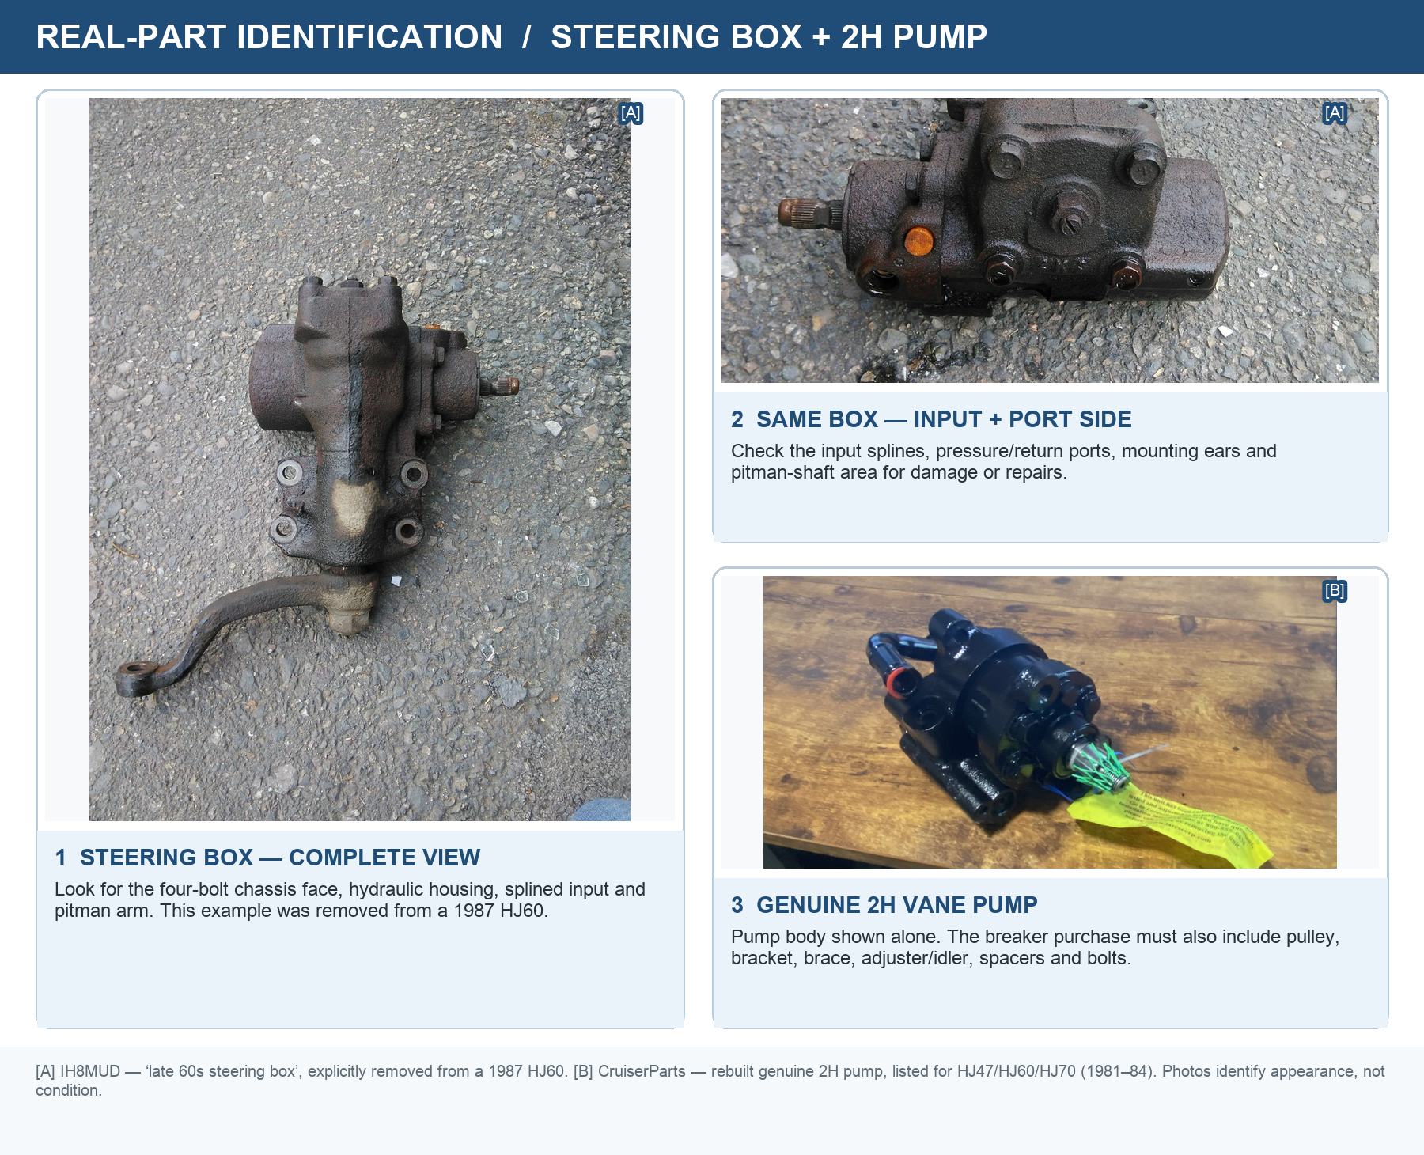
Real-part examples 1–3 — the box views are of one unit removed from a 1987 HJ60; the pump is a genuine rebuilt 2H example.
Source pages: [A] 1987 HJ60 steering-box photographs • [B] genuine 2H pump photograph

Real-part identification: bracket, shaft and reservoir
The reservoir photo is an appearance reference only
It shows the period metal remote reservoir in a right-hand-drive 2H installation. Do not copy that mounting position. Buy the reservoir, cap, bracket and fittings from the same HJ60 donor as the pump, then mount it for the J40 as specified by the steering specialist.

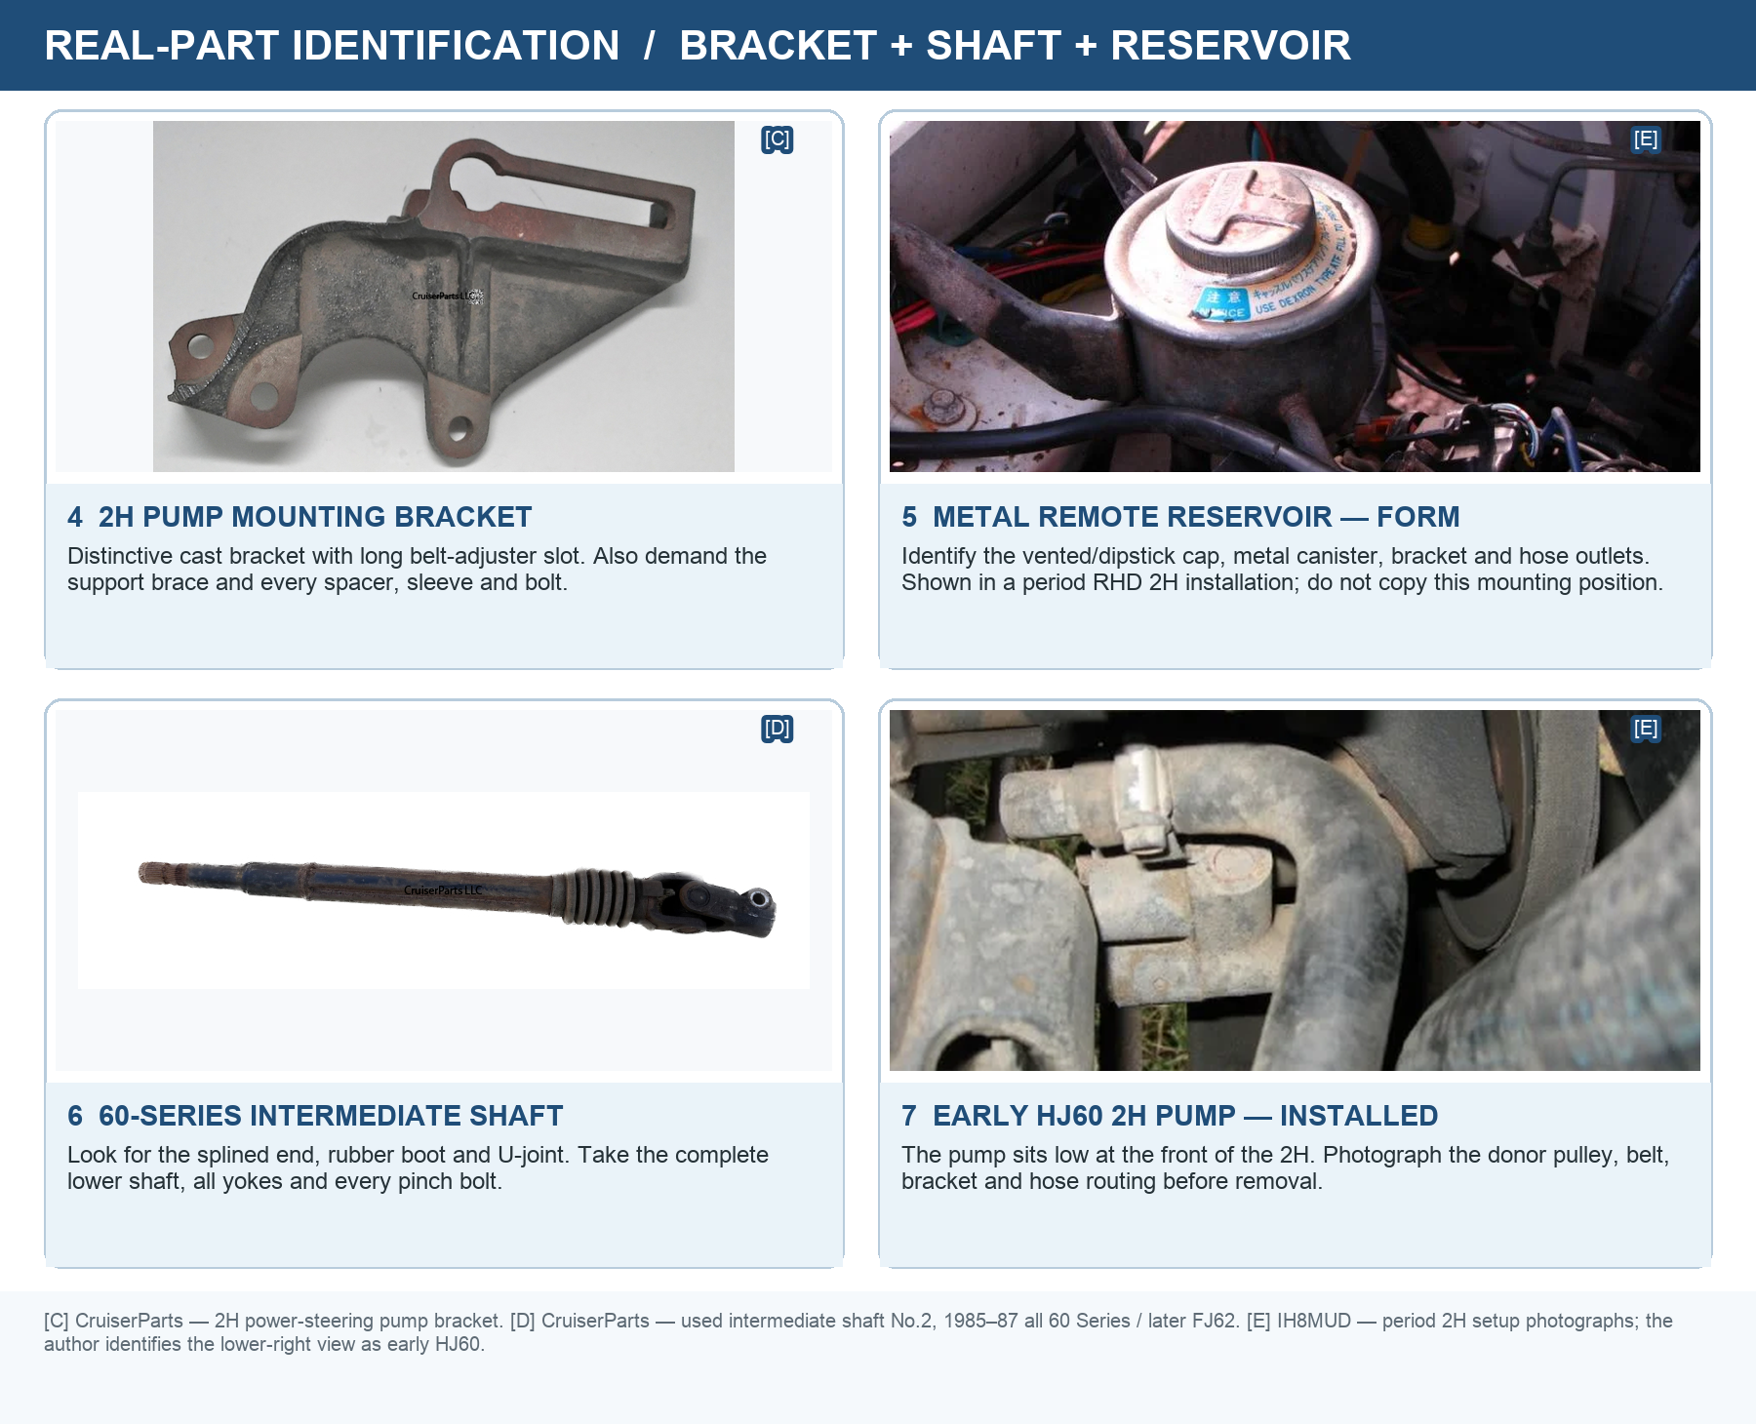
Real-part examples 4–7 — use the shapes and connection points to identify parts, then verify the donor as RHD HJ60 / 2H.
Source pages: [C] 2H pump bracket • [D] 60-series shaft • [E] period 2H setup photographs

Reservoir purchasing details
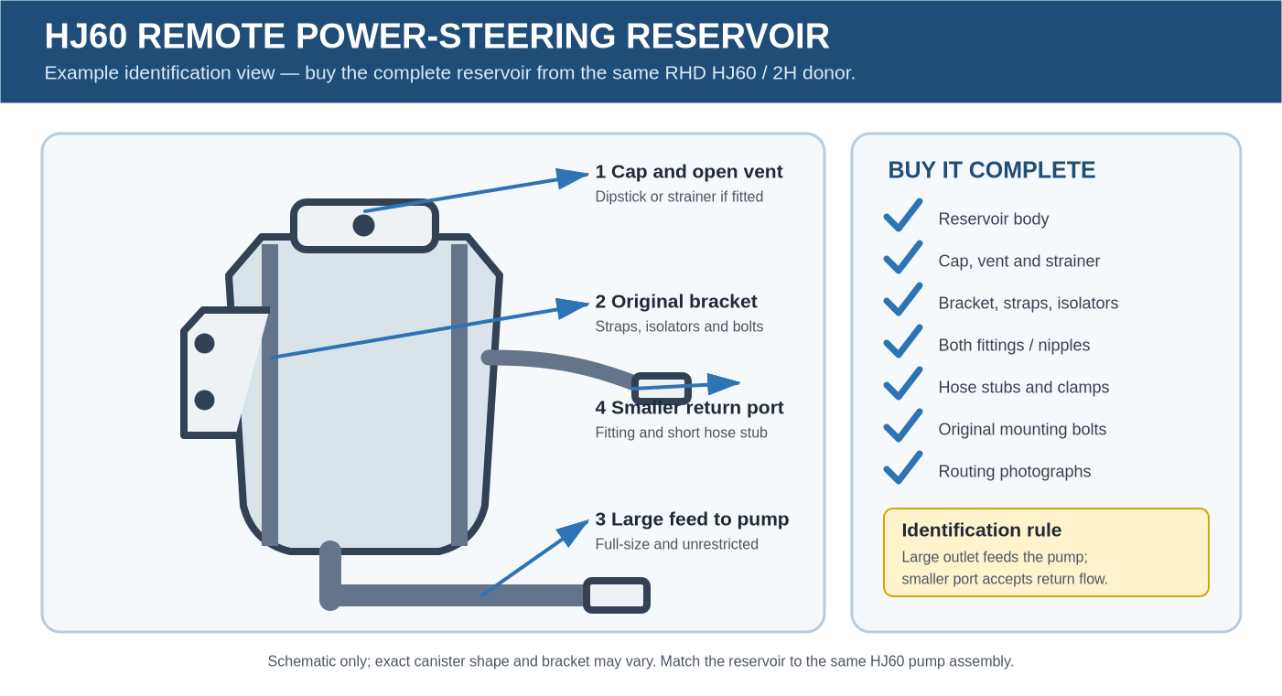
Reservoir identification example — exact canister shape may vary; buy the one attached to the matching HJ60 pump system.

Take every part in this group
- Reservoir body with cap, working vent and dipstick or removable internal strainer if fitted.
- Original mounting bracket, straps, rubber isolators, spacers and mounting bolts.
- Large pump-feed outlet and smaller return fitting, both undamaged and uncut.
- Short hose stubs, original clamps and clear photographs of the donor routing. The hose stubs are size/routing samples only.

Reject it if
- It is a brake/clutch reservoir, washer bottle, coolant bottle or an unrelated universal tank.
- The body is cracked, swollen, heavily dented, rusted through, badly repaired or deeply contaminated with sludge/water.
- The cap or vent is missing/blocked, an outlet is crushed or split, or an internal strainer is torn and cannot be replaced.
- The bracket is missing, badly cracked or altered so heavily that its original mounting relationship cannot be copied.

One sentence for the seller
Complete RHD HJ60 2H power-steering set chahiye: box with pitman and input joint; complete 2H pump with bracket, brace, pulley, adjuster and every spacer/bolt; lower shaft with both joints; all box/pump pipe fittings and the pitman-end relay-rod joint; original power-steering reservoir with cap, bracket and both pipe connections. Brake/clutch bottle nahi chahiye.

Test at the breaker before paying
Best buying method
See the parts on the original RHD HJ60/2H if possible. Photograph the engine-side pump layout, brackets, hose routing, steering-box orientation and linkage before dismantling. Lay the complete set out together before money changes hands.

Identity and completeness
- Confirm the donor is an HJ60 with a 2H diesel and right-hand drive; do not accept a mixed 60/70-series set.
- Count the five groups against the image on page 1. Check that the pump hardware and complete reservoir group are both present.
- Keep every hose union and threaded pipe end attached or bagged and labelled. Photograph the complete layout.

Steering box
- Reject cracks, broken mounting ears, impact damage, fresh weld repairs, damaged splines or badly damaged threads.
- Turn the input smoothly from lock to lock. Reject tight spots, grinding or a heavy notch near the centre.
- Hold the pitman arm and rock the input around centre. Some wear may be rebuildable; obvious clunking, excessive lost motion or a loose sector shaft is a poor core.
- Check the pitman arm is not bent and that its tapered joint and retaining threads are intact.

Reservoir
- Open the cap and inspect inside with a light. Reject heavy rust scale, water, gelled fluid, metal debris or sludge that cannot be removed without damaging the tank.
- Confirm the cap seals, the vent is open and the dipstick/strainer is present if the donor design uses one.
- Inspect the large feed and smaller return outlets for cracks, crushed sections, damaged threads/barbs and previous brazing/weld repairs.
- Fill with a small amount of clean compatible test fluid and check the body, seams and outlet bases for leakage; drain it before transport.

Pump, shaft and pattern parts
- Spin the pump by hand. It should turn smoothly; reject a seized, gritty or badly corroded pump.
- Rock the pump pulley/shaft. Reject obvious radial wobble, a bent pulley, cracked bracket or welded/cracked support brace.
- Move both shaft joints through their full angle. Reject binding, heavy rust, loose needle bearings, damaged splines or a seized sliding section.
- Confirm the hose ends and pitman-end steering-link pattern are not cut through the threaded/tapered parts that must be copied.
Agree this before paying
Treat the box and pump as rebuildable cores and the reservoir as a clean/test item, not guaranteed ready-to-fit parts. Ask for a short return window in case stripping or cleaning reveals cracks, severe corrosion or non-matching components.

Workshop testing and final acceptance
This is a safety-critical steering conversion. Fabrication, hose manufacture, hydraulic testing and final sign-off should be done by experienced steering, hydraulic and 4×4 chassis specialists.

1 Bench overhaul and component tests
- Strip, clean and inspect the steering box; replace seals/bearings as required; check housing, worm/sector surfaces and shafts for cracks, pitting or unacceptable wear.
- Centre the box and set travel, backlash and preload to the manual/specification for the actual donor box; then pressure-test for leakage, smooth travel and load-holding.
- Strip/inspect the pump as required; check shaft, bearings, rotor/vanes, housing and relief valve. Bench-test flow, pressure and relief operation to the specification for the actual donor pump.
- Strip the reservoir only as far as its design permits; clean it without leaving lint, abrasive or water. Clean/replace the strainer, verify the vent, then fill and leak-test the body, seams, cap and outlet bases before connection.
- Have new pressure and low-pressure feed/return hoses professionally made from compatible new hose and the correct donor fittings; proof-test the completed hoses.

2 Static installation checks
- Use an engineered J40 frame mounting plate with chassis sleeves/reinforcement. Fit suitable new fasteners, torque them to the approved design and apply witness marks.
- Ensure full spline engagement; every pinch bolt must pass through its correct groove. Retain a working collapsible/sliding section—no solid butt-welded shaft.
- Centre the steering box before connecting the linkage. Confirm equal steering each way and that axle steering stops prevent the box reaching internal hydraulic lock.
- Cycle full left/right lock at full droop, normal ride height and full compression. Check the shaft, pitman arm, drag link and hoses clear the chassis, suspension, exhaust, fan and belts.
- Align the pump pulley and belt; fit a new belt and verify tension. Mount the original HJ60 reservoir above and close to the pump, with a short unrestricted large-bore feed and a correctly routed smaller return.

3 Bleed and hydraulic checks
- Fill with the fluid specified for the actual HJ60 box/pump combination. With the front axle unloaded and engine off, cycle slowly lock-to-lock while maintaining the reservoir level.
- Start at idle and continue slow cycles until bubbles and foam stop. Never hold the wheel against either stop.
- Check for equal assist, pump whine/cavitation, hose ballooning, foaming and leaks at every union, shaft seal and reservoir connection—cold and fully warm.

4 Road test and reinspection
- Begin with a walking-speed yard test: figure-eights, braking, return-to-centre, steering effort and free play. Then set wheel alignment.
- Increase speed in stages on a safe route. Reject wander, pull, shimmy, bump steer, kickback, binding, delayed assist or different effort left versus right.
- After the fully warm test, inspect for leaks and movement; recheck fluid level, belt tension, fastener witness marks, frame/mount condition and linkage play.
- Repeat the complete inspection after approximately 160 km / 100 miles, or earlier if any noise, looseness, fluid loss or steering change appears.

Sign-off record
Donor / seller |  | Date bought
Box test by |  | Pump test by
Fabrication by |  | Hose/reservoir test
Road-test sign-off |  | 100-mile recheck

