VISUAL MARKET BUYING PACK
J40 Radiator + A/C Parts
For buying new parts and reusing original templates in Bilal Ganj
CRIMPING DECISION: Do not buy the tool for this one job. Fit and mark the loose hoses on the car, then have the A/C shop crimp them with the correct dies.
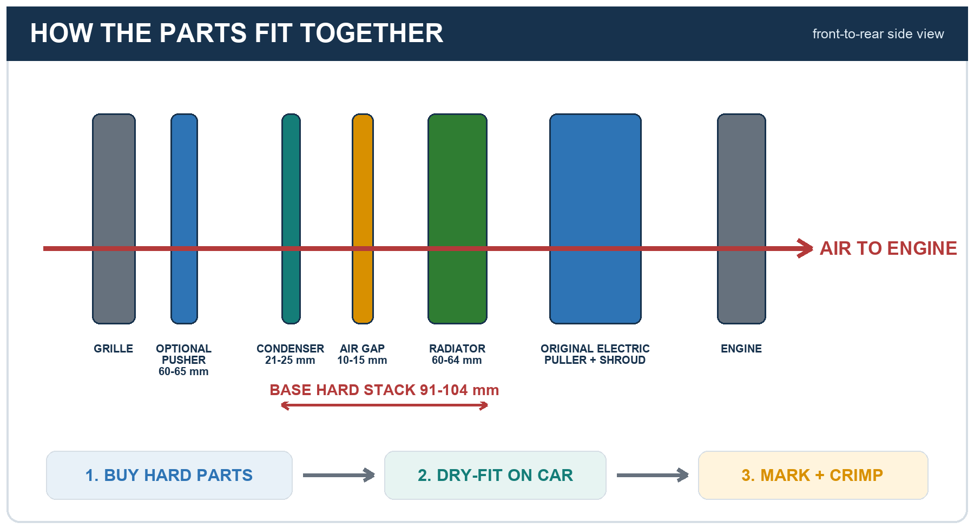
Purana radiator sample saath le kar jao. Pehle parts gaari par fit karo. Hose mark karo. Crimp baad mein karwao.

Original cooling stack before removal
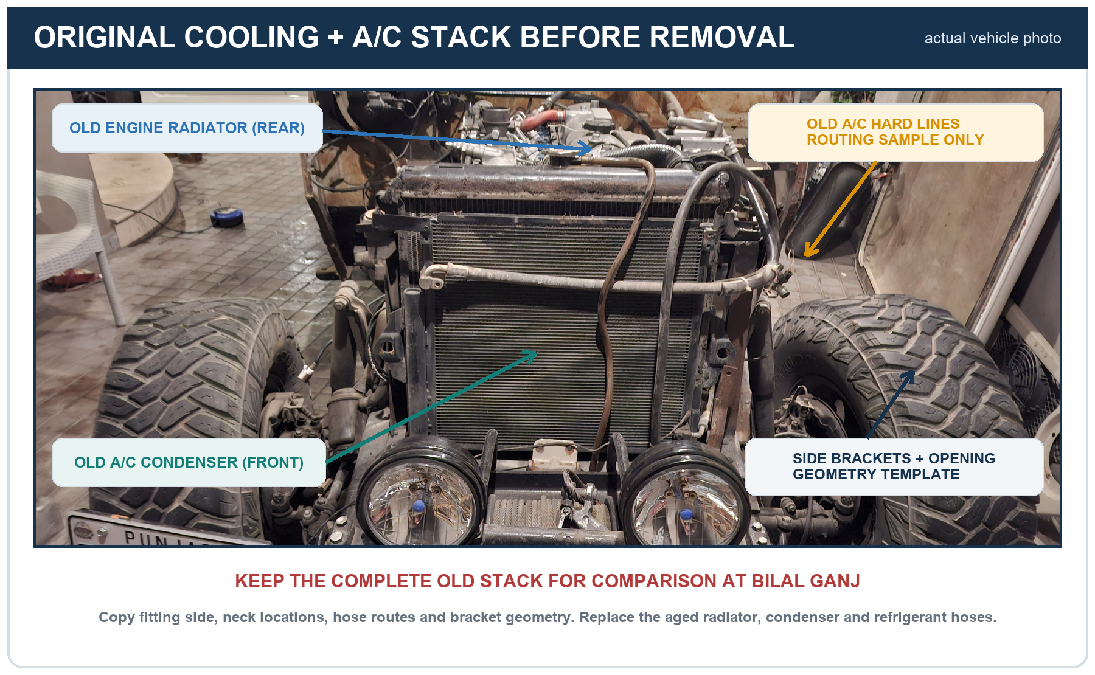
The photographed original is an electric puller fan with an integrated shroud. Recondition and reuse it behind the radiator as the primary fan. Add a separate front pusher only if hot-idle cooling and A/C testing proves it is necessary.

Original engine-side parts to retain
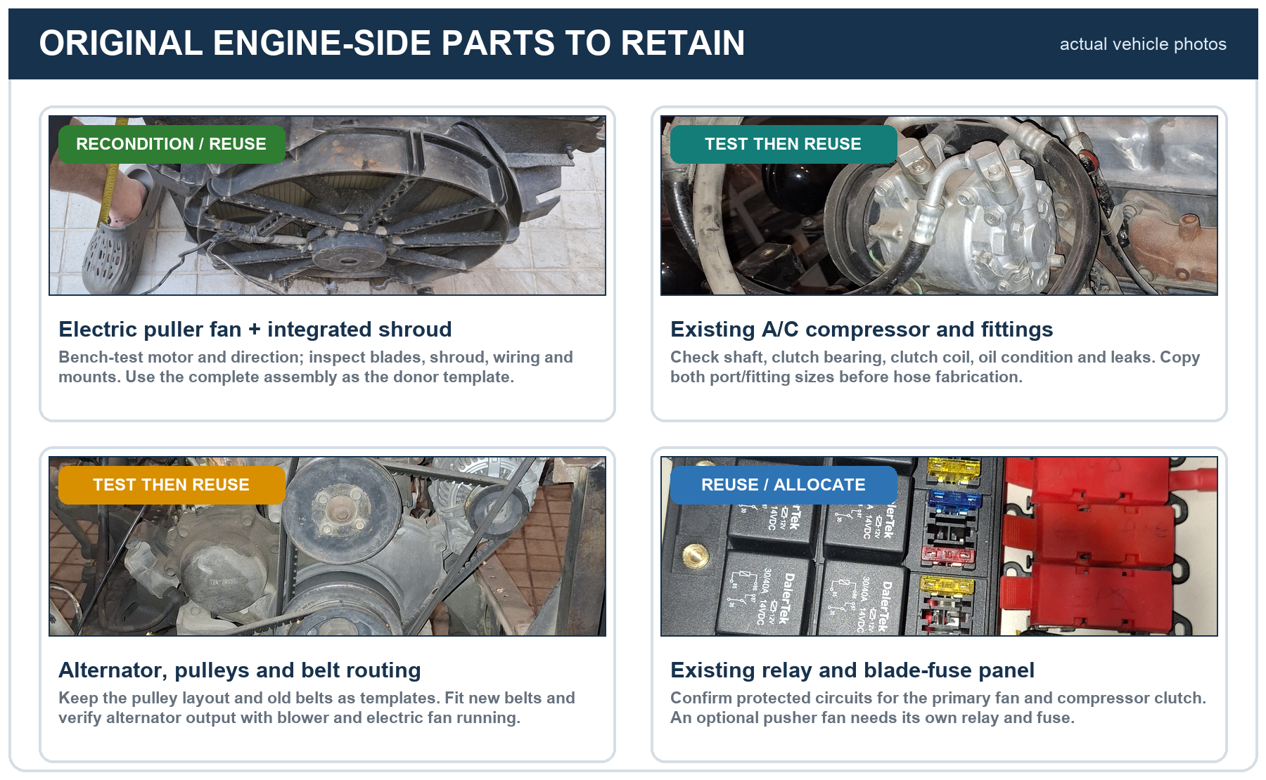

Original electric puller fan and integrated shroud
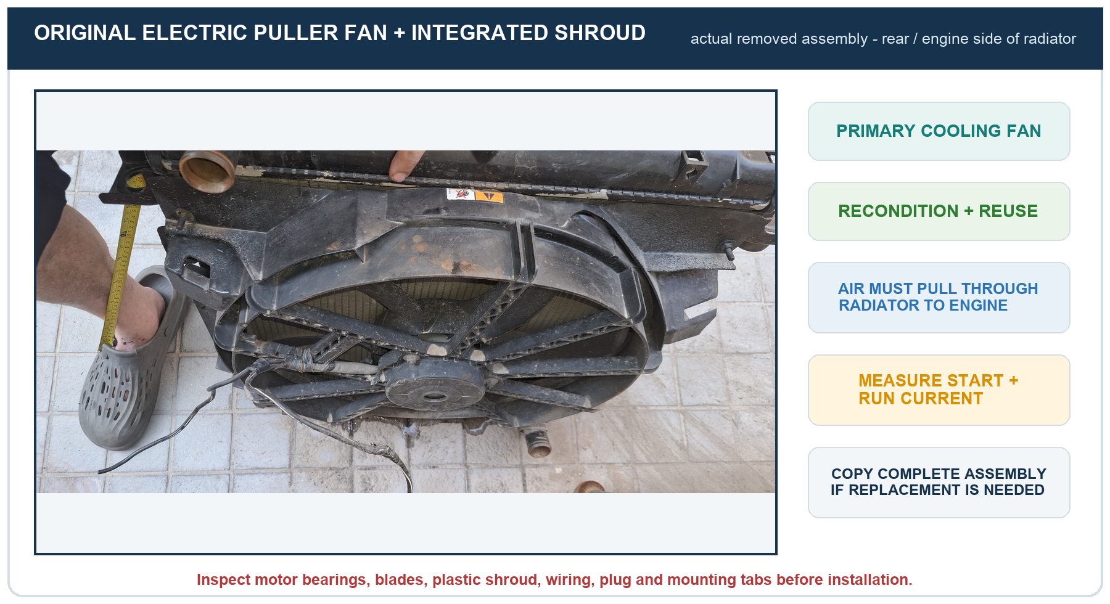

Primary electric fan installation
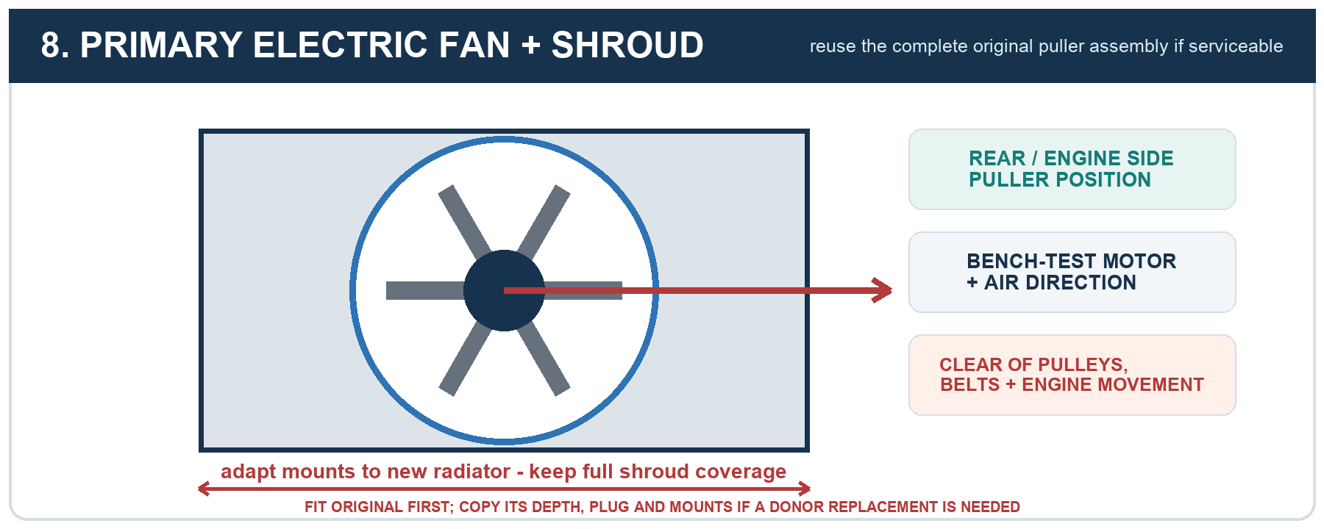

Original cooling parts to carry as samples
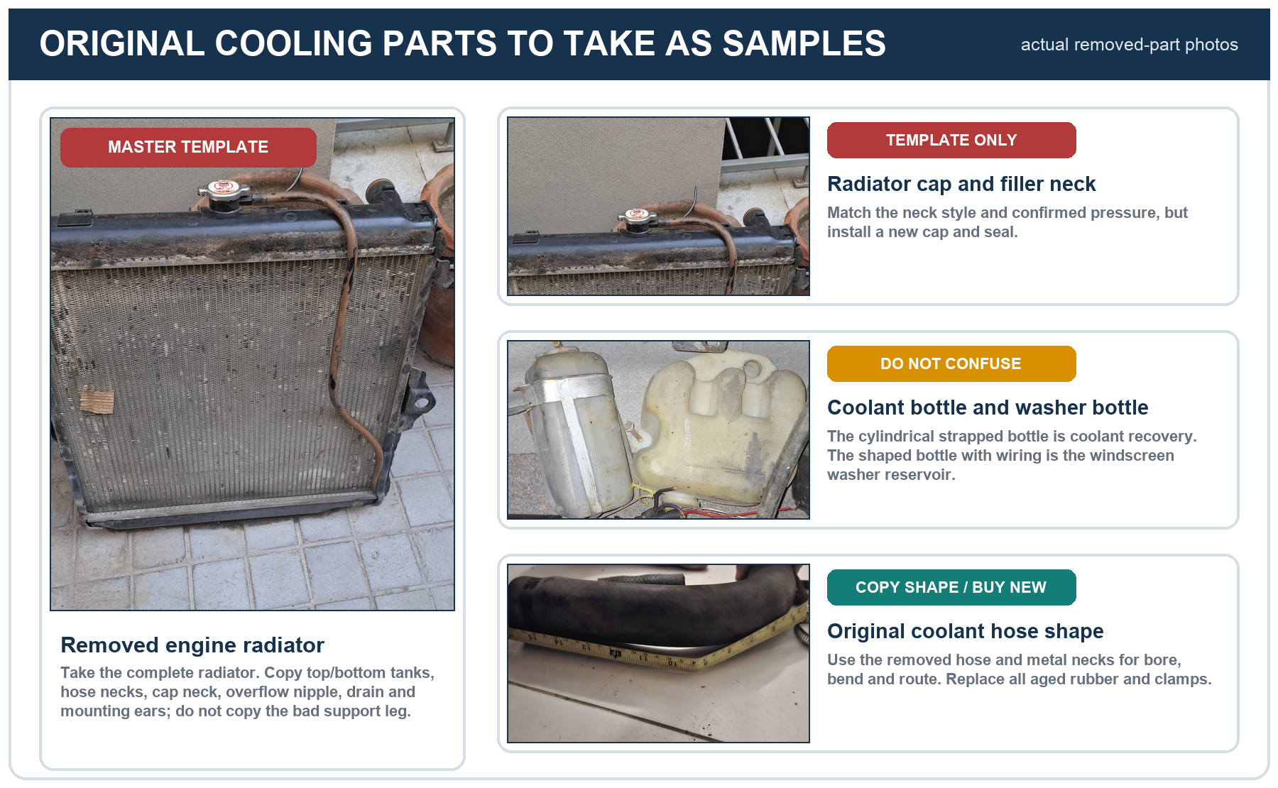

Radiator
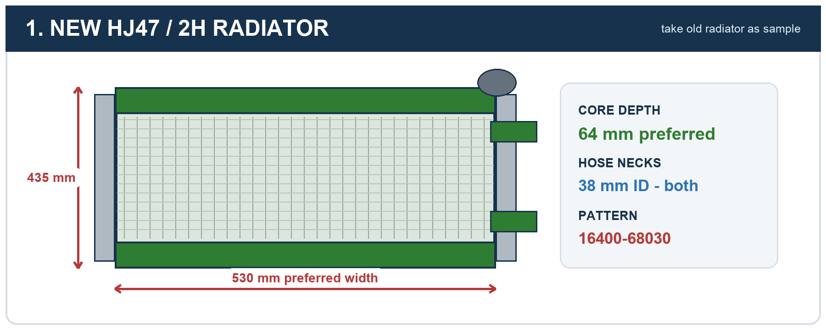

A/C condenser
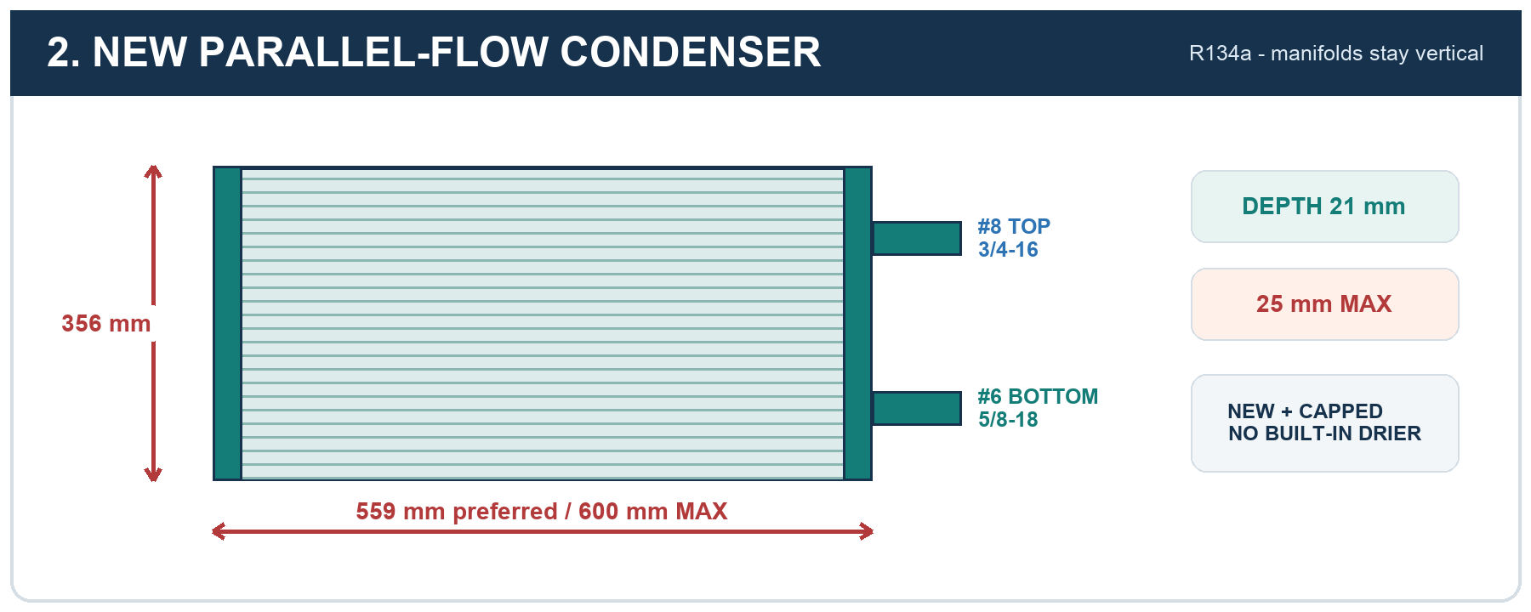

Optional front condenser pusher fan
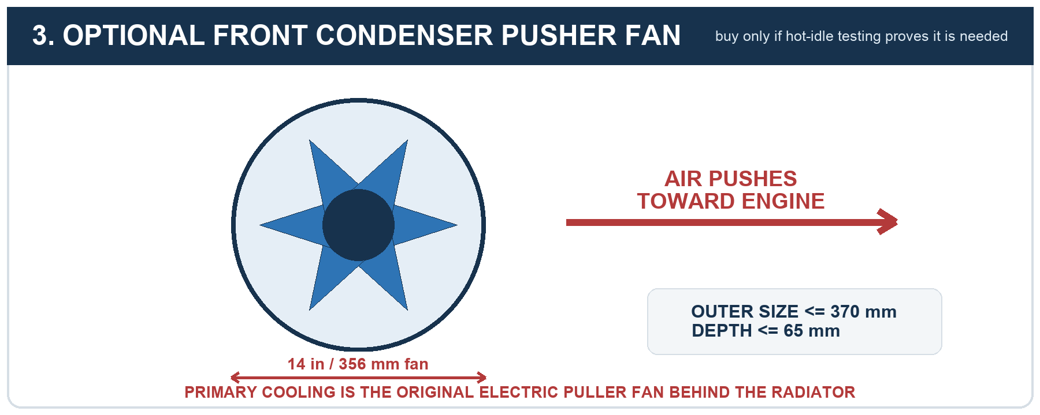

Receiver-drier and pressure switch
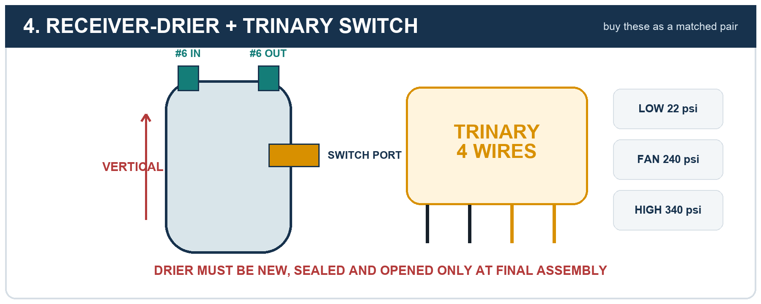

Radiator hoses and joiners
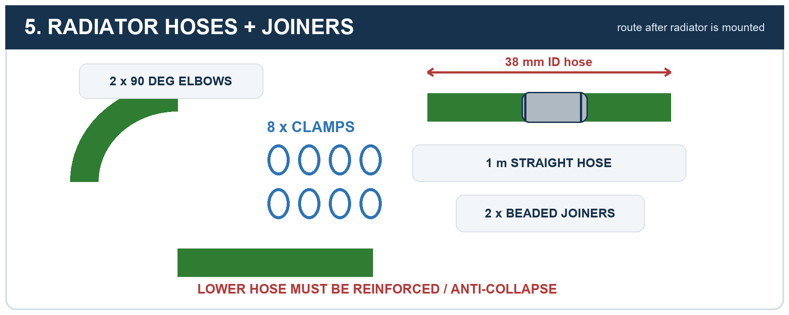

Recovery bottle
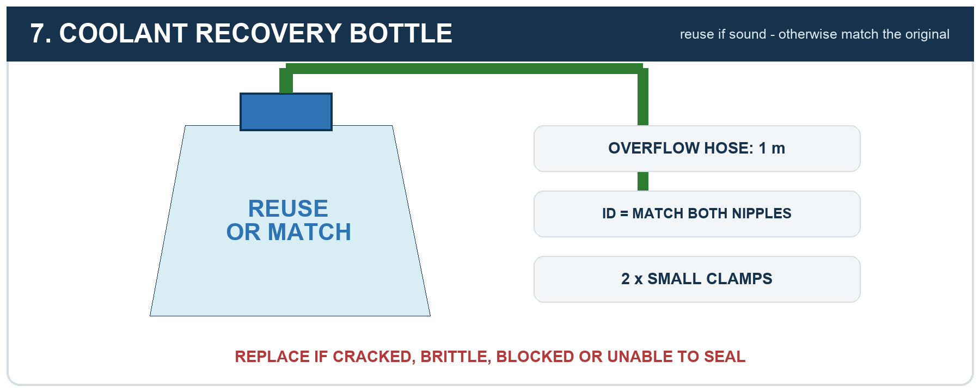

Radiator service parts
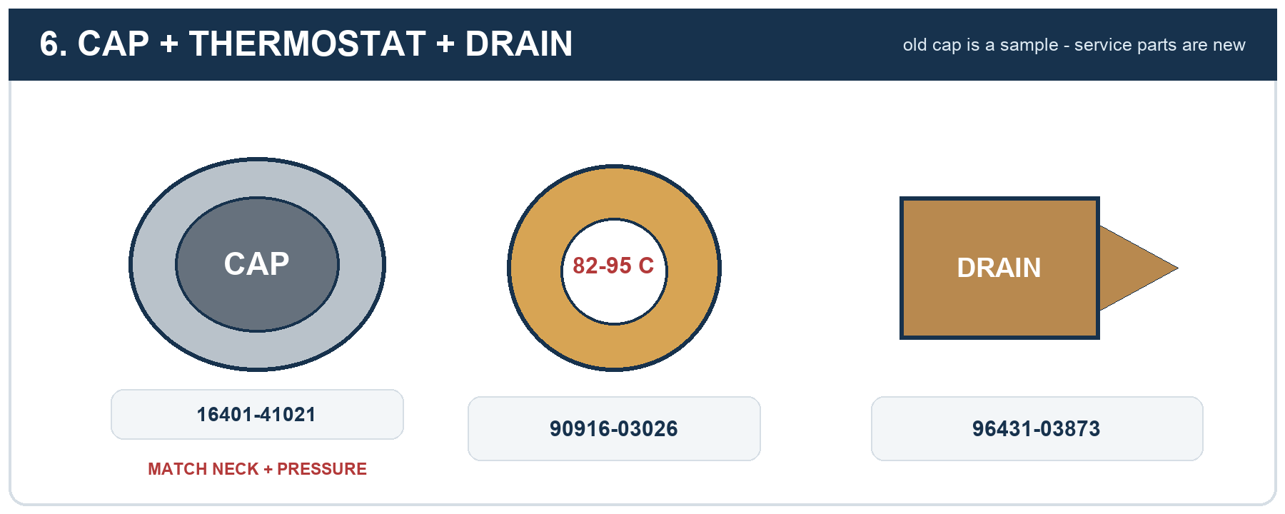

Original radiator cap and filler neck
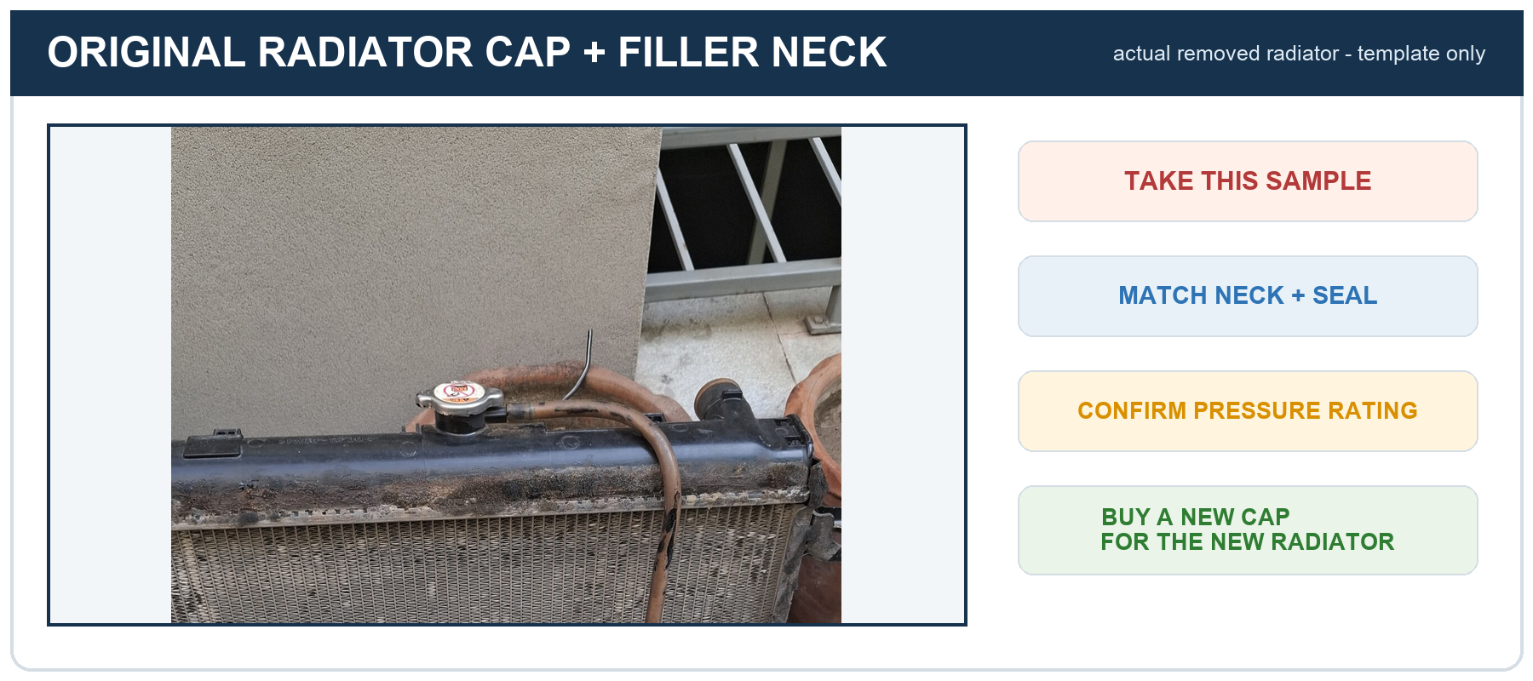

A/C barrier hoses
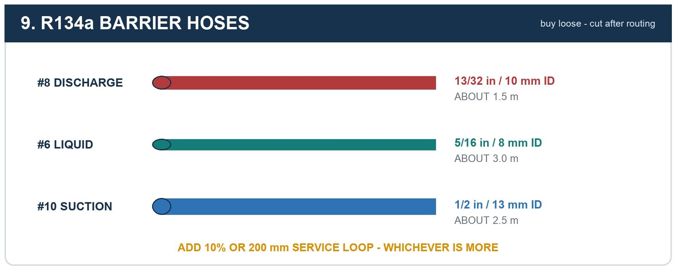

A/C fittings and service ports
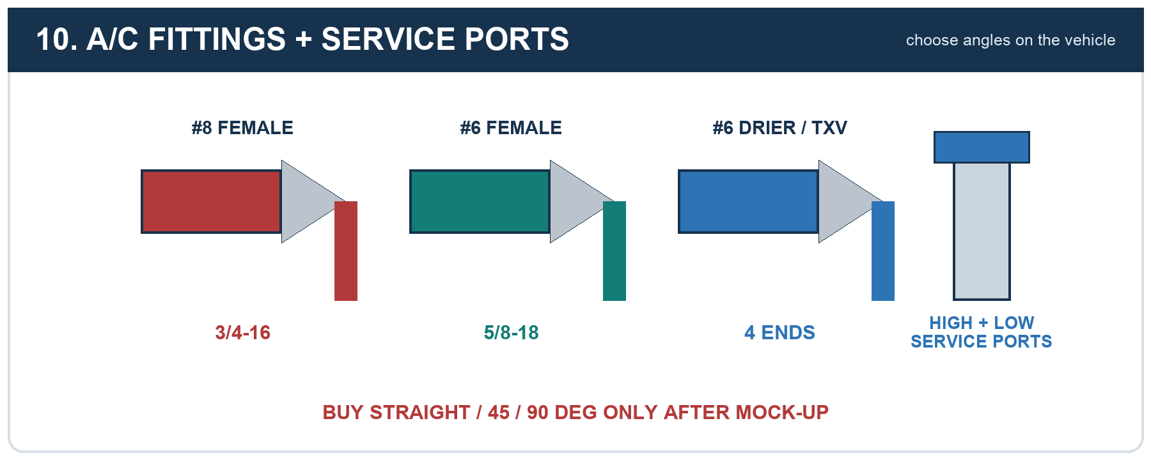

Hose marking and professional crimping
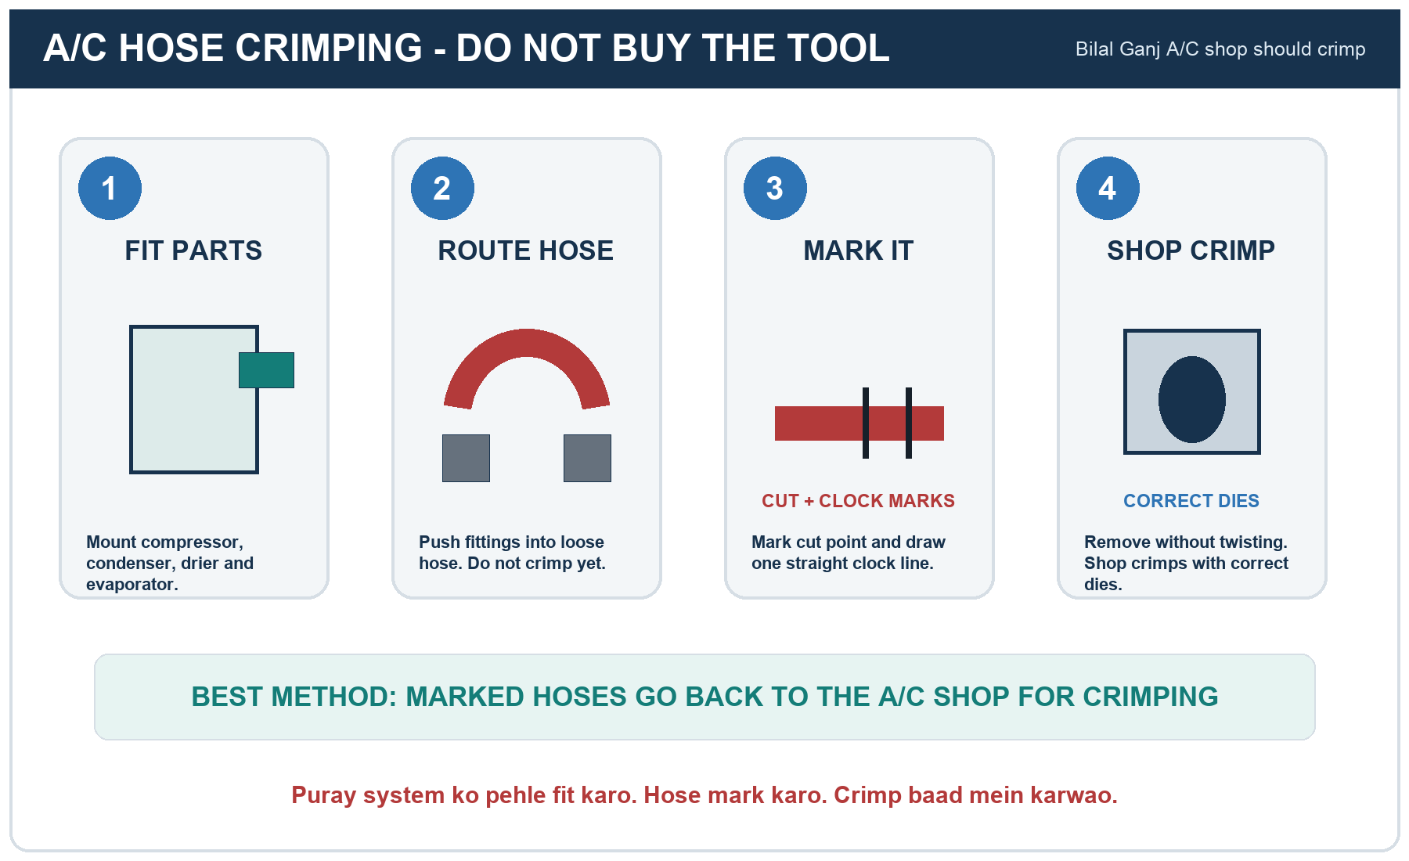
Why not buy the tool? A proper hydraulic kit must match the hose construction, ferrules and dies. One wrong crimp can leak refrigerant, admit moisture or fail under pressure. Professional crimping is cheaper and easier to verify for a one-off build.

Steel frame and rubber mounts
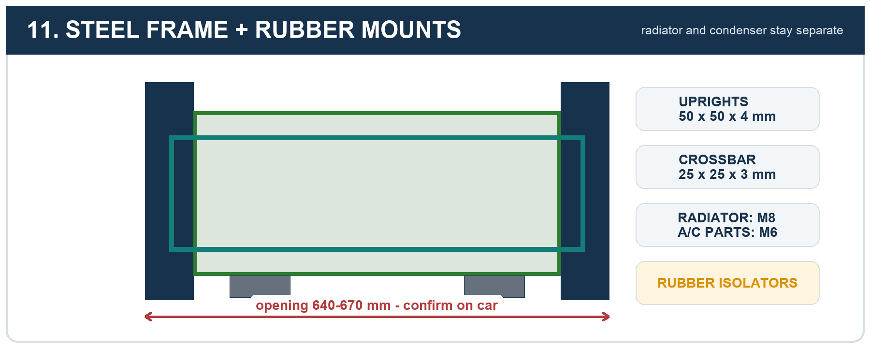

Relays, fuses and wiring
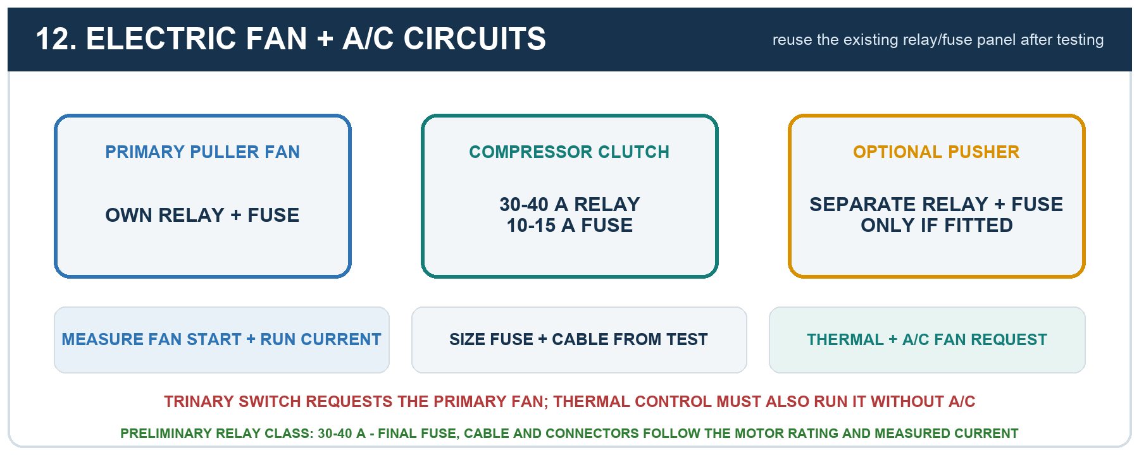

Original belts and pulley routing
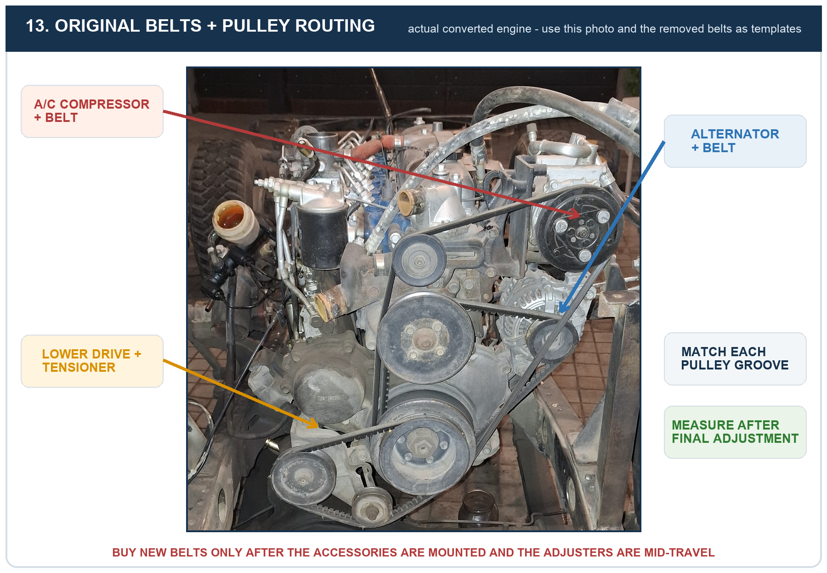

Coolant, refrigerant and tests
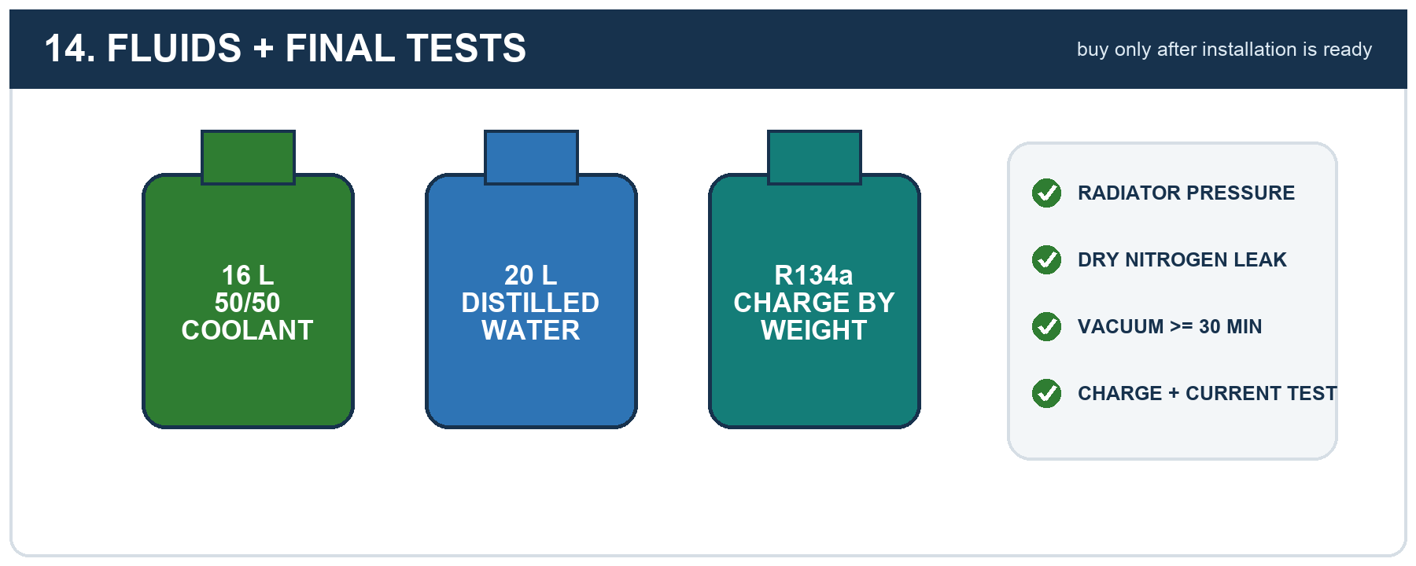

Final market checklist
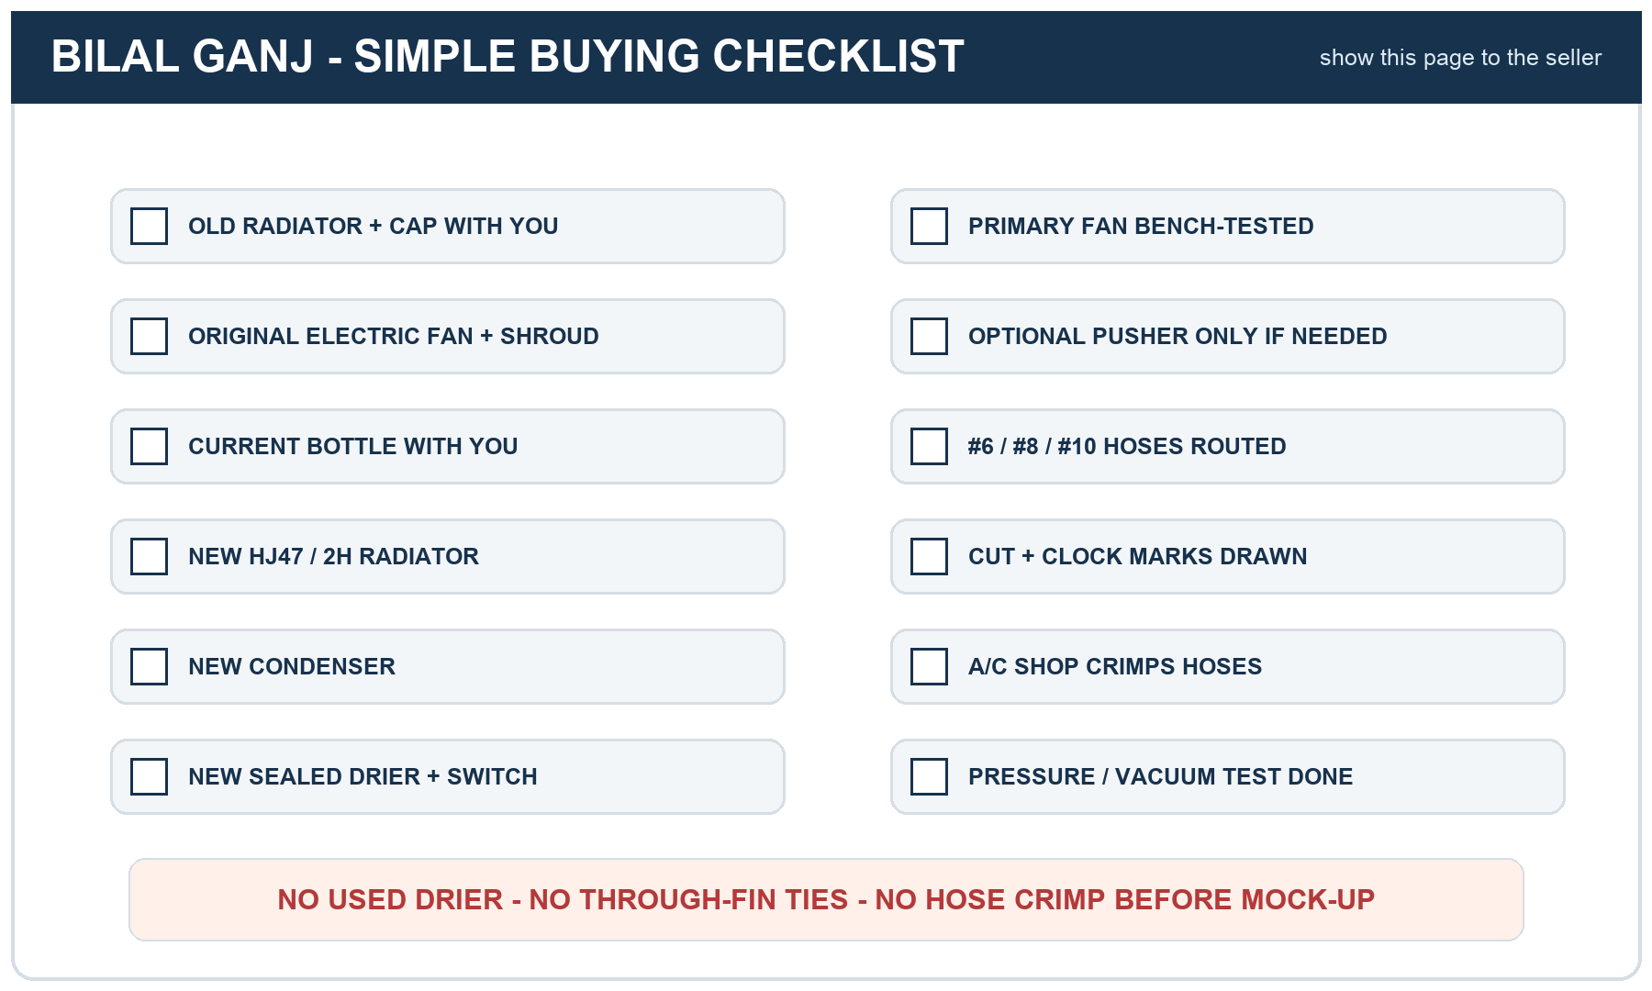
Pattern references only: Toyota 16400-68030 radiator; 03262-VUC/CNFP1422 condenser class; Mastercool 61-25642 trinary-switch function. New purchases are local; the original electric puller fan/shroud, bottle and electrical panel are reuse candidates subject to inspection and testing.

