Rubber Hose Sample Collection Photo Sheet
Bilal Ganj sample hunt - rubber hoses only - 2026-07-06
Use this only to find and bag old samples. Label each sample with the ID below. Ignore wires, metal pipes, hard lines, clips, grommets, and control cables.

Cooling / Heater
RPO-COOL-001 Upper radiator hose  Collect the old upper radiator hose.  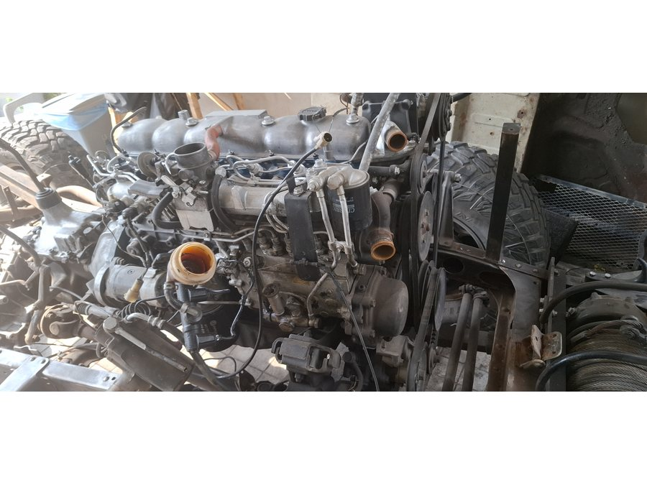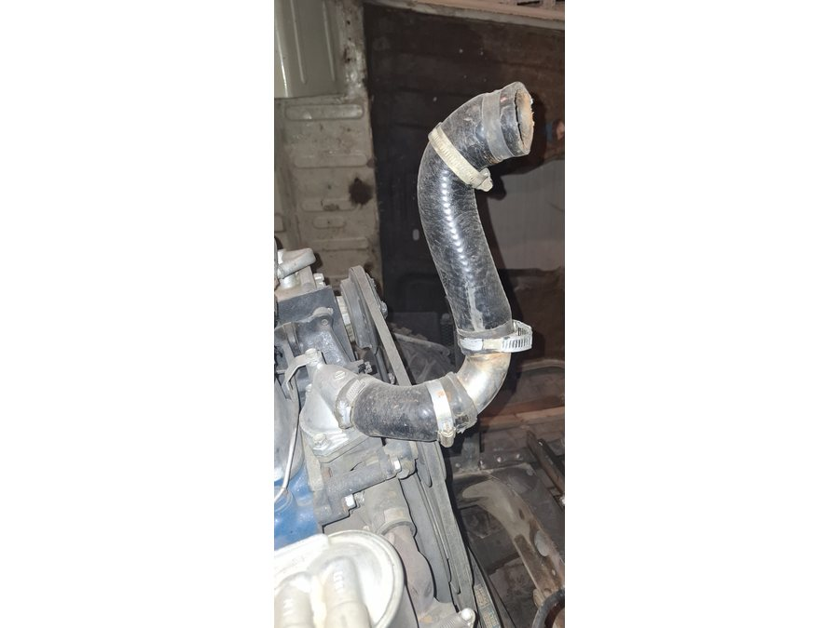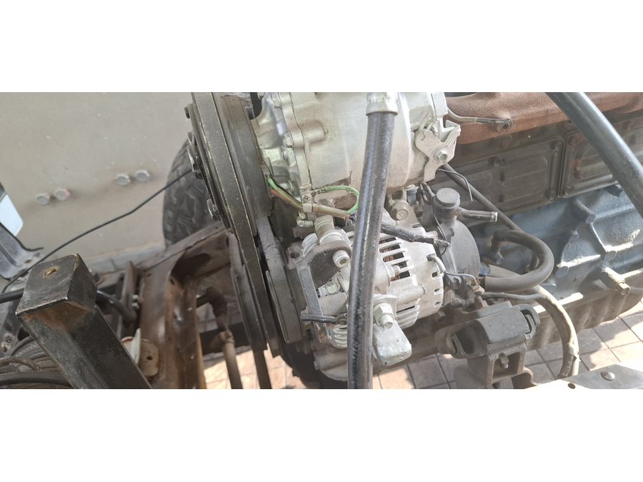 | RPO-COOL-002 Lower radiator hose  Collect the old lower radiator hose.  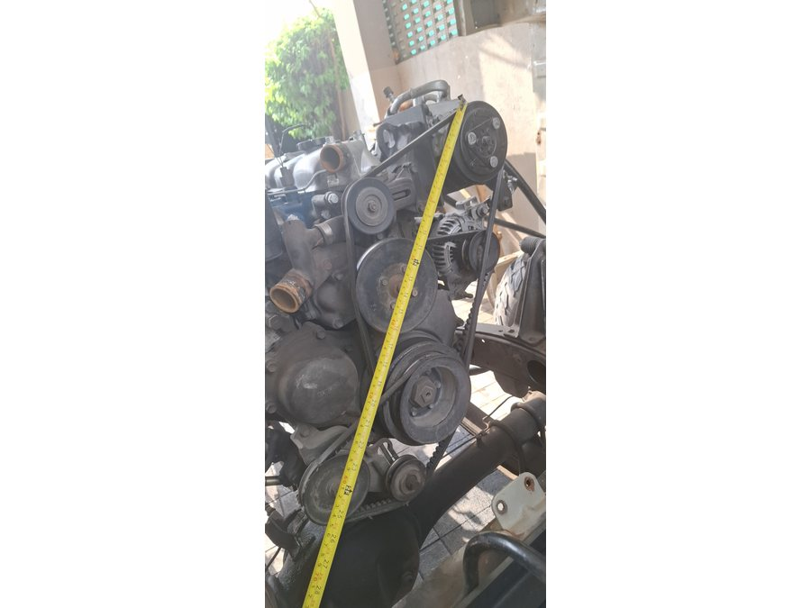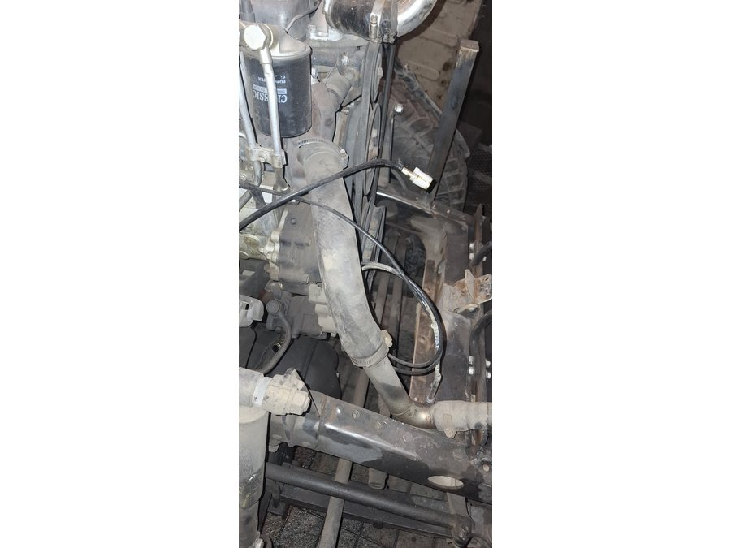
RPO-COOL-003 Radiator overflow hose  Collect the small overflow hose from radiator neck to bottle.  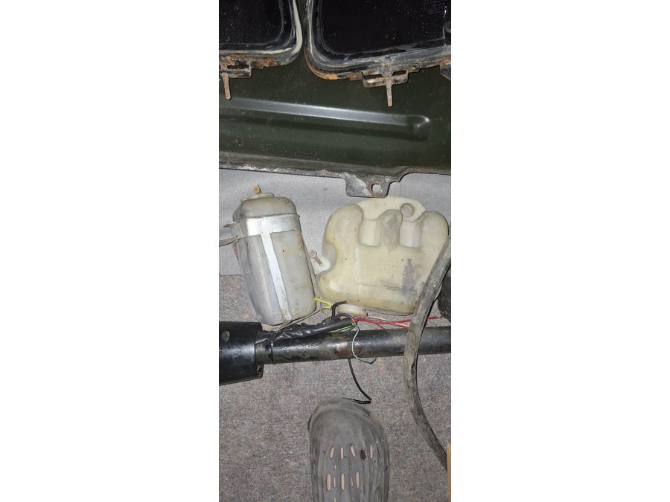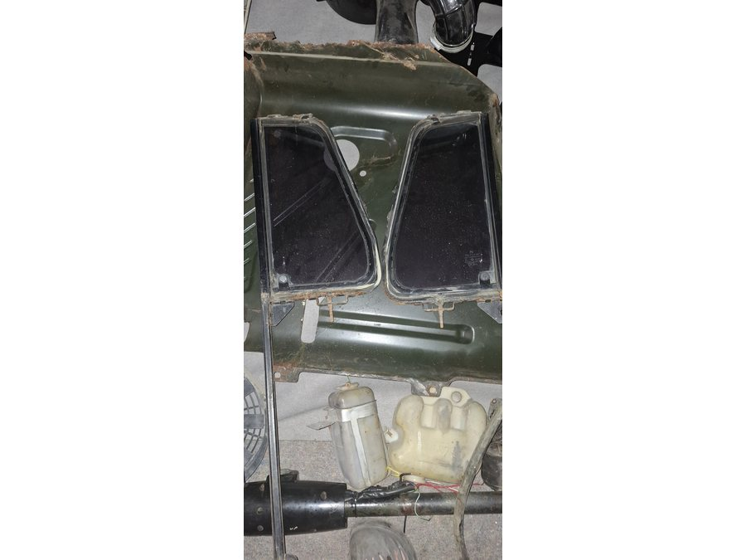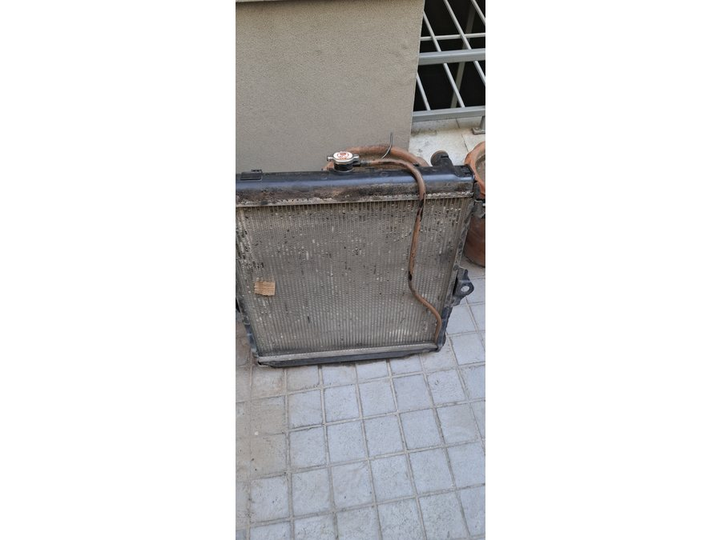 | RPO-COOL-004A Heater inlet hose  Collect and label the heater inlet hose if identifiable.  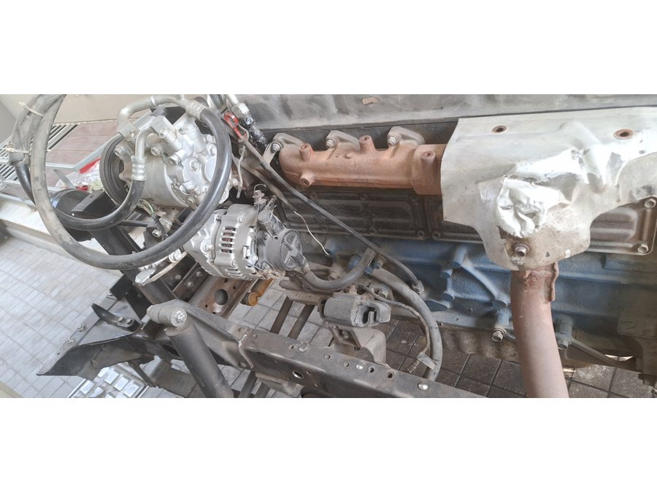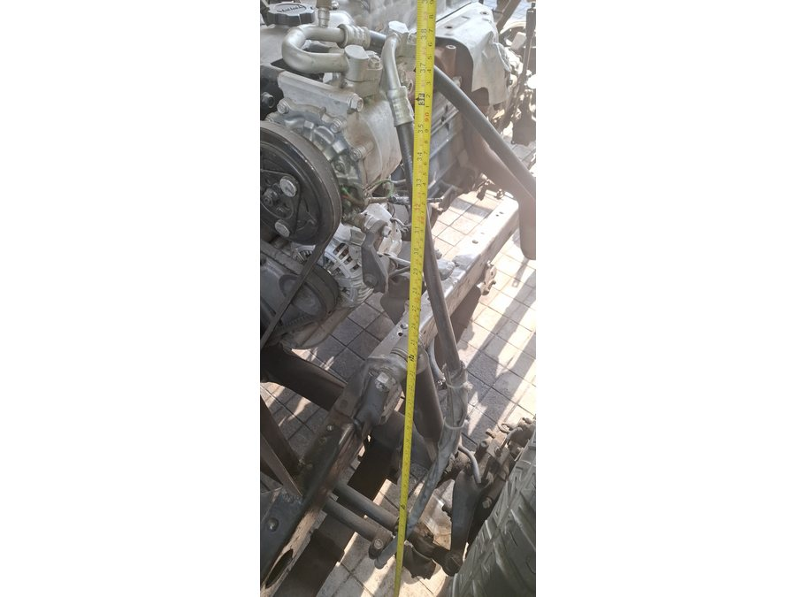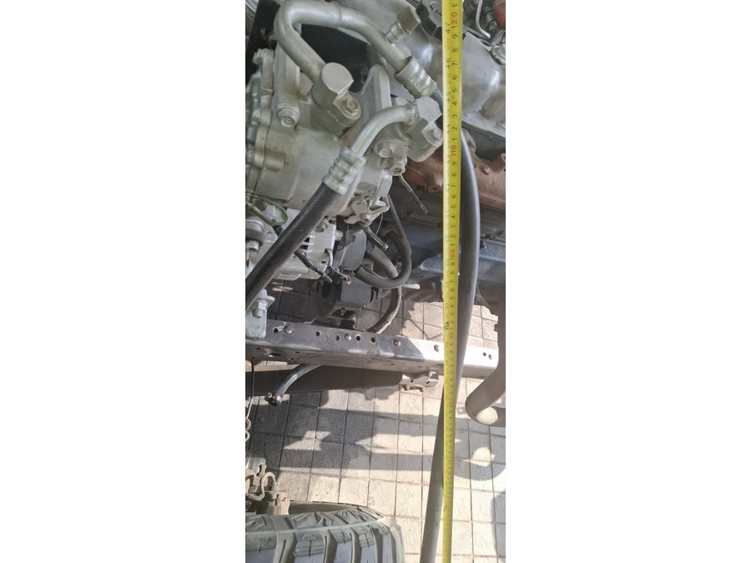
RPO-COOL-004B Heater outlet hose  Collect and label the heater outlet hose if identifiable.  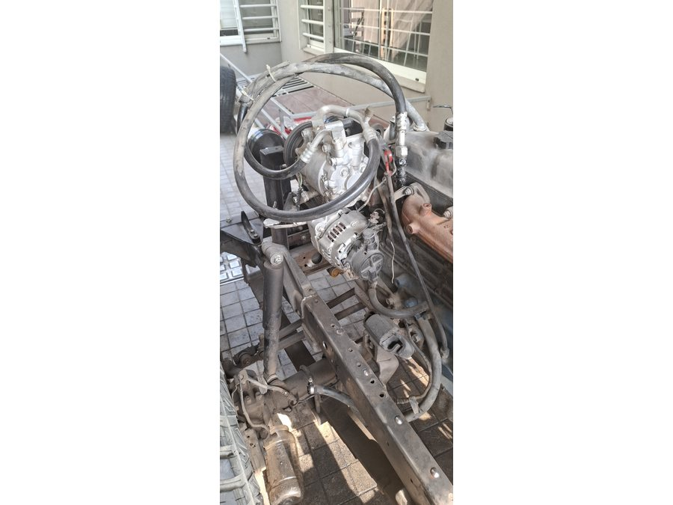 | RPO-COOL-006A Formed-pipe connector hose A  Collect the short rubber connector from one end of the formed coolant pipe.  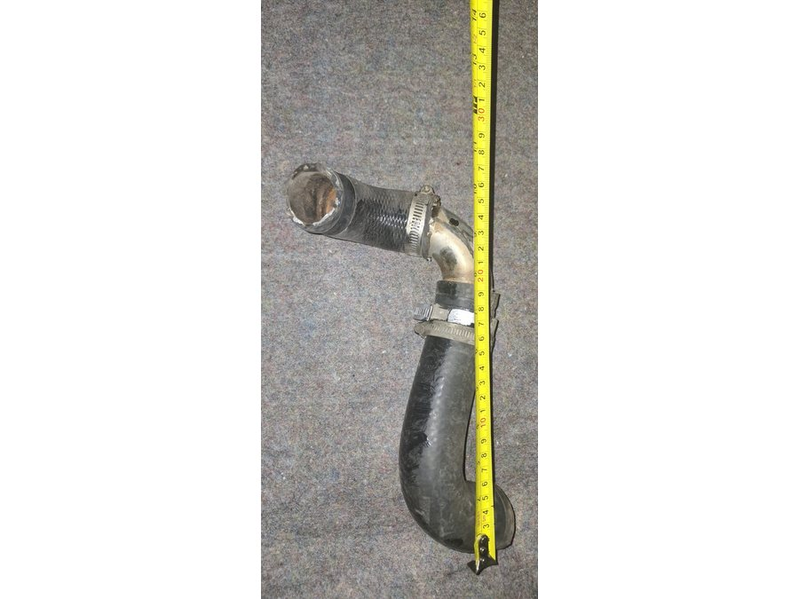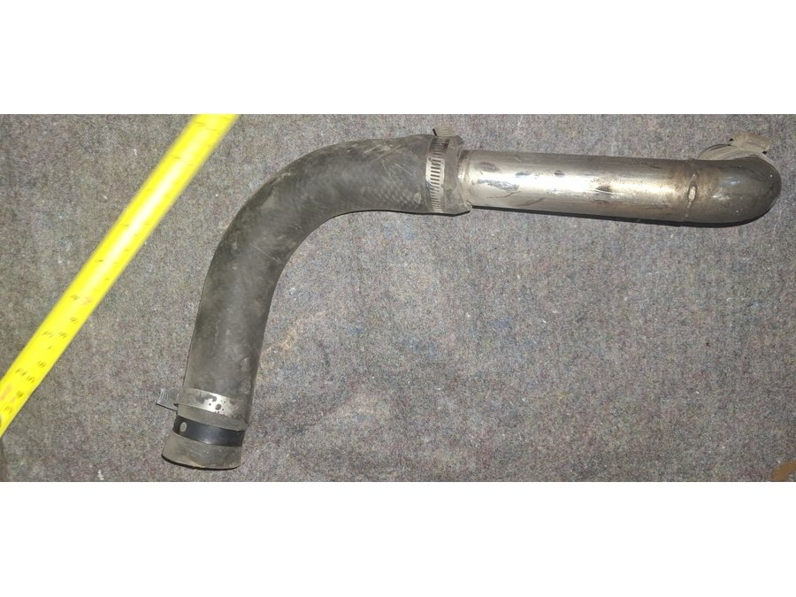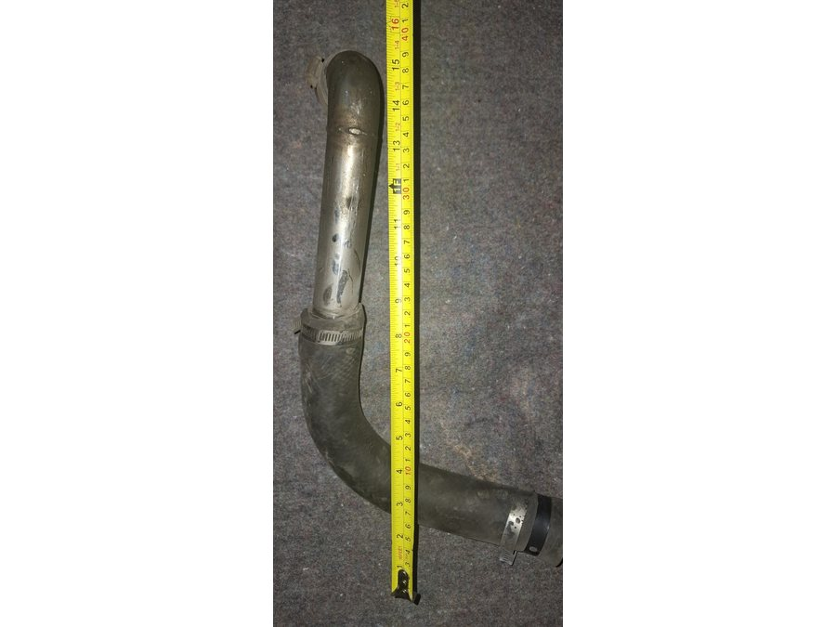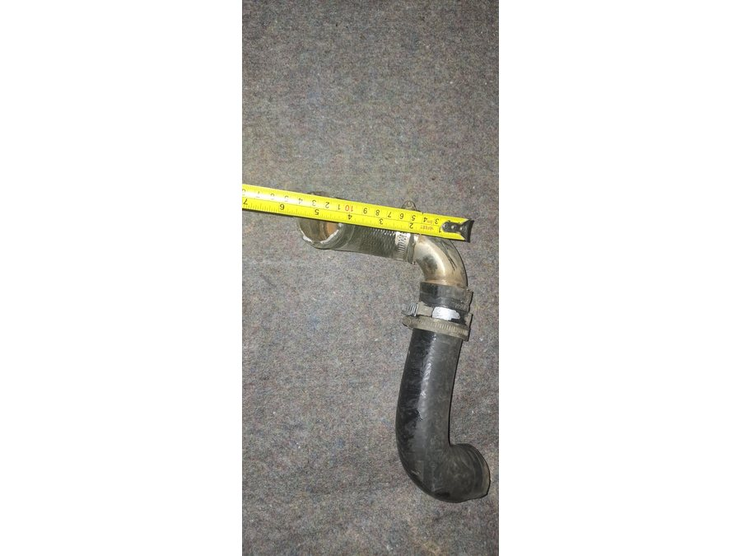
RPO-COOL-006B Formed-pipe connector hose B
Collect the second short rubber connector from the formed coolant pipe.
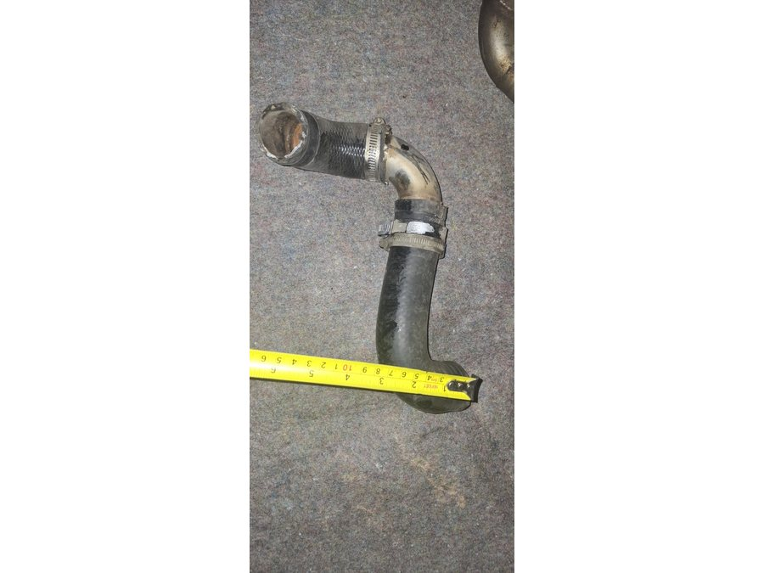

Fuel / Filler
RPO-FUEL-001A Low-pressure diesel feed hose  Collect the diesel feed hose sample from tank/chassis to engine side.  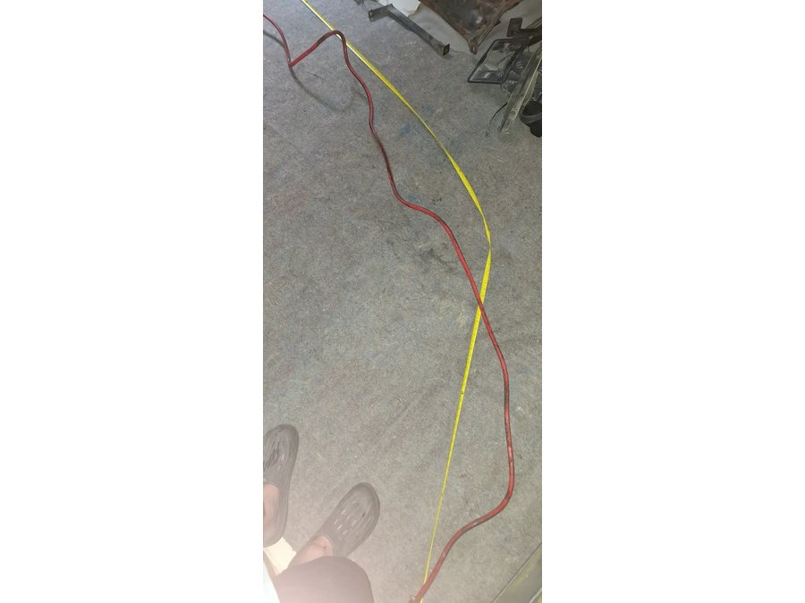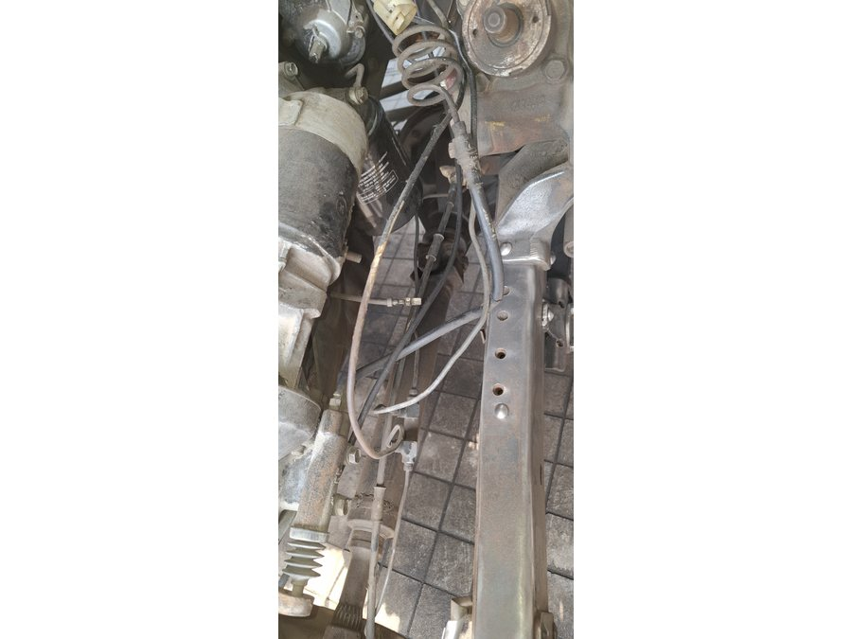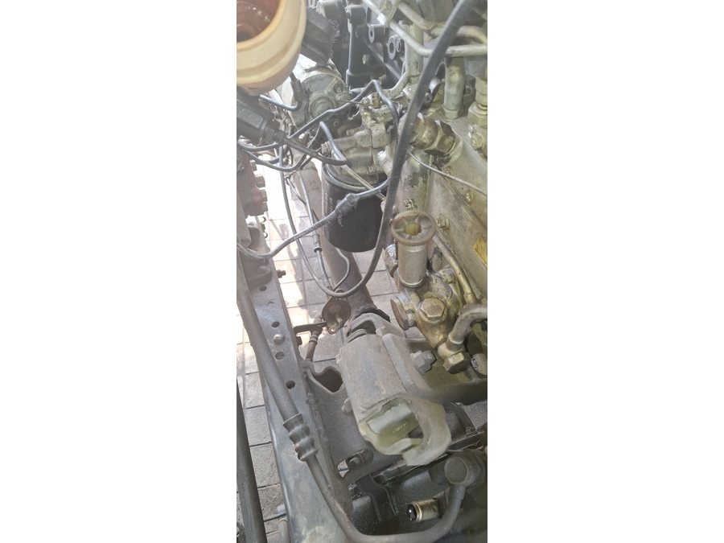 | RPO-FUEL-001B Low-pressure diesel return/bleed hose  Collect the return and bleed hose samples.  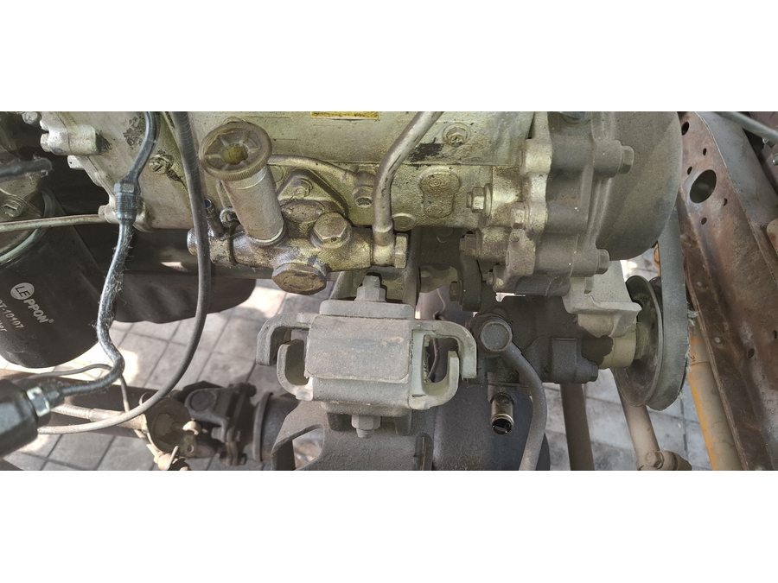
RPO-FUEL-001C Injector leak-off hose  Collect the small injector leak-off hose pieces and end/cap sample.  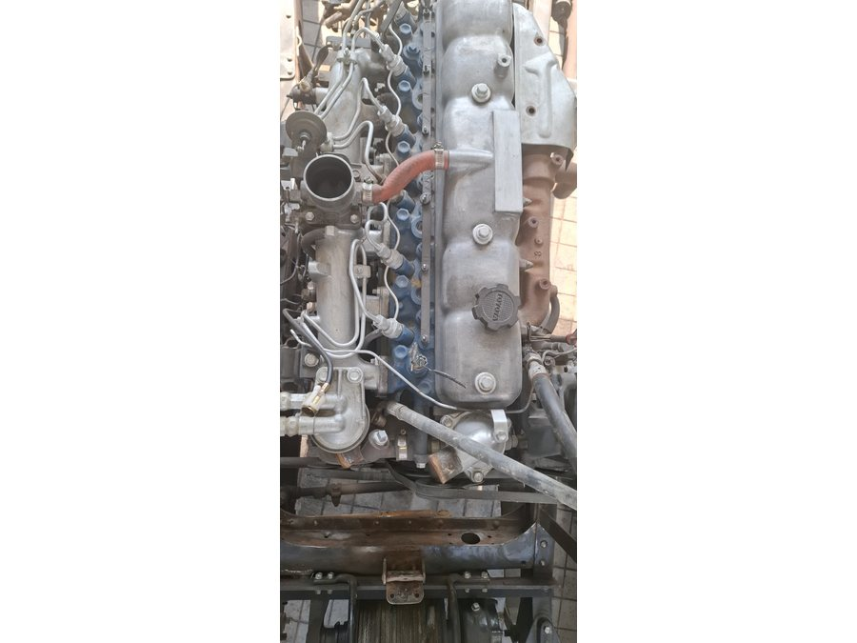 | RPO-FUEL-003 Filler neck and vent hoses  Collect the rubber filler neck hose and any vent hose from the tank/body area.  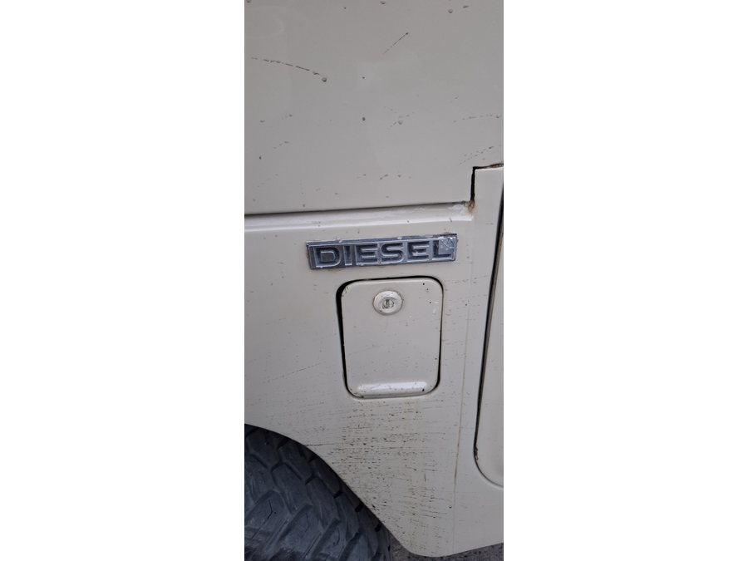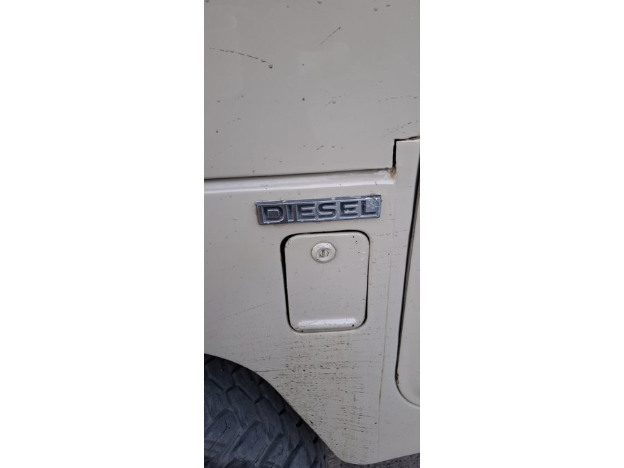

Vacuum / Breather / Drain
RPO-VAC-001A Brake-booster vacuum hose  Collect the booster vacuum hose and check-valve orientation if loose.  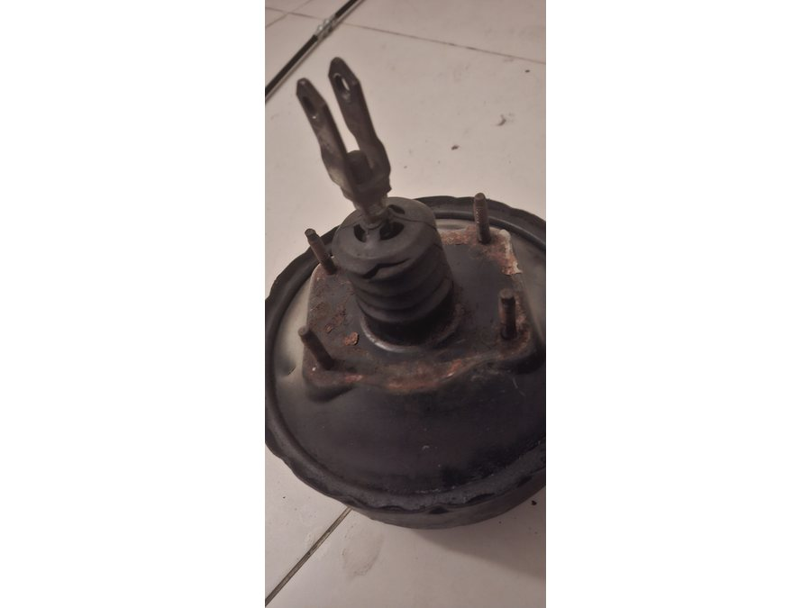 | RPO-VAC-001B Crankcase breather / oil-mist hose  Collect the crankcase breather or oil-mist hose sample.  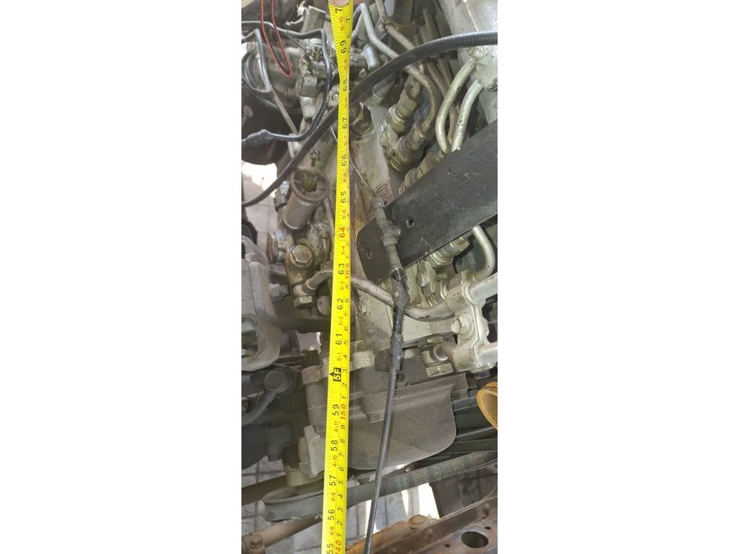
RPO-VAC-001C 2H vacuum pump oil outlet hose, if fitted  Check if this hose is fitted; collect it only if present.   | RPO-AIR-001 Engine air-cleaner intake duct/couplers  Collect the old rubber intake duct or couplers if present.  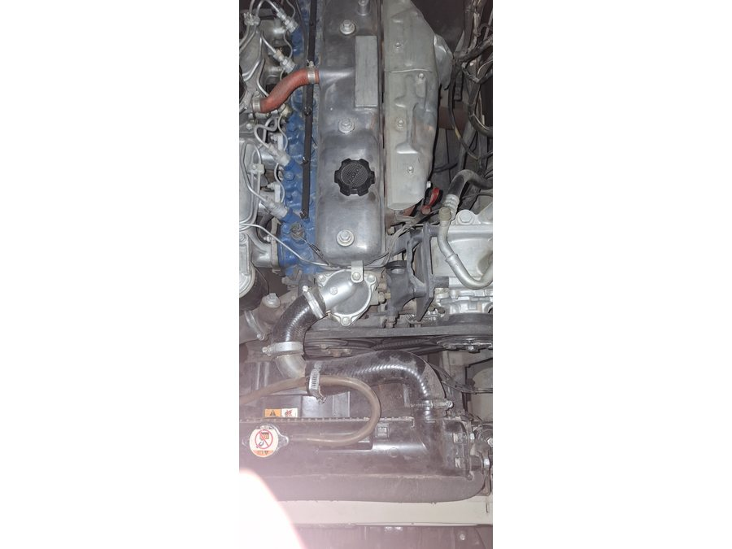
RPO-DRAIN-001 A/C condensate drain
Locate and collect the drain hose if the evaporator mock-up has one.
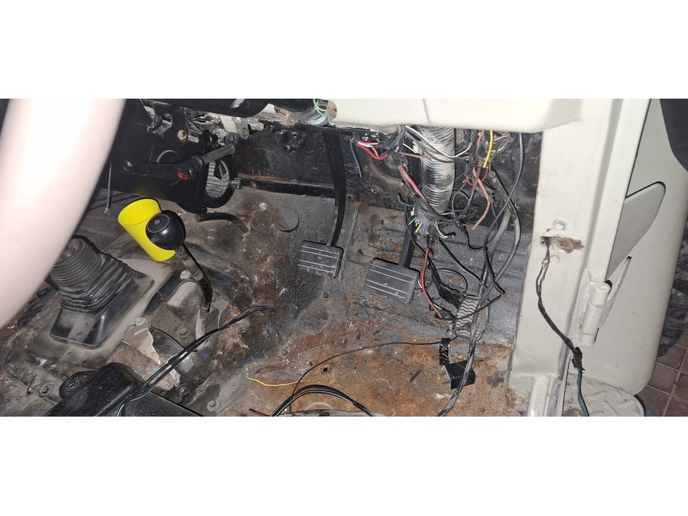

Hydraulic Flex Hoses
RPO-BRAKE-001A Brake flex hose assemblies  Collect front-left, front-right, and rear-centre old flex hose assemblies.  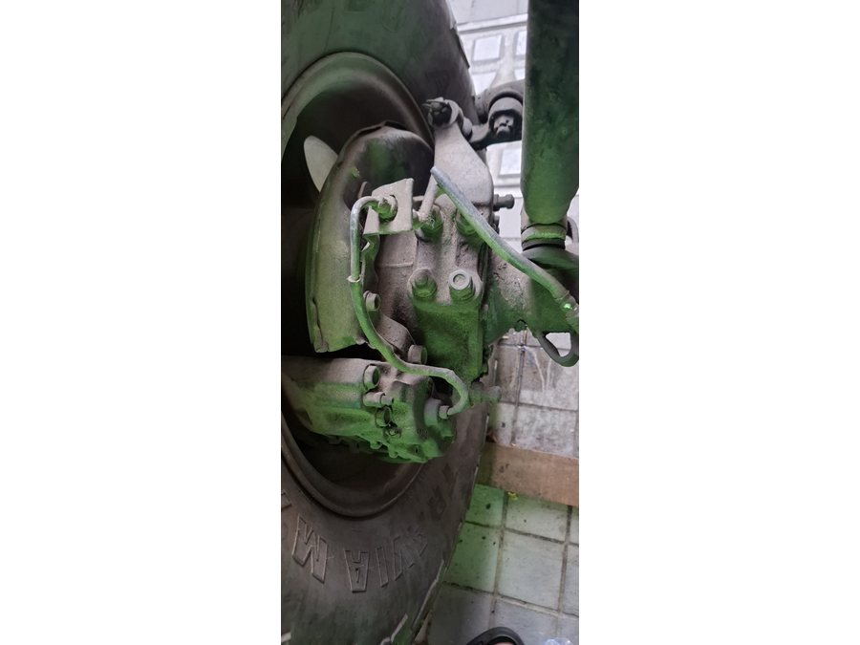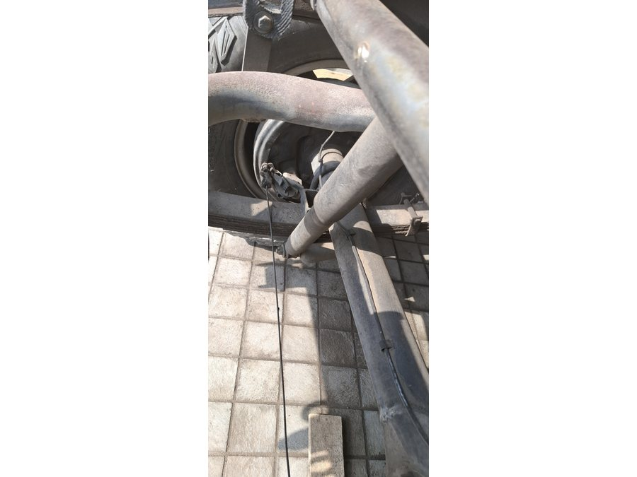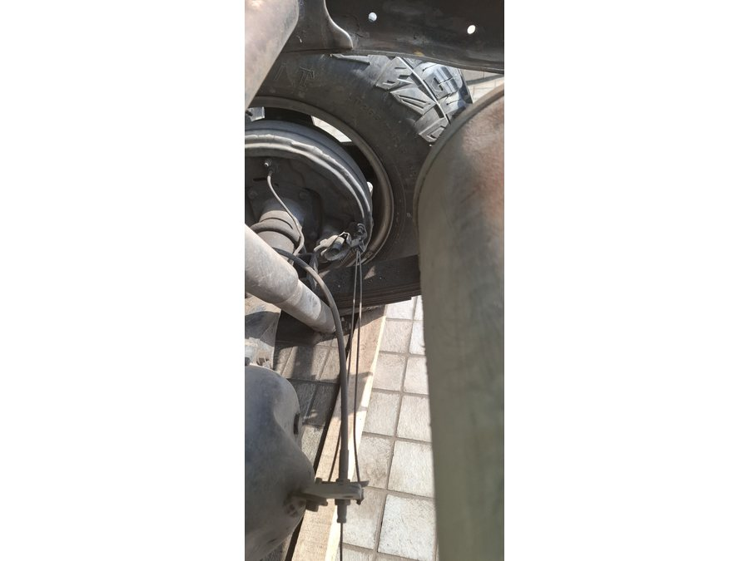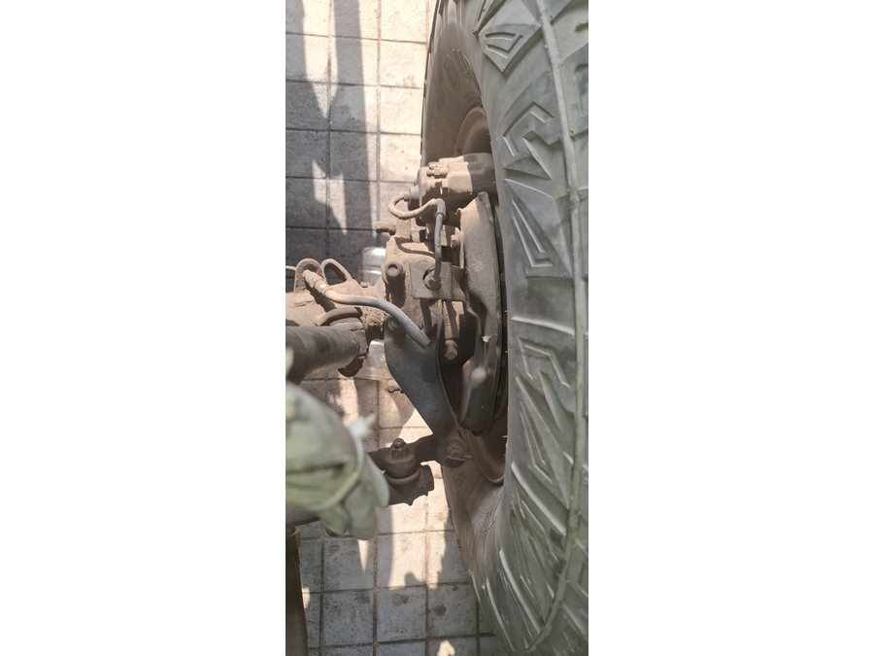 | RPO-CLUTCH-001A Clutch flex hose  Collect the old clutch flex hose assembly.  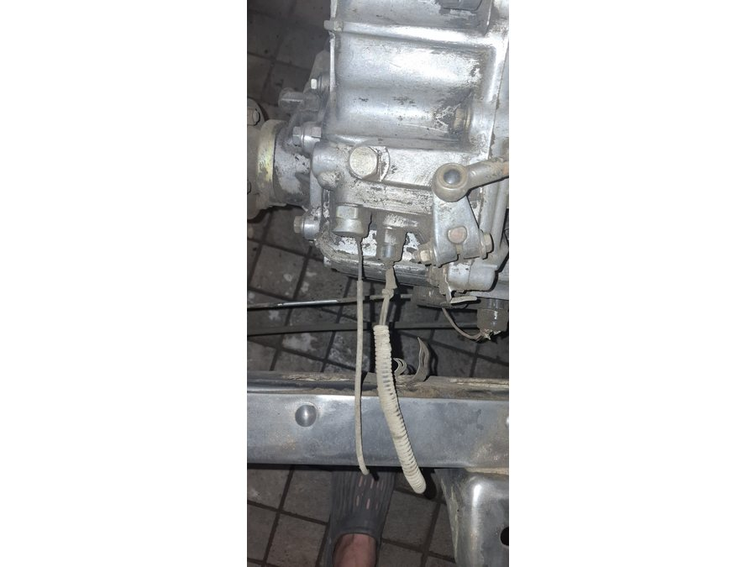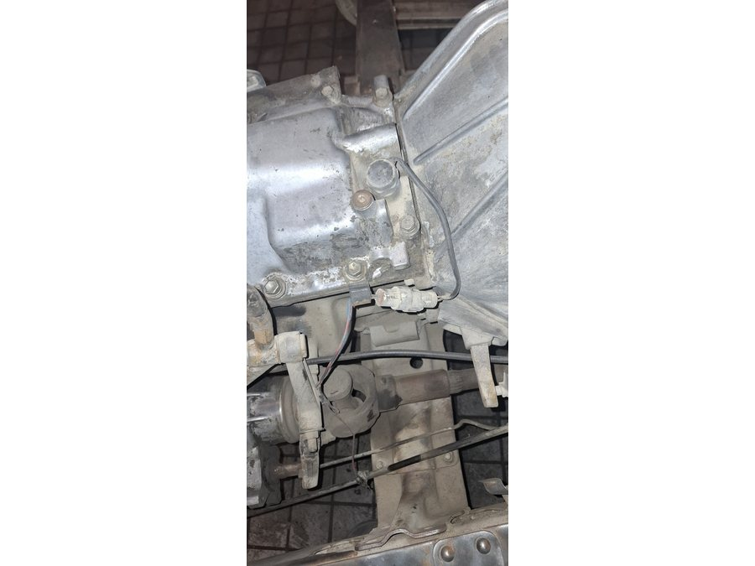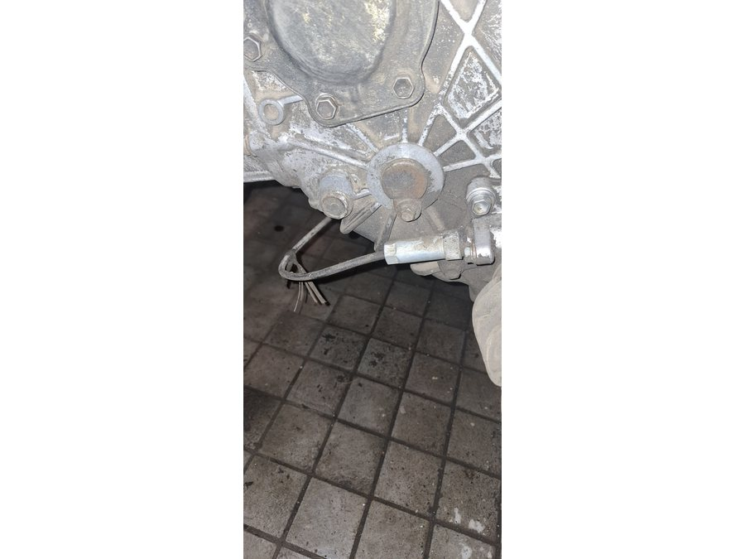

A/C Barrier Hoses
RPO-AC-001 Compressor discharge to condenser  No old sample expected; use route photos unless a fitted hose exists.  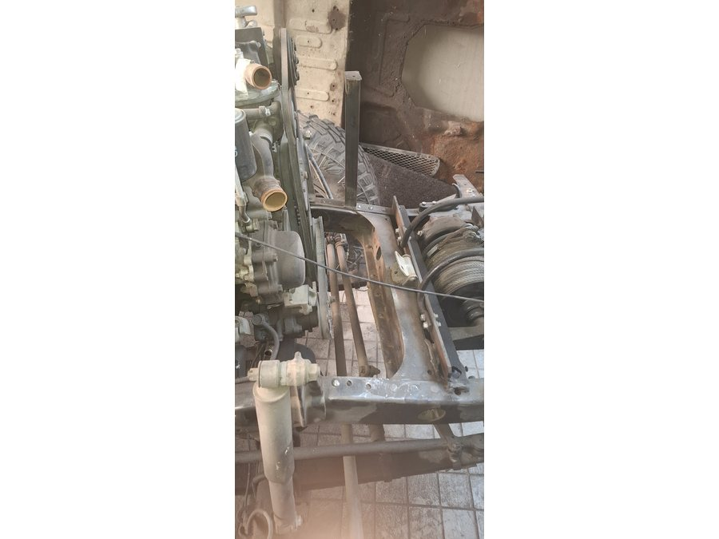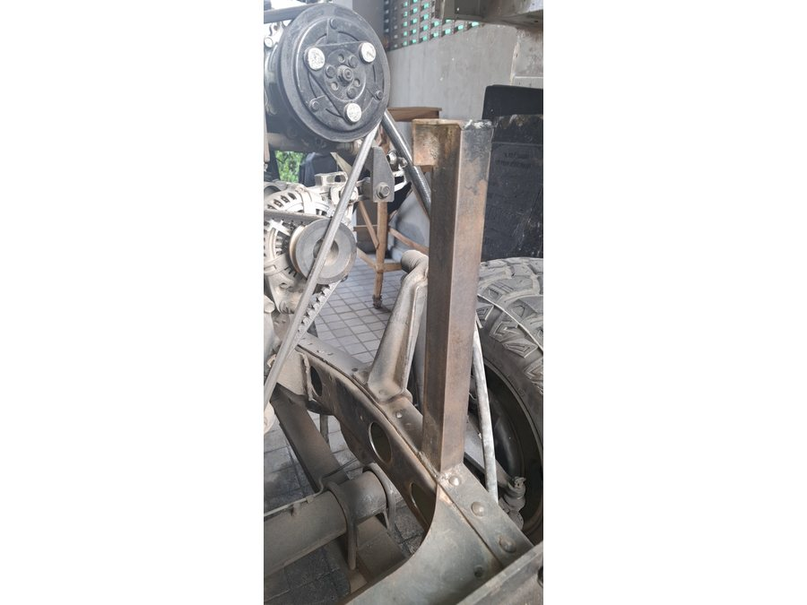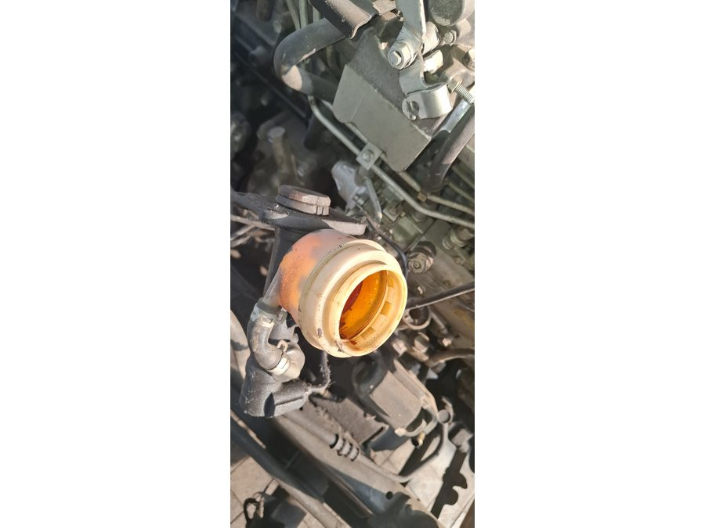 | RPO-AC-002 Condenser to receiver-drier liquid line  No old sample expected; use condenser/drier route photos for layout.  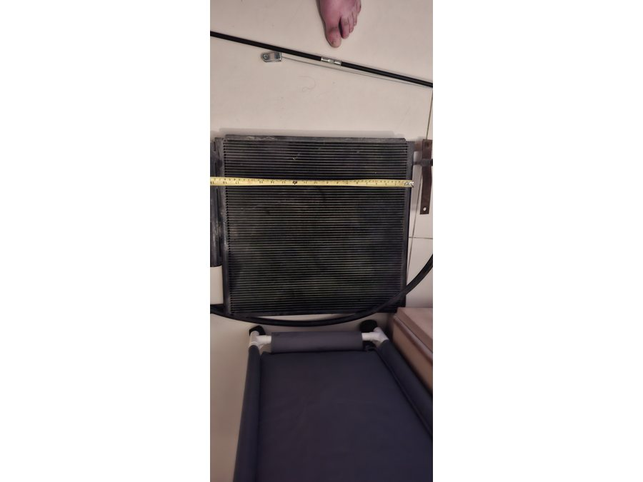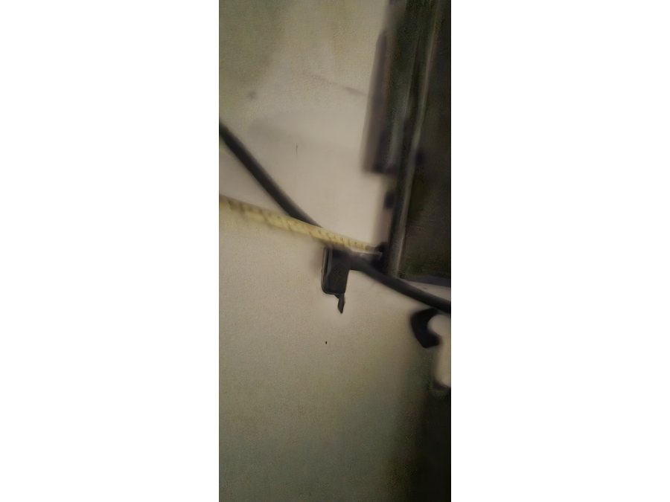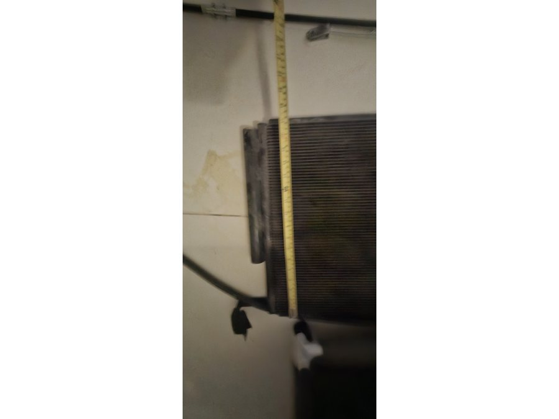
RPO-AC-003 Drier to evaporator and suction return
No old sample expected; use firewall/evaporator route photos for layout.
