Bilal Ganj Rubber Tubing Reproduction List
Toyota J40/HJ47 - 2H diesel build - rubber hoses and hose assemblies only - 2026-07-06
Scope: rubber tubing only. Excludes electrical wiring/cables, control cables, metal pipe, brake/fuel/clutch hard lines, P-clips, grommets, and guards.
Use the old sample and the vehicle dry-fit as the authority for final length, ID/OD, bends, fitting angles, clamp lands, and clocking.

Shop Rules
- Label every old hose before removal with the ID, end A/end B, route direction, and installed side.
- Photograph the hose in place, then photograph the removed sample beside a tape measure.
- Record free length, ID, OD, bend shape, clamp land, fitting angle, and any support or pass-through position.
- Use EPDM for coolant/heater hose, diesel-rated hose for fuel, oil-resistant hose for oil mist, reinforced hose where vacuum collapse is possible, and barrier hose for A/C.
- Brake and clutch flex hoses must be new crimped hydraulic-rated assemblies only.
- Dry-fit every replacement before payment: no kink, rub, stretch, twist, clamp mismatch, or heat/chafe conflict.

Priority Sample Bags
Bag | Contents
Cooling/heater | Upper radiator, lower radiator, overflow, heater inlet/outlet, and both formed-pipe connector hoses.
Fuel | Diesel feed, return/bleed, injector leak-off, filler neck, and vent hoses.
Vacuum/breather/intake | Brake-booster vacuum, crankcase breather, vacuum-pump oil outlet if fitted, and air-cleaner duct/couplers.
Hydraulic flex | Front-left, front-right, rear-center brake flex assemblies plus clutch flex assembly.
A/C | Barrier hose routes only after A/C hardware is positioned and fitting angles are known.

Rubber Tubing Reproduction List
Estimated lengths are ordering and dry-fit guides only. The old hose sample controls the final copied shape and cut.

Cooling and heater rubber hoses
Picture | Task details
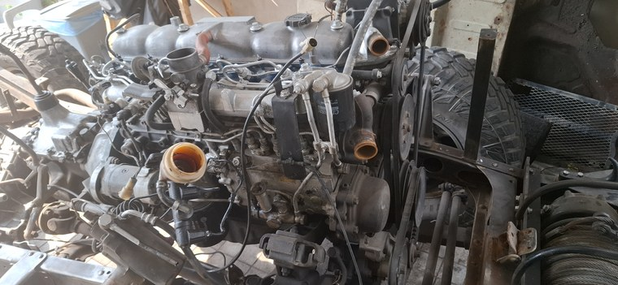  RPO-COOL-001 | RPO-COOL-001 - Upper radiator hose  Estimated length / order length: 355 mm molded free length basis  Collect and measure: Old upper hose if available; thermostat neck OD, radiator upper neck OD, clamp OD  Remake instruction: New molded EPDM upper radiator hose for HJ47/2H route. Shape controls; do not replace with straight hose by length alone.
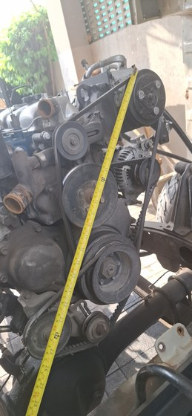  RPO-COOL-002 | RPO-COOL-002 - Lower radiator hose  Estimated length / order length: 480 mm molded free length basis  Collect and measure: Old lower hose if available; radiator lower outlet OD, engine/water-pump inlet OD, clamp OD  Remake instruction: New molded EPDM lower radiator hose for HJ47/2H route. Check lower bend clearance before coolant fill.
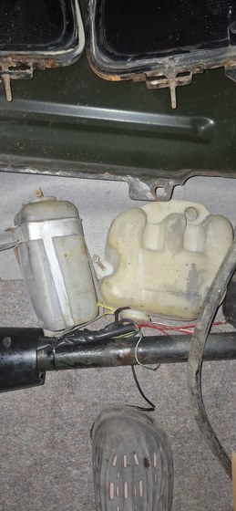  RPO-COOL-003 | RPO-COOL-003 - Radiator overflow hose  Estimated length / order length: Buy 1000 mm, OE reference 600 mm  Collect and measure: Radiator overflow nipple OD, bottle nipple OD, final route length  Remake instruction: Small EPDM coolant/overflow hose, cut on vehicle with clips/clamps matched to OD.
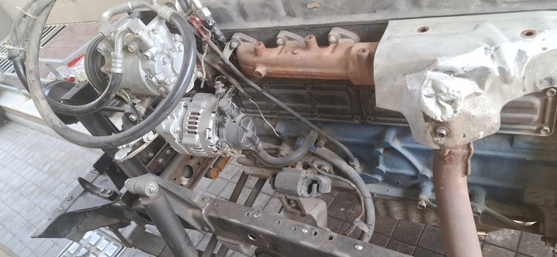  RPO-COOL-004A | RPO-COOL-004A - Heater inlet hose  Estimated length / order length: 400 mm cut from 1000 mm stock  Collect and measure: Engine heater nipple OD, heater-core nipple OD, clamp OD  Remake instruction: 16 mm / 5/8 in ID EPDM heater hose, SAE J20R3 or better; final ID by measured nipples.
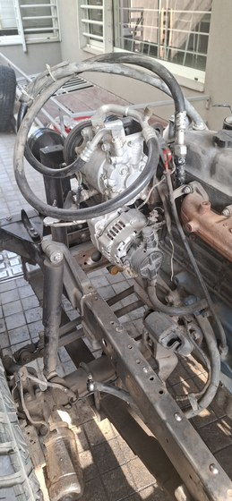  RPO-COOL-004B | RPO-COOL-004B - Heater outlet hose  Estimated length / order length: 280 mm cut from same 1000 mm stock  Collect and measure: Same as inlet; confirm no rear-heater branch  Remake instruction: 16 mm / 5/8 in ID EPDM heater hose, trimmed after dry-fit.
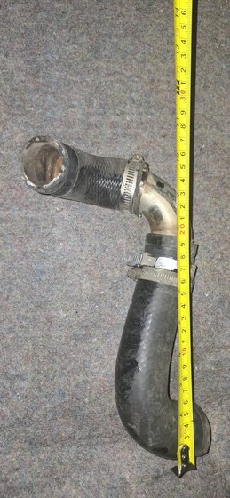  RPO-COOL-006A | RPO-COOL-006A - Formed-pipe connector hose A  Estimated length / order length: Buy 500 mm blank  Collect and measure: Old connector A, pipe-end OD/bead, mating spigot OD, final cut length, overlap  Remake instruction: New 28-30 mm ID EPDM radiator/coolant hose. Use straight only if it does not kink; otherwise match molded shape.
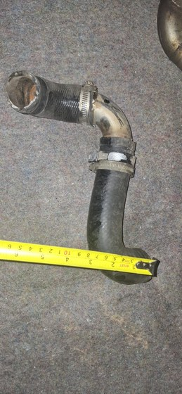  RPO-COOL-006B | RPO-COOL-006B - Formed-pipe connector hose B  Estimated length / order length: Buy 500 mm blank  Collect and measure: Old connector B, pipe-end OD/bead, mating spigot OD, final cut length, overlap  Remake instruction: Same as connector A. Old hose is a pattern only, not reused.

Diesel fuel and vent rubber hose
Picture | Task details
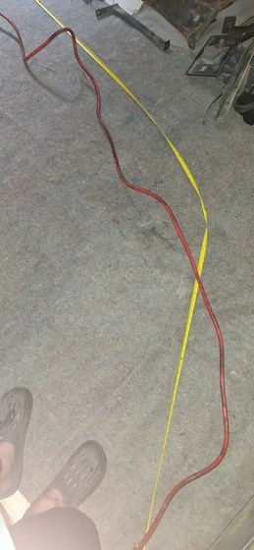  RPO-FUEL-001A | RPO-FUEL-001A - Low-pressure diesel feed hose  Estimated length / order length: Measured route about 1200 mm; buy 1500 mm  Collect and measure: Tank/chassis end OD, filter or pump barb OD, final cut length  Remake instruction: 8 mm ID diesel-rated hose, SAE J30R9/J30R14T2/DIN 73379-3E or equivalent. Use rolled-edge fuel clamps.
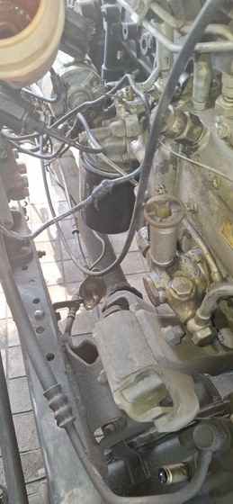  RPO-FUEL-001B | RPO-FUEL-001B - Low-pressure diesel return/bleed hose  Estimated length / order length: Buy 2000 mm  Collect and measure: Pump/filter return barb ODs, cut lengths, clamp OD  Remake instruction: 6 mm ID diesel-rated hose, cut on vehicle.
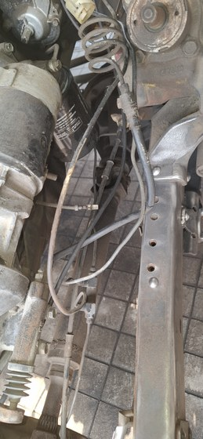  RPO-FUEL-001C | RPO-FUEL-001C - Injector leak-off hose  Estimated length / order length: Buy 1000 mm  Collect and measure: Injector nipple OD and end/cap arrangement  Remake instruction: 3.2-3.5 mm ID braided diesel leak-off hose. No vacuum/coolant substitute.
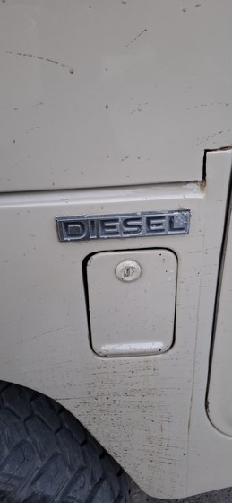  RPO-FUEL-003 | RPO-FUEL-003 - Filler neck and vent hoses  Estimated length / order length: CAD route estimate 440 mm; final by tank/body sample  Collect and measure: Filler neck OD, tank neck OD, vent nipple ODs, body pass-through  Remake instruction: Replace by old sample with diesel/fuel-compatible filler/vent hose and clamps. Dry-fit before body closeout.

Vacuum, breather, intake, and drain hose
Picture | Task details
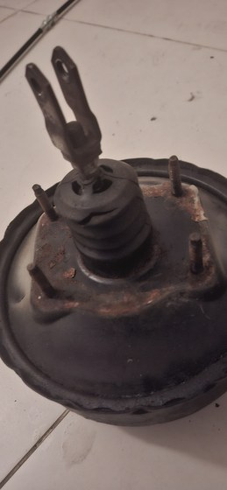  RPO-VAC-001A | RPO-VAC-001A - Brake-booster vacuum hose  Estimated length / order length: Buy 2000 mm  Collect and measure: Pump/booster/check-valve barb ODs, route, check-valve direction  Remake instruction: Reinforced oil-resistant vacuum hose, 10-12 mm ID, that will not collapse. Confirm brake assist vacuum after install.
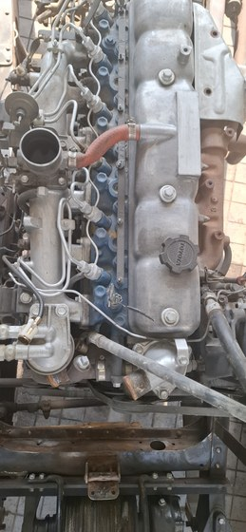  RPO-VAC-001B | RPO-VAC-001B - Crankcase breather / oil-mist hose  Estimated length / order length: Buy 1000 mm  Collect and measure: Breather spigot OD, route length, heat/oil exposure  Remake instruction: Oil-resistant NBR or fuel/oil-rated hose, 16-19 mm ID. Do not use coolant-only EPDM in oil mist.
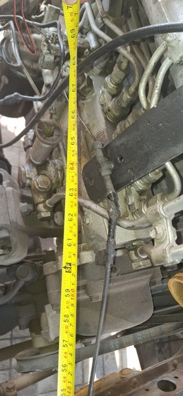  RPO-VAC-001C | RPO-VAC-001C - 2H vacuum pump oil outlet hose, if fitted  Estimated length / order length: TBD from fitted sample  Collect and measure: Confirm fitted presence, free length, end IDs, bend shape, fitting ODs  Remake instruction: Buy/make new oil-compatible molded hose only if this engine actually has it. Toyota/OEM 90923-02079 is reference only.
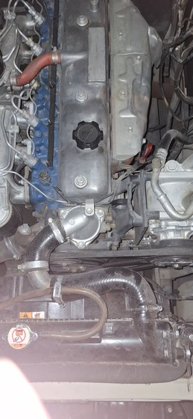  RPO-AIR-001 | RPO-AIR-001 - Engine air-cleaner intake duct/couplers  Estimated length / order length: TBD from old duct  Collect and measure: Air-cleaner outlet OD, intake/manifold inlet OD, branch nipple OD, free length, offset  Remake instruction: Match by sample using oil-mist-resistant intake duct rubber or reinforced air duct. No coolant/fuel/vacuum hose substitute.
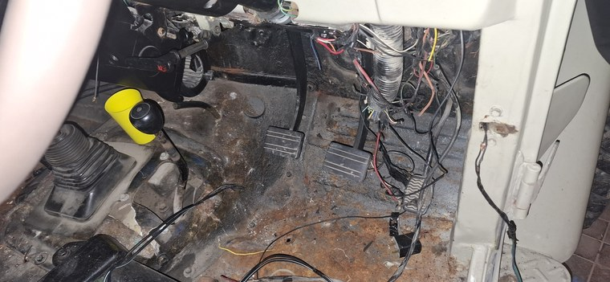  RPO-DRAIN-001 | RPO-DRAIN-001 - A/C condensate drain  Estimated length / order length: CAD route estimate 430 mm; buy 1000 mm  Collect and measure: Evaporator drain nipple OD, floor/firewall exit, fall direction  Remake instruction: 10-12 mm ID drain hose with grommet/duckbill if suitable. Water-pour test must drain outside cabin.

Hydraulic rubber hose assemblies
Picture | Task details
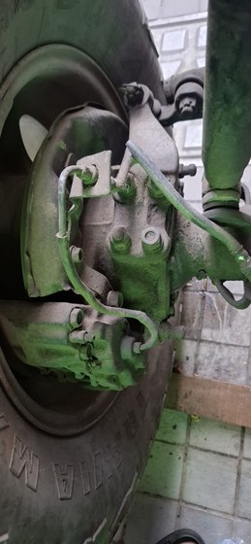  RPO-BRAKE-001A | RPO-BRAKE-001A - Brake flex hose assemblies  Estimated length / order length: 3 complete assemblies, free length copied from old hose; CAD front flex sweep about 250 mm each  Collect and measure: Front left, front right, rear center old hoses; end thread/banjo/seat; bracket groove  Remake instruction: New complete crimped DOT/SAE J1401 or OEM-equivalent brake hose assemblies only. No roll hose or used hose.
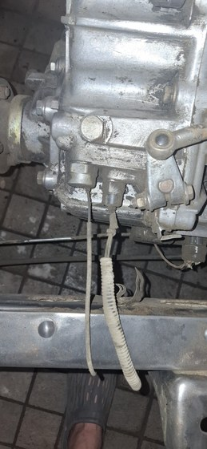  RPO-CLUTCH-001A | RPO-CLUTCH-001A - Clutch flex hose  Estimated length / order length: Free length copied from old assembly  Collect and measure: Master/slave end thread, seat, bracket retention, drivetrain movement  Remake instruction: New crimped brake/clutch hydraulic-rated assembly only.

A/C barrier rubber hose assemblies
Picture | Task details
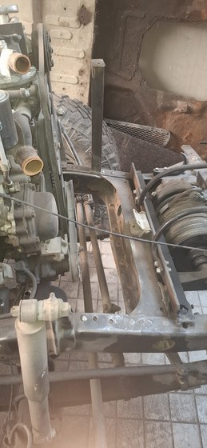  RPO-AC-001 | RPO-AC-001 - A/C compressor discharge to condenser  Estimated length / order length: CAD route estimate 680 mm; stock includes #8 discharge hose 1500 mm  Collect and measure: Compressor port, condenser port, fitting angle, service loop  Remake instruction: R134a barrier hose only. Do not crimp until compressor/condenser positions are fixed.
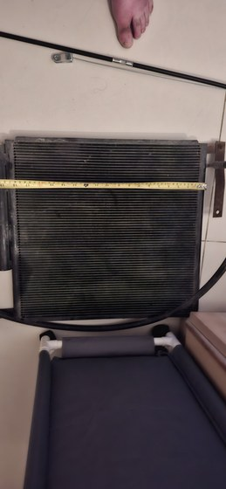  RPO-AC-002 | RPO-AC-002 - A/C condenser to receiver-drier liquid line  Estimated length / order length: CAD route estimate 930 mm; stock includes #6 liquid hose 3000 mm  Collect and measure: Condenser port, drier port, switch/service access  Remake instruction: R134a barrier hose with correct O-ring fittings. Dry-fit drier and switch before crimp.
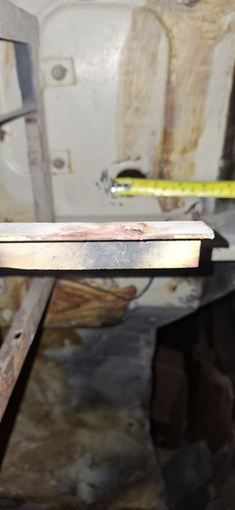  RPO-AC-003 | RPO-AC-003 - A/C drier to evaporator and suction return  Estimated length / order length: CAD route estimate 650 mm; stock includes #10 suction hose 2000 mm plus #6 liquid allowance  Collect and measure: Two firewall passages, bulkhead/grommet choice, TXV/compressor fittings  Remake instruction: R134a barrier hose and protected firewall pass-through. Crimp only after evaporator and compressor fittings are identified.

Excluded From This Rubber-Only Handoff
- Electrical wires, battery cables, ground straps, loom sleeves, and connector work.
- Parking-brake, throttle, choke, fuel-stop, heater-control, and speedometer cables.
- Brake, fuel, and clutch rigid hard lines.
- Formed metal coolant/radiator pipe.
- P-clips, grommets, guards, and general line-support hardware.

Final Fit Checks
- Cooling: Pressure-test coolant hoses and connector hoses before final fill.
- Fuel: Prime and leak-test feed, return, leak-off, filler, and vent hoses.
- Brake/clutch: Pressure bleed, hold pedal pressure, and sweep movement.
- Vacuum/breather: Confirm booster assist, check-valve direction, and no collapse.
- A/C: Nitrogen leak-test after crimp; do not charge before leak and wiring tests.
- Drain: Water-pour test must drain outside the cabin.

