Bilal Ganj Wire And Pipe Reproduction Task List
Embedded-photo handoff for old-sample collection and remake - 2026-07-06
Purpose: send this with the old samples so Bilal Ganj / Montgomery Road shops can remake the J40/HJ47 routed parts by sample. The photo in each row is the best available project evidence. Lengths are estimate/order lengths only; the removed sample and vehicle dry-fit control the final cut, bends, fittings, and clocking.
Vehicle basis: Toyota Land Cruiser J40/HJ47-style build with Toyota 2H diesel, rebuilt electrical power corner, front disc/rear drum brake layout, and planned under-dash A/C.

Non-Negotiable Shop Rules
- Tag before removal: tape-label each old part with the ID below, end A/end B, route direction, and installed side.
- Photograph each part in place before removal, then photograph the removed sample beside a tape measure.
- Keep old hoses, hard lines, and wires intact where possible. Do not cut a sample unless the new part has already been copied.
- For every hose or pipe, record free length, ID, OD, wall/thickness if metal, fitting size, bend direction, clamp land, and any clip or grommet position.
- For every wire, record gauge, colour/marking, lug hole size, terminal type, route, protection sleeve, and support points.
- Brake and clutch hydraulic parts must be new brake/clutch-rated parts. No used hose, generic roll hose, compression fittings, single flare unless sample-proven, or bare copper tube.
- Fuel hose must be diesel-rated. No coolant hose, vacuum hose, clear PVC, washer pipe, or sharp perforated clamps.
- Coolant/heater hose must be EPDM coolant hose. Do not substitute fuel hose or soft water pipe.
- A/C barrier hoses must not be crimped until compressor, condenser, drier, evaporator, and firewall pass-through locations are dry-fitted.
- High-pressure injector pipes are out of scope for generic fabrication. If any injector pipe is bad, source the correct 2H pipe by cylinder/sample.

Priority Collection Pack
- Formed coolant pipe with both short connector hoses and clamps.
- Upper/lower radiator hose samples if present.
- Heater inlet/outlet hose samples.
- Diesel feed, return, and leak-off hose samples.
- Brake flex hoses: front left, front right, rear center, plus any extra front frame hose if fitted.
- One intact brake hard-line sample with flare nut for thread/seat/flare proof.
- Clutch flex hose and clutch hard line.
- Fuel hard-line sections if separate rigid feed/return lines exist.
- Battery/starter/alternator/ground heavy cables and all loose lugs.
- Front/rear/dash loom bundles only if a loom is being remade; otherwise keep built loom and verify.

Pipes, Hoses, And Hard Lines
Evidence | Task Details
RPO-COOL-001  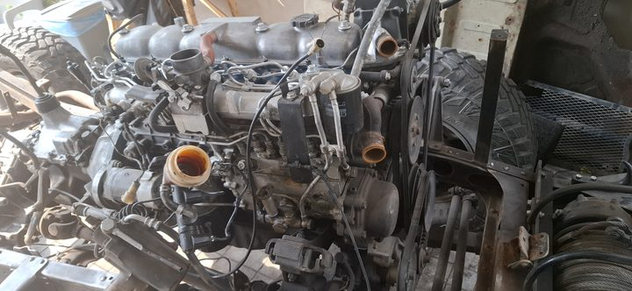  Length: 355 mm molded free length basis | Upper radiator hose  Collect / measure: Old upper hose if available; thermostat neck OD, radiator upper neck OD, clamp OD  Reproduce / verify: New molded EPDM upper radiator hose for HJ47/2H route. Shape controls; do not replace with straight hose by length alone.
RPO-COOL-002  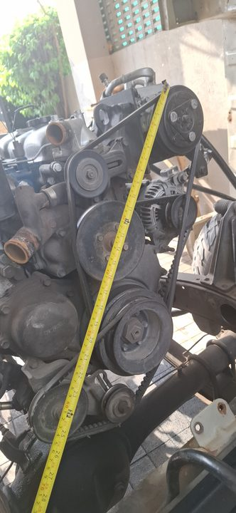  Length: 480 mm molded free length basis | Lower radiator hose  Collect / measure: Old lower hose if available; radiator lower outlet OD, engine/water-pump inlet OD, clamp OD  Reproduce / verify: New molded EPDM lower radiator hose for HJ47/2H route. Check lower bend clearance before coolant fill.
RPO-COOL-003  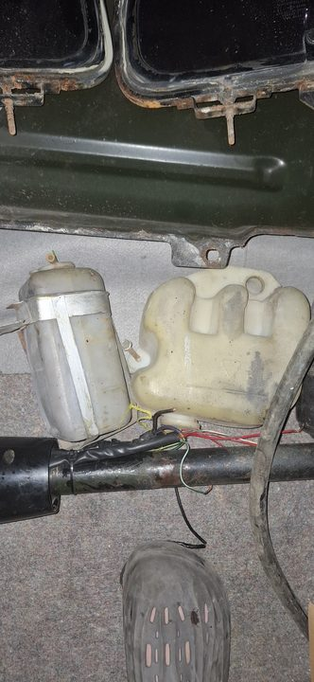  Length: Buy 1000 mm, OE reference 600 mm | Radiator overflow hose  Collect / measure: Radiator overflow nipple OD, bottle nipple OD, final route length  Reproduce / verify: Small EPDM coolant/overflow hose, cut on vehicle with clips/clamps matched to OD.
RPO-COOL-004A  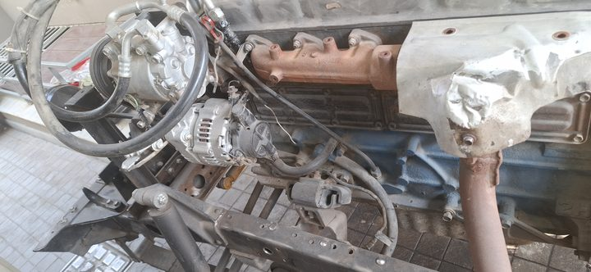  Length: 400 mm cut from 1000 mm stock | Heater inlet hose  Collect / measure: Engine heater nipple OD, heater-core nipple OD, clamp OD  Reproduce / verify: 16 mm / 5/8 in ID EPDM heater hose, SAE J20R3 or better; final ID by measured nipples.
RPO-COOL-004B  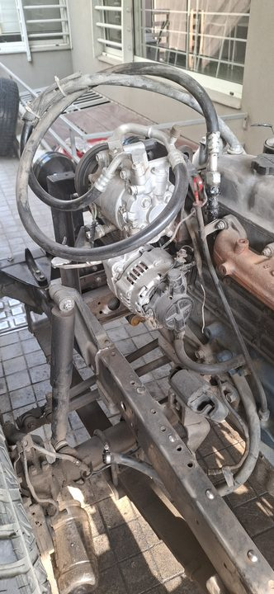  Length: 280 mm cut from same 1000 mm stock | Heater outlet hose  Collect / measure: Same as inlet; confirm no rear-heater branch  Reproduce / verify: 16 mm / 5/8 in ID EPDM heater hose, trimmed after dry-fit.
RPO-COOL-005  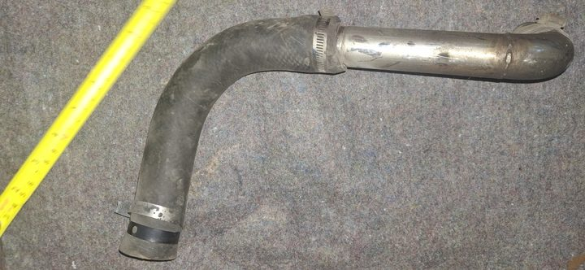  Length: Quote 1000 mm tube stock; 750 mm absolute minimum blank | Formed metal coolant/radiator pipe  Collect / measure: Old formed pipe, tube OD, wall, centerline length, bend radii, bend clocking, bead height  Reproduce / verify: Fabricate from physical sample in 28-30 mm OD, 1.2-1.6 mm wall coolant-compatible tube. Add beaded ends and 25-30 mm clamp lands. Pressure-test before coating.
RPO-COOL-006A  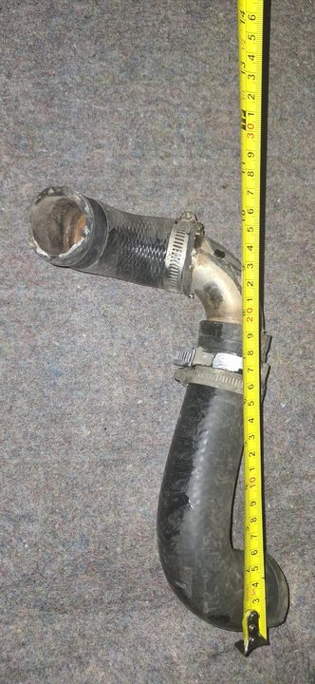  Length: Buy 500 mm blank | Formed-pipe connector hose A  Collect / measure: Old connector A, pipe-end OD/bead, mating spigot OD, final cut length, overlap  Reproduce / verify: New 28-30 mm ID EPDM radiator/coolant hose. Use straight only if it does not kink; otherwise match molded shape.
RPO-COOL-006B  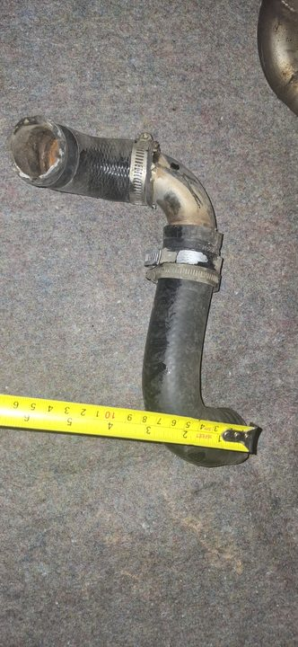  Length: Buy 500 mm blank | Formed-pipe connector hose B  Collect / measure: Old connector B, pipe-end OD/bead, mating spigot OD, final cut length, overlap  Reproduce / verify: Same as connector A. Old hose is a pattern only, not reused.
RPO-FUEL-001A  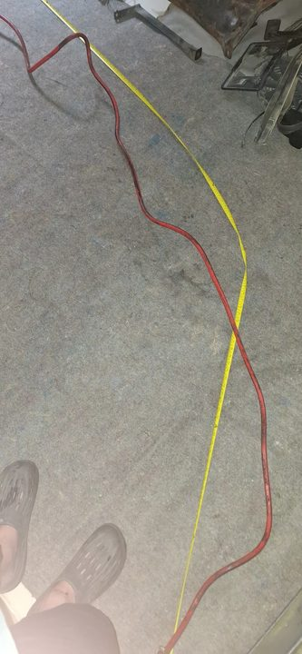  Length: Measured route about 1200 mm; buy 1500 mm | Low-pressure diesel feed hose  Collect / measure: Tank/chassis end OD, filter or pump barb OD, final cut length  Reproduce / verify: 8 mm ID diesel-rated hose, SAE J30R9/J30R14T2/DIN 73379-3E or equivalent. Use rolled-edge fuel clamps.
RPO-FUEL-001B  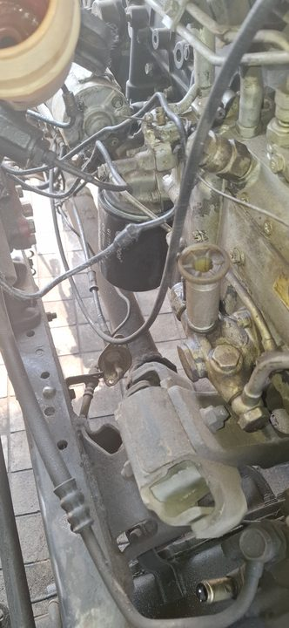  Length: Buy 2000 mm | Low-pressure diesel return/bleed hose  Collect / measure: Pump/filter return barb ODs, cut lengths, clamp OD  Reproduce / verify: 6 mm ID diesel-rated hose, cut on vehicle.
RPO-FUEL-001C  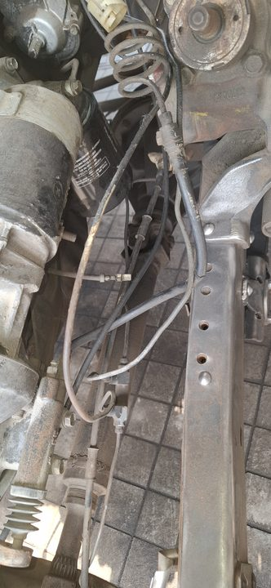  Length: Buy 1000 mm | Injector leak-off hose  Collect / measure: Injector nipple OD and end/cap arrangement  Reproduce / verify: 3.2-3.5 mm ID braided diesel leak-off hose. No vacuum/coolant substitute.
RPO-FUEL-002A  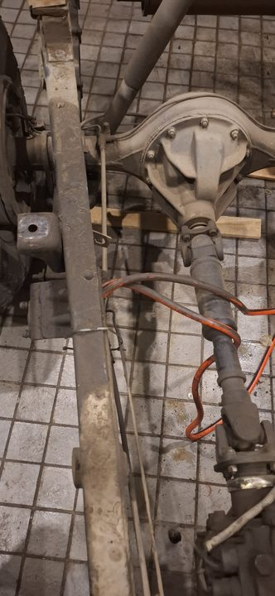  Length: Conditional 5000 mm stock allowance | Conditional rigid fuel feed hard line  Collect / measure: Confirm a separate rigid feed line exists beyond the flexible feed hose; copy bends, unions, clips  Reproduce / verify: New 8 mm OD automotive bundy steel or CuNi/Cunifer tube only where a rigid feed line exists. Do not duplicate the measured flexible feed hose.
RPO-FUEL-002B  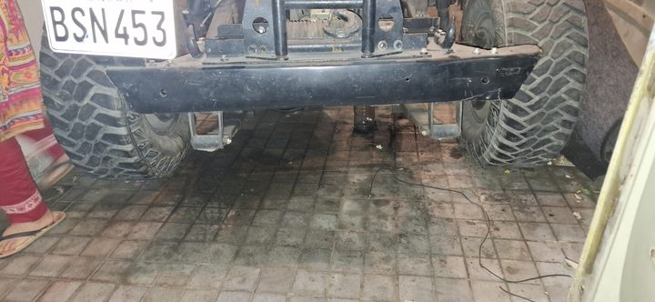  Length: 5000 mm stock allowance | Rigid fuel return hard line  Collect / measure: Old return hard-line route, union/end style, bends, clip points  Reproduce / verify: New 6 mm OD automotive bundy steel or CuNi/Cunifer tube. No bare copper or plumbing tube.
RPO-FUEL-003  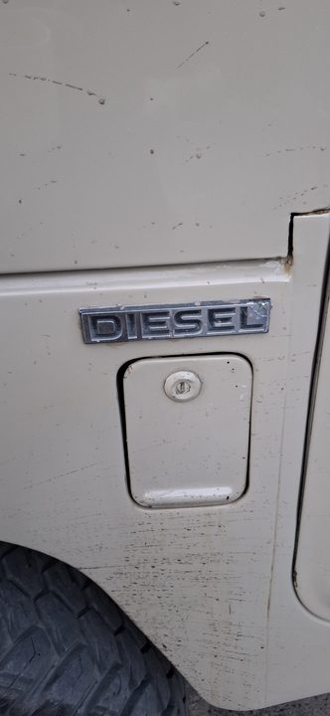  Length: CAD route estimate 440 mm; final by tank/body sample | Filler neck and vent hoses  Collect / measure: Filler neck OD, tank neck OD, vent nipple ODs, body pass-through  Reproduce / verify: Replace by old sample with diesel/fuel-compatible filler/vent hose and clamps. Dry-fit before body closeout.
RPO-VAC-001A  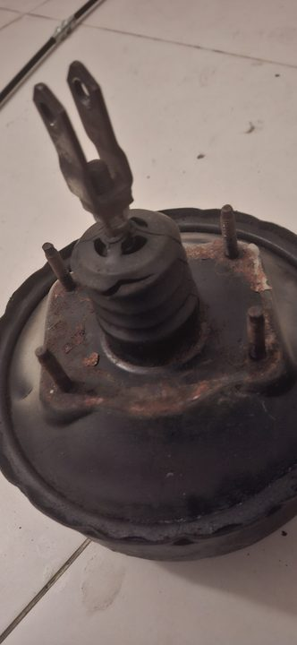  Length: Buy 2000 mm | Brake-booster vacuum hose  Collect / measure: Pump/booster/check-valve barb ODs, route, check-valve direction  Reproduce / verify: Reinforced oil-resistant vacuum hose, 10-12 mm ID, that will not collapse. Confirm brake assist vacuum after install.
RPO-VAC-001B  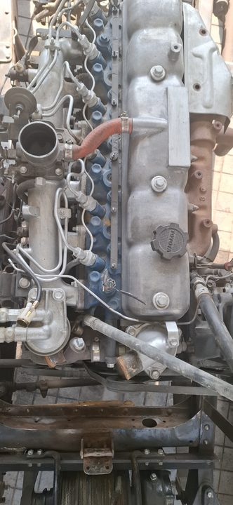  Length: Buy 1000 mm | Crankcase breather / oil-mist hose  Collect / measure: Breather spigot OD, route length, heat/oil exposure  Reproduce / verify: Oil-resistant NBR or fuel/oil-rated hose, 16-19 mm ID. Do not use coolant-only EPDM in oil mist.
RPO-VAC-001C  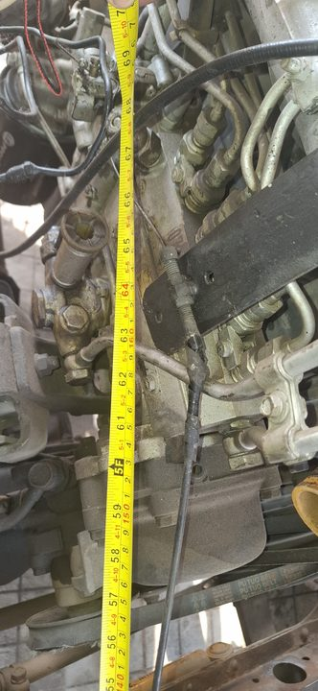  Length: TBD from fitted sample | 2H vacuum pump oil outlet hose, if fitted  Collect / measure: Confirm fitted presence, free length, end IDs, bend shape, fitting ODs  Reproduce / verify: Buy/make new oil-compatible molded hose only if this engine actually has it. Toyota/OEM 90923-02079 is reference only.
RPO-AIR-001  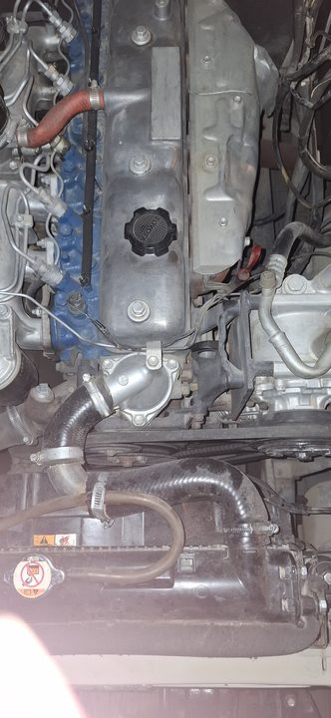  Length: TBD from old duct | Engine air-cleaner intake duct/couplers  Collect / measure: Air-cleaner outlet OD, intake/manifold inlet OD, branch nipple OD, free length, offset  Reproduce / verify: Match by sample using oil-mist-resistant intake duct rubber or reinforced air duct. No coolant/fuel/vacuum hose substitute.
RPO-BRAKE-001A  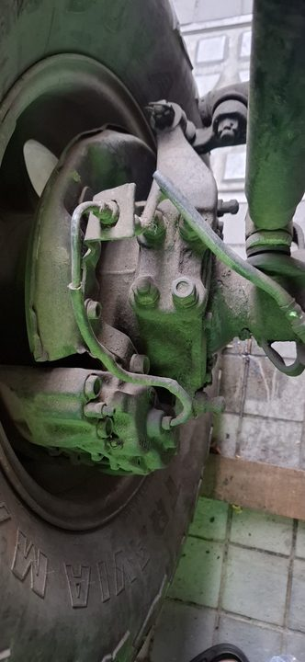  Length: 3 complete assemblies, free length copied from old hose; CAD front flex sweep about 250 mm each | Brake flex hose assemblies  Collect / measure: Front left, front right, rear center old hoses; end thread/banjo/seat; bracket groove  Reproduce / verify: New complete crimped DOT/SAE J1401 or OEM-equivalent brake hose assemblies only. No roll hose or used hose.
RPO-BRAKE-001B  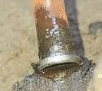  Length: 7600 mm / 25 ft brake-only coil; 10000-12000 mm if brake+clutch combined | Brake hard lines  Collect / measure: Remove one old line intact; confirm 4.75 mm / 3/16 in OD, flare, thread, seat, bend template  Reproduce / verify: New brake-rated bundy steel or CuNi/Cunifer tube. Working basis is Toyota-style double/inverted flare, but old sample controls.
RPO-BRAKE-001C  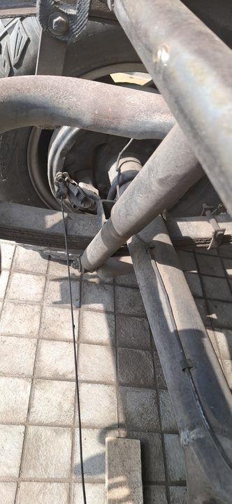  Length: CAD route estimate 920 mm | Front brake master/proportioning to crossmember run  Collect / measure: Master/proportioning fittings, clips, steering/full-lock clearance  Reproduce / verify: Cut from brake coil after flare/thread proof. Pressure bleed and full-lock clearance test before road use.
RPO-BRAKE-001D  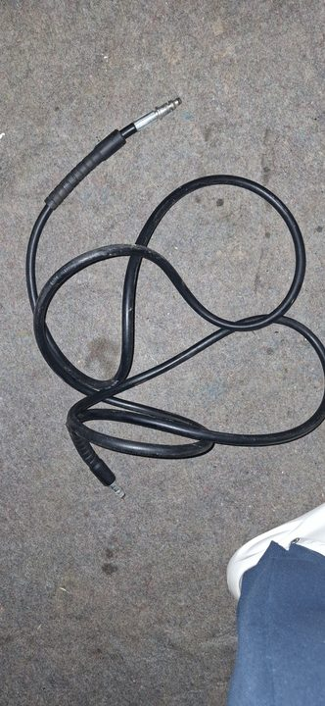  Length: CAD route estimate 1330 mm; rear center flex length copied from sample | Rear axle hard line, center flex, wheel-cylinder lines  Collect / measure: Rear T, axle hard lines, wheel-cylinder entries, clip points  Reproduce / verify: New brake-rated hard lines and complete center flex assembly. Sweep axle/suspension before coating closeout.
RPO-CLUTCH-001A  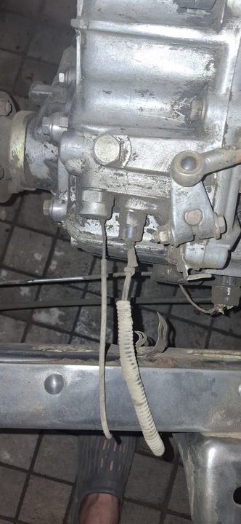  Length: Free length copied from old assembly | Clutch flex hose  Collect / measure: Master/slave end thread, seat, bracket retention, drivetrain movement  Reproduce / verify: New crimped brake/clutch hydraulic-rated assembly only.
RPO-CLUTCH-001B  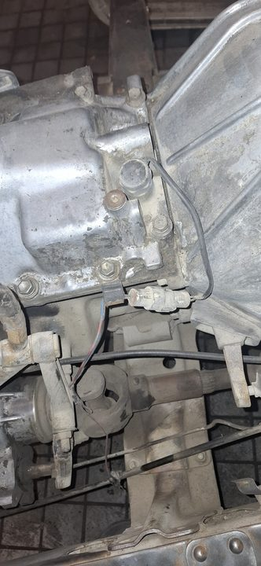  Length: 1500 mm blank allowance | Clutch hard line  Collect / measure: Master-to-slave route, 4.75 mm / 3/16 in OD, flare/thread/seat  Reproduce / verify: New brake/clutch-rated bundy steel or CuNi/Cunifer line, cut and flared after sample proof.
RPO-AC-001  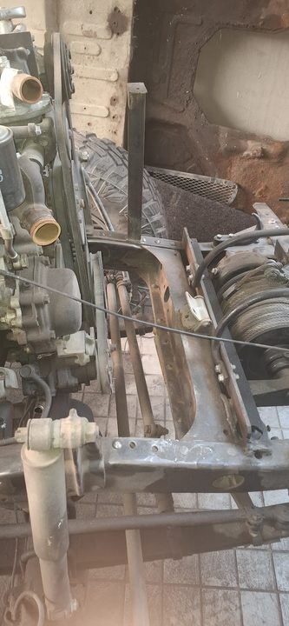  Length: CAD route estimate 680 mm; stock includes #8 discharge hose 1500 mm | A/C compressor discharge to condenser  Collect / measure: Compressor port, condenser port, fitting angle, service loop  Reproduce / verify: R134a barrier hose only. Do not crimp until compressor/condenser positions are fixed.
RPO-AC-002  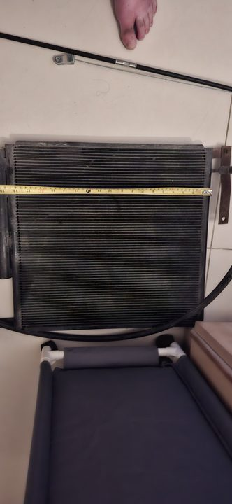  Length: CAD route estimate 930 mm; stock includes #6 liquid hose 3000 mm | A/C condenser to receiver-drier liquid line  Collect / measure: Condenser port, drier port, switch/service access  Reproduce / verify: R134a barrier hose with correct O-ring fittings. Dry-fit drier and switch before crimp.
RPO-AC-003  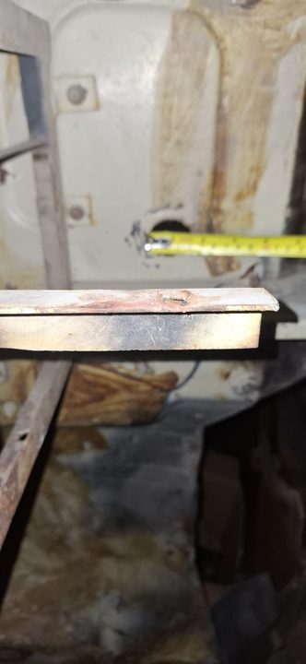  Length: CAD route estimate 650 mm; stock includes #10 suction hose 2000 mm plus #6 liquid allowance | A/C drier to evaporator and suction return  Collect / measure: Two firewall passages, bulkhead/grommet choice, TXV/compressor fittings  Reproduce / verify: R134a barrier hose and protected firewall pass-through. Crimp only after evaporator and compressor fittings are identified.
RPO-DRAIN-001  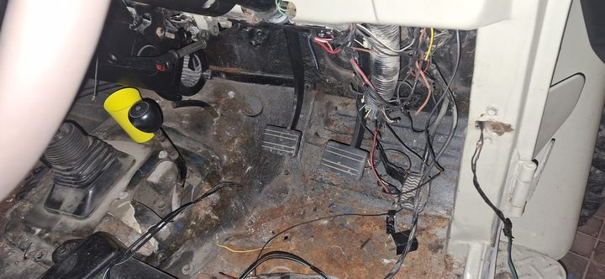  Length: CAD route estimate 430 mm; buy 1000 mm | A/C condensate drain  Collect / measure: Evaporator drain nipple OD, floor/firewall exit, fall direction  Reproduce / verify: 10-12 mm ID drain hose with grommet/duckbill if suitable. Water-pour test must drain outside cabin.
RPO-CLIP-001  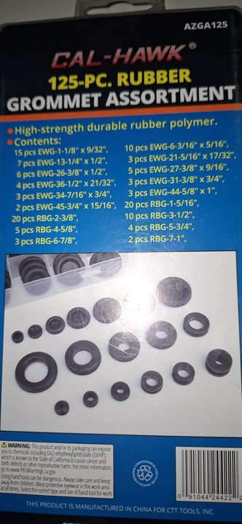  Length: On-hand assortment; buy only missing sizes | P-clips, grommets, guards for all hard lines and cables  Collect / measure: Match to 4.75, 6, 8, 10, 12, 16, 20, 25, 32 mm OD/bundle sizes  Reproduce / verify: Rubber-lined P-clips and edge/pass-through protection. No cable ties as permanent fuel/brake/clutch support.

Electrical Wires, Cables, And Looms
Evidence | Task Details
HD1-PWR-04  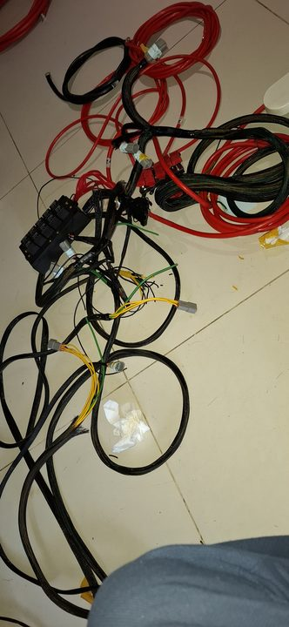  Length: 25 mm2 red, 0.30 m plus up to 50 mm slack | Battery positive to 100A breaker input  Collect / measure: Battery post terminal, breaker stud size, lug hole size  Reproduce / verify: Separate cable with crimped lugs, adhesive heat-shrink, and ID label. Do not leave as part of one long run.
HD1-PWR-05  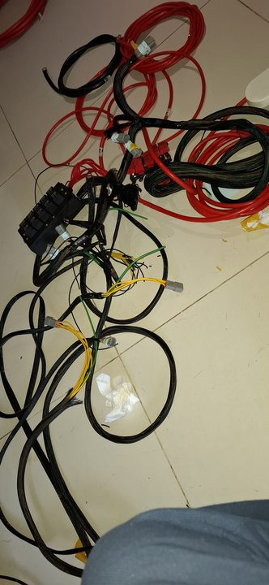  Length: 25 mm2 red, 0.60 m plus slack | 100A breaker output to junction stud  Collect / measure: Breaker output stud, junction stud, route bend  Reproduce / verify: Separate cable, labelled both ends, continuity and voltage-drop checked.
HD1-PWR-06  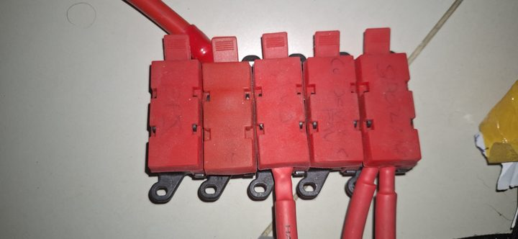  Length: 25 mm2 red, 0.30 m plus slack | Junction stud to MIDI/ANL fuse block input  Collect / measure: Junction stud, fuse block input stud, grommet/guard  Reproduce / verify: Separate cable with proper lug clocking and bend radius.
HD1-PWR-10    Length: 25 mm2, 1.00 m | Fused output to glow plug feed  Collect / measure: Glow feed endpoint, fuse rating, route heat clearance  Reproduce / verify: Keep independent heavy branch. Fuse/load-test glow circuit before final wrap.
HD1-PWR-11    Length: 25 mm2, 1.00 m | Fused output to EPS feed  Collect / measure: EPS donor/controller endpoint when selected, pass-through, fuse rating  Reproduce / verify: Keep 25 mm2 plan unless EPS load is deliberately re-specified. EPS route not closed until adapter/controller access is proven.
HD1-PWR-13  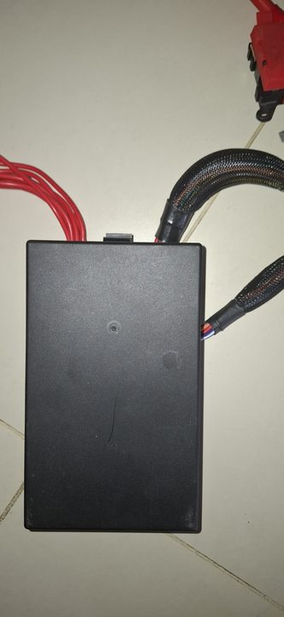  Length: 16 mm2, 1.00 m | Junction to relay bank  Collect / measure: Junction stud, relay bank input, protection sleeve  Reproduce / verify: Independent feed with lugs/rings. Load test relay outputs before final wrap.
HD1-PWR-09  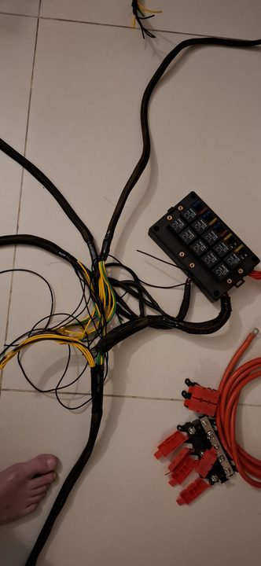  Length: 16 mm2, 5.00 m | Fused output to amp/sub accessory  Collect / measure: Actual accessory location, fuse rating, cabin pass-through  Reproduce / verify: Route only if audio accessory remains in scope; otherwise hold as spare stock.
HD1-PWR-14  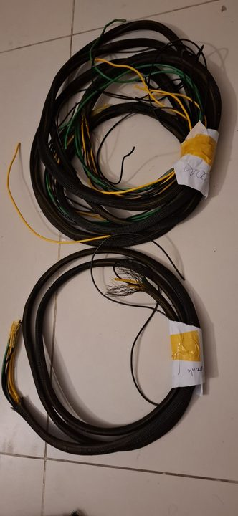  Length: 10 mm2, 1.50 m | Junction to ignition relay  Collect / measure: Junction stud, ignition relay input, fuse plan  Reproduce / verify: Independent protected feed. Label both ends.
HD1-PWR-15  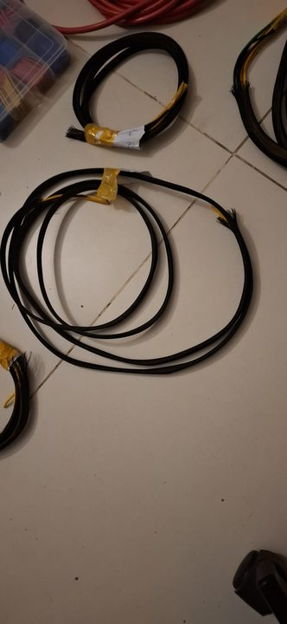  Length: 10 mm2, 1.20 m | Junction to dash constant feed  Collect / measure: Dash fuse carrier input, pass-through/grommet, fuse grouping  Reproduce / verify: Supports under-dash constant feed group. Confirm rear terminal protection on fuse block.
HD1-PWR-07  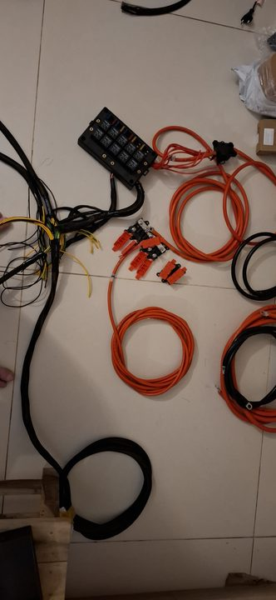  Length: 6 mm2, 1.50 m | Fused accessory area #1  Collect / measure: Accessory endpoint and fuse rating  Reproduce / verify: Optional accessory feed. Only terminate when destination is named.
HD1-PWR-08  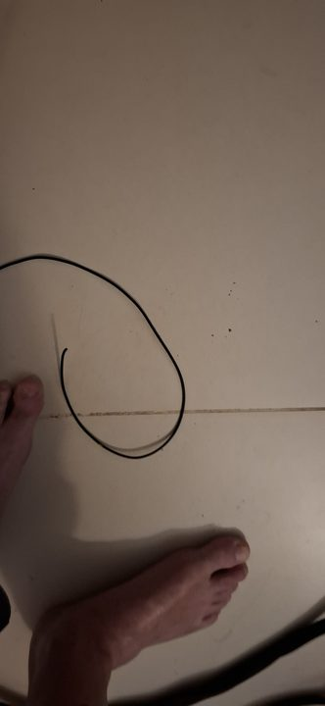  Length: 6 mm2, 1.50 m | Fused accessory area #2  Collect / measure: Accessory endpoint and fuse rating  Reproduce / verify: Optional accessory feed. Only terminate when destination is named.
J40-RT-002  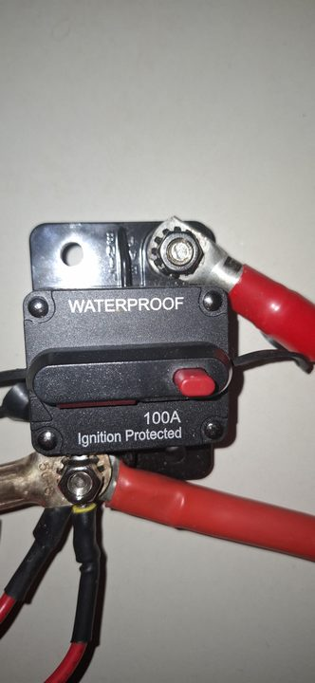  Length: CAD route estimate 430 mm | Battery positive to cutoff / power-corner sweep  Collect / measure: Cable centerline, lug clocking, cutoff entry/exit, guard/grommet  Reproduce / verify: Use as-fitted route estimate for dry-fit only. Final cable follows installed cutoff/breaker layout.
J40-RT-003    Length: CAD route estimate 430 mm | Cutoff output to relay-box feed  Collect / measure: Relay box input hole, service lid sweep, battery lift-out clearance  Reproduce / verify: Dry-fit cable before final lugs. Protect with sleeve and P-clips.
J40-RT-004    Length: CAD route estimate 470 mm | Cutoff output to MIDI common feed  Collect / measure: MIDI input hole, grommet size, holder spacing  Reproduce / verify: Confirm lid hinge clearance and output fanout bend radius before final wrap.
J40-RT-005    Length: CAD route estimate 360 mm fanout body; individual branches above | MIDI five-output fanout  Collect / measure: Five output destinations, fuse ratings, output hole sizes, bundle OD  Reproduce / verify: Name every destination before closing the fuse bank.
J40-RT-006A  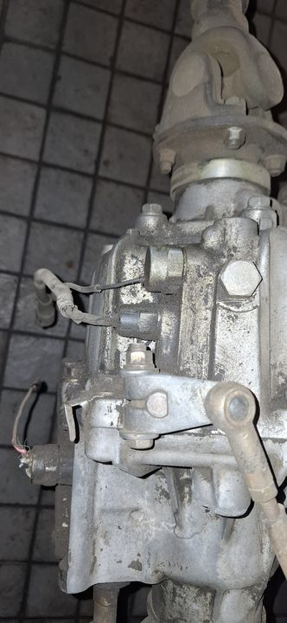  Length: CAD route estimate 520 mm | Battery negative to engine/chassis ground  Collect / measure: Battery negative, engine block point, chassis point, lug holes  Reproduce / verify: Fine-strand copper or braided ground strap. Clean metal, serrated hardware where suitable, torque, coat after voltage-drop test.
J40-RT-006B    Length: CAD route estimate 280 mm | Body-to-chassis ground strap  Collect / measure: Body tab, chassis tab, movement allowance  Reproduce / verify: Flexible braided/fine-strand ground strap. Do not paint contact faces before test.
J40-RT-007A    Length: CAD route estimate 550 mm | Starter main cable  Collect / measure: Starter B+ lug, battery/fuse endpoint, exhaust and linkage clearance  Reproduce / verify: Heavy copper cable sized by existing HD1/actual starter load, not diagram guess. Cranking voltage-drop test required.
J40-RT-007B    Length: CAD route estimate 460 mm | Starter solenoid trigger  Collect / measure: Solenoid terminal marking, ignition/start endpoint, terminal type  Reproduce / verify: Small automotive wire branch; do not assign by old colour alone. Continuity and key START test required.
J40-RT-008  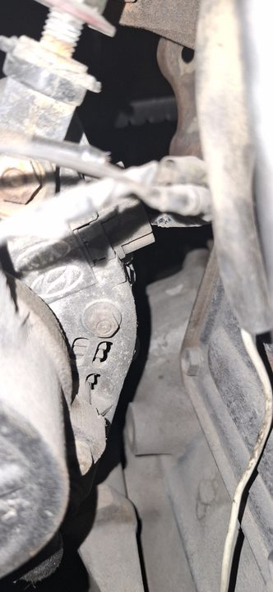  Length: CAD route estimate 590 mm | Alternator B+, regulator/sense/exciter branch  Collect / measure: Alternator terminal labels, charge output, warning/exciter, sense/regulator, ground  Reproduce / verify: Replace taped/weak terminals. Confirm charging voltage and warning-lamp behavior after start.
J40-RT-009  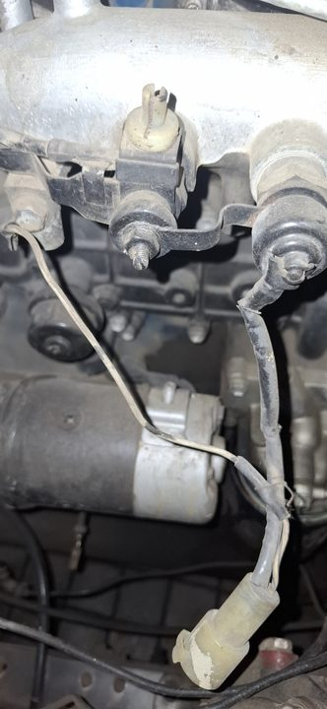  Length: CAD route estimate 760 mm | Engine sender / injection-pump / fuel-stop branch  Collect / measure: Fuel-stop/idle-up device identity, sender terminals, unknown connectors U-01/U-02  Reproduce / verify: 1.0-1.5 mm2 automotive copper sensor/control wire as needed. No blind reconnection. Prove each endpoint and key-state behavior.
L2 / J40-RT-010    Length: CAD front cross-loom estimate 1280 mm; loom makeup 5 x 2.5, 1 x 1.5, 2 x 1.0 mm2 | Front trunk: headlamp, marker, horn, aux lamp branch  Collect / measure: Headlamp/indicator/horn/aux endpoints, earth points, grille/radiator clearance  Reproduce / verify: Built/verify unless damaged. If remade, copy existing loom and connector map, then continuity/load-test lights, indicators, horn, fan/clutch feeds.
J40-RT-011    Length: CAD route estimate 720 mm | A/C clutch, pressure switch, condenser fan electrical branch  Collect / measure: Compressor clutch, pressure switch, fan relay output, fan earth  Reproduce / verify: Hold final routing until A/C hardware is dry-fitted. Use automotive copper wire and relay/fuse logic proof before charge.
J40-RT-012  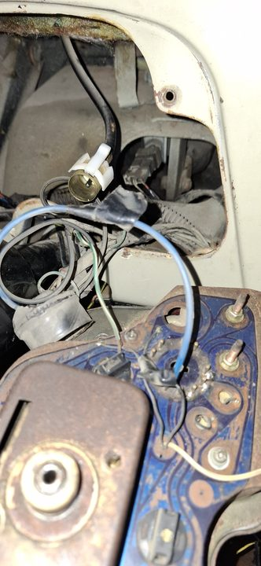  Length: CAD route estimate 520 mm | Under-dash evaporator blower/control feed  Collect / measure: Blower feed, control panel, thermostat/sensor, drain route  Reproduce / verify: Keep clear of pedals/column and service access. Final after evaporator mock-up.
J40-RT-013    Length: No wire length; pass-through assignment task | Firewall main pass-throughs and grommets  Collect / measure: Hole diameter, bundle OD, grommet groove, edge condition, steering/pedal clearance  Reproduce / verify: No wire or control cable through bare sheet metal. Reuse only with measured grommet/bulkhead, strain relief, and seal.
L3 / J40-RT-014  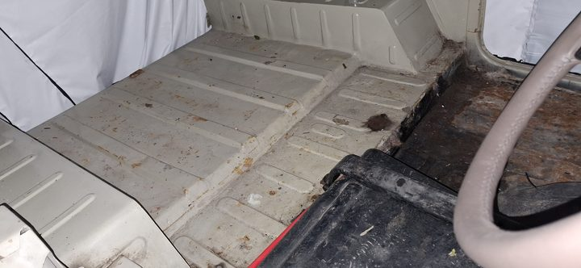  Length: CAD rear-body segment estimate 1160 mm; loom makeup 2 x 2.5, 3 x 1.5, 8 x 1.0 mm2 | Rear body: tail lamp, number plate, fuel sender loom  Collect / measure: Tail lamps, brake/reverse, number plate, sender, body-to-chassis flex  Reproduce / verify: Built/verify unless damaged. If remade, copy route and connector IDs; continuity-test rear lights and sender.
L4  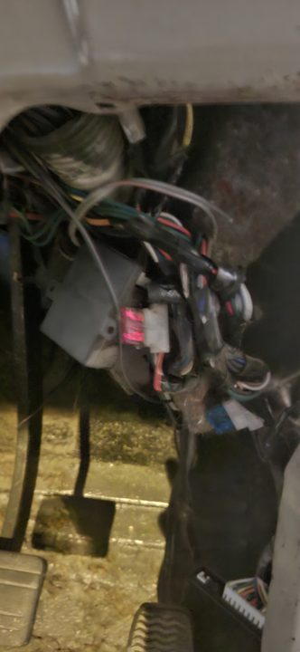  Length: Length TBD by installed dash route; makeup 1 x 10, 1 x 2.5, 5 x 1.5 mm2 | Ignition loom  Collect / measure: Ignition switch, ACC/RUN/START, ignition relay, fuse inputs  Reproduce / verify: Built/verify. Resolve ignition security and fuel-stop behavior before final wrap.
L5A  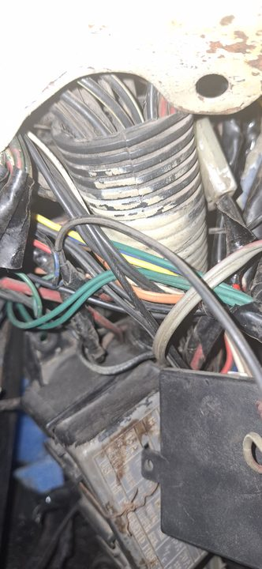  Length: Length TBD by installed dash/column route; makeup 1 x 2.5, 3 x 1.5, 4 x 1.0 mm2 | Left dash/column branch  Collect / measure: Column/stalk, left-dash controls, connector X3  Reproduce / verify: Built/verify; pin-by-pin continuity and retention pull check.
L5B  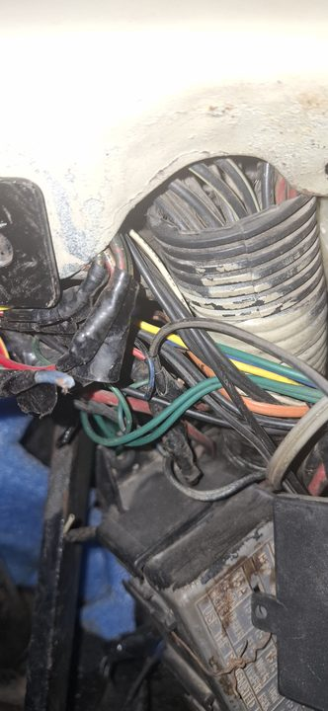  Length: Length TBD by installed dash/cabin route; makeup 2 x 2.5, 3 x 1.5, 4 x 1.0 mm2 | Right dash/cabin branch  Collect / measure: Right-dash/cabin devices, connector X4/X10  Reproduce / verify: Built/verify; update master if any field reroute changes.
L6  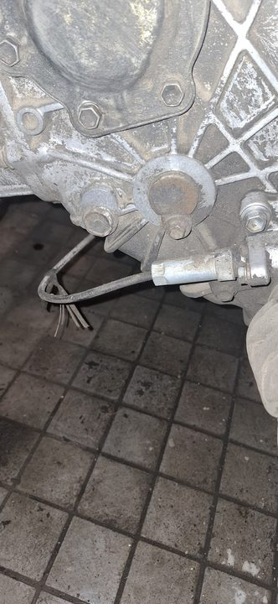  Length: Approx 1000 mm; makeup 3 x 1.5, 1 x 1.0 mm2 | VC / gearbox service loom  Collect / measure: VC service connectors X7/X8, gearbox/reverse/control endpoints  Reproduce / verify: Built/verify after drivetrain route is clear. Protect from heat, linkage, and driveline movement.
PK-RTE-WIRE-001  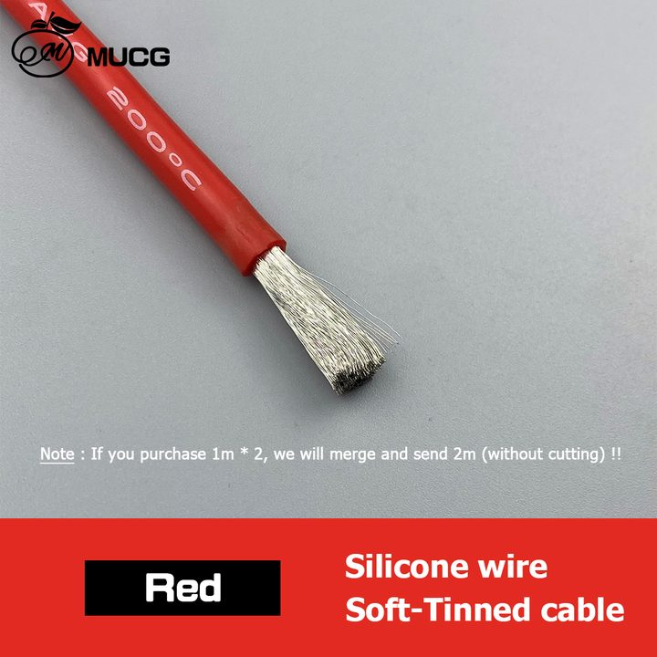  Length: Top-up only: 2.5 mm2 red/blue/black 10 m each; 1.5 mm2 mixed 10 m each; 1.0 mm2 sensor colours as needed | Small automotive wire top-up stock  Collect / measure: Stock count before buying  Reproduce / verify: Buy copper automotive wire only if on-hand stock is short. Reject CCA, house wire, all-one-colour unlabeled wiring.
PK-RTE-SLEEVE-001  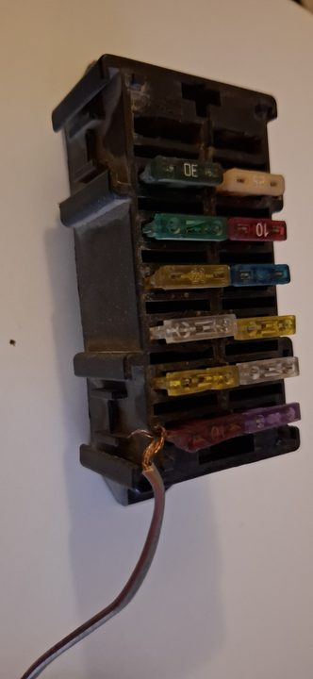  Length: Use on-hand first; top-up 12 mm x 10 m, 16 mm x 6 m only if short | Sleeve, split loom, heat-shrink for all wiring  Collect / measure: Bundle OD and heat/chafe exposure  Reproduce / verify: Final sleeve/clips/grommets happen after continuity and load tests, not before.

Related Control Cables And Service Lines
Evidence | Task Details
J40-RT-017    Length: CAD route estimate 980 mm for shown equalizer-to-axle scope; full cable length by old sample | Parking-brake cables, equalizer, clips  Action: Buy/remake by old sample only, with clevises, springs, clips, and adjustment range. Sweep suspension/exhaust/prop shaft clearance.
J40-RT-024  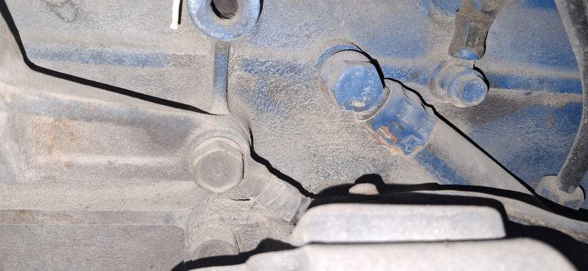  Length: CAD route estimate 560 mm for engine-side control scope; final by sample | Throttle, choke, fuel-stop, heater-control cables  Action: Copy retained controls by old sample: knob end, clevis, sheath length, mount thread, full travel.
J40-RT-025  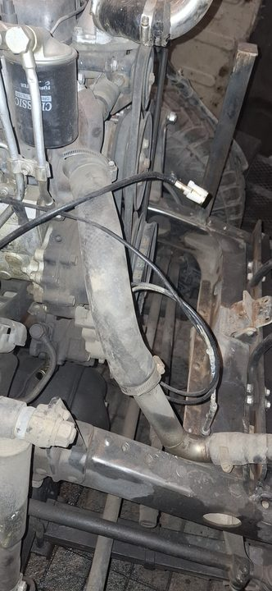  Length: CAD route estimate 780 mm; final by old cable | Speedometer cable to transfer/gearbox  Action: Match cluster end and fitted gearbox/transfer drive end by sample. Keep away from exhaust and prop shaft.

Final Verification Before Payment / Install Closeout
- Cooling: pressure-test formed pipe and coolant hoses before coating/final fill.
- Fuel: prime and leak-test feed, return, leak-off, and hard lines.
- Brake: pressure bleed, hold pedal pressure, check every flare/flex end, and sweep steering/suspension.
- Clutch: bleed and check no line tension through drivetrain movement.
- Vacuum: confirm booster assist and check-valve direction.
- A/C: nitrogen leak-test after crimp; do not charge before leak and wiring tests.
- Electrical: continuity-test every connector, retention-pull terminals, then voltage-drop/load-test starter, alternator, glow, EPS, fan/blower, lights, horn, and grounds.
- Protection: final P-clips, grommets, abrasion sleeve, heat shielding, and drip loops only after functional tests pass.

Source Records
- docs/replacement-pipes-workstream.md
- docs/engine-hose-tube-replacement-specs.md
- docs/pipe-fabrication-spec-20260502.md
- docs/wire-heavy-resize-cutlist.md
- docs/electrical-diagram-reconciliation-20260518.md
- docs/engine-electrical-inputs-reconciliation-20260517.md
- docs/cabin-engine-firewall-holes-survey-20260517.md
- docs/j40-digital-twin-as-fitted-cable-scope-20260531.md
- docs/j40-as-fitted-route-pakistan-purchase-bom-20260531.md
- data/manual/cad/j40_reference_model/05_reports/j40_as_fitted_route_model_coverage_20260531.csv
- data/manual/cad/j40_reference_model/04_exports/scaffold_rev_c/j40_full_vehicle_scaffold_rev_c_parts.csv

