J40 ORIGINAL-RADIATOR
REFURBISHMENT + TURBO-FAN PACK
FABRICATOR SPECIFICATION · REV I · 02 AUGUST 2026
START HERE — TAKE THE ACTUAL RADIATOR TO THE SHOP
The photographed copper/brass engine radiator is R0, the master fit sample. Do not build from photo dimensions. Recore R0 and preserve—or exactly copy—its tanks, two coolant necks, filler/cap seat, overflow, drain, side rails, upper mounting ears and lower locators. The old core is not to be reused.

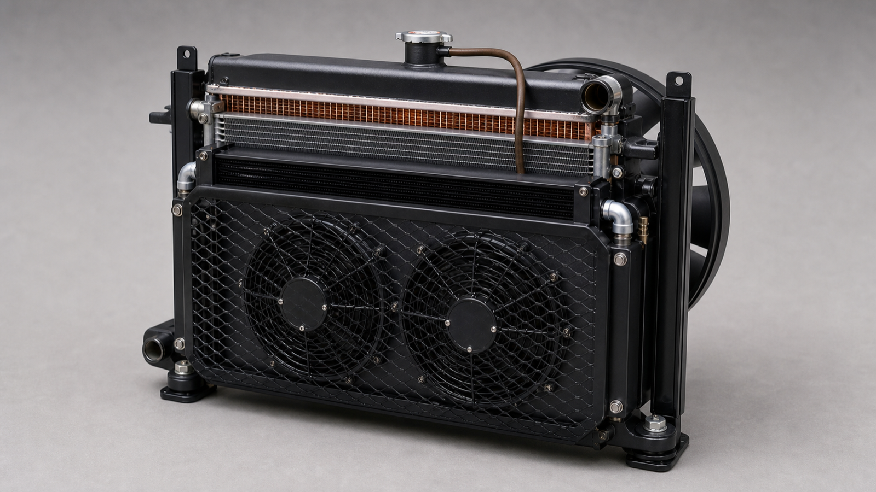
Opaque assembled concept. Final metal dimensions come from R0 and the chassis fixture.
Purpose: a simple, locally repairable cooling pack for Pakistan use, including 50 °C ambient operation and the planned 150 bhp / 112 kW turbo ceiling.
Air order: grille → removable stone guard → two centred electric pushers → charge-air cooler → A/C condenser → recored R0 radiator → sealed shroud → 2H mechanical puller → engine.

Physical donor samples — identify these parts first
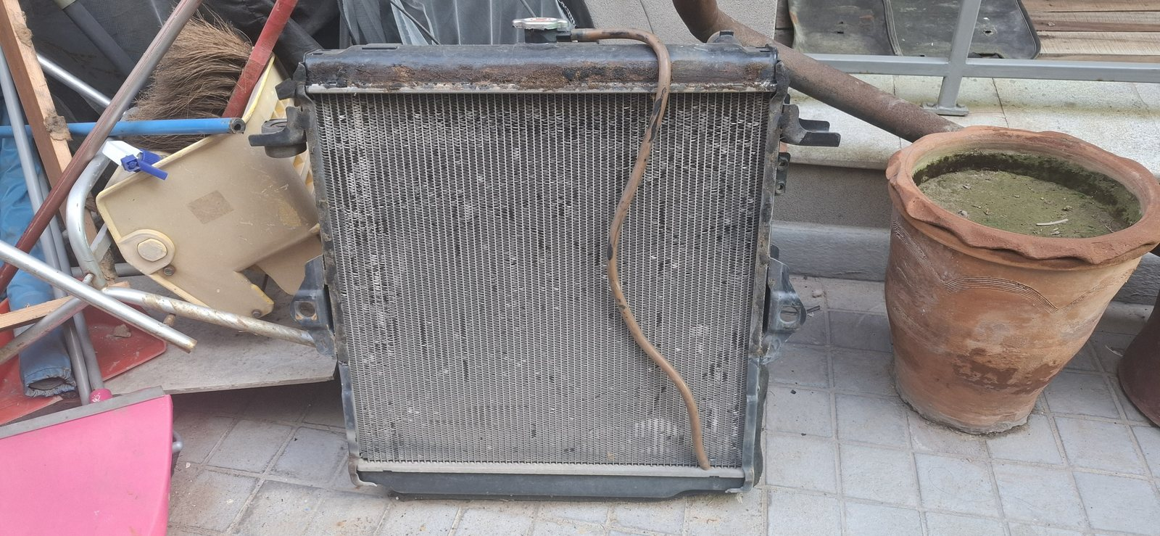
R01 — Actual removed copper/brass engine radiator R0. This physical part is the fit and interface master; measure it before dismantling.
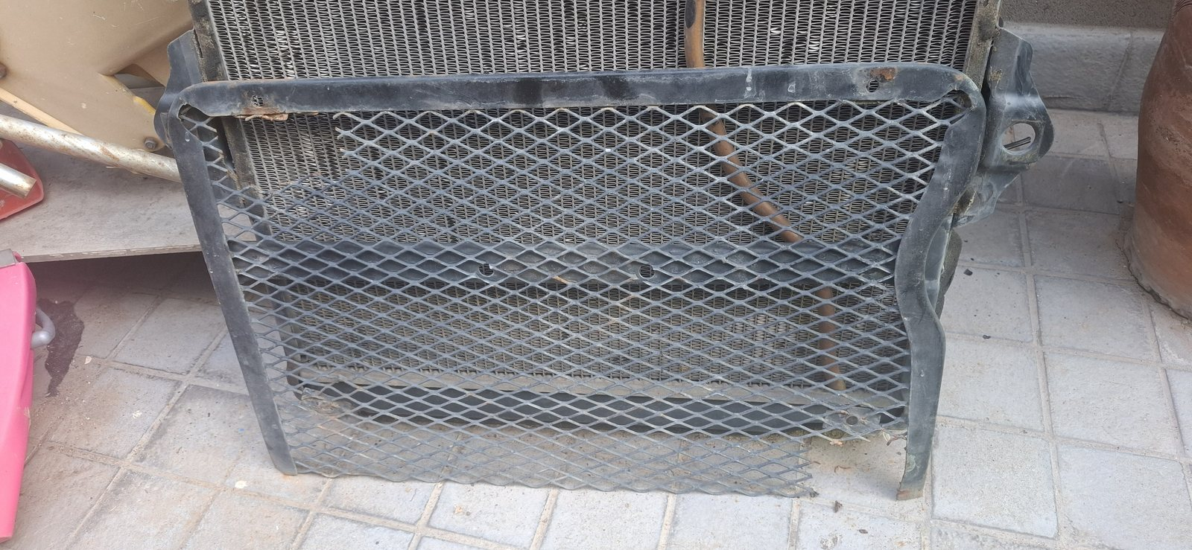
R02 — Actual removable expanded-mesh stone guard. Refurbish or reproduce it inside the measured opening with at least 70% open area.

1. What is being built
Item | Count | Job
R0 original engine radiator | 1 | Dismantle, inspect and fit a new heavy-duty copper/brass core; retain exact vehicle interfaces.
Charge-air cooler | 1 | Slim front core for the turbo; two 57 mm beaded air ports only.
A/C condenser | 1 | Inspect/identify existing thin aluminium sample; reuse only after pressure/flush/fit pass, otherwise fit checked replacement.
Front electric pushers | 2 | Matched Toyota/Denso 248 mm units, horizontally centred. Fan 2 is the turbo/charge-air assist.
Rear mechanical puller | 1 | Retained Toyota 2H engine-driven fan behind a full-face shroud; pulls air toward engine.
Stone guard | 1 | Refurbish/reproduce the photographed removable expanded-mesh guard, ≥70% open area.
FAN COUNT IS THREE
Two front electric fans plus one rear engine-driven mechanical fan. Fan 2 is the turbo/charge-air-assist role; it is not a fourth fan. Both electric fans push through the shared stack.

2. Dimension and fit-release sheet
Code | Measure / requirement | Release value
R0-W/H/D | Complete radiator envelope including tanks, seams, ears, filler, necks and drain | MEASURE PHYSICAL R0
RC-W/H/D | Active core face and depth | MEASURE R0; new core matches header/tank footprint
T0-L / T0-R | Upper chassis-hole 3D coordinates and centre-to-centre | COPY IN RIGID 1:1 FIXTURE
L0-L / L0-R | Lower saddle/tab coordinates and span | COPY IN SAME FIXTURE
N1 / N2 | Coolant neck OD, centre and angle; also filler, overflow and drain | COPY R0 EXACTLY
W0 | Clear opening at top, middle and bottom | MEASURE CHASSIS; every component stays inside
F1 | Front fan hubs | C0−133 and C0+133; 266 C-C; midpoint and height ±2
F2 | Rear radiator-to-blade static clearance | ≥20; 25–30 preferred
F3 | Rear blade radial clearance inside shroud | ≥15 throughout sweep
P0 | Front stack installed depth | Target ≤225; prove against actual fore/aft space
The previous 530 × 435 × 64 mm radiator concept is not a fit-release dimension. R0 and the 1:1 chassis fixture now control fit.
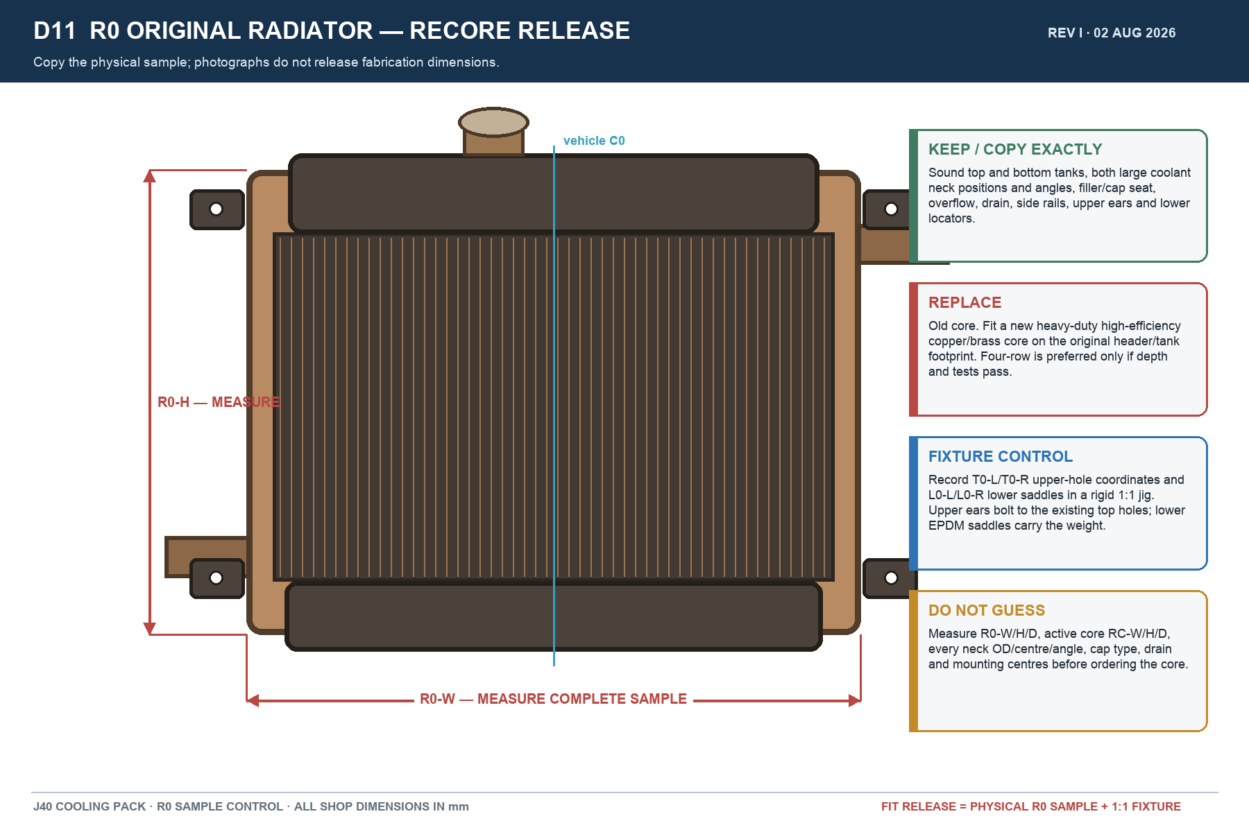

3. Radiator-shop instructions
- Tag R0 before dismantling. Photograph and measure every neck, cap seat, drain, bracket and locating feature.
- Strip paint and scale; dismantle and chemically clean. Pressure- and flow-check tanks, seams, necks, side rails and ears.
- Reject any pitted, thinned or cracked tank/neck/rail. If an original piece is unsafe, reproduce its external geometry from the physical sample before discarding it.
- Install a new heavy-duty high-efficiency copper/brass core on the original header/tank footprint. Four-row construction is preferred only if R0-D, airflow and clearance gates pass; thermal test performance controls acceptance.
- Use thin fin-safe black coating only. Do not bury fins or solder joints under thick paint.
- Pressure-test at the verified system/shop test pressure. The cap rating must match the actual cap neck and engine system; do not guess.
- Flow-test, hot-recirculation test and leak-test after final soldering. Record the results on the release sheet.

4. Mounting
- Use the existing two upright side rails. Upper radiator ears must visibly bolt through the existing holes at the top returns using M8 hardware, sleeves and rubber isolation.
- Lower EPDM saddles carry radiator weight. Upper bolts locate and retain; they must not crush or twist the tanks.
- Keep at least 5 mm hard clearance to metal throughout the radiator, guard, cores and fan frames.
- No crossbar, fan frame, fuse box or relay box may widen the pack beyond W0. Electrical boxes use independent high/rear brackets and rain hoods.
- Stone guard stays independently removable 10–15 mm ahead of the front fan/shroud face and must not rub the fans.
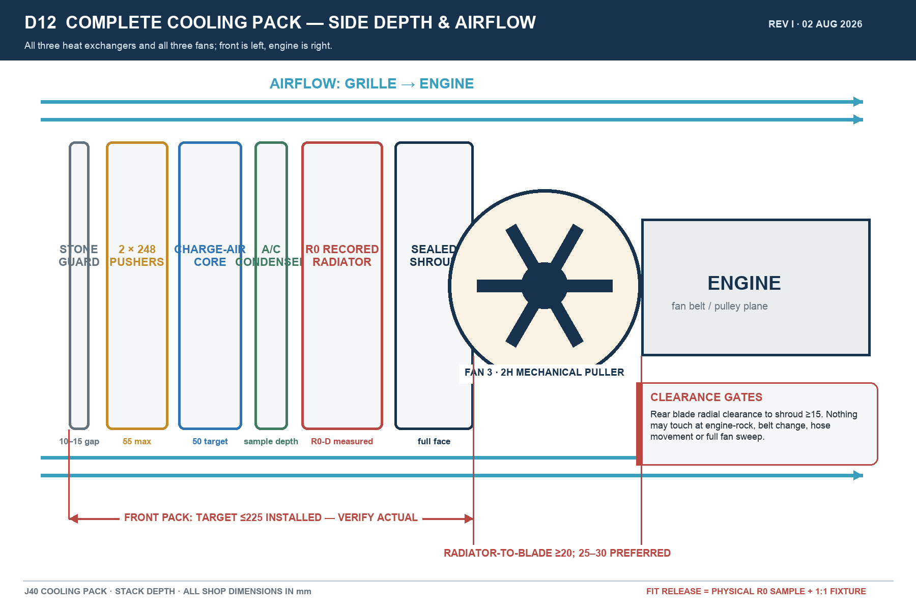

5. Fans, turbo function and wiring
Fan | Physical part | Lead trigger | Direction
Fan 1 | Toyota/Denso 248 mm front pusher | A/C demand or coolant-temperature lead | Grille → engine
Fan 2 | Matching Toyota/Denso 248 mm front pusher | High intake-air temperature / boost lead | Grille → engine
Fan 3 | Toyota 2H engine-driven mechanical puller | Engine speed / fan coupling as fitted | Pulls grille → engine
- Use two matched Prado 120 / GX470 Toyota/Denso 248 mm fan assemblies. Nominal hub centres are C0−133 mm and C0+133 mm, exactly 266 mm apart; group midpoint and hub height tolerance ±2 mm.
- Provide at least a 258 mm clear ring for each nominal 248 mm blade. Confirm the actual donor frame, plug, tab and wire-bend envelope before steel cutting.
- Fan 2 is called the turbo fan because its electrical lead trigger is charge-air temperature/boost. It cools the charge-air core by pushing ambient air through the shared stack; it does not blow directly onto the turbocharger housing.
- On high coolant temperature, high IAT, high A/C pressure, high load, sensor fault or manual override, both electric fans run together.
- Use one sealed relay and one closed MIDI-fuse branch per electric motor. Earth each motor with equal-size cable to a clean chassis/negative point. Put no exposed fuses in the airflow or rain path.
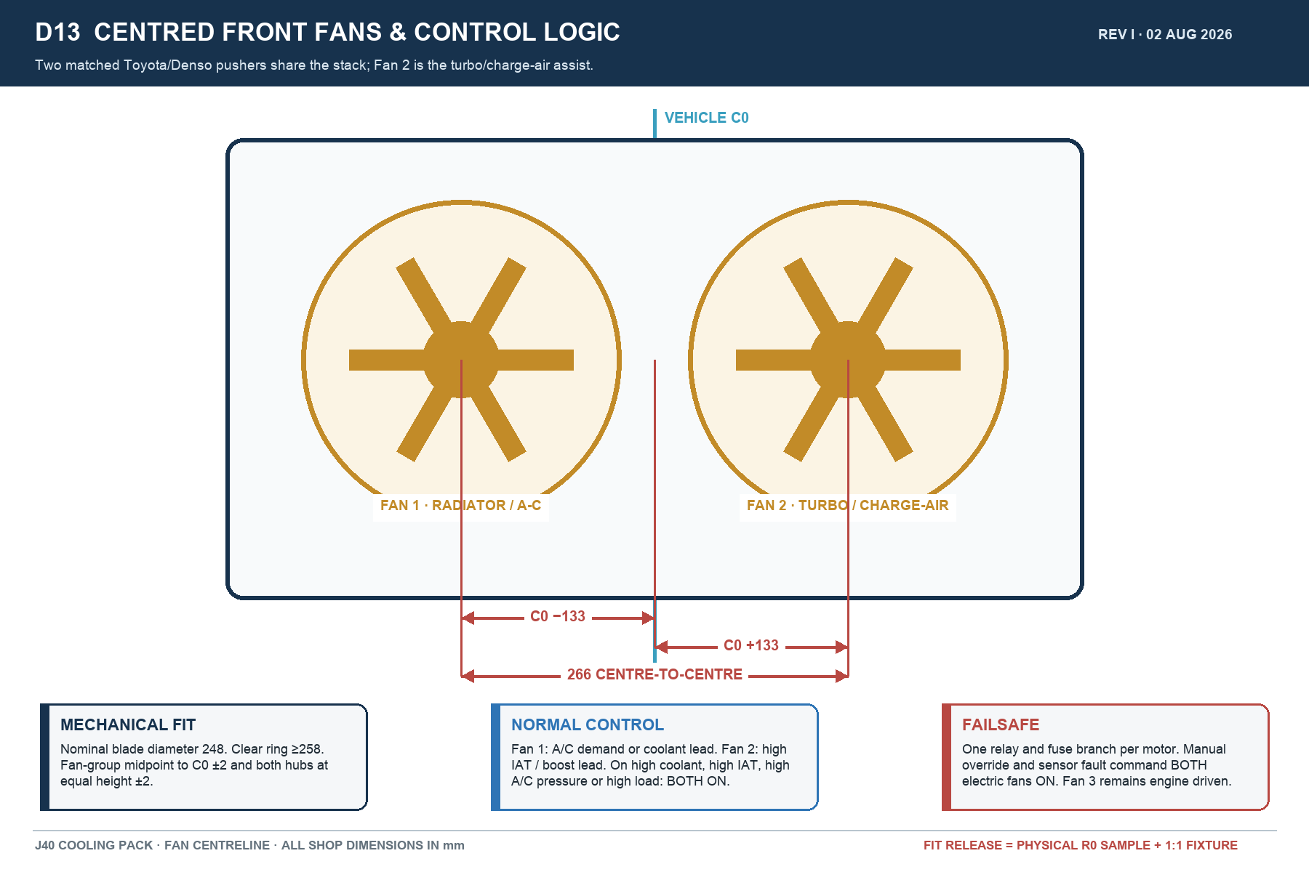

6. Standard donor parts — buy only after sample check
Part | Preferred source / reference | Rule
Front fan assemblies ×2 | Prado 120 / GX470 Toyota/Denso 248 mm; 88590-60040 / -60050 / -60051 / -60060 | Buy a matching pair with frames, plugs and pigtails; verify actual envelope.
Fan motor | Toyota/Denso 88550-12160 reference | Use matched working motors; confirm connector and rotation.
Fan blade | Toyota 88453-60010 reference | Confirm 248 mm blade and correct pusher rotation.
Rear mechanical blade | Toyota 16361-68030 / 16361-68031 candidate | Use only after hub, sweep and blade-count check against engine.
Rear shroud | Toyota 16711-47040 candidate | Use only if it seals R0 face and passes clearances; otherwise fabricate full-face shroud.
A/C condenser | Existing sample after identification/test, or common 14 × 22 in R134a parallel-flow | Bench-measure fittings, drier, frame and W0 before purchase.
Receiver/drier | Toyota 88471-34010 candidate or common #6 | Port and refrigerant compatibility must be checked.
Relays / fuses | Toyota 90987-02027 or sealed ISO 40 A; closed MIDI fuse box | One relay and fuse branch per motor; rate from measured current.

7. 50 °C thermal release
- Radiator duty: ≥115 kW continuous heat rejection and ≥130 kW for 10 minutes at 50 °C ambient, or equivalent supplier-certified/tested performance on the released core.
- Charge-air core: target 500 × 180 × 50 mm only after W0/P0 check; ≥15 kW duty, two 57 mm beaded ports, route pressure drop ≤10 kPa, and post-cooler IAT ≤80 °C at the agreed full-load test.
- Two-front-fan installed airflow target ≥3,000 m³/h aggregate; 3,300 m³/h preferred. Accept installed measurements, not free-air catalogue numbers alone.
- Run hot-idle soak with A/C on, repeated low-speed pulls, and sustained loaded road testing. No boiling, coolant loss, hose collapse, fan/shroud contact, electrical overheating or progressive temperature rise.
- Record coolant in/out temperatures, IAT before/after cooler, ambient, fan states, voltage and current. A 50 °C claim is not released until the completed vehicle passes the agreed test or equivalent instrumented simulation.

8. Fabricator acceptance checklist
Check | Pass requirement | Initial / date
R0 measured before dismantling | All R0/RC/T0/L0/N1/N2 fields recorded | __________
Core and tanks | New core; tanks/rails/necks sound or exact-copy replacements | __________
Top-hole attachment | Both upper ears bolt to existing top holes without strain | __________
Lower support | Both lower EPDM saddles carry weight and cannot walk out | __________
Fan centring | C0±133; 266 C-C; midpoint/height ±2 | __________
Rear fan clearance | ≥20 axial (25–30 preferred), ≥15 radial, all conditions | __________
Stack width/depth | Inside W0; target front pack ≤225; no electrical side growth | __________
Pressure/flow/electrical | No leaks; flow pass; current/voltage/fuse/relay records complete | __________
50 °C thermal validation | Recorded full-system pass at agreed test condition | __________

Appendix A — Visual assembly reference
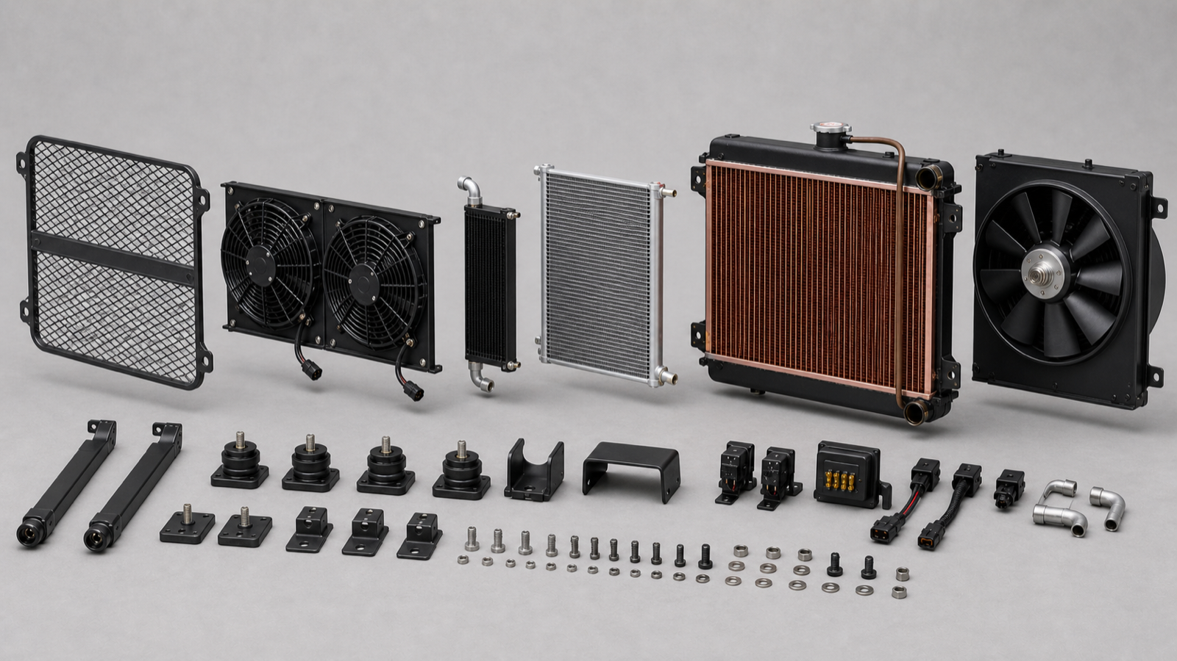
Exploded component relationship. Do not dimension from the rendering.
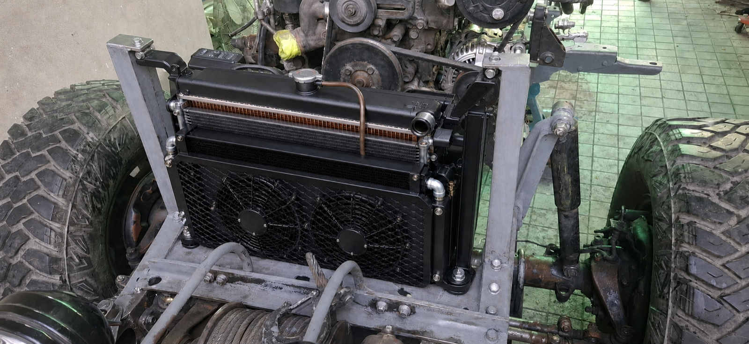
Opaque installed concept: upper ears attach to the existing top holes; rear fan is behind the radiator.
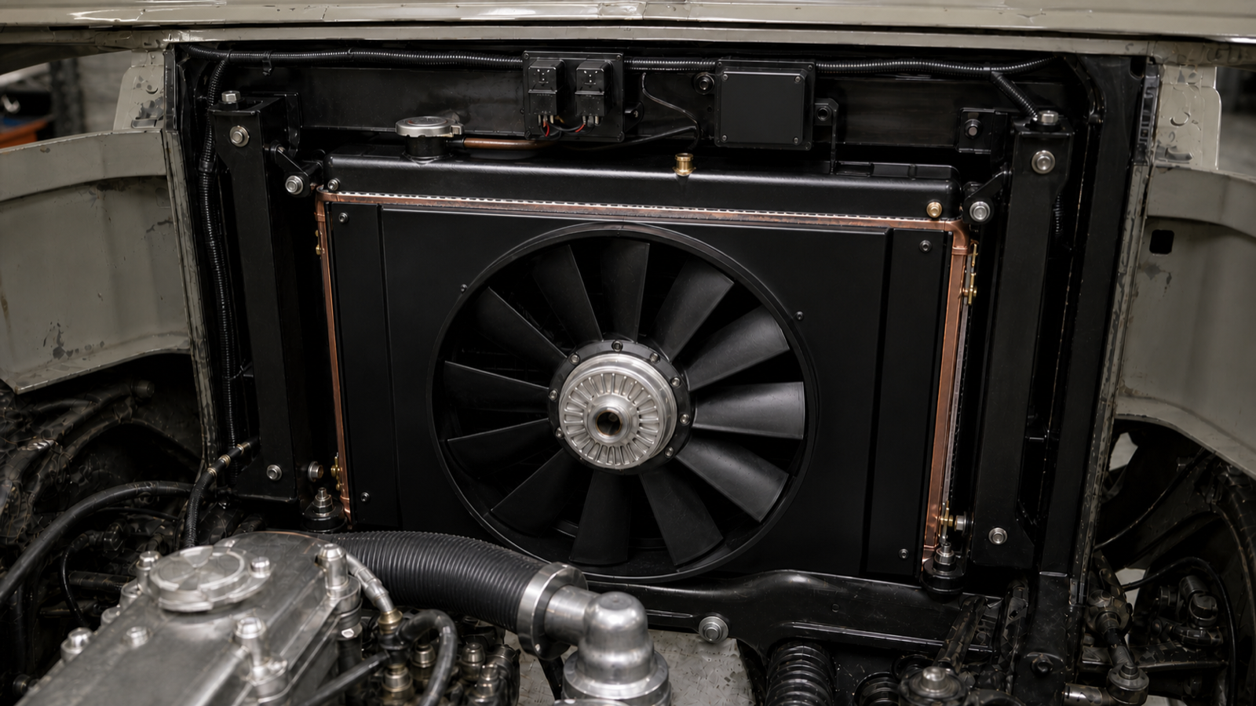
Engine-side reference: full-face shroud and rear mechanical puller remain visible and serviceable.

