Engine degradation

Data analysis report

Date: 28.9.2020

Analysis and reporting by David Rais

=== Tasks

- Perform an exploratory analysis of the data.
- Develop a predictive model for the remaining useful life of the engine and report its accuracy in terms of R-squared and RMSE error.
- Explain your process and chosen model.

Results

Data exploration
details in Jupyter notebook:
“DataFormating.ipnb”

The dataset origin is unknown, but shows strong similarity with the synthetic data Commercial
Modular Aero-Propulsion System Simulation (C-MAPSS) published previously. The published data are synthetic datasets of run-to failure time series of sensor reading records (train) from simulation of a turbofan aircraft engine. The test records that were truncated some time prior to the failure. The remaining useful lifetime, RUL, for each trajectory in the test datasets wan known. The four published datasets are with different complexity of the simulation parameters. The published data were treated previously. The prevailing method of analysis in the published datasets is modeling with the recursive neural networks (RNN).

Pre-processing steps

1) Data filtering

The datasets are showing 21 sensor readings, sri and three operational conditions opj for each trajectory. The data for each trajectory in all datasets were smoothed by exponentially-weighted moving average filter (pandas.DataFrame.ewm) with window size of 10 consecutive sensor readings.

2) Time reversal
For the purpose of temporal alignment of the train data, all datasets (both the train and the test) were reversed in time, so that the time in the train dataset is given in RUL units. The RUL information was then added as new feature (column) to the datasets (both train and test).

3) Scaling
The sensor readings were of various magnitudes, spanning over 8 orders of magnitude. All sensor readings in all data sets were scaled linearly to show mean value near zero, and near unit variance. Function StandardScaler from sklearn.preprocessing module was used.

After the scaling step, the filtered datasets were saved as .csv files, with the similar naming pattern as the original data, e.g. for original data file train_FD001.txt, the transformed data are in file train_FD001_smooth.csv

The details of the data pre-processing steps 1-3 are in jupyter notebook:
DataFormating.ipnb

4) Data reduction:

The filtered datasets were showing large correlation between the individual sri. (Figure 1) Thus they were transformed by principal component analysis (PCA). Four principal components (PC1 through PC4) were used in most cases. It explained more than 97% of the dataset variance. The individual PCs were fitted for each train dataset separately. They were then applied to the corresponding train and test datasets. Thus the PCs were identical for both the train and test parts of each dataset.
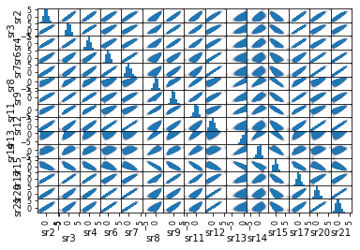
Figure 1: Correlations between the sensor readings in FD002 train dataset.

The details of each PCA are shown in separate jupyter notebooks, each of which treats a separate dataset.

The operational settings information was left as-received and merged with the transformed sensor readings (PC1..PC4).

Exponential fitting of the datasets:

The exponential decay function fitted the individual transformed sensor trajectories well in the datasets FD001 and FD003, therefore it was tested as a model for prediction of the RUL. The model has proven best for predicting RUL value for test trajectories, which ended less than 50 cycles before the actual system failure (Figure 6a).

Classification of the fault modes
Various failure modes in FD002, FD003 and FD004 were distinguished from the sign of the slope of trajectories of PCs. Figure 2 and Figure 3 shows the case of four trajectories train data in FD003 and FD002. The meaning of class numbers vary between the datasets. Single failure mode was assumed in datasets FD001, Two modes were assumed in other datasets.
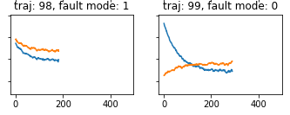
Figure 2: The classification result of trajectories 98 and 99 in train dataset FD003 (blue-PC1, orange-PC2)
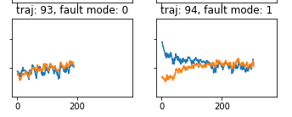
Figure 3: The classification result of the train trajectories 93 and 94 in dataset FD002 (blue-PC3, orange-PC4)

An attempt for classification of the trajectories directly using K-means algorithm (with dynamical time warping of the time series) was performed, but the results were not used, because of high computational resource demands and low accuracy. (present in notebook)

K-means clustering was used to classify the fault mode in trajectories from FD004 dataset. In this case, the sign of slope factor from linear regression of PC3 was used for classification – naturally, two classes were the result.
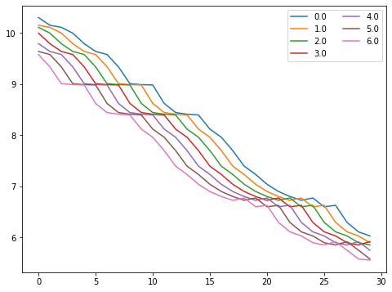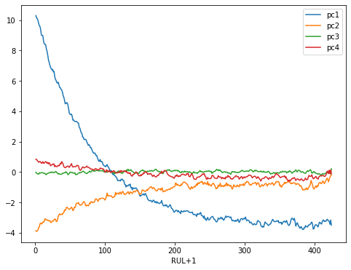
Figure 4: The example of widowing of random train trajectory 2 from the train dataset FD003. (top) The trajectory with transformed principal components pc1-pc4. (bottom) The seven overlapping segments (windows) of pc1 with the individual RUL learning targets shown in the legend.

RUL prediction
The data for the neural network training was formatted in windows of fixed temporal length:
“window_width” parameter was chosen to accommodate well into the shortest trajectory in the dataset. In individual datasets it was 21-30 cycles. WindowGenerator_RUL class was used to generate the training windows. The Figure 4 shows how the example of widowing of random train trajectory 2 from the train dataset FD003.

For testing of various recurrent neural network implementations, a single training trajectory was selected from each dataset for training of the test three types of recurrent neural networks (RNNs): Long-Short Time Memory (LSTM), stateful LSTM, and Gated Recurrent Units (GRU). These variants of the RNNs were mentioned as favorable strategies for prediction of RUL in the case of the published time series of datasets, including the C-MAPSS datasets. To keep the comparison simple, all tested RNNs were having the same number of internal units (25).

The performance of various RNN models was similar, and GRU was best in the case of FD001 (Figure 5). The GRU was chosen for training with all the trajectories in the train datasets.
The training procedure was performed separately for each fault mode, resulting from the above-mentioned classification. The training was performed by feeding the model with the sequentially windowed trajectories. The sequence of trajectories was ordered randomly, within the given fault mode.
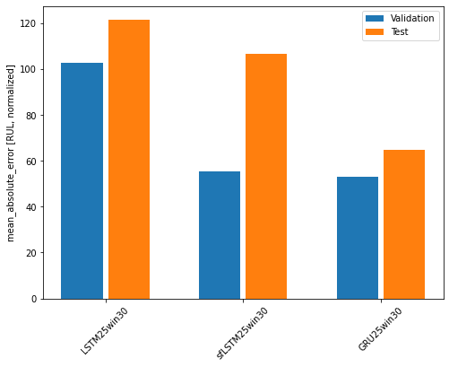
Figure 5: Evaluation of various models trained on a single trajectory of dataset FD001.

Evaluation of the models was done by predicting the RULs for each trajectory in the test dataset using the model trained on the train trajectories with the same fault mode class label.

Summary of the RUL prediction is given in the Table 1. The correlation graphs between the predicted and actual RUL value for the test trajectories is shown in Figures 6-8.

The exponential model performs very well for predicting the RUL in case, when long sequence of ends about 50 cycles before the system breakdown FD001 dataset (Figure 6a). Naturally, it shows large error when trying to predict the end-of-life from short initial records with mostly healthy system. In dataset FD003 (Figure 7), the predicting power of exponential fit has shown similar results. The discrepancy between the RMSE and Rsquared estimates for FD001 and FD003 is caused by implementation of finite fit bounds in the case of FD003. In FD001, no bounds for the fit parameters were in place, which resulted in large errors for some trajectories, deteriorating the overall fit statistics.

The RNN model was showing better results in the case of FD001 and FD003, where the fault mode classification was quite straightforward. In the case of FD002 and FD004, the RUL was estimated from less than 3 % of the overall variance of the data. Therefore, the chosen prognostic transformed signals suffered from lower signal-to-noise ratio. Also, the classification criterion was probably not sufficiently separating the trajectories in their respective types, and thus the model performance was worse.

Obviously, the RNN model parameters can be optimized to tune the model predictive performance. The optimization was however not done.

Table 1: Evaluation of the results:

dataset: FD001, model: exponential, RMSE = 82.2 cycles, Rsquared = -2.917
dataset: FD001, model: GRU25win31_fully, RMSE = 54.3 cycles, Rsquared = -0.710
dataset: FD002, model: GRU25win21_fully, RMSE = 76.6 cycles, Rsquared = -1.027
dataset: FD003, model: exponential, RMSE = 66.9 cycles, Rsquared = -1.614
dataset: FD003, model: GRU25win30_fully, RMSE = 35.7 cycles, Rsquared = 0.255
dataset: FD004, model: GRU25win19_fully, RMSE = 61.8 cycles, Rsquared = -0.286

Correlation graphs:
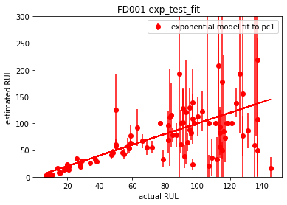
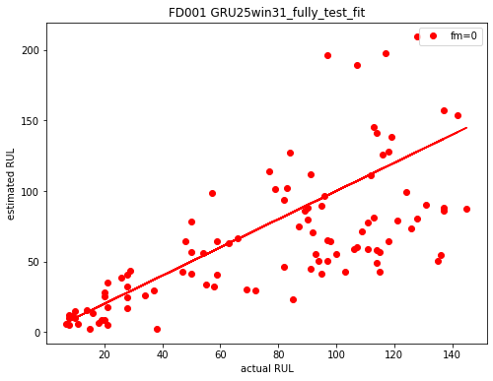

(a) (b)
Figure 6: Correlation between the ground truth (acrual RUL) value on x-axis and predicted RUL value on the y-axis. (a) fitting of exponential model, (b) fit of the RNN model.
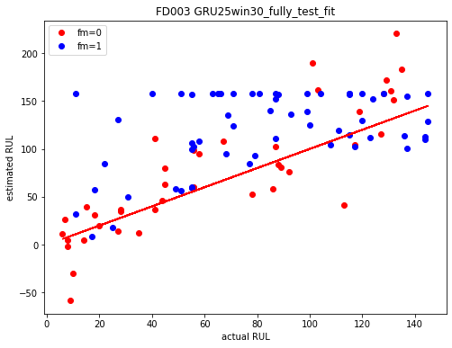
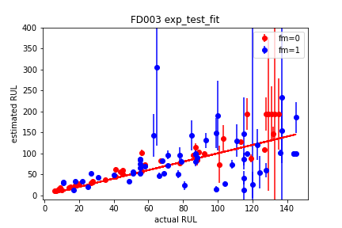

(a) (b)
Figure 7: Correlation between the ground truth (acrual RUL) value on x-axis and predicted RUL value on the y-axis. (a) fitting of exponential model, (b) fit of the RNN model to the dataset FD003. The fault mode is shown in the legend.
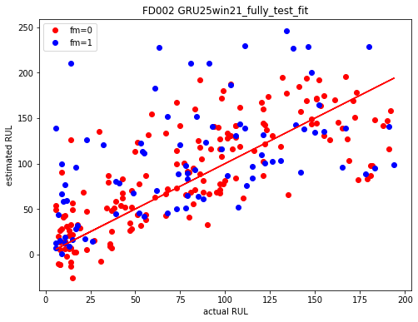
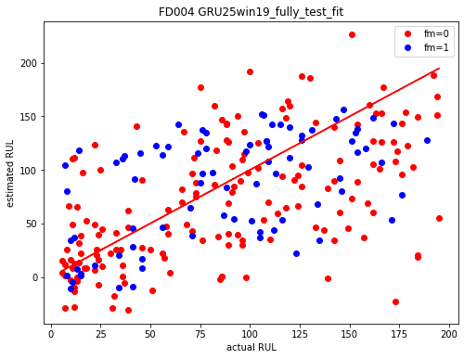

(a) (b)
Figure 8: Correlation between the ground truth (acrual RUL) value on x-axis and predicted RUL value on the y-axis. The fit of the RNN model to (a) the test dataset FD002, (b) the test dataset FD004. The fault mode is shown in the legend.

A. Saxena, K. Goebel, D. Simon and N. Eklund, "Damage propagation modeling for aircraft engine run-to-failure simulation," 2008 International Conference on Prognostics and Health Management, Denver, CO, 2008, pp. 1-9, doi: 10.1109/PHM.2008.4711414.
Marcia L. Baptista, Elsa M.P. Henriques, Kai Goebel, “More effective prognostics with elbow point detection and deep learning,” Mechanical Systems and Signal Processing, Volume 146, 2021, 106987, doi: 10.1016/j.ymssp.2020.106987; Marco Rigamonti, Piero Baraldi, Enrico Zio, Indranil Roychoudhury, Kai Goebel, “Ensemble of optimized echo state networks for remaining useful life prediction”, Neurocomputing, 281 (2018) 121, doi: 10.1016/j.neucom.2017.11.062; M. Rigamonti, P. Baraldi, E. Zio, et al., Echo state network for the remaining useful life prediction of a turbofan engine, in: European Conference of the Prognostics and Health Management Society (PHME), (2016), 255.
FD001_exponential.ipnb
FD001_exponential.ipnb
FD001-RNN.ipnb
FD002-RNN.ipnb
FD003-exponential.ipnb
FD003-RNN.ipnb
FD004-RNN.ipnb

