

Transition Guide
v2024-06-16


What is QuestGuard?
QuestGuard is a gamified tactical tabletop roleplaying game for the younger generation, who are more used to video games and board games, and want a fast, rules-light, combat-focused alternative to the mainstream and older systems: it’s the opposite of old-school!

While playing QuestGuard, you will find more “gamified” elements, both for the players and for the Quest Master. There is an emphasis on build variety, combos, and rules to help Quest Masters have an easier time, and depth through interactions, not complexity.

We created QuestGuard out of love for tabletop roleplaying, to fit our needs and, most importantly, to fit with how the current generation actually plays combat RPGs.

If you’ve played Dungeons & Dragons or Pathfinder, you will find QuestGuard very easy to pick up!

Is this a spin-off?
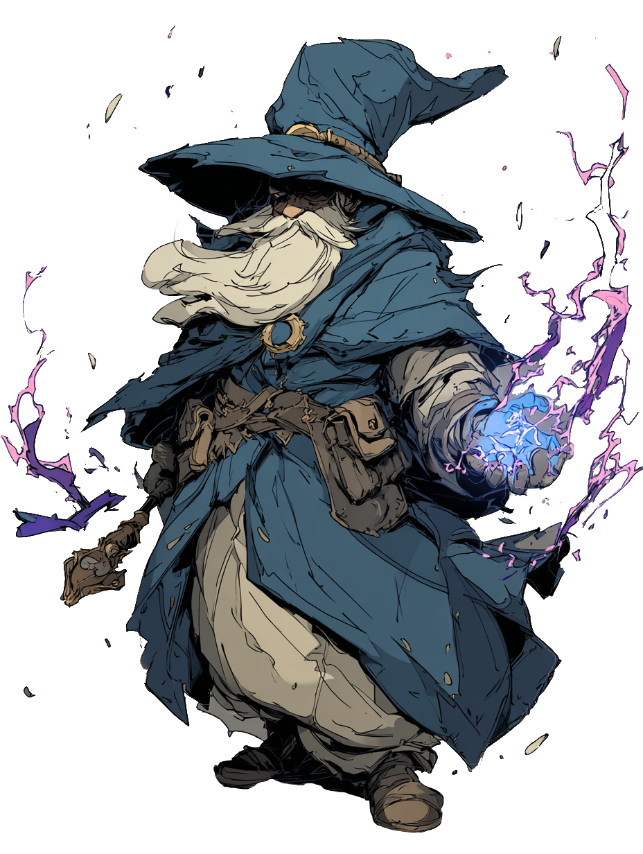
No, QuestGuard is its own game, completely separate from D&D.

What to expect?
QuestGuard is systems-light - there are hardly any tables, no concentration rule, no spell components or spell slot levels, no roll to hit or opportunity attacks, no saves (checks) in combat (crowd control/status effect is direct and fair).
There are no long or short rests, as the Quest Master has better control over the pacing through the Adventure and Enemy Worthiness system.

Character abilities are gamified for gameplay rather than realism, to be able to do things such as creating gold or magic items out of thin air or farming enemies. Characters can respec between Adventures, all monsters are tactical and change how you must approach combat, and this is just the tip of the iceberg!

How to get into it?
You’re already in it!
Our website https://questguardrpg.com features a “Play With Us!” button. Once clicked, it will redirect you to our Discord group, where we regularly host campaigns and one-shot adventures for new and old players alike!

Feel free to say hi and show your character!


Why QuestGuard?
There are plenty of reasons to choose and play QuestGuard!

It’s “gamey” and it flows
Everything in QuestGuard is intended to have a good flow in combat, be simple and allow for awesome Ability combinations.

The complexity and skill expression does not come from number crunching, but rather from how you choose to combo your character pieces together.

Your character build flows and all game elements fit in such a way that they don’t hinder one-another. It’s clean.

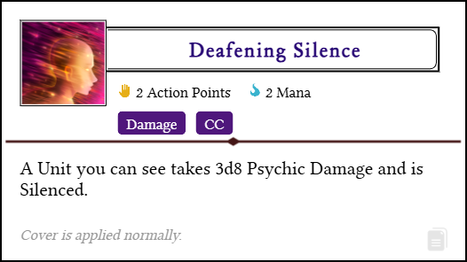

Figure out your own combos and unleash them upon your foes!

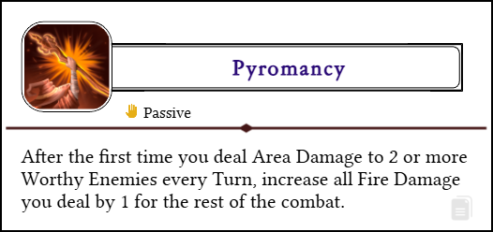
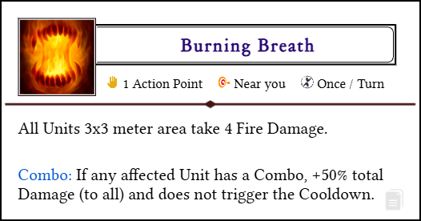

Every class and build path is different and breaks the rules of the game!

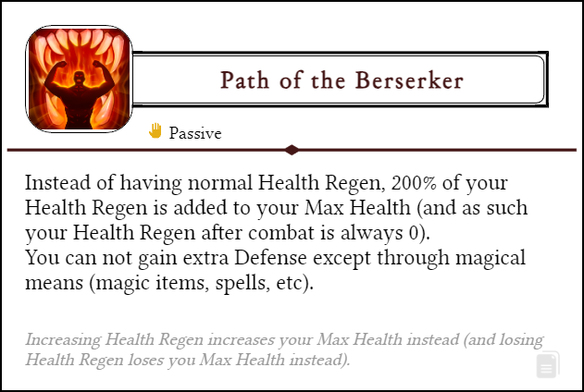
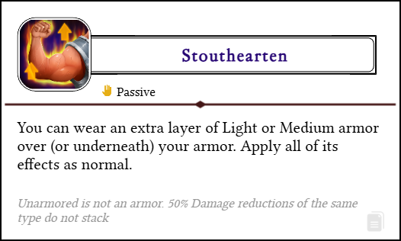

There are hundreds of such Abilities in the game, and the possibilities are in the millions!

Being a Quest Master is easy
QuestGuard is made to be cool for players, and easy and fun for the Quest Master (the game master). Through rules such as the Adventure, Worthiness, Skills, Quirks, etc, you will find running Quest Guard both enjoyable and easy to manage.

Always online
All the resources are always online. As such, there are frequent patches, balance improvements, content updates, and much, much more!


The Dice
QuestGuard is a 2d6 system. Whenever you roll a Check, you roll 2 6-sided dice and add any modifiers to it.

Rolling evens (1-1, 2-2, 3-3, and so on) means getting Plot Points! If it was a success, you gain a Plot Point. Otherwise, the Quest Master gains a Plot Point.
Spend Plot Points to introduce Actually facts to the current situation,whether you’re a Quest Master or a player. Here are some examples:
“Actually, the shopkeep did leave a window open…”
“Actually, there is a chandelier I could swing on…”
“Actually, since your Hero has Claustrophobia, they are afraid to take this short route.”

Which dice are used
In QuestGuard, we use the standard polyhedral dice - d4, d6, d8, d10, d12 and d20 (although the d20 is rarely used).

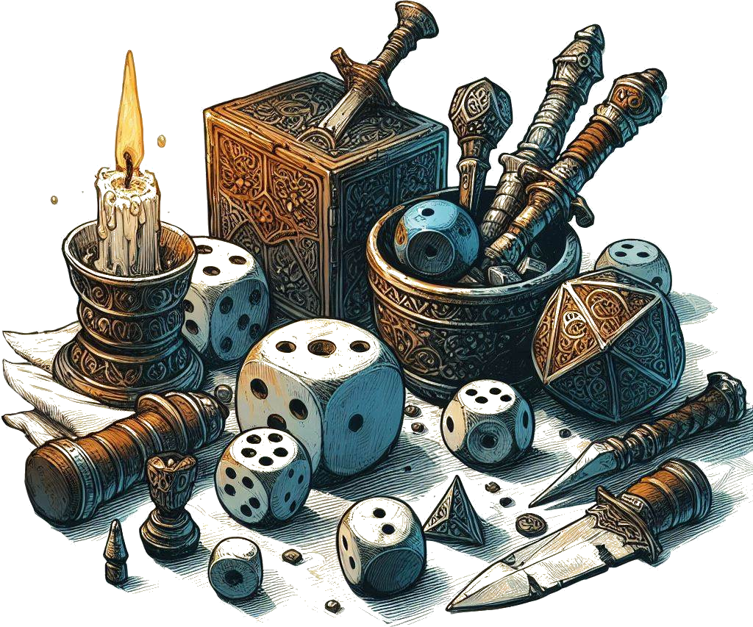
Combat dice
In combat, there is no rolling to hit. Whenever you attack, you roll for Damage directly - most of the time, what you see is what you get. If you rolled a total of 14 on 3d6, you deal 14 Damage.

By default, there are no critical strikes, but some weapons and Abilities can trigger bonus effects based on the rolls. If it can, it is neatly mentioned in its text box.

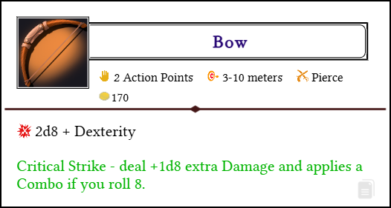

Most of the time, you will deal and take Damage. Be prepared!


Characters

Hero Creating
Like in most RPG’s, a Player Character needs a character sheet. Normally, we do it online, on the website, with a dedicated Hero builder.
You can find it on the website at https://questguardrpg.com under Create Hero.

Of course, if you want to do it on paper, you’re free to do so, and you can download the Hero Sheet under Game, Downloads, Hero Sheet (PDF, PNG, or PSD).

What makes a Hero
A Hero is made up of a Race plus a Class. Each of these has a ton of customization options.

Each Race is different, and you can customize it with 2 Racial Features! Every Level, you get a choice of one out of 3 or more Talents to pick from your Class. Talents are powerful Abilities that shape how your Character plays and fights.

Don’t be afraid to try strange combinations! Heroes Characters can freely “respec” between missions, changing all Talent choices and learned Abilities.
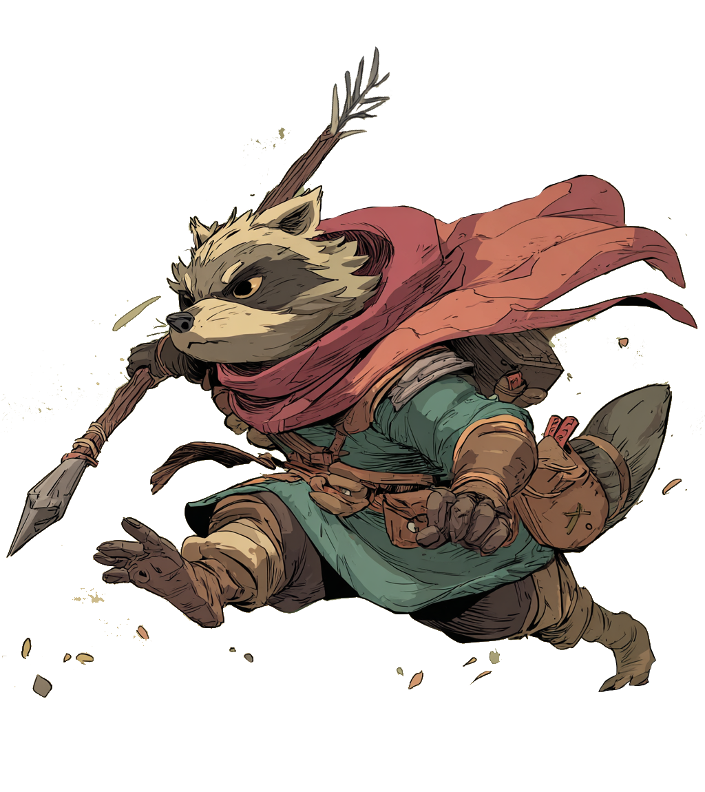

Progression
There are 10 Levels Players can progress through with their Characters.

Levels are packed with interesting options. Every Level unlocks new Abilities, and every Adventure ends with players getting Quirks!

The recommended way to Level-Up is through milestones or checkpoints set by the Quest Master. If using the Experience system, however, going from Level 1 to Level 10 should not take an eternity, either. QuestGuard intends campaigns to play out spanning a few months at most, but it’s all up to you and your group.


Stats
There are 4 Main Stats in QuestGuard: Might, Instinct, Focus, and Presence. The Stat is directly the “modifier”. In combat, each Stat affects an aspect of your character.

- Might affects base Health (+3 / point).
- Instinct affects Movement Speed (+0.5 / point).
- Focus affects Initiative (+0.5 / point), and you get +1 Action Point on your first Turn per 1 Initiative.
- Presence affects Health Regen (+2 / point)

All Stats also contribute to Checks.

Starting Stats
You can assign your Stats at Level 1 as you like, as long as you respect the rule of 2’s: the sum of all Stats must be 2, and no Stat can go higher than +2 or lower than -2.
Each way to distribute Stats is perfectly valid - there are builds and variations for any combination. QuestGuard is designed so that there is no objectively best way to do anything.

Plus, don’t worry, you get +1 in any Stat every Level!

Note: you can’t actualy have Movement and Initiative in fractions! Round it down: 1.5 is the same as 1, -0.5 is the same as -1.

Skills & Substats
There are no Skills listed on your Character Sheet.

When you want to do something, the Quest Master will simply call out for a “Might Check” or a “Focus Check”, for example (2d6).

However, each Character will have non-combat Skills they can add themselves to the Roll if appropriate.
Each Skill you have explicitly has a bonus (e.g. +3 in Persuasion, +1 in Monstrology, -2 in Control Emotions, etc).

The Quest Master might call for a Presence Roll to ask a quest giver for more reward money, and, if you have a Skill that fits, you can say “I have a +2 in Convincing, can I add it to the roll?”, to which the Quest Master might say yes or no, depending on the situation.

Feel free to invent your own Skills, but you can find a list of recommendations on the website.

The main sense, though, are separate from eachother (e.g. + in Smelling, Sight, Hearing, etc).

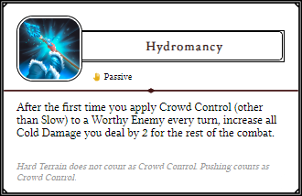
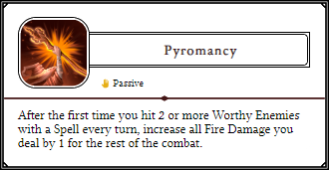
Abilities
Almost everything you get in this game is an Ability. Skills, spells, attacks, moves, Feats, Talents, even weapons and armor!

An Ability is simply a rectangle with a clearly defined text, a little colorful icon and tags to help you identify its properties, such as the costs of using it, how often you can use it, the range, etc.

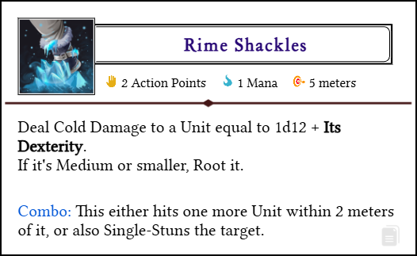

Most of the time, the only thing you need to use an Ability is your hands. No need for materials, a focus, spoken words, etc.

Nifty website trick…
On the website, click on the little document icon on the bottom-right of an Ability to copy it to your clipboard. You can then paste it in a Word document, in Paint, Discord, etc.

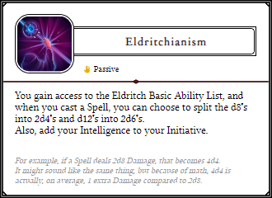
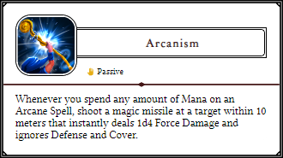


Combat
Combat usually happens on a map, preferably on a grid, and distances are measured in meters.

Turn order is clockwise around the table, with monsters somewhere in-between players.

Actions
Each character or monster in combat has 3 Action Points. You can use these Action Points as you like, with no diminishing returns (e.g. you can attack 3 times with a one-handed weapon even).
Abilities that cost 0 Actions are free and can be done as many times as you like.

Also, on your first Turn in Combat, you gain +1 Action Point for each 1 Initiative you have!

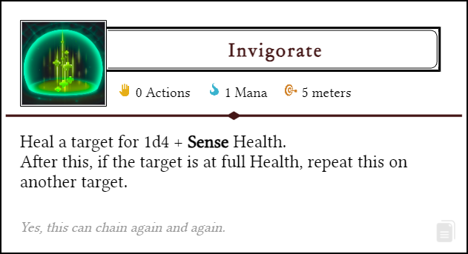

There is no “minor-action”, “bonus-action”, etc.

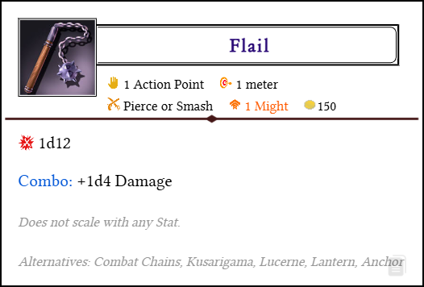

Combo
Many Abilities and weapons “apply a Combo”.
Many Abilities and weapons trigger an extra effect if the target had a Combo! Then the Combo is removed.

Anyone can trigger anyone’s combo. Go make some combos with your team!

Mana
The resource used to cast more powerful Abilities is called Mana. Most Classes use Mana.

You have a number of Mana Points you can use on Abilities.
If you have 5 Mana Points and an Ability requires 2 Mana, you spend 2 Mana and use the Ability. Then, you are left with 3 Mana.

Usually, Mana regenerates in the downtime between Adventures.

Resting & regeneration
There are no rests like short rests or long rests.

You regenerate Health equal to your Health Regen after every Combat. Your Health Regen is defined by your Race.
You regenerate all resources (Health, Mana, Cooldowns, etc) at the end of every Adventure.

Adventures
An Adventure is a time period defined by the Quest Master. It could be a full dungeon, a play session, completing a quest, etc.

An Adventure that makes will have you use everything in your will to survive you will typically contain 3 medium-difficulty combat.


Important Concepts
So far so good? Let’s discuss some extra things you should know, to get you up and running.

Turn Order
Players may take Turns clockwise (or counter-clockwise) around the table, starting from any player they choose.
Monsters have a stat called Setback that tells them after how many players they can take their Turn.

Initiative
Your Initiative does not affect Turn order, but tells you how many extra Action Points you get on your first Turn in Combat.

Monsters usually don’t have Initiative.

Quirks
At the end of every Adventure, each Player Character gets a Quirk, be it positive or negative, based on their performance. These can be phobias, extra Health from being healthy, etc.

We’re still testing out Quirks, so the system is not entirely nailed down, but it works!

Balance
The game is balanced mathematically with tables and calculations, so that you may pick any Class and Race combination and have no disadvantage over other players.

Naturally, not everything is perfect, and balance is subject to change.

Tools
The website is full of useful tools, such as the Character Creator, Ability Sheet Maker, etc. Make sure you explore and use them!


Premium Content
There are menus and pages with a icon.
This represents Premium Content that will be available only via purchasing it.

However, all Premium Content is freely available right now! Enjoy!


Using the Website
All information on QuestGuard can be found for free online at https://questguardrpg.com

All Races, Classes, Abilities, etc are found under the Game menu.




What’s next?
You should build a Hero and show it to us on Discord! We’re happy to have you here and play with you and your new Character!

Click on this link to jump straight into the character creation.
Or, if the link doesn’t open, go to the Learn To Play section of the website (https://questguardrpg.com), scroll down and click on the Character Creation guide. It will walk you through everything you need to create your first Character!

Feel free to also contact me (Dave) directly over there, I’ll gladly talk to you about the game, and answer any question you might have.
You can also find me at davedoubleedev@gmail.com.


Happy adventuring!

