

Transition Guide
v2024-06-16


What is QuestGuard?
QuestGuard is a gamified tactical tabletop roleplaying game for the younger generation, who are more used to video games and board games, and want a fast, rules-light, and combat-focused alternative to the mainstream and older systems.

While playing QuestGuard, you will find more “gamified” elements, both for the players and for the Quest Master. There is an emphasis on build variety, combos, rules to help Quest Masters have an easier time, and depth through interactions, not complexity.

We created QuestGuard out of love for tabletop roleplaying, to fit our needs and, most importantly, to fit with how the current generation actually plays combat RPGs.

If you’ve played Dungeons & Dragons or Pathfinder, you will find QuestGuard very easy to pick up!

Is this a D&D mod or spin-off?
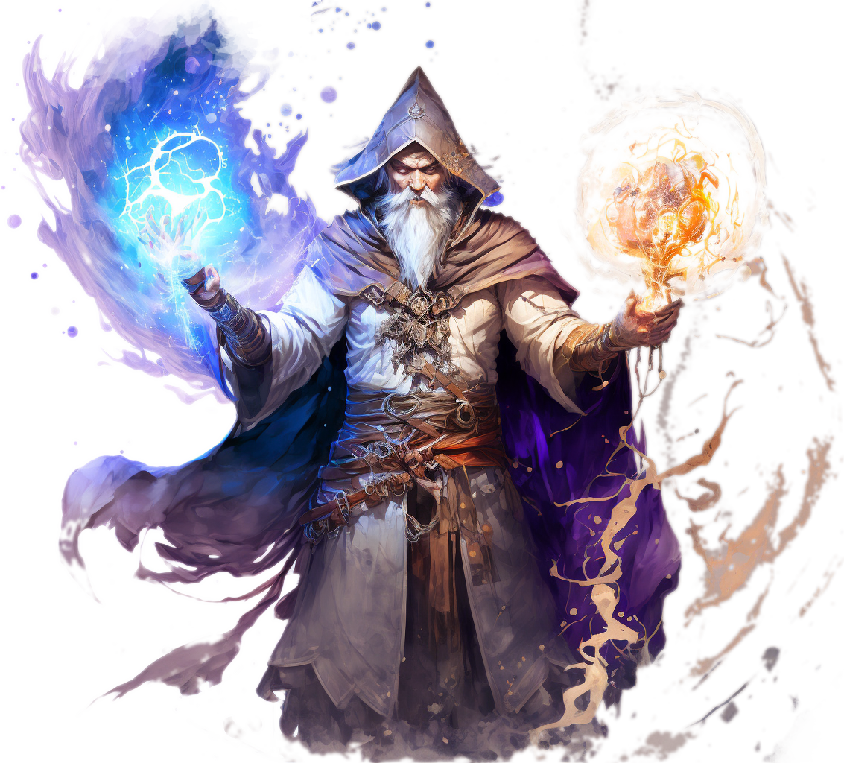
No, QuestGuard is its own game, completely separate from D&D.

What to expect?
QuestGuard is systems-light - there are hardly any tables, no concentration rule, no spell components or spell slot levels, no roll to hit or opportunity attacks, no saves (checks) in combat (crowd control/status effect is direct and fair).
There are long or short rests, as the Quest Master has better control over the pacing through the Adventure and enemy Worthiness system.

Character abilities are gamified for gameplay rather than realism, to be able to do things such as creating gold or magic items out of thin air or farming enemies. Characters can respec between Adventures, all monsters are tactical and change how you must approach combat, and this is the tip of the iceberg!

How to get into it?
You’re already in it!
Our website https://questguardrpg.com features a “Play With Us!” button. Once clicked, it will redirect you to our Discord group, where we regularly host campaigns and one-shot adventures for new and old players alike!

Feel free to say hi and show your character!


Why QuestGuard?
There are plenty of reasons to choose and play QuestGuard!

It’s “gamey” and it flows
Everything in QuestGuard is intended to have a good flow in combat, be simple and allow for awesome Ability combinations.

The complexity and skill expression does not come from number crunching, but rather from how you choose to combo your character pieces together.

Your character build flows and all game elements fit in such a way that they don’t hinder one-another. It’s clean.

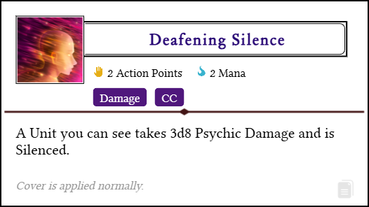

Figure out your own combos and unleash them upon your foes!

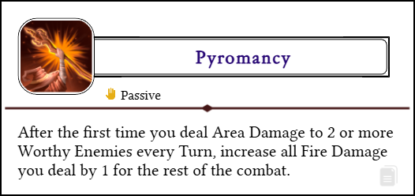
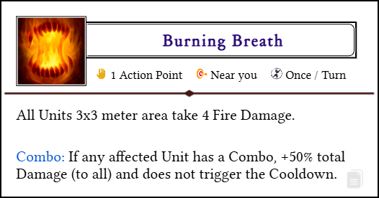

Every class and build path is different and breaks the rules of the game!

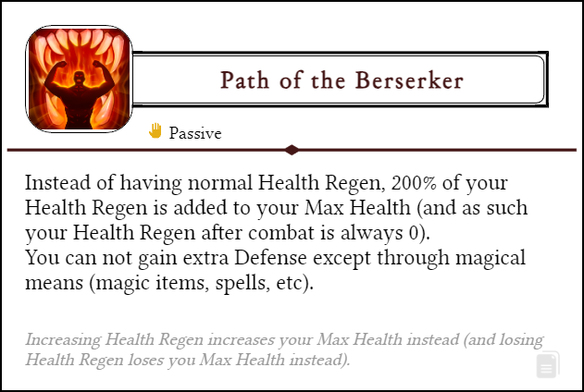
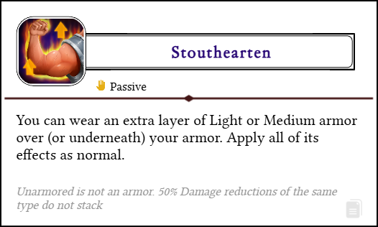

There are hundreds of such Abilities in the game, and the possibilities are in the millions!

Being a Quest Master is easy
QuestGuard is made to be cool for players, and easy for the Quest Master (the game master). Through rules such as the Adventure, Worthiness, Skills, etc, you will find running Quest Guard both enjoyable and easy to manage.

Always online
All the resources are always online. As such, there are frequent patches, balance improvements, content updates and much, much more!


The Dice
QuestGuard is a 2d6 system. Whenever you roll a Check, you roll 2 6-sided dice and add any modifiers to it.

Rolling evens (1-1, 2-2, 3-3, and so on) mean rolling with an Event. An Event is just something that happens, and depending on the roll amount, it may be pretty good or quite bad for you.
Getting 0 or less on a Check would constitute a Critical Failure (through negative modifiers).

Which dice are used
In QuestGuard, we use the standard polyhedral dice - d4, d6, d8, d10, d12 and d20 (although the d20 is rarely used).

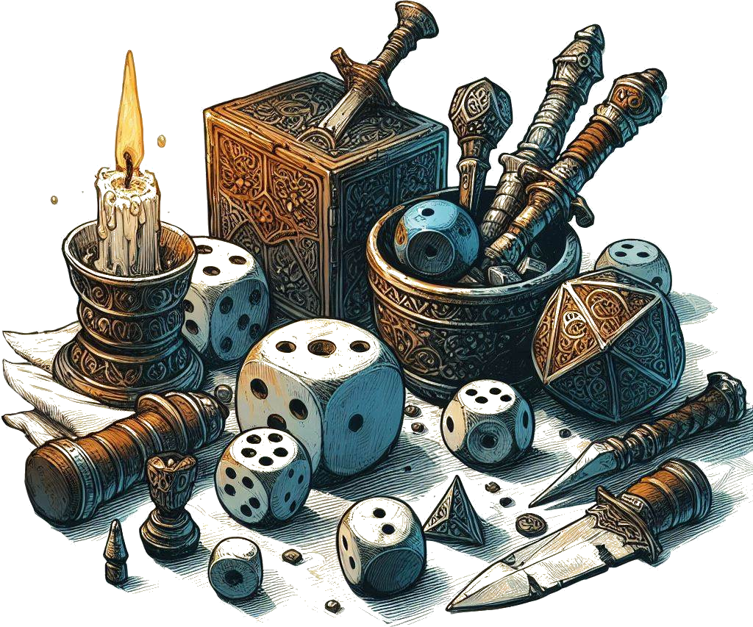
Combat dice
In combat, there is no rolling to hit. Whenever you attack, you roll for Damage directly - most of the time, what you see is what you get. If you rolled a total of 14 on 3d6, you deal 14 Damage.

By default, there are no critical strikes, but some weapons and Abilities can trigger bonus effects based on the rolls. If it can, it is neatly mentioned in its text box.

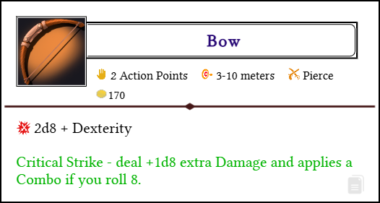

Most of the time, you will deal and take Damage. Be prepared!


Characters

Character sheet
Like in most RPG’s, a Player Character needs a character sheet.
You can find it on the website at https://questguardrpg.com under Downloads.

The PDF version is editable. Make sure you save it!

What makes a Character
A Player Character is made up of a Race plus a Class. Each of these has a ton of customization options.

Each Race has a Racial Ability you can choose. Each Class has a Specialization, and then, every level, gets a choice of one out of 2 or 3 Talents to pick, which are powerful Abilities that shape how your Character plays and fights.

Don’t be afraid to try strange combinations! Player Characters can freely “respec”, changing all Talent choices and learned Abilities.

Progression
There are 10 Levels Players can progress through with their Characters.

Levels are packed with interesting options. Every Level unlocks new Abilities, new pets or choices to make, new Talents, and more!

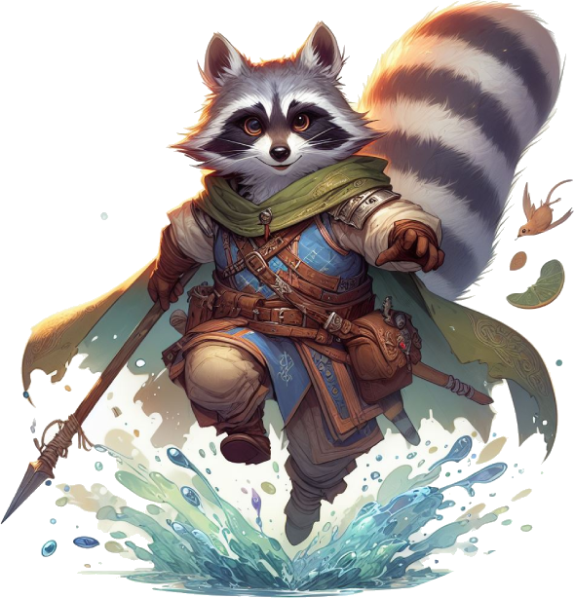
The recommended way to Level-Up is through milestones or checkpoint set by the Quest Master. If using the Experience system, however, going from Level 1 to Level 10 should not take an eternity, either. QuestGuard intends campaigns to play out spanning a few months at most, but it’s all up to you and your group.


Stats
There are 4 Main Stats in QuestGuard: Might, Dexterity, Intelligence, Presence. The Stat is directly the “modifier”. In combat, each Stat affects an aspect of your character.

- Might affects base Health (+ 3 per Might point).
- Dexterity affects Movement Speed (+1 per 2 Dexterity points).
- Intelligence usually affects the availability of Abilities, non-combat Skills and other roleplaying aspects (+1 available Minor Talent per Intelligence).
- Presence affects Health Regen (+2 per Spirit point).

All Stats also contribute to roleplay for Checks.
The calculations are be explained in Character Creation.

Starting Stats
Everyone (usually) has the same stat numbers, ordered as you like: -1, 0, 1, 2. Put these numbers however you like in your 5 Stats.

Each way to distribute Stats is perfectly valid - there are builds and variations for any combination. QuestGuard is designed so that there is no objectively best way to do anything.

Races & Stats
Races don’t increase or decrease Stats, but instead, each Race imposes some restrictions on Stats.



Skills & Substats
There are no Skills listed on your Character Sheet.

When you want to do something, the Quest Master will simply call out for a “Might Roll” or a “Presence Roll”, for example (2d6).

However, each Character will have non-combat Skills they can add themselves to the Roll if appropriate.
Each Skill you have explicitly has a bonus (e.g. +3 in Persuasion, +1 in Monstrology, -2 in Control Emotions, etc).

The Quest Master might call for a Presence Roll to ask a quest giver for more reward money, and, if you have a bonus in Persuasion, you can say “I have a +2 in Persuasion, can I add it to the roll?”, to which the Quest Master might say yes or no, depending on the situation.

Let’s keep the Character Sheets clean!

Feel free to invent your own Skills, but you can find a list of recommendations on the website. Don’t be too broad with them.

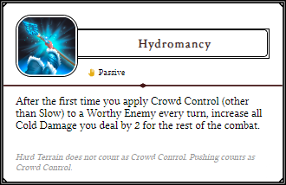
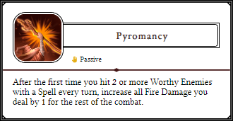
Abilities
Almost everything you get in this game is an Ability. Skills, spells, attacks, moves, Feats, Talents, even weapons and armor!

An Ability is simply a rectangle with a clearly defined text, a little colorful icon and tags to help you identify its properties, such as the costs of using it, how often you can use it, the range, etc.

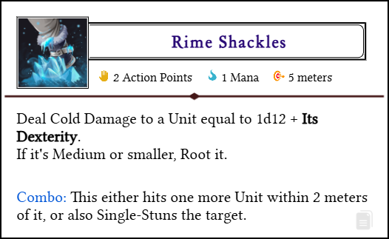

Most of the time, the only thing you need to use an Ability is your hands. No need for materials, a focus, spoken words, etc.

Nifty website trick…
On the website, click on the little document icon on the bottom-right of an Ability to copy it to your clipboard. You can then paste it in a Word document, in Paint, Discord, etc.

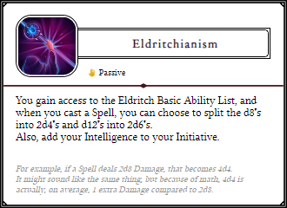
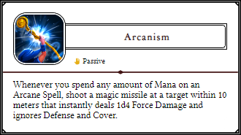


Combat
Combat usually happens on a map, preferably on a grid, and distances are measured in meters.

The turn order is determined by the Initiative attribute. Everyone has fixed initiative and groups of monsters will take their turn simultaneously.

Actions
Each character or monster in combat has 3 Action Points. You can use these Action Points as you like, with no diminishing returns (e.g. you can attack 3 times with a one-handed weapon even).
Abilities that cost 0 Actions are free and can be done as many times as you like.

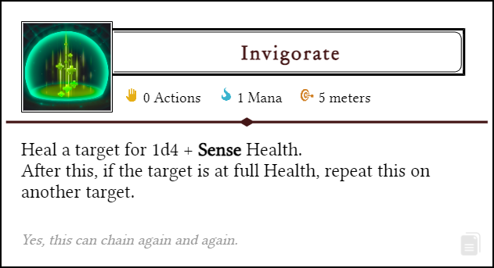

There is no “minor-action”, “bonus-action”, etc.

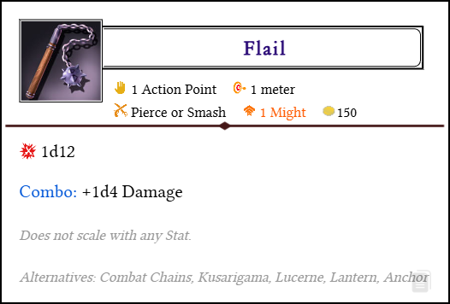

Combo
Many Abilities and weapons “apply a Combo”.
Many Abilities and weapons trigger an extra effect if the target had a Combo! Then the Combo is removed.

Anyone can trigger anyone’s combo. Go make some combos with your team!

Mana
The resource used to cast more powerful Abilities is called Mana. All Classes (except Hunters and Rogues) use Mana.

You have a number of Mana Points you can use on Abilities.
If you have 5 Mana Points and an Ability requires 2 Mana, you spend 2 Mana and use the Ability. Then, you are left with 3 Mana.

Usually, Mana regenerates in the downtime between Adventures.

Resting & regeneration
There are no rests like short rests or long rests.

You regenerate Health equal to your Health Regen after every Combat. Your Health Regen is defined by your Race.
You regenerate all resources (Health, Mana, etc) at the end of every Adventure.

Adventures
An Adventure is a time period defined by the Quest Master. It could be a full dungeon, a play session, completing a quest, etc.

An Adventure that makes will have you use everything in your will to survive you will typically contain 3 medium-difficulty combat.


Using the Website
All information on QuestGuard can be found for free online at https://questguardrpg.com

All Races, Classes, Abilities, etc are found under Databases.




What’s next?
You should build a Character and show it to us on Discord! We’re happy to have you here and play with you and your new Character!

Click on this link to jump straight into the character creation.
Or, if the link doesn’t open, go to the Learn To Play section of the website (https://questguardrpg.com), scroll down and click on the Character Creation guide. It will walk you through everything you need to create your first Character!

Feel free to also contact me (Dave) directly over there, I’ll gladly talk to you about the game, and answer any question you might have.


Happy adventuring!

